Commonwealth of Massachusetts
Department of Housing &
Community Development

Deval L. Patrick, Governor  Timothy P. Murray, Lt. Governor  Tina Brooks, Undersecretary

100 Cambridge Street, Suite 300 www.mass.gov/dhcd
Boston, Massachusetts 02114 617.573.1100

PUBLIC INFORMATION SESSION

Neighborhood Stabilization Program (NSP)
of the
Housing and Economic Recovery Act of 2008

Substantial Amendment to the Fiscal Year 2008
CDBG One-Year Action Plan

The Massachusetts Department of Housing and Community Development (DHCD) will hold a public information session in order to provide opportunity for public comment and discussion on the draft Substantial Amendment to the CDBG FY 2008 One-Year Action Plan. The draft amendment establishing the Neighborhood Stabilization Program is available on DHCD’s website at www.mass.gov/dhcd.

Thursday, November 13, 2008
Worcester Public Library
3 Salem Square
3:00 pm to 5:00 pm
Worcester, MA

Interested parties should feel free to submit comments, in writing or via email, directly to DHCD prior to the scheduled session. Public comments will be accepted through close of business on November 19, 2008. Comments may be directed to: Mark Siegenthaler, Community Development Manager, DHCD, 100 Cambridge St, Suite 300, Boston, MA 02114 or mark.siegenthaler@state.ma.us.

DIRECTIONS & MAPS
3 Salem Square
Worcester, MA 01608
508-799-1655
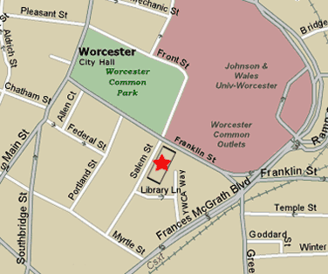
From Interstate 290 (can be reached from Rte. 495 from the East and Mass Pike from the West) (can be reached from Rte. 146 from the South, enter in eastbound direction) (can be reached from Rte. 190 from the North, enter in westbound direction)
From the East: Exit 16, bear right at light at end of off-ramp.
From the West: Exit 16. Turn left at light.
Proceed through intersection at Summer Street (Post Office will be on your left.)
After passing under the bridge, turn left on Major Taylor Boulevard (DCU Center will now be on your right. Hospital will be on your left.)
Proceed to next intersection (Worcester Common Outlets will be in front of you.) Turn left (Parking garage will now be on your right.)
Continue through intersection at Franklin Street. There will be a brick wall on your right. At end of wall, turn right on YWCA Way. Turn left into municipal parking lot. Library is adjacent to parking lot.
(From Rte 495. it is approx. 20 minutes to the Library. From Mass Pike it is approximately 10 minutes to the Library.)
From Rte. 122A North (Holden): Main Street to Shrewsbury Street to Doyle Road, which becomes West Mountain Street, to Rte. 190 to Rte.290 westbound. Follow directions above.
From Rte. 122 North (Paxton): Pleasant Street South. Turn right on Chandler Street (at bottom of long hill, area is called Tatnuck Square) Follow Chandler Street for approximately 3 miles. (Chandler bears left at Worcester State College) (Cross Park Avenue and cross Main Street. Street name changes to Madison Street at Main Street) Turn left on Southbridge Street. Turn right on Myrtle Street. Turn left on Salem Street and turn right into municipal parking lot. Library is adjacent to parking lot.

