Commonwealth of Massachusetts
Department of Housing &
Community Development

Deval L. Patrick, Governor  Timothy P. Murray, Lt. Governor  Tina Brooks, Undersecretary

100 Cambridge Street, Suite 300 www.mass.gov/dhcd
Boston, Massachusetts 02114 617.573.1100

PUBLIC INFORMATION SESSION

Neighborhood Stabilization Program (NSP)
of the
Housing and Economic Recovery Act of 2008

Substantial Amendment to the Fiscal Year 2008
CDBG One-Year Action Plan

The Massachusetts Department of Housing and Community Development (DHCD) will hold a public information session in order to provide opportunity for public comment and discussion on the draft Substantial Amendment to the CDBG FY 2008 One-Year Action Plan. The draft amendment establishing the Neighborhood Stabilization Program will be available on DHCD’s website on November 3, 2008, at www.mass.gov/dhcd.

Thursday, November 6, 2008
DHCD
3:00 pm to 5:00 pm
100 Cambridge Street
2nd Floor Conference Room B
Boston, MA

Interested parties should feel free to submit comments, in writing or via email, directly to DHCD prior to the scheduled session. Comments may be directed to: Mark Siegenthaler, Community Development Manager, DHCD, 100 Cambridge St, Suite 300, Boston, MA 02114 or mark.siegenthaler@state.ma.us.

If you plan to attend this session, please RSVP via email to Patrick Hart at patrick.hart@state.ma.us. Please allow at least 15 minutes to be cleared through building security at the 2nd floor lobby. Security badges with your name will be available for you.

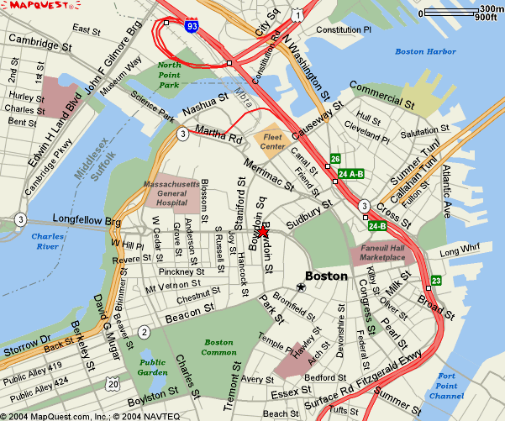

Directions to DHCD 100 Cambridge St. Boston

Driving from the North
From Rt. 93S take the Storrow Drive exit, at the bottom of the bridge turn off at Nashua Street. DO NOT GO INTO THE TUNNEL. Turn right at end of ramp onto Nashua Street going towards the TD Bank North Garden. Follow Nashua Street around the Jail and past Spaulding Hospital. The street will make a right turn and come to a traffic light where you have to turn left. Turn left. Go to the next traffic light and go straight. This is Merrimac Street. Follow Merrimac to the next traffic light and turn as if going right. The entrance to the Government Center garage will be in front of you. If you are going to 100 Cambridge Street continue turning right (New Chardon Street). Follow New Chardon up the hill thru the pedestrian light and to the working traffic light at Cambridge Street. 100 Cambridge Street is diagonally across on your left (a large 100 is in the window over the front entrance). If you are going to the Saltonstall garage, turn left on Cambridge, then right on Somerset.

Driving from the South
Take Rt. 95N to Rt. 93N to Boston, enter new Rt. 93N Tunnel. Take Exit 26/Storrow Drive. After exiting you are on Martha Way. Bear left on Merrimac Street. Government Center Parking Garage is straight
ahead at the end of Merrimac (across New Chardon).

Driving from the West
Take Rt. 90E (Mass Pike) to Rt. 93N to Boston, enter new Rt. 93N Tunnel. Take Exit 26/Storrow Drive. After exiting you are on Martha Way, bear left on Merrimac Street. The Government Center Parking Garage is straight ahead at the end of Merrimac (across New Chardon).

