INSTRUCTION FOR INITIAL APPLICATION
USING DEPARTMENT OF PUBLIC HEALTH’S
ONLINE APPLICATION SITE

OVERVIEW & ELIGIBILITY
The Office of Emergency Medical Services (OEMS) has joined other health care professional licensure and certification programs within the Massachusetts Department of Public Health in utilizing a centralized, online licensing and certification system. This system allows EMS personnel to submit their initial and biannual recertification, application and associated fees online via a secure website. These step-by-step instructions are to be utilized by initial applicants for all levels of Massachusetts Emergency Medical Technician who have completed an initial training course and hold current certification from the National Registry of Emergency Medical Technicians (NREMT).

TIMELINE
The typical processing time is 10 business days for a complete online application. This timeline is subject to change due to inaccuracies of information submitted by the candidate, invalid NREMT certification, out of state verification, and possibly a CORI and criminal history review.

CHECKLIST
Items listed below are needed in order for the Office of Emergency Medical Services to process and issue a certification.
□ FEE Massachusetts certification fee of $150, payable online by Visa, Mastercard, or eCheck

□ NREMT CERTIFICATION All initial candidates must have NREMT certification in order to be eligible for MA EMT certification. If applying online, you do not need to submit a copy of your NREMT card—it will be verified electronically.

□ Out Of State Verification If a candidate has have ever held certification or licensure as an EMT (at any level) they MUST have all states where they were/are certified submit a “State Verification” form to OEMS

□ CORI Packet (Only if a candidate indicated “YES” to QUESTION 4 on the application.) A CORI packet must be submitted for review. This packet must include the following items: a detailed written explanation concerning the circumstance(s) in question. Forms must be notarized based on a government-issued photo ID and include the signature of a Notary Public with a stamp or seal on page 3. Notaries are commonly found at banks. The original signed CORI acknowledgement must be mailed to the address listed at the top of the form. The form is available at http://www.mass.gov/dph/oems

NOTE REGARDING CPR and ACLS COMPLETION CARDS: Please note that in order to function as an EMT, you must hold proof of required training, meeting the minimum standard established by the Committee on Cardiopulmonary Resuscitation and Emergency Cardiac Care of the American Heart Association, in Basic Cardiac Life Support health care professional cardiopulmonary resuscitation, including utilization of an automatic/semiautomatic defibrillator in the form of a current course completion card. Paramedic personnel must have proof of Advanced Cardiac Life Support training in the form of a current course completion card.

Section One - Registering a person. All first time users of the Online Licensing system must register as a person. This process includes entering demographics later used for certification application and setting up a username and password for future use of the system. This future use includes, but is not limited to recertification, updating mailing address and updating email address.
www.mass.gov/dph/oems/elicensing

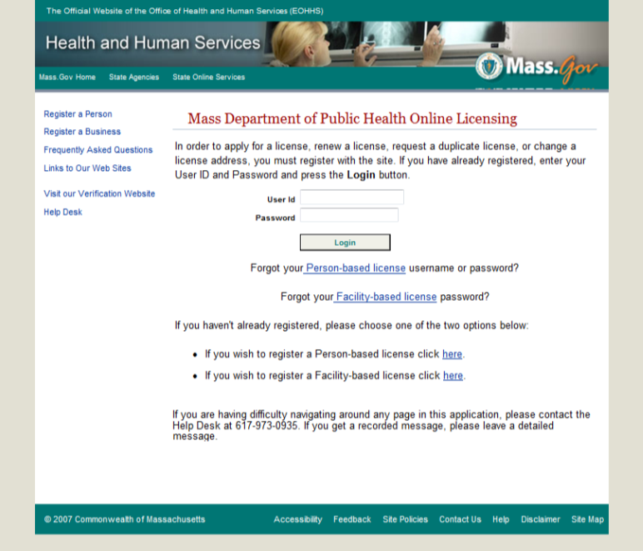
Step Two: Search for any existing record by using your date of birth (xx/xx/xxxx) and Social Security Number (xxxxxxxxx), then click “Search”
Note: if a record was found, please contact eLicensing Help Desk to retrieve the username and password. (617-973-0935)
Step One: Begin by selecting "Register a person"

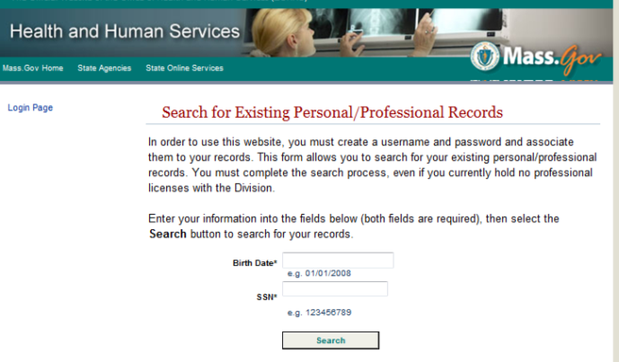

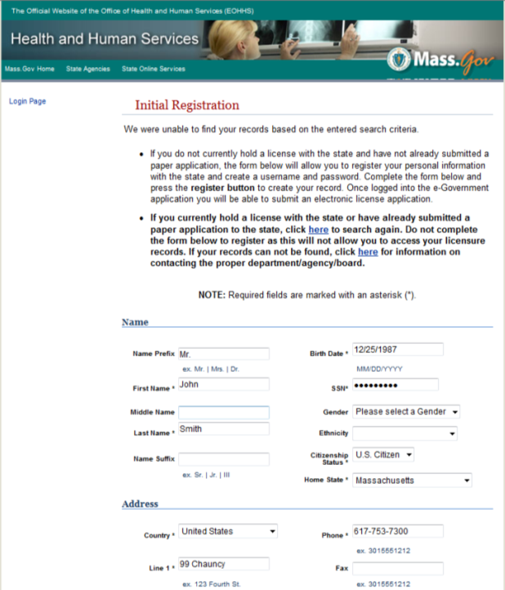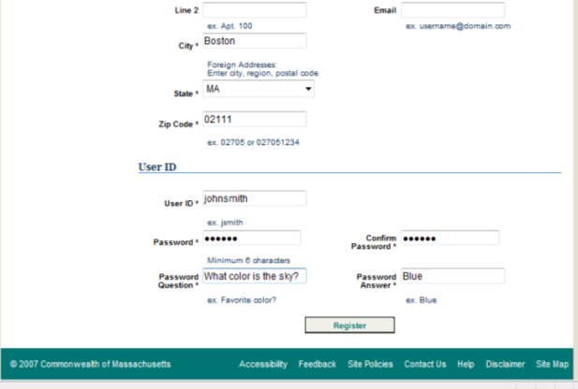
Step Three: The system will be unable to locate records of first time users. Please read instructions and fill out demographics below.
Note: While not all the fields are required, it is recommended that this form be filled out as completely as possible.
Once complete, click the button that say “Register” at the bottom of the page.

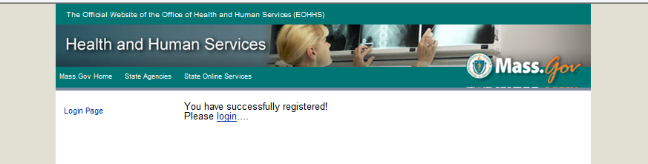

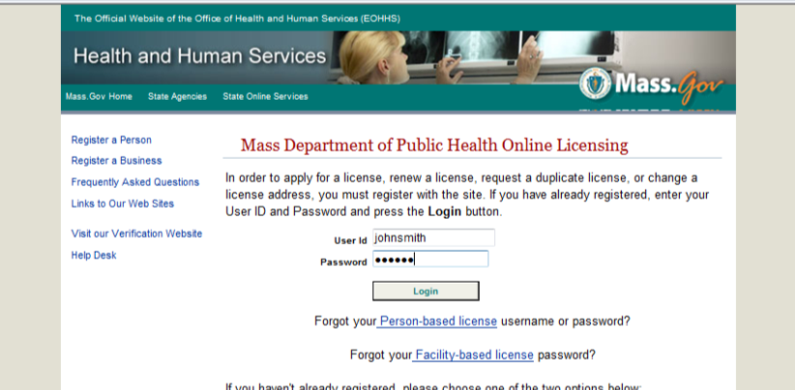
Step Four: Using the username and password you just created, you must now log onto the system.

Section Two – Applying for an initial license using the online elicensing system.

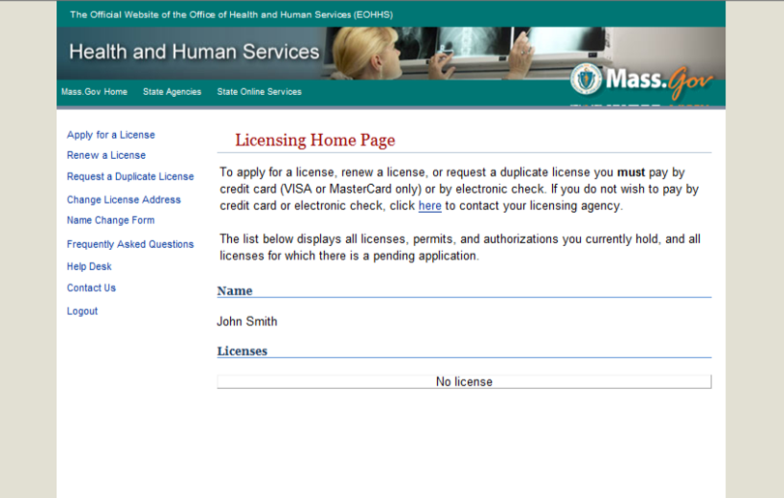

Step One: Once logged into your account, click on “Apply for a License”

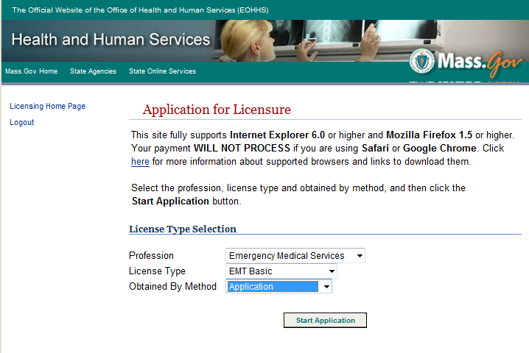
Step Two: Using the drop down options, select the following:
Profession: Emergency Medical Services
License Type: EMT, Advanced, or Paramedic
Obtained By Method: Application

Then click “Start Application”

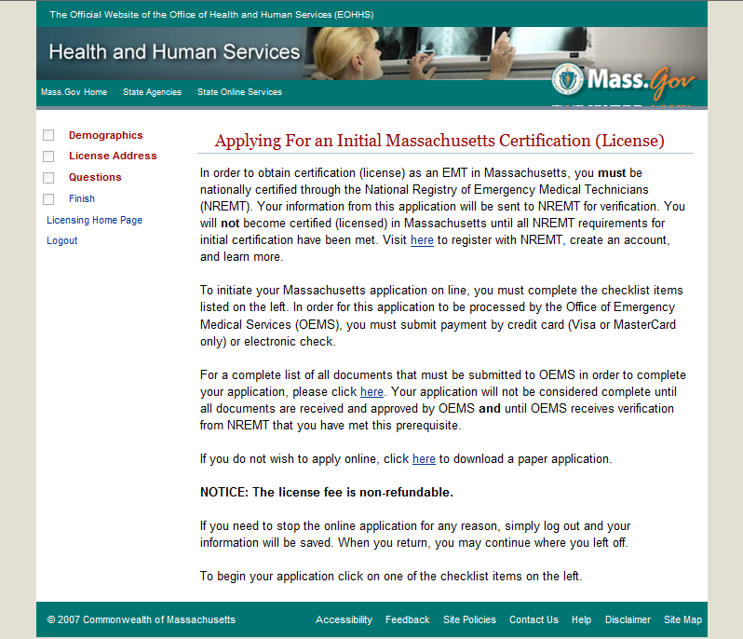
Step Three: To begin the application you will need to compete the three part checklist on the left; Demographics, License Address and Questions. Then you will need to finish the application and pay the certification fee.

Step Four: Verify your permanent address, edit as needed using the edit button, then click “Complete”. Once you see a check box in front of Demographics, please move onto “License Address” by clicking the red text on the left.
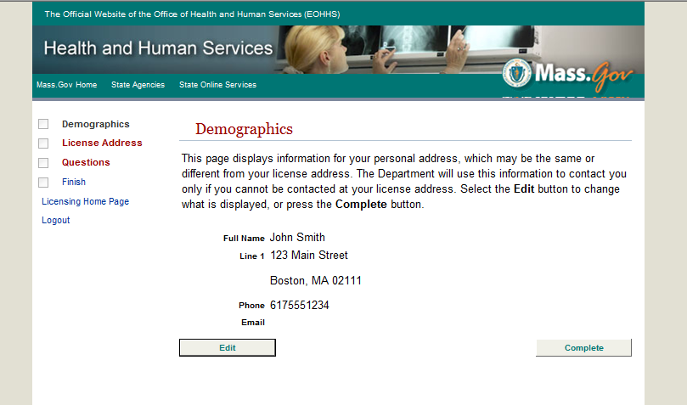

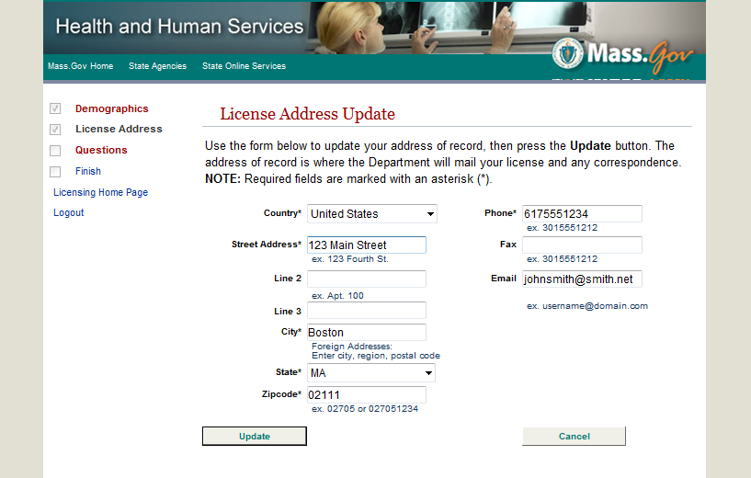
Step Five: Enter the mailing address where you want your license to be send then click “Update”.

Step Six: Click “Complete”, then select “Questions” in red on the left.
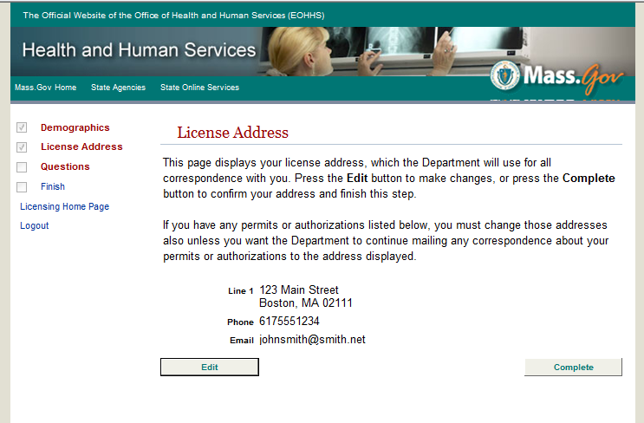
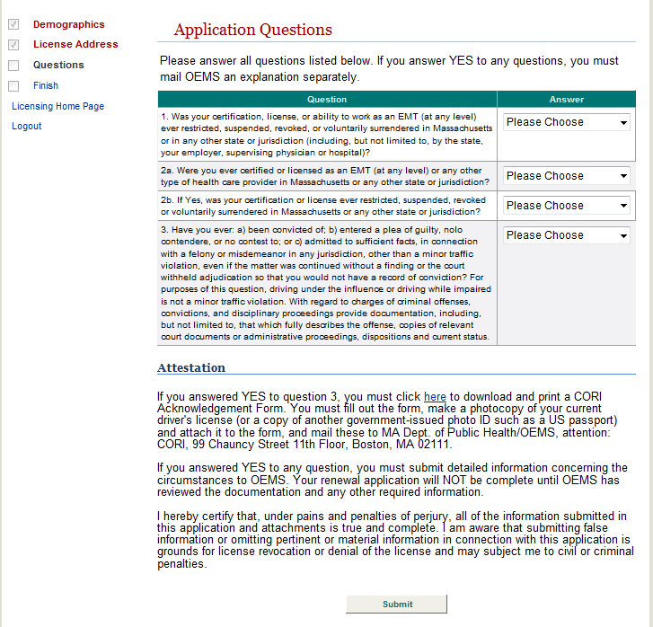
Step Seven: You must read carefully and pick answers to all questions using the drop down answers. Any questions answered “YES” to you must submit a written explanation to OEMS. If you answered “YES” to question 3, please ensure to submit CORI packet in addition to your written explanation of why you selected “YES”.
OUT OF STATE CERTIFICATION NOTE: If you have ever held certification or licensure as an EMT (at any level) you MUST have all states where you were/are certified submit a “State Verification” form, available on http://mass.gov/dph/oems, to OEMS
After answering the questions, click “Submit” and then click on “Finish” on the checklist

Step Four: Verify your permanent address, edit as needed using the edit button, then click “Complete”. Once you see a check box in front of Demographics, please move onto License Address by clicking the red text on the left.

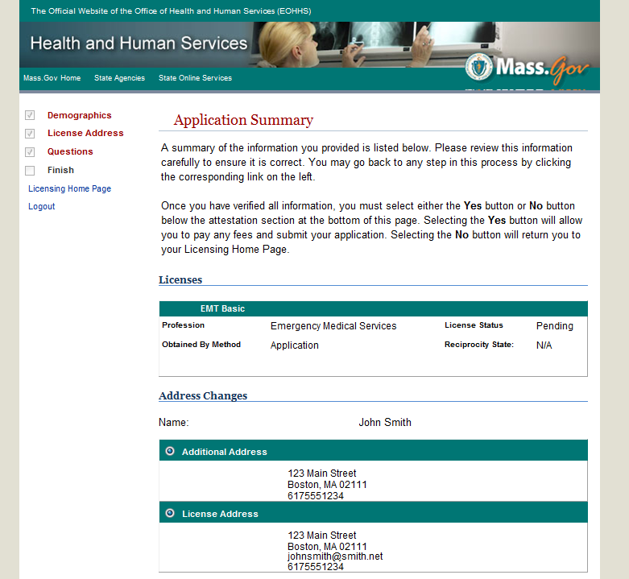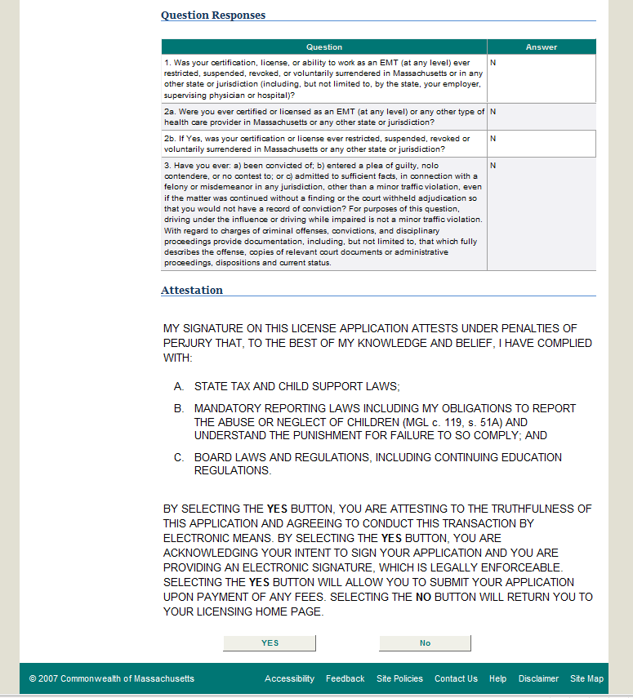
Step Eight: Attestation and submission of application for certification.
Read attestation items carefully, if entire application (including answers to questions) are correct, click “YES”.
If NO, please edit application and then attest to correct application and items listed.

Section Three: Submission of payment for application. This fee is NON REFUNDABLE

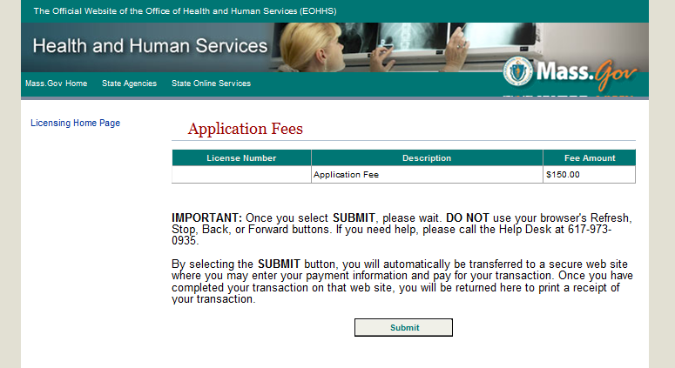
Step One: To pay certification fee’s click the “Submit” button once.

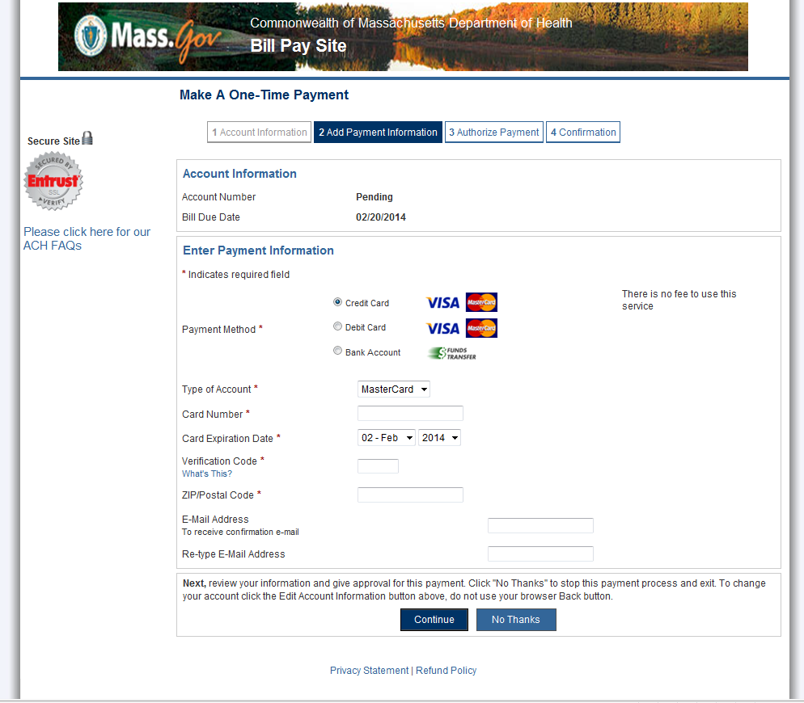
Step Two: Select payment method and type of account. Then enter individual information including card number, expiration, and verification name.
Once information entered, click “Continue”

Step Three: Review information entered. If not edit the payment information
Once information verified, click “Authorize Payment”
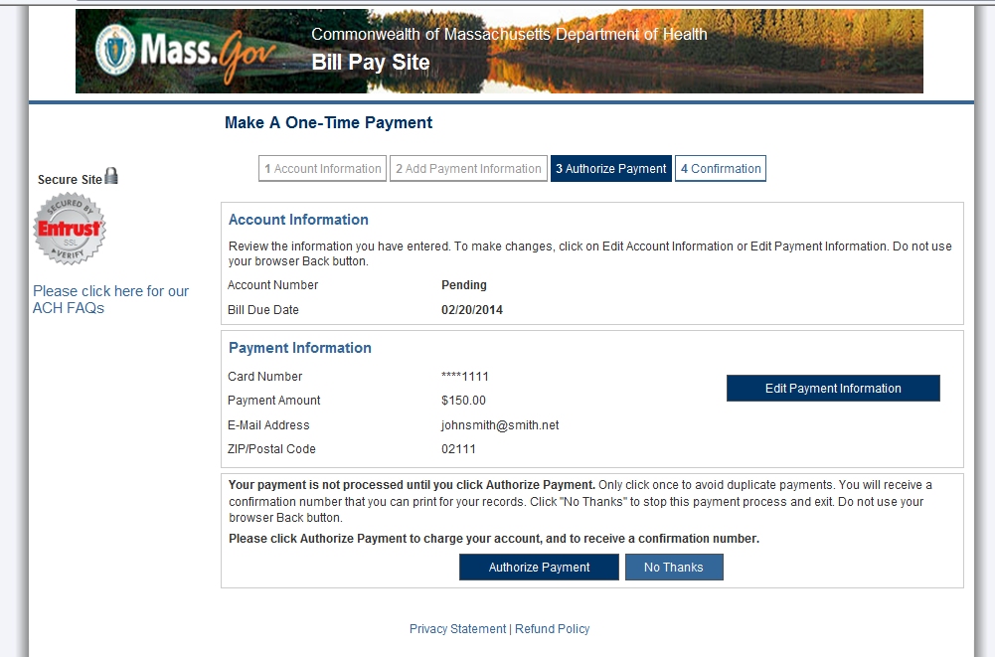

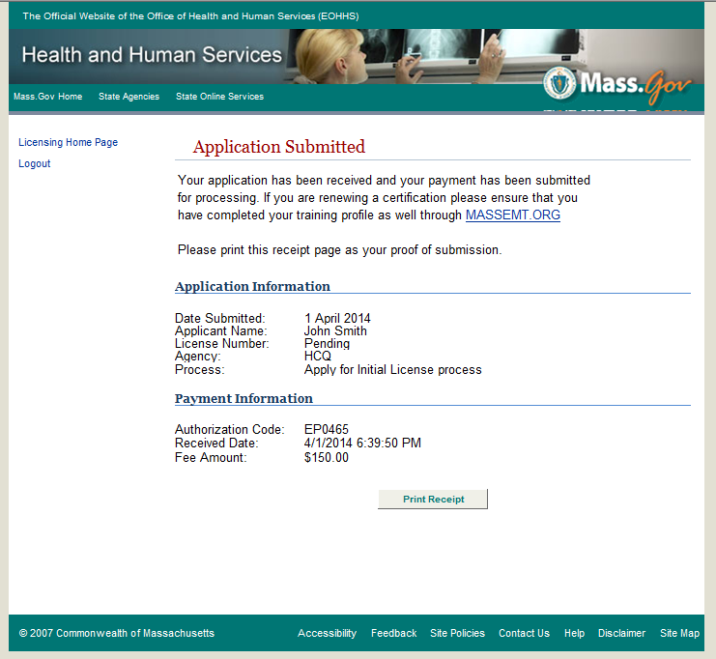
Step Four: Verify application submitted by reaching this page. If needed, click “Print Receipt”. This will be your only time to print the receipt for this payment.

The system will verify NREMT certification based on demographics entered on application then issue a certification. There could be delays due to out of state verification, incorrect demographics entered, or CORI Packet review. If you have any questions with the status of your application, please email oems.recert@state.ma.us.

