Massachusetts Department of Environmental Protection
Bureau of Resource Protection - Title 5
DEP Approved Inspection and O&M Form for Title 5 I/A
Treatment and Disposal Systems

 | A. Installation
Important: When filling out forms on the computer, use only the tab key to move your cursor - do not use the return key.  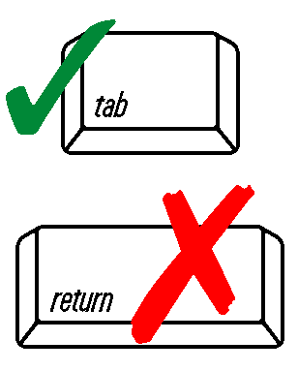 | Owner
 | Facility Street Address
 | City |  |  |  | Zip
 | Mailing address of owner, if different:
 | Street Address/PO Box:
 | City |  |  | State |  |  | Zip
( ) - ext.
Telephone Number

 | B. Authorized Service Provider
 | O&M Firm
 | Street Address
 | City |  |  | State |  |  | Zip
( ) - ext.
Telephone Number
 | Certified Operator Name |  |  |  | Certification Number
 | C. Facility/System Information
 | DEP ID |  |  | Manufacturer ID |  |  | Model Number
 | Installation Date |  |  |  | Start of Operation
 | Approval Type: General Provisional Piloting Remedial
 | Seasonal Residence – used less than 6 mo./year: Yes No
 | D. Operating Information
 | Inspection Date |  |  |  | Previous Inspection Date
 | Sludge Depth (to be checked yearly) |  |  |  | Pumping Recommended Yes No
 | E. Field Testing
 | Field Inspection:
 | Color: gray brown clear turbid
 | Other (specify):
 | Odor: musty earthy moldy offensive turbid
 | Effluent Solids: no some
 | pH | SU  6 to 9 | DO | mg/L  2 or greater | Turbidity | NTU  40 or less
 | Should a Remedial or General Use system fail the Field Testing, effluent samples shall be collected per Standard Methods and analyzed for BOD and TSS.
 | F. Sampling Information
 | Samples Taken: Influent Effluent
 | Commercial systems or systems with a design flow of 2000 gpd and greater, and General Use nitrogen reducing systems:
 |  |  |  |  | gpd
 | Parameters sampled: pH BOD CBOD TSS TN Other (list below)
 | Other 1 |  |  | Other 2 |  |  | Other 3
 | G. Inspection and Maintenance
 | Description of any maintenance performed since previous inspection & during this inspection:
 | Notes and Comments:
 | H. Certification
 | I certify: I have inspected the sewage treatment and disposal system at the address above, have conducted the required Field Testing and/or sample collection in accordance with Standard Methods, have completed this report and the attached technology operation and maintenance checklist, and the information reported is true, accurate, and complete as of the time of the inspection. I am a Massachusetts certified operator in accordance with 257 CMR 2.00.
 | Operator Signature |  |  |  | Date
 | System owner must submit this report, technology O&M checklist, and any required sampling results to the local board of health as follows for each inspection performed:
 | Remedial Use – by January 31st of each year for the previous calendar year
 | Piloting Use - within 45 days of inspection date
 | Provisional Use – by March 31th of each year for the previous 12 months
 | General Use – by September 30th of each year for the previous 12 months
Send to:
Department of Environmental Protection
Attention: Title 5 Program
One Winter Street, 5th Floor
Boston, MA 02108

