Installing the MassGIS DataViewer Toolbar

This document describes how to install the MassGIS DataViewer Toolbar for use in ESRI’s ArcMap versions 9.x and 10. The procedure differs depending on what version of ArcMap you are using.

The MassGIS DataViewer Toolbar is meant to be used with data and layer files received from MassGIS that are stored in a specific folder structure. Once installed, the Viewer allows you to add data to ArcMap by choosing from a menu of categories. When added to ArcMap, the data appear already symbolized and, when appropriate, with labels. The symbology, labeling and other display properties are stored in the layer (.lyr) files distributed by MassGIS, facilitating data display in ArcMap.

Installing the Data

- In Windows Explorer/My Computer create a new folder in an accessible drive. Do not use spaces in the name of this folder. We will use C:\MassGIS_DV as an example.
- Copy all the folders and files (including the data) from the MassGIS DataViewer DVD(s) or hard drive you received from MassGIS into this new folder.

Installing the Toolbar for ArcMap 10

ArcGIS 10 uses the concept of an Add-In, an extension to a software program that performs a custom task. ESRI provides various developer add-ins as part of the ArcGIS developer kit. The MassGIS DataViewer Toolbar is a custom Add-In written by MassGIS programmers. You do not need administrator privileges on your PC to install this Add-In.

Follow these steps to install the MassGIS DataViewer Toolbar Add-In:

- Navigate to the ArcGIS folder now in your new folder (for example, C:\MassGIS_DV\ArcGIS) and double-click on the file called AZAddIn.esriAddIn.
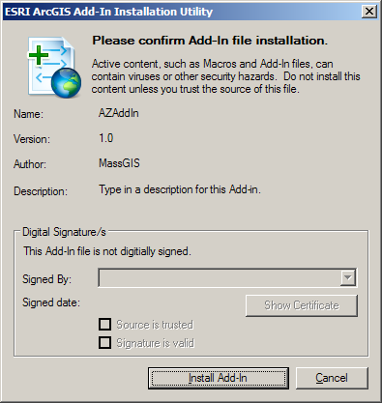
This form should appear:

- Click on Install Add-In:

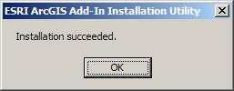
This form should appear:

- Click OK.
- Open ArcMap
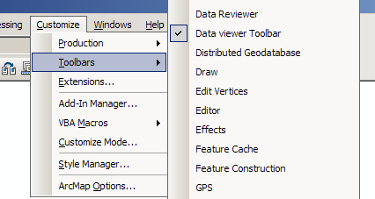
- In the Customize menu, select Toolbars.

- Check the Data viewer Toolbar

The DataViewer toolbar will appear and you can move or dock it wherever you like:
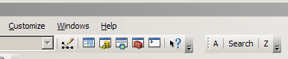

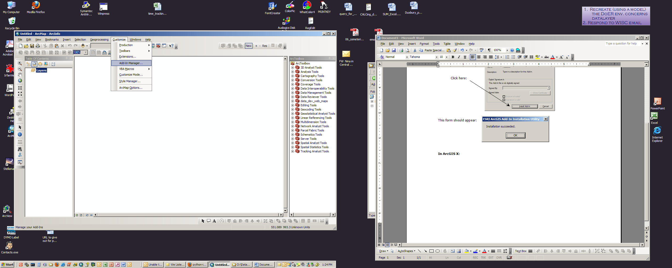
Note: Add-Ins may be managed with
the Add-In Manager in ArcMap:
For more information see http://help.arcgis.com/en/sdk/10.0/java_ao_adf/conceptualhelp/engine/index.html#/How_to_deploy_using_the_Add_In_Manager/0001000002mn000000/

Installing the Toolbar for ArcMap 9.x

Loading the DataViewer Toolbar into ArcMap 9.x involves adding a .dll file to your ArcMap settings. This means you MUST have administrative privileges on your computer. Once you have loaded the .dll file, anytime you open a new or existing ArcMap 9.x document the MassGIS DataViewer Toolbar will be available to you.

To load the DataViewer Toolbar, first make sure all ArcMap documents are closed, then follow these steps:

- Browse to the ‘ArcGIS’ folder (if you received the Viewer and data on media from MassGIS).
- Run (Double-click) the installation file: Install_DataViewer.bat.
(This will pop up one or more DOS Command Windows that will install the DataViewer Toolbar into ArcMap. The DOS window will disappear when finished.)
- Open ArcMap. The toolbar will be turned off.
- To turn on the toolbar, go to View ->Toolbars and check the box beside the new toolbar: MassGIS SHP Data Viewer 9.x (v.2.1).

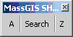

Now any time you open ArcMap you should have access to the MassGIS SHP DataViewer 9.x(v.2.1) toolbar.

If you ever need to remove the ArcMap 9.x DataViewer Toolbar (error from loading, upgrading to the ArcMap 10 or other newer version, etc.) you need to close ArcMap and run the file Uninstall_DataViewer.bat provided in your DataViewer installation ‘ArcGIS’ folder.

MassGIS
May 23, 2012
http://www.mass.gov/mgis

