Instructions--PLEASE READ these important notes before you begin:
- There is an audio portion of the orientation course, be sure to adjust your speakers so you can hear it.
- There is closed captioning, click on the caption box/dialog bubble to the left of the progress bar on the bottom of the slide.
- Only PCAs named in the letter from the FI will be paid to complete the orientation during non-working hours.
- If you are in the course and scroll back to previously covered material, you cannot fast forward, it is advised to go through all the material without going back to complete the course within the required three hours.
- The PCA will only be paid for three hours to complete the orientation.
- There are 10 parts to this 3-hour course, once all 10 parts have been completed; a system-generated report is emailed directly to your FI for payment to your PCA.
Step | Instructions |  | Photo/Illustration
1 | Go to |  | https://pcaworkforcecouncil.training.ehs.state.ma.us
2 | The login screen looks like this:  Your username is your Consumer ID and the PCAs unique ID. For example, if your Consumer ID is ‘EW12’ and your PCA unique ID is ‘123456’, you would enter: EW12123456 in the username field.  Password1 is the password for the system, this is case sensitive and you can change the password to something else after you complete the registration process. Instructions for changing your password are on www.mass.gov/pca |  | 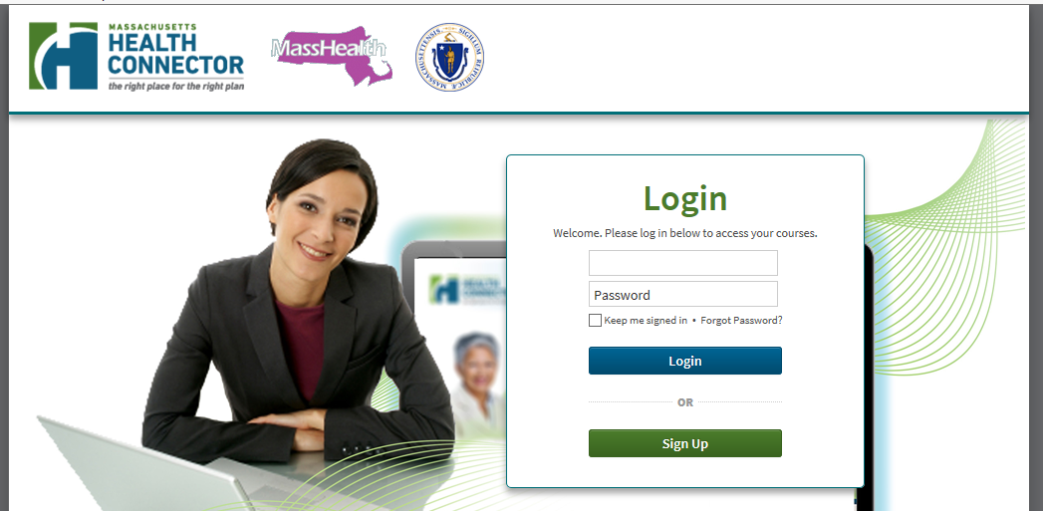
3 | After you log in, you will be on the home page of the PCA New Hire Orientation, which looks like this: |  | 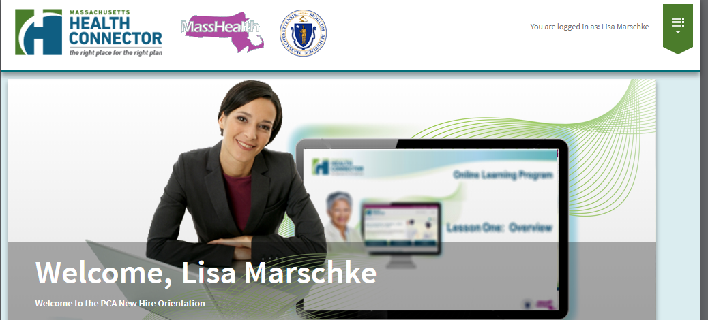
4 | Click anywhere in the green box called “My Courses” on the left. |  | 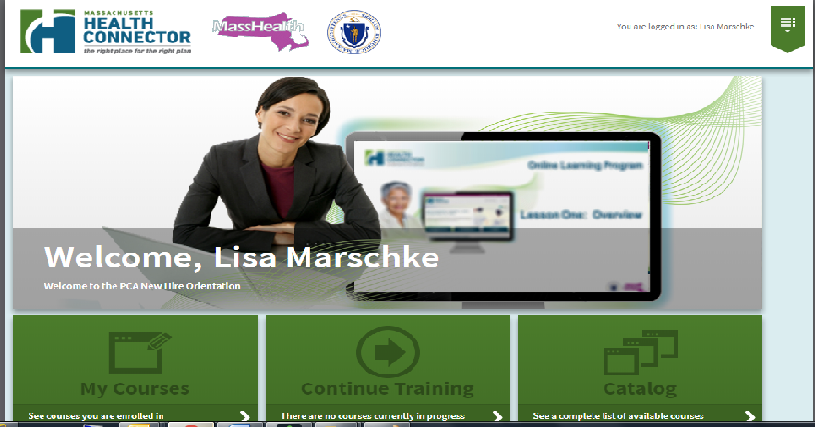
5 | The My Courses page opens, click on the blue “Launch” button to open the course |  | 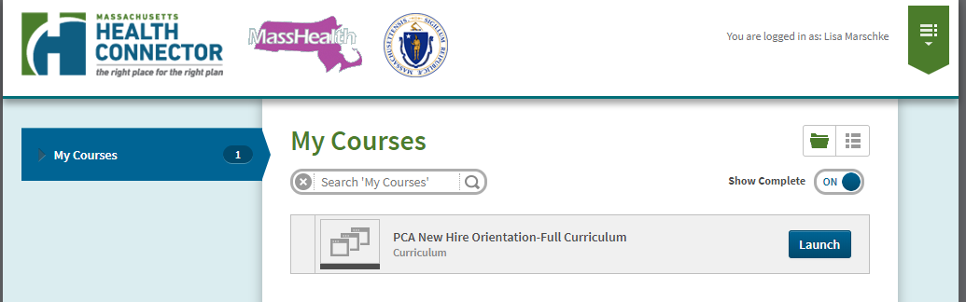
6 | The PCA New Hire Orientation-Full Curriculum page opens and shows all 10 parts to the PCA New Hire Orientation.  After you finish the Intro, the next module becomes available and so on.  Click on “Launch” to open the first part, Introduction to the PCA New Hire Orientation. |  | 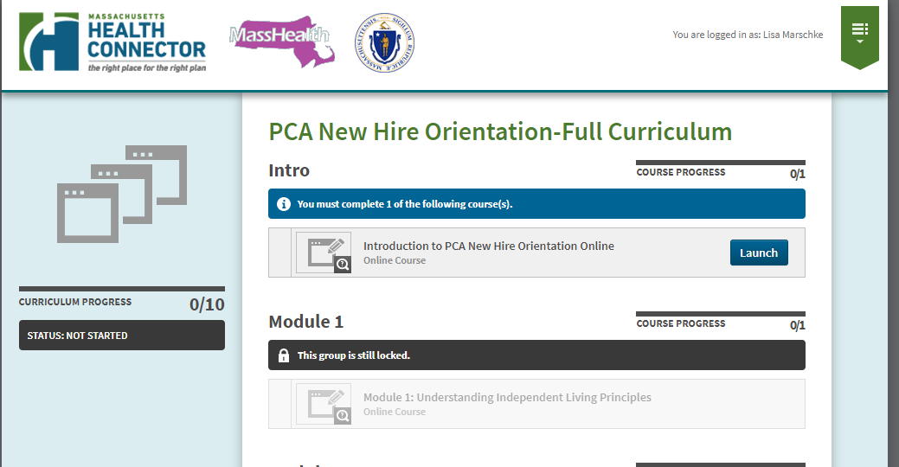
7 | This New Chapter page appears, click on “Launch” and the course begins. |  | 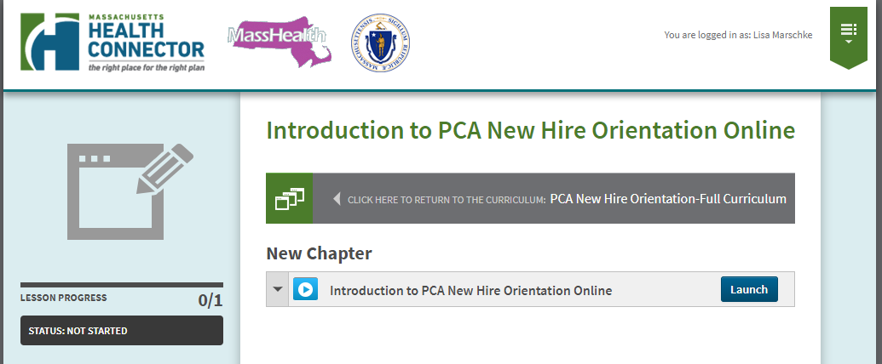
8 | This is the first slide of the first part of the PCA New Hire Orientation course.  Click on the “Next” button after the audio has stopped to advance through the material. |  | 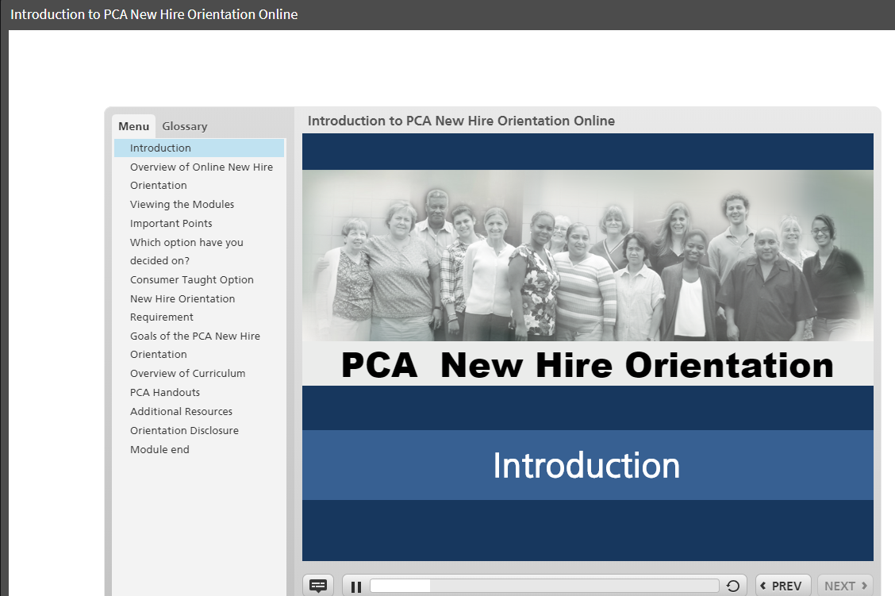
9 | The closed caption button (A) is located on the left of side of the navigation bar. |  | A
10 | The play/pause button (B) is to the right of the closed caption (A) button on the navigation bar. |  | B
11 | If you leave the course, you should resume where you left off (click “YES”) otherwise, you start from the beginning without the ability to fast forward through the material you have already viewed. |  | 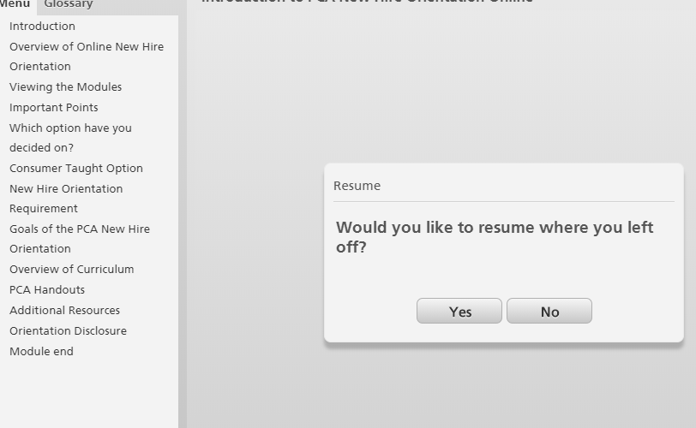
12 | The PCA New Hire Orientation has 10 parts, as you complete them they inform you of which are completed, in progress, or locked. |  | 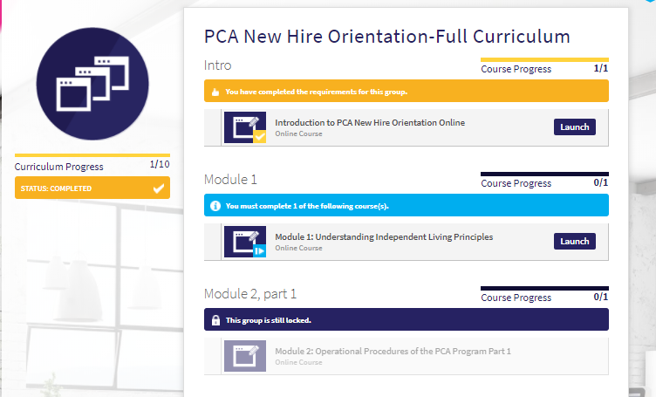
13 | When you complete a part of the training and cancel out of it, the system brings you to a screen that looks like this, click on “PCA New Hire Orientation-Full Curriculum” to get to the list of parts to begin the next one. |  | 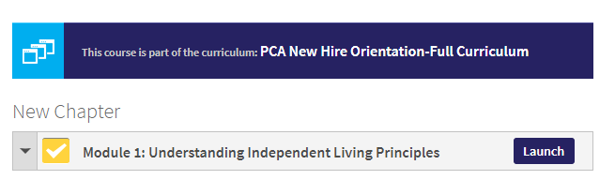
iPhone and smartphone tips
A |  | Using a smartphone, after logging in, click on “My Courses”. |  | 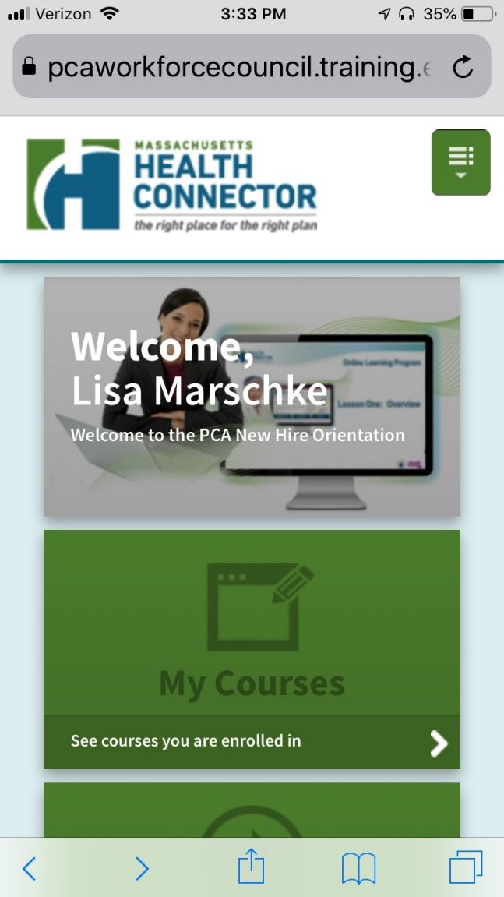
B |  | Launch the module |  | 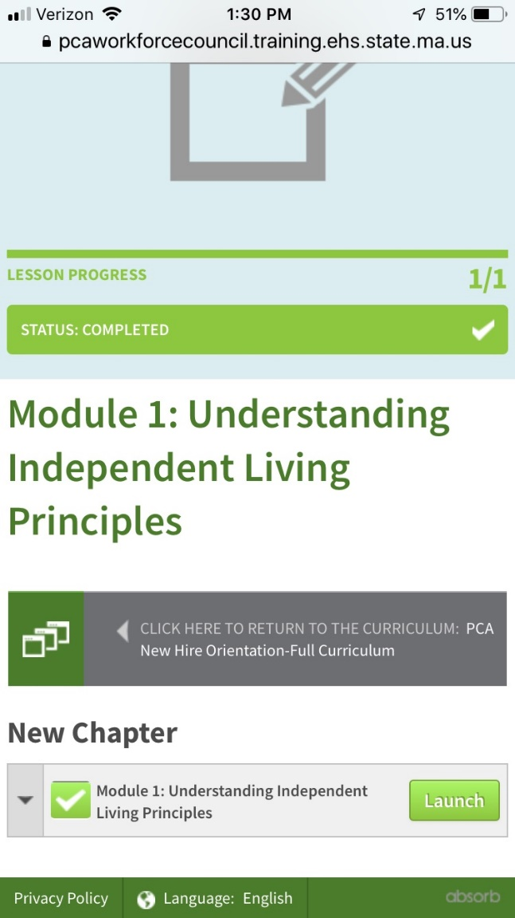
C |  | You will be instructed to open a new browser to continue the training. |  | 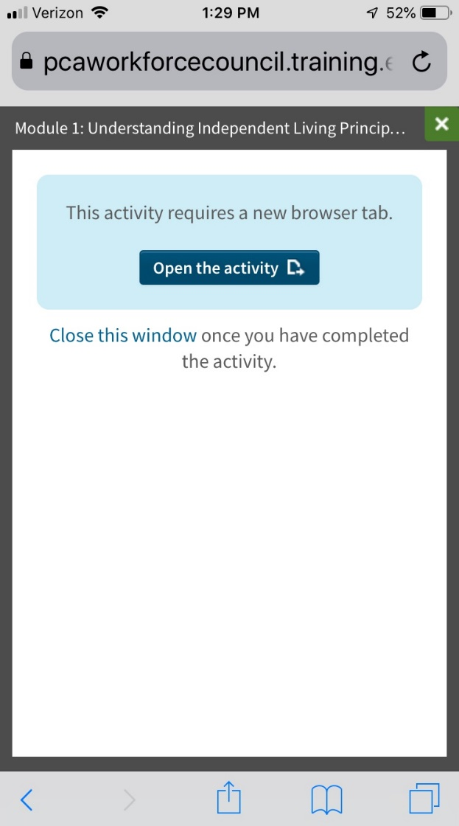
D |  | Either press “continue”or “restart” based on where you are in the training.  When you have finished the module, you need to go back to the menu (see A above) to launch the next module.  You will need to close the browser tab in the module that is completed and will be prompted to open another (see C above) as you continue through the orientation. |  | 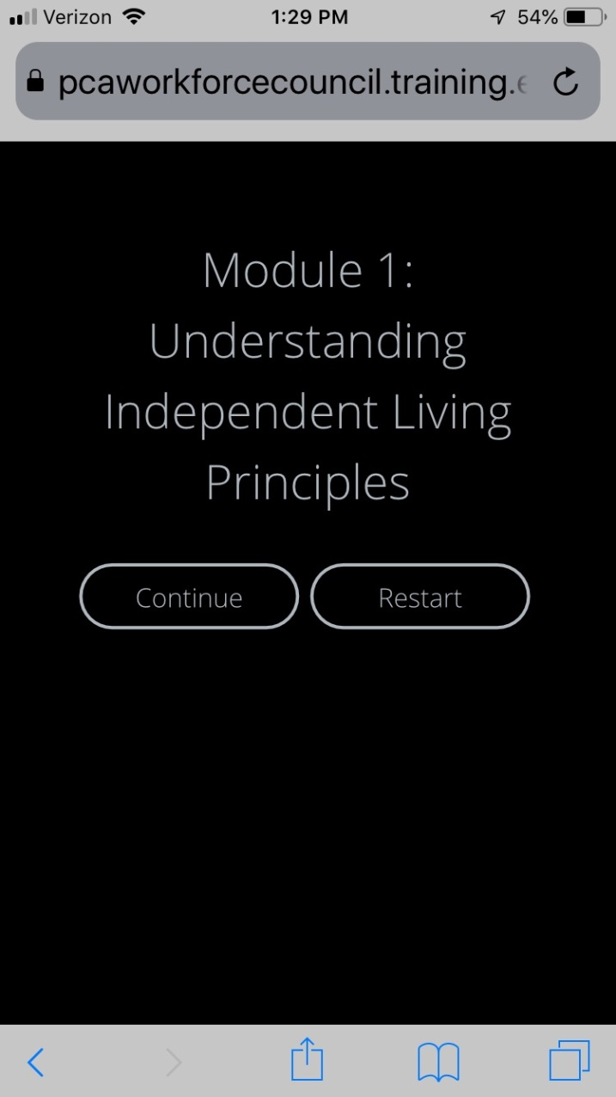
If you have questions regarding the online PCA New Hire Orientation training, please email ABCsdirectcare@umassmed.edu or the PCA Workforce Council at pcacouncil@state.ma.us

