STEP1 - Select Community Name from drop-down box on spreadsheet:
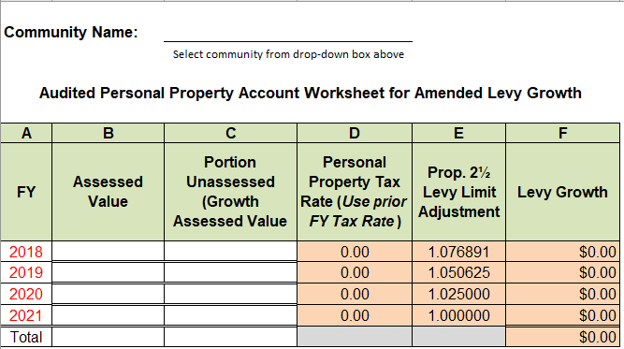
STEP 2 - DETERMINE AND REPORT LEVY GROWTH FOR ALLOWABLE YEARS

Column A: Fiscal Year – This lists the fiscal years that can be included in the personal property audit, beginning with the earliest fiscal year.

Column B: Assessed Valuation – Include the amount of additional assessed valuation for the fiscal year included in omitted and revised assessments made in FY21 for audited accounts.

Column C: Portion Unassessed (Growth Assessed Value) – Include only that amount of the additional assessed valuation for the fiscal year not already assessed in an original or omitted or revised commitment for FY21 or before, including a year shown in the spreadsheet.

Example: An existing personal property account was audited for FY20 and FY21. Based on the results, revised assessments were made during FY21 for both years.

During the audit, the assessors discovered 10 articles of taxable personal property owned by the taxpayer as of January 1, 2019 that had not been reported on the form of list and assessed for FY20.
- The 10 articles had a total assessed valuation as of January 1, 2019 of $100,000.
- Report the $100,000 under Assessed Value Column B for FY20.
- For Growth Assessed Value: Only 9 of the discovered articles would have qualified as growth in FY20 as articles taxed for the first time as of January 1, 2019. The total assessed valuation of the 9 articles as of January 1, 2019 is $90,000. (Note: 1 article had been reported assessed as of January 1, 2018 for FY19).
- Report the $90,000 in Portion Unassessed (Growth Assessed Value) under Column C for FY20.

- The audit also shows that the same 10 articles were not taxed in FY21, and 5 new articles acquired during 2019, were not reported on the form of list and assessed for FY21. The 15 articles had a total assessed valuation as of January 1, 2020 of $125,000, with $50,000 of that amount attributable to the 5 new articles.
- The $125,000 is reported Assessed Value Column B for FY21.
- Only the 5 articles acquired during 2019 would have qualified as growth in FY21. Report the $50,000 in allowable growth value for those 5 articles Portion Unassessed (Growth Assessed Value) under Column C for FY21.
- Note: The assessed valuation of the other 10 articles was already reported as growth in the FY19 original commitment (1 article) or the FY20 revised commitment made after the audit (9 articles).

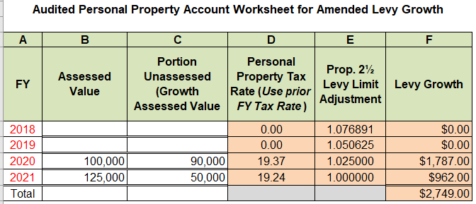
Column D: Personal Property Tax Rate – The personal property tax rate for the fiscal year prior to the fiscal year the assessed valuation qualified as growth will automatically populate in the column.

Column F: Levy Growth – The spreadsheet will automatically populate the allowable levy growth for amounts entered for FY18, FY19, FY20 and FY21 for the community designated.

STEP 3 - DETERMINE TOTAL LEVY GROWTH

The spreadsheet will then convert the total growth assessed value into a “Growth Valuation” amount to be entered on the LA13A.
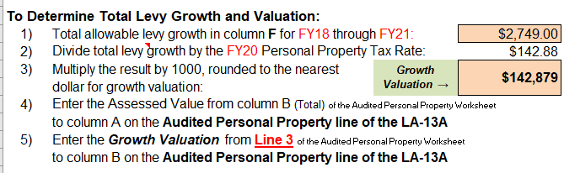
STEP 4 - REPORT TOTAL LEVY GROWTH ON THE LA-13A Amended Tax Base Levy Growth

Enter the Assessed Value from column B (Total) of the Audited Personal Property Worksheet to column A “Omitted and Revised Value Committed to Tax Collector” on the Audited Personal Property line of the LA-13A

Enter the Growth Valuation from Line 3 of the Audited Personal Property Worksheet to column B “Portion Unassessed in Prior FY” on the Audited Personal Property line of the LA-13A.

