Table of Contents

- introduction
- guidance
- application fact sheet
- completeness checklist

Introduction

MassDEP Permit Applications, as well as Instructions & Support Materials, are available for download from the MassDEP website at mass.gov/dep in two file formats: Microsoft Word and Adobe Acrobat PDF.

Instructions & Support Materials provide guidance on how to prepare a permit application.

These Permit Applications, supporting documents, and the fee payment (if applicable) must now be submitted through the ePLACE Portal. See ePLACE step-by-step instructions on the mass.gov page for this application.

REQUIREMENTS TO OBTAIN A GROUNDWATER DISCHARGE PERMIT
The MassDEP Groundwater Discharge Permit Program regulates the location, construction, operation and monitoring of wastewater treatment plants designed for flows exceeding 10,000 gallons per day or for facilities where site constraints would require a discharge of less than 10,000 gallons per day of treated sanitary wastewater to obtain a groundwater discharge permit.
New systems, unpermitted systems and some systems to be modified will undergo a review process that will assure compliance with 314 CMR 5.00 and will result in the issuance of a groundwater discharge permit. The hydrogeologic evaluation of the site is the first part of that process and consists of 3 parts:
- Pre-scoping Meeting with DEP
- Scope of Work -Submittal and approval
- Hydrogeologic evaluation and WP83 Application Submittal

- Pre-Scoping Meeting:
Prior to the submission of the BRP WP 83 application form, the applicant will have a pre-scoping meeting with MassDEP to discuss the details of the site for the Scope of Work submittal. Following this meeting, the applicant will develop and submit to Mass DEP a scope of work for a hydrogeologic investigation in accordance with 314 CMR 5.09 that is specific to the proposed site, including consideration of downgradient receptors.

- Scope of Work:
The Scope of Work defines the tasks that must be completed for the preparation and approval of the hydrogeologic evaluation report assessing the site characteristics and the fate and effects of the treatment plant discharge. An assessment of potential impacts of the proposed discharge on all public and private potable water supplies, wetlands and waterways, and other environmental sensitive receptors should be made. A determination if whether the proposed discharge will cause or contribute to a violation of the Massachusetts Surface Water Quality Standards or impair the actual or potential use of the ground water as a source of potable water should also be made

Provide the following:

- Scope of Work

- Description of the project including:
  - General description of the project including the proposed use
  - The estimated Title 5 design flow
  - A description of the site including locus maps
  - Discussion of the primary and reserve disposal areas including the proposed dimensions, location, include location map(s)
  - A discussion of the number, locations and dimensions of the proposed deep hole test pit locations and percolation tests, including locus map(s)
  - Soil evaluations will be performed by a Massachusetts Certified Soil Evaluator and percolation test will be performed by a qualified individual(s)
- Regional Site Description
  - General description of the site from a regional perspective
  - Relation of the site to surface water features and wetlands
  - Direction of streamflow in the basin/subbasin
  - Sensitive receptors downgradient of the site that could potentially be impacted
  - Public water supplies, private wells, other sensitive receptors within ½ mile of the site
  - If the proposed discharge is located within a Source Protection Area of a public water supply, is it estimated to be within a 2 year or 6-month time of travel of the proposed site?
  - Appropriately scaled maps such be provided identifying all relevant features
  - A discussion of environmentally sensitive areas should be provided that includes any rare wetland wildlife habitat or certified vernal pools in the vicinity of the proposed site and the potential impact(s) the discharge will have on these features. Appropriately scaled maps should be provided identifying all relevant features.
- Soils Description
  - General description of the soils in the area of the proposed site
  - Soils information can be obtained from the NRCS Web Soil Survey or the UC Davis SoilWeb websites
  - Appropriately scaled soils maps should be provided with relevant features identified
- Proposed Borings, Monitoring Wells and Deep Holes
  - Discussion of proposed borings/monitoring wells including the proposed locations, methods of well construction and installation details including screen depths
  - Borings and monitoring wells should be constructed in accordance with MassDEP’s Standard References for Monitoring Wells (WS-310-91), dated April,1991
  - If the intention is to utilize wells as monitoring points in the final monitoring well plan, they should be installed with 15 ft. screens that straddle the water table with 5 ft. above and 10 ft. below the water table
  - Monitoring wells installed with the intention of being utilized in the final monitoring well plan may be subject to relocation and/or additional wells may be required based on the Department’s review of the Hydrogeologic Report.
  - Discussion of deep holes should be provided including the number and location in relation to the footprint of the proposed SAS
  - Discussion of infiltration rate methods to be utilized, i.e., standard percolation test, double-ring infiltrometer, Guelf Permeameter, loading tests, etc.
  - Form 11s and 12s will be completed for each deep hole dug and percolation tests performed based on soils observed and percolation test results and submitted as part of the Hydrogeologic Report
  - Deep holes shall be dug as deep as possible (minimally 10 ft.).
  - Soil evaluations may be performed in a 4-5 ft. hole when initially excavating the deep hole, by shelving a 4-5 ft hole off the deep hole or excavating a 4-5 ft. hole adjacent to the deep hole.
- Proposed Hydraulic Conductivity Evaluation
  - A discussion of what methodology will be utilized to estimate hydraulic conductivity including a description of the methodology (rising/falling/constant head tests, etc.) should be provided
  - A description of the instrumentation that will be utilized to capture the field results, the method to be utilized to analyze the test results, if laboratory soil grain size distribution analyses will be performed, etc., should be provided
- Existing and Estimated Seasonal High Groundwater (ESHGW)
  - A discussion of the existing water table conditions as well as Estimated Seasonal High Groundwater (ESHGW), if previous site work has shown evidence of such
  - A discussion about what steps will be taken to characterize the water table at the site including the number and locations of wells to be utilized
  - If no evidence of ESHGW is available, a discussion of what method will be utilized to determine ESHGW (Frimpter, etc.). 310 CMR 15.103 describes the acceptable methods to determine ESHGW with the primary method of determination found in 310 CMR 15.103(a), evidence of redoximorphic features
- Proposed Groundwater Mounding Model and Analyses
  - A discussion of the proposed modeling effort including the model to be utilized (Hantush, MODFLOW, etc.) should be provided
  - A discussion of the boundary conditions such as top of rock, impervious layers, groundwater features including streams wetlands, etc., should be provided
  - Model data inputs should include the dimensions of the SAS, the effluent application rate (design flow volume per footprint area), distance and direction to constant head or transient head model boundary (e.g, wetlands, initial saturated thickness, average hydraulic conductivity, duration of application, simulation time and soil porosity. The duration of application should be for a 90-day period.
  - A discussion of the model should focus on evaluating the hydraulic capacity of the receiving soil layers, estimating the mounded groundwater levels in the vicinity of the leaching field area and checking for potential breakout of treated effluent along existing slopes and other sensitive environmental areas or existing structures should be provided
  - Modeled flows should be 80% of design flows
  - If the proposed discharge is potentially within the two-year time of travel of a public water supply, an appropriate discussion should be provided as to how this will be addressed/calculated (i.e., groundwater flow direction, hydraulic conductivity, hydraulic gradient and porosity)
- Proposed Monitoring Well Plan
  - A preliminary discussion of the proposed monitoring well plan to include the number of monitoring wells and their location based on groundwater flow direction and the elevation of the water table in the vicinity of the site should be included (minimum of one upgradient and two downgradient wells, more may be required based on sit complexity, proximity to sensitive areas and/or design of the system)
  - A discussion of well construction details and the screen depths as determined from water table elevations (15-foot screens straddling the water table – 5 feet above and 10 feet below) should be included

- Proposed Soil Absorption System
  - A discussion of the proposed WWTF including the manufacturer of the system, a description of the system components, the proposed loading rate, the configuration, and locations of the primary and reserve disposal areas, etc., should be provided
  - If the proposed discharge is to be placed at the location of an existing system, or to increase the loading rate to an existing system, new test pit locations around the perimeter of the existing system should be proposed
  - Applicants should be aware that any change in the location of a proposed SAS after field work has been observed by MassDEP will require additional field analyses.
  - Proposals to request 50% sizing of a reserve area(s) must be accompanied by a detailed description of the treatment technology proposed to provide enhanced solids removal

- Summary and Conclusion
  - A general summary of the Scope of Work shall include, but not be limited to, general conclusions of the site, positive and/or negative impacts of a wastewater discharge at the site, potential regulatory roadblocks and local concerns, as well as any other issues that would assist in the evaluation of the site.

Hydrogeologic Evaluation Report and BRP WP 83 application:

Upon MassDEP approval of the scope of work, the applicant will then prepare a hydrogeologic evaluation report consistent with that scope.

The completed hydrogeologic evaluation report will be submitted to the Mass DEP with the BRP WP 83 application form, the fee and other required materials. Once MassDEP has approved the report submitted with the BRP WP 83 application form, the applicant will then be able to apply for a groundwater discharge permit through the submittal of the appropriate groundwater discharge permit application. In accordance with 314 CMR 5.09A (4) & (5), the MassDEP may require the submission of plans and specifications with the permit application or anytime during the application’s review.

To obtain a groundwater discharge permit, owners of new systems, unpermitted systems, and some systems to be modified must complete the following requirements:

1. Hydrogeologic Assessment
Soils shall be described using the standard Title 5 soil evaluation techniques. Soil evaluations shall be performed by a Massachusetts Certified Soil Evaluator (“CSE”). Data from test pits to be considered in the hydrogeologic evaluation must be witnessed by a CSE. Site geology shall be determined by a variety of subsurface exploratory techniques that include the use of test pits, borings, peizometers, and observation wells. Hydrologic parameters may be estimated from an analysis of lithologic data, sieve analysis, in-situ permeability testing and pumping tests. This includes regional and historic information regarding the site. This will also include noting adjacent surface water feature and the potential interaction.

Provide the following:

a. Locus map and site plan at a suitable scale (such as 1”=40’)
- Provide USGS maps available (topographic map, surficial geology map, hydrologic atlas)
- Include well and surface water PWS protection areas (such as, but not limited to; Zone II’s, IWPA’s, Surface Water Protection Zones)
- Include areas of sensitive habitats (such as, but not limited to ACEC’s, vernal pools, mapped habitat areas)
b. Previous subsurface work, such as, but not limited to;
- Soil and water quality
- As built diagrams and logs
- Water table fluctuation (high, low and adjusted seasonal high water using MassDEP approve method)
- Tidal influences to water levels (if any)
c. Determine the contributing watershed area
d. Locate public and private wells within ½ mile of the site
- Indicate type of well (public/private, bedrock or sand/gravel and depth)
e. Indicate areas of potential water supply development (such as, but not limited to mapped medium and high yield aquifers)
f. Determine private wells within ½ mile radius of proposed discharge location and whether it is up, down or cross gradient under natural and discharge conditions
g. Provide past use or nearby use which may have resulted in water quality or site specific conditions pertinent to development.
- This may include past or current waste site clean up activities.
- Areas which may be subject to cleanup standards under MGL 21E
- Depth to bedrock
- If bedrock encountered during exploration, depth, fracture and joint pattern

2. Nutrient Analysis.
- If located within a MassDEP approved Zone II or an IWPA, determine the impact the discharge may have on the public supply well(s).
- If located adjacent surface water, assess potential impacts to that water with respect to nitrogen or phosphorus.

3. Soil Evaluation and Subsurface Testing
a. Provide Certified Soil Evaluator logs and summaries for the site
- Perc tests and logs
- Tests witnessed by MassDEP
b. Provide additional test data such as sieve tests, double ring or other approved tests.
c. Indicate on a site map the location of the tests
d. Soil boring data including split spoon and core logs (if applicable)
e. Well construction (per MassDEP Standards)
- As built diagrams
- Water levels
- Water quality (pH, Specific Conductance if available or required)
f. Any onsite monitoring such as VOC vapor analysis, specific conductance, pH of the water.

4. Groundwater Monitoring Program
a. Indicate location and construction of monitoring wells
- Provide locations and elevations of wells and the corresponding measuring point elevation for ground water levels.
- Wells to be constructed according to Standard Methods for Monitoring Wells (MassDEP BWSC publication)
- Assess groundwater flow
- Vertical gradient
- Flow direction
- Permeability of the soils and aquifer
- Groundwater flow rate
- Interaction of overburden/bedrock with respect to groundwater flow to determine infiltration and pumping effects.
- Estimate seasonal high groundwater (using approved methods)
- indicate if the well is upgradient, cross gradient or downgradient of the discharge
- indicate the sampling frequency and list of analytes to be sampled
5. Time of Travel Calculation
- Applicable if within a public water supply protection area (including, but not limited to Zone II’s, IWPA’s and Surface Water Protection Areas)
- Assess potential input into surface water and if that surface water is intercepted by a PWS.
- Calculate the time of travel from the discharge to the public water supply
- Provide the calculations or model results indicating the methodology used

6. Final Site Report
- Show final grade and the relationship to seasonal high water and under loading conditions
- Mounding analysis and relationship to topography and final site grade.
- Provide cross sections (one parallel and one perpendicular to ground water flow direction, indicating system bottom, seasonal high water and projected mound).
- Well locations of all wells including those submitted under previous work, including as built diagrams and logs.
- Pre and Post loading ground water flow maps
- Show other important site modifications and structures, including but not limited to;
- Detention, retention ponds
- Wells (Potable, irrigation, injection, Ground Source Heat Pump)
- Buildings (note if the building have basements)
- Roads and streets

7. Include section of summary, conclusions and recommendations
- Additional site characterization
- Site feasibility
- Potential impacts and mitigation (if any)
- To nearby property
- To ground water or surface water supply
- To nearby sensitive receptors (including, but not limited to; rare species habitats, and vernal pools)
- Location of existing or proposed compliance monitoring wells.

The publication Standard References for Monitoring Wells is available at: https://www.mass.gov/lists/policies-guidance-technical-support-for-site-cleanup#monitoring-wells-.

Monitoring Well Proposals

The following is a list of information to be submitted to the MassDEP Regional Office location (Primary Permit Location) for Hydrogeologic Report applications with monitoring well proposals and with post-installation details. Monitoring wells are required in order to receive a groundwater discharge permit. See MassDEP publication Standard References for Monitoring Wells, Publication No. WSC-310-91, and 314 CMR 5.00.

Monitoring well proposals must include:

1. a locus map indicating the regional location of the sites. A USGS 1:25000 Scale 7 1/2 minute Topographic Series quadrangle sheet is most appropriate.

2. a site map to include:

a) location of proposed and existing monitoring wells, borings, test pits, deep holes and subsurface work;
b) cultural features (buildings, roads, leachfields, existing wells, subsurface utilities, etc.);
c) assumed groundwater flow directions.

3. any written descriptions of subsurface conditions expected to be encountered, e.g. published surficial geologic, bedrock, or hydrogeologic atlases (USGS), existing drillers' or geologists' logs, test pit or deep hole test results with percolation rates.

4. a well construction detail describing construction materials and installation technique must be included. Construction details shall conform with the well construction guidelines concerning construction and screen placement. (See attached diagram.)

These materials must be submitted to and accepted by the MassDEP prior to the installation of the monitoring well(s). The MassDEP reserves the right to request additional information on a case-by-case basis if in its opinion the sensitivity of the potentially impacted area warrants additional investigation.

Following the acceptance of the monitoring well plan by the MassDEP regional office and the installation of the well(s), the following materials must be submitted:

1. A site plan including:

a) all the features described in section 2a;
b) the as-built well locations;
c) groundwater contours and elevations based on monitoring well data.

2. Geologists' and drillers' logs for all monitoring wells.

3. Monitoring calculations describing potential mounding below the discharge.

4. A geologic cross-section utilizing three monitoring wells and including relevant features such as leaching fields, existing and proposed stormwater detention basins, subsurface utilities, streams, roadways,etc.

5. A background sampling of the monitoring wells for, at a minimum, the following parameters: water level, ph, specific conductance, alkalinity, nitrogen series, total phosphorus, orthophosphate, chloride and sodium.

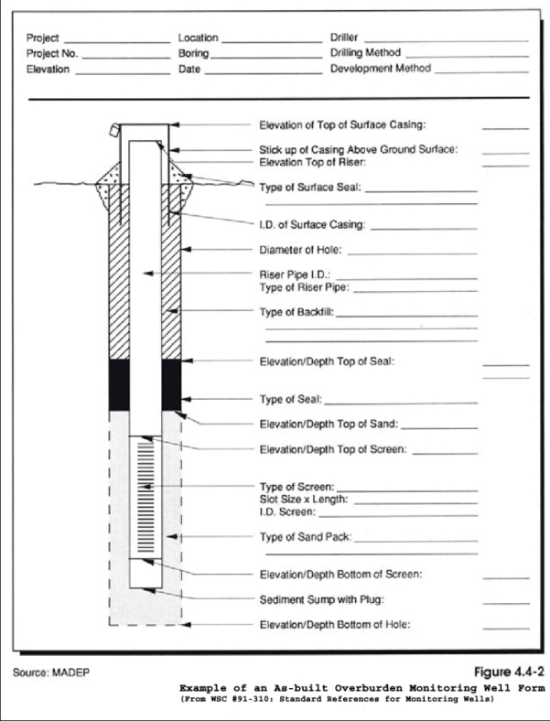
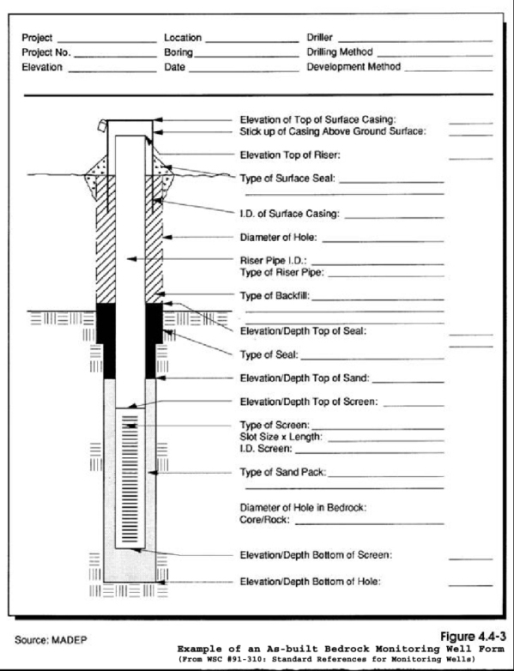

1. What is the purpose of this report approval?

This report approval is a prerequisite for the issuance of a permit to discharge treated sanitary wastewater in excess of 10,000 gallons per day (gpd) or to discharge treated wastewaters otherwise subject to a groundwater discharge permit. This report approval serves to protect the public health, welfare, and the environment through the control of these discharges onto or into the ground. If, following this report approval, the permittee intends to apply for either an Individual or General Groundwater Discharge Permit, the approved report will be a part of the permit application submittal.

Statutory authority for this permit is stated in MGL Chapter 21 Section 43. Regulatory authority for these permits is stated in 314 CMR 5.00.

2. Who must apply?

Any individual, business, or organization required to obtain a groundwater discharge permit is subject to the approval of a scope of work and hydrogeologic evaluation pursuant to MGL c. 21, s. 43 and 314 CMR 5.00 (unless exempted in 314 CMR 5.05).

3. What other requirements should be considered when applying for these report approvals?

The applicant must show evidence that a public notice has been placed in the Environmental Monitor stating that a scope of work has been prepared and has been submitted to MassDEP. Additionally, if the site is located within the Zone II or Interim Wellhead Protection Area (IWPA) of a ground water source of potable water for a public water system, the applicant must show evidence that the public water system has been notified in writing by certified mail when the scope of work and the Hydrogeologic Evaluation Report have been submitted to MassDEP.

- Where should the application be sent?

The application must be submitted through ePLACE, located here: https://eplace.eea.mass.gov/citizenaccess

Additional visual ePLACE step-by-step instructions to assist in submitting your compliance certification are available at: https://www.mass.gov/how-to/wp-83-hydrogeologic-evaluation-report

- Log into the ePLACE Portal at: https://eplace.eea.mass.gov/citizenaccess and create an account.
- Once logged in, click on the large blue button on the right, “File an Online Application”.
- Read and agree to the disclaimer. Click “Continue”.
- To find this application, click on “Apply for DEP Authorization – Water Pollution Wastewater (WP)”, and check on WP 83, and click “Continue Application”.
- Follow instructions on each screen and click “Continue Application” to move to the next step. The WP 83 application and supporting forms are to be completed in MS Word™ or Acrobat Adobe PDF™ and attached in the Documents section.
- Note that you can return to an application provided you select “Save and Return Later”. Once you submit an application you can no longer upload documents without approval from MassDEP personnel.
- At the end of the application steps, the ePLACE system will take you directly to a screen where you can pay the fee, if applicable. Complete payment information in ePLACE.
- Once an application has been submitted, you will receive an email that will provide you the record number.
- From the “My Records” button, you will be able to view the status of your application through the review and approval processes.

Important Contacts
- For technical assistance regarding online filing, contact the ePLACE Help Desk Team at (844) 733-7522 or ePLACE_helpdesk@mass.gov.
- To see a copy of your application after submittal, also see: https://eeaonline.eea.state.ma.us/EEA/PublicApp.

5. What is the application fee?

BRP WP 83 Preparation of a Hydrogeologic Evaluation.................$10,005

6. Where can I get a copy of the timelines?

The timelines are available on the MassDEP Website: https://www.mass.gov/lists/massdep-fees-timelines.

    - What is the annual compliance fee?

Current Annual Compliance Fees can be found at the MassDEP Website:
https://www.mass.gov/lists/massdep-fees-timelines.

8. How long is this report approval in effect?

There is no fixed time limit when this approval would expire. However, at the time of submission of a groundwater permit application for an Individual Permit or a Notice of Intent for General Permit coverage, the permittee must certify whether the conditions upon which the approval was based have changed. If the answer is that conditions have changed, then an additional technical evaluation may be required to determine if the existing approval should remain in force or an amended approval is necessary.

9. How can I avoid the most common mistakes made in applying for this report approval?

a. Answer all questions on the application form and indicate "not applicable" (N/A) where appropriate. One copy of all application forms must have an original signature in ink.

b. Applications for BRP WP 83 must include:

- Copy of the approved scope of work.

- Copy of the public notice from the Environmental Monitor that the scope of work has been submitted.

3) If the proposed site is within a Zone II or Interim Wellhead Protection Area, a copy of the notice to the public water system notifying them that a scope of work and, when appropriate, that the Hydrogeologic Report has been submitted to the Department.

c. Submit the application & documents listed above and pay fee through ePLACE, https://eplace.eea.mass.gov/citizenaccess

10. What are the regulations that apply to these report approvals? Where can I get copies?

These regulations include, but are not limited to:

a. Groundwater Discharge Regulations, 314 CMR 5.00.
b. Timely Action and Fee Provisions, 310 CMR 4.00.
c. Administrative Penalty Regulations, 310 CMR 5.00.

These may be purchased at:

State House Bookstore State House West Bookstore
Room 116 436 Dwight Street
Boston, MA 02133 Springfield, MA 01103
617-727-2834 413-784-1376

Massachusetts Department of Environmental Protection
Bureau of Resource Protection - Groundwater Discharge Permits
BRP WP 83 Hydrogeologic Evaluation Report
Application Completeness Check List

The Hydrogeologic Evaluation Report Application Form is properly filled out by the applicant and the consultant engineer and signed in ink.

A copy of the public notice from the Environmental Monitor that the scope of work has bee has been prepared and submitted to MassDEP in accordance with 314 CMR 5.09.

A copy of the Scope of Work and the MassDEP approval letter is included with the application.

The Hydrogeologic Evaluation Report is included with the application.

If the site is within the Zone II or Interim Wellhead Protection Area of a ground water source of potable water for a public water system, a notice has been sent to the public water system notifying them that a scope of work and, when appropriate, that the Hydrogeologic Evaluation Report has been submitted to MassDEP in accordance with 314 CMR 5.09.

To submit the application package:

Submit the application and documents listed above through ePLACE, https://eplace.eea.mass.gov/citizenaccess

Pay fee of:

$10,005 for BRP WP 83;

You can pay online in ePLACE or pay by mail in the form of a check or money order made payable to Commonwealth of Massachusetts (please follow email instructions provided to you once your application is submitted).

