Table of Contents

- Introduction
- Permit fact sheet
- Completeness Checklist
- Simplified License Plan Checklist

A. Introduction

MassDEP Permit Applications, as well as Instructions & Support Materials, are available for download from the MassDEP Web site at: www.mass.gov/dep in two file formats: Microsoft Word™ and Adobe Acrobat PDF™. Either format allows documents to be printed.

Instructions & Support Materials files in Microsoft Word™ format contain a series of documents that provide guidance on how to prepare a permit application. Although we recommend that you print out the entire package, you may choose to print specific documents by selecting the appropriate page numbers for printing.

Permit Applications in Microsoft Word™ format must be downloaded separately. Users with Microsoft Word™ 97 or later may complete these forms electronically.

Permitting packages in Adobe Acrobat PDF™ format combine Permit Applications and Instructions & Support Materials in a single document. Adobe Acrobat PDF™ files may only be viewed and printed without alteration. Permit Applications in this format may not be completed electronically.

1. What is the purpose of this renewal application?

A project licensed under MGL Chapter 91, the Public Waterfront Act, using the simplified license option has a limited term of generally 10-15 years. For the authorization to continue, the Licensee, or his/her successor, must request the simplified license be renewed.

2. Who must apply?

Anyone who obtains a Waterways simplified license under 310 CMR 9.00, must file an application to extend the term of the license prior to the expiration of the license to maintain lawfully the structures and activities authorized in the license. This includes anyone who obtained an Interim Approval under the amnesty provisions pursuant to 310 CMR 9.28.

To renew a standard license, a Licensee is required to file a license amendment pursuant to 310 CMR 9.25.

3. What prerequisites should be considered before applying for this renewal request?

An existing simplified license can only be renewed if the structure remains sound and conforms to plans attached to the original authorization. If the authorized structure or use has changed, an application for a new Simplified License is required.

4. What concurrent actions are related to this renewal request?

At the time an application for renewal is submitted, the applicant must send a copy of the application to the mayor or board of selectmen, planning board, and conservation commission of the city or town where the project site is located, The Department may require additional pubic notice based on comments received about the structure or other relevant information. If such additional pubic notice for renewal is required the public comment period is 30 days.

5. What fees are associated with this renewal request?

There is an application fee of $35.

Chapter 91 licenses are subject to Tidewater Displacement fees, Annual Compliance fees and Commonwealth Tidelands Occupation fees. However, Simplified Licenses are exempt from Displacement Fees. Commonwealth Occupation fees are calculated at a rate of $1 per square yard occupied multiplied by the license term. The applicant will be notified of the amount due following review of the renewal request.

6. To which MassDEP Office should the renewal request be sent?

Renewal application packages are reviewed in the MassDEP Boston office for projects located in the Northeast, Central and Boston regions. Projects located in the Southeast and Western regions are reviewed in their corresponding MassDEP regional office: https://www.mass.gov/service-details/massdep-regional-offices-by-community. Renewal of a simplified license for a nonwater-dependent application should be sent to MassDEP’s Boston Office.

7. Where can I get a copy of the timelines?

The timelines are available on the MassDEP Website: https://www.mass.gov/lists/massdep-fees-timelines

8. What is the term of the renewed Simplified Licenses?

A Simplified License may be renewed for up to 15 years in accordance with 310 CMR 9.10(5).

9. How can I avoid the most common mistakes made in applying for this renewal?

- Submit fee and one copy of the MassDEP Transmittal Form to:

Department of Environmental Protection
P. O. Box 4062
Boston, MA 02211

- Send a copy of the completed application and plans to the mayor/board of selectman, planning board and conservation commission of the city or town in which the project site is located.

- Include a copy of the plan attached to the original simplified license that is being renewed. If the plan attached to the original simplified license is unavailable, a plan may be submitted that is drawn in accordance with the Simplified License Plan Checklist.

10. What are the regulations that apply to this certificate? Where can I get copies?

These regulations include, but are not limited to:

a. Waterways Regulations, 310 CMR 9.00.
b. Timely Action and Fee Provisions, 310 CMR 4.00.
c. Administrative Penalty Regulations, 310 CMR 5.00.

These may be purchased at:

State House Bookstore State House West Bookstore
Room 116 436 Dwight Street
Boston, MA 02133 Springfield, MA 01103
617-727-2834 413-784-1376

Appendix A: Simplified License Plan Checklist
Enclose a copy of the plan attached to the original simplified license that is being renewed with your request. If the plan attached to the original simplified license is unavailable, prepare drawings using the Sample Plan and Plan Template as guides (see Appendices B and C). Note: The template in Appendix C can be printed and used a hard-copy form. Drawings should include the following information:

Plan View

Please refer to the sample plan drawings included in the appendices.

Drawings must be prepared on the 8.5 X 11 inch paper. A 1-inch margin should be left at the top edge of each drawing for purposes of reproduction and binding. A 1/2 inch margin is required for the three other edges. Please use the Sample Template (Appendix C).
Each drawing submitted should include a title block that identifies the project and contains the name of the waterway, the name of the applicant, the number of the sheet and the total number of sheets in the set, and the date the drawing was prepared.
North Arrow
Locus Map shall depict the subject property in relation to the surrounding area. This may be prepared as illustrated on the Sample plan, in the upper right-hand corner or the applicant may simply photocopy a street map circle the property and label it.
Scale – All drawings shall be in a suitable scale (e.g. 1 inch = 40 feet) and the scale should be indicated on each sheet of the plan.
Subject property – Illustrate as much of the subject property as possible, including any residence, adjacent streets, property lines, and the tax assessor’s information (map number).
Mean high and low water lines – The mean high water (MHW) and mean low water (MLW) lines must be clearly delineated. In inland waters, such as ponds and non-tidal rivers, the ordinary high and low water shorelines (OHW and OLW) should be used. Color shading cannot be used because the Department reproduces the plans. Please use dashed or dotted lines, or crosshatching where necessary. (See definitions of “High Water Mark” and “Low Water Mark” at 310 CMR 9.02, C.91 Regulations).
Licensed activities – All structures and/or fill to be licensed must be clearly depicted, accompanied by their dimensions. Linear distances, in feet, must be provided from the structures to each property line along the waterway and residence.
Abutters – Abutters’ names must appear in the lower left-hand block, and the corresponding number (1, 2, or 3, etc.) should be placed on the appropriate lot location.
Title Block– Prepare the lower-middle and right-hand blocks as indicated on the Sample template.

Profile View

Profiles – Bottom and bank profiles should be delineated as accurately as possible.
Mean high water (MHW) and mean low water (MLW) lines – MHW and MLW (or ordinary high and low water lines (OHW/OLW) must be illustrated. The elevation of MLW may be given as 0.0 ft. Elevations for MHW and all other structures should then be given relative to MLW.
Licensed activities – All structures and/or fill to be licensed must be clearly depicted. Dimensions of piles, and any other structures not indicated on the first sheet(s), must be provided with the Cross-section view.
Title Blocks – the lower middle and right-hand blocks shall be prepared as indicated on the Sample template (Appendix C).

Appendix B: Simplified License – Sample Plan
Appendix B: Simplified License Plan - Template
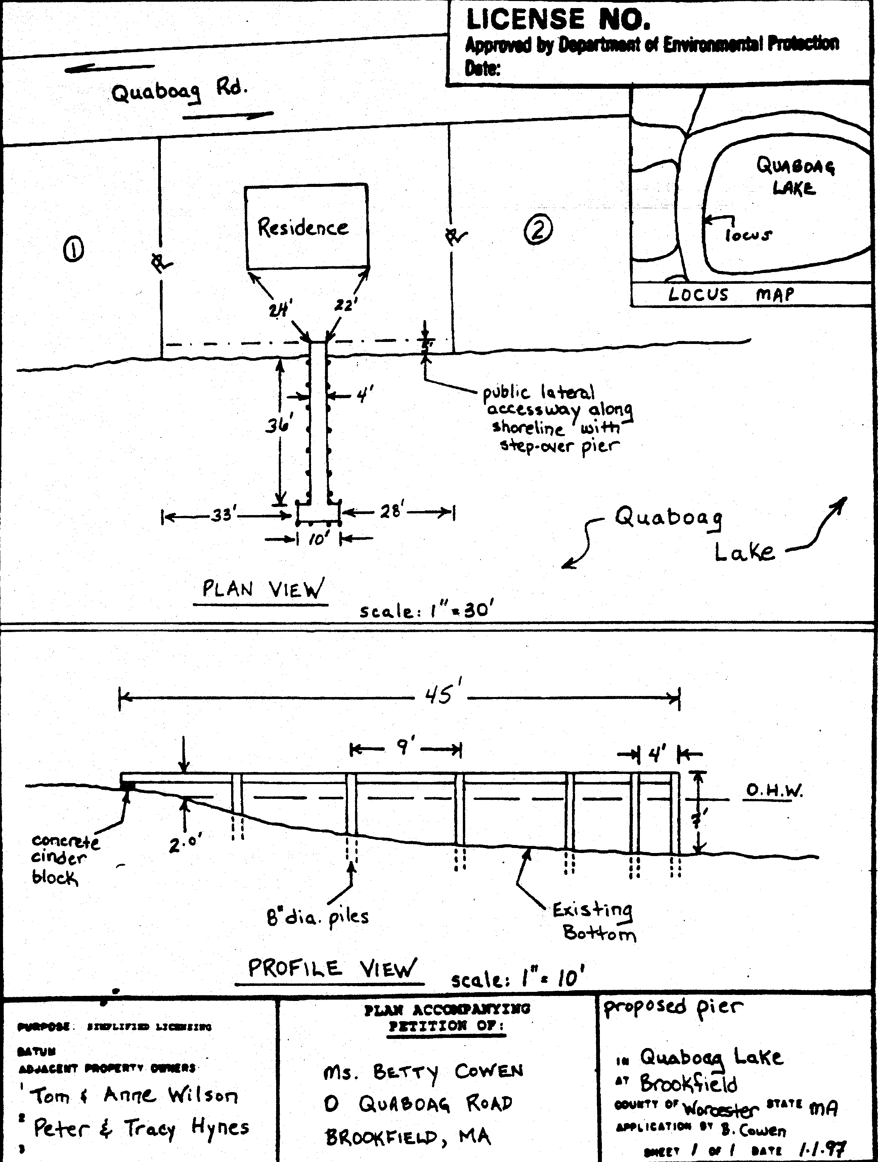
License No.

Approved by Department of Environmental Protection
Date:
Purpose: Simplified Licensing | Plan accompanying petition of: |  | Project Description:
 | ___________________ |  | _________________________
Adjacent Property Owners: | ___________________ |  | _________________________
1. ____________________ | ___________________ |  | In__________ At:___________________
2._____________________ | ___________________ |  | County of: _________________________
3._____________________ | ___________________ |  | State: ____________________________
4._____________________ | ___________________ |  | By applicant_______________________
 |  |  | date:__________ sheet: ___ of _____

Complete the MassDEP Transmittal Form. This form may be obtained from the MassDEP website at https://www.mass.gov/service-details/transmittal-form-number-for-massdep-permit-application-payment or any MassDEP regional office.
.
Complete the application form and have it signed by the applicant, the landowner (if different from the applicant), and the authorized agent (if any).

Include a copy of the sketch plan attached to the original license or, if that is unavailable, recreate the plan in accordance with the Simplified Plan Checklist.

Deliver a copy of the completed application form and accompanying plan to the mayor/board of selectman, planning board and conservation commission of the city or town in which the project site is located.

Send one copy of the application form, the plan and one copy of the MassDEP Transmittal Form to MassDEP’s, Waterways Regulation Program in Boston for projects located in the Northeast, Central and Boston regions. Application packages for projects located in the Southeast and Western regions should be sent to the corresponding MassDEP regional office: https://www.mass.gov/service-details/massdep-regional-offices-by-community. Renewal of a simplified license for a nonwater-dependent application should be sent to MassDEP’s Boston Office – Department of Environmental Protection, Waterways Regulation Program, One Winter Street, Boston, MA 02108

Send fee of $35 in the form of check or money order made payable to Commonwealth of Massachusetts, along with one copy of the MassDEP Transmittal Form to:

Department of Environmental Protection
P.O. Box 4062
Boston, MA 02211

