What is the Federally Required Disclosure Form (FRDF) for Entities?
As required by 42 CFR § 455.104 Disclosure by Medicaid providers and fiscal agents: Information on ownership and control.
    - who must provide disclosures. The Medicaid agency must obtain disclosures from disclosing entities, fiscal agents, and managed care entities.
    - what disclosures must be provided. The Medicaid agency must require that disclosing entities, fiscal agents, and managed care entities provide the following disclosures:
(1)
(i) The name and address of any person (individual or corporation) with an ownership or control interest in the disclosing entity, fiscal agent, or managed care entity. The address for corporate entities must include as applicable primary business address, every business location, and P.O. Box address.
(ii) Date of birth and Social Security Number (in the case of an individual).
(iii) Other tax identification number (in the case of a corporation) with an ownership or control interest in the disclosing entity (or fiscal agent or managed care entity) or in any subcontractor in which the disclosing entity (or fiscal agent or managed care entity) has a 5 percent or more interest.
(2) Whether the person (individual or corporation) with an ownership or control interest in the disclosing entity (or fiscal agent or managed care entity) is related to another person with ownership or control interest in the disclosing entity as a spouse, parent, child, or sibling; or whether the person (individual or corporation) with an ownership or control interest in any subcontractor in which the disclosing entity (or fiscal agent or managed care entity) has a 5 percent or more interest is related to another person with ownership or control interest in the disclosing entity as a spouse, parent, child, or sibling.
(3) The name of any other disclosing entity (or fiscal agent or managed care entity) in which an owner of the disclosing entity (or fiscal agent or managed care entity) has an ownership or control interest.
(4) The name, address, date of birth, and Social Security Number of any managing employee of the disclosing entity (or fiscal agent or managed care entity).

How do I submit the FRDF?
Upload a completed/signed FRDF to the attachments panel on the POSC for enrollments initiated on the POSC.
Fax: Mail:
(617) 988-8974 MassHealth Provider Enrollment and Credentialing
PO Box 278
Quincy, MA 02171-0278
- Tip: All fields must be completed. Nothing should be left unanswered. If the section does not apply, check the box above the name field for the section.
- Tip: Each service location must have a separate FRDF, even if they are listed on one application as it is expected that each location will have a different Managing Employee.
- Tip: If addition space is needed, you must make a copy the appropriate page and attach each such copy to the signed form. All entries must be submitted using this form.

How to complete the FRDF

Review FRDF: Page 1
Enter the contact information for the person completing the form. We will contact this person with any questions.
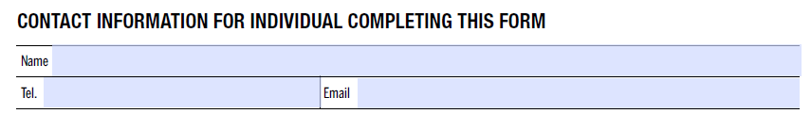

Review FRDF: Page 3, Section 1
Enter the disclosing entity DBA name and address, FEIN and NPI.
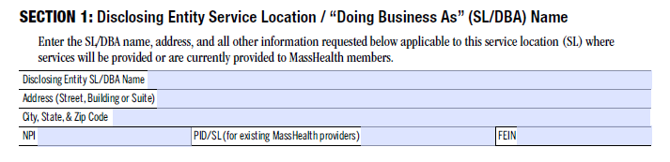

Review FRDF: Page 3, Section 2
Indicate which ownership or control interest describes your entity.
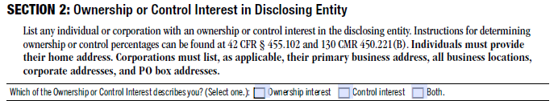
For individuals, you must enter the name, answer if the individual is on the board of directions, their DOB, home address, SSN % ownership (if applicable) and NPI (if applicable).

For corporations you must enter the name, primary address, FEIN, % ownership (if applicable) and NPI (if applicable).
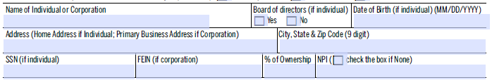

Review FRDF: Page 3, Section 2
If the individual above is related as noted, you must list the individual and indicate their relationship.
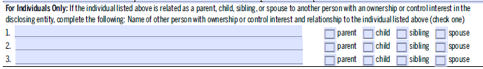
If a corporation was listed above, you must list all other business locations, corporate addresses and PO Boxes.
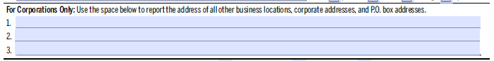
There is another section to enter ownership or control interest information.
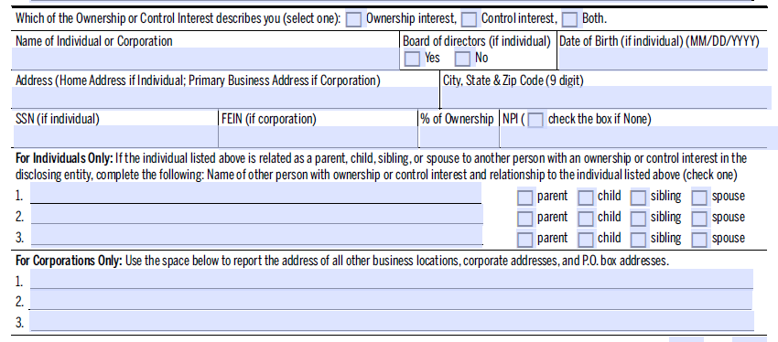
If additional space is needed, you must make a copy this page and include with the submitted form.

Review the FRDF: Page 4, Section 3
Enter ownership information as requested in other disclosing entities. If none, check the box above the name field.
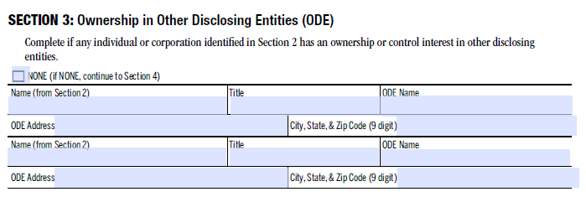

Review the FRDF: Page 4, Section 4
Enter ownership information in subcontractors. If none, check the box above the name field.
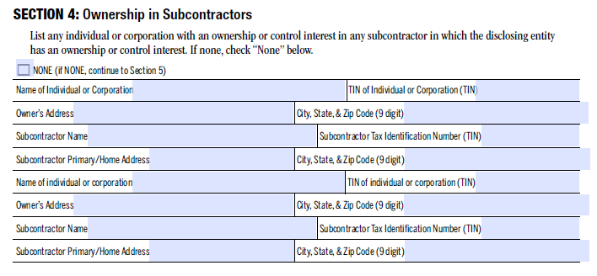

Review the FRDF: Page 4, Section 5
Enter familial relationship in subcontractors. If none, check the box above the name field.

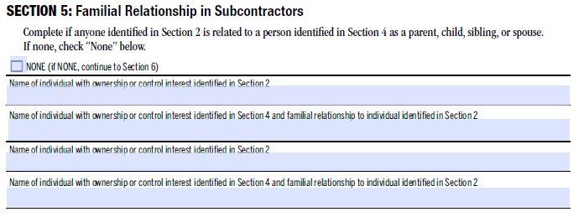

Review the FRDF: Page 4
If additional space is needed, you must make a copy this page and include with the submitted form.

Review the FRDF: Page 5, Section 6
Enter the agents and managing employees. It is expected that an organization will have at least one agent or managing employee per service location.

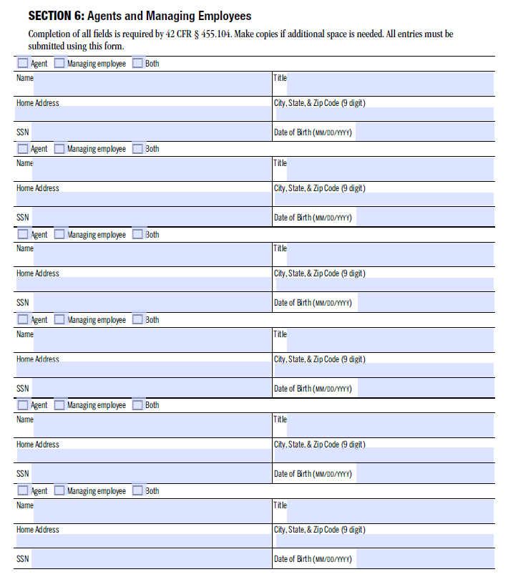
If additional space is needed, you must make a copy this page and include with the submitted form.

Review the FRDF: Page 6, Section 7
Answer each question with regard to disclosure of criminal convictions and relationships to excluded individuals.
Each question must be answered yes or no.

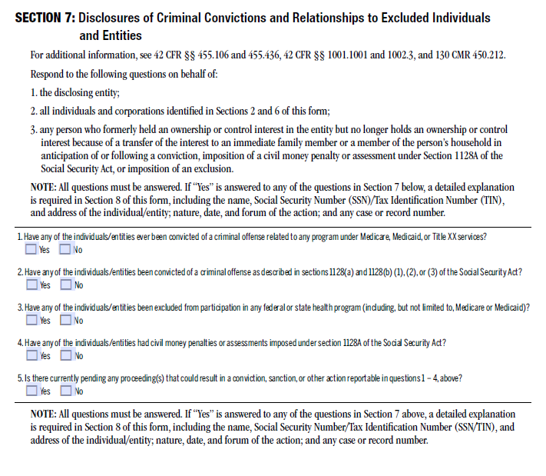

Review the FRDF: Page 7, Section 8
Enter any additional explanation for questions answered in Section 7
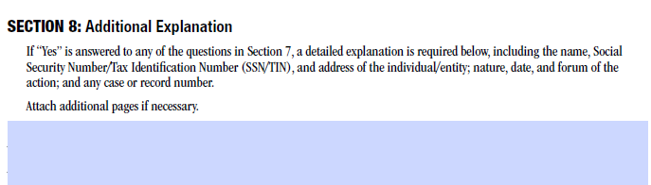
If additional space is needed, you must make a copy this page and include with the submitted form

Review the FRDF: Page 8, Section 9
The form must be signed by an authorized representative. Their name, title and the date must be printed as well.
