What is the Federally Required Disclosure Form (FRDF) for Individuals?
As required by 42 CFR § 455.104 Disclosure by Medicaid providers and fiscal agents: Information on ownership and control.
    - who must provide disclosures. The Medicaid agency must obtain disclosures from disclosing entities, fiscal agents, and managed care entities.
    - what disclosures must be provided. The Medicaid agency must require that disclosing entities, fiscal agents, and managed care entities provide the following disclosures:
(1)
(i) The name and address of any person (individual or corporation) with an ownership or control interest in the disclosing entity, fiscal agent, or managed care entity. The address for corporate entities must include as applicable primary business address, every business location, and P.O. Box address.
(ii) Date of birth and Social Security Number (in the case of an individual).
(iii) Other tax identification number (in the case of a corporation) with an ownership or control interest in the disclosing entity (or fiscal agent or managed care entity) or in any subcontractor in which the disclosing entity (or fiscal agent or managed care entity) has a 5 percent or more interest.
(2) Whether the person (individual or corporation) with an ownership or control interest in the disclosing entity (or fiscal agent or managed care entity) is related to another person with ownership or control interest in the disclosing entity as a spouse, parent, child, or sibling; or whether the person (individual or corporation) with an ownership or control interest in any subcontractor in which the disclosing entity (or fiscal agent or managed care entity) has a 5 percent or more interest is related to another person with ownership or control interest in the disclosing entity as a spouse, parent, child, or sibling.
(3) The name of any other disclosing entity (or fiscal agent or managed care entity) in which an owner of the disclosing entity (or fiscal agent or managed care entity) has an ownership or control interest.
(4) The name, address, date of birth, and Social Security Number of any managing employee of the disclosing entity (or fiscal agent or managed care entity).

How do I submit the FRDF?
Upload a completed/signed FRDF to the attachments panel on the POSC for enrollments initiated on the POSC.
Fax: Mail:
(617) 988-8974 MassHealth Provider Enrollment and Credentialing
PO Box 278
Quincy, MA 02171-0278
- Tip: All fields must be completed. Nothing should be left unanswered. If the section does not apply, check the box above the name field for the section.
- Tip: If addition space is needed, you must make a copy the appropriate page and attach each such copy to the signed form. All entries must be submitted using this form.

How to complete the FRDF

Review FRDF: Page 1, Section 1
Enter the legal information for the provider. Note the legal address must be their home address.
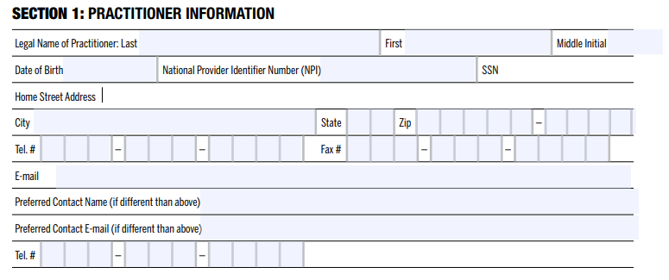
Enter the primary address where the provider practices.
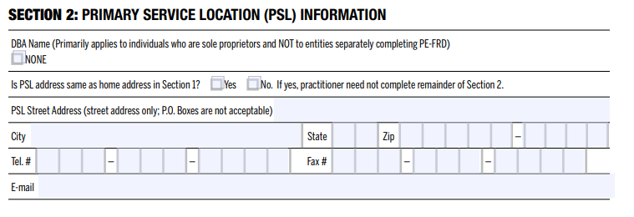

Review FRDF: Page 2, Section 3
Enter the information for individual and entities related to the practitioner as described. Include all applicable information.
If you need additional space, copy this page and indicate the page numbers on the bottom right.
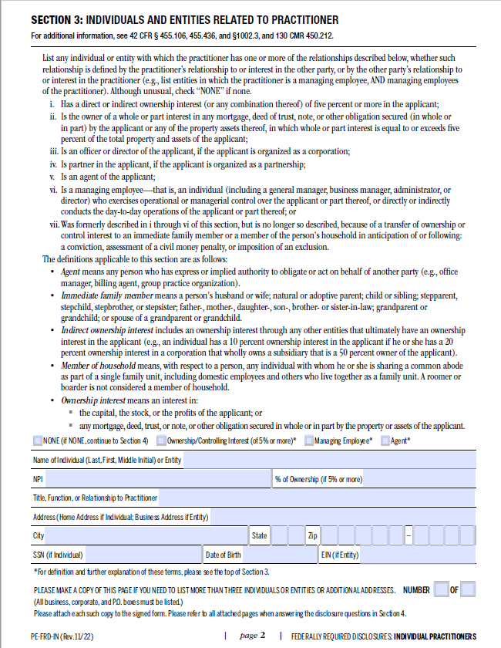

Review FRDF: Page 3, Section 4A
Answer Yes or No to each of the disclosure questions. If any are answered Yes, provide a detailed explanation on the next page.
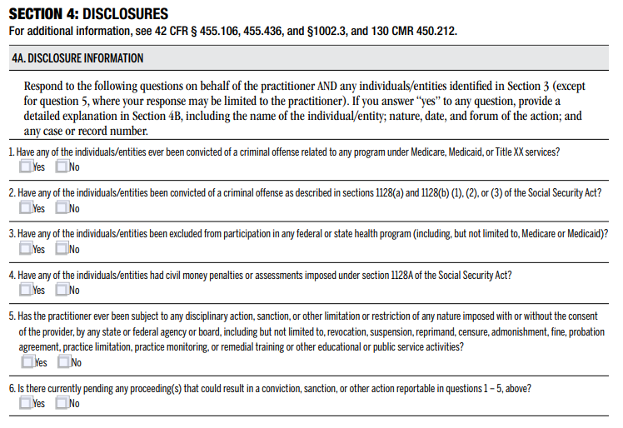

Review FRDF: Page 4, Section 4B
If any of the questions in Section 4A were answered Yes, provide a detailed explanation.
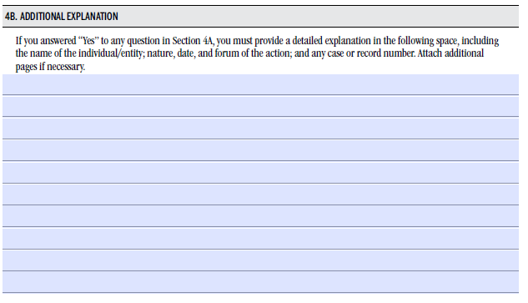

Review the FRDF: Page 4, Section 5
The form must be signed by the provider.
