Instructions for Uploading 4-Factor Analysis for the Language Access Plan in CHAMP

Overview: LHAs are required to upload a 1) Language Access Plan, 2) Fair Housing Marketing Plan, and 3) Reasonable Accommodation Policy and supporting documents in CHAMP. Supporting documents include: 1) verification of Board Approval for each of these respective documents, 2) Board Approval for their Affirmative Action Goal, and 3) “4-Factor Analysis” for their Language Access Plan.
Follow the below steps to complete the upload of the “4-Factor Analysis” for their Language Access Plan:

Login to CHAMP, navigate to the Waitlist Tab, and Click the Fair Housing Details button at the bottom
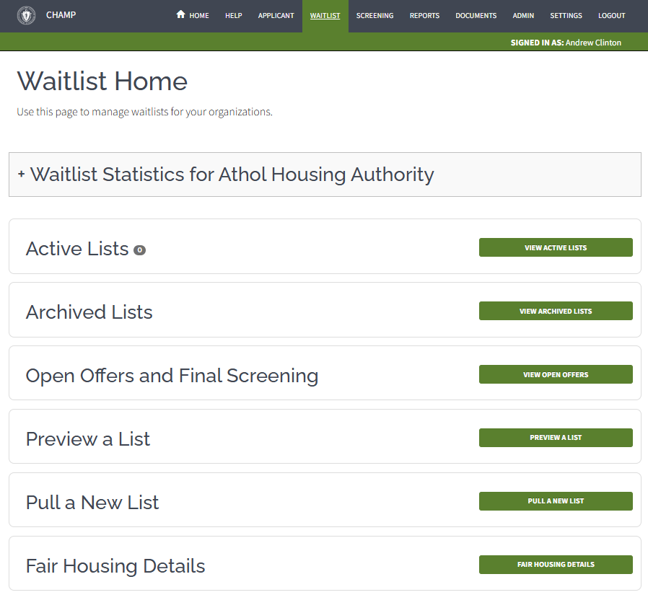



Scroll to the bottom of the Manage Fair Housing Details page until you see the Fair Housing Documents table.

Confirm you uploaded all of the required Plans, Policies, and Approval Documents.

Open your Language Access Plan and review the 4-Factor Analysis you included within it. If you used the EOHLC template, it will be called Attachment A within the document.

You will need to get a PDF copy of only the pages that contain the 4-Factor Analysis to upload it as a document separate from the Language Access Plan.
How can I separate the 4-Factor Analysis from the Language Access Plan?
Make a copy of the PDF and use editing the remove pages, OR
Create a PDF copy using your original Word document, OR
Scan the pages and create a PDF.
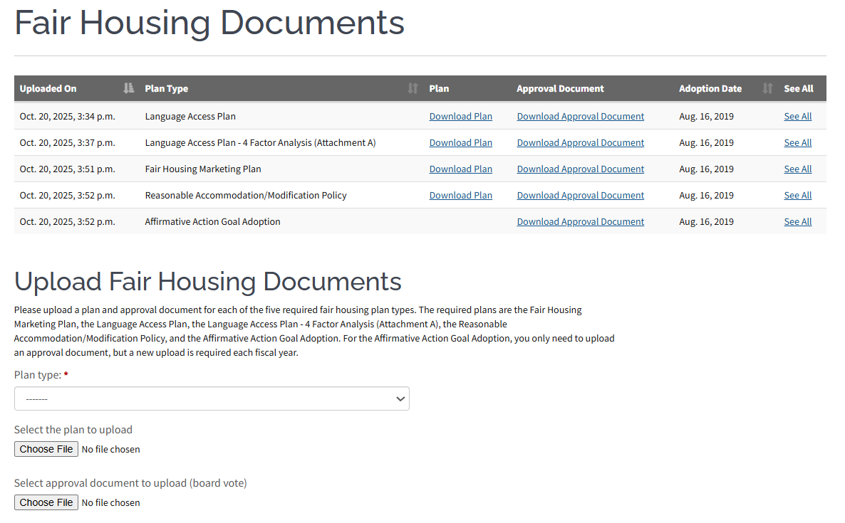

Once you have created your stand-alone copy of the 4-Factor Analysis, use the Upload Fair Housing Documents to upload the document to CHAMP.
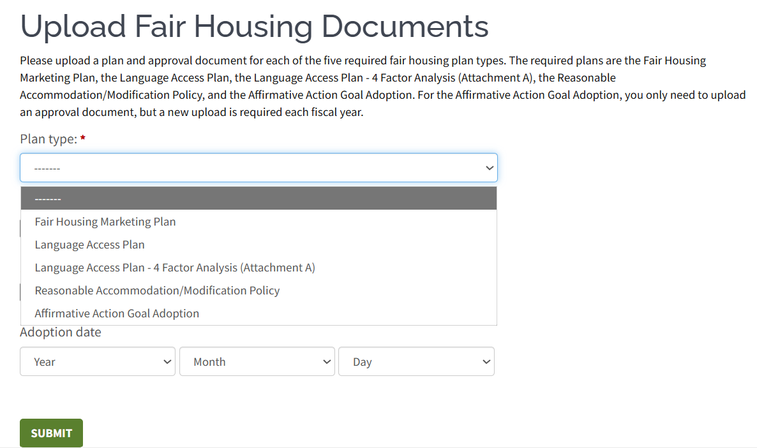

Under Plan Type, select the “Language Access Plan – 4-Factor Analysis (Attachment A), then browse for both the 4-Factor Analysis Document PDF as well as any relevant Board Approval documents.

If your Board previously approved the 4-Factor Analysis as part of your Language Access Plan, LHAs should use the same Board Approval Document and Adoption Date as the Language Access Plan.

Click the Green Submit button at the bottom.

You will then be able to view the 4-Factor Analysis in the Fair Housing Documents table.

