EOTSS Remote Access VPN

BYOD PC Client Install

Table of Contents
Ensure your computer is compatible 2
Remove an old VPN client before installing a new one (if necessary) 3
Download the Commonwealth VPN client 5
Unpack and install the Commonwealth VPN client 8
Common errors and how to troubleshoot 10
Helpful Links 11
Support 11

Prepared by the Massachusetts Executive Office of Technology Services and Security

Last Updated: June 24, 2021

Ensure your computer is compatible
Before getting started, you need to ensure that:

You are enrolled in Multi-Factor Authentication (MFA).

In order to use the new EOTSS VPN, you must be enrolled in MFA. Instructions on how to set up MFA can be found here: https://www.mass.gov/guides/set-up-azure-ad-mfa

You have a Commonwealth-issued device, or a Windows 10 personal device.

EOTSS prohibits the use of Windows 7 or older personal devices because Microsoft no longer provides support or security patches for the older operating system. Commonwealth-issued devices running Windows 7 are still allowed because EOTSS has purchased extended maintenance and support to cover these devices.
If you are trying to install the Commonwealth VPN client on a Commonwealth-issued device via SCCM (Software Center) OR a Mac, please use the following instructions:
Instructions for VPN client install/uninstall for Secretariats/Agencies on EOTSS SCCM
Instructions for VPN client install BYOD Mac devices

You have been provisioned with a Commonwealth VPN account.

Once the requested VPN account has been provisioned, your agency will notify you that you have access to VPN. If you download the VPN client and are unable to log in, you may need to wait until a VPN account has been provisioned for you.

You have Local Admin Rights.

To install the EOTSS VPN client or remove an old VPN client, you will need local administrator rights. If you are using a Commonwealth-issued computer, you will likely need to work with your IT support group to install the VPN client. If you are using your personal device, you likely already have local administrator rights.

Remove an old VPN client before installing a new one (if necessary)
Check to ensure you do not already have a version of Pulse installed. All previous versions must be removed before installing the latest version of Pulse.

Step 1: Click the Windows logo on the bottom left of the screen, then click “Settings.”
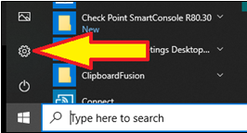

Step 2: Select “Apps” on the Settings page.

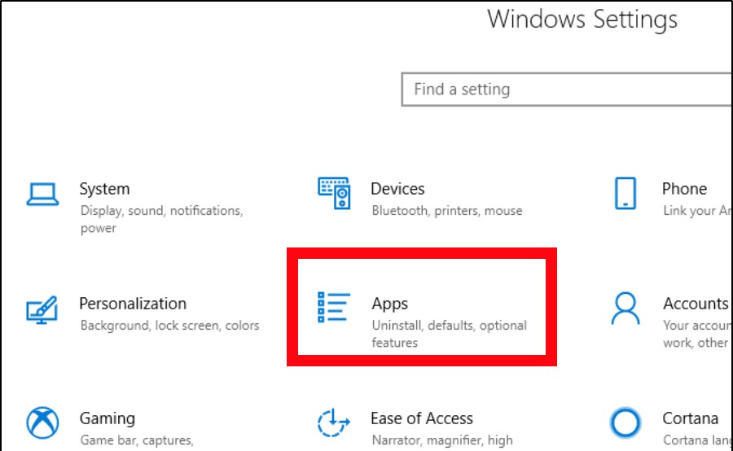

Step 3: On the Apps page, uninstall any item starting with “Pulse Secure.”
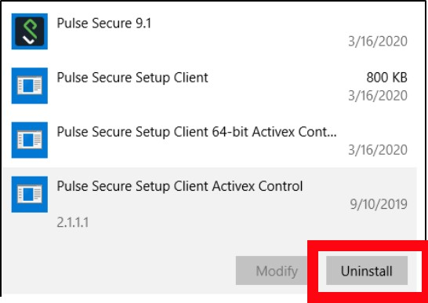

Step 4: Once all old clients have been removed, please reboot the device and then start the tssrav2.exe installation a second time, following the instructions below on how to install the Commonwealth VPN client.

Download the Commonwealth VPN client
For the purposes of these instructions, you MUST use Windows File Explorer. Google Chrome and Internet Explorer no longer support ftp.

Step 1: Open Windows File Explorer (Start -> Windows System -> File Explorer OR type "File Explorer" in the Windows search bar).

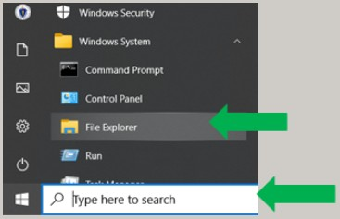

Step 2: In the address/browser line in Windows File Explorer enter ftp://cjisftp.chs.state.ma.us and press enter/return.
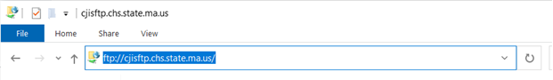

Step 3: You will be prompted to log on.
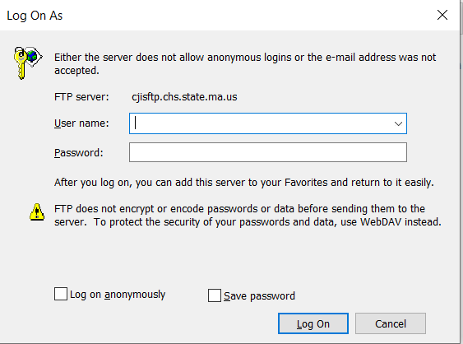

- Type in the username: eotssvpn
- Type in the password (case sensitive): VPN@eotss
- Click “Log On”.

Step 4: Right-click on the ﬁle “tssrav2.exe” shown and select “Copy To Folder”.

STOP – Be sure to download the correct file. DO NOT download the “tss-rav1.exe” file. This is the OLD Commonwealth VPN client. You MUST download the “tssrav2.exe” file to install the most up-to-date version of the Commonwealth VPN client.

Step 5: Select “Desktop”, then click “OK”.

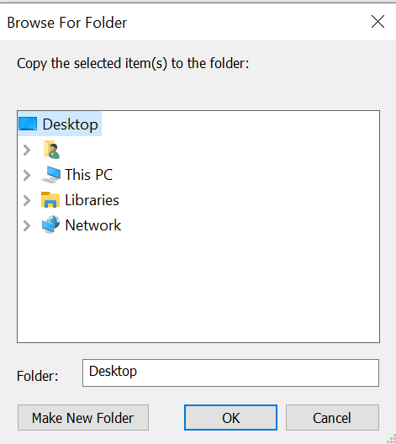

Unpack and install the Commonwealth VPN client

Step 1: Once the ﬁle “tssrav2.exe” is downloaded to the desktop, double-click on the ﬁle to begin installation.
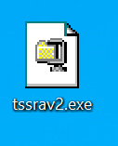

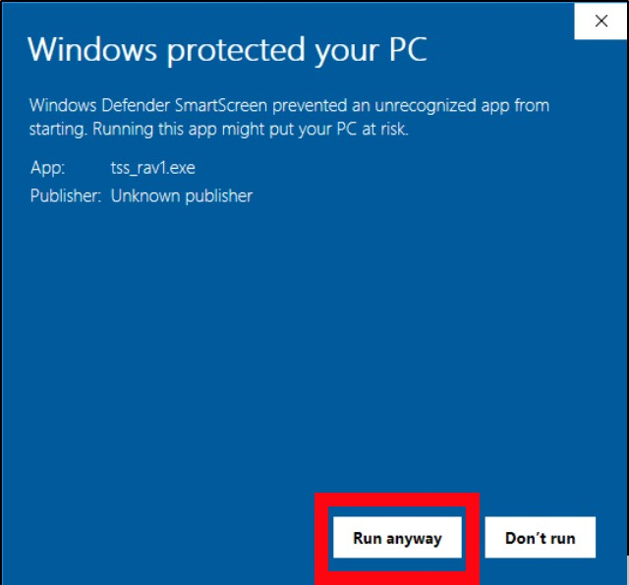
Step 2: If you receive the message below, click “More info” then click “Run anyway”. If you do not receive the message below, move to Step 3.

Step 3: If prompted by Windows, click “Yes” to allow tssrav2.exe or the temporary msi file to run.
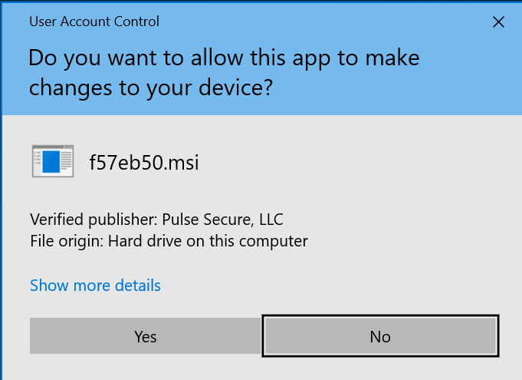.

Step 4: If you receive the message below, click “This program ran correctly”.
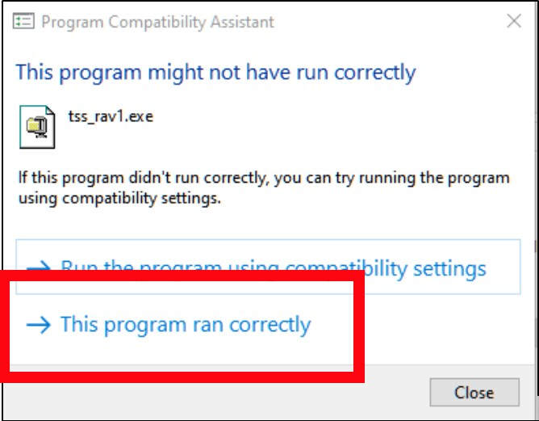

You are now ready to use the Commonwealth VPN!

Common errors and how to troubleshoot

If you click “This program ran correctly” and a message like the one below appears telling you “Client Already Installed”:
- Follow the instructions above to Remove an old VPN client before installing a new one (if necessary).
- Then, follow the instructions to Download the Commonwealth VPN client and Unpack and install the Commonwealth VPN client.

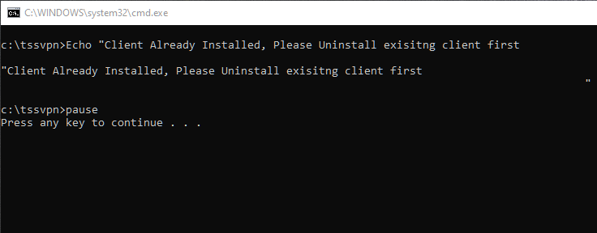

Helpful Links

VPN
Commonwealth VPN Service
https://www.mass.gov/commonwealth-vpn-service

Commonwealth VPN FAQs
https://www.mass.gov/info-details/commonwealth-vpn-faqs

Commonwealth VPN Eligibility and Requirements
https://www.mass.gov/info-details/commonwealth-vpn-eligibility-and-requirements

How to use the Commonwealth VPN
https://www.mass.gov/info-details/how-to-use-the-commonwealth-vpn

MFA
Multi-factor Authentication service page
https://www.mass.gov/multi-factor-authentication

How to set up Multi-factor authentication
https://www.mass.gov/guides/set-up-azure-ad-mfa

Multi-factor authentication FAQs
https://www.mass.gov/info-details/multi-factor-authentication-faqs

Changing your Azure MFA security information and default options
https://www.mass.gov/info-details/configuring-azure-mfa-security-options-and-changing-default-methods

Support

Request IT support or services
https://www.mass.gov/how-to/request-it-support-or-services

ServiceNow Portal
https://massgov.service-now.com/sp

