1. ASCs that are NOT CURRENTLY ENROLLED in NHSN should begin the enrollment process now:
   1. [**Click here**](http://www.cdc.gov/nhsn/ambulatory-surgery/enroll.html) for NHSN enrollment instructions
   2. Enroll in NHSN under the Healthcare Personnel Safety Component.
2. ASCs that are CURRENTLY enrolled in NHSN should:
   1. Add *the Healthcare Personnel Influenza Vaccination Module* in order to submit Influenza Vaccination data for the 2014-2015 flu season. For more information about CMS reporting of HCP flu reporting, go to <http://www.cdc.gov/nhsn/ambulatory-surgery/hcp-vaccination/index.html>.
3. Once enrolled in NHSN ASCs must join the MDPH ASC Group;
   1. To join the MDPH ASC Group in NHSN, you will need to login to the CDC/NHSN and navigate to the Group, Join page
4. On the blue navigation bar on the left of the NHSN Navigation page, click “Group”

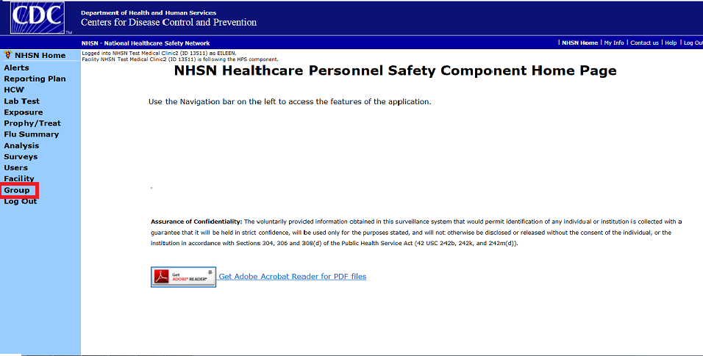

**1**

1. On the blue navigation bar on the left of the NHSN Navigation page, click “Join”.

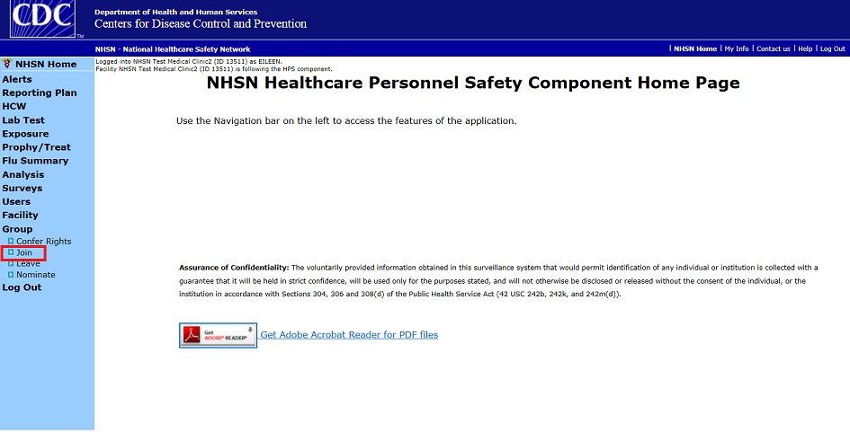

**2**

3. Enter the MDPH Group ID: **20964**

4. Enter the Group Joining Password: **ASC** (be sure the letters are upper-case)

5. Click “Join Group”

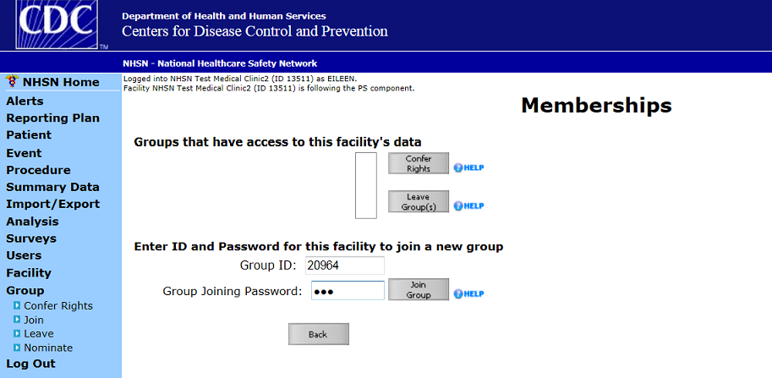

**5**

4

**3**

Once you are a member of the MDPH ASC Group, you must **confer rights**. Conferring rights allows MDPH to be able to

view and analyze submitted data.

1. On the blue navigation bar on the left of the page, click “Group”, and then click “Confer Rights”.
2. Click on “MDPH ASC (ID 20964)” in the “Groups that have access to this facility’s data” drop down box.
3. Once “MDPH ASC (ID 20964)” is highlighted, click on the “Confer Rights” box to the right.

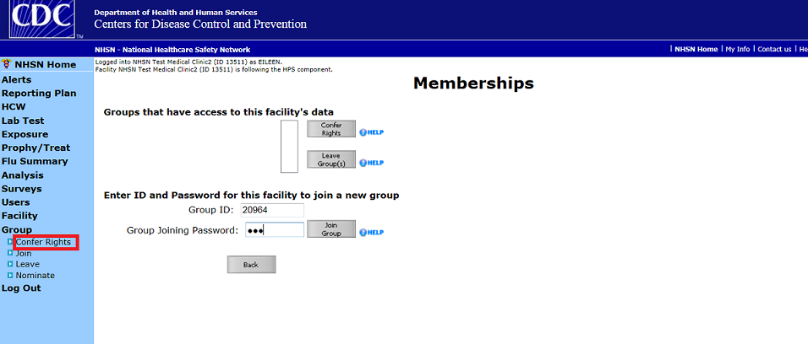

MDPH ASC (ID 20964)

**2**

**3**

**1**

You will then be taken to the “confer rights” page, where you will be prompted to accept the rights requested by MDPH.

The MDPH Group is responsible for requesting rights from facilities using a “confer rights template. Facilities in the group are required to “accept” the template.

1. Click the **“Accept”** button at the bottom of the page, and you’re done! Any time a new confer rights template is

created by MDPH you will receive a message on your NHSN home page indicating that you need to review the rights.

Accept and Back buttons