The Department of Early Education and Care (EEC) is moving to a new system to run Background Record Checks (BRCs) called EEC BRC Navigator. Due to your role within a Group and School Aged (GSA) Child Care Program, you have been authorized by EEC to access the [BRC Program Portal](https://brcprogramportal.mass.gov), one of the modules of the EEC BRC Navigator. The BRC Navigator is the new system being used by EEC to process BRCs on candidates and affiliated individuals, and the BRC Program Portal will be used by programs to update a roster of individuals within programs starting February 2019 and to run EEC BRCs on new candidates beginning April 2019.

Your EEC BRC Manager account will be phased out. From February to April 2019, you will continue to run new BRCs through BRC Manager. As of April 2019, you can no longer use BRC Manager to run new BRCs. After that date, you may only login to BRC Manager to review your existing EEC BRC requests, including any BRC checks that are in process. To run new BRCs after April 2019, you must create an account and use the BRC Program Portal. Your login information will not carry over from BRC Manager to the [BRC Program Portal](https://brcprogramportal.mass.gov).

All Licensees and BRC Program Administrators will have accounts associated with their own unique e-mail address. An account has been created for you because you meet the eligibility criteria to access the [BRC Program Portal](https://brcprogramportal.mass.gov).

If you are affiliated with a licensed GSA program and are eligible for an account on the BRC Program Portal, you will receive an e-mail with instructions on how to activate your account.

From February to April 2019, functionality in the Program Portal will be limited to Licensees and BRC Program Administrators reviewing and updating their staff rosters and providing access to candidates designated as BRC Program Administrators (referred to in BRC Manager as Reviewer with Access and Reviewer with Authority).

**EEC migrated candidates working in the program (designated as employees, volunteers, and interns) from BRC Manager that are listed in an open or active licensed GSA program if they have completed and were approved for all EEC-required BRCs, including Criminal Offender Record Information (CORI), Sex Offender Record Information (SORI), Department of Children and Families (DCF), and a fingerprint-based check within the past 3.5 years and their overall EEC BRC status is “*Suitable*”.**

A candidate including Licensees and BRC Program Administrators may be listed more than once if they are affiliated with more than one program and/or umbrella. The most current EEC BRC with the overall status of “Suitable” in BRC Manager will be the BRC of record in the BRC Program Portal.

**Candidates in process (new or renewal) in BRC Manager through April 2019, will be migrated when their BRC is a complete and marked “*Suitable*”.**

When you have activated your BRC Program Portal account through the e-mail process, you can sign in and look at your roster.

After you sign into the BRC Program Portal, the following screen will be displayed:

1. The “APPLICANTS” Tab will be empty. Eventually it will be used to show individuals who have been submitted for an EEC BRC through the BRC Program Portal. You cannot submit a BRC using the BRC Program Portal until April 2019 (until that time, all EEC BRCs must be submitted via BRC Manager).

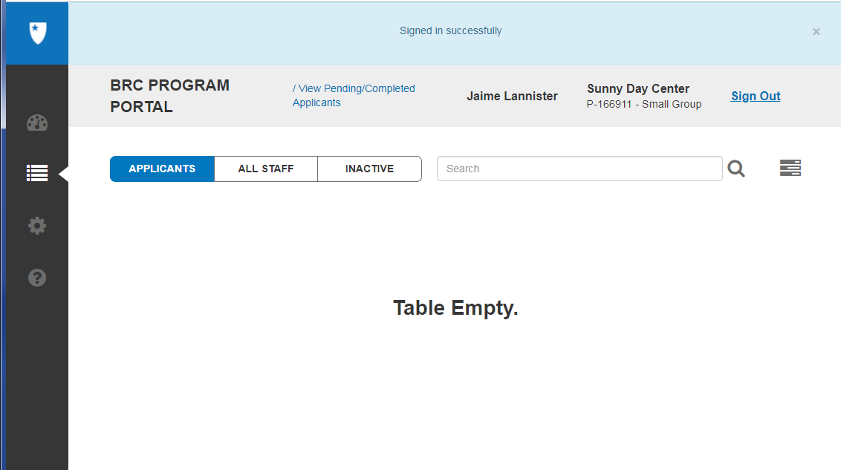

1. The “ALL STAFF” tab will include your staff roster by program for all candidates designated as “hired” in BRC Manager and found “suitable” after completing all EEC-required BRCs. This includes being found approved after the Criminal Offender Record Information (CORI) check, Department of Children and Families (DCF) check, Sex Offender Record Information (SORI) check, and a fingerprint-based check of state and national criminal databases within the past 3.5 years.

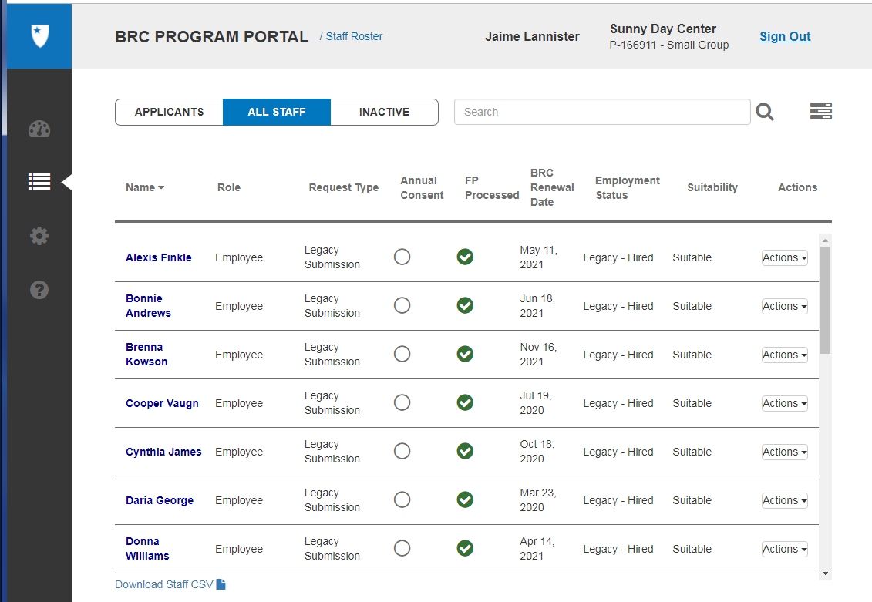

1. The “INACTIVE” tab will include your staff roster by program for individuals who were not designated as “hired” in BRC Manager but were found “suitable” after completing all EEC-required BRCs. This includes being approved after completing a Criminal Offender Record Information (CORI) check, Department of Children and Families (DCF) check, Sex Offender Record Information (SORI) check, and a fingerprint-based check of state and national criminal databases within the past 3.5 years and the BRC overall status is “Suitable”.

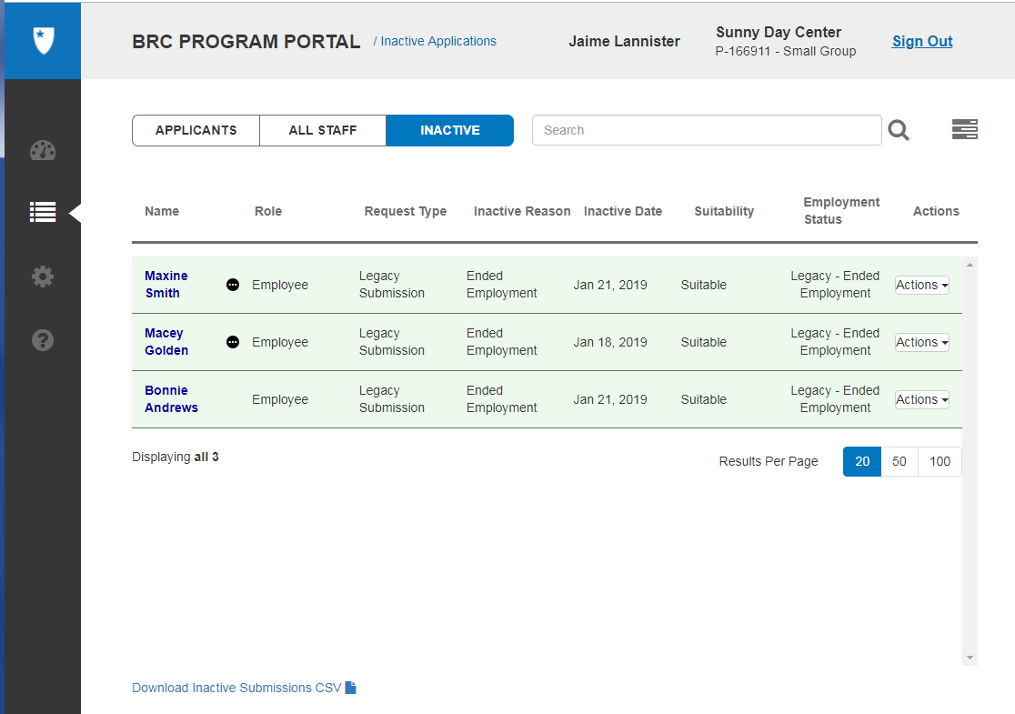

1. The BRC Program Portal has 3 features to view a candidate.
   * Users can use “Search Bar” to search for members, currently you can use the search for:

* Submission id/Request ID
* Role
* First name
* Last name
* Maiden name
* Date of birth (format for search YYYY-MM-DD or YYYY-DD-MM)
* Alias first name
* Alias middle name
* Alias last name
* Program number (LOC)
* Program name /(LOC)
  + Users can filter the listing page based on criteria within the Filter panel
  + Users can download the list page as a .csv file and open in excel. This file contains additional columns including Program Name.

1. As part of roster cleanup, each program must confirm the hiring status for candidates listed in the “ALL STAFF” and “INACTIVE” tabs.
   * If an employee is listed on the “ALL STAFF” tab but they are no longer an employee, use the drop down menu, select either “Legacy - Ended Employment”.
     + The former employee will be moved to the “INACTIVE” tab designated as “Legacy - Ended Employment”.
   * If the employee is listed on the “ALL STAFF” tab and they were not hired or no longer employed, use the drop down menu, to select “Inactive”.
     + The former employee will be moved to the “INACTIVE” Tab designated as “Legacy-Inactive”.

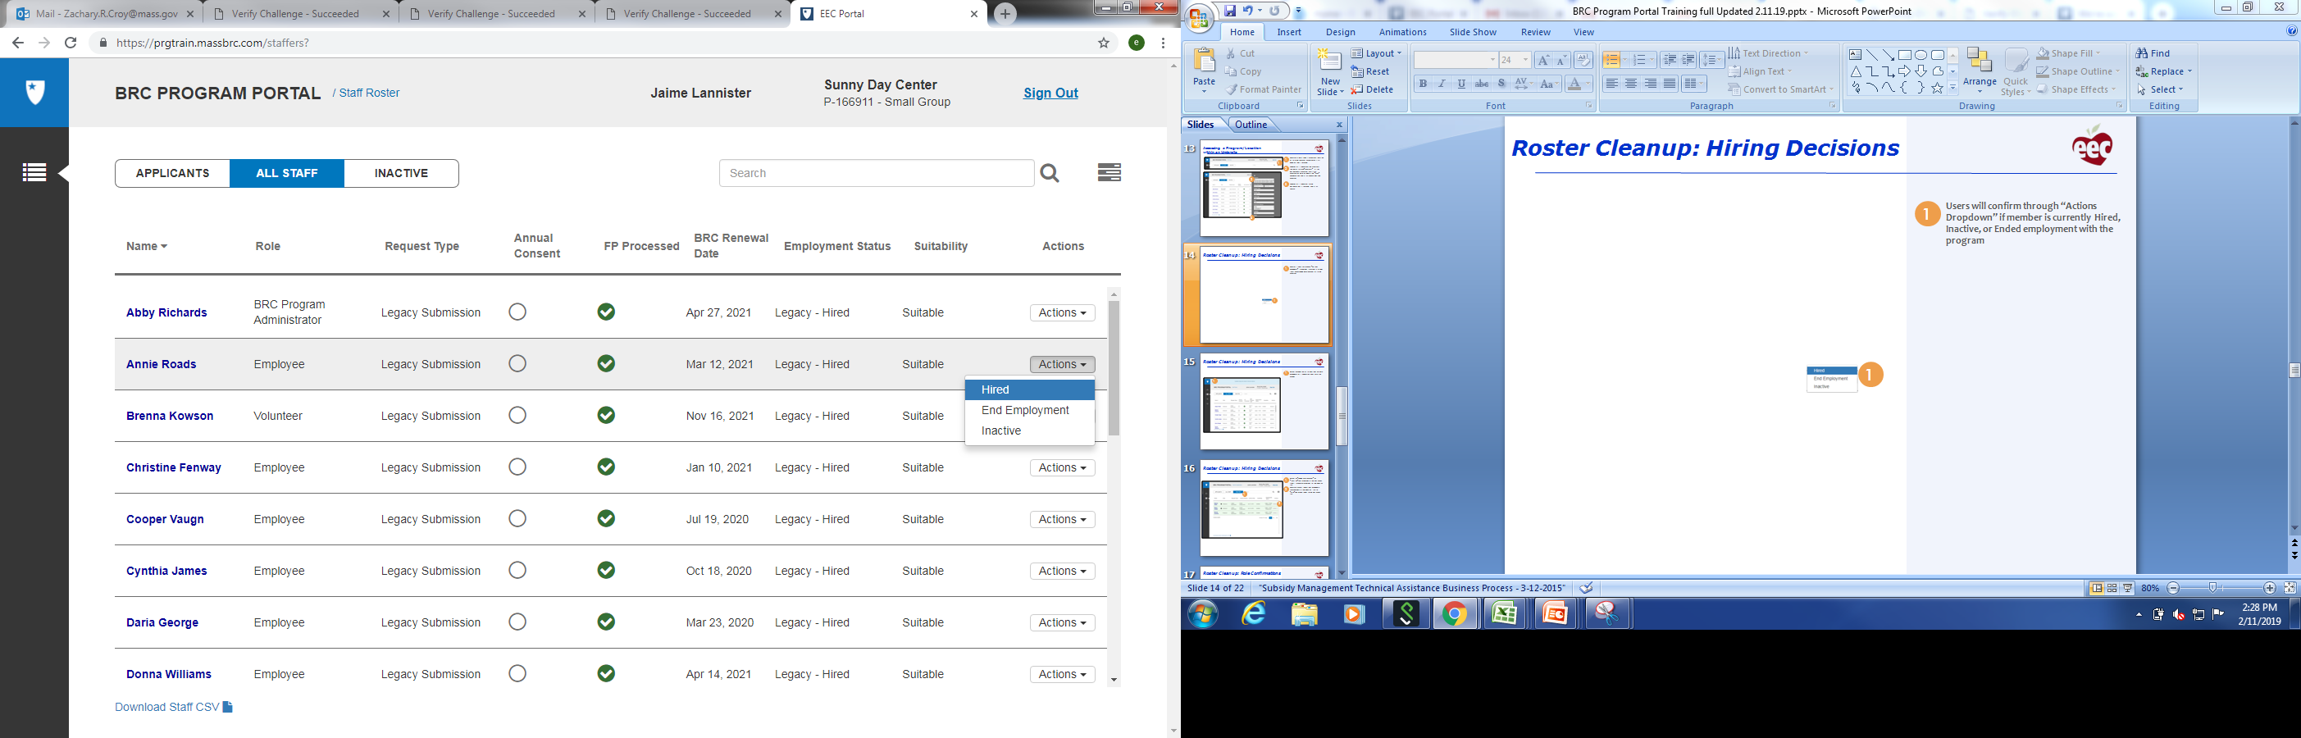

* + If the employee is listed on the “INACTIVE” tab and they are currently candidates at the program, then use the drop down “Actions” menu and select “Activate”.

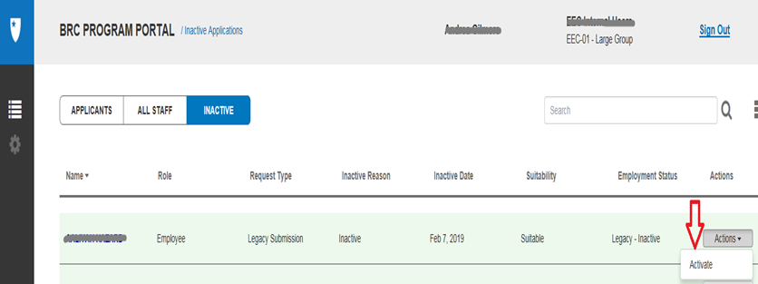

* + After you select the “Activate” action, the candidate will move to the “ALL STAFF” tab.
    - The candidate’s “employment status” will change to “Legacy - Hired”.
    - If you accidentally mark a candidate as “Hired” and move to the “ALL STAFF” in error, you can move them back to the “INACTIVE” tab by going to “Actions” and selecting “Inactive” or “End Employment”.



* + The candidate’s status can also be changed when you are viewing the candidate detail page.
    - Go to “Edit Employment Info”
    - Select applicable employment status

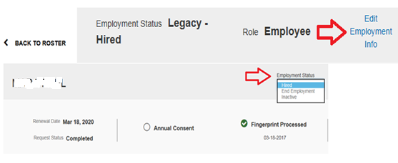

1. As part of the roster cleanup, you may update the candidate’s personal information:
   * To access the candidate’s profile page, click on the candidate’s name on the “ALL STAFF” tab.
   * **All employees, including volunteers, interns, and BRC Program Administrators (including a reviewer with access or reviewer with authority), and affiliated candidates** will be migrated to the BRC program Portal as an ***Employee****.* You may update the employee to the correct role in the BRC Program Portal, except for Licensee.
   * If the employee should be the Licensee, then you must make this change in LEAD. Additional guidance can be found on the EEC BRC website, the following link will direct you to the guidance, [Requirements for GSA Licensees BRC Program Portal access](https://www.mass.gov/doc/requirements-for-group-school-age-child-care-licensees-to-obtain-a-brc-program-portal-account).
   * Please check [EEC's BRC website](https://www.mass.gov/eec-background-record-checks)regularly for additional information about the new BRC Navigator system.

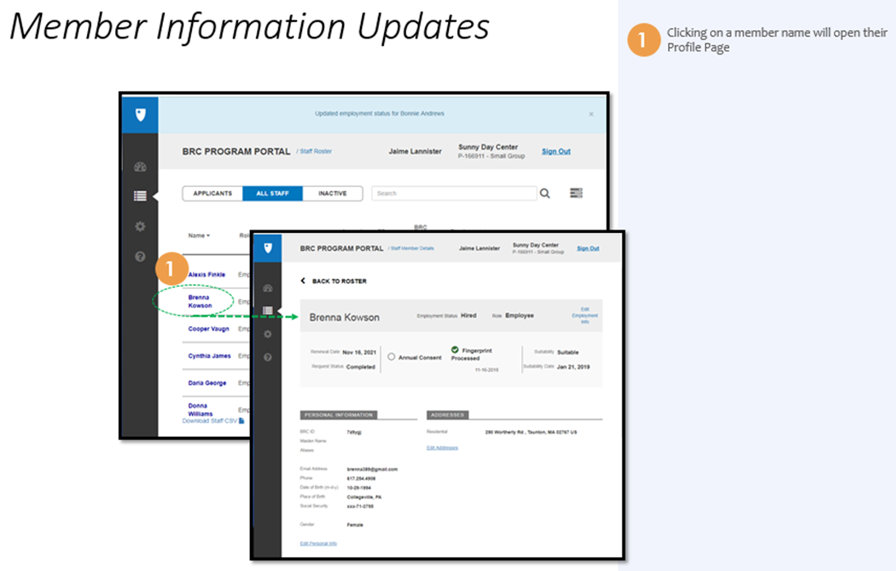

* You may update the candidate’s role to the applicable category:
  + Employee
  + Volunteer
    - In BRC Manager, interns are categorized as volunteers/interns will be migrated as a volunteer.
    - If that person is an intern and not actually a volunteer, then you must change their role to intern in the BRC Program Portal.
  + Intern
  + Affiliated Person
  + BRC Program Administrator
    - Reviewers with access and Reviewers with Authority are not being brought into the BRC Program Portal in that role. They will not immediately have access to the BRC Program Portal if they are not designated as Main Contact/Licensee in LEAD.
    - An employee should not be designated as a BRC Program Administrator if they have an expired BRC.
      * If the FP processed date has a red “**X**” the BRC has expired**.**
    - **An employee should not be designated as a BRC Program Administrator until they complete and sign a non-disclosure form posted on the EEC BRC website. This document must be kept on file at the program.**
    - **Before you update an employee to BRC Program Administrator, you must first add or update their email address.**
    - **If you do not complete this step, then an error message will appear at the top of the page:** 
      * You must update the email address for First Name Last Name by clicking 'Edit Personal Info' below before proceeding.

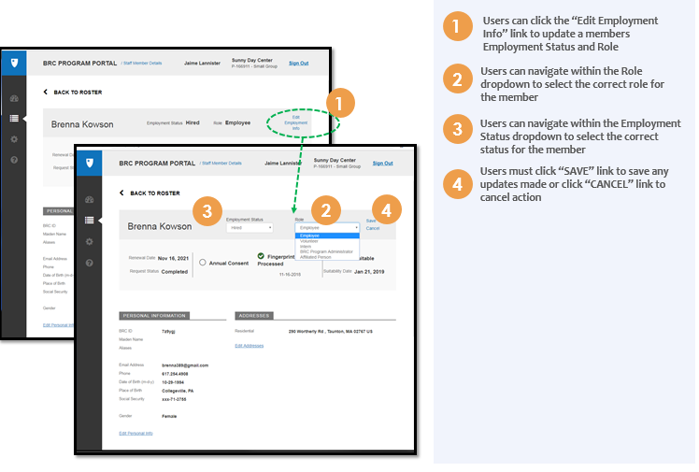

* You may update the candidate’s following personal information:
  + E-mail address –
    - The e-mail address entered will be used to send any BRC results if there any findings and by EEC to communicate with the candidate.
    - The e-mail must be associated with the candidate and only accessible by the candidate – not the program.
    - If you designate a candidate as a BRC Program Administrator, then this e-mail address will be used to set up an account to access BRC Program Portal.
      * The candidate will receive an e-mail with instructions on how to activate their account.
  + Phone number

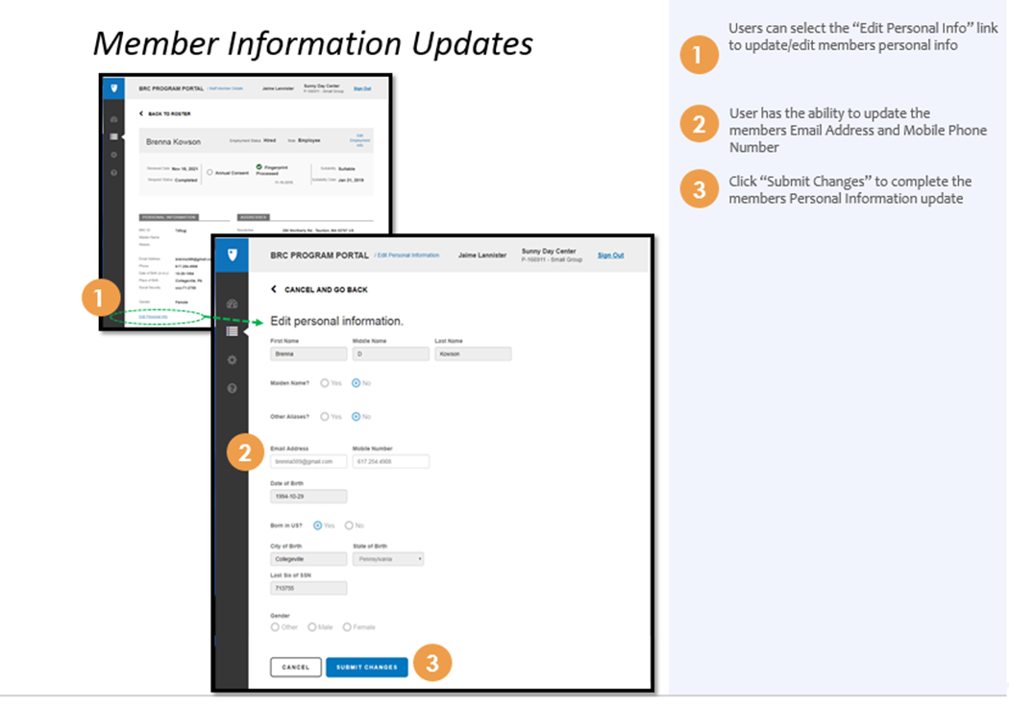

* Update the candidate’s Location of Care:

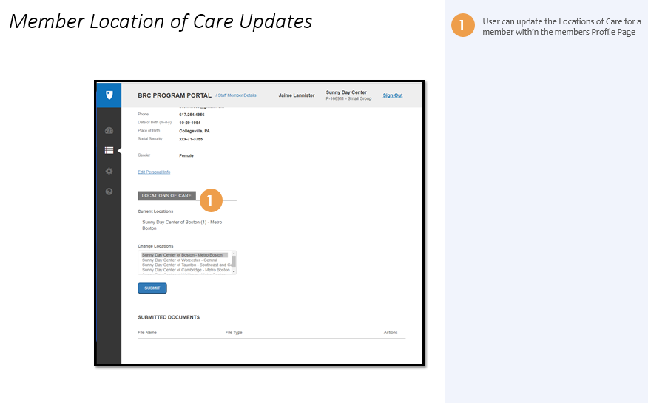

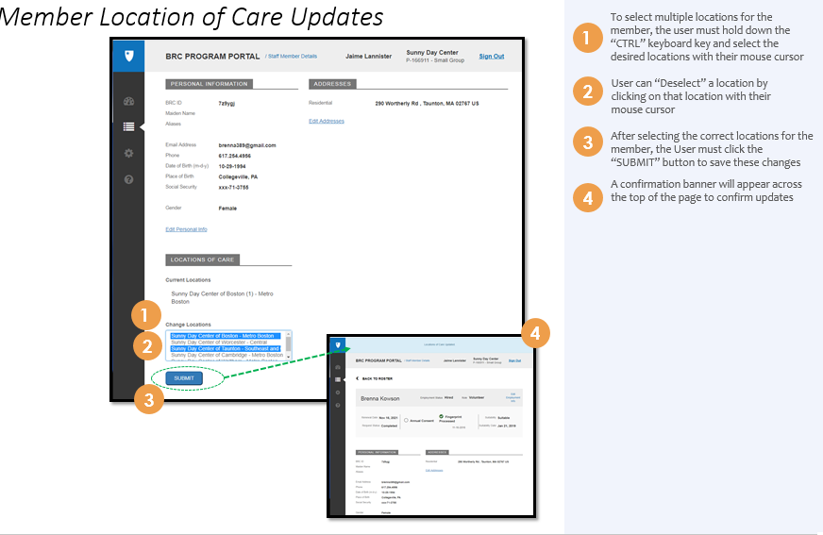

**Frequently Asked Questions**

1. **Q:** What do I do if I changed an employee to a BRC Program Administrator and they did not receive e-mail requesting them to set up their user account?

**A:** Please submit a Work Order to the [BRC Support Tool](https://massgov.service-now.com/brc), you will receive an email with the work order number. The BRC Contact Center will respond to you inquiry as soon as possible. It may take a few days to receive a response, but it is not necessary to submit another work order.

1. **Q:** Who do I contact to reset my password if I forgot my password and cannot log back in *OR* I am locked out and not able to reset password?

**A:** Please submit a Work Order to the [BRC Support Tool](https://massgov.service-now.com/brc), you will receive an email with the Work Order number.

1. **Q:** Why am I viewing a different Program’s roster?

**A:** As a Licensee or BRC Program Administrator you will have access to all programs within your organization’s Licensee/Umbrella. Please follow your employer’s procedures for the programs you should be managing in the BRC Program Portal.

1. **Q:** Why am I seeing a different Licensee or Umbrella’s roster?

**A:** If you are affiliated with more than one umbrella, you may have access to another umbrella. Access to other umbrellas require a different user ID and password. If you are viewing multiple umbrellas using the same user ID and password, then please submit a Work Order to the [BRC Support Tool](https://massgov.service-now.com/brc), and you will receive an email with the work order number.

1. **Q:** Why are only some of my candidates (employees, volunteers, interns or affiliated persons) listed in the BRC Program Portal on the “ALL STAFF” and “INACTIVE” tab?

**A:** EEC only brought in staff (employees, volunteers, interns, and affiliated individuals) from BRC Manager if they are listed in an open licensed GSA program and were found suitable after completing all EEC-required BRCs within the prior 3.5 years. As staff become suitable in BRC Manager, they will be brought into the BRC Program Portal. It may take a few days for suitable candidates to be brought into the BRC Program Portal. If you do not see the candidate after a few days, then you may submit a Work Order to the [BRC Support Tool](https://massgov.service-now.com/brc).

1. **Q:** Why don’t I see those who were approved as Licensee/Reviewers, Reviewers with Authority, Reviewer’s with Access, or Data Entry Users, in the BRC Program Portal as BRC Program Administrators?

**A:** Only those who were designated as Licensee/Main Contact in LEAD are visible in BRC Program Portal. Licensee/Main Contacts will be able to designate candidates in their roster as BRC Program Administrators. Before providing access to BRC Program Administrators, candidates must sign a non-disclosure form that is kept on file by the program. They also must have a completed BRC within the past 3.5 years found “*Suitable”*.

1. **Q:** Why are Licensee or BRC Program Administrators only allowed to change an employee’s address, email address, phone number, and location of care?

**A:** Licensees and BRC Program Administrators may only change those fields because changing other personal information may require EEC to resubmit a BRC.If you need to change any other field, then you must submit a Work Order to the [BRC Support Tool,](https://massgov.service-now.com/brc) you will receive an email with a work order number.

1. **Q**: Why am I not able to change my own personal information as a Licensee?

**A:** Licensees may not change their own personal information because itmay require EEC to resubmit a BRC.You may submit a Help Desk ticket in the LEAD Portal to change your personal information. The EEC Regional Office will execute the transaction in LEAD, and you will receive the link to the DocuSign Consent Form via e-mail.

1. **Q**: Why can I only update my roster, when will we be able to use BRC program Portal to submit a new BRC for employees, volunteers, interns, affiliated persons and BRC program administrators**?**

**A:** Starting April 2019, the BRC Program Portal will be used to process new BRC’s. Until then all BRC’s will continue to be processed using BRC Manger. All BRC’s initiated from January 2019 through April 2019 will be completed in BRC Manager.

1. **Q:** Why am I in the staff roster if I am actually the Licensee?

**A**. All staff, volunteers, interns, BRC Administrators and Licensees are required to have completed a BRC every three years and are included on the roster. If you are the Licensee but not listed as the Licensee on the roster, you may submit a Help Desk ticket in the LEAD Portal to change your personal information. The EEC Regional Office will execute the transaction in LEAD, and you will receive the link to the DocuSign Consent Form via e-mail.

* + Additional guidance can be found on the EEC BRC website, the following link will direct you to the guidance, [Requirements for GSA Licensees BRC Program Portal access](https://www.mass.gov/doc/requirements-for-group-school-age-child-care-licensees-to-obtain-a-brc-program-portal-account).
  + Please check [EEC's BRC website](https://www.mass.gov/eec-background-record-checks) regularly for additional information about the new BRC Navigator system.