Instructions to Create an Electronic Signature
To create an electronic signature, please follow these steps:

- IN THE FILLABLE FORM, CLICK THE SIGNATURE FIELD.
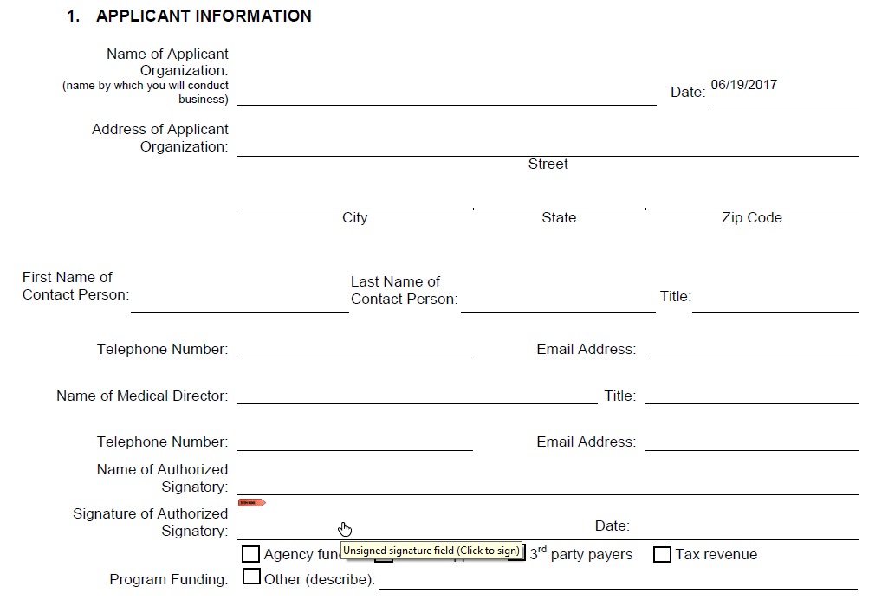

- CLICK “CONFIGURE DIGITAL ID” IN THE POPUP WINDOW.
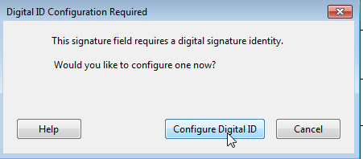

- SELECT “CREATE A NEW DIGITAL ID” AND CLICK “CONTINUE”.
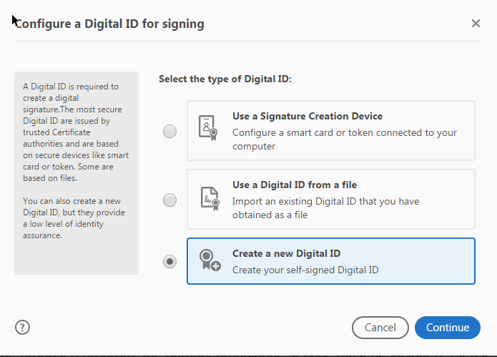
- SELECT “SAVE TO WINDOWS CERTIFICATE STORE” AND CLICK “CONTINUE”.
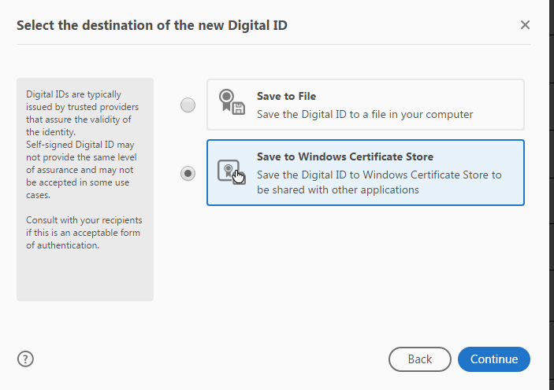

- FILL IN THE FIRST FOUR FIELDS (NAME, ORGANIZATIONAL UNIT, ORGANIZATION NAME, EMAIL ADDRESS) AND CLICK “SAVE”.

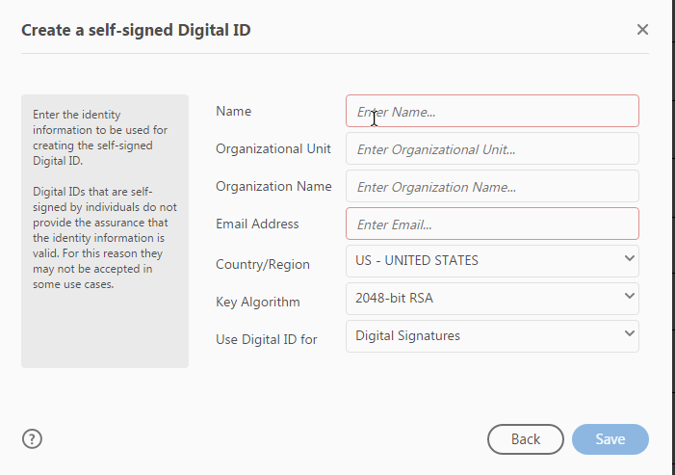

- WHEN THE DIGITAL ID SIGNATURE IS CREATED, CLICK “CONTINUE”.

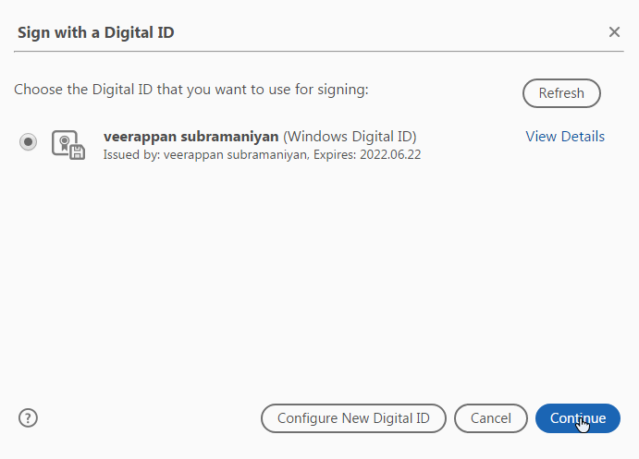

- TO SIGN THE FORM WITH A PRINTED NAME, CLICK “SIGN” IN THE POPUP BOX.
IF YOU PREFER TO USE AN ACTUAL SIGNATURE INSTEAD OF A PRINTED NAME, PLEASE REFER TO STEPS 8-11 BELOW.
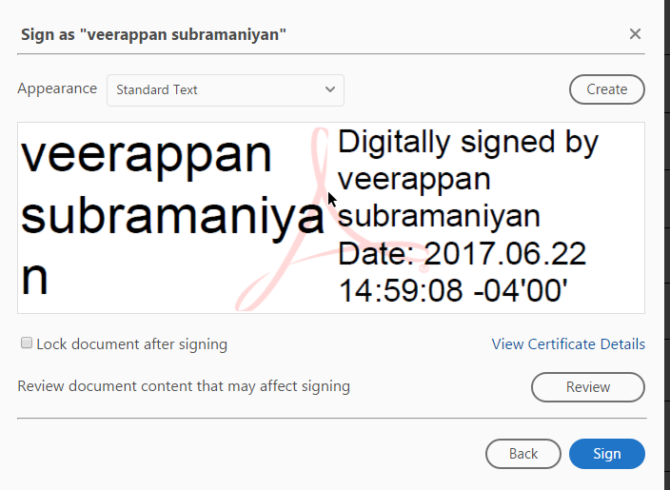

- TO CREATE A SIGNATURE, CLICK “CREATE”.
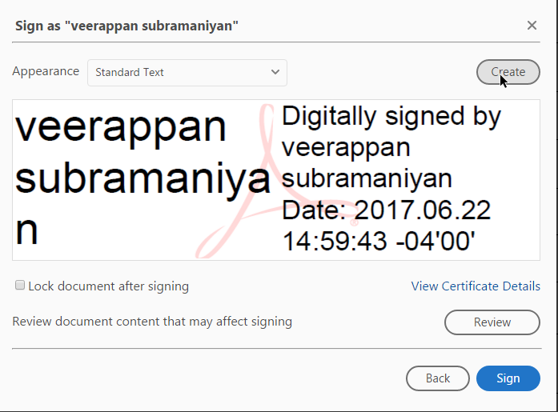

- CLICK “DRAW”.
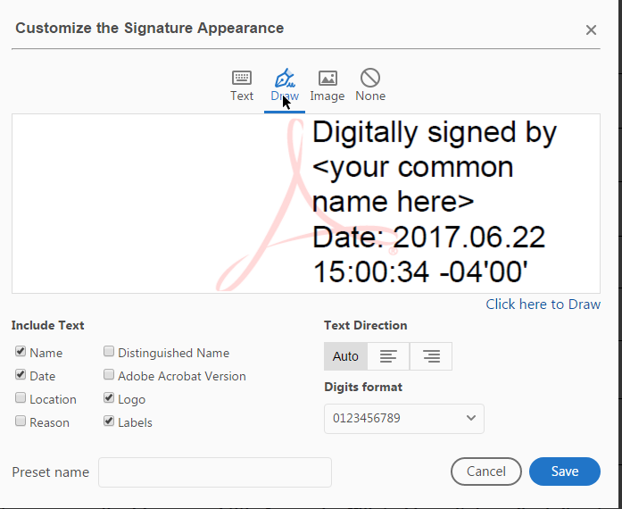

- DRAW YOUR SIGNATURE USING YOUR MOUSE. ONCE FINISHED, CLICK “APPLY”, THEN CLICK “SAVE”.
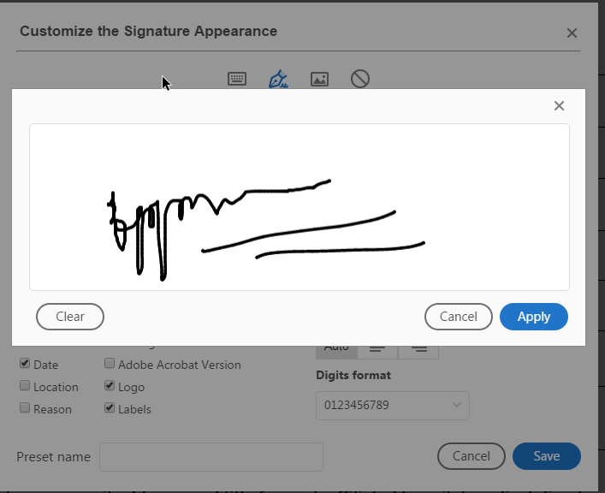

- YOU CAN NOW SEE THE TWO SIGNATURE OPTIONS IN THE “APPEARANCE” DROPDOWN MENU. TO SIGN THE FORM, SELECT THE SIGNATURE YOU WOULD LIKE TO USE, THEN CLICK “SIGN”.
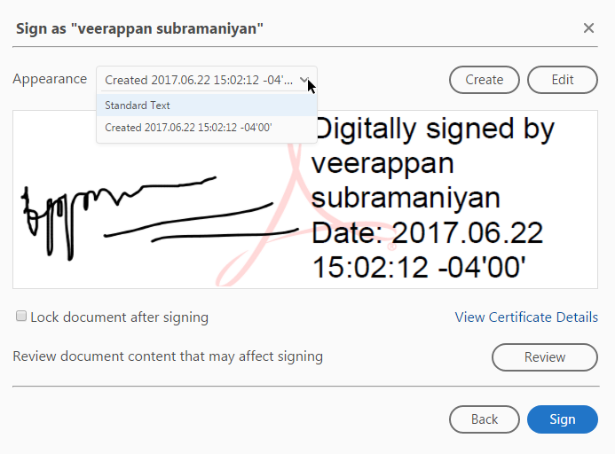

To clear all signatures and create new ones, please follow these steps:
- OPEN INTERNET EXPLORER

- SELECT “TOOLS” FROM THE MENU BAR

- SELECT “INTERNET OPTIONS”
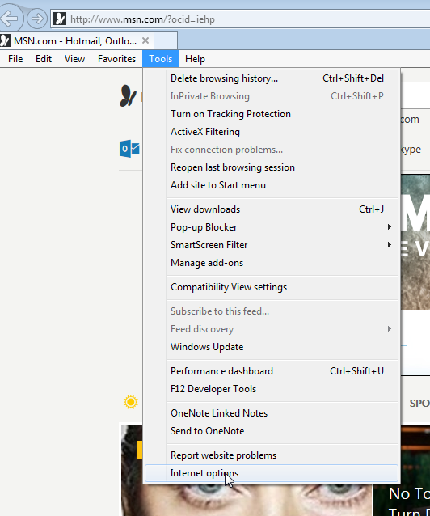

- IN THE POPUP WINDOW, CLICK “CERTIFICATES”

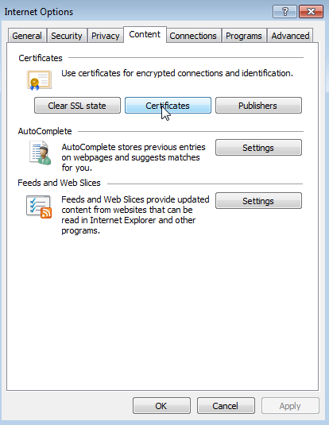

- SELECT THE SIGNATURE YOU WANT TO DELETE AND CLICK “REMOVE”
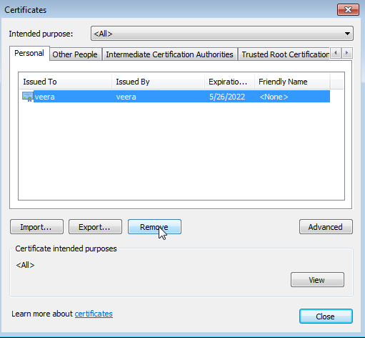

- IN THE POPUP BOX, CLICK “YES” TO DELETE THE SIGNATURE
