The Commonwealth of Massachusetts
Executive Office of Elder Affairs

One Ashburton Place, 5th Floor

Boston, Massachusetts 02108

CHARLES D. BAKER
Governor

KARYN E. POLITO
Lieutenant Governor

MARYLOU SuDDERS
Secretary, Executive Office of Health and Human Services
ELIZABETH C. CHEN, PhD, mba, mph
Secretary

Tel: (617) 727-7750
Fax: (617) 727-9368
TTY/TTD: 1-800-872-0166
www.mass.gov/elders

Memorandum

TO: Assisted Living Residence Executive Directors
FROM: Secretary Elizabeth Chen
SUBJECT: Integrated Guidance and Resources for Assisted Living Residences (ALRs) During the COVID-19 Pandemic
DATE: April 8, 2022

This updated guidance integrates and replaces all previously released COVID-19 guidance and is effective April 8, 2022. Specifically, it incorporates updated CDC and the MA DPH guidance as of March 18, 2022.

The timing, severity, and size of surges in COVID-19 cases are unpredictable. EOEA strongly recommends that you incorporate the practices described in this guidance to minimize risk of widespread infection at your ALR when community levels inevitably rise. Know Your COVID-19 Community Level.
This document includes guidance and recommendations on the following:
- Infection Control
- COVID-19 Vaccination
- COVID-19 Testing Requirements
- Separation of COVID-19 Positive Residents and Quarantine Policies
- Managing a COVID-19 Outbreak
- Group Dining and Activities
- COVID-19 Reporting Requirements
- Temporary ALR Policies: overview of current policies and relevant extensions
Note: This document contains a substantial number of hyperlinks, which are not accessible if read only in paper form.
- Infection Control

All ALRs must be prepared to care for COVID-19 positive residents. Residents infected with COVID-19 may vary in severity from lack of symptoms to mild or severe symptoms. Symptoms may be mild and not require admission to a hospital. All ALRs are strongly recommended to follow the infection prevention and control practices recommended by DPH.

- Ongoing Infection Prevention and Control Audits
EOEA strongly recommends that every ALR identify an individual, internally, or externally, to conduct formal COVID-19 infection prevention and control audits at least monthly. If an audit indicates that the ALR is deficient overall, or in any audit core competency, then the audit should be conducted weekly until the ALR is no longer deficient.^{1,}
Formal audits help identify system-level issues, but ongoing, real-time adherence is key. Interruptions, fatigue, time pressure, anger, distraction, anxiety, fear, or boredom can lead to lapses in adherence to protocol. A supportive culture encouraging real-time, peer, and community correction of non-adherence will be most effective.

ALRs should follow CDC guidance for cleaning and hygiene protocols.

- Screening for Symptoms and Exposure to COVID-19
Staff screening requirements:
ALRs should develop a process for screening all staff before their shift, all visitors before they enter the ALR, and all special care residents daily. Screening should include the following:
- The presence of fever, chills, cough, or other symptoms of COVID-19;
- A diagnosis of COVID-19 in the prior 5 days; and,
- Potential exposure to someone with COVID-19 in the prior 10 days.

Staff should not work if they are exhibiting symptoms of COVID-19 or have had a diagnosis of COVID-19 within the past 5 days. Staff should follow the DPH Isolation and Quarantine Guidance for Health Care Personnel following infection or exposure to COVID-19 before returning to work.

Resident screening requirements:

All residents should be encouraged to consult the Resident Care Director if they exhibit COVID-19 symptoms or feel concerned about being exposed to someone with COVID-19. It is recommended that ALRs distribute this CDC graphic to help residents identify symptoms.

Residents in Special Care Units should be screened daily by a staff member until the county that the ALR is located in has a low level of community transmission, as they may not be able to identify and communicate COVID-19 symptoms readily.

Visitor screening requirements:

Visitors should be offered a rapid antigen test and advised about the risks to the resident if the visit takes place while the visitor is:
  - experiencing symptoms associated with COVID-19,
  - was diagnosed with COVID-19 within the past 5 days, or
  - was exposed to someone with COVID-19 within the past 10 days;
  - Advised that the resident will be informed of a positive screening and offered an opportunity for remote, rather than an in-person visit; and,
  - Advised if there are active cases in the building.

Testing cannot be required as a condition for visitation and visitors cannot be barred from visiting a resident in their unit.

A resident receiving a visitor who responds in the affirmative to any of the screening questions should be advised of the visitor’s reported symptoms, diagnosis, or potential exposure, and be offered an opportunity for a virtual, rather than an in-person visit. The ALR should offer facemasks to be worn during the visit and provide a reminder to open windows and doors to facilitate fresh airflow.

IMPORTANT NOTE: Residents have the right to accept visitors without restriction. ALRs that limit visits without the consent of a resident or their legal representative, or without a local public health order, may be subject to sanctions. (651 CMR12.08(1))

- Masks and Personal Protective Equipment (PPE)
Masks:

ALR residents regardless of vaccination status, will not be required to wear a facemask
within their ALR units or common areas. If ALR residents choose to leave the premises
they should follow any applicable local municipal mask ordinances.

All ALR staff should continue to wear a facemask while they are in the facility and follow DPH’s recommendations for PPE when caring for residents with suspected or confirmed COVID-19.
All visitors, regardless of vaccination status, must always wear a facemask in common areas inside the ALR unless dining in the common area. Visitors may remove their facemask within the resident’s unit.

PPE:

ALRs should ensure all staff are using appropriate PPE when they are interacting with residents and in alignment with DPH and CDC guidance.

All staff must wear a mask correctly while inside the ALR. When caring for residents with COVID-19 staff must wear NIOSH N95 respirators, eye protection, gowns, and gloves in accordance with the DPH Comprehensive PPE Guidance. A list of NIOSH-approved N95 respirators can be found here.

For ALR staff, Eye protection is no longer required unless you are providing direct care to a positive (or suspected positive) resident. If a staff member on a unit tests positive, it is recommended that eye protection remains in place for staff until all residents and staff test clear of covid on that unit.

ALRs must have available and provide as appropriate, facemasks for residents, visitors, and staff.

COVID-19 Vaccinations

COVID-19 Vaccine Availability | Mass.gov shows updated vaccination locations and the COVID-19 In-Home Vaccination Program | Mass.gov can vaccinate individuals who have difficulty leaving their homes.
All staff are required by DPH Order 2022-01 to be fully vaccinated against COVID-19 and receive a booster in a timely manner. ALRs must maintain documentation of staff members’ COVID-19 vaccine status, including a list of individuals who have been granted medical or religious exemptions.
In accordance with DPH Order 2022-01, issued January 6, 2022, all eligible Assisted Living Resident personnel must have received a COVID-19 booster vaccination by February 28, 2022.
- Eligible personnel are those who completed their primary COVID-19 vaccination series at least five (5) months prior if they received Pfizer or Moderna or at least two (2) months prior for J&J/Janssen.
- Individuals who become eligible for a booster after February 28, 2022, are required to complete their booster no later than three weeks from the date of eligibility.
- Any individual who has been granted a reasonable accommodation by their employer based on medical contraindication or a sincerely held religious belief is exempt from the requirement to receive a booster.

All residents should be encouraged to be up to date with COVID-19 vaccination. Up to date means the resident has received all recommended doses in their primary series of COVID-19 vaccine, and a booster dose when eligible. ALRs should facilitate resident access to the administration of boosters in a timely manner.

COVID-19 Testing Requirements
Staff Surveillance: EOEA recommends that ALRs conduct weekly surveillance testing of staff in accordance with the DPH Long-term Care Surveillance guidance.
Outbreak Testing: ALRs should use rapid antigen tests to conduct outbreak testing on any exposed residents and staff as determined by contract tracing as soon as one staff or resident case is detected. A person is considered exposed to COVID-19 if they are within 6 ft. for a total of 15 minutes within 24 hrs. of someone diagnosed with COVID-19 while they were symptomatic. If needed, the ALR should seek guidance from a DPH epidemiologist, who can be reached 24/7, by calling 617-983-6800 and selecting Option 3.

Rapid Antigen Tests can be requested through DPH until June 30, 2022, following the conditions outlined in Appendix A. ALRs may also purchase directly from manufacturers or from distributors. To help meet immediate needs, there are distributors on existing Statewide Contracts that offer COVID-19 at-home rapid antigen test kits that ALRs may purchase from. Additional information can be found here. The FDA provides an updated list of authorized antigen tests that do not need a prescription or CLIA certificate of waiver and can be self-administered in a home setting. Positive results using rapid antigen tests do not need to be confirmed via PCR testing.

Separation of COVID-19 Positive Residents and Quarantine Policies

The CDC and DPH use the term “isolate” to describe procedures for individuals who have COVID-19 symptoms or have tested positive; and “quarantine” to describe procedures for individuals who have been exposed to someone with COVID-19 and have no symptoms.

The decision tree in Appendix B reflects EOEA recommendations regarding resident participation in group dining and activities based on CDC and DPH guidance. ALRs are encouraged to incorporate these practices for the overall health and wellness of all residents.

Note: ALRs are subject to landlord/tenant law. ALRs that subject residents to isolation or quarantine without the consent of a resident or their legal representative, or without a local public health order, may be subject to sanctions.

Managing a COVID-19 Infection Outbreak

If One Staff Member or Resident Tests Positive:
- Immediately test any residents and staff who may have been exposed using rapid antigen tests and establish separate, dedicated staffing teams to serve residents according to their COVID-19 status.
- If additional support or guidance is needed then call the DPH epidemiology line (617-983-6800, Option 3) which is staffed 24/7 to discuss the nature of your outbreak, your ALR’s physical and staffing configuration, and request advice on how to continue group dining and social engagement opportunities for residents.

EOEA is recommending and urging every ALR to:
- Ensure residents receive a COVID-19 vaccine booster as soon as they become eligible.
- Conduct frequent infection control audits and address gaps in infection prevention and control.
- Develop a staffing escalation plan for limited, moderate, and widespread infection at the ALR that ensures separate and dedicated staff for COVID-19 positive units and residents. This may include contracting with staffing agencies to ensure that resident needs can be met during periods of widespread infection and staff shortages.
- Develop strategic and targeted approaches for dining and activities during an outbreak to minimize disruption of routines for residents and risk of infection.
- Prepare accordingly for timely onsite administration or access to monoclonal antibody or antiviral therapies:
  - Ensure transportation options are in place to transfer residents to a monoclonal antibody or antiviral treatment center or for delivery of oral antiviral prescriptions, as appropriate.
  - Secure resident consent for on-site administration and other processes needed in case of a large outbreak.
  - Information about therapeutic options changes rapidly. EOEA recommends checking the following website weekly to stay informed.

Group Dining and Activities

EOEA recommends offering a rapid antigen test to visitors prior to dining and other congregate activities as a precautionary step, especially when Community Levels are Moderate or High.

COVID-19 Reporting Requirements
(651 CMR 12.06(9)(f)(2), 651 CMR 12.04(11)(d), and 651 CMR 12.04(13)(a)(3)

- Resident and Staff Cases and Deaths: ALRs are required to (1) submit incident reports for every new COVID-19 case and death for staff and residents within 24 hours using this link, and (2) submit information in accordance with Chapter 93 of the Acts of 2020 using this link.
- Vaccination Status of Residents and Staff upon request.
- Status of Infection Prevention and Control Audits upon request.
- Other Information upon request to inform policy development or to monitor infection, prevention, and control of COVID-19.

Temporary ALR Policies: overview of current policies and relevant extensions

Extension of Skilled Nursing Services

In accordance with Section 7 of Chapter 22 of the Acts of 2022 a nurse employed or contracted by an ALR may provide skilled nursing care subject to the following provisions:
  - Skilled care may only be provided to residents receiving such care under a plan of care in place as of July 15, 2022.
  - The prohibition on retaining residents who require skilled care for more than 90 consecutive days in accordance with M.G.L c.19D, s.11, resumes upon the expiration of the Order.
  - The skilled care to be provided may include, but is not necessarily limited to, the application or replacement of simple non-sterile dressings, the application of eye drops, the application of ointments, the management of oxygen on a regular and continuing basis, and injections.
  - The nurse providing skilled care must hold a valid license to provide such care.
  - Any skilled care to be provided must be authorized by a physician or relevant medical professional.
  - Skilled care may only be provided if the setting is medically appropriate for such care and the proper equipment, medication, and supplies are readily available.
  - The Resident must be evaluated by the nurse before any skilled care may be provided.
  - Prior to the provision of skilled care, the ALR must obtain the consent of the Resident, the Resident Representative, or Legal Representative.
  - Any charges that may result from the provision of skilled care must be disclosed and accepted by the Resident, the Resident Representative, or Legal Representative.
Administrative Requirements are as follows:
- An ALR providing skilled care must notify EOEA that it is to provide skilled care to Residents and submit reports on the skilled care provided as required by the Secretary of EOEA. ALR compliance with such reporting requirements is required as a condition for the provision of skilled care.
- Documentation concerning medical orders for skilled care, Resident consent, Resident evaluations, notice of charges, and the skilled care provided must be included in the Resident’s record.
- Information must be submitted daily by the nurse who provides the skilled services. EOEA will provide guidance on submitting data in April 2022. All ALRs must report whether they are providing skilled services and, if so, their standard operating procedures (link, see also 3/30/2022 email communication from Patricia Marchetti).

Extension of Removing minimum Staffing requirements
In accordance with Section 7 of Chapter 22 of the Acts of 2022, the requirement that no fewer than two staff members be on duty in a Special Care Unit (SCU), is suspended until July 15, 2022.
ALRs are required to always have sufficient staff to meet the scheduled and reasonably foreseeable unscheduled Resident needs. The ALR must track and document SCU staffing levels.

Extension of Removing Training requirements
In accordance with Section 7 of Chapter 22 of the Acts of 2022 the training requirements for ALR staff, as described in 651 CMR 12.07, are waived until July 15, 2022, subject to the following:
- All newly hired ALR employees must have adequate experience to fulfill the requirements of the position safely and professionally.
- All newly hired employees must receive sufficient on-the-job training to familiarize them with the operational and administrative standards of the ALR, and to enable them to safely carry out their assigned duties.
- ALRs must provide any critical training as necessary to protect the health, safety, and welfare of ALR Residents.

Appendix A

Requesting BinaxNOW Kits from DPH

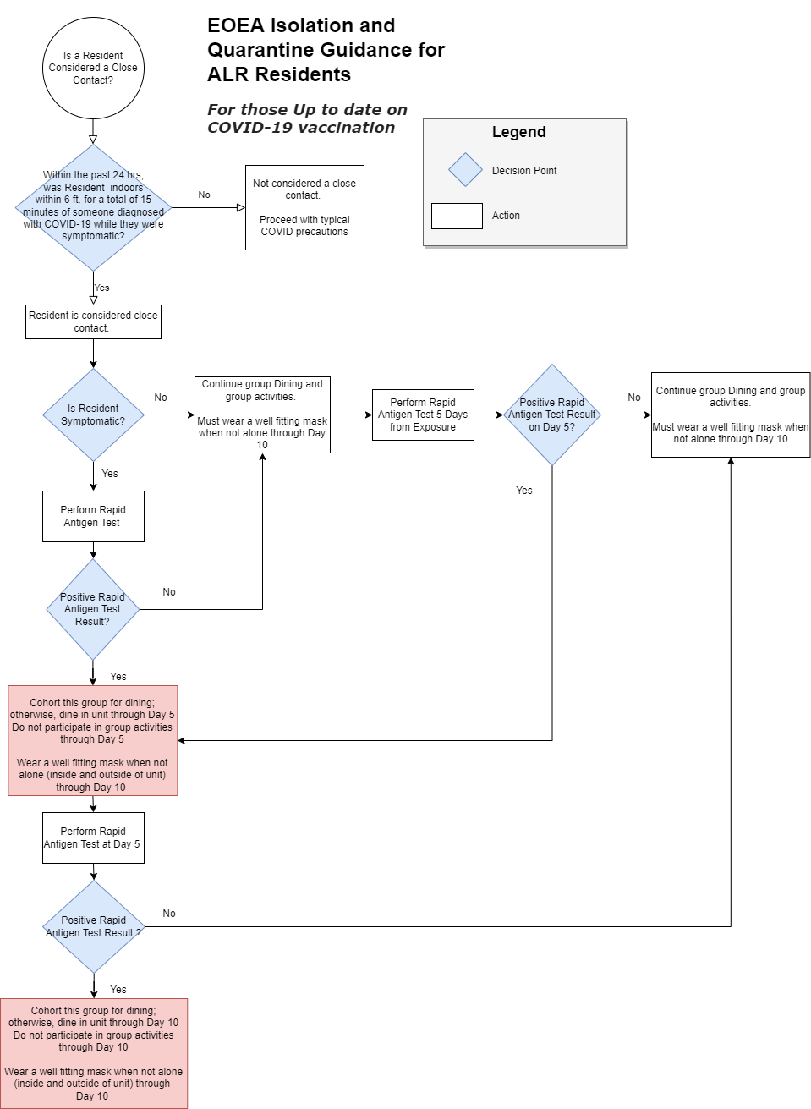
Within the past 48 hours, was resident indoors within 6 ft. for a total of 15 minutes of someone diagnosed with COVID-19 while they were symptomatic?

10
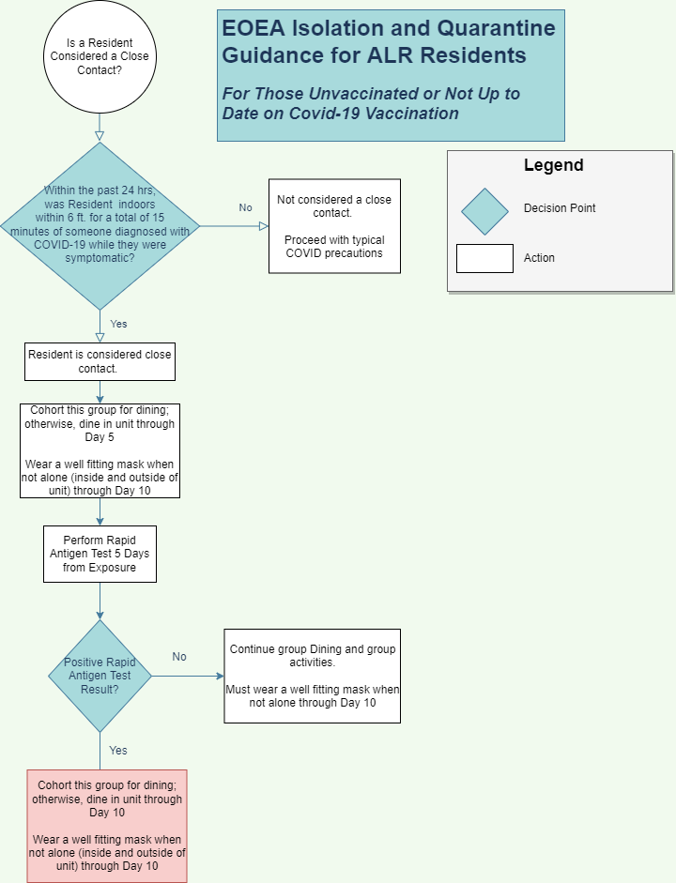
Within the past 48 hours, was resident indoors within 6 ft. for a total of 15 minutes of someone diagnosed with COVID-19 while they were symptomatic?

11

Appendix C

Quick Reference Guide to Resources

Assisted Living Regulations – October, 2020

https://www.mass.gov/doc/651-cmr-12-certification-procedures-and-standards-for-assisted-living-residences/download?_ga=2.254787086.749878762.1630080810-1438394668.1621624072

Access Dynamics Incident Reporting:

https://umassmedcwm05.crm.dynamics.com/main.aspx?appid=bf1d17b4-5934-48e7-ab00-069a887bf163&forceUCI=1&pagetype=entitylist&etn=alr_individualincidentreporting&viewid=62ab00cc-4591-e911-a82a-000d3a315bf6&viewType=1039

Questions on Incident reporting including user requests

ALRincidentreport@MassMail.State.MA.US

Reporting non-resident (staff) COVID cases

https://app.keysurvey.com/f/41535389/a1fc/ -

ALR Support Blog for Incident reporting

https://alrir.800ageinfo.com/

REDCAP Reporting – DPH Chapter 93

https://www.mass.gov/redcap/chapter-93

Redcap Email for questions to DPH

Chapter93.ElderFacilities@mass.gov.

Questions for all other non-IR related questions

ALRHelp@MassMail.State.MA.US

BinaxNOW

BINAX orders (must have a CLIA waiver before this step)

Attestation (required by DPH via EOEA (MV)

https://app.keysurvey.com/f/41597656/1411/

12

EXPIRED TEST KITS ?

All requests go through this email address. COVID19.Resource.Request@mass.gov

Obtaining a CLIA Waiver Questions:

clialab@mass.gov

DPH EPI -line 617-983-6800

COVID-19 Treatment Information

Information for providers about therapeutic treatments for COVID-19 | Mass.gov

13

Lipsitz, L. A., Lujan, A. M., Dufour, A., Abrahams, G., Magliozzi, H., Herndon, L., & Dar, M. (2020). Stemming the Tide of COVID‐19 Infections in Massachusetts Nursing Homes. Journal of the American Geriatrics Society, 68(11), 2447-2453.
Bharmal, Aamir, Carmen Ng, and Rohit Vijh. (2021). COVID-19 prevention assessments: A promising tool for preventing outbreaks in long-term care homes. Journal of the American Medical Directors Association, 2032-2033.
An Overview of To Err is Human: Re-emphasizing the Message of Patient Safety - Patient Safety and Quality - NCBI Bookshelf (nih.gov)
Houghton C, Meskell P, Delaney H, Smalle M, Glenton C, Booth A, Chan XHS, Devane D, Biesty LM. Barriers and facilitators to healthcare workers’ adherence with infection prevention and control (IPC) guidelines for respiratory infectious diseases: a rapid qualitative evidence synthesis. Cochrane Database of Systematic Reviews 2020, Issue 4. (link)
See CDC Symptoms of COVID-19 | CDC and associated graphic COVID FactSheet (cdc.gov)
See CDC Your Guide to Masks | CDC, “Do’s and Don’ts” and appropriate mask removal graphics, and recommendations to Improve How Your Mask Protects You | CDC (available in multiple languages)
https://www.cdc.gov/coronavirus/2019-ncov/vaccines/stay-up-to-date.html

