Integrated Treatment Team (ITT) Approach
Facilitator Guide

This module has:
- Handouts(3):
- Common Acronyms used in ACCS
- Examples of ITT Member Roles for Scenario Activity
- Activity: Scenario
- Video(1):
- Disability Etiquette
- Breakout Activity (1):
- Activity: Scenario

Slide 1 | Slide 1: Title Slide  Introduce Trainers  Establish any ground rules for discussion.  Explain:  This training series starts by covering Integrated Treatment Teams because the ‘team’ is the cornerstone of ACCS – we all work together as a team to assist persons served. Most decisions about how to best assist our persons served will be made in your Integrated Treatment Team (or ITT).
Slide 2 | Slide 2: Learning Objectives  Explain:  During this module you will:  - Explore the makeup and purpose of ITT at your site.  - Discuss challenges working on teams and ways to overcome those challenges.  - Consider ways you can support and be supported by an ITT.
Slide 3 | Slide 3: Acronyms  Refer to Handout: Common Acronyms used in ACCS.  Discuss
Slide 4  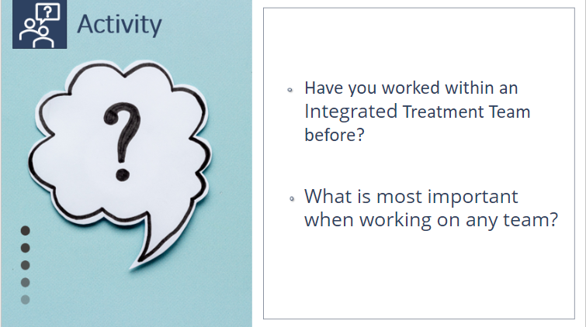 | Slide 4: Activity  Ask:  Have you worked within an Integrated Treatment Team before?  (Prompt a yes/no response and ask a little about their experiences).  What is most important when working on any team?
Slide 5 | Slide 5: What is an Integrated Treatment Team (ITT)?  Explain:  An Integrated Treatment Team (ITT) is a multi-disciplinary team of clinical, direct care and peer supporter staff working collaboratively with persons served and ITT members to provide all service components of ACCS.  - ACCS persons served are assigned to an integrated treatment team that is involved with their care.  - ACCS persons served remain with the same Team throughout their tenure in ACCS, including when the person’s housing setting changes (e.g., moves from a GLE to independent housing)
Slide 6 | Slide 6: What is an Integrated Treatment Team (ITT)? (continued)  - ACCS Teams (ITT) must have, at a minimum, at least 1 FTE licensed clinical staff member performing the LPHA responsibilities per 28 persons served.  - These Teams (ITT) are required to meet once per week, to facilitate ongoing communication and coordination of assessment, treatment planning and service delivery.
Slide 7 | Slide 7: The ITT includes: (Overview Slide)  Refer to Handout: Examples of ITT Member Roles for Scenario Activity  Facilitator Note:  Slide 7 is an overview – slides 8-13 highlight specific roles.  Explain:  - Provide details of the composition of your ITTs – including responsibilities and roles in treatment planning  - Add - We must also ensure that Teams (ITT) have access to psychiatry, vocational therapy, occupational therapy and psychology consultation time and interpreter services.
Slide 8 | Slide 8: Program Director
Slide 9 | Slide 9: Assistant Program Director
Slide 10 | Slide 10: Licensed Clinical Staff
Slide 11 | Slide 11: Direct Care Staff
Slide 12 | Slide 12: Housing Coordinator
Slide 13 | Slide 13: Peer Specialists & Recovery Coaches
Slide 14 | Slide 14: Core Principles of the ACCS Integrated Treatment Team  Explain:  ACCS Integrated Treatment Teams are guided by the following Core Principles:  1.Emphasis on Relationship Building.  The service approach is individualized and emphasizes the use of evidence-based strategies to engage, build a relationship with, and promote active involvement with the persons served to assist with his/her daily activities and treatment goals. Members practice active listening to understand person’s needs and preferences instead of listening to respond.  2.Clinical and Recovery Oriented Service Delivery.  Clinical services and a recovery-oriented approach are utilized by Integrated Treatment Teams in partnership with the person served to improve their health and wellness; achieve symptom stabilization and self-management; develop and/or restore skills impacted by their mental health conditions; live a self-directed life; and strive to reach their full potential.  3.Services are Flexible and Timely.  The frequency, duration and type of supports are readily adjusted in response to the changing needs, preferences, or life situations of persons served.  4.Team Approach.  ACCS is anchored by an Integrated Treatment Team model designed to ensure early and sustained persons served engagement and clinical accountability. This approach ensures the full complement of services are person-centered and available to all persons served. Members of the Team bring their individual expertise while working together-where each member’s contribution is heard and acknowledged-in response to persons’ preferences and to achieve optimal service delivery.  5.Services are Aligned and Integrated with Other Systems.  The service aligns with health care, including addiction treatment, employment, and housing services, and leverages existing resources to improve coordination and avoid duplication of services.  Ask:  How do these core principles align with your past experiences? Which do you think will be challenging? Discuss possible solutions with the group.
Slide 15

Slide 16 | Slide 16: Video  (4:39 minutes)  Show video clip from Disability Etiquette – Moses Mallard (NAMI) talking about the person as the expert in “me”, you don’t have to do it alone, use your allies.  Video: https://youtu.be/jVc-g16Uvdg
Slide 17 | Slide 17: Activity  Ask:  What resonated with you in this video?
Slide 18 | Slide 18: Why is it important to have ITT involved in our persons’ served care?  Read through each reason adding explanations:  Reason 1:  - 25-30% of the adult population with serious and persistent mental health conditions also present with a substance use disorder or other co-occurring conditions. Addiction and substance use disorder expertise are required on the ITT.  - Individuals with severe and persistent mental health conditions can also have co-occurring developmental or intellectual disabilities, some severe enough to require specialized treatment expertise beyond mental health and addiction expertise.  Explain:  - Interdisciplinary teams that bring both mental health and addiction expertise (or clinicians that are cross trained) are essential for effectively treating persons served with dual diagnosis.  - Integrated treatment teams that include peer supporters and recovery coaches have demonstrated effectiveness in helping people with behavioral health conditions to connect to, engage in, and be active participants in treatment and recovery support services across all levels of care.  Reason 2: Housing and Financial Specialists are key members of the integrated treatment team.  - Prevention of homelessness is a core treatment function of the integrated treatment team. Poverty, unemployment, and lack of affordable housing are commonly recognized causes of homelessness.  Explain:  These risk factors can be exacerbated in the behavioral health population, but can be recognized, addressed, and resolved by members of the Team (ITT)  - Research shows interventions to prevent homelessness are more cost effective than addressing issues after someone is already homeless.  Explain:  The longer a person is homeless, the harder and more expensive it becomes to re-house this person, which can negatively impact a person’s served overall well-being and impede recovery.  Reason 3: Employment and Education Services and resources are critical services for Person’s treatment and recovery.  Explain:  Unemployment worsens mental health and gaining employment can improve mental health, even for people with the most serious mental health conditions. Opportunities for employment and education can also increase community engagement and social support.
Slide 19 | Slide 19: Benefits of the Integrated Treatment Team approach for our persons served?  Explain:  - Persons served benefit from the richness of perspective from different individuals with different levels of expertise.  - Clinicians do not make all the decisions, it is a balanced team approach, which provides collaboration, consensus building, and person-centered care.  - Integrated treatment teams provide comprehensive services and specialized expertise that contribute to a person’s holistic health and overall well-being.  - Integrated Treatment Teams help to ensure that selected treatment interventions are supported by the person served and the team and implemented during every interaction with the persons served-at all levels of care.  - Persons served benefit from information shared by team members, referrals, and advocacy and are connected to services they often did not know were available to them or how to access.
Slide 20 | Slide 20: Benefits of the Integrated Treatment Team approach to ACCS staff?  Explain:  - Integrated treatment teams not only improve persons served outcomes but also contribute significantly to each team member’s occupational well-being.  - Serving on an integrated treatment team  - Increases staff’s self-reported confidence and produces lasting changes in clinician and staff confidence and practice (based on self-reported survey results).  - Offers opportunities for coaching and mentoring across different expertise and specialties.  - Provides a format for support and shared decision-making.  - Spreading assignments and tasks across a broader group reduces burn out, benefiting team members as well as improving persons served care.  - Contributes to job satisfaction and employee retention.
Slide 21  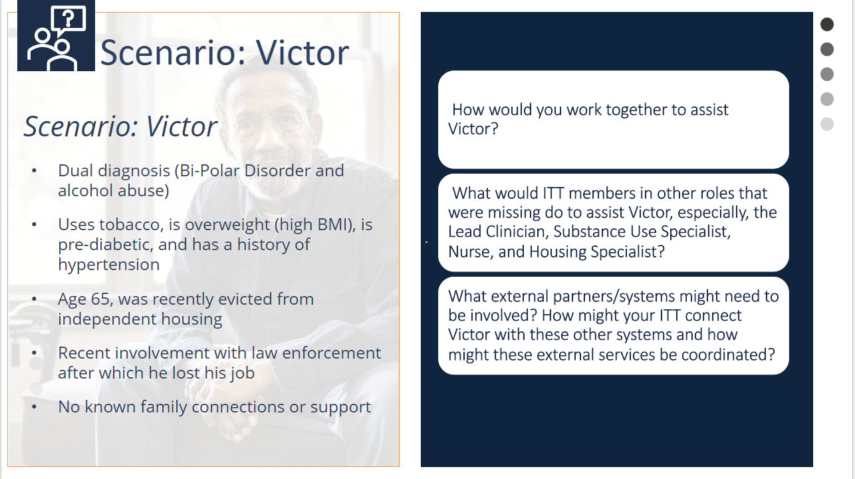 | Slide 21: Breakout Activity: Scenario  (10-minute breakout + discussion)  Refer to Handouts:  - Activity: Scenario  - Examples of Integrated Treatment Team Member Roles for Scenario Activity  Facilitator Instructions:  - Explain: This is an exercise to practice being part of an ITT. Determine how you might approach working with Victor?  - Read out loud the scenario on the slide.  - Separate into groups of 3 to 5 and ask each group to pick a recorder & reporter for the later discussion.  - Provide handout: Example of Integrated Treatment Team Member Roles for Scenario Activity.  - Instruct groups to:  - Play their role on the ITT. They might want to refer to Handout #2. How would you work together to assist Victor?  - For roles that are missing from your group, discuss as a group, what these individuals might do to assist Victor, especially the Lead Clinician, Substance Use Specialist, Nurse, and Housing Specialist?  For instance, the Substance Use Specialist or Recovery Coach would do this, the nurse would assist by.., etc.  - Victor also may need to be connected to other resources offered by external partners/systems. Discuss what those might be? How might your ITT connect Victor with these other systems and how might these external services be coordinated?  - Breakout for approximately 10 minutes to discuss these questions.  - Bring the group back for discussion and review. Ask how they handled the questions:  - How would you work together to assist Victor?  - What would ITT members in other roles that were missing do to assist Victor?  - What external partners/systems might need to be involved? How would the group coordinate these?  Facilitator Notes:  If necessary, while facilitating the group, mention these external partners might be needed:  - Massachusetts Rehabilitation Commission  - Primary Care Provider  - Day/Community Programs  - 12 Steps AA  Mention that coordination with external partners will be covered in the Integration with Systems of Care Module.  --------------------  Reference Ehrlich, C., Slattery, M., Vilic, G., Chester, P., & Crompton, D. (2019). What happens when peer support workers are introduced as members of community-based clinical mental health service delivery teams: a qualitative study. Journal of interprofessional care. 34(1):107-115. doi: 10.1080/13561820.2019.1612334.

