Intensive Care Coordination (ICC)
Survey of Family Satisfaction
REPORT OF THE FINDINGS
January 31, 2013

Prepared for the Executive Office of Health and Human Services
Children’s Behavioral Health Initiative
By the E. K. Shriver Center / University of Massachusetts Medical School

Intensive Care Coordination (ICC)
Survey of Family Satisfaction
REPORT OF THE FINDINGS
January 31, 2013
Executive Summary
In an effort to better understand how Intensive Care Coordination (ICC) is working for children, youth and families, the Executive Office of Health and Human Services (EOHHS) conducted a survey of parents and caregivers of children who have received ICC or “wrap-around” services. Four hundred families from across the state were randomly selected and invited to participate, with the online survey available from November 26, 2012 to December 15, 2012.
The survey was provided in both English and in Spanish, and consisted of 10 brief questions and opportunities to add comments. Over 38% of the families invited completed the survey, resulting in a relatively high response rate of 38.5%. One hundred and fifty-four (154) unique responses were collected: 152 in English and two in Spanish.
Participants indicated that the majority of children served were male. White/Caucasian was the most frequent race indicated (at 61%). Twenty-nine percent (29%) of respondents indicated the child had parents of Mexican, Hispanic, or Latino origin. All ethnic groups listed were represented, including Black/African American, Native Hawaiian/Other Pacific Islander, Asian, and “Other”.
The most common age for children at the time of service clustered between 11- and 13-years old (31% of the respondents). Almost half (44%) of all participants indicated that their children received services for 9 months or less. Children’s Services of Roxbury was the Community Service Agency most frequently indicated as the source of service delivery (at 23% of respondents), however CSAs from across the state were represented in the survey.
When considering services delivered, outcomes, and their support network, the majority of participants felt that the staff treated them with respect (88%) and spoke to them in a way they understood (88%). A small percentage of participants indicated they felt more services were needed to help their child (4%). Participants felt that their child got along better with family members (77%) and was better at handling daily life (73%). Others still saw improvement needed regarding their child’s ability to cope (15%). Ninety percent (90%) felt they had people in their lives, other than service providers, who would listen and understand, while 82% felt there were people with whom they could do enjoyable things.
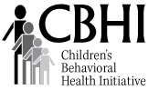
Brief History
Children's Behavioral Health Initiative
The Children's Behavioral Health Initiative (CBHI) is an interagency initiative of the Commonwealth's Executive Office of Health and Human Services whose mission is to strengthen, expand and integrate Massachusetts state services into a comprehensive, community-based system of care, to ensure that families and their children with significant behavioral, emotional and mental health needs obtain the services necessary for success in home, school and community.
CBHI was created by Dr. Judy Ann Bigby, Secretary of the Executive Office of Health and Human Services (EOHHS) to implement the remedy in Rosie D v Patrick, a class action lawsuit filed on behalf of MassHealth-enrolled children under age of 21 with serious emotional disturbance. Through CBHI, MassHealth requires primary care providers to offer standardized behavioral health screenings at well child visits, mental health clinicians to use a standardized behavioral health assessment tool (the “Child and Adolescent Needs and Strengths” or CANS), and provides new or enhanced home and community-based behavioral health services. CBHI also includes a larger interagency effort to develop an integrated system of state-funded behavioral health services for children, youth and their families.
CBHI places the family and child at the center of the service delivery system, and aims to build an integrated system of behavioral health services that meets the individual needs of the child and family. Policies, financing, management and delivery of publicly-funded behavioral health services will be integrated to make it easier for families to find and access appropriate services, and to ensure that families feel welcome, respected and receive services that meet their needs, as defined by the family.
Client Satisfaction
In order to further understand the families and children CBHI serves, the Shriver Center of the University of Massachusetts Medical School was contracted to collaborate with EOHHS to design a measure of family satisfaction, and construct, conduct, and summarize such a survey targeting families whose children received CBHI services.
Family or client “satisfaction” has multiple dimensions and may be concerned with both technical (practitioner skill) and interpersonal (practitioner style) aspects of care. In general, satisfaction measures are used to provide a documented understanding of the client’s perspective of the services (Fratalli, 1991). Generally there are three main reasons for the measurement of consumer satisfaction (Stallard, 1996):
- Satisfaction is a key objective
A fundamental requirement of any encounter with an agency is to feel satisfied after it. Minimal satisfaction is a prerequisite for treatment success since treatment cannot occur unless the client is satisfied with and attends treatment sessions (Lebow, 1982).
- An index of outcome
Consumer satisfaction is an important indicator of outcome and is useful way of assessing services, particularly where therapeutic change is harder to identify and quantify. Satisfaction has been found to be related to client ratings of general improvement and compliance with treatment (Stallard, 1994).
- Quality assurance and service improvement
One of the primary aims of consumer research is to make services more acceptable to users and to encourage better use of services. Consumer satisfaction surveys therefore provide a way of assessing and monitoring service quality over time and potentially provide a basis for making comparisons with other services (Webb, 1993).
Survey Methods
Survey Design
The current research regarding client and family satisfaction, as well as a number of models for behavioral health satisfaction surveys were reviewed [such as the Youth Services Survey For Families (YSS-F) used by the California Department of Mental Health and the Behavioral Health Patient Satisfaction Survey used by Group Health]. Key topical elements in satisfaction surveys include communication with service providers/practitioners, outcomes or changes in daily interactions, and life after the services have ended. In collaboration with representatives from EOHHS, the Shriver team designed a 10-question survey instrument that would gather both participant demographic information, as well as satisfaction ratings regarding the quality and breadth of services provided, outcomes for the child and the family, and the ongoing systems of support in place. Satisfaction ratings were indicated along a 5-point scale. Appendix B includes an English version and Appendix C, a Spanish version of the survey. Three questions were required for survey completion (child gender, length of services, age at the time of service) and the survey was only submitted to the database when the participant clicked “DONE” at the end of the survey.
The survey was constructed using Survey Monkey (www.surveymonkey.com) as a tool to both provide access to the survey as well as collect analyzable results. The survey was made available online, 24-7, without any technology requirements except an Internet connection.

Participant Sample Selection
The participant sample was gathered by CBHI, using the following methods:
- Initial identification began with all CANS records finalized in the system through 11/2/2012 as of 11/9/2012. This garnered approximately 243,000 records.
- Only those records of individuals in ICC were then selected. This resulted in approximately 38,500 records.
- Using the date 11/14/2012, records that met the following conditions were identified:
  - The last “CANS” date within 150 days
  - The previous CANS, by same provider, occurred between 30 and 110 days prior to last CANS
This resulted in a pool of 959 records. This selection procedure resulted in 17 instances of a repeated record (a record that appeared more than once). The repetitions were excluded, resulting in a pool of 942 unique individual records.
- The 942 individual records were then randomized, with the first 400 names drawn serving as the initial sample. The remaining names from the list of 942 were retained for potential use in step #6.
- Each Community Service Agency (CSA) was then provided with a list of records of individuals who were in the system as receiving services from their agency. This would comprise the list of individuals to be invited to participate in the survey.
- If a CSA indicated that an individual record name was unknown, or if the child had not received services since 8/1/2012, the record was removed from the sample. The CSA was then provided the next name from the remaining records of youth (from step #4) who had received services from that CSA.
- The CSAs were then instructed to distribute a letter explaining the survey and providing generic access information, as well as a participation incentive, to all potential participants on their list.
Appendix A contains a copy of the invitation letter in English. A version was also available in Spanish.

Participant Confidentiality
Great effort was made to ensure participant confidentiality, and thus the survey was constructed to not require a participant “log in” or the recording of any personally identifiable information. CSAs were aware of the participant pools for their agency, but were not provided with information about who did or did not complete a survey.

Participant Incentives
Research has shown that incentives to participate in surveys almost always reliably increase participant response rates. Incentives are often in the form of money, small gifts, raffle opportunities, future services, etc., and may be provided before, during, or after the start or completion of a survey. For example, Berk and others (1987) compared the effectiveness of providing $5 prepaid (before) to $5 promised (after) as incentives for completion of a health panel questionnaire and clearly found the use of prepaid monetary incentives increased response rates. In addition, it has been shown that people frequently interact on the principle of reciprocity, (Cialdini, 2001) generally trying to return favors or pay back when indebted.
In order to support participant confidentiality (by not requiring tracking of which individuals had completed a survey) and to potentially increase response rates, a prepaid (before) incentive was provided. A $10.00 gift card for Dunkin’ Donuts® accompanied each letter inviting participation in the survey. The gift card was available for client/family use without any requirement to complete the survey.

Response Rate
Participant response rate is most often characterized as the number of surveys completed, out of total surveys offered. The National Business Research Institute states the average response rate for most customer-satisfaction surveys is 10-15%. Quinntessential, a marketing consultant firm, reports that online client satisfaction surveys with incentives and follow-up reminders typically garner a response rate of between 10 and 20% of those solicited to participate. Satisfaction surveys in the health care area, especially when there has been prolong or sustained contact (and the likelihood of future contact), may garner response rates as high as 60-70%. If there is personal contact during the survey administration (i.e., face-to-face or in office surveys) high response rates are likely to occur, but there may be a trade-off in response quality (Kalantar & Talley, 1999). Other variables that have been shown to increase response rates include shorter survey length, ease of survey access, frequent reminders to complete the survey, a relatively near completion deadline, and personal desire or belief that the survey results will result in some meaningful change.
Four hundred (400) participants were solicited to participate in this brief online survey that was available for approximately 3 weeks. One hundred and fifty-four (154) responded, resulting in a relatively high response rate of 38.5%. Five of the 154 surveys were completed in paper format by a participant, given to the CSA, then provided to Shriver for inclusion in this report. Two of the surveys were completed in Spanish.

Data Review
Once the survey was closed (i.e., the survey URL displayed a page that said “The ICC Survey is now closed.”) all responses were downloaded for analysis of each individual response record, including the submission times and the tracked computer IP addresses. This was done to remove any potential duplicate records that would be created if a participant double-clicked the “DONE” (Submit Survey) button or hit the browser back arrow and re-clicked submit. Records that met the following criteria were flagged: (1) identical IP address; (2) submitted on the same day; (3) timestamp within 10 minutes of each other; (4) identical demographic information; and (5) identical rating responses and comments. If all of the criteria were met, any record after the “original” (earliest date/time stamp) was removed. If any single criterion was not met, the record was retained.
This filtering resulted in the removal of 27 identical duplicate records, based on 19 originals (some records had more than one duplicate). Five potentially duplicate records were retained, due to at least one difference across the 5 criteria (most often differing date and time stamps). These 5 potential duplicates are most apparent when reading the rating question comments, and are listed below:
Date/Time Stamp | Comment
11/29/12 17:55 | I enjoyed working with the program. I only experience one dislike and it wasn't the program it was the individual.
12/6/12 15:46 | I enjoyed working with the program. I only experience one dislike and it wasn't the program it was the individual.
11/28/12 15:43 | I have seen a significant progress
11/29/12 19:50 | I have seen a significant progress
11/28/12 15:43 | My support is the best in all area and they give me space when I need
11/29/12 19:50 | My support is the best in all area and they give me space when I need
12/3/12 21:54 | My support is the best in all areas an they give me space when i need it
12/3/12 20:44 | I would highly reccomend other families to the CSR-CSA.
12/3/12 22:49 | I would highly reccomend other families to the CSR-CSA.
12/4/12 0:56 | I wouldn't have been able to get through everything that was going on in my life without all the help from ICC. The services have been great and extremely helpful.
12/4/12 1:01 | I wouldn't have been able to get through everything that was going on in my life without all the help from ICC. The services have been great and extremely helpful.

Online survey instruments provide various methods to reduce response duplication while maintaining participant confidentiality, each with pros and cons. Surveys may be set up to place a (harmless) “cookie” on the users machine, which would allow one survey per computer. After a survey is completed the cookie would prevent the survey page from being loaded again on that computer. This method may not be ideal for ICC survey respondents, as some may need to access shared or public computers. Another method would providing a unique survey URL to each survey respondent which would allow only one survey completion for that URL. This would require providing a unique invitation letter to each survey respondent while still reassuring anonymity. Another method, reminding participants in the invitation letter and on the actual online survey to only respond once or only click the “DONE” button once, may help decrease but not prevent duplicate survey responses.

Future Considerations
EOHHS and CBHI plan to regularly use survey tools to gain ongoing information about client and family satisfaction with services provided and how to better improve their services over time. In future surveys, additional consideration should be given to reducing the potential for duplicate responses, further ensuring survey accessibility (both online and paper-based formats), and perhaps increasing the number of languages supported. Stronger outreach to non-English families could be encouraged. Future surveys could stratify the sample by CSA (randomly selecting members to survey from each CSA’s cohort) to increase the likelihood of respondent participation from all CSAs. A system to maintain client/family confidentiality while being able to track multiple surveys over time (year to year) would allow for an analysis of change within families or across services or service providers.

Itemized Survey Results
Following is a question-by-question analysis of the responses made by participants.

Part I: Demographics and Client Information

- What is your child’s gender?
Respondents indicated that the children receiving services were predominantly male, at almost 70% of the total. Females comprised 32.5% of children receiving services, with 1 response as “Other.”

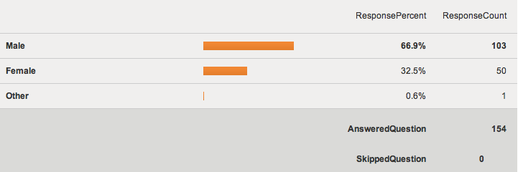

2. What year was your child born?
152 respondents (2 participants not responding) indicated that most of the children receiving services were born between the mid-1990’s and the mid 2000’s.
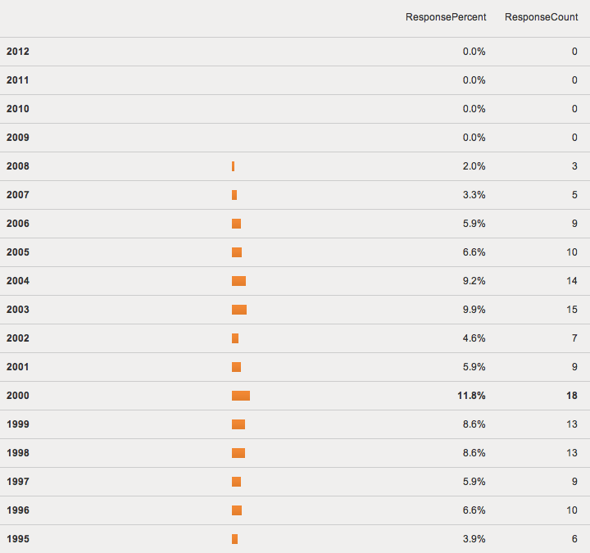
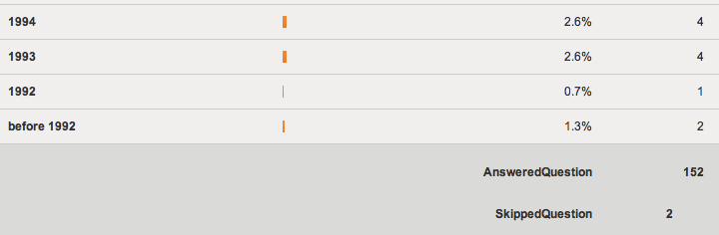

3. Are either of your child’s parents of Mexican/Hispanic/Latino origin?
153 participants responded, with 71% indicating that the child’s parents were not of Mexican, Hispanic, or Latino origin. One participant skipped the question.

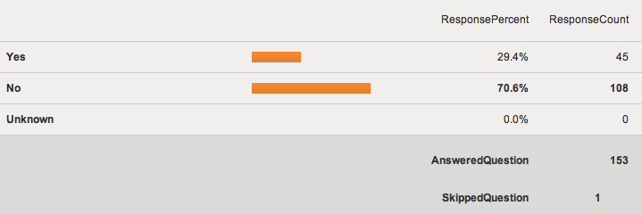

4. What is your child’s race?
Participants could make multiple selections (choose all that applied). Three participants skipped the question while the remaining participants indicated that children served were predominantly “White/Caucasian” (61%) followed by “Other” (28%) and then “Black/African American” (23%).

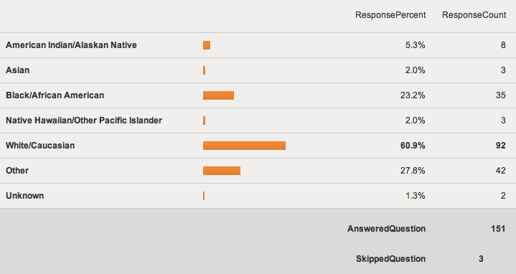

5. How long has your child been in ICC?
If the child started ICC more than once, respondents were instructed to base their response on the last time. All 154 participants responded, indicating that children most frequently received services for 6-9 months (26%). Almost half (44%) of all participants indicated that their children received services for 9 months or less.

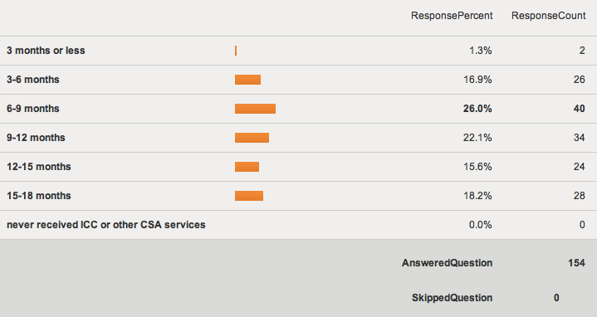

6. How old was your child when he or she received ICC services?
Participants could choose between 1- and 20-years of age. The age distribution for the 154 respondents is presented below, with the most frequent responses (31%) clustering between 11- and 13-years old. Another smaller cluster occurs at the 7- to 8-year-old range, with 18% of the children served falling into that age bracket.
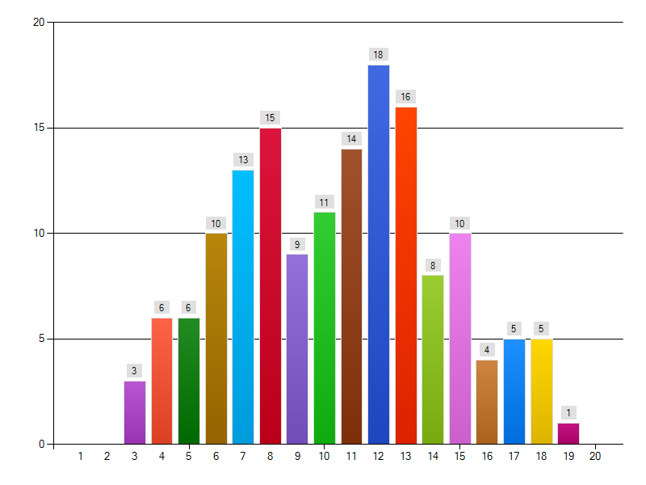

7. From which agency is your child receiving ICC services?
Ten participants did not respond to this question. The remaining 144 received services from across the state, with 33 respondents (23%) reporting receiving services from Children’s Services of Roxbury. Other agencies with higher response rates include Family Service Association - Fall River (9%), Northeast Behavioral Health – Haverhill (8%), Justice Resource Institute - Cape and Islands (7%), and Bay State Community Services – Plymouth (5%). Only four agencies did not garner any respondents: Behavioral Health Network (BHN) – Chicopee, Ware; Learning Center for the Deaf - Walden School – Framingham; MSPCC – Jamaica Plain; and North Suffolk Mental Health Association – Revere. It should be noted that the Participant Selection method, although randomized, resulted in a great variation in the numbers of potential participants from each agency. If the survey is repeated in the future, we recommend this methodological issue be addressed to ensure a good representation of all CSAs.

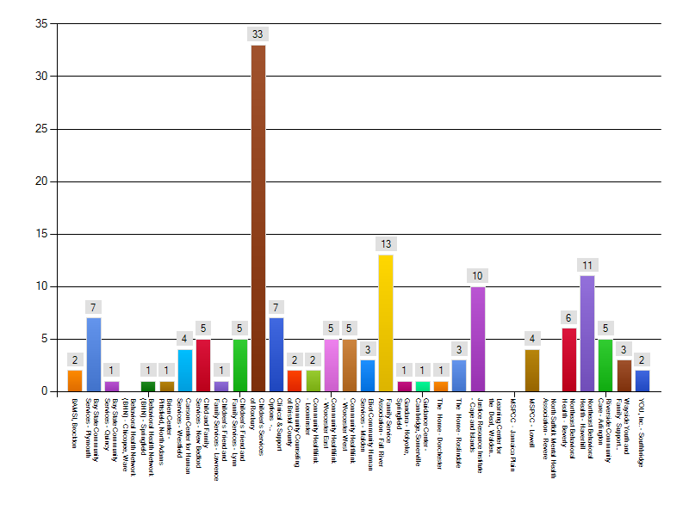

Part II: Participant Satisfaction with Services and Outcomes
Rating Scale Questions
For questions 8, 9, and 10 the participants were given statements about services and outcomes from ICC services, and instructed to choose one of the following to represent their reaction: Strongly Agree, Agree, Undecided, Disagree, Strongly Disagree. Participants were also encouraged to make additional remarks (positive or negative) in a comment box for each of these questions.

8. When thinking about ICC and the behavioral health services received:
Between 152 and 153 participants rated each of these statements, with the following distributions:

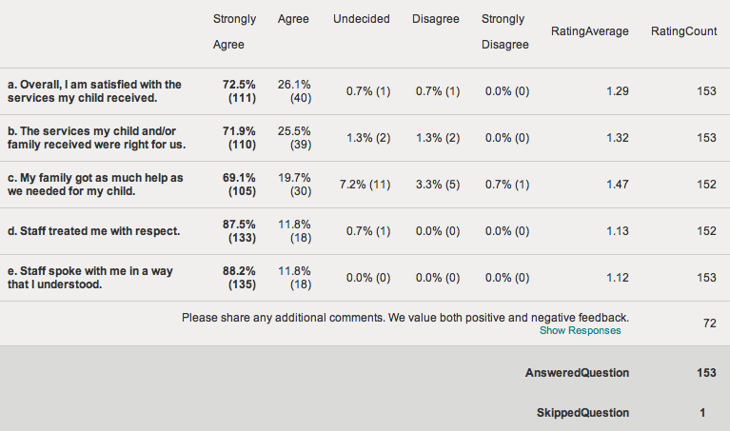

The following bar chart indicates that participants overwhelmingly “Strongly Agreed” with positive statements describing satisfaction with services. Participants felt that the staff treated them with respect (88%) and spoke to them in a way they understood (88%). A small percentage of participants indicated they felt more services were needed to help their child (4%).
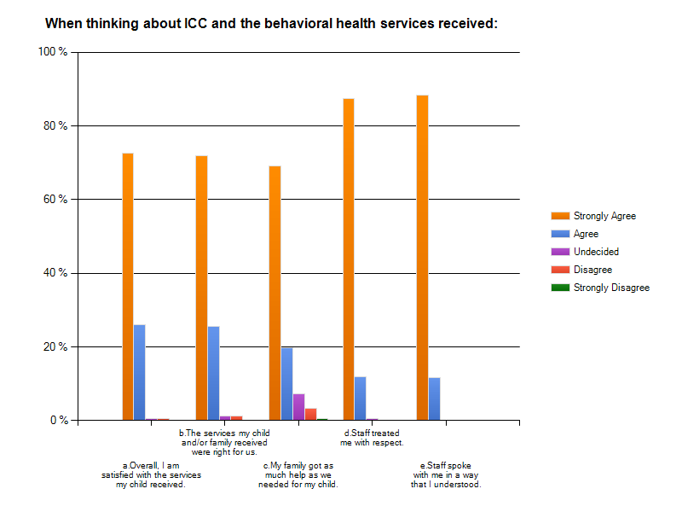

Participant Comments
Almost half of the participants (72) added additional comments about the ICC and the behavioral health services received. The list below contains all statements from survey participants who entered comments regarding Question 8. Except for the removal of any identifying information about the client, all comments are unedited.

Date | Comment
Nov 26, 2012 3:32 PM | had a great time working with everyone worked with a lot of different people there with boths my sons and learned a lot from all the people fantastic services i recived thanks a bunch
Nov 27, 2012 2:40 PM | Although the identified client is my young daughter, we are a family of single mother, young adult daughter, and young son as well. We have received invaluable support as individual family members and as a family unit for a wide variety of individual challenges. The staff has been wonderfully creative and greatly supportive in responding to the needs of my family individually and collectively. I cannot imagine my life as mother and woman without having had the range of expertise of each of my team members over the last year.
Nov 27, 2012 3:57 PM | N/a
Nov 27, 2012 9:20 PM | Lauren Russo and her manager Lauren Almedia are amazing , dedicated and most knowledgeable people I have met during this process with my daughter . They went above and beyond each time . They navigated us thru a tricky MH system and fought for services for our daughter . We ALWAYS felt supported and like we were in the best hands . These two women are true assests to your organization .
Nov 28, 2012 3:53 AM | Since icc has been involved with me and my family, they have help allot with things I didn't know before.
Nov 28, 2012 3:58 AM | There is no comment at this time cause everything is fine thinks to csor
Nov 28, 2012 1:47 PM | the staff has been very helpful for my family and I.
Nov 28, 2012 3:43 PM | My support is the best in all area and they give me space when I need
Nov 28, 2012 4:51 PM | Eliot is the best thanks for all your help
Nov 28, 2012 6:04 PM | Children's services of Roxbury have been awesome. They are the best!!
Nov 28, 2012 7:47 PM | the services i recived are well manner an well oriented an very well orangized an an the help i need for my daughter and or me or both at the same time its resolved or we find a way as we work together an always keepin me on the same page .mi workers im glad i them an very happy wit theservices completly satistfied !!!!!!!!!!!
Nov 29, 2012 2:52 PM | The program is the best for my familiy my kids change for good.
Nov 29, 2012 2:56 PM | Thanks for help my family.
Nov 29, 2012 3:02 PM | very attentive, support, advocate, great listener
Nov 29, 2012 4:18 PM | We have yet to find any services that will actually help my child function. ICC is a great idea, but we do not have many services to coordinate. My child cannot manage too many interventions at once and has not responded well to interventions.
Nov 29, 2012 5:55 PM | I enjoyed working with the program. I only experience one dislike and it wasn't the program it was the individual.
Nov 29, 2012 7:22 PM | They were very supportive at a time when I was going to return the child back to the system. The agency was very supportive but the child is very difficult.
Nov 29, 2012 7:50 PM | My support is the best in all area and they give me space when I need
Nov 29, 2012 8:52 PM | i feel very comfortable with my icc team they are on top of everything and i have had good services through them. very thankfull great experience.
Nov 30, 2012 12:26 AM | My ICC was/is wonderful. She is professional, competent and best of all compassionate. She has helped facilitate everything for both of my children.
Nov 30, 2012 1:38 PM | All the people who work with my family, are very professional and they been doing a good job and a great support to my children.
Nov 30, 2012 1:42 PM | The best services.
Nov 30, 2012 1:56 PM | Michella Agrella was awesome to work with! So were most of the people on our team.
Nov 30, 2012 3:27 PM | knowing that i have support for my kids is great and helping me with resources that i may not know about to better my kids education is great i feel icc services has been very helpful in mine and my children lives
Nov 30, 2012 7:37 PM | The child is in DCF care and I am a foster parent the bio parents are not yet involved in the care planning This is the second time I have been involved with an ICC this time is a far better experience.
Dec 1, 2012 12:09 AM | Within 2 days I had an appointment with an ICC after the initial phone call to get help for my son who was not attending school, severely depressed and not able to handle any simple demands placed on him or enjoy the things he used to. Within one day from the intake, our family partner came with me to an emergency meeting with the school' and let them know they were out of compliance and were not meeting FAPE. My ICC/FP has been with me every step of the way through battles with the school to get an out of district placement, a 2 week hospitilization at Franciscan hospital and helped me interview schools when we were finally granted permission from the school district. They were there for every major meeting with DR.s, therapists, and schools. We are so THANKFUL for all their help and support. We truly could not have navigated my son's mental health crisis without their guidance. they have helped put us in touch with the people who could help my son through this difficult time and continue to help us manage his care.
Dec 1, 2012 12:56 AM | I appreciate all the help that BAMSI gave me.
Dec 1, 2012 6:08 AM | My son's In home therapists are amazing! He looks forward to seeing them and seeing his face light up when he walks through the door and they are here.
Dec 2, 2012 10:39 PM | My Team has always been able to find the proper resources for me.
Dec 3, 2012 3:29 PM | Working with JRI and their suggestions has saved my child's life.
Dec 3, 2012 8:44 PM | I would highly reccomend other families to the CSR-CSA.
Dec 3, 2012 9:54 PM | My support is the best in all areas an they give me space when i need it
Dec 3, 2012 10:49 PM | I would highly reccomend other families to the CSR-CSA.
Dec 4, 2012 5:31 AM | I would reccomend anyone in need of services to the Children's Services of Roxbury CSA.
Dec 5, 2012 1:04 AM | The staff have been extremly helpful to our entire family.
Dec 5, 2012 4:17 AM | Couldn't ask for a better team for support. Thank you Icc Candice Watch and family partner.
Dec 5, 2012 5:51 PM | Love the way that the had help the Fam n still helping
Dec 6, 2012 3:46 PM | I enjoyed working with the program. I only experience one dislike and it wasn't the program it was the individual.
Dec 6, 2012 10:04 PM | The team was very helpful to us and they didn't leave us hanging when the case was closed. they made sure we had help outside the agency.
Dec 7, 2012 12:43 AM | I wish I had called for help from this agency right after a lost my husband and had to deal with managing my child's issue by myself. it my not have gotten as bad as it is, the team is great and I am getting alot of help to handle dealing with my child.s issues nwith out stressing so much and blaming myself.
Dec 7, 2012 3:50 PM | I dont know what Id do without ICC.
Dec 7, 2012 8:11 PM | ICC and FP are very professional, they go above and beyound duties.
Dec 8, 2012 6:38 PM | Both partners that have been working with my family and myself have been great. They stay on top of the game and they know exactly who to get things done. they are very involved with my family. I love them Sharlene and Danielle.
Dec 9, 2012 10:47 PM | Colleen Josefek left and Joanna Rosenberg stepped in and was amazing. We also had Deb Grazulis as a family partner and she was the best!!!
Dec 10, 2012 3:48 AM | i feel that there needs to b more services that the family needs : such as , help with rent , bills and also educational advocates these r things families in crisis desperatly need help with and this company couldnt help with any of those things
Dec 10, 2012 4:18 PM | I love you guys!
Dec 10, 2012 5:57 PM | Tremendous service that works closely with home and school.
Dec 10, 2012 11:59 PM | Parent had a good time working with ICC and Family partner
Dec 11, 2012 5:25 PM | I reccomend CSA to anyone I know
Dec 11, 2012 10:25 PM | The team was very supportive.
Dec 12, 2012 2:05 PM | They worked aroundn my schedule and really made me equipped to deal with situations on my own. It was a long but learning process.
Dec 12, 2012 2:56 PM | One staff member who works with my child is not always available for appointments set by the team.
Dec 12, 2012 2:58 PM | For the first time in our search for assistance, JRI treated us with the upmost respect and consideraton that we deserve. They have helped ease our situation.
Dec 12, 2012 4:51 PM | My brother was involved, then I became the enrolled youth. I didn't have much hope because I had to go through many different ICC's but then I finally got a male ICC that was able to respect me and push me to find a team and now I am passing school and have a job.
Dec 12, 2012 5:12 PM | They are a great help and worked very well with the situation.
Dec 13, 2012 12:15 AM | i think they should have funding because alot of people need it and we need the services some people cannot aford the coast of things are in posible for most familys we need the funding
Dec 13, 2012 12:21 AM | Staff is very attentive to understanding and valuing our family's concerns and needs.
Dec 13, 2012 3:54 PM | ICC Jen and FP April have been very helpful and I'm happy with their work for my family.
Dec 13, 2012 6:27 PM | The staff who are part of my child's ICC services are just such a perfect match for our family. They have made a HUGE impact on our lives and have been a great support. I don't know what we would do without our team!
Dec 13, 2012 6:40 PM | very careing and supportive
Dec 13, 2012 6:47 PM | The services my family and my child recieve have been such a blessing. I know without these services my child would not be able to live in our home. I was at my witts end before we recieved services and did not think we would be able to go on. Now my child is doing so much better. I have learned so much on how to be a good advicate for my daughter and our family. I can never thank you enough or tell you just how important these services are to a family like ours.
Dec 13, 2012 9:44 PM | They llisten to me and my family
Dec 14, 2012 12:20 AM | Melissa is our ICC coordinator and has been great. She is always there to help out and be supportive. Our Family partner Phyllis is also helpful in our planning treatment. The team works very well together.
Dec 14, 2012 12:24 AM | This is a wonderful service and I am so glad that there is help for families that can receive it.
Dec 14, 2012 2:41 PM | Merry Christmas!
Dec 14, 2012 5:03 PM | I have had a great expiriance with icc.They have treated my family with respect and all my questions were answer. I have recieved the help i needed for my child and i appriciate everything they have done for us.
Dec 14, 2012 7:57 PM | Very understanding and none judgemental.
Dec 15, 2012 10:11 PM | Our son is still in our home because of this service.
Dec 16, 2012 5:03 AM | I hope to continue getting services..
Jan 29, 2013 2:45 PM (from a paper survey) | Lisa & Mary has got my Granddaughter & myself through such very hard times.

9. As a result of the behavioral health services received:
Between 149 and 152 participants rated each of these statements, with the following distributions:

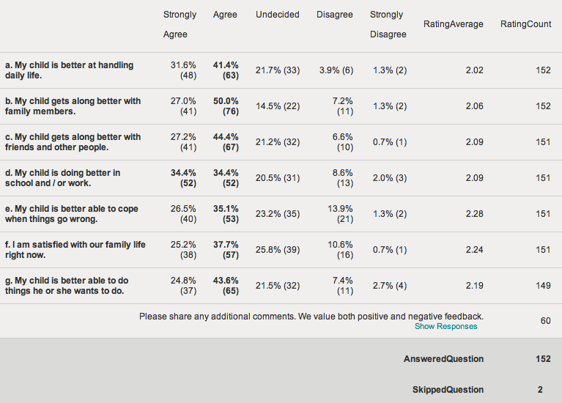

The following bar chart indicates that most participants either “Strongly Agreed” or “Agreed” with positive statements describing satisfaction with services. Participants felt that their child got along better with family members (77%) and friends, and other people (72%), and was better at handling daily life (73%). Others still saw improvement needed based on ratings of “Disagree” or “Strongly Disagree” for positive statements regarding their child’s ability to cope (15%), doing better at school and work (11%), and satisfaction with family life (11%).
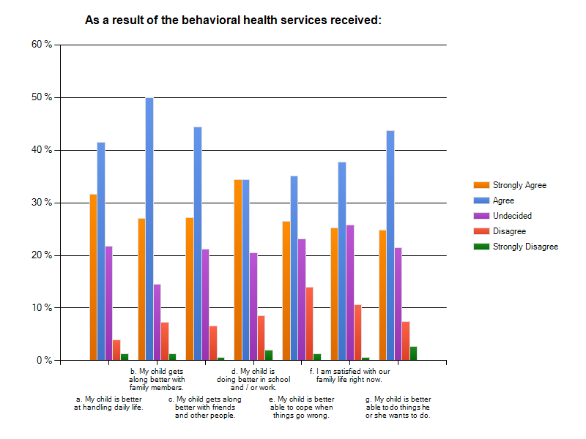

Participant Comments
Sixty participants added additional comments about the results of behavioral health services received. The list below contains all statements from survey participants who entered comments regarding Question 9. Except for the removal of any identifying information about the client, all comments are unedited.

Date | Comment
Nov 27, 2012 2:40 PM | The reasons I am not able to "strongly agree" have more to do with the significant medical and social history of my child and certainly does not reflect any level of dissatisfaction with services provided.
Nov 27, 2012 3:57 PM | N/a
Nov 27, 2012 9:20 PM | my daughter is in residential now and this is no reflection upon the ICC services . That is why my answers are alittle skewed in terms of my daughters emotional well being . She is very sick at this time but the ICC did help us so much .
Nov 28, 2012 3:53 AM | There is nothing much to say, the experience that have been brought to my life have been wonderful.
Nov 28, 2012 3:58 AM | We have been treated womderfully
Nov 28, 2012 1:47 PM | it has been a positive experience being with the staff.
Nov 28, 2012 3:43 PM | I have seen a significant progress
Nov 28, 2012 4:51 PM | my boys are autistic and can now get along sometimes better than before
Nov 28, 2012 6:04 PM | The team is still in place and is in wraparound process
Nov 28, 2012 6:08 PM | The services are still in place and we are working on my son and his behavior.
Nov 28, 2012 7:47 PM | my daughter is progressin but its all the hard work that me an my icc workers are workin on weekly an wt i do ever day i stay in touch wit them an they help me through very helpful !!!!!!!!
Nov 29, 2012 12:40 PM | My son is away at a residential treatment facility, getting more help.
Nov 29, 2012 2:52 PM | My daugther have a best grade she is A and B she can handling much better.
Nov 29, 2012 2:56 PM | Him do better in school
Nov 29, 2012 4:18 PM | I don't believe ICC can help with the questions in # 9. Perhaps the behavioral health services should be able to, but my child is still entirely self-isolating and does no activities of daily living. He is going to school at an assessment program, which is slow progress, but that was due to mediation with our district.
Nov 29, 2012 7:22 PM | You can lead a horse to water, but u can't make them drink
Nov 29, 2012 7:50 PM | I have seen a significant progress
Nov 30, 2012 1:38 PM | I'm very satisfied.
Nov 30, 2012 1:42 PM | Beyond good.
Nov 30, 2012 1:56 PM | My son has gotten slightly better control of himself and his actions, but we still haven't been able to get him the right "fit" for a therapist that can get through to him. Still searching!
Nov 30, 2012 3:27 PM | trying to get my son behavior and education on task and working with the icc to get him on the right track
Nov 30, 2012 6:27 PM | We are currently requesting testing for learning disabilities, etc. I am very happy with the services we have received to date and the way in which they were given - - it is still unclear how much my child has benefited or if other factors (such as learning disabilities) have interfered.
Nov 30, 2012 7:37 PM | client has been with me three months just took his
Dec 1, 2012 12:09 AM | My son is stable, and thriving and doing things that he enjoys again. He has much support from a Therapeutic Mentor, personal counselor, in home therapist and clinicians at his school who check in with him on a regular basis to hold him accountable, to attending school, getting along with his brothers and using coping skills to manage his feelings.
Dec 3, 2012 7:49 PM | I did not have any problems with getting along with myfamily members. My mental health needs have been addressed by the ICC people but other agencys didnt want to deal with my needs after the ICC people tried to get them involved.
Dec 3, 2012 9:54 PM | I have seen significant progress
Dec 4, 2012 12:56 AM | I wouldn't have been able to get through everything that was going on in my life without all the help from ICC. The services have been great and extremely helpful.
Dec 4, 2012 1:01 AM | I wouldn't have been able to get through everything that was going on in my life without all the help from ICC. The services have been great and extremely helpful.
Dec 5, 2012 4:17 AM | My son currently has services that are helping in but he also is lacking in other areas because he currently waiting to be transferred because school can't provide him with proper services if staff to assist him. I'm hoping he gets into a therapeutic school which would provide him with one on one devices that he truly needs. I work with a great team and services have helped family a lot but we are still trying to find diagnosis or if meds are properly helping him. I'm hoping he gets better when all is in place with his school.
Dec 5, 2012 5:51 PM | He is doing better from before
Dec 6, 2012 12:44 AM | We still have more work to do as a family to get to a place where we are all comfortable with eachother.
Dec 6, 2012 10:04 PM | we are still a work in progress and have been connected with services.
Dec 7, 2012 12:43 AM | services are still working on coning up with stratagies to help my daughter and family to be successful in moving foward to manage her anxity and be mindful in how she is feeling and dealing approperatly with her feelings. It would be unfair to answer on these questions because we are still working on them. I'm very pleased with how the team is working on them.
Dec 7, 2012 1:56 PM | my son might be expelled from school, however it does not have to do with the services we have recieved. It is nice to have them here to advocate for him, and our family.
Dec 7, 2012 3:08 PM | The services are good for us as parents but not so good for our child because they haven't started the plan as of yet
Dec 7, 2012 8:11 PM | Behavioral services did not help, child continues to defy his parent and continues to be aggressive with siblings due to in consistency of service providers.
Dec 8, 2012 6:38 PM | JRI have been a great help but my son still has a bit of trouble staying in school.
Dec 9, 2012 10:47 PM | I don't think the health services were poor in any way but our child's ability to deal with life's ins and outs are not necessarily something that can be "fixed" with services.
Dec 10, 2012 4:18 PM | Its all good
Dec 10, 2012 5:57 PM | We are still receiving services so have not completed programs etc. Otherwise I would have rated things higher. Thus far we are progressing and very happy with changes we are seeing.
Dec 11, 2012 5:24 PM | My choosing disagree has nothing to do with the people providing the service. They are tryin geverything they can but this is a difficult situation that is going to take lots of time.
Dec 11, 2012 8:48 PM | There are alote of disagrees but there are being worked on right know
Dec 11, 2012 10:25 PM | Although my son still has difficulties, the team was very helpful in the school process I needed help with. He also obtained employment.
Dec 12, 2012 2:58 PM | Still early in our process of instituting therapeutic tools, my son still has a lot more work to do. This will not be a quick fix. But with JRI help we will be successful.
Dec 12, 2012 7:33 PM | Child has severe trauma history and fully decompensated and DCF closed her bed, she was placed on CBAT, but then had to be moved to a higher level of care facility.
Dec 12, 2012 9:08 PM | During the first 6 months of services my child's behavior got worse. She was placed in a group home for 3 months. Since returning home (6 months) her behaviors have slightly improved. It is the goal of the team to keep making forward progress, even if it is extremely slow.
Dec 13, 2012 12:15 AM | my son still haves a hard time to deal withthings that go wrong and my family is not the best it needs alot more work
Dec 13, 2012 12:21 AM | Staff is working hard to remedy our difficult family situation.
Dec 13, 2012 3:54 PM | [My child] is doing so much better in school and at home, because of the help we have had from CSA and in home therapy
Dec 13, 2012 6:47 PM | My child is doing better then she ever was before but has a long way to go. The only services i feel that did not work for our family was the emergancy crisis team that needs so much improvement to be of any help to families. I could go on forever about the nightmare that is emergancy services,, but,, families should not have to sit in emergancy rooms for ten to twelve hours before anyone comes to see their child or any help is given. This part of the program is a huge failure and needs to be changed big time. The mentors are one of the greatest parts of services,, that and family partners, care coordinators they are wonderful, putting team together for the family and having that gives the family the power and strength it needs to go on.
Dec 13, 2012 10:52 PM | Progress is slow with him (not because of ICC), but overall I am very satisfied with the program
Dec 14, 2012 12:20 AM | The service has been very helpful to our family. My son also has found it to be very helpful and likes when he has a team to support him with his treatment plan. I know that this service has made a huge difference in our family. The support from the team has been fantastic.
Dec 14, 2012 2:50 AM | My child is currently in CBAT Care and we are still looking to find proper placement for him. He is happy and comfortable where he is for the most part and we are satisfied to have him be as he is for now.
Dec 14, 2012 5:18 AM | It is a work in progress and don't think we will reach a plateau until he is old enough to understand and process his trauma. May be years.
Dec 14, 2012 2:41 PM | no comments
Dec 15, 2012 7:11 PM | A lot of this is due to finally getting her on the right meds. This has been a long process and it wasnt until her placement in Boston and then a transfer to Burncoat in Worcestor that we were finally able to get her meds correct..we have a ways to go with her but the quality of life is much better now.
Dec 16, 2012 5:03 AM | Its a work in process..
Jan 29, 2013 2:45 PM (from a paper survey) | We still have a long way to go.
Jan 29, 2013 2:47 PM (from a paper survey) | It's my son's fault, not the staff.

10. As a result of the behavioral health services received:
Between 152 and 153 participants rated each of these statements, with the following distributions:

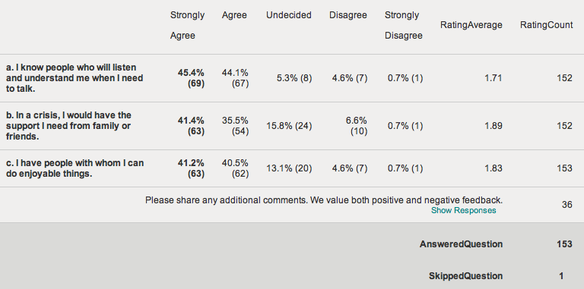

The following bar chart indicates that participants “Strongly Agreed” or “Agreed” with positive statements regarding their support network. Ninety percent (90%) felt they had people who would listen and understand, while 82% felt there were people with whom they could do enjoyable things. Seventy-seven percent (77%) felt they would have support from family or friends in a crisis. Five to seven percent (5-7%) did not agree that a support network was available to them.
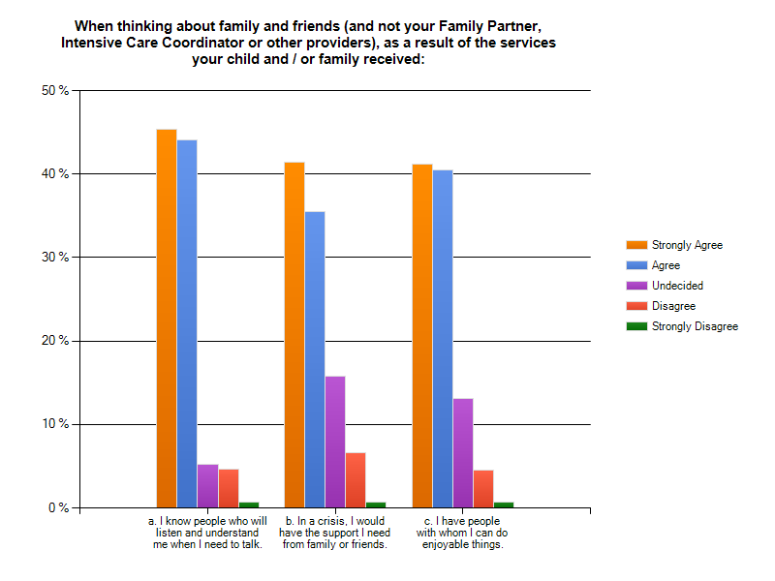
Participant Comments
Thirty-six participants added additional comments about the results of behavioral health services received. The list below contains all statements from survey participants who entered comments regarding Question 10. Except for the removal of any identifying information about the client, all comments are unedited.

Date | Comment
Nov 26, 2012 3:32 PM | in a crisis i would be set no the whole crisis team a good thing
Nov 27, 2012 2:40 PM | I have learned the concept of "natural supports" through my team, how to access and how to use beneficially for my family.
Nov 27, 2012 3:57 PM | N/a
Nov 27, 2012 9:20 PM | our family was falling apart until Lauren Russo walked thru my door - thanks to her we are on a path to healing . I will never be able to thank Lauren for all that she has done . I have no problems with you sharing this information with her or her management . They should know what a true asset they have . Thanks
Nov 28, 2012 3:53 AM | No comment icc have done a wonderful job.
Nov 28, 2012 3:58 AM | Its a wonderful experience
Nov 28, 2012 1:47 PM | there are some people in the family I can talk to in times of needs.
Nov 28, 2012 7:47 PM | services are very an strongly in tack an with workin wit them instead of against them an workin the iep is wounderful an love wen we keep touch everyday an for the most weekly so we get more done than just rush to it they take their time an its very enjoyable an a phonominall pleasure to work wit kevein an stacy !!!!!!!!! they get stuff done an are very on top of things thank you for pickin me for thwe survy an nhope mi response is helpfull .!!!!!!!!
Nov 29, 2012 12:40 PM | I have support in a crisis from family & friends, if they're available. They all work, & have families, too. So My support is on a if they're available basis.
Nov 29, 2012 2:52 PM | Thanks for help my family i hope can help someone all to
Nov 29, 2012 2:56 PM | Thanks for everything.
Nov 29, 2012 3:02 PM | great worker
Nov 29, 2012 4:18 PM | I am frustrated that I have to be a care giver for a mentally ill person. I am better skilled at being out in the workplace, but I do what I have to do right now.
Nov 30, 2012 1:38 PM | They always next to my family.
Nov 30, 2012 1:42 PM | best satisfaction.
Nov 30, 2012 3:27 PM | not having too much family support its great for me to have someone to talk too about my kids behavior and education there are there to listen
Nov 30, 2012 6:27 PM | I think of my "team" as my lifesavers and feel strongly that they have helped me and my child begin to recover from a very traumatic time in our lives.
Nov 30, 2012 7:37 PM | because this is foster care friends and family usually respond to me with why do you do it just send them back support groups are helpful and where I turn when I need to
Dec 1, 2012 12:09 AM | Really did not understand this question. Initially family did not believe our son had mental health problems severe enough to cause so much stress and blamed us as parents for not controlling him or managing him better. We could not look to family and friends for support and information. It was another person that I had met years ago through NAMI support groups who told me about the Wrap around services and how they could help. So as a result, I guess, family are coming to understand the severity of my son's condition by noticing how much better he is now doing . I don't know if they would be there for us through another crisis with him if it ever happens again. He still has daily struggles but the supports put in place by ICC/Wraparound have been a lifeline for us as a family and for my son.
Dec 5, 2012 5:43 PM | Thank you an God Bless.......Have aa Merry Christmas O:-)
Dec 7, 2012 12:43 AM | I don't know what I would have done if I didn't find the services of the i.c.c. team. I feel alot more confadent in handling my child's issue with them behind me with their support.
Dec 7, 2012 1:56 PM | I have only a few friends, and one of them will be moving in the spring. She is the only one that I do fun things with. This of course is not because of the services I recieved, it is how it was when the came in.
Dec 7, 2012 3:08 PM | We don't have time to go and do things
Dec 7, 2012 8:11 PM | Family members is not as supportive as expected.
Dec 10, 2012 4:18 PM | I a m getting the hope that I need formyself with or without family
Dec 12, 2012 2:58 PM | My quality of life is improving because I am feeling stronger and more confident about myself. We feel safer!
Dec 12, 2012 8:25 PM | THE STAFF WENT ABOVE ANY BEYOND OUR EXPECTATIONS.
Dec 12, 2012 8:38 PM | staff went above and beyond our expectations.
Dec 12, 2012 9:08 PM | My child is diagnosed with several disorders, one of which is RAD. (Reactive Attachment Disorder) When we first started with ICC, I don't feel anyone on our team had an understanding of what RAD is or what the behaviors are. We feel we spent a lot of time in the beginning trying to make our team accept the disorder and not judge us as parents. It was difficult to feel compassion when the symptoms of RAD were questioned by ICC staff. Once the behaviors became more obvious, we didn't feel like we were judged as harshly. I don't expect every diagnosis to be studied by the ICC team members, but there is clearly nothing taught about RAD in any training. Parents of RAD children often feel alone and misunderstood in society, it wasn't expected when we had asked for professionals to step in and help our situation. There was an effort to try to understand our situation, but no research was done to gain more insight by our team members as to what RAD is. Our ICC members do a great job trying to come up with solutions for us, but not sure they still fully comprehend how difficult RAD behaviors can be.
Dec 13, 2012 12:15 AM | we really need funding that would be great
Dec 13, 2012 12:21 AM | There has been very little intervention/progress on community and family support yet.
Dec 13, 2012 6:47 PM | I have a very few family members i can count on in a crisis situation or to do things for my girls. The few family members and friends i have do what they can but it is not easy getting help. My biggest problem is transportation to appointments or for my girls to do activities.
Dec 14, 2012 12:20 AM | The service provided from NorthEast Behavioral Health - Beverly has been wonderful. I am so pleased with how well organized and helpful my team has been for our family.
Dec 14, 2012 2:50 AM | My family has remained "removed" from my child's illness and behavior issues, my guess is that they will continue to remain that way. I have come to accept this.
Dec 14, 2012 2:41 PM | no comments
Jan 29, 2013 2:45 PM (from paper survey) | I am all Good.

Appendix A: Letter Distributed to Parents (English Version)
Dear parent or caregiver,

We need your help to learn more about how Intensive Care Coordination (ICC) is working for children, youth and families! Intensive Care Coordination is provided by your Community Service Agency (CSA) and is also called “Wraparound care planning.”

We will use your anonymous, confidential information to improve ICC.

Your name was picked as part of a random sample of 400 families who have a child receiving ICC. If you are interested in sharing your feedback about the service, please use a computer or smartphone to go to: https://www.surveymonkey.com/s/MAICC and fill out the short survey – it should take less than ten minutes. Your answers will be anonymous because we don’t ask for your name or other information on the website, just your opinions!

Please fill out the survey as soon as possible, and no later than DECEMBER 15th.

Thank you, and please enjoy the $10 gift card to Dunkin’ Donuts attached to this letter as a token of our gratitude for your participation.

Emily Sherwood
Children’s Behavioral Health Initiative
Executive Office of Health and Human Services

Appendix B: Survey Questionnaire (English Version)

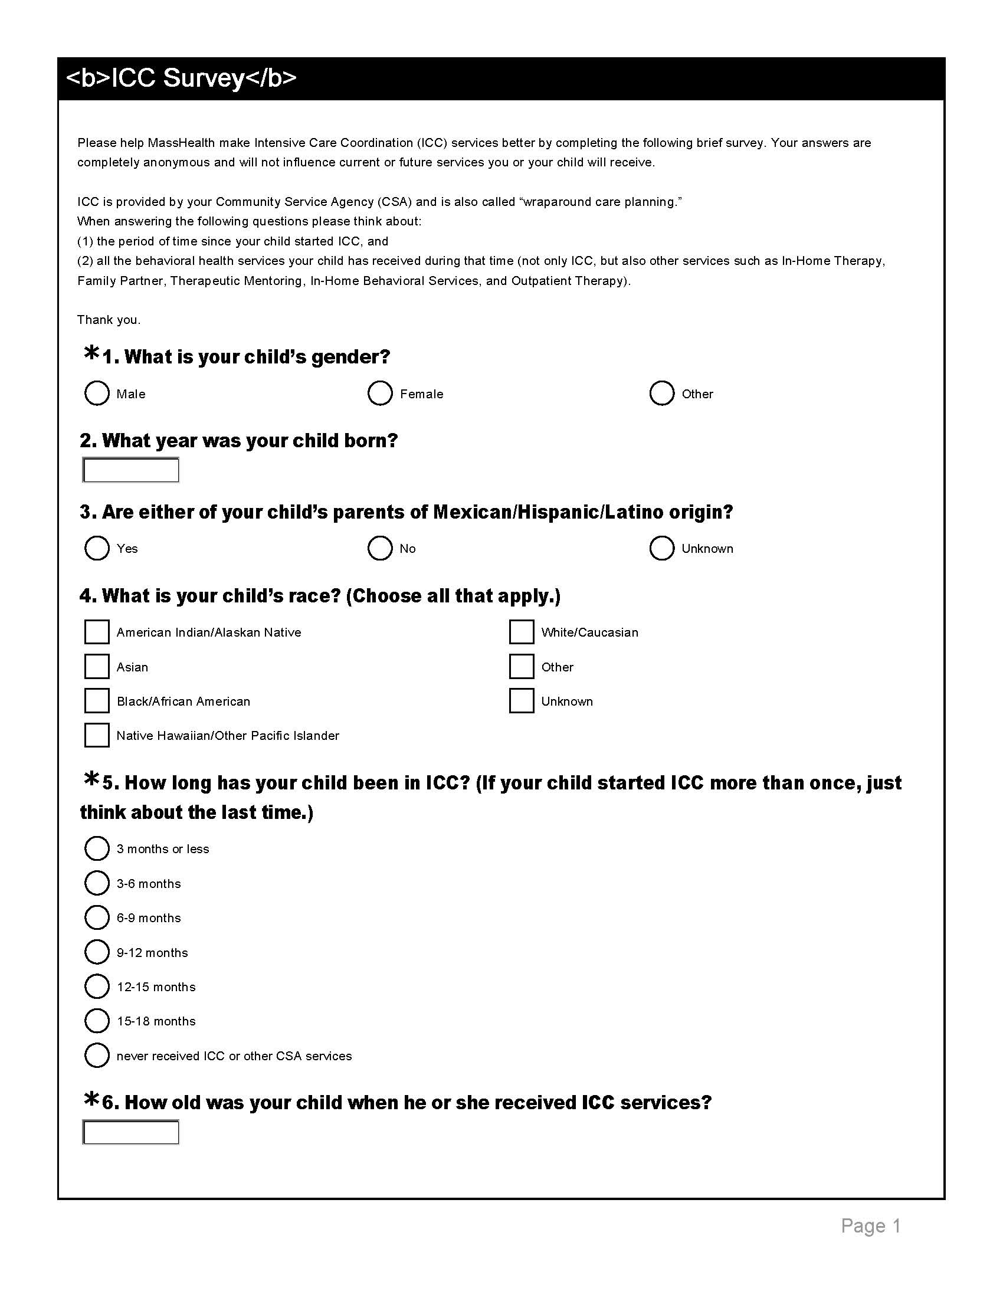

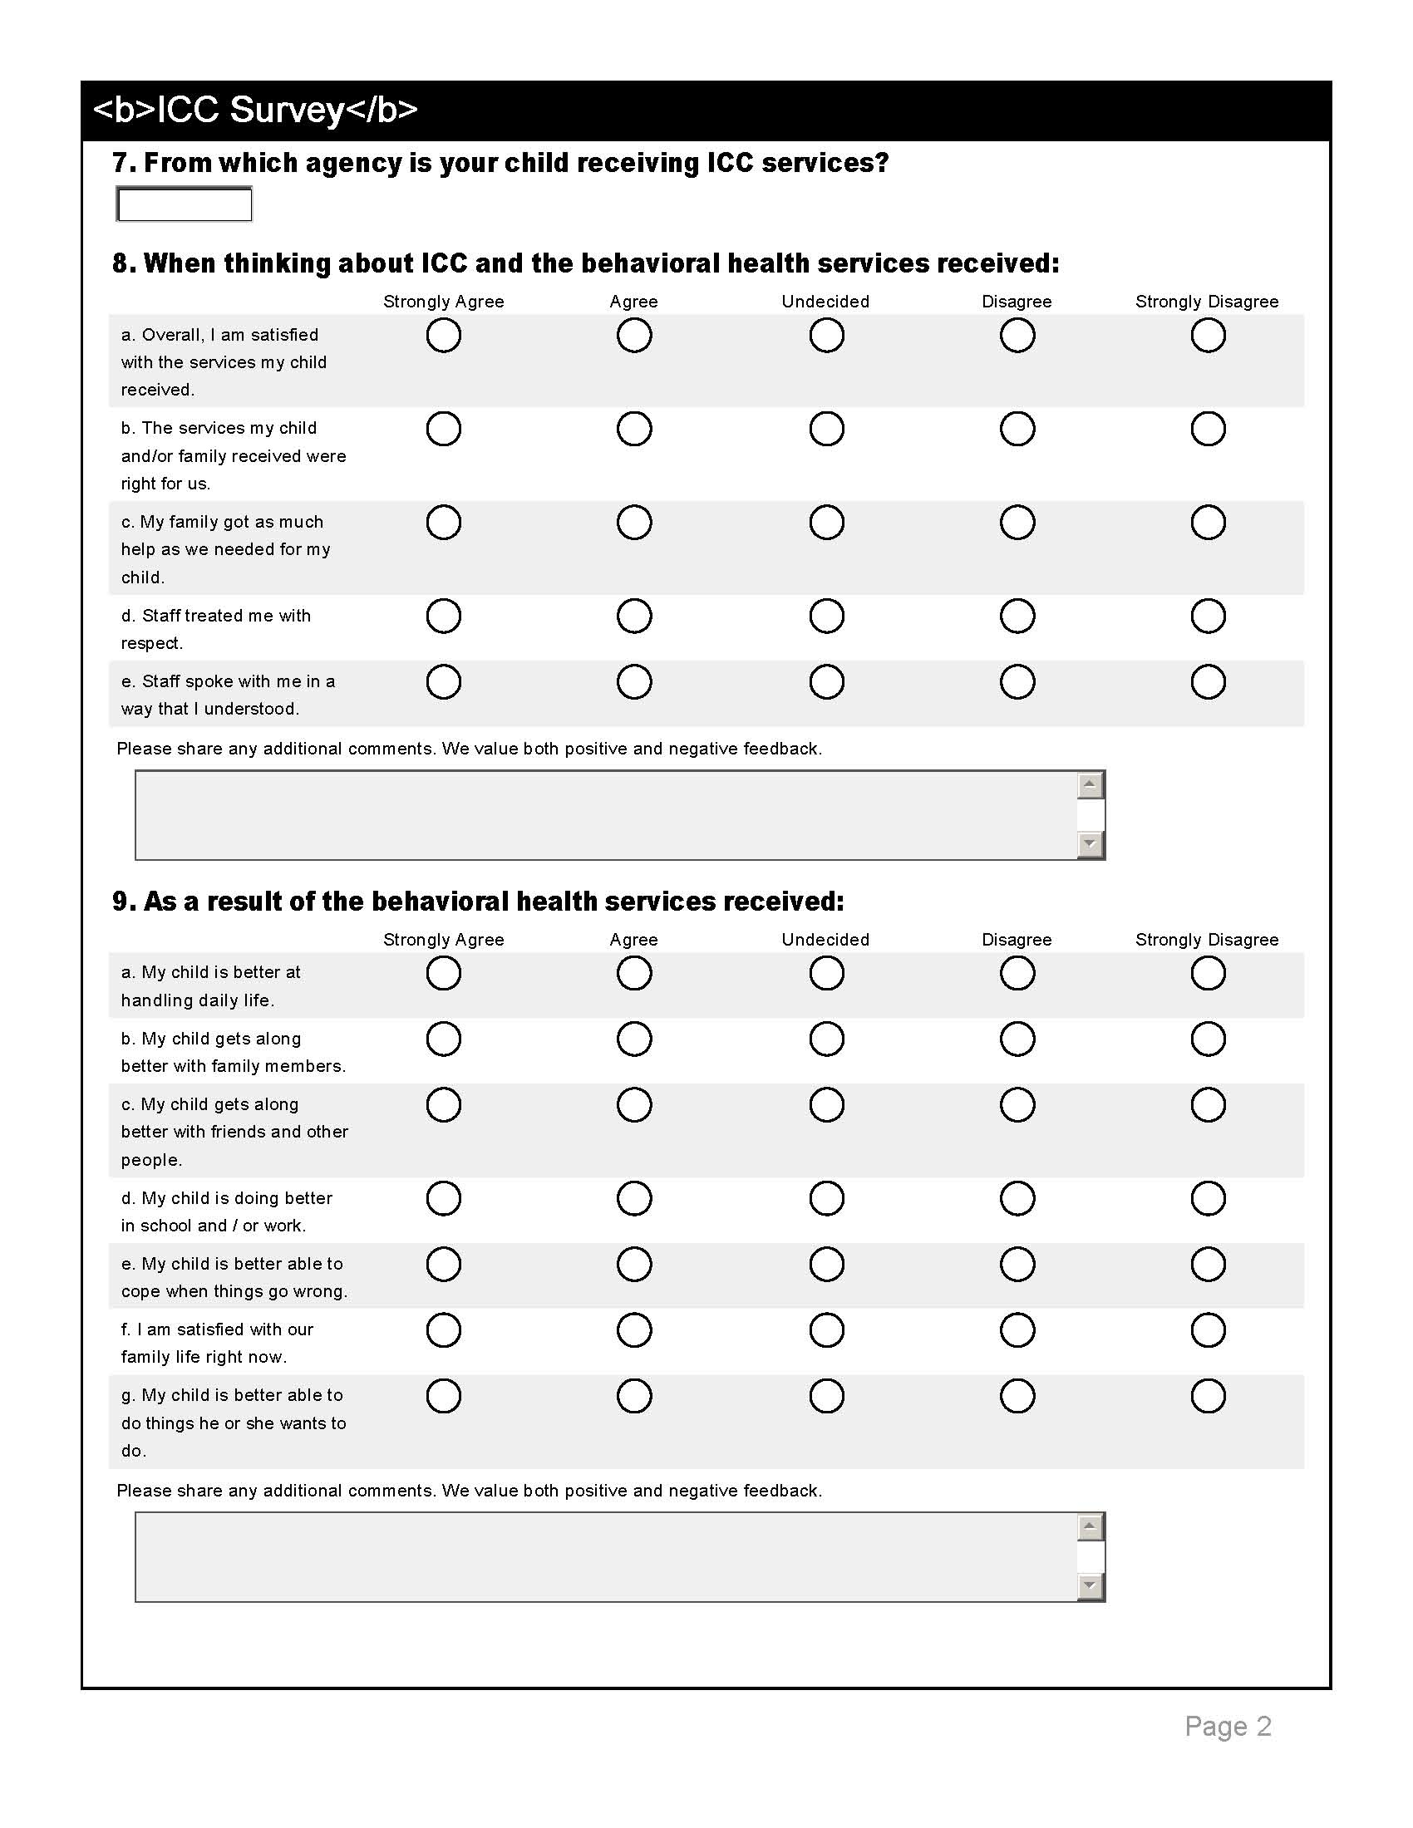
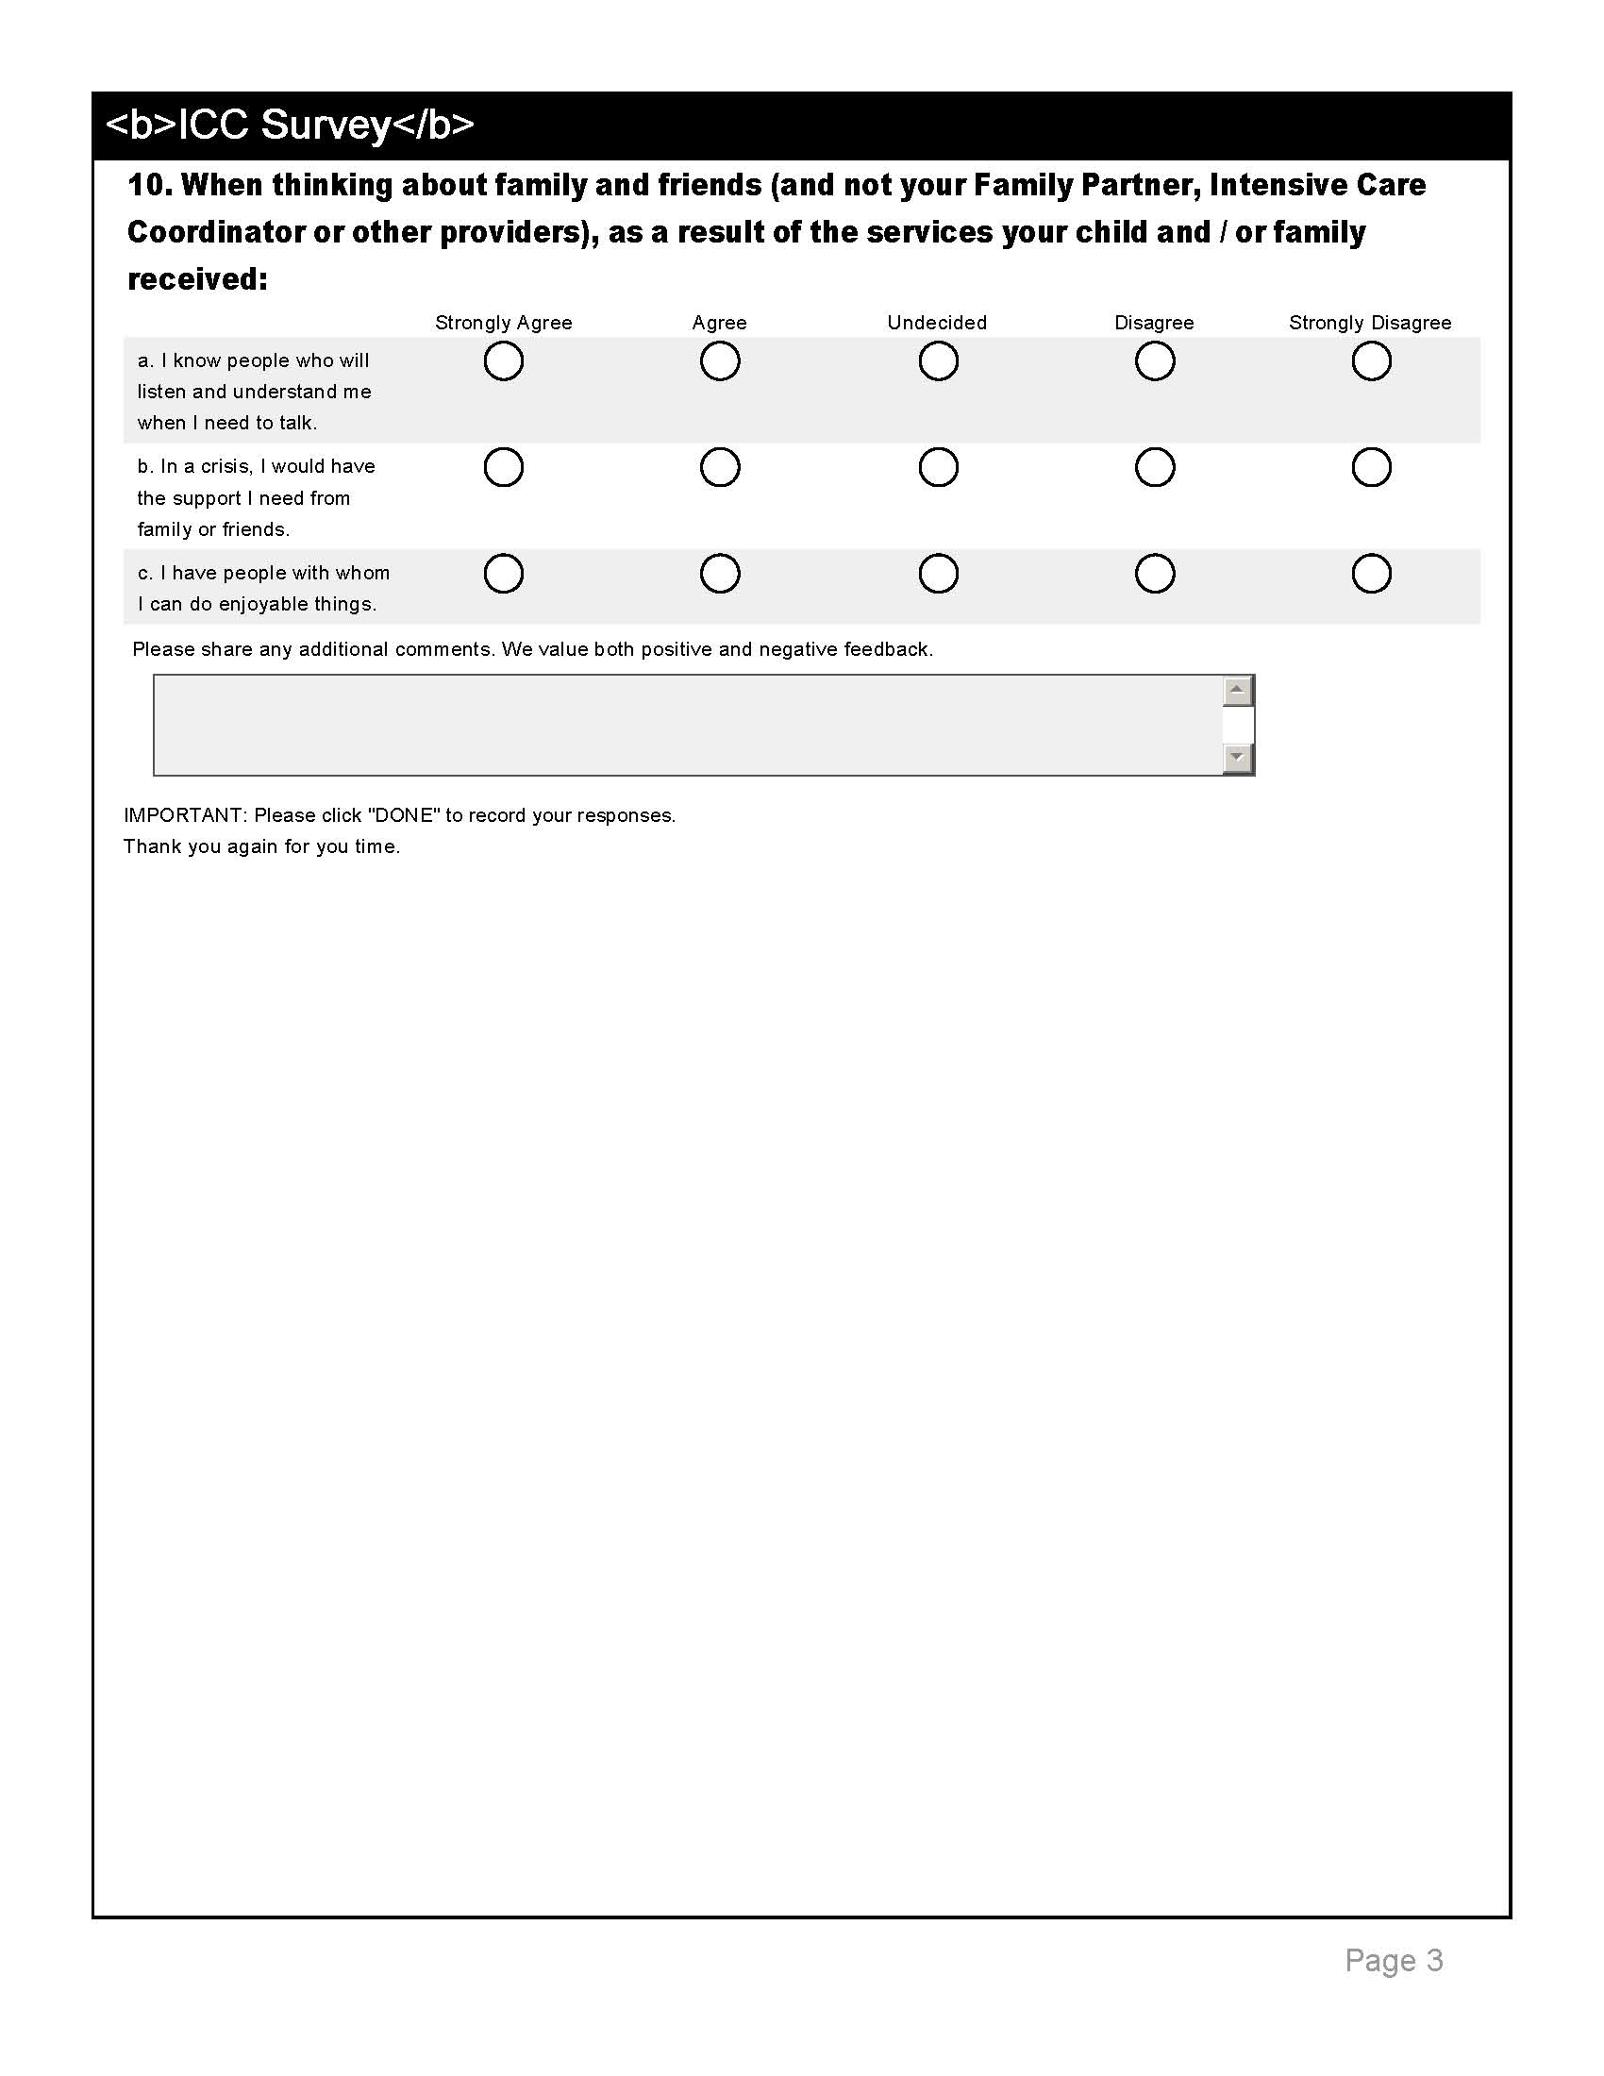

Appendix C: Survey Questionnaire (Spanish Version)

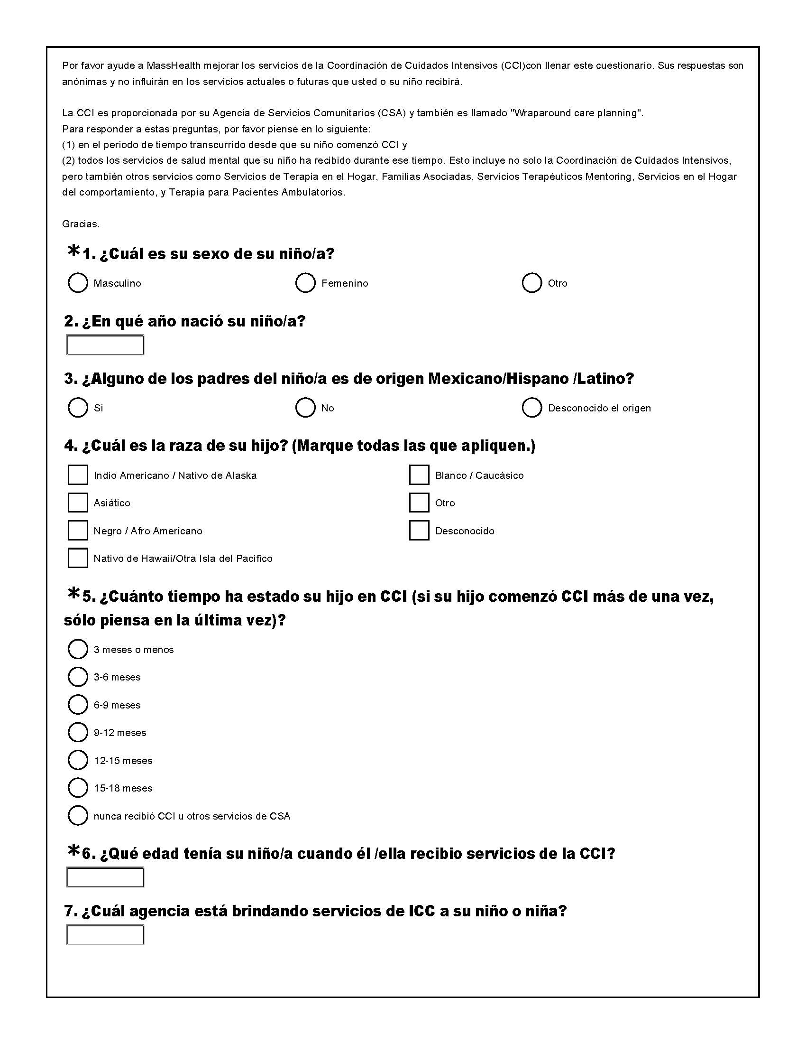

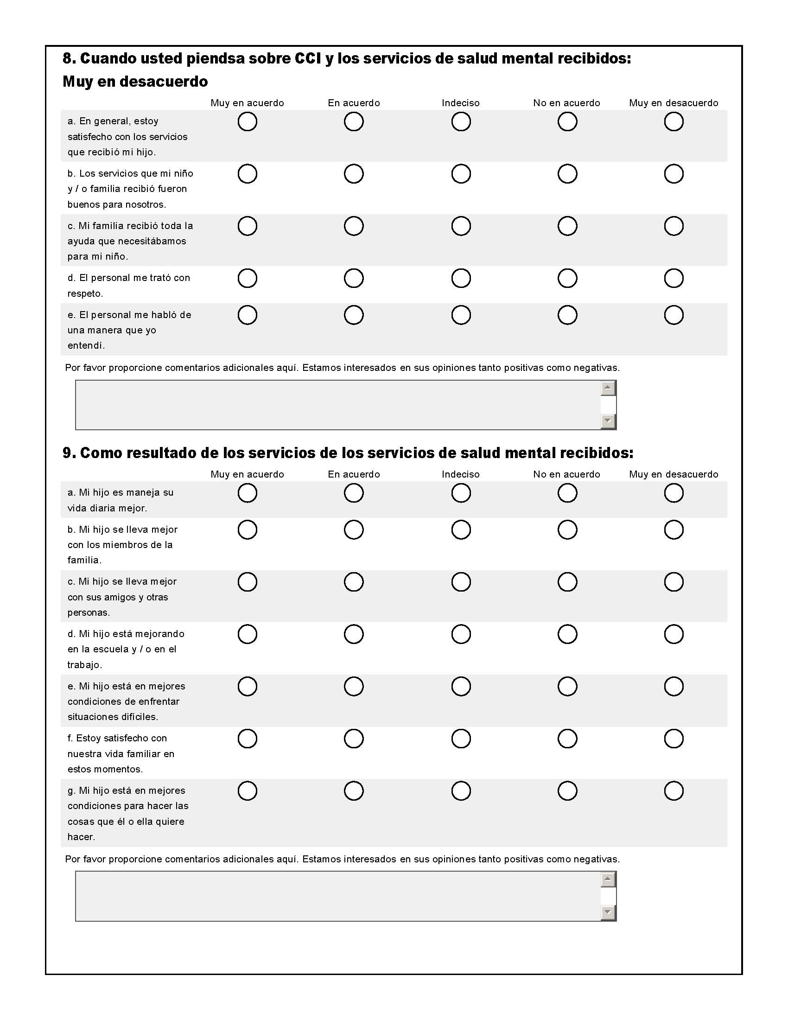

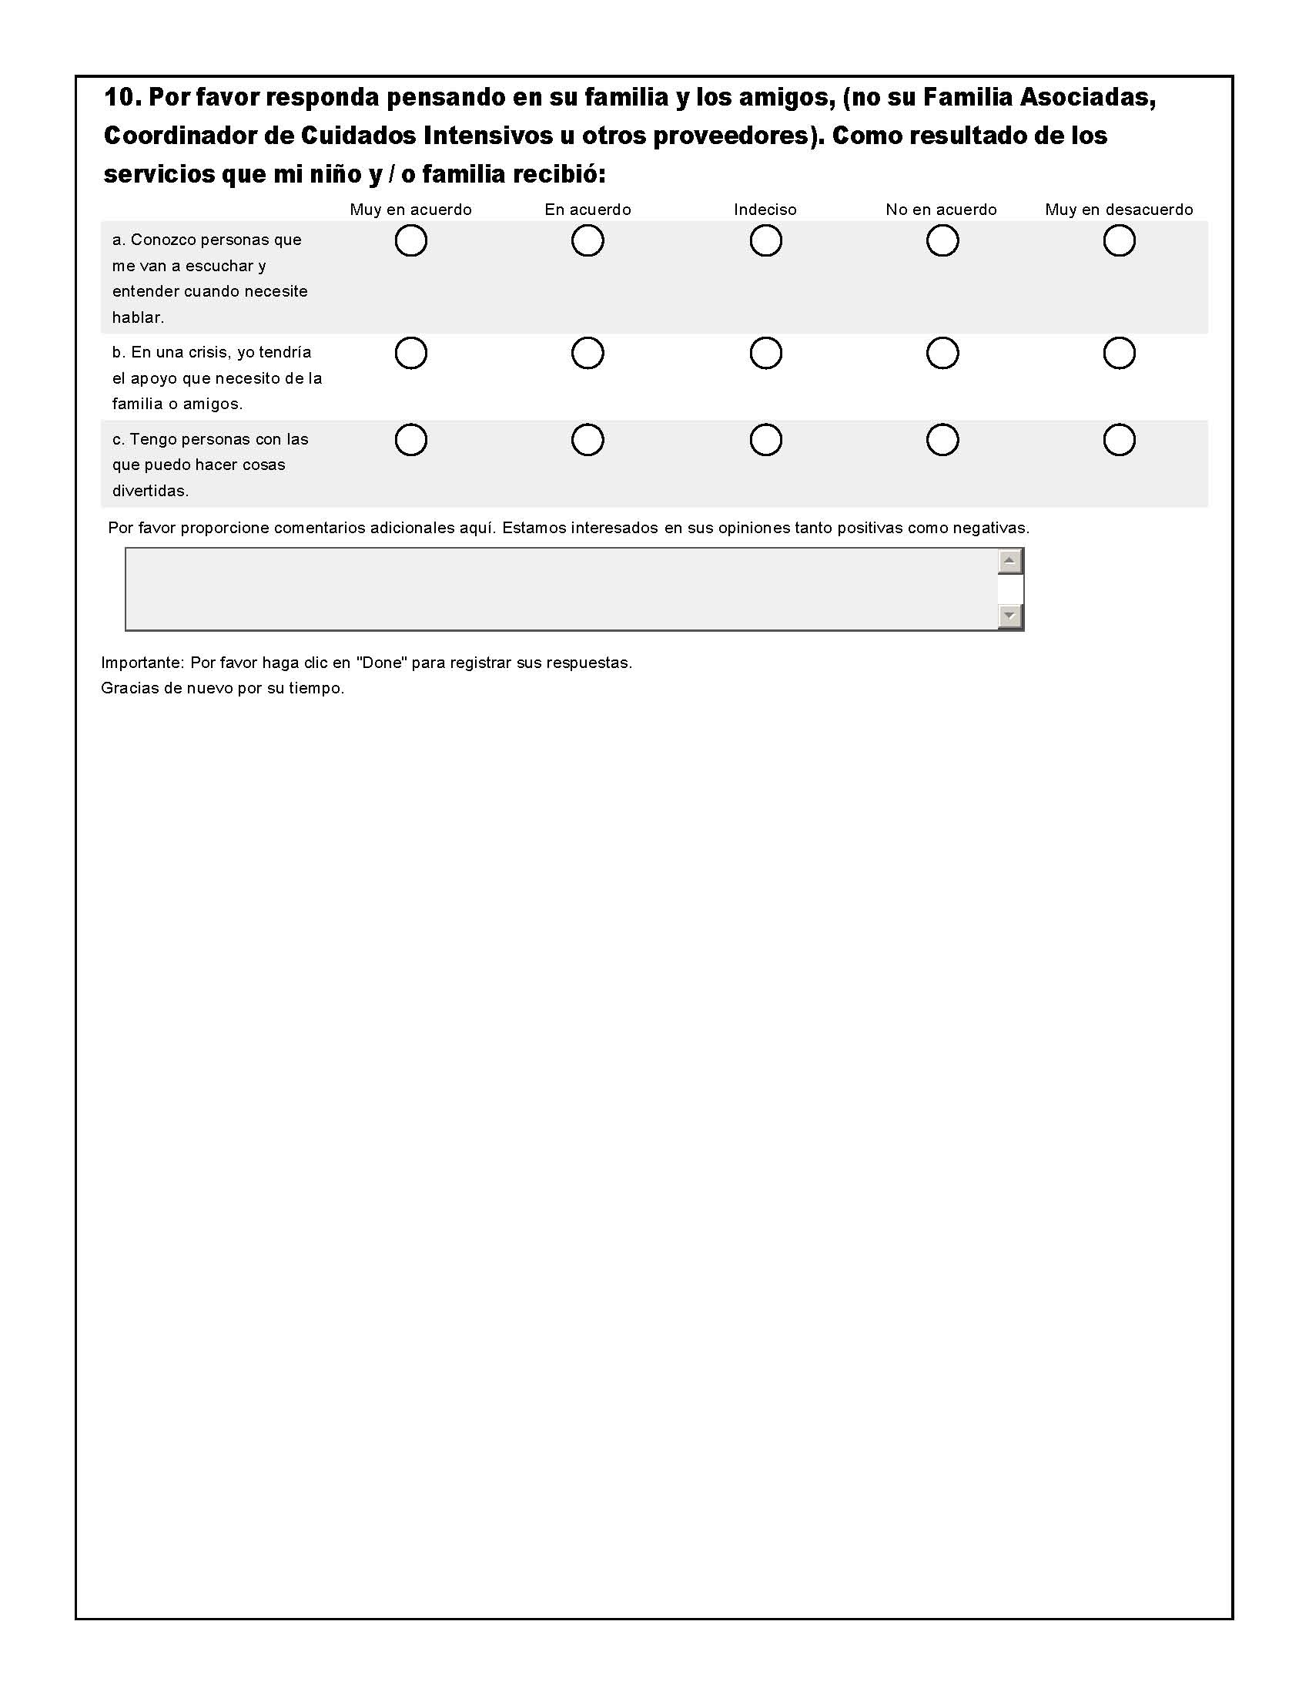

From: http://www.mass.gov/masshealth/cbhi/
Fratalli, C. M. (1991, Winter). Measuring client satisfaction. Quality Improvement Digest.
Stallard, P. (1996). The role and use of consumer satisfaction surveys in mental health services. Journal of Mental Health, 5(4), 333-349.
Lebow, J. L. (1983). Research assessing consumer satisfaction with mental health treatment: A review of findings. Evaluation and Program Planning, 6, 211-236.
Stallard, P. (1994). Monitoring and assuring quality: the role of consumer satisfaction surveys. Clinical Psychology and Psychotherapy, 1, 233-239.
Webb, Y. (1993). Consumer surveys: an overview. In: R. Leiper, & V. Field (Eds), Counting for something in mental health services. Aldershot, Avebury.
Berk ML, Mathiowetz NA, Ward EP and White AA (1987), The effect of prepaid and promised incentives: Results of a controlled experiment. Journal of Official Statistics, 3(4): 449-457.
Cialdini, R. B. (2001). The science of persuasion. Scientific American, 284, 76-81.
Kalantar, JS. & Talley, NJ. (1999). The effects of lottery incentive and length of questionnaire on health survey response rates: A randomized study. Journal of Clinical Epidemiology, 52(11), 1117–1122.

