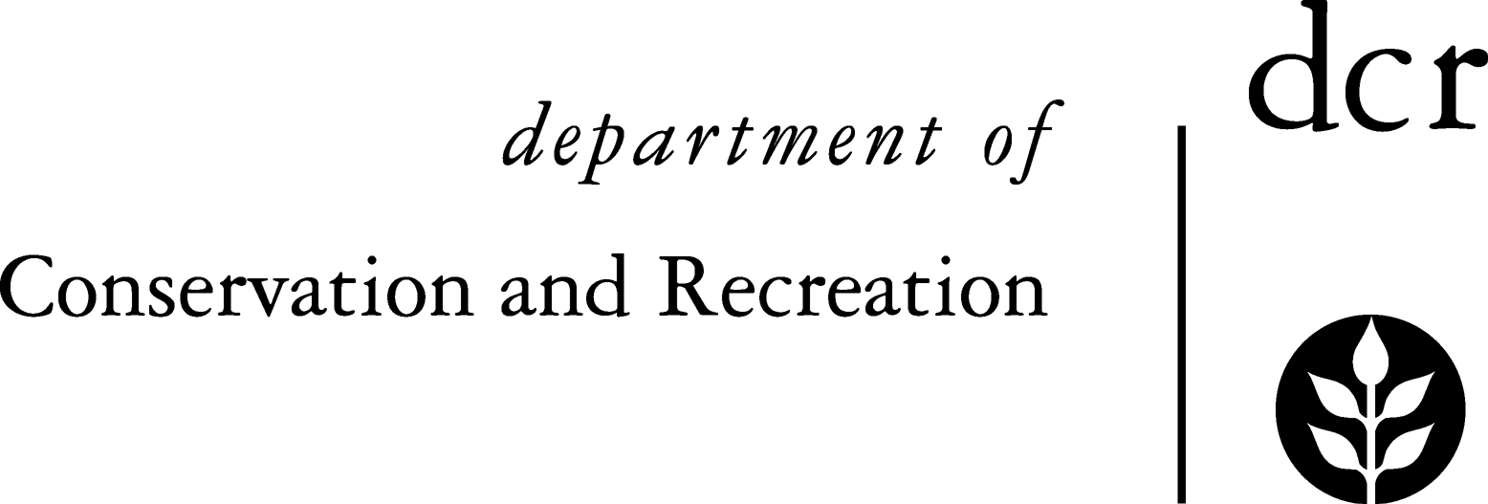

[National Grid](http://www.nationalgridus.com/index.asp)

**Massachusetts DCR Urban and Community Forestry**

**National Grid Partnership Challenge Intent to Apply**

**Application Deadline (Post-marked on or before) November 1**

Applicant (Entity Name):

Mailing Address:

Contact Person:

Phone:

Email:

Fax:

Grant Request: $ + Match: $ +Volunteer Value______= Total Project Cost $______

Short Project Title: (Seven words or less) ___________________________________________

Project Summary: **In the following space**, briefly describe the project, including what you expect to be developed, produced, performed, and/or implemented. The project must relate to urban and community forestry:

Please attach a more detailed budget indicating sources of match, details of expenses, etc.

**This application has the support of the entity that is applying.**

________________________________ _____________ Signature of Authorized Agent Date

________________________________

Printed Name and Title

**Mail to: Julie Coop, DCR Urban Forestry Program, 251 Causeway St., Suite 600, Boston, MA 02114**