Introduction

Background
Opioid use disorder (OUD) affects people of all ages, races, ethnicities, income levels, and geographic regions. Since 2016, OUD decreased from 2.0 million in 2018 to 1.6 million in 2019.1 Solutions that helped initiate this decrease include increased access to medication for opioid use disorder (MOUD), along with the establishment of psychosocial and community recovery support groups.2 However, with this decrease in cases across the country, opioid-related deaths in Massachusetts have remained consistently high from 2016 to 2020—2,102 and 2,104 (estimated), respectively.3 Nationally, older adults, in particular, may be at risk for opioid misuse, and, in 2018, 25% of adults who were 65 years of age and older had at least one opioid prescription filled.4
Further, nationally in 2020, there were 1,895 opioid-related overdose deaths where a toxicology screen was available. Findings show that cocaine was present in approximately 40% of opioid-related deaths, and amphetamines were present in about five percent.5 The rate of deaths involving cocaine (a stimulant) and opioids increased substantially from 2009 to 2019 in the U.S., with the highest percentage of deaths found in the Northeast.6 Approximately 22,200 Massachusetts clients received MOUD in opioid treatment programs (OTPs) and another 11,600 in office-based opioid/addiction treatment (OBOT/OBAT) clinics.7 Medicaid enrollees with OUD and other substance use disorders (SUD) were significantly less likely to receive MOUD than those with OUD only.8 Best practices for the care and treatment of co-occurring opioid and stimulant use in long-term care settings are not currently widely established. Therefore, an unexpected hospitalization followed by a transfer to a long-term care facility (LTCF) poses challenges to the continuity of care for these patients.
Stimulant use disorder (StUD) is also on the rise. Amphetamines and other stimulants are the second most widely used class of illicit drugs globally after cannabis.9 Deaths involving psychostimulants, including cocaine and methamphetamines, and illicitly manufactured fentanyl contributed to recent increases in stimulant- involved overdose deaths. The specific drugs and drug combinations involved in overdose deaths have implications for SUD treatment regimens and outcomes, overdose prevention strategies (e.g., avoidance of using drugs alone), and overdose response. According to the Substance Abuse and Mental Health Services Administration (SAMHSA), naloxone effectively reverses overdoses where opioids are present in combination with other sedatives or stimulants. Naloxone does not work on overdoses where the only substance present is

benzodiazepines. Naloxone effectively treats only opioid overdoses; however, other substances, such as fentanyl, may contain opioids. In this case, naloxone should be administered. Naloxone has no effect on someone who does not have opioids in their system.
Historically, there have been four waves of opioid overdose deaths in the U.S.: first, a rise in prescription and non- prescription opioid deaths, then a rise in heroin-related deaths, and now, a rise in
Figure 1: Four Waves of the Rise in Overdose Deaths

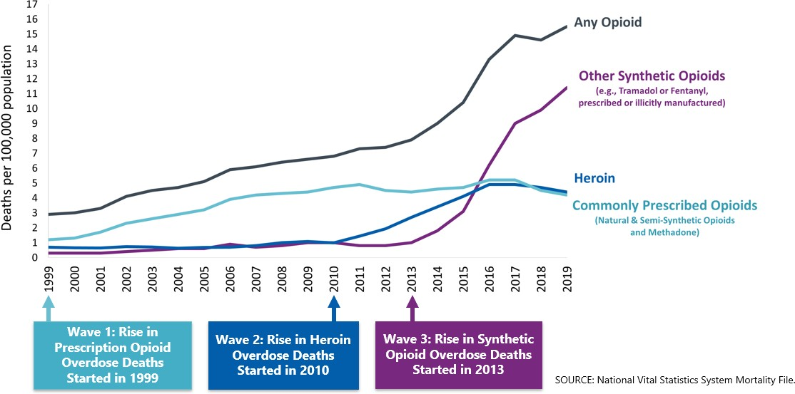

synthetic opioids (e.g., fentanyl) deaths. These national trends have been reflected in Massachusetts (Figure 1).

Data from 2019 shows a decline in overdose deaths, due in part to an expansion of life-saving emergency naloxone and expanded access to MOUD (Figure 210). Preliminary data from 2020, however, is showing a 5% increase in opioid–related overdose deaths in Massachusetts.11
Figure 1: Age-Adjusted Opioid Related Death Rate by Year per 100,000 People
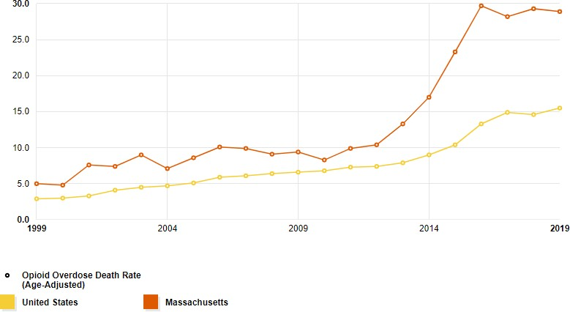
According to the Centers for Disease Control and Prevention (CDC), 28 people die every day from overdoses involving psychostimulants. Between February 2019 and February 2020, Massachusetts was one of four states, including Washington, New York, and Florida, with a significant increase in suspected all-stimulant overdoses.12 In 2018, there were over 27,000 stimulant overdose deaths, which is roughly 40% of all overdose deaths in the United States.
According to SAMHSA and the National Institute on Drug Abuse (NIDA), addiction is a chronic, treatable illness requiring continuing care for effective treatment. Like other chronic diseases, addiction often involves cycles of relapse and remission. In 2018, an estimated 2 million Americans had OUD, but only 26% received any addiction treatment.13
MOUD, as defined in the next section, is an evidence-based life-saving treatment for OUD, which supports long- term recovery. In 2017, 22,200 Massachusetts residents received MOUD in OTPs and another 11,600 via OBOTs/OBATs. Of the Massachusetts OTPs, 27% offer programs specific to the older adult population. Access to MOUD has been and continues to be, expanded. Emergency orders during the coronavirus disease (COVID-19) pandemic lifted the training requirements for eligible providers to prescribe buprenorphine. They also expanded access for support through telehealth.
For residents with OUD or StUD, a stay in a LTCF can pose challenges for continuous care. The Massachusetts Department of Public Health (MDPH) issued a circular letter14 in 2016 asserting that LTCFs must provide MOUD to residents who require such treatment and who are otherwise eligible for admission. Failure to provide MOUD to people with OUD is a violation of the Americans with Disability Act. This toolkit will assist your efforts to care for residents diagnosed with OUD and StUD while addressing timely coordination of care among OTPs, OBOTs/OBATs, hospitals, and LTCFs.

Management of Opioid and Stimulant Use Disorders

Treatment for Opioid Use Disorder
Like other chronic diseases, medications are central to the treatment of OUDs. People with OUD benefit from treatment with medication for varying lengths of time, including lifelong treatment.15 The U.S. Food and Drug Administration (FDA) has approved three types of medication for the treatment of OUD:
- naltrexone (Vivitrol®)
- buprenorphine (Subutex®), buprenorphine/naloxone (Suboxone®), buprenorphine extended-release (Subclocade®)
- methadone
These medications block the effects of opioids; methadone and buprenorphine also normalize the brain chemistry and body function, suppress withdrawal, reduce opioid cravings, and significantly decrease opioid overdose mortality.16,17 MOUD is an integral component of caring for patients diagnosed with OUD and is often combined with behavioral health counseling.
As with any other resident undergoing treatment for chronic disease, residents with OUD should have access to medications, individually tailored counseling, support services, and disease management care plans. If an individual is treated with methadone or buprenorphine and misses a dose, they may experience withdrawal symptoms. If not managed, withdrawal will make the resident more irritable, participate less in care, seek out opioids or other substances to treat their symptoms or leave against medical advice (AMA). If an individual is treated with extended-release naltrexone and misses a dose, there will be no withdrawal symptoms; rather, the resident may experience more cravings.
Additionally, stopping any of these medications has been shown to increase mortality as the individual’s tolerance for opioids declines; if they return to use, they will have an increased risk of overdose.18 Residents on MOUD should have consistent connections with their physicians and other licensed prescribers, OTP, or OBOT/OBAT to ensure no missed doses and that there are no stops to medications.
Here are two helpful videos that discuss MOUD in more detail.19
- Medication-Assisted Treatment Overview: Naltrexone, Methadone, and Suboxone20 (5 minutes)
- Medication-Assisted Treatment21 (10 minutes)
The table in Appendix 1 compares the different pharmacotherapy options for MOUD, including how they treat OUD, their side effects, and recommended safety precautions.

Treatment for Stimulant Use Disorder
There are no FDA-approved medications to treat StuD, although research is ongoing. Psychostimulants, n- acetylcysteine, opioid agonist therapy, disulfiram, and antidepressant pharmacological interventions were found to have insufficient evidence to support or discount their use.22 Current pharmacological treatment options focus on patients’ ongoing withdrawal symptoms, such as medications for sleep, appetite stimulation, and psychiatric symptoms. Other treatment options for StUD include behavioral and psychosocial interventions and practices are listed below and in Exhibit 1.

Exhibit 1: Treatment Options for Stimulant Use Disorder in Long-Term Care Settings
Evidence-Based Treatments | Description of Treatment | Details
Contingency Management | Provides incentives (money, gift cards, motivational encouragement, etc.) for treatment attendance and expected urine toxicology screens. Strong evidence. Contingency management is grounded in classical and operant conditioning theory and can be offered in various settings (some programs have adapted to be web-based). A variety of providers can deliver, meaning having a clinical background is not necessary. It has been used successfully for individuals with co-  occurring OUD. | - Yes, training is available.  - No prescribed intensity and duration.  - Typically a duration of 12-weeks.
Motivational Interviewing | Resolving clients’ ambivalent feelings and insecurities and enhancing the internal motivation need to change behavior.  Strong evidence. Motivational interviewing can be used by clinical and non-clinical providers (e.g., peers) with little or no training in counseling or therapy. It is effective in various settings and can be provided in a single or multiple sessions. | - Yes, training is available.  - No prescribed intensity and duration.
Exercise Supported Recovery | There are varying exercise programs, but those with a combination of daily aerobic and anaerobic exercise are associated with a positive correlation for long-term recovery. | - No training is available.  - Intensity and duration are based on the physical limitations of the individual resident.
Trauma- Informed Care Seeking Safety | A therapeutic model for treating co-occurring post-traumatic stress disorder and SUD that emphasizes the need to be safe to explore and cope with trauma. It can be done in group or individual sessions. | - Yes, training is available.  - Duration and intensity varies based on the target population.
Community Reinforcement Approach | It is identifying behaviors that reinforce stimulant use and making a substance-free lifestyle more rewarding than one that includes substances.  Strong evidence. Community reinforcement approach is often used in conjunction with contingency management. It is generally provided in inpatient settings or during home visits, although used successfully in outpatient settings. Best provided by clinical staff with solid counseling skills. | - Yes, training is available.  - No prescribed intensity and duration.  - Recommended for 24 weeks.
Cognitive Behavioral Therapy | Helping clients improve the quality of their lives not by changing their circumstances but by altering perceptions of those circumstances.  Strong evidence. It is a psychotherapy treatment provided in various settings, administered by professionals trained in CBT principles.  National training is available to mental health professionals and non- professionals with a 4-year college degree. | - Yes, training is available.  - No prescribed intensity and duration.  - Typically a duration of 5- 10 month.
Source: This was modified from the Substance Use and Mental Health Services Administration (SAMHSA) Evidence-Based Resource Guide Series, Treatment of Stimulant Use Disorders and from the Boston Medical Center Office-Based Addiction Treatment Training and Technical Assistance presentation, Introduction to Methamphetamines, presented to the Lynn Health Center, May 10, 2021.

Understanding Opioid Use Disorder and the Co-Occurring Use of Stimulants
National data shows there is an increase in the counts of deaths involving co-occurring use of opioids and stimulants.23 Rates of first-time stimulant use have increased significantly since 2015, while the number of cocaine, and other psycho-stimulant related deaths have climbed sharply.24 Cocaine use is highest among those aged 18-25 and methamphetamine use is highest among those aged 26-49.25
Overdose deaths that involve both opioids and stimulants can represent individuals who knowingly consumed both opioids and stimulants or individuals who consumed a stimulant that unknowingly contained an opioid. In 2018, 86% of deaths involving stimulants also involved opioids. The number of deaths involving stimulants without opioids declined by 4% between 2000 and 2015 and has remained relatively stable since. While stimulant-related deaths have increased since 2010, this increase is closely linked to the opioid overdose epidemic, specifically fentanyl. These data suggest that interventions that address stimulant use alone will not be sufficient to reduce stimulant-related deaths.26
The rate of overdose deaths involving stimulants and opioids is higher among males than females. The rate rose by 28% per year for males and 27% per year for females from 2010 to 2018. Understanding the gender breakdown and the risk that males experience is vital to inform gender-specific strategies to engage individuals who use both opioids and stimulants and those who primarily use stimulants. 27
The rate of overdose deaths involving stimulants and opioids is currently highest among Hispanic residents (12.3 per 100,000). The rate among Hispanics increased by 36% per year from 2012 to 2018. The rate among non-Hispanic whites increased 35% per year from 2010-2015, and the rate among non-Hispanic blacks increased 31% per year from 2012-2018. Over time, understanding who is at most significant risk by race and Hispanic ethnicity allows us to best focus prevention programs and treatment resources to address population- specific needs. 28
For a variety of reasons, the lesbian, gay, bisexual, transgender, queer, intersex, asexual, gender-diverse, or those who identify on the spectrum of sexuality or gender identity (LGBTQIA+) community is disproportionately affected by SUD. In a 2015 national survey on drug use, LGBTQIA+ people were far more likely to misuse prescription pain relievers and showed a three times greater risk of OUD. When initiating MOUD in this population, it is essential to note that medications such as methadone and buprenorphine have known interactions with certain antiretroviral and hormone modulating medications, which may unnecessarily deter some individuals from seeking treatment. Co-prescribing, particularly buprenorphine, is safe with appropriate clinical monitoring and follow-up.29

Using This Toolkit
This toolkit outlines six tips to help your LTCF care for your residents with OUD and the co-occurring use of stimulants. Administrators, directors of nursing (DON), medical directors, social workers, nurses, and certified nursing assistants (CNA) can all use these resources. This toolkit will help you comply with state and federal policies and provide evidence-based care to residents with OUD and StUD. Each tip has a list of suggested policies, processes, and educational resources to help your LTCF be better prepared to work with and provide continuity of care to those residents. Finally, in the appendices you will find a table of pharmacotherapy options, process maps for transitions of care, and template forms.

Tip 1: Understanding Opioid Use Disorder and Stimulant Use Disorder

Tip 2: Creating A Therapeutic Environment

Tip 3: Organizational and Workforce Approaches

Tip 4: Competencies

Tip 5: Community-Wide Partnerships

Tip 6: Transitions of Care

