CHAPTER IV:
INVESTIGATING FOODBORNE ILLNESSES AND OUTBREAKS

IMPORTANT RESOURCES

Enteric Disease Reporting Form: Enter into MAVEN, or

if not using MAVEN, fax to ISIS at 617-983-6813.

(If food related, complete Foodborne Illness Complaint Worksheet.)

Foodborne Illness Complaint Worksheet: Enter into MAVEN, or if not using MAVEN,

fax to Food Protection Program (FPP) at 617-983-6770. FPP Telephone: 617-983-6712

MAVEN Questions: call ISIS at 617-983-6801.

On Weekends: Call the Epi on call for instructions at 617-983-6800.

105 CMR 300.000: Summary of Reportable Disease, Surveillance, and Isolation and Quarantine Requirements at:

http://www.mass.gov/eohhs/docs/dph/cdc/reporting/rdiq-reg-summary.pdf

June 2017
Attachment 4-1: Summary of Sequential Steps in the Investigation of Foodborne Illness Complaints and Outbreaks is essentially the outline of the remaining chapters in this manual. Steps often occur simultaneously but all are essential to completing the investigation.

A. Responsibilities of the Local Board of Health (LBOH)

The LBOH is the recipient of two kinds of surveillance reports: pathogen-specific case reports of diagnosed illness from MA Department of Public Health (MDPH) or health care providers, and resident complaints of illness symptoms that they usually associate with a meal eaten at a local restaurant. In either case, careful follow-up by knowledgeable and trained staff is extremely important to determine whether these cases are true foodborne illnesses and whether they are a small part of a much larger outbreak. Some level of investigation should be done for even a single possible case of foodborne illness.

In general, the Public Health Nurse, or other designated staff, receive the pathogen-specific reports and is then required to complete the Enteric Disease Reporting Form by telephone calls to the physician and/or the patient. If during any of the interviews, it appears that the illness is associated with food, a Foodborne Illness Complaint Worksheet must also be completed. Copies of these reports are Attachments 4-2 and 4-4 at the end of this chapter, although all communities are strongly encouraged to use the Massachusetts Virtual Epidemiologic Network (MAVEN) modules for entering this data.

As stated at the beginning, this process may also occur in reverse. The LBOH may receive a resident complaint of a possible foodborne illness. After being referred to their health care provider, a pathogen-specific diagnosis may result, so that one or more Enteric Disease Reporting Forms will be required. In a foodborne illness outbreak, these two forms, when completed carefully, will provide the bulk of the data.

B. The Enteric Disease Reporting Form

This form may be used to record information on a diagnosed case of enteric disease that was reported to the LBOH either by a health care provider or via MAVEN. Information obtained by the LBOH during its investigation should be directly entered into MAVEN, or copies of the reports may be faxed. (U.S. Postal Service mail is highly discouraged.) If U.S. Postal Service is the usual reporting manner for a LBOH, all foodborne illness cases must be reported to the Food Protection Program (FPP) or the Epidemiology Program within 24 hours. All reportable diseases and reporting requirements can be found in 105 CMR 300.000, Reportable Diseases, Surveillance, and Isolation and Quarantine Requirements. Information on MAVEN can be found in Chapter VI. Attachment 4-3, Diseases Reportable by Health Care Providers, is provided at the end of this chapter.

Regardless of how the LBOH receives the information, the task of collecting relevant clinical, epidemiological and risk information must be started as soon as possible. The initial reports usually contain minimal information on the case and the details collected by the LBOH are critical for determining the possible, or probable, means by which a case may have become infected. In order to obtain this information, it may be necessary to contact the laboratory or provider to get the case's contact information. It is also extremely helpful to speak with the provider and clarify what the case had been told about his/her illness. Consider the following points when investigating a potential foodborne illness:

1. Onset of illness. Be sure to accurately record dates and times of the onset of illness and symptom information.
2. Incubation period. Please refer to the correct incubation period range for the etiologic agent reported. See Attachment 4-5: Onset & Predominant Symptoms Associated with Selected Foodborne Organisms and Toxins, at the end of this chapter.
3. Exposure history. Once you know the incubation period range, then ask the case about exposure history during one incubation period range before the illness started (i.e. if the patient had Salmonella, ask about exposures during the time period 6 to 72 hours before the illness started).
a. Questions about travel history and outdoor activities are asked in order to identify where the patient became infected.
b. Questions about animal contact are asked because certain animals can carry and transmit enteric diseases to humans (i.e. Salmonella from pet reptiles).
c. Information about water usage is collected because many agents that cause gastrointestinal illness can be transmitted through water.
d. Day care or supervised care questions are asked to examine the case's risk for having acquired illness from household or day care contacts, and the potential for transmitting the illness to others.
4. Occupation. Asking about the case's occupation is very important to assist with determining where the case might have gotten the illness, and where there is opportunity for transmitting the illness to others. All food handling occupations are important and include positions that might not come to mind initially. The exact definition of a Food Handler from 105 CMR 300.000: Reportable Diseases, Surveillance, and Isolation and Quarantine Requirements is:
"Any person directly preparing or handling food. This could include the food handling facility owner, individual having supervisory or management duties, person on the payroll, family member, volunteer, person performing work under contractual agreement, or any other person working in a food handling facility. This also includes any person handling clean dishes or utensils. Any person who dispenses medications by hand, assists in feeding, or provides mouth care shall be considered food handlers for the purpose of 105 CMR 300.000. In health care facilities, this includes those who set up trays for patients to eat, feed or assist patients in eating, give oral medications or give mouth/denture care. In day care facilities, schools and community residential programs, this includes those who prepare food for clients to eat, feed or assist clients in eating, or give oral medications. This term does not include individuals in private homes preparing or serving food for individual family consumption."

The Federal Food Code refers to "Food Handlers" as "Food Employees." Massachusetts uses the term "food employee" but will continue to use the expanded definition as described above. This is discussed again in Chapter VII regarding the environmental investigation.

C. The Foodborne Illness Complaint Worksheet

If during the pathogen-specific investigation, done in response to a reported disease, it appears likely that food was the source of the illness, a Foodborne Illness Complaint Worksheet should be completed (preferably via the MAVEN foodborne illness complaint module or faxed to the FPP) and the appropriate investigations initiated as with any other foodborne illness complaint. 105 CMR 300.131 requires that any illness believed to be caused by the consumption of food must be reported to the LBOH by health care providers and those in supervisory positions at a school, day care, hospital, institution, clinic, medical practice, laboratory, labor or other camp. Complaints of possible foodborne illness are also reported by consumers, neighboring health officials, and restaurant owners.

Regardless of who reports a potential foodborne illness, the Foodborne Illness Complaint Worksheet should be used to record all information and should be filed as a permanent record of the complaint. Notification, as described above, is very important and information needs to be entered into the MAVEN, FBI complaint module, or the case reported to the FPP or EPI within 24 hours. All foodborne illness complaints initially received by MDPH will be forwarded to the LBOH via fax. The following are very important when completing the Foodborne Illness Complaint Worksheet:

1. Collecting Information. Always try to collect as much information as possible from the complainant during the first interview. It might be difficult to contact this individual again or he/she may not want to be interviewed a second time. If the complainant cannot provide critical pieces of information, then try to find out who may be able to, and contact that person. By collecting enough information in the initial stages, you will be able to determine the validity of the complaint more easily, and possibly avoid conducting an unnecessary investigation.
2. Laboratory Diagnosis. A laboratory diagnosis is not required for a foodborne illness complaint to be considered valid. Also, many foodborne illnesses are difficult to diagnose strictly through laboratory results. It is fairly typical that a victim of foodborne illness does not seek medical care, but in the interest of the individual's health, staff should encourage the individual to seek medical advice.
3. Food Consumption History. A complainant may be "sure" about the source of the illness and report only one suspect food or food establishment. Explain that there can be many sources of a gastrointestinal illness, including water, animals, and person-to-person, and that symptoms appear from a few minutes to a few weeks after ingestion. Do not be deterred from obtaining a complete, 72-hour food consumption history.

Figure 4-1: Guidelines for Determining Suspect Foods

1) One Person is reported ill:
a) If the cause (organism) is NOT KNOWN, determine foods/beverages/meals consumed for at least 72 hours prior to the onset of illness.
b) If the cause (organism) is KNOWN, determine foods/beverages/meals which were consumed during the appropriate incubation period* prior to the onset of illness.

2) Two or more Persons are reported ill:
a) If the cause (organism) is NOT KNOWN, determine foods/beverages/meals COMMON to all persons for at least 72 hours prior to the onset of illness.
b) If the cause (organism) is KNOWN, determine foods/beverages/meals COMMON to all persons which were consumed during the appropriate incubation period* prior to the onset of illness.

* Attachment 4-5 at the end of this chapter lists typical incubation periods for selected illnesses.

4. Accuracy of Recording. Be sure to accurately record dates and times of the onset of illness, dates and times of food consumption, and symptom information. Ask them to look at their calendar, events, both personal and work; restaurant credit card receipts that they might have; and shopper cards they might have that would enable them to give permission to access a record of purchases. Ask leading questions that might jog their memory. Remind them that their time could assist in ending a possible foodborne illness outbreak and prevent many other cases of illness.
5. File and Communicate. The hard copy of the Foodborne Illness Complaint Worksheet should be filed in the LBOH office with easy accessibility. If an illness does evolve into a large outbreak, these investigation forms will be invaluable in analyzing how many of the former cases were actually the beginning of the outbreak. The information should be entered into the MAVEN FBI complaint module or faxed to MDPH.
The information on the Foodborne Illness Complaint Worksheet should be discussed with staff members who regularly inspect the food service establishments in the community to determine whether an environmental investigation should be done at the location indicated in the complaint. Several staff members, including the sanitarian and public health nurse, should participate in the environmental investigation since there are multiple possible sources of illness, including ill food employees.

D. Determining the Validity of Complaints

Record all single complaints, since the single case may be the first of an outbreak. Record all anonymous complaints that appear to be valid. Complainants often request anonymity for fear of retribution. Some LBOHs have different policies on whether or not they will accept anonymous complaints. They are strongly encouraged to accept anonymous complaints, since, as stated earlier, the single case may be the first of an outbreak. Immediately record foodborne illness complaints in one logbook or electronic database to help identify a potential outbreak.

Single case complaints should be investigated if there is a possibility that the confirmed diagnosis and/or clinical symptoms are consistent with the foods eaten and the onset time of illness. For example, one person reports having bloody diarrhea three days after eating ground beef, which may indicate potential E.coli infection. Other factors such as the possibility of sick food employees and poor food handling/physical facility violations, observed by the complainant, should also be considered when determining if an investigation is warranted. Failure to respond to a valid single case complaint may result in additional persons becoming ill, if corrective actions are not initiated. If the complaint appears at all valid, it is the responsibility of the LBOH to investigate and make a presumptive determination if the implicated food is the causal factor.

In some situations, a follow-up investigation may not be warranted or minimal follow-up may be sufficient:
- It is obvious that the symptoms or diagnosis are clearly unrelated to the food which the complainant believes was the cause.
- There is incomplete information such as the required food history.
- Complainant is absolutely sure what made him/her sick and refuses to cooperate with the questioning.
- Repeated complaints come from the same individuals and prior investigations revealed no significant findings.
- Invalid complaints may be generated by disgruntled employees, competitors, unfriendly neighbors or dissatisfied customers.

Whatever the situation, always briefly summarize for the file your reasons why an investigation was not conducted. Before acting on a suspect foodborne illness complaint, always obtain a complete 72-hour or longer food history to determine if other food may have been the causal factor. Some references strongly suggest a 5-day history for each complaint, especially if symptoms are consistent with pathogens which have longer incubation periods. (See Attachment 4-5 for assistance.)

Consumers often focus on foods prepared or eaten at commercial food establishments, rather than home-prepared meals. It may be necessary to explain to the complainants the possibility of other exposures, such as home-prepared foods, daycare centers and pet reptiles. It is appropriate, as well as good public health practice, to evaluate and review procedures used in preparing suspect home-cooked food.

If it is determined that an environmental investigation is not warranted, notify, preferably in person, the food establishment that has been implicated in a suspected foodborne illness complaint. Establish, through an interview with the manager, if food employees have been ill and if the establishment has received any other similar complaints.

Often complainants will call their LBOH implicating food prepared outside of the LBOH jurisdiction. Immediately refer complaints involving food prepared in another jurisdiction to the appropriate LBOH or, if outside of Massachusetts, to the FPP. The FPP will investigate foods manufactured in Massachusetts and will forward complaints implicating foods manufactured out of state to the appropriate state or federal regulatory agency.

If the complaint appears valid, an environmental and/or epidemiological investigation should be initiated within 24 to 48 hours. The LBOH should have coverage for weekends and holidays in emergency situations. The Epidemiological investigation is covered in Chapter V and the Environmental investigation in Chapter VII.

E. Foodborne Illness in Private Homes

Suspect foods prepared in private homes are sometimes the causative factor in reported illnesses. While it is not within the LBOH's authority to conduct an onsite inspection of private homes, the LBOH should try to conduct a HACCP risk assessment based on an interview with the food preparer to identify possible sources of contamination. Often, friends and family are hesitant to participate in an interview or epidemiology questionnaire studies, but should be encouraged to participate if the LBOH feels it is warranted. With the exception of botulism, MDPH laboratory resources are not available for complaints regarding food prepared in private homes. LBOHs are encouraged, however, to address particular situations with the FPP or the Epidemiology Program if necessary. Offer advice or educational materials on safe food handling practices and advocate the prevention of further illnesses by encouraging sick individuals to seek medical attention. Additionally, they should be informed of work restrictions associated with certain diseases transmissible through food.

If it appears that a commercially processed food prepared in the home may have been contaminated when the consumer purchased it, obtain product information (e.g. manufacturer name and address, package size and type, code or lot number, expiration dates) and immediately notify the FPP. Try to obtain the suspect food itself, if there are leftovers. See additional information on contaminated commercially prepared foods in Chapter VII: Conducting an Environmental Investigation. Information on sampling can be found in Chapter IX: Working with the State Public Health Laboratory. For in-depth information on documenting the investigation see Chapter X: Summarizing the Investigation.

References:

Council to Improve Foodborne Outbreak Response (CIFOR). Guidelines for Foodborne Disease Outbreak Response. 2nd edition. Atlanta: Council of State and Territorial Epidemiologists; 2014.

Food and Drug Administration. Bad Bug Book, Foodborne Pathogenic Microorganisms and Natural Toxins. Second Edition. (Appendix 5) 2012.
https://www.fda.gov/downloads/Food/FoodborneIllnessContaminants/UCM297627.pdf

Attachments:

Attachment 4-1: Summary of Sequential Steps in the Investigation of Foodborne Illness Complaints and Outbreaks
Attachment 4-2: Enteric Disease Reporting Form
Attachment 4-3: Diseases Reportable by Health Care Providers
Attachment 4-4: Foodborne Illness Complaint Worksheet
Attachment 4-5: Onset & Predominant Symptoms Associated with Selected Foodborne Organisms and Toxins

Attachment 4-1: Summary of Sequential Steps in the Investigation
of Foodborne Illness Complaints and Outbreaks

1) Be prepared. Designate responsible individual(s) trained in foodborne disease prevention and control to evaluate and investigate foodborne illness complaints and outbreaks.

2) Maintain a foodborne illness surveillance system. This is necessary to determine any changes in the frequency or distribution of cases and allows early identification of outbreaks or potential outbreaks of foodborne illness.

3) Record complaints on a Foodborne Illness Complaint Worksheet or in the Massachusetts Virtual Epidemiologic Network (MAVEN). Send paper worksheets to the MDPH Food Protection Program (FPP) via fax. Immediately refer complaints of food prepared or manufactured in another jurisdiction to the appropriate LBOH.

4) Decide whether to investigate. Is the complaint valid?

5) Report all suspected or identified clusters or outbreaks to the FPP (617-983-6712) or the Epidemiology Program (617-983-6800).

6) Take steps to verify diagnosis.
- Collect leftover food samples, when appropriate, from the food establishment and/or complainant in a timely manner.
- Obtain clinical samples when appropriate in a timely manner.
- Obtain case histories.
- Immediately investigate reports of suspect sick food employees and exclude if necessary. Request all symptomatic food employees to submit stool specimens as appropriate. In an outbreak situation, request ALL food employees to submit stool specimens, especially when an implicated food is not apparent. Food employees who do not submit stool specimens must be restricted from work until they comply.

7) Conduct an environmental investigation within 24 hours. Conduct a Hazard Analysis Critical Control Point (HACCP) risk assessment of the implicated foods as part of your investigation. For outbreaks, fill out the NEARS Environmental Observations checklist.

8) Develop a case definition and identify cases. Make epidemiological associations (Time, Place, and Person). Formulate hypotheses.

9) If necessary, initiate immediate correction or enforcement actions (embargo, disposal, emergency closure, suspension of operations). Coordinate food recalls and tracebacks with industry and other local, state and federal regulatory agencies. If necessary, issue a press release or public notice.

10) Expand investigation. Find and interview additional cases and persons at risk. Collect data, make calculations, and analyze data. Test hypotheses. Take control action.

11) Complete your investigation of reportable diseases in MAVEN or by paper case report forms submitted to MDPH.

12) Document all LBOH actions. Submit all reports of your investigation including a copy of the last routine food inspection report for the implicated establishment to the FPP.

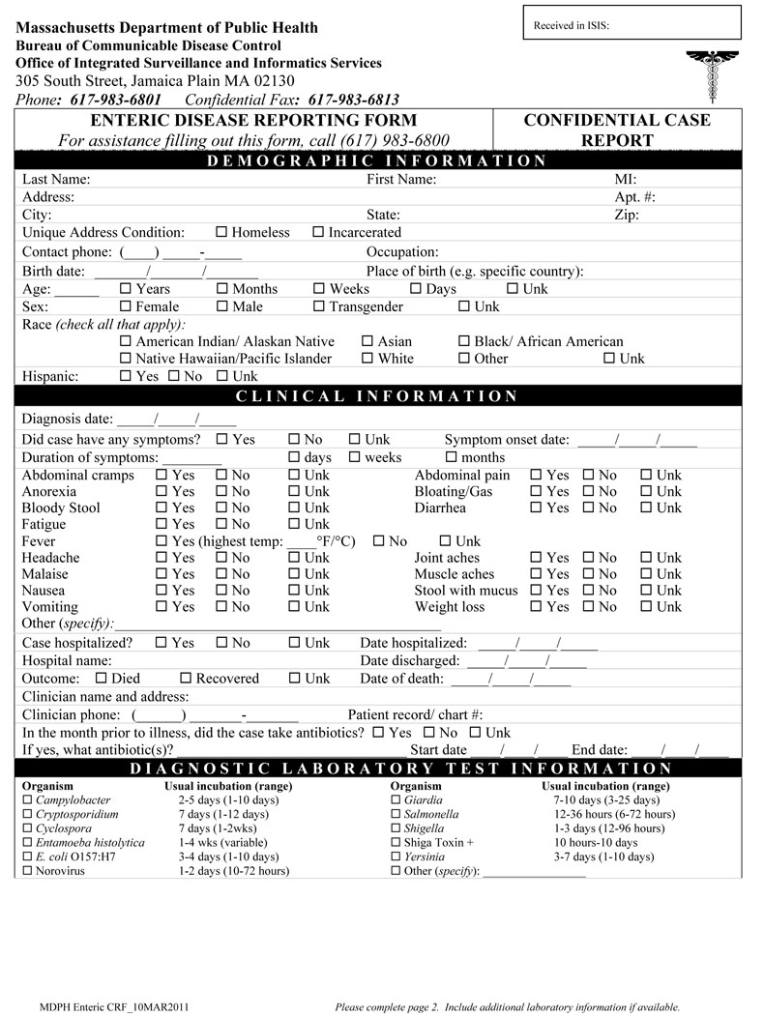
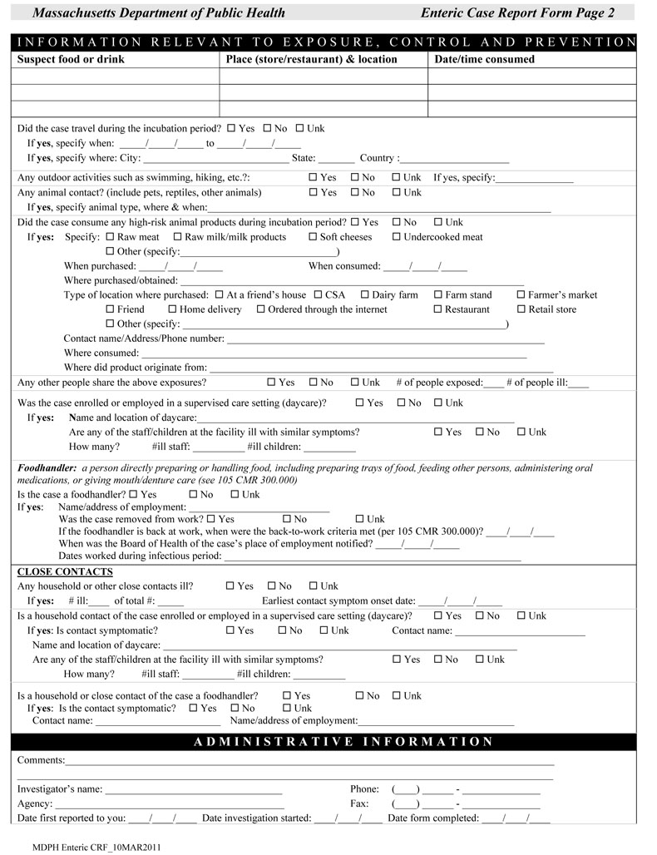
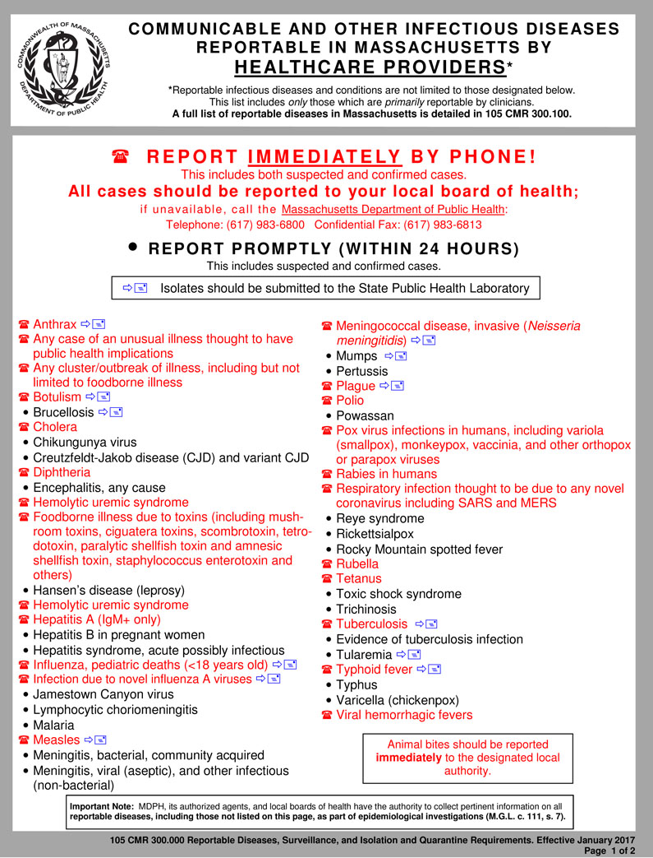
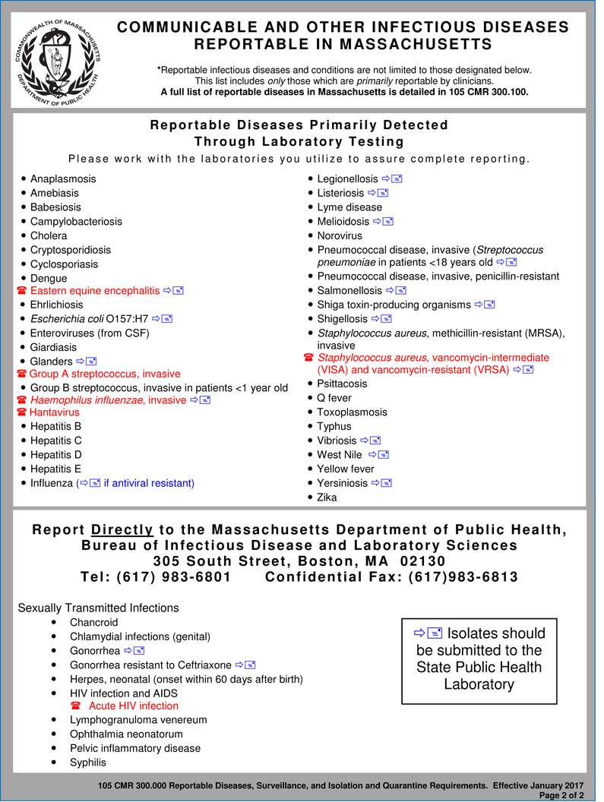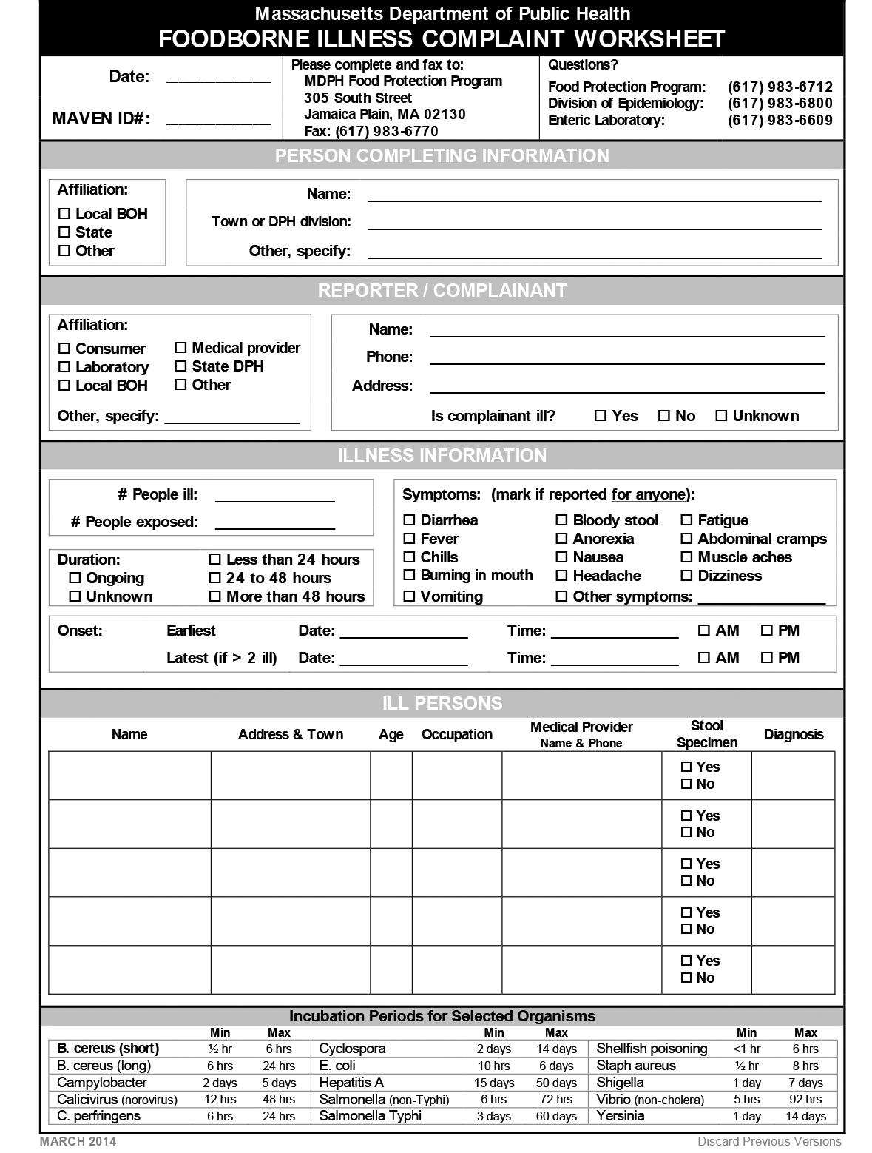
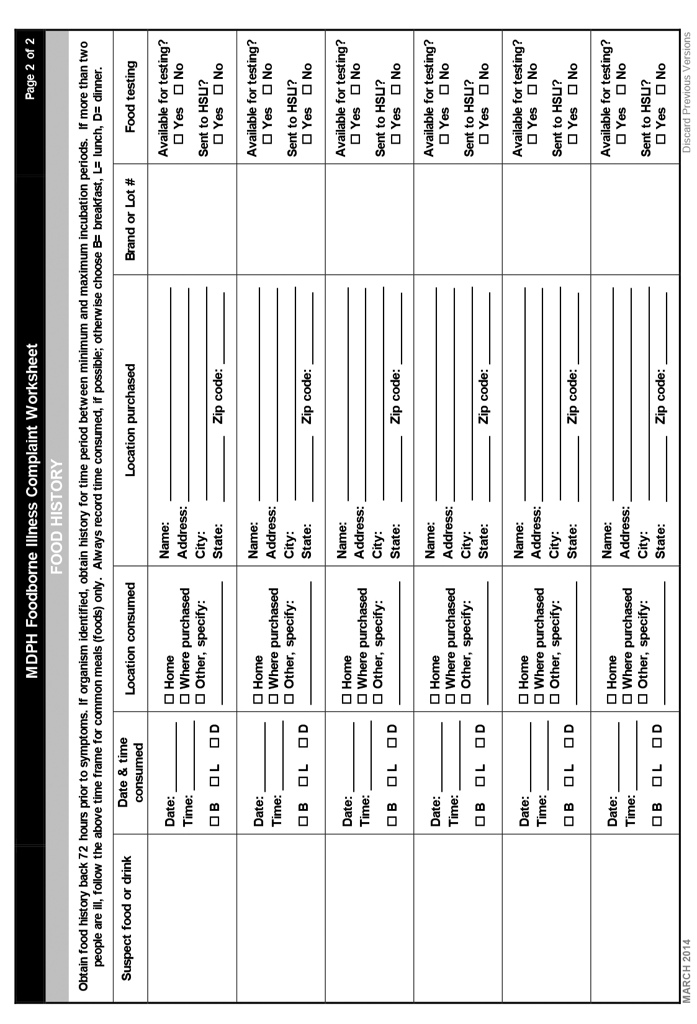
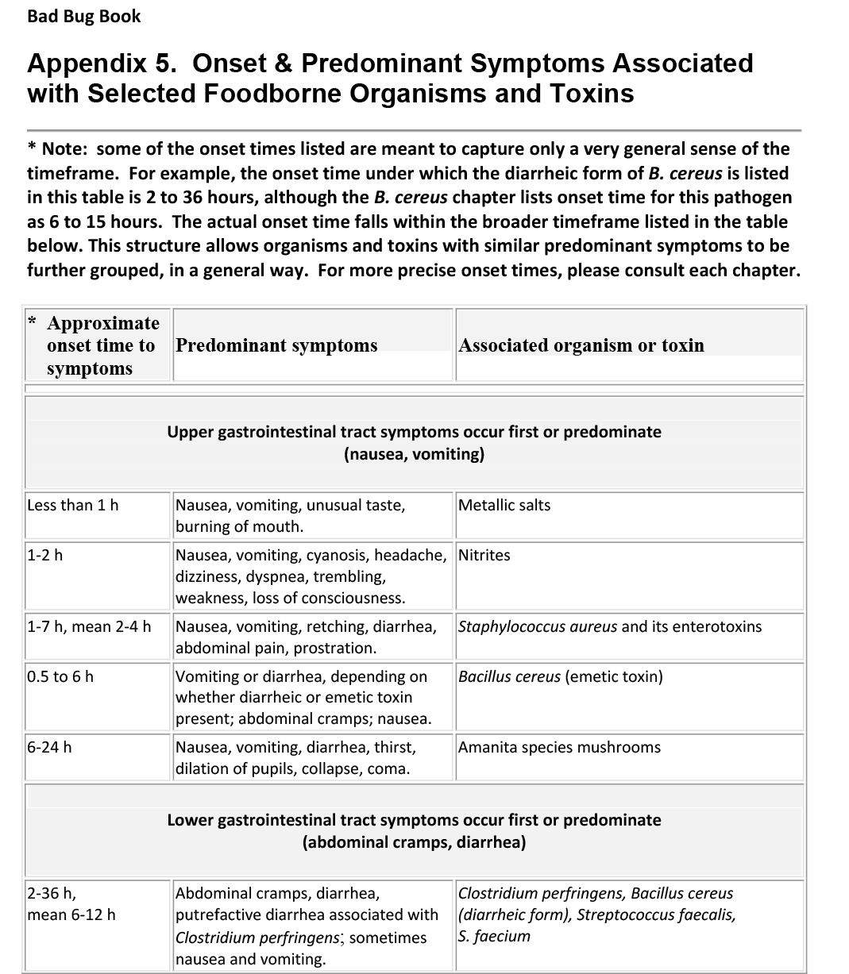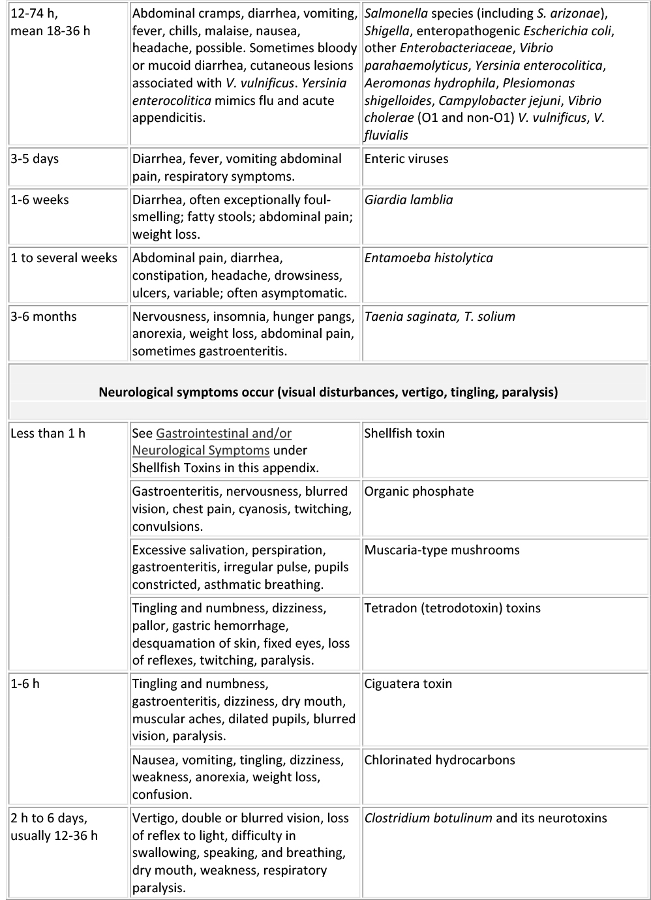
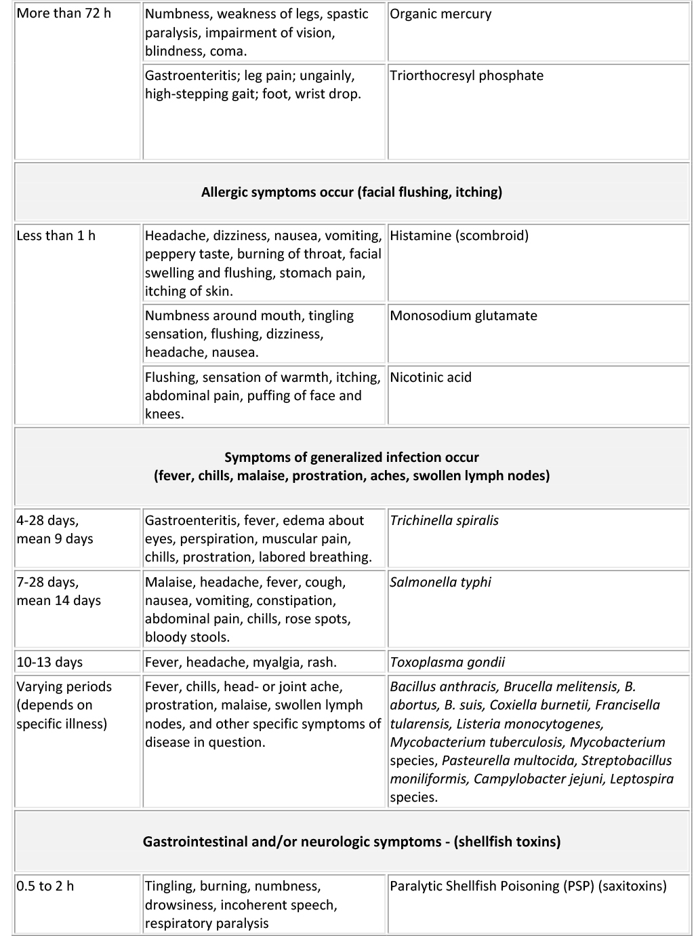

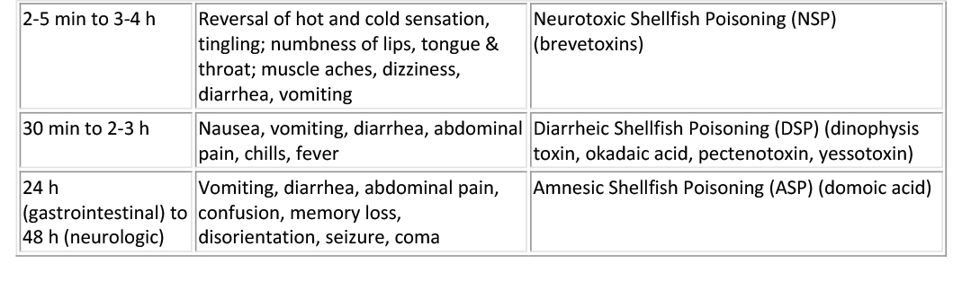
SOURCE: Page 265 from Bad Bug Book, Appendix 5

