Add a New Invoice
Add a New Invoice:
- Select the Billing module.
- Click Invoice Search from the navigation bar.
- Click.
- Select a contract and click.
(Note: If you manage a large number of contracts, you might find the Filter helpful. It restricts the Contract listing to only those that meet your filter criteria. For example, you could use “%DMH% if you wanted to show only DMH contracts.)
- Enter Billing Period dates.
- The Invoice Reference Number field is available for providers who want to enter a reference number for internal tracking purposes. It may be used later within a PRC search to learn payment status.
- Click.
Tips:
- Invoices must be submitted sequentially; if there are no expenses during a billing period, the provider must submit a zero balance invoice.
- If an organization needs to submit more than one invoice a month, a supplemental invoice must be created.
Create a Personnel Summary Report
Create a Personnel Summary Report (PSR):
Depending on the program, you may need to enter a Personnel Summary for Category 1 line items.
Note: If you do not need to enter a PSR, see “Updating Line Items.”

To add a PSR for a Category 1 Line Items:

1. Access the Invoice Summary page.
2. Select Personnel Summary from the navigation bar.
3. Click.
4. Select a Budget Number and click.
The Personnel Summary Add page appears.
5. Enter all required information.
Note: The Employee Amount field is a total for all wages for the employee for the billing period.
6. Click.
Note: If a PSR exists in draft status and needs to be edited, click not in step 3.
- Update as needed and click.
Update Line Items
Update a Line Item (Category 1 or non-Category 1):

- Repeat step 1 from above to access an invoice.
- Click to enter “edit” mode.
- Enter new Invoice Amount(s), as needed.
- Click . This returns you to “read only” mode.

Search for an Invoice
Searching for an Invoice:
- Select the Billing module and Invoice Search from the navigation bar.
The Invoice Search page appears.
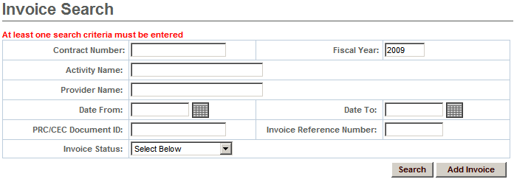
- Enter your search criteria in one of the following fields:
  - Contract Number
  - Activity Name
  - Fiscal Year
  - Provider Name
  - Date From
  - Date To
  - PRC/CEC Document ID
  - Invoice Reference Number
  - Invoice Status

Tip: Use the wildcard % to search for records beginning with or ending with a text string. Or use partial criteria by entering the beginning letters or text string.

- Click.

The search results appear.

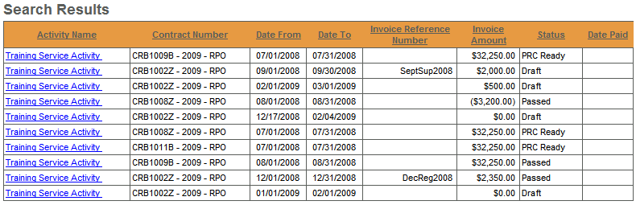
- Click an Activity Name link.
The Invoice Summary page appears including information about the invoice you selected.
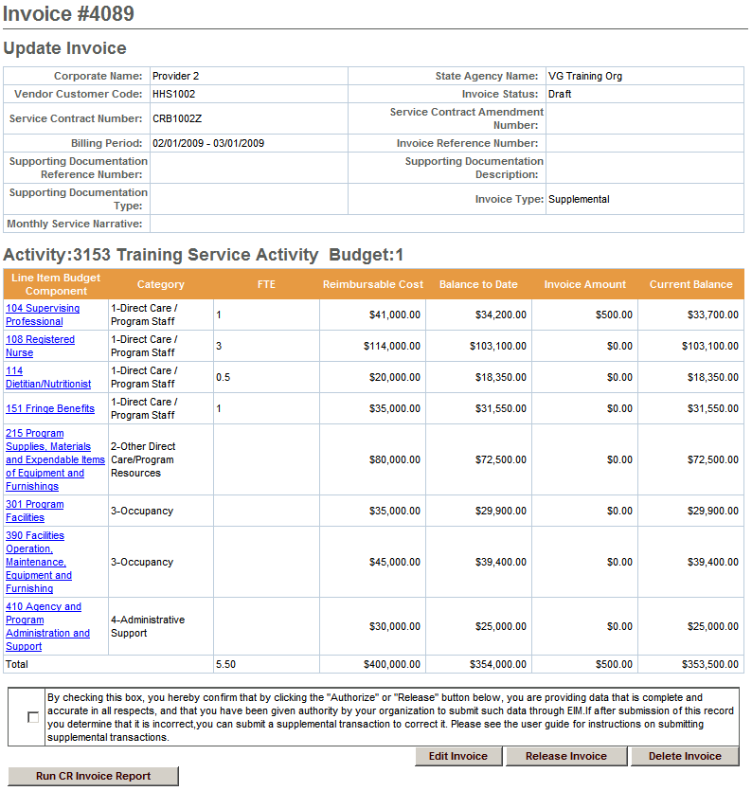

Edit, Release or Disapprove an Invoice
Edit an Invoice:
If you need to edit an invoice in draft status:
1. Access the Invoice Summary page.
2. Click to enter “edit” mode.
3. Enter changes in either Header Level data (under Update Invoice) or at the Activity level, as needed.
4. Click. This returns you to “read only” mode.
Release an Invoice:
If the invoice is ready to be released:
1. Access the Invoice Summary page.
2. Click the checkbox to confirm data is complete and accurate.
By clicking the check box you are complying with legal requirements on releasing an invoice.
3. Click.
Disapprove an Invoice:
To change the status of an invoice with an error from released to draft:
- Access the Invoice Summary page of a released invoice.
- Click.
Authorize or Copy an Invoice
Authorize an Invoice:
If the invoice is ready to be authorized and submitted:
- Access the Invoice Summary page of a released invoice.
- Click the checkbox to confirm data is complete and accurate.
By clicking the check box you are complying with legal requirements on authorizing an invoice.
- Click.
Copy an Invoice Forward:
To copy an invoice forward:
- Access the Invoice Summary page of an invoice from a previous month.
- Click.
- Enter the new Billing Period Dates and any additional information.
- Click.
Print an Invoice
Print an Invoice (User must have reports role for both)
There are two ways that an invoice can be printed:
- From the Invoice Summary page
- From the Reports module
To print an invoice from the Invoice Summary screen:
- Access the Invoice Summary page.
- Click.
Note: The report will generate a report in PDF format for the particular invoice shown on the screen. If a PSR or a CR-Service Delivery Report in reported status exists for the invoice, it will be printed as well.
To print an invoice from the Reports module:
- Access the Report module.
- Select the Cost Reimbursement Invoice report link within “EIM Reports.”
- Enter required criteria and click .
Note: Printing in this way allows you to select an Excel format. It also allows you to omit the PSR Report, as desired.
Search for Payment Request for Commodity
Search for a Payment Request for Commodity (PRC)
- Select the Billing module and select Search for PRC from the navigation bar.
- Enter search criteria and click.
- Click an Activity Name link.
The Update PRC page appears.
Tip: Providers can use the Invoice/SDR Reference Number field to search against a particular Invoice Reference Number, which must be entered prior to invoice authorization.
View Adjudication Data for a Paid Invoice
View Adjudication Information for a Paid Invoice
- Access the Invoice Summary page.
- Select a Payment Date link.
The Invoice Adjudication Summary lists the adjudications, amounts, and status for the line item selected.

Questions or need assistance?
Call Virtual Gateway Customer Service: 1-800-421-0938
(617-847-6578 - TTY for the deaf and hard of hearing)
8:30 am to 5:00 pm Monday through Friday

