INDOOR AIR QUALITY ASSESSMENT

Ipswich Department of Public Works
100 County Road
Ipswich, Massachusetts

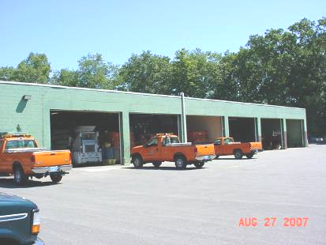

Prepared by:
Massachusetts Department of Public Health
Bureau of Environmental Health
Indoor Air Quality Program
January 2008

Background/Introduction
At the request of Coleen Fermon, Health Director for the Ipswich Board of Health (IBOH), and Bob Gravino, Public Works Director, Town of Ipswich, an indoor air quality assessment was done at the Ipswich Department of Public Works (DPW) facility located at 100 County Road, Ipswich, Massachusetts. The assessment was conducted by the Massachusetts Department of Public Health (MDPH), Bureau of Environmental Health (BEH).
On August 27, 2007, a visit to conduct an indoor air quality assessment was made to the DPW by Cory Holmes, an Environmental Analyst in BEH’s Indoor Air Quality (IAQ) Program. The DPW is a cinderblock structure with an exterior foam insulation system (EFIS) that appears to be constructed in the mid- to late-1950s. The facility mainly consists of garage space for DPW vehicles. Occupied areas include an office, a break room and a restroom. A storage loft in located in the garage that contains a small office/workshop which is reportedly utilized by the Ipswich Forestry Department.

Methods
Air tests for carbon monoxide, carbon dioxide, temperature and relative humidity were conducted with the TSI, Q-Trak, IAQ Monitor, Model 8551. Air tests for airborne particle matter were conducted with a TSI, P-Trak™ Ultrafine Particle Counter Model 8525. Screening for total volatile organic compounds (TVOCs) was conducted using a Thermo Environmental Instruments Inc., Model 580 Series Photo Ionization Detector (PID).

Results
The DPW has an employee population of approximately 10. The tests were taken during normal operations. Test results for general air quality parameters (e.g., carbon dioxide, temperature and relative humidity) appear in Table 1. Test results for ultrafine particles and carbon monoxide are listed in Table 2.

Discussion
Ventilation
It can be seen from Table 1 that the carbon dioxide levels were below 800 parts per million (ppm) in all areas surveyed, which generally indicates adequate air exchange in a building. However, it is important to note that the DPW does not have any means of mechanical ventilation. The building relies on windows to introduce fresh air.
The Massachusetts Building Code requires that each room have a minimum ventilation rate of 20 cubic feet per minute (cfm) per occupant of fresh outside air or openable windows in office space and 1.5 cfm per square foot (cfm/ft²) for garages (SBBRS, 1997; BOCA, 1993). The ventilation must be on at all times that the room is occupied. Providing adequate fresh air ventilation with open windows and maintaining the temperature in the comfort range during the cold weather season is impractical. Mechanical ventilation is usually required to provide adequate fresh air ventilation.
Carbon dioxide is not a problem in and of itself. It is used as an indicator of the adequacy of the fresh air ventilation. As carbon dioxide levels rise, it indicates that the ventilating system is malfunctioning or the design occupancy of the room is being exceeded. When this happens a buildup of common indoor air pollutants can occur, leading to discomfort or health complaints. The Occupational Safety and Health Administration (OSHA) standard for carbon dioxide is 5,000 parts per million parts of air (ppm). Workers may be exposed to this level for 40 hours/week, based on a time-weighted average (OSHA, 1997).
The MDPH uses a guideline of 800 ppm for publicly occupied buildings. A guideline of 600 ppm or less is preferred in schools due to the fact that the majority of occupants are young and considered to be a more sensitive population in the evaluation of environmental health status. Inadequate ventilation and/or elevated temperatures are major causes of complaints such as respiratory, eye, nose and throat irritation, lethargy and headaches. For more information concerning carbon dioxide, please see Appendix A.
Temperature readings were measured in a range of 79º F to 83º F, which were above the MDPH recommended comfort range and consistent with outdoor ambient temperature due to exterior doors and windows being open. The MDPH recommends that indoor air temperatures be maintained in a range of 70º F to 78º F in order to provide for the comfort of building occupants. In many cases concerning indoor air quality, fluctuations of temperature in occupied spaces are typically experienced, even in a building with an adequate fresh air supply. BEH staff noted breaches around exterior doors and missing damaged caulking around single-paned windows, which can allow drafts and/or moisture into the building making it difficult to maintain comfort (Pictures 1 and 2). These breaches can also serve as a means for pests to gain entry into the building. It is also difficult to maintain comfortable temperatures without mechanical ventilation or a means of air conditioning.
Relative humidity measurements ranged from 36 to 40 percent, which were at or slightly below the lower end of the MDPH recommended comfort guidelines. The MDPH recommends that indoor air relative humidity is comfortable in a range of 40 to 60 percent. Relative humidity would be expected to drop below comfort levels during the heating season. The sensation of dryness and irritation is common in a low relative humidity environment. Low relative humidity is a very common problem during the heating season in the northeast part of the United States.

Microbial/Moisture Concerns
A number of areas had water-stained, missing or damaged ceiling tiles (Picture 3). Occupants reported that the building has on-going roof leaks. Water-damaged ceiling tiles can provide a source for mold growth and should be replaced after a moisture source or leak is discovered and repaired.
Breaches in the building envelope were observed in a number of areas around the building (Pictures 4 through 6), which can undermine the integrity of the building envelope and provide a means of water entry by capillary action into the building through the exterior wall system. The US Environmental Protection Agency (US EPA) and the American Conference of Governmental Industrial Hygienists (ACGIH) recommend that porous materials be dried with fans and heating within 24 to 48 hours of becoming wet (US EPA, 2001; ACGIH, 1989). If porous materials are not dried within this time frame, mold growth may occur.

Carbon Monoxide and Ultrafine Particulates
Under normal conditions, a garage/public works facility can have several sources of environmental pollutants present from the operation of vehicles. These sources of pollutants can include:
- Vehicle exhaust containing carbon monoxide and soot;
- Vapors from diesel fuel, motor oil and other vehicle liquids which contain volatile organic compounds (VOCs);
- Water vapor from vehicle washing equipment; and
- Rubber odors from new vehicle tires.
Of particular importance is vehicle exhaust. In order to assess whether contaminants generated by vehicles were accumulating and/or migrating into occupied areas of the DPW, measurements for airborne particulates in combination with carbon monoxide were taken.
The process of combustion produces a number of pollutants, depending on the composition of the material. In general, common combustion emissions can include carbon monoxide, carbon dioxide, water vapor and smoke. Of these materials, carbon monoxide can produce immediate, acute health effects upon exposure. The MDPH established a corrective action level concerning carbon monoxide in ice skating rinks that use fossil-fueled ice resurfacing equipment. If an operator of an indoor ice rink measures a carbon monoxide level over 30 ppm, taken 20 minutes after resurfacing within the rink, that operator must take actions to reduce carbon monoxide levels (MDPH, 1997).
The US Environmental Protection Agency has established National Ambient Air Quality Standards (NAAQS) for exposure to carbon monoxide in outdoor air. Carbon monoxide levels in outdoor air must be maintained below 9 ppm over a twenty-four hour period in order to meet this standard (US EPA, 2006).
Carbon monoxide should not be present in a typical, indoor office work environment. If it is present, indoor carbon monoxide levels should be less than or equal to outdoor levels. However, in an industrial setting where carbon monoxide exposure is normally occurring (e.g., garages, warehouses, shipping/receiving), several work place safety standards exist to reduce exposure. The OSHA permissible exposure limit (PEL) in work places for carbon monoxide is 50 ppm as a time-weighted average (TWA) over an 8-hour workday (OSHA, 1994). The National Institute for Occupational Safety and Health (NIOSH) recommended exposure limit (REL) for carbon monoxide is 35 ppm as an 8-hour TWA and 200 ppm as a ceiling [NIOSH 1992]. The American Conference of Governmental Industrial Hygienists (ACGIH) has a carbon monoxide threshold limit value (TLV) of 25 ppm as a TWA for an 8-hour workday and 40-hour workweek (ACGIH 1994).
Outdoor carbon monoxide was measured at 1 ppm. Carbon monoxide levels measured in the building peaked at 27 ppm in the loft after several minutes of vehicle idling in the garage. Levels dissipated to background after approximately 20-25 minutes with all garage doors opened. It is important to note that the garage is not equipped with any means of local exhaust ventilation to remove products of combustion from operating vehicles, which allows products of combustion to accumulate and linger within the DPW.
Another source of carbon monoxide and particulates was a gas-fired hot water heater located in the loft. BEH staff examined the water heater and found that the exhaust duct was corroded/damaged and was not centered above the exhaust flue, which could provide a means for pollutants to migrate into adjacent areas (Pictures 7 through 9).
The process of combustion also produces airborne liquids, solids and gases (NFPA, 1997). The measurement of airborne particulates, in combination with carbon monoxide measurements can be used to identify the source of combustion products. The combustion of fossil fuels can produce particulate matter that is of a small diameter (10 μm) which can penetrate into the lungs and subsequently cause irritation. For this reason, a device that can measure particles of a diameter of 10 μm or less was also used to identify pollutant pathways from vehicles into the occupied areas. Inhaled particles can cause respiratory irritation.
MDPH air monitoring for airborne particulate was conducted with a TSI, P-Trak™ Ultrafine Particle Counter (UPC) Model 8525, which counts the number of particles that are suspended in a cubic centimeter (cm³) of air. This type of air monitoring device is useful for screening, since it can be used to trace and identify the source of airborne pollutants by counting the actual number of airborne particles. The source of particles can be identified by moving the UPC through a building towards the highest measured concentration of airborne particles. Particles/cm³ of air increases as the UPC is moved closer to the source of particle production.
Air monitoring for ultrafine particles (UFPs) was conducted in the garage, as well as within areas on first and second floors of the facility. Measurements were taken during normal operations. The highest readings for UFPs were taken in the garage after vehicle operation. Higher UFP readings would be expected during these activities.
As mentioned previously, the DPW is not equipped with a mechanical exhaust system to remove exhaust emissions and other pollutants from the building. Several potential pathways for exhaust emissions and other pollutants to migrate from the garage into occupied areas were identified. The doors to the office and break room were open and/or were damaged (Pictures 10 through 12). In addition, the glass to the office window was missing, allowing free flow of air between the office and garage (Picture 12). Each of these breaches presents a pathway for airborne pollutants to move from the garage into adjacent areas. In order to explain how these pollutants may be impacting adjacent areas, the following concepts concerning heated air and creation of air movement must be understood.
- Heated air will create upward air movement, a condition known as the stack effect.
- Cold air moves to hot air, which creates drafts.
- Negative pressure is created as heated air rises. This pressure in turn draws cold air to the equipment creating heat (e.g., vehicle engines).
- Combusted fossil fuels contain heat, gases and particulates that will rise in air. In addition, the more heated air becomes the greater airflow increases.
- The operation of HVAC systems (including rest room exhaust vents if operating) can create negative air pressure, which can draw air and pollutants from the garage and mechanics’ bay.
Each of these concepts has influence on the movement of airborne pollutants to adjacent areas. As motor vehicles operate indoors, the production of vehicle exhaust in combination with cold air moving from outdoors through open exterior doors into the warmer garage creating positive pressure. Positive pressure within a room will force air and pollutants through spaces around doors, utility pipes and other holes in walls, doors and ceilings. To reduce airflow into adjacent areas, sealing of these pollutant pathways should be considered.

Other IAQ Evaluations
Occupants reported that sometime in the 1980s, a five-gallon container of malathion, an organo-phosphate pesticide, was spilled in the second floor forestry workshop directly above the DPW office. DPW staff also recalled that a hazmat team had responded in protective gear to conduct clean-up operations, which included removal of portions of contaminated ceiling materials. No further details or paperwork could be provided by DPW staff regarding specific dates or who had conducted the remediation. Although no odors could be detected in the DPW office by BEH staff during the assessment, DPW staff claim to experience periodic odors described as “irritating”. Staff suspected the source may be lingering odors from the pesticide spill in the wall cavities. Due to the short half-life of organo-phosphate pesticides, it is likely that the active ingredients have long become inert (ATSDR, 2003). However, there is a possibility that the adjuvant or “carrier” solvent that the pesticide was suspended in may be a possible source of odor.
DPW staff also reported odors in the forestry office on the second floor (where the spill had reportedly occurred). However, it appeared that the odor was more likely related to activities conducted in the room such as small engine repair and other mechanical equipment. The room contained a number of chain saws, oils, parts, and a carpet that was extremely soiled with oil/grease stains and other accumulated debris (Picture 13). In addition, the room contained no mechanical ventilation, passive vents or windows to provide a means of air exchange, which allows odors to accumulate.
Indoor air quality can also be impacted by the presence of materials containing volatile organic compounds (VOCs). VOCs are substances that have the ability to evaporate at room temperature. Frequently, exposure to low levels of total VOCs (TVOCs) may produce eye, nose, throat and/or respiratory irritation in some sensitive individuals. For example, chemicals evaporating from a paint can stored at room temperature would most likely contain VOCs. In an effort to determine whether VOCs were present in the building, air monitoring for TVOCs was conducted. Outdoor air samples were taken for comparison. Outdoor TVOC concentrations were ND. Indoor measurements of TVOCs were also ND.
Throughout the building florescent light fixtures were missing covers (Pictures 14 and 15). Fixtures should be equipped with access covers installed with bulbs fully secured in their sockets. Breakage of glass can cause injuries and may release mercury and/or other hazardous compounds.
Finally, although the restroom is equipped with a local exhaust vent that was operable, the configuration of the vent was of concern. It is normal practice to have the electric components installed above the ceiling system. At the DPW the electric components were fed through the vent into the occupied area of the restroom (Picture 15).

Conclusions/Recommendations
The conditions noted at the DPW raise a number of indoor air quality issues. The absence of a local exhaust system in the garage prevents the removal of products of combustion which can accumulate and migrate into adjacent areas via obvious pathways identified in this report. In addition, the general building conditions, maintenance practices and the concern of potential exposure to pesticides present conditions that could degrade indoor air quality. When combined, these conditions can serve to further negatively affect indoor air quality. Some of these conditions can be remedied by actions taken by building occupants. Other remediation efforts will require alteration to the building structure and equipment. For these reasons a two-phase approach is required, consisting of short-term measures to improve air quality and long-term measures that will require planning and resources to adequately address the overall indoor air quality concerns.

The following short-term measures should be considered for implementation:
- Contact an HVAC engineering to design and install local exhaust fan(s) in the garage to remove exhaust emissions. Passive louvered vents (see Picture 16 for an example) should be installed, preferable on an opposite wall to provide makeup air.
- Due to occupant concerns of lingering odors from the reported pesticide spill, the interior wall materials of the DPW office should be removed to examine conditions in the wall cavity. If materials are found soiled/damaged they should be removed and replaced.
- Have water heater inspected to ensure proper installation/operation. Make repairs to exhaust ductwork to prevent the escape of exhaust emissions into the building.
- Consider installing a window or local exhaust in the forestry office if small engine work is to be conducted.
- Remove and discard soiled carpeting in forestry office.
- Keep all doors accessing the garage closed at all times.
- Ensure doors with access to the garage fit completely flush with their threshold, replace if necessary. Seal doors on all sides with foam tape, and/or weather-stripping. Ensure tightness of doors by monitoring for light penetration and drafts around doorframes.
- Install window for DPW office.
- Identify and seal any utility holes that traverse the common wall between the garage and mechanics’ bay and their terminus to reduce/eliminate pollutant paths of migration.
- Repair/replace exterior door to break room to reduce drafts/moisture/pest entry.
- Have restroom exhaust vent inspected by town electrical inspector and/or licensed electrician to ensure proper installation/operation.
- Make temporary roof repairs to eliminate current leaks. Once leaks are repaired replace water damaged ceiling tiles.
- Replace all covers for florescent light fixtures.
- Make repairs to building exterior to prevent water/draft/pest intrusion.
- Install carbon monoxide detectors in the garage and one in the occupied area (where occupants spend the bulk of their time).
- For buildings in New England, periods of low relative humidity during the winter are often unavoidable. Therefore, scrupulous cleaning practices should be adopted to minimize common indoor air contaminants whose irritant effects can be enhanced when the relative humidity is low. To control for dusts, a high efficiency particulate arrestance (HEPA) filter equipped vacuum cleaner in conjunction with wet wiping of all surfaces is recommended. Avoid the use of feather dusters. Drinking water during the day can help ease some symptoms associated with a dry environment (throat and sinus irritations).
- For further building-wide evaluations and advice on maintaining public buildings please refer to the MDPH’s website at http://mass.gov/dph/indoor_air.

The following long-term measures should be considered:
- Consider consulting with an architect, masonry firm or general contractor regarding the integrity of the building envelope, primarily concerning water penetration through the roof and exterior walls. This measure should include a full building envelope evaluation.
- Repair/replace loose/broken windowpanes and missing or damaged window caulking building-wide to prevent water penetration through window frames.
- Examine the feasibility of a total roof replacement. Hire a roofing contractor to evaluate existing roof membrane, ballast, substrate and all associated building materials. Examine the area above and around these areas for microbial growth. Disinfect areas of water leaks with an appropriate antimicrobial.

References
ACGIH 1994. Threshold limit values for chemical substances and physical agents and biological exposure indices for 1994-1995. Cincinnati, OH: American Conference of Governmental Industrial Hygienists.
ACGIH. 1989. Guidelines for the Assessment of Bioaerosols in the Indoor Environment. American Conference of Governmental Industrial Hygienists, Cincinnati, OH.
ATSDR. 2003. Agency for Toxic Substances & Disease Registry. Toxicological Profile for Malathion, September 2003.
BOCA. 1993. The BOCA National Mechanical Code-1993. 8th ed. Building Officials & Code Administrators International, Inc., Country Club Hills, IL. M-308.1
MDPH. 1997. Requirements to Maintain Air Quality in Indoor Skating Rinks (State Sanitary Code, Chapter XI). 105 CMR 675.000. Massachusetts Department of Public Health, Boston, MA.
NFPA. 1997. Fire Protection Handbook. 18th ed. Cote, A.E., ed. National Fire Protection Association, Quincy, MA.
NIOSH. 1992. Recommendations for occupational safety and health: Compendium of policy documents and statements. Cincinnati, OH: U.S. Department of Health and Human Services, Public Health Service, Centers for Disease Control, National Institute for Occupational Safety and Health. DHHS (NIOSH) Publication No. 92-100.
OSHA. 1997. Limits for Air Contaminants. Occupational Safety and Health Administration. Code of Federal Regulations. 29 C.F.R. 1910.1000 Table Z-1-A.
SBBRS. 1997. Mechanical Ventilation. State Board of Building Regulations and Standards. Code of Massachusetts Regulations. 780 CMR 1209.0
US EPA. 2001. “Mold Remediation in Schools and Commercial Buildings”. Office of Air and Radiation, Indoor Environments Division, Washington, DC. EPA 402-K-01-001. March 2001. Available at: http://www.epa.gov/iaq/molds/mold_remediation.html
US EPA. 2006. National Ambient Air Standards (NAAQS). . US Environmental Protection Agency, Office of Air Quality Planning and Standards, Washington, DC. http://www.epa.gov/air/criteria.html.
Picture 1

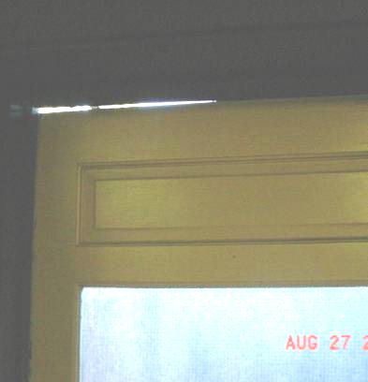

Large Space at Top of Closed Exterior Break Room Door

Picture 2

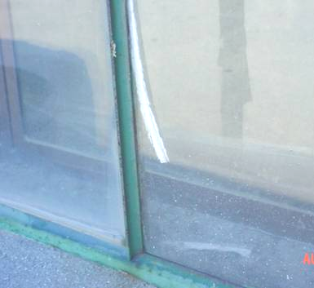

Missing/Damaged Window Caulking

Picture 3

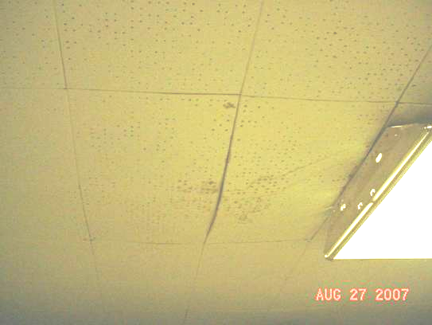

Water Damaged/Bulging Ceiling Tiles in Break Room

Picture 4

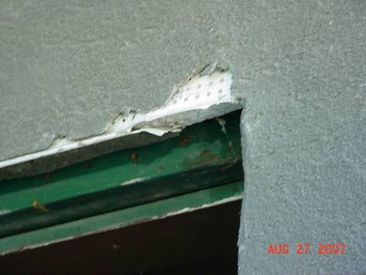

Damaged Building Exterior

Picture 5

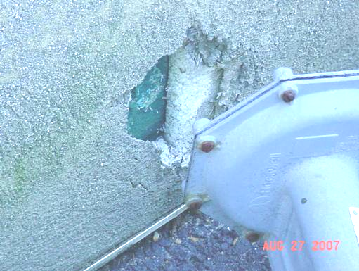

Damaged Building Exterior, Exposing Insulation Material

Picture 6

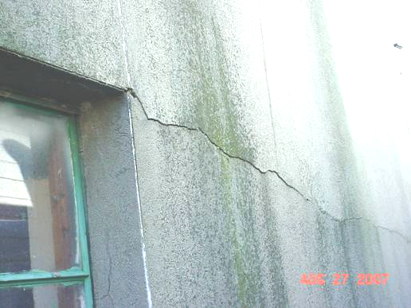

Damaged Building Exterior
Picture 7

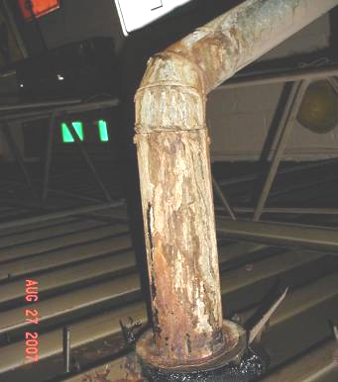

Corroded Water Heater Vent Pipe

Picture 8

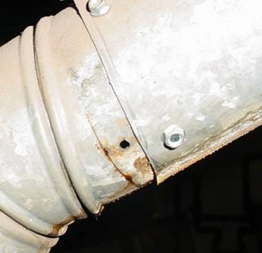

Hole in Water Heater Exhaust Vent Duct

Picture 9

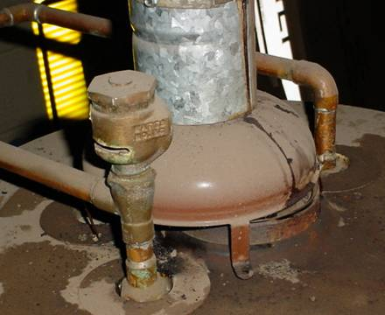

Water Heater Exhaust Duct, Note Duct is not Centered over Exhaust Flue

Picture 10

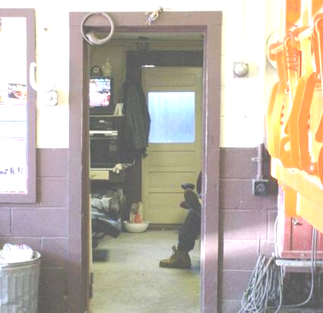

Door to Break Room Held Open
Picture 11

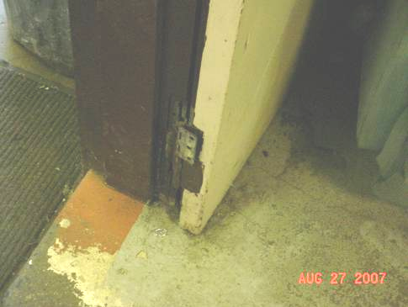

Damaged Door Hinge to Break Room, Note Door Held Open by Chair

Picture 12

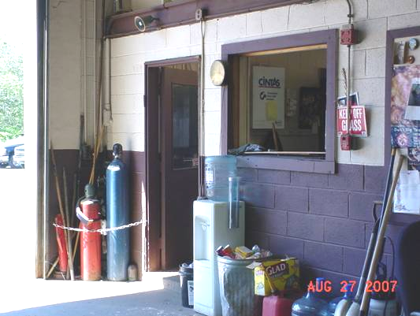

Missing Window and Door to Office Open to the Garage

Picture 13

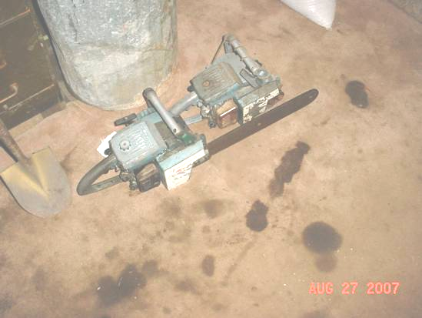

Chainsaws on Soiled Carpet in Forestry Office

Picture 14

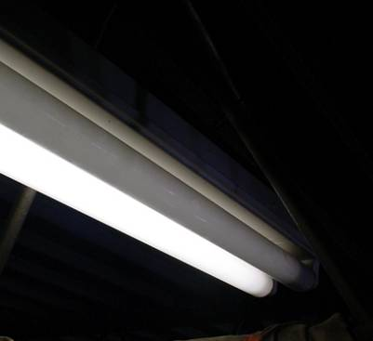

Florescent Light in Loft Missing its Cover
Picture 15

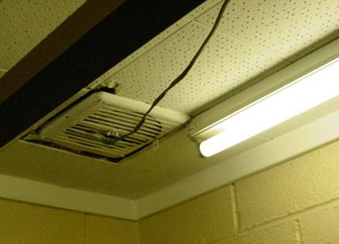

Restroom Exhaust Vent, Note Electric Cord and Florescent Light Missing Cover

Picture 16

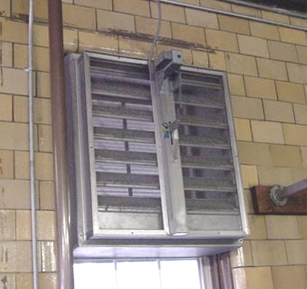

Example of Louvered Make-Up Air Vent
Location | Carbon  Dioxide  (*ppm) |  |  | Temp  (°F) |  | Relative  Humidity  (%) |  | **TVOCs |  | Occupants  in Room |  | Windows  Openable |  | Ventilation |  |  |  | Remarks
 |  |  |  |  |  |  |  | (*ppm) |  |  |  |  |  | Supply |  | Exhaust
Background |  | 405 | 85 |  | 40 |  | ND
DPW Office |  | 450 | 79 |  | 43 |  | ND |  | 3 |  | Y |  | N |  | N
Break Room |  | 579 | 83 |  | 36 |  | ND |  | 2 |  | N |  | N |  | N |  | Spaces around exterior door, water damaged/bowing ceiling tiles, active roof leaks reported
Bathroom |  | 507 | 82 |  | 37 |  | ND |  | 0 |  | N |  | N |  | Y |  | Configuration of exhaust vent-wiring
Loft |  | 405 | 81 |  | 41 |  | ND |  | 0 |  | N |  | N |  | N |  | Water heater-corroded exhaust duct/hole/off-center
Forestry Workshop |  | 472 | 81 |  | 40 |  | ND |  | 0 |  | N |  | N |  | N |  | Soiled/dirty carpet, chainsaw/small engine repair/maintenance
Garage |  | 408 | 80 |  | 39 |  | ND |  | 0 |  |  |  |  |  |  |  | Garage doors open
* ppm = parts per million
** TVOC = total volatile organic compounds
Location | Carbon  Monoxide  (*ppm)  Before | Carbon  Monoxide (*ppm)  After | Carbon  Monoxide (*ppm)  After | Ultrafine  Particulates  **1000p/cc³  Prior to Vehicle Operation | Ultrafine  Particulates  **1000p/cc³  After Vehicle Operation | Ultrafine  Particulates  **1000p/cc³  20-25 minutes after Vehicle Operation | Comments
Background | 1 | 1 | 1 | 2.9
DPW Office | 1 | 1 | 1 | 2.7 | 180.0 | 2.6 | Peak of 180.0 with garage doors closed, dissipated to 2.6 with all garage doors open
Break Room | 1 | 2 | 2 | 5.8 | 137.0 | 3.7 | Peak of 137.0 with garage doors closed, dissipated to 3.7 with all garage doors open
Loft | 1 | 2 | 2 | 4.6 | 137.0-174.0 | 9.0-13.0 | Peak of 174.0 (near water heater) with garage doors closed, dissipated to 9.0-13.0 with all garage doors open
Garage Center | 1 | 2 | 2 | 2.9 | 309.0 | 3.2 | Peak of 309.0 with garage doors closed, dissipated to 3.2 with all garage doors open

