INDOOR AIR QUALITY ASSESSMENT

Ipswich Middle/High School
130 – 134 High Street
Ipswich, Massachusetts 01938

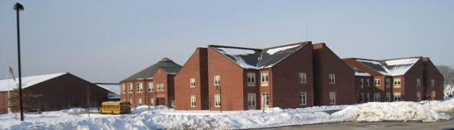

Prepared by:
Massachusetts Department of Public Health
Bureau of Environmental Health
Indoor Air Quality Program
April 2009

Background/Introduction
At the request of Mr. Paul Bedard, Facilities Maintenance/Custodial Supervisor for Ipswich Public Schools, the Massachusetts Department of Public Health (MDPH), Bureau of Environmental Health (BEH) provided assistance and consultation regarding indoor air quality concerns at the Ipswich Middle/High School (IMHS). On November 24, 2008, Susan Koszalka, Sharon Lee and James Tobin, Environmental Analysts/Inspectors within BEH’s Indoor Air Quality (IAQ) Program visited the school to conduct an assessment. On January 23, 2009, Michael Feeney, Director of the IAQ Program, and Mr. Tobin made a follow-up visit to the IMHS. On February 18, 2009, Mr. Feeney and Mr. Tobin returned to the IMHS to examine the attic, classroom unit ventilators (univents) and exterior walls. Concerns regarding mold issues and general indoor air quality prompted the assessment.
The IMHS is a multi-level brick building that was constructed in 1999. The building consists of the east and west wings. The east wing is a two-story structure with an enclosed courtyard. The east wing houses general and science classrooms, work rooms, offices and the library. The west wing contains the cafeteria/kitchen, auditorium/performing arts center, art rooms, music rooms, offices, woodshop and two gymnasiums with locker rooms.

Methods
Air tests for carbon monoxide, carbon dioxide, temperature and relative humidity were conducted with the TSI, Q-Trak, IAQ Monitor, Model 7565. Air tests for airborne particle matter with a diameter less than 2.5 micrometers were taken with the TSI, DUSTTRAK™ Aerosol Monitor Model 8520. BEH staff also performed visual inspection of building materials for water damage and/or microbial growth.
Results
The school houses both middle and high school students in grades 6 through 12. It has a student population of approximately 1200 and a staff of approximately 200. Tests were taken during normal operations at the school and results appear in Tables 1 to 3.

Discussion
Ventilation
It can be seen from Tables 1 and 2 that carbon dioxide levels at the IMHS were above 800 parts per million (ppm) in 34 of 81 areas surveyed on November 24, 2008 and in 39 of 73 areas surveyed on January 23, 2009, indicating poor air exchange in a number of areas. It is important to note that some classrooms had open windows and/or were empty/sparsely populated, which can result in lower carbon dioxide levels. Carbon dioxide levels would be expected to be higher with increased occupancy and windows closed.
Fresh air is supplied to classrooms by unit ventilator (univent) systems (Picture 1). A univent draws air from the outdoors through a fresh air intake located on the exterior wall of the building and returns air through an air intake located at the base of the unit (Figure 1). Fresh and return air are mixed, filtered, heated and provided to classrooms through an air diffuser located in the top of the unit.
BEH staff found univents switched ‘off’ in a number of areas, preventing adequate ventilation of these rooms (Table 1). In addition, books, furniture and other stored items were blocking the top and front of univent air diffusers and returns, thereby limiting airflow in these rooms (Pictures 2 to 4). Further, an accumulation of debris and dust was observed in the air diffusers of several univents (Picture 5). In order for univents to provide fresh air as designed, air diffusers, intakes and returns must remain free of obstructions. Univents should be cleaned before operating to prevent the aerosolization of debris and dust particles. Importantly, these units must remain “on” and be allowed to operate while rooms are occupied.
The heating, ventilating and air conditioning (HVAC) for common areas and interior rooms is provided by rooftop or ceiling-mounted air handling units. AHUs draw in air through outdoor fresh air intakes, and then filter, heat and/or cool the air. Air is then distributed to occupied areas via ceiling-mounted air diffusers and ducted back to the AHUs via ceiling or wall-mounted return vents. Elevated carbon dioxide levels were measured in the gymnasium (819 ppm) at the time of the assessment, which can indicate that the AHUs were deactivated and/or not functioning properly at the time of the assessment.
The mechanical exhaust ventilation system consists of ceiling and wall-mounted exhaust vents (Picture 6) connected to rooftop fan units. Little or no draw of air was detected in some classrooms (Table 1) which can indicate that either the exhaust ventilation was turned off, or that the attic motors were not functioning. It is important to note that classroom exhaust vents are located above or near hallway doors (Picture 7). When classroom doors are open, exhaust vents tend to draw air from the hallway, thereby reducing the effectiveness of the vents to remove common environmental pollutants from classrooms.
The HVAC system in rooms B224 and B226 appear to supply air continuously to these rooms, pressurizing the rooms to the extent that hallway doors to classrooms are resistant to opening. There appears to be an exhaust vent in room B226; however, it did not appear to be functioning at the time of assessments. No exhaust vent exists in B224. In this configuration, neither of these rooms have the ability to provide exhaust ventilation, resulting in odors and other pollutants lingering.
Work rooms in the school house photocopiers, laminators, and/or vending machines. Some of these rooms are not equipped with exhaust ventilation allowing heat and odors to linger in and around the room (Table 1). At various times during the building’s assessment, BEH staff could detect odors in the hallway areas outside the work rooms where photocopier and laminating equipment was in use.
To maximize air exchange, the MDPH recommends that both supply and exhaust ventilation operate continuously during periods of school occupancy. In order to have proper ventilation with a mechanical supply and exhaust system, the systems must be balanced to provide an adequate amount of fresh air to the interior of a room while removing stale air from the room. It is recommended that HVAC systems be re-balanced every five years to ensure adequate air systems function (SMACNA, 1994). The system at IMHS was reportedly balanced in 2007.
The Massachusetts Building Code requires that each room have a minimum ventilation rate of 15 cubic feet per minute (cfm) per occupant of fresh outside air or openable windows (SBBRS, 1997; BOCA, 1993). The ventilation must be on at all times that the room is occupied. Providing adequate fresh air ventilation with open windows and maintaining the temperature in the comfort range during the cold weather season is impractical. Mechanical ventilation is usually required to provide adequate fresh air ventilation.
Carbon dioxide is not a problem in and of itself. It is used as an indicator of the adequacy of the fresh air ventilation. As carbon dioxide levels rise, it indicates that the ventilating system is malfunctioning or the design occupancy of the room is being exceeded. When this happens, a buildup of common indoor air pollutants can occur, leading to discomfort or health complaints. The Occupational Safety and Health Administration (OSHA) standard for carbon dioxide is 5,000 parts per million parts of air (ppm). Workers may be exposed to this level for 40 hours/week, based on a time-weighted average (OSHA, 1997).
The MDPH uses a guideline of 800 ppm for publicly occupied buildings. A guideline of 600 ppm or less is preferred in schools due to the fact that the majority of occupants are young and considered to be a more sensitive population in the evaluation of environmental health status. Inadequate ventilation and/or elevated temperatures are major causes of complaints such as respiratory, eye, nose and throat irritation, lethargy and headaches. For more information concerning carbon dioxide, consult Appendix A.
Indoor temperature measurements ranged from 68º F to 75º F on November 24, 2008, and from 66º F to 80º F on January 23, 2009 (Tables 1 and 2). These measurements were within the MDPH recommended comfort range in the majority of areas surveyed on both days of the assessment. The MDPH recommends that indoor air temperatures be maintained in a range of 70º F to 78º F in order to provide for the comfort of building occupants. In many cases concerning indoor air quality, fluctuations of temperature in occupied spaces are typically experienced, even in a building with an adequate fresh air supply.
The relative humidity measured in the building ranged from 14 to 25 percent on November 24, 2008, and from 13 to 33 percent on January 23, 2009 (Tables 1 and 2). Relative humidity measurements were below the MDPH recommended comfort range in all areas surveyed on both days of the assessment. The MDPH recommends a comfort range of 40 to 60 percent for indoor air relative humidity. Relative humidity levels in the building would be expected to drop during the winter months due to heating. The sensation of dryness and irritation is common in a low relative humidity environment. Low relative humidity is a very common problem during the heating season in the northeast part of the United States.
Microbial/Moisture Concerns
The IMHS east wing has a history of water leaks through its roof. IMHS staff reported that in the winter of 2006, ice dams caused roof leaks resulting in damage to ceiling gypsum wallboard and insulation in the attic. The roof and damaged insulation was reportedly repaired/replaced (Pictures 8 and 9). At the time of the January 2009, the roof of the east wing was found to have large ice dams, particularly on side of the building facing north (Picture 10 and 11).
Ice dams occur when snow (in contact with the roof) melts to form water on the upper section of the roof and refreezes on the lower portion of the roof to form ice. Heated air from occupied spaces moves upwards and gathers in the peak of the roof, warming the roofing material above water’s melting point (32º F). As water rolls down the sloped roof, it freezes into ice when it comes into contact with roof materials on the lower section of the roof that are below 32º F. This ice creates a dam, which then collects and holds melting snow or rainwater against the roof shingles. Pooling water can then penetrate through the roof materials via cracks and crevices, resulting in wetting of the interior of the building.
In order to prevent ice dams, a combination of methods are often used. Ridge vents can be installed along the roof ridge to allow for free exhaust of heat from the attic space. Soffit vents can be installed beneath the eave in the roof to provide a source of cold outdoor air to replace the heated air that escapes through the ridge vent. The floor of the attic space is can be insulated to prevent air movement and heat loss from the occupied space. This configuration of vents can allow heat to escape so that the attic space has a temperature roughly equal to the outdoor temperature. The addition of insulation will prevent warm air from penetrating the attic and cool air from penetrating the occupied spaces below. In that way, the attic space is maintained at a temperature which reduces the potential for roof materials to melt snow in contact with the roof. If attic insulation is inadequate, or ridge vents/soffit vents are sealed, then heat can accumulate in the roof peak and start the cycle of ice dam creation.
The roof and attic of the east wing has an unusual configuration that consists of cement decking and gypsum wallboard, which is attached to floor joists and covered with bales of fiberglass insulation (Pictures 12 and 13). In essence, the building is cement and steel construction, which is then covered with a roof more typical of residential construction. The attic houses the school’s HVAC system. In order to prevent IMHS staff from stepping on the GW/joist sections of the attic floor, floor-to-ceiling walls of plywood were installed within the attic to separate the cement floor area from the GW/joist floor area (Picture 14).
Neither ridge vents nor soffit vents were visible on the east wing roof. The insulation around the GW/joists in the attic floor was either missing (Picture 13) or had significant spaces that would readily allow heated air to move from occupied areas into the attic space. This lack of insulation allows heat to gather in the attic roof peak, subsequently melting snow on the roof to form ice dams. The draw of air from occupied areas through cracks and crevices in ceilings and walls can be increased, resulting in more heated air penetrating into the attic space. Another confounding problem is moistening of insulation resulting from these ice dams. The ability of insulation to prevent temperature transfer is decreased if the material becomes moistened. The loss of temperature control can result in more heat transfer into the attic space, creating larger ice dams and more water penetration. The conditions contributing to the creation of the ice dams should be corrected to prevent moisture problems.
When ice dams melt, water also drips and refreezes at the base of the building beneath the roof which results in univent fresh air intakes being partially blocked with ice (Picture 15). In some areas, the first floor univent fresh air intakes are less than a foot above the ground (Picture 16); these vents are also prone to blockage by accumulated snow, which can reduce the fresh air supply to these classrooms and may result in water penetrations into the univents.
In the east wing, BEH staff identified rooms with water-damaged GW around the univents (Pictures 17 and 18; Table 3). Damaged GW around univents was endemic of east- and south-facing classrooms of the east wing. The source of this water damage is likely driving rain from an easterly direction.
It is important to note that the drip edges of exterior window sills above a number of univent fresh air intakes were sealed with concrete (Picture 19). A drip edge is a notch on the underside of an exterior window’s sill. Its purpose is to prevent water penetration through the seam beneath the exterior window sill by causing the water to bead and drip at this notch. Without a drip edge, water will adhere to the underside of the sill (by capillary action) and accumulate at the seam between the underside of the sill and exterior wall, resulting in possible penetration into the building interior. Further, sealant on some univent fresh air intake vent louver frames was found cracked (Picture 20). These cracks may provide a pathway for water penetration into the univents.
At the time of the January 2009 assessment, remediation of water damaged materials in the library was near completion. The water damage was the result of a burst water pipe. GW in this area was dry and free of visible mold and musty odors.
Several rooms had water-damaged ceiling tiles which can indicate leaks from either the roof and/or plumbing system (Pictures 21 and 22). Water-damaged ceiling tiles can provide a source for mold growth and should be replaced after a water leak is discovered and repaired.
The US Environmental Protection Agency (US EPA) and the American Conference of Governmental Industrial Hygienists (ACGIH) recommend that porous materials be dried with fans and heating within 24 to 48 hours of becoming wet (US EPA, 2001; ACGIH, 1989). If not dried within this time frame, mold growth may occur. Once mold has colonized porous materials, they are difficult to clean and should be removed and discarded.
Plants were noted in several classrooms (Pictures 23 and 24). Plants can be a source of pollen and mold which can be respiratory irritants to some individuals. Plants should be properly maintained and equipped with drip pans and should be located away from univents to prevent the aerosolization of dirt, pollen and mold.
Open seams between sink countertops and walls were observed in some rooms (Picture 25). If not watertight, water can penetrate through the seam, causing damage. Improper drainage or sink overflow can lead to water penetration into the countertop, cabinet interiors and areas behind cabinets. Water penetration and chronic exposure of porous and wood-based materials can cause these materials to swell and show signs of water damage. Repeated moistening of porous materials can result in mold growth.
Around the exterior of the IMHS, trees were observed growing in close proximity to the building and univent fresh air intakes (Picture 26). Trees, shrubs, and plants can hold moisture against exterior brick and prevent drying. Additionally, vegetation growing on or near the fresh air intakes can provide a source for pollen and odors to be entrained into the building by the air handling equipment. The aforementioned condition represents a potential moisture penetration source. Over time, this condition can undermine the integrity of the building envelope and provide a means of water entry into the building via capillary action through foundation concrete and masonry (Lstiburek & Brennan, 2001).

Other IAQ Evaluations
Indoor air quality can be negatively influenced by the presence of respiratory irritants, such as products of combustion. The process of combustion produces a number of pollutants. Common combustion emissions include carbon monoxide, carbon dioxide, water vapor, and smoke (fine airborne particle material). Of these materials, exposure to carbon monoxide and particulate matter with a diameter of 2.5 micrometers (μm) or less (PM2.5) can produce immediate, acute health effects upon exposure. To determine whether combustion products were present in the school environment, BEH staff obtained measurements for carbon monoxide and PM2.5.
Carbon monoxide is a by-product of incomplete combustion of organic matter (e.g., gasoline, wood and tobacco). Exposure to carbon monoxide can produce immediate and acute health affects. Several air quality standards have been established to address carbon monoxide and prevent symptoms from exposure to these substances. The MDPH established a corrective action level concerning carbon monoxide in ice skating rinks that use fossil-fueled ice resurfacing equipment. If an operator of an indoor ice rink measures a carbon monoxide level over 30 ppm, taken 20 minutes after resurfacing within a rink, that operator must take actions to reduce carbon monoxide levels (MDPH, 1997).
The American Society of Heating Refrigeration and Air-Conditioning Engineers (ASHRAE) has adopted the National Ambient Air Quality Standards (NAAQS) as one set of criteria for assessing indoor air quality and monitoring of fresh air introduced by HVAC systems (ASHRAE, 1989). The NAAQS are standards established by the US EPA to protect the public health from six criteria pollutants, including carbon monoxide and particulate matter (US EPA, 2006). As recommended by ASHRAE, pollutant levels of fresh air introduced to a building should not exceed the NAAQS levels (ASHRAE, 1989). The NAAQS were adopted by reference in the Building Officials & Code Administrators (BOCA) National Mechanical Code of 1993 (BOCA, 1993), which is now an HVAC standard included in the Massachusetts State Building Code (SBBRS, 1997). According to the NAAQS, carbon monoxide levels in outdoor air should not exceed 9 ppm in an eight-hour average (US EPA, 2006).
Carbon monoxide should not be present in a typical, indoor environment. If it is present, indoor carbon monoxide levels should be less than or equal to outdoor levels. Outdoor carbon monoxide concentrations were non-detect (ND) on both days of the assessment (Tables 1 and 2). Carbon monoxide levels measured in the building were also ND on both days of the assessment (Tables 1 and 2).
The US EPA has established NAAQS limits for exposure to particulate matter. Particulate matter is airborne solids that can be irritating to the eyes, nose and throat. The NAAQS originally established exposure limits to particulate matter with a diameter of 10 μm or less (PM10). According to the NAAQS, PM10 levels should not exceed 150 microgram per cubic meter (μg/m³) in a 24-hour average (US EPA, 2006). These standards were adopted by both ASHRAE and BOCA. Since the issuance of the ASHRAE standard and BOCA Code, US EPA established a more protective standard for fine airborne particles. This more stringent PM2.5 standard requires outdoor air particle levels be maintained below 35 μg/m³ over a 24-hour average (US EPA, 2006). Although both the ASHRAE standard and BOCA Code adopted the PM10 standard for evaluating air quality, MDPH uses the more protective PM2.5 standard for evaluating airborne particulate matter concentrations in the indoor environment.
Outdoor PM2.5 concentration on November 24, 2008 was measured at 16 μg/m³, which were below the NAAQS PM2.5 level of 35 μg/m³. PM2.5 levels measured inside the school ranged from 2 to 61 μg/m³ (Table 1). Indoor PM2.5 levels were below the NAAQS in the majority of areas surveyed; however, two areas (C112 and C116) had PM2.5 level which exceeded the NAAQS PM2.5 level. These elevated levels were related to ceramic/pottery activities taking place at the time of the assessment. Clay particles were also noted in the univent supply diffuser, indicating that the univent has been used for drying pottery projects (Picture 5). Use of the univent in such manner can result in distribution of clay particles throughout the room. Pottery/clay artworks should be placed away from univents to prevent aerosolization of particles. Several measures to avoid the accumulation of clay dusts include wet mopping and wet wiping of horizontal surfaces (sweeping and dusting can stir up fine particulates) and use of a vacuum cleaner equipped with a high efficiency particulate arrestance (HEPA) filter to reduce the aerosolization of respirable dusts.
The outdoor PM2.5 concentration on January 23, 2009 was measured at 43 μg/m³, which exceeds the NAAQS PM2.5 level of 35 μg/m³. PM2.5 levels measured inside the school ranged from 8 to 33 μg/m³ (Table 2), all of which were below the NAAQS PM2.5 level of 35 μg/m³.
Frequently, indoor air levels of particulates (including PM2.5) can be at higher levels than those measured outdoors. A number of mechanical devices and/or activities that occur in schools can generate particulates during normal operations. Sources of indoor airborne particulates may include, but are not limited to, particles generated during the operation of fan belts in the HVAC system, cooking in the cafeteria stoves and microwave ovens; use of photocopiers, fax machines and computer printing devices; operation of an ordinary vacuum cleaner and heavy foot traffic indoors.
Indoor air concentrations can be greatly impacted by the use of products containing volatile organic compounds (VOCs). VOCs are carbon-containing substances that have the ability to evaporate at room temperature. Frequently, exposure to low levels of total VOCs (TVOCs) may produce eye, nose, throat and/or respiratory irritation in some sensitive individuals. For example, chemicals evaporating from a paint can stored at room temperature would most likely contain VOCs. In an effort to identify materials that can potentially increase indoor VOC concentrations, BEH staff examined classrooms for products containing these respiratory irritants.
Dry erase materials were present classrooms throughout the school. Materials such as dry erase markers and dry erase board cleaners may contain VOCs, (e.g., methyl isobutyl ketone, n-butyl acetate and butyl-cellusolve) (Sanford, 1999) which can be irritating to the eyes, nose and throat. Cleaning products were also observed in a number of classrooms. Like dry erase materials, cleaning products contain VOCs and other chemicals. These chemicals can be irritating to the eyes, nose and throat and should be kept out of reach of students.
As previously mentioned, work rooms in the school did not have exhaust ventilation. These rooms contain photocopiers and laminators which can be sources of pollutants such as VOCs, ozone, heat and odors, particularly if the equipment is older and in frequent use. Both VOCs and ozone are respiratory irritants (Schmidt Etkin, 1992).
Air fresheners and deodorizing materials were observed in a number of areas (Picture 27). Air deodorizers contain chemicals that can be irritating to the eyes, nose and throat of sensitive individuals. Many air fresheners contain 1,4-dichlorobenzene, a VOC which may cause reductions in lung function (NIH, 2006). Furthermore, deodorizing agents do not remove materials causing odors, but rather mask odors that may be present in the area.
BEH staff observed tennis balls which had been sliced open and placed on chair and/or table legs. Tennis balls are made of a number of materials that are a source of respiratory irritants. Constant wearing of tennis balls can produce fibers and cause VOCs to off-gas. Tennis balls are made with a natural rubber latex bladder, which becomes abraded when used as a chair leg pad. Use of tennis balls in this manner may introduce latex dust into the school environment. Some individuals are highly allergic to latex (e.g., spina bifida patients) (SBAA, 2001). It is recommended that the use of materials containing latex be limited in buildings to reduce the likelihood of symptoms in sensitive individuals (NIOSH, 1997).
Other conditions that can affect indoor air quality were observed during the assessment. The chemistry classrooms contain chemical fume hoods (Picture 28), which capture and exhaust contaminants at the source. At the time of the MDPH assessment, the efficacy of the draw of air through this equipment could not be determined. Chemical hoods should be calibrated on an annual basis as recommended by the manufacturer to ensure proper function.
The woodshop machine room contains various wood cutting equipment that lacks dedicated local exhaust to collect saw dust and debris. As a result, saw dust and debris was accumulated on the machines, floor and flat surfaces (Pictures 29 and 30). Although this classroom had general exhaust ventilation, a local dedicated exhaust ventilation system should be used for woodworking operations. Wood dust is a fine particulate, which can be easily aerosolized and become irritating to the eyes, nose, throat and respiratory system. In addition, under certain conditions, wood dust is a fire hazard.
As mentioned, items were observed on the univents, floor, windowsills, tabletops, counters, bookcases and desks in classrooms. The large number of items stored in classrooms provides a source for dusts to accumulate. These items (e.g., papers, folders, boxes) make it difficult for custodial staff to clean. Items should be relocated and/or be cleaned periodically to avoid excessive dust build up. In addition, these materials can accumulate on flat surfaces (e.g., desktops, shelving and carpets) in occupied areas and subsequently be re-aerosolized causing further irritation.
A number of air diffusers, exhaust vents and personal fans were observed to have accumulated dust/debris. These diffusers, vents and fans should be cleaned in order to prevent dust/debris from being aerosolized and redistributed throughout the room.
A number of aquariums and terrariums were located in classrooms. Aquariums should be properly maintained to prevent microbial/algae growth, which can emit unpleasant odors. Similarly, terrariums should be properly maintained to ensure soil does not become a source for mold growth.
Food containers reuse (e.g. for art projects) was observed in a few classrooms. The reuse of food containers that cannot be adequately cleaned and disinfected is not recommended, since food residue adhering to the container’s surface may serve to attract pests. Food containers that are made of porous materials (e.g., cardboard, wax paper, soft plastic, paper beverage (milk) cartons) cannot be adequately cleaned of food residues and should not be reused. Materials made of metal or glass are acceptable if thoroughly cleaned.
Items hanging from ceiling tiles were seen in some classrooms. The movement or damage to ceiling tiles can release accumulated dirt, dust, and particulates that accumulate in the ceiling plenum into occupied areas. Building occupants should refrain from hanging objects from the ceiling tile system and any damaged ceiling tiles should be replaced.

Conclusions/Recommendations
The conditions observed in the IMHS are somewhat complex. The IMHS staff appear to have acted promptly to remediate water damage and arrest mold growth. Without the mean to prevent ice dams, however, continued water penetration is inevitable. In order to address the conditions listed in this assessment, the recommendations made to improve indoor air quality are divided into short-term and long-term corrective measures. The short-term recommendations should be implemented as soon as possible. Long-term solution measures are more complex and will require planning and resources to adequately address overall indoor air quality concerns. In view of the findings at the time of the visit, the following recommendations are provided.
Short Term Recommendations
- Remove water-damaged GW around univents.
- Remove cement from the drip edge of window sills.
- Examine the installation of univent fresh air intake vents for possible leaks, particularly for univents on the east and south exterior walls of the east wing.
- Ice and snow blocking univent fresh air intakes should be routinely removed after snow storms.
- Use openable windows in conjunction with mechanical ventilation to facilitate air exchange. Care should be taken to ensure windows are properly closed at night and weekends to avoid the freezing of pipes and potential flooding.
- Consider adopting a balancing schedule of every 5 years for all mechanical ventilation systems, as recommended by ventilation industrial standards (SMACNA, 1994).
- Examine attic exhaust motors for proper function. Repair/replace belts and parts as necessary.
- Remove all obstructions from univents and mechanical exhaust vents to facilitate air flow. School staff should be encouraged not to deactivate classroom univents rather, to report any complaints concerning temperature control to the facilities department.
- Repair any existing water leaks and replace any remaining water-damaged ceiling tiles. Examine the area above these tiles for mold growth. Disinfect areas of water leaks with an appropriate antimicrobial, as needed.
- For buildings in New England, periods of low relative humidity during the winter are often unavoidable. Therefore, scrupulous cleaning practices should be adopted to minimize common indoor air contaminants whose irritant effects can be enhanced when the relative humidity is low. To control dusts, a high efficiency particulate arrestance (HEPA) filter equipped vacuum cleaner in conjunction with wet wiping of all surfaces is recommended. Avoid the use of feather dusters. Drinking water during the day can help ease some symptoms associated with a dry environment (throat and sinus irritations).
- Relocate or consider reducing the amount of materials stored in classrooms to allow for more thorough cleaning of classrooms. Clean items regularly with a wet cloth or sponge to prevent excessive dust build-up.
- Remove objects hanging from the ceiling tile system in order to avoid introducing ceiling tile material into classrooms.
- Ensure plants are equipped with drip pans. Examine drip pans periodically for mold growth and disinfect with an appropriate antimicrobial, as needed. Move plants away from univents.
- Refrain from using plug-in air fresheners or other air deodorizers.

- As budgets allow, consider replacing carpeting in classrooms with floor tile.

- Trim trees along exterior walls back approximately 5 feet to prevent moisture impingement; and clear any leaf and organic debris from the areas near univent intakes.
- Consider adopting the US EPA (2000) document, “Tools for Schools”, as an instrument for maintaining a good indoor air quality environment in the building. This document is available at: http://www.epa.gov/iaq/schools/index.html.
- Refer to resource manual and other related indoor air quality documents located on the MDPH’s website for further building-wide evaluations and advice on maintaining public buildings. These documents are available at: http://mass.gov/dph/indoor_air.

Long Term Recommendations

- Consult with a building engineer concerning the best methods to retrofit the roof to prevent ice dams. Methods may include the installation of soffit and ridge vents in the existing roof.
- Make efforts to have the non-cement sections of the attic space complete covered with insulation to reduce heat loss into the attic space. Penetrations for ductwork through the attic floor should be sealed. Consideration should be given to covering the insulation and floor joist with flooring to prevent heat loss and provide r means of access for maintenance staff to inspect and conduct repairs to the roof as needed.
- Consider providing exhaust ventilation for rooms B224 and B226.
References

ACGIH. 1989. Guidelines for the Assessment of Bioaerosols in the Indoor Environment. American Conference of Governmental Industrial Hygienists, Cincinnati, OH.
ASHRAE. 1989. Ventilation for Acceptable Indoor Air Quality. American Society of Heating, Refrigeration and Air Conditioning Engineers. ANSI/ASHRAE 62-1989
BOCA. 1993. The BOCA National Mechanical Code/1993. 8th ed. Building Officials and Code Administrators International, Inc., Country Club Hill, IL.
Lstiburek, J. & Brennan, T. 2001. Read This Before You Design, Build or Renovate. Building Science Corporation, Westford, MA. U.S. Department of Housing and Urban Development, Region I, Boston, MA
MDPH. 1997. Requirements to Maintain Air Quality in Indoor Skating Rinks (State Sanitary Code, Chapter XI). 105 CMR 675.000. Massachusetts Department of Public Health, Boston, MA.
Mycometrics. 2007. ERMI Analysis: Test 36 Fungal Species of EPA Mold Panel Report. Mycometrics, LLC. Monmouth Junction, NJ.
NIH. 2006. Chemical in Many Air Fresheners May Reduce Lung Function (#06-11). National Institutes of Health, Research Triangle Park, NC.
NIOSH. 1997. NIOSH Alert: Preventing Allergic Reactions to Natural Rubber Latex in the Workplace. National Institute for Occupational Safety and Health, Atlanta, GA.
OSHA. 1997. Limits for Air Contaminants. Occupational Safety and Health Administration. Code of Federal Regulations. 29 C.F.R 1910.1000 Table Z-1-A.
PES Associates. 2007. Post Remediation Airborne Mold Sampling, Ipswich Middle/High School, Ipswich, MA. PES Associates. Dedham, MA
Sanford. 1999. Material Safety Data Sheet (MSDS No: 198-17). Expo® Dry Erase Markers Bullet, Chisel, and Ultra Fine Tip. Sanford Corporation. Bellwood, IL.
SBBRS. 1997. Mechanical Ventilation. State Board of Building Regulations and Standards. Code of Massachusetts Regulations. 780 CMR 1209.0
SMACNA. 1994. HVAC Systems Commissioning Manual. 1st ed. Sheet Metal and Air Conditioning Contractors’ National Association, Inc., Chantilly, VA.
US EPA. 2001. “Mold Remediation in Schools and Commercial Buildings”. Office of Air and Radiation, Indoor Environments Division, Washington, DC. EPA 402-K-01-001. March 2001. Available at: http://www.epa.gov/iaq/molds/mold_remediation.html
US EPA. 2006. National Ambient Air Quality Standards (NAAQS). US Environmental Protection Agency, Office of Air Quality Planning and Standards, Washington, DC. http://www.epa.gov/air/criteria.html.
Picture 1

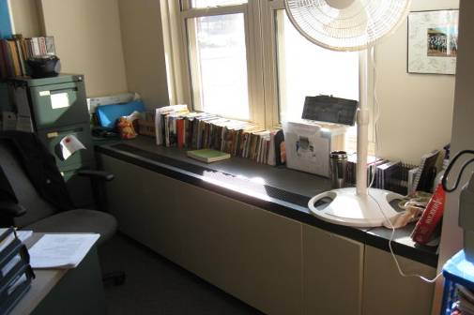

Univent

Picture 2

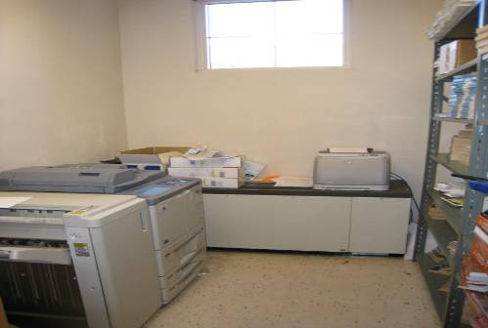

Office Equipment and Documents on Univent

Picture 3

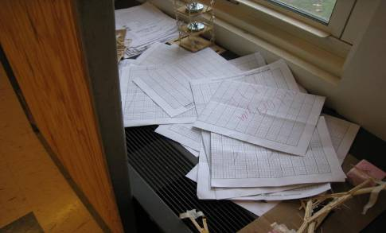

Clutter on Univent

Picture 4

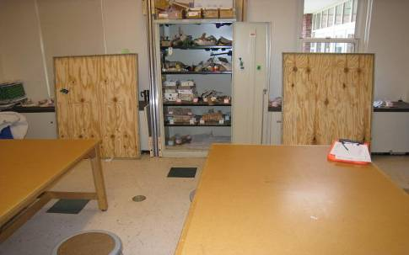

Two Large Wood Panels Blocking Univents

Picture 5

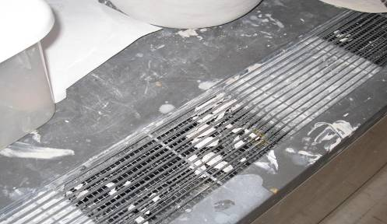

Debris in Univent

Picture 6

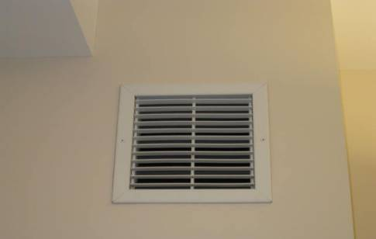

Wall Mounted Exhaust

Picture 7

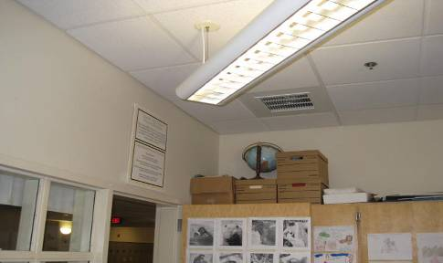

Ceiling Mounted Exhaust (note open door)

Picture 8

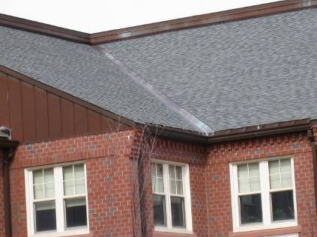

Roof Valley

Picture 9

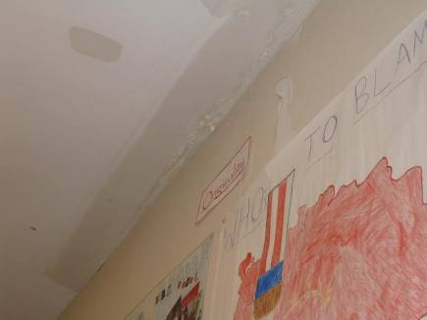

Repaired Ceiling GW in classroom below roof valley

Picture 10

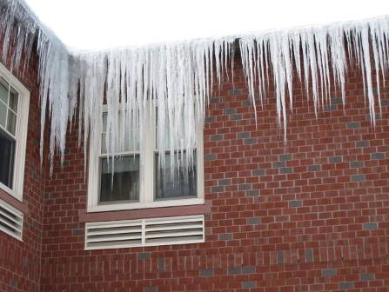

Ice Dam of Roof Edge
Picture 11

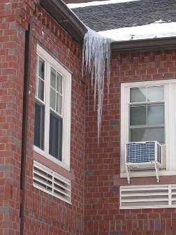

Ice Dam on Roof Edge

Picture 12

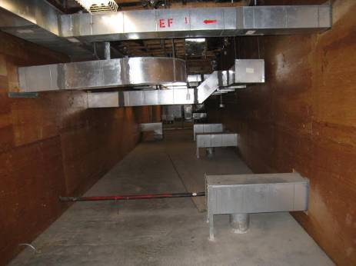

Cement attic floor section
Picture 13

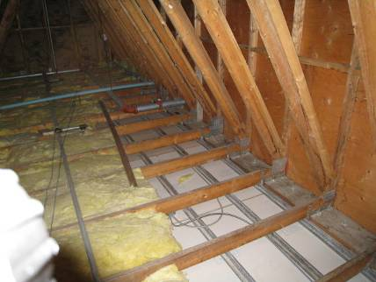

Attic with wood joists and fiberglass insulation bales
Note Missing Insulation from surface of GW

Picture 14

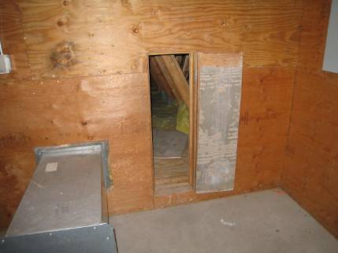

Plywood wall with entrance into wood/GW section.
Note cement floor in foreground

Picture 15

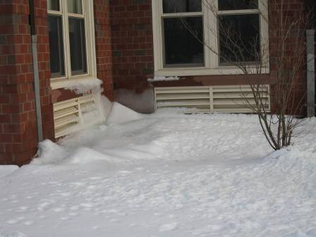

Univent Fresh Air Intake Partially Blocked by Ice

Picture 16

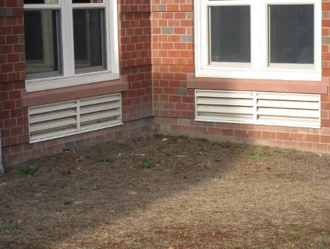

Univent Fresh Air Intake Less than one foot above ground level

Picture 17

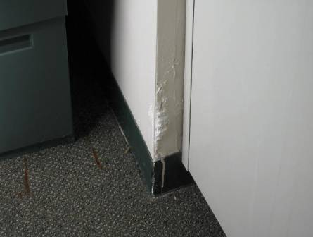

Example of Water Damaged GW around Univent

Picture 18

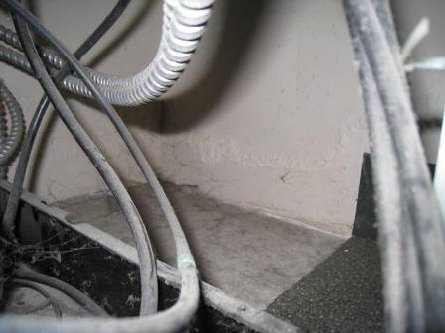
Example of Water damaged GW in univent cabinet,
Note no discoloration, indicating no mold growth
Picture 19

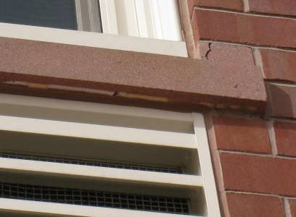

Window Sill Drip edge filled with cement

Picture 20

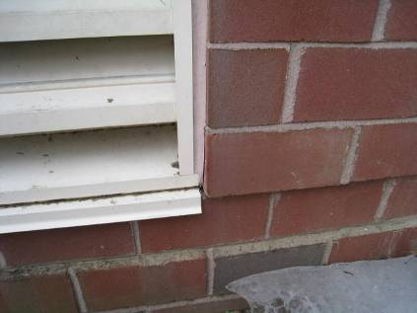

Crack in Fresh Air Intake Vent Sealant

Picture 21

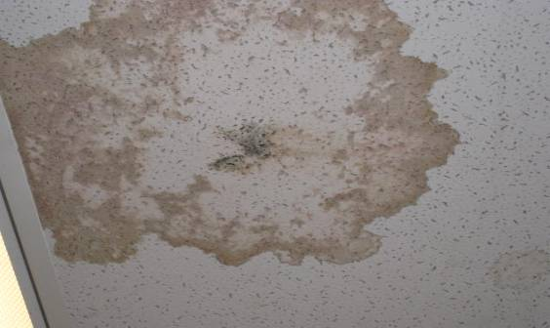

Water Damaged Ceiling Tile

Picture 22

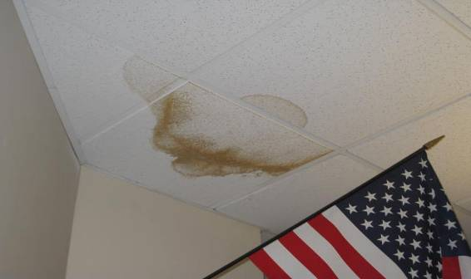

Water Damaged Ceiling Tiles

Picture 23

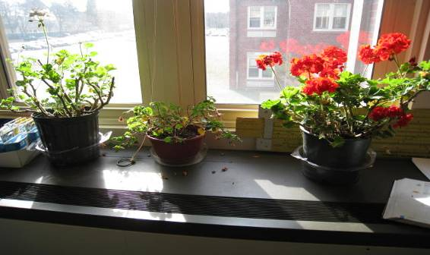

Plants near Univent

Picture 24

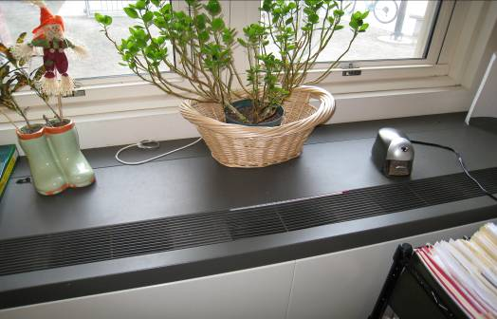

Plants, Straw Items, and Pencil Sharpener near Univent

Picture 25

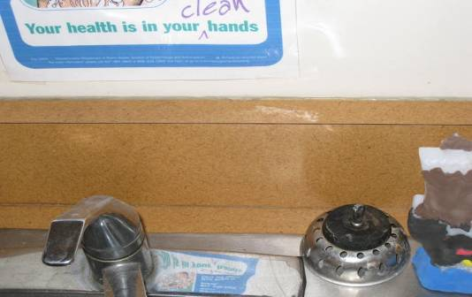

Open Seam between Sink Countertop and Wall

Picture 26

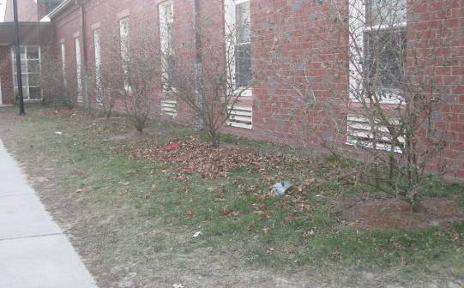

Trees and Leaf Debris in Close Proximity to Univent Intakes and Building

Picture 27

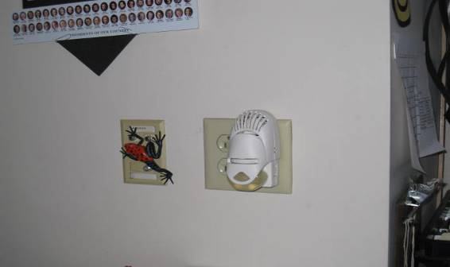

Plug-In Air Freshener

Picture 28

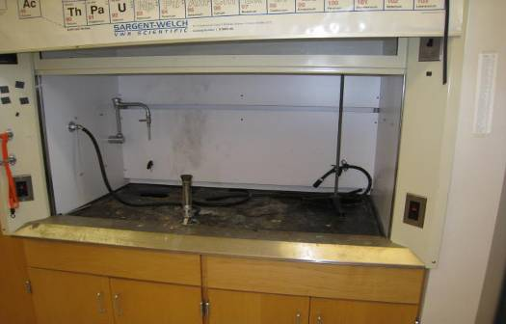

Fume Hood in Science Lab

Picture 29

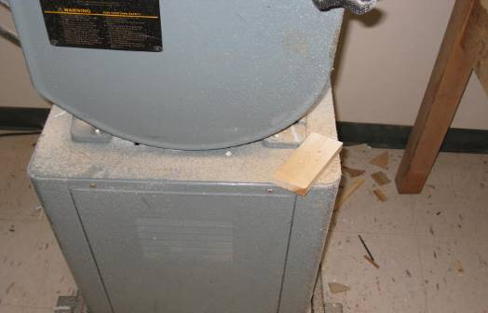

Sawdust and Wood Debris in Machine Room

Picture 30

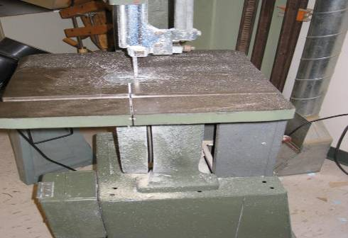

Sawdust in Machine Room
Location/ Room | Occupants  in Room | Temp  (°F) | Relative  Humidity  (%) | Carbon  Dioxide  (ppm) | Carbon Monoxide  (ppm) | PM2.5  (µg/m³) | Windows  Openable | Ventilation |  | Remarks
 |  |  |  |  |  |  |  | Supply | Exhaust | Remarks
background | 0 | 47 | 26 | 385 | ND | 16
A101 | 0 | 73 | 14 | 425 | ND | 11 | Y | Y | Y | DEM, DO
A105 | 0 | 68 | 22 | 784 | ND | 2 | Y | Y | Y  VL | Items on UV; 1 MT; DO; DEM
A106 | 0 | 73 | 18 | 829 | ND | 13 | Y | Y  UV off | Y | DO; door to A105 open
A107 | 1 | 69 | 22 | 902 | ND | 2 | Y | Y | Y  VL | 24 occupants gone 5 minutes; DO; DEM
A108 | 25 | 70 | 22 | 1041 | ND | 4 | Y | Y | Y  off | DEM
A111 | 2 | 73 | 17 | 702 | ND | 10 | Y | Y | Y | DO
A112 | 0 | 72 | 16 | 705 | ND | 10 | Y | Y | N | DO
A115 | 0 | 73 | 15 | 518 | ND | 13 | Y | Y | Y | 2 PCs, refrigerator; laminator; DO
A116 | 3 | 72 | 17 | 580 | ND | 2 | Y | Y | Y | DEM
A118 | 6 | 71 | 17 | 752 | ND | 4 | Y | Y | Y | DEM
A119 | 5 | 70 | 19 | 759 | ND | 3 | Y | Y | Y | DEM
A121 | 20 | 71 | 19 | 767 | ND | 13 | Y | Y | Y | PF, plants
A124 | 20 | 71 | 19 | 822 | ND | 12 | Y | Y | Y | MT exposing pipe
A125 | 0 | 70 | 17 | 624 | ND | 3 | Y | Y | Y  VL | CPs; TB; Aqua; Terra; plants
A126 | 19 | 72 | 18 | 825 | ND | 12 | Y | Y | Y
A127 | 20 | 72 | 20 | 1082 | ND | 4 | Y | Y | Y  VL | Plants; PS on UV
A201 | 21 | 72 | 18 | 726 | ND | 10 | Y | Y | Y  VL | UV blocked; DO; DEM; AD; PF
A202 | 15 | 73 | 19 | 746 | ND | 12 | Y | Y | Y  VL | Plants on UV; DEM; DO; PF
A203 | 12 | 71 | 19 | 744 | ND | 12 | Y | Y | Y | Stored items and PS on UV; DEM; PF
A204 | 0 | 72 | 20 | 911 | ND | 8 | Y | Y | Y  dust | Window AC, 3 aqua
A207 | 0 | 73 | 18 | 648 | ND | 10 | Y | Y | Y | PF
A208 | 0 | 72 | 18 | 637 | ND | 10 | Y | Y | Y | Plants, PS, DO
A218 | 0 | 71 | 17 | 762 | ND | 10 | Y | Y | N | DEM; 3 WD CTs; DO
A221 | 25 | 71 | 16 | 565 | ND | 8 | Y | Y | Y  VL | DEM; DO
A222 | 20 | 73 | 16 | 562 | ND | 11 | Y | Y | Y | DO
A223 | 20 | 73 | 20 | 1042 | ND | 10 | Y | Y  UV off | Y  VL | DEM; DO; PF; AD
A224 | 25 | 74 | 19 | 706 | ND | 14 | Y | Y | Y | TB
A225 | 23 | 71 | 24 | 1139 | ND | 10 | Y | Y  UV off | Y  VL | DEM; TB
A226 | 0 | 70 | 23 | 925 | ND | 12 | Y | Y | Y
Ananian | 1 | 74 | 18 | 785 | ND | 3 | Y | Y | Y
Auditorium | 0 | 70 | 15 | 472 | ND | 7 | N | Y | Y  dust
B102 | 0 | 72 | 23 | 1375 | ND | 15 | Y | Y  UV off | Y  VL | Books and stored items on UV; PF; DEM; DO; WD CT
B104 | 0 | 72 | 17 | 710 | ND | 12 | Y | Y | Y  VL | PF, DO
B105 | 11 | 72 | 24 | 1710 | ND | 13 | Y | Y  UV off | Y | Stored items on UV; PF
B106 | 18 | 72 | 19 | 720 | ND | 13 | Y | Y  UV off | Y
B108 | 18 | 71 | 24 | 1229 | ND | 14 | Y | Y | Y | DEM, PF
B112 | 0 | 72 | 14 | 523 | ND | 9 | Y | Y | N | Books and stored items on UV; 4 computers
B114B | 0 | 73 | 18 | 856 | ND | 9 | N | Y | N | Printer on UV; PC
B203 | 16 | 73 | 23 | 1095 | ND | 12 | Y | Y  UV off | Y | PF in open window; PF on UV
B205 | 18 | 73 | 22 | 1061 | ND | 10 | Y | Y | Y  VL | Stored items on UV; AD; DEM
B206 | 13 | 73 | 22 | 1196 | ND | 6 | Y | Y | Y  VL | Stored items on UV; PF; DEM
B207 | 15 | 72 | 21 | 1054 | ND | 10 | Y | Y | Y  VL | DEM; PF
B208 | 0 | 72 | 19 | 818 | ND | 8 | Y | Y | N | Books on UV, DO
B215 | 1 | 74 | 20 | 782 | ND | 10 | Y | Y | N | PC, vending machine, PC odors in hallway
B221 | 3 | 73 | 18 | 708 | ND | 9 | Y | Y | Y | Oven, refrigerator; stove, gap in sink backsplash
B223 Computer Lab | 0 | 74 | 18 | 743 | ND | 18 | Y | Y | Y | 8 computers
B224 | 0 | 75 | 16 | 619 | ND | 4 | Y | Y  floor vents | N | Debris on floor vents; Fridge on carpet
B225 | 0 | 74 | 16 | 680 | ND | 4 | Y | Y  floor vents | Y | Debris on floor vents
B226 | 0 | 74 | 17 | 728 | ND | 7 | Y | Y  floor vents | Y | Debris on floor vents
B227 | 11 | 72 | 22 | 930 | ND | 10 | Y | Y | Y | DO
B234 | 0 | 74 | 18 | 745 | ND | 4 | N | Y | Y  VL | Plants
C101 | 0 | 72 | 18 | 851 | ND | 10 | Y | Y  1 of 2 UV off | Y | DO
C101 Machine Room | 0 | 73 | 17 | 744 | ND | 11 | Y | Y  2 UVs on | Y | Sawdust on flat surfaces, local exhaust in disrepair, DO
C107 | 8 | 73 | 16 | 672 | ND | 10 | Y | Y | Y  VL | DO; DEM
C107 CADD Room | 0 | 73 | 18 | 751 | ND | 12 | N | Y | Y | 16 computers
C107 Storage |  |  |  |  |  |  |  | N | Y  VL | DO
C112 | 2 | 73 | 18 | 811 | ND | 18 | Y | Y | Y | Stored items, paint, dust on UV; 4 WD CTs; DEM; DO; PC
C112 Work Room | 0 | 75 | 18 | 961 | ND | 37 | Y | Y | Y | Dry Pottery in UV diffusers; Pottery wheels
C116 | 5 | 75 | 21 | 1068 | ND | 61 | Y | Y  1 of 2 UV off | Y  VL | Dust, Debris and Plant on UV; pottery
C116 Storage |  |  |  |  |  |  |  | N | N | 4 WD CTs
Ciulla | 1 | 74 | 18 | 811 | ND | 2 | Y | Y | Y | DO; WD CT
D121 | 0 | 71 | 15 | 444 | ND | 6 | N | Y | Y  VL | PF; DO
D214 | 3 | 75 | 18 | 660 | ND | 8 | N | Y | Y | DO
D224 | 2 | 74 | 16 | 595 | ND | 12 | N | Y | Y | DO, AC
E118 | 22 | 70 | 23 | 1311 | ND | 7 | Y | Y | Y
E119 | 0 | 69 |  | 631 | ND | 8 | N | Y | Y | PC; DO
E127 | 20 | 70 | 25 | 1040 | ND | 8 | Y | Y | Y
E127 Green room practice | 0 | 70 | 23 | 1079 | ND | 5 | Y | Y | N | DO
E134 | 2 | 70 | 23 | 1162 | ND | 9 | Y | Y | Y | DEM
E134 Band practice near exit | 0 | 68 | 18 | 727 | ND | 4 | N | Y | N
E139 | 0 | 71 | 17 | 517 | ND | 4 | Y | Y | Y | 3 WD CTs; PC; DO
Guidance | 2 | 74 | 18 | 783 | ND | 3 | N | Y | Y | 2 WD CTs; PC
Guidance Suite Conference Room | 0 | 73 | 18 | 787 | ND | 9 | Y | Y | Y | 1 WD CT, DO
Health Suite Office | 2 | 74 | 20 | 922 | ND | 14 | Y | Y | Y | Space heater; PF
Health Suite Treatment Room | 0 | 73 | 20 | 941 | ND | 11 | Y | Y | Y | DO
Kitchen office | 2 | 71 | 20 | 705 | ND | 5 | N | N | N
Men’s Locker Room | 0 | 74 | 18 | 713 | ND | 14 | N | Y | Y
Middle School Conference | 0 | 72 | 18 | 816 | ND | 3 | N | Y | Y | Laminator; DO
Middle School Nurse Treatment | 0 | 73 | 18 | 870 | ND | 5 | Y | Y | Y | DO
Middle School Nurses Main | 3 | 74 | 20 | 1049 | ND | 7 | N | Y | Y | DO
Olzewski office | 0 | 72 | 17 | 708 | ND | 2 | Y | Y | Y  VL, dust | DEM; DO
Starz | 0 | 72 | 16 | 707 | ND | 4 | Y | Y | Y | DO
Tongas office | 2 | 72 | 18 | 754 | ND | 3 | Y | Y | Y  VL | DO

Location/ Room | Occupants  in Room | Temp  (°F) | Relative  Humidity  (%) | Carbon  Dioxide  (ppm) | Carbon Monoxide  (ppm) | PM2.5  (µg/m³) | Windows  Openable | Ventilation |  | Remarks
 |  |  |  |  |  |  |  | Supply | Exhaust | Remarks
background |  | 43 | 31 | 389 | ND | 43
A101 | 1 | 73 | 18 | 610 | ND | 21 | Y | Y | Y  VL | DO
A102 | 1 | 73 | 19 | 729 | ND | 19 | Y | Y | Y  VL | DO
A104 | 24 | 74 | 22 | 1075 | ND | 19 | Y | Y | Y  VL | DO
A105 | 0 | 74 | 18 | 598 | ND | 18 | Y | Y | Y  VL | Books on UV
A106 | 1 | 73 | 20 | 758 | ND | 22 | Y | UV off | Y  VL | PF
A107 | 0 | 72 | 21 | 727 | ND | 25 | Y | Y | Y | DEM; DO
A108 | 24 | 72 | 21 | 741 | ND | 22 | Y | Y | Y | DEM; DO
A111 | 2 | 74 | 17 | 617 | ND | 17 | Y | Y | Y
A116 | 7 | 73 | 20 | 834 | ND | 19 | Y | Y | Y
A118 | 2 | 70 | 19 | 540 | ND | 20 | Y | Y | Y | DEM
A119 | 4 | 72 | 20 | 773 | ND | 20 | Y | Y | Y
A121 | 25 | 72 | 21 | 859 | ND | 22 | Y | Y | Y | DEM; Plants
A122 | 18 | 72 | 21 | 868 | ND | 22 | Y | Y | Y | DEM; DO
A123 | 16 | 74 | 21 | 829 | ND | 22 | Y | Y | Y | DEM
A124 | 18 | 73 | 24 | 964 | ND | 22 | Y | Y | Y | DEM; DO
A125 | 24 | 71 | 21 | 941 | ND | 23 | Y | Y | Y | UV blocked; DEM
A126 | 18 | 73 | 22 | 885 | ND | 22 | Y | Y | Y | WD CT; DEM; DO
A127 | 16 | 73 | 21 | 1034 | ND | 21 | Y | Y | Y | Plants on UV; DEM; DO
A128 | 0 | 73 | 21 | 956 | ND | 17 | Y | Y | Y | DO; DEM
A203 | 11 | 72 | 21 | 975 | ND | 20 | Y | Y | Y | Books on UV; PF; DO
A204 | 1 | 73 | 24 | 998 | ND | 14 | Y | Y | Y | Chemical hood; DO
A205 | 24 | 74 | 24 | 1078 | ND | 8 | Y | Y | Y | Chemical hood; DO
A206 | 1 | 74 | 21 | 922 | ND | 12 | Y | Y | Y | Chemical hood; DEM
A207 | 1 | 74 | 17 | 589 | ND | 17 | Y | Y | Y | PF; CPs
A208 | 1 | 73 | 18 | 634 | ND | 18 | Y | Y | Y  VL | DO
Auditorium | 30 | 70 | 18 | 539 | ND | 20 | N | Y | Y
B101 | 1 | 70 | 19 | 626 | ND | 22 | Y | Y | Y | Books and items stored on UV; PFs; DO
B102 | 1 | 73 | 25 | 1258 | ND | 25 | Y | UV off | Y | 13 occupants gone 3 minutes; CPs; PFs
B105 | 1 | 72 | 22 | 835 | ND | 22 | Y | Y | Y | DEM
B106 | 16 | 71 | 23 | 894 | ND | 29 | Y | Y | Y | DEM
B107 | 5 | 71 | 20 | 716 | ND | 24 | Y | Y | Y
B108 | 5 | 71 | 23 | 993 | ND | 24 | Y | Y | Y | Stored items on UV; 20 occupants gone 1 minute
B111 | 0 | 71 | 20 | 783 | ND | 13 | Y | Y | Y | DO; tile floor
B112 | 0 | 73 | 19 | 689 | ND | 20 | Y | Y | N | DO
B114B | 0 | 73 | 20 | 883 | ND | 28 | N | Y | N | PC with odors; tile floor
B131 | 7 | 73 | 23 | 933 | ND | 24 | Y | Y | Y
B131 Chem Room | 0 | 74 | 20 | 863 | ND | 20 | Y | Y | Y
B150 | 1 | 74 | 19 | 859 | ND | 27 | N | Y | Y
B160 | 3 | 74 | 22 | 1005 | ND | 23 | Y | Y | Y
B160 Office | 0 | 75 | 21 | 901 | ND | 22 | Y | Y | Y | DO
B201 | 9 | 72 | 21 | 887 | ND | 20 | Y | Y | Y | DO
B202 | 17 | 73 | 32 | 2698 | ND | 20 | Y | Y | Y
B203 | 13 | 73 | 25 | 1253 | ND | 26 | Y | Y | Y
B204 | 1 | 76 | 17 | 552 | ND | 21 | Y | Y | Y | DEM
B205 | 17 | 72 | 22 | 958 | ND | 18 | Y | Y | Y | WD CT; DEM
B206 | 15 | 72 | 23 | 1070 | ND | 10 | Y | Y | Y | DEM
B208 | 1 | 73 | 17 | 608 | ND | 14 | Y | Y | N | PF
B211 | 0 | 73 | 19 | 773 | ND | 15 | Y | N | Y | WD CTs; DO
B221 | 7 | 75 | 16 | 702 | ND | 17 | Y | Y | Y | DO; oven; stove; refrigerator; tile floor
B221 | 7 | 76 | 15 | 658 | ND | 16 | Y | Y | Y | Gas stove
B224 | 1 | 75 | 16 | 637 | ND | 16 | Y | Y | N | Supply vents on the floor; Room under positive pressure, difficult to push door open
B226 | 4 | 72 | 18 | 647 | ND | 13 | Y | Y | Y | DEM; window shade blocking air flow
B227 | 4 | 73 | 22 | 1055 | ND | 15 | Y | Y | Y | DEM
B246 | 1 | 76 | 16 | 611 | ND | 14 | Y | Y | Y | WD plaster
Café | 1 | 70 | 20 | 469 | ND | 22 | Y | Y | Y
D119 | 1 | 71 | 22 | 687 | ND | 23 | Y | Y | Y
D123 | 1 | 71 | 23 | 805 | ND | 21 | Y | Y | Y | DEM
D201 | 0 | 73 | 20 | 725 | ND | 22 | Y | Y | Y
D207 | 0 | 72 | 21 | 724 | ND | 22 | N | Y | N | DO
D214 | 3 | 74 | 25 | 1025 | ND | 23 | N | Y | N | DO
D224 | 2 | 74 | 21 | 867 | ND | 21 | N | Y | Y
E116 | 30+ | 66 | 26 | 847 | ND | 30 | Y | Y | Y
E118 | 35 | 70 | 25 | 1213 | ND | 33 | Y | Y | Y | WD CTs
E118 | 4 | 69 | 23 | 920 | ND | 18 | Y | Y | Y
E119 | 0 | 69 | 23 | 928 | ND | 28 | N | Y | Y | PC
E122 | 1 | 70 | 26 | 587 | ND | 25 | Y | Y | Y | PC
E139 | 1 | 70 | 20 | 521 | ND | 20 | Y | Y | Y
Gym basketball | 7 | 73 | 24 | 819 | ND | 22 | N | Y | Y
Gym lower | 23 | 71 | 24 | 817 | ND | 26 | N | Y | Y
Library | 5 | 80 | 15 | 697 | ND | 15 | Y | Y | Y | Skylight center of room; CF at top of skylight; Computer workstations
Library Office | 0 | 79 | 14 | 673 | ND | 14 | N | N | Y | DO
Library Staff Work Room | 0 | 79 | 14 | 675 | ND | 15 | N | Y | N | CPs
Lucido | 0 | 79 | 13 | 648 | ND | 15 | N | Y | Y

Classrooms on the Outside Wall of the East Wing
A101 | No visible WD
A102 | No visible WD
B101 | WD on wall
B102 | WD on wall
B103 | WD on wall; Breach exterior wall between air intake and wall
B104 | No visible WD
B107 | No visible WD
B108 | No visible WD
B112 | No visible WD
B201 | WD on wall near UV
B202 | WD on wall near UV
B203 | WD on wall near UV
B204 | Water penetration into UV
B205 | WD on wall
B206 | WD on wall near UV
B207 | WD on wall near UV; WD on ceiling above whiteboard on wall
B208 | WD on wall near UV
B211 | WD on wall near UV

