INDOOR AIR QUALITY ASSESSMENT

Ipswich Public Library
44 School Street
Ipswich, Massachusetts

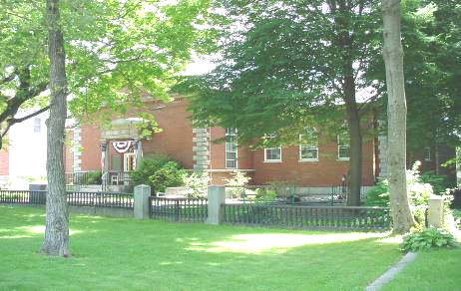

Prepared by:
Massachusetts Department of Public Health
Bureau of Environmental Health
Emergency Response/Indoor Air Quality Program
August 2007

Background/Introduction
At the request of Coleen Fermon, Health Director for the Ipswich Board of Health (IBOH), an indoor air quality assessment was done at the Ipswich Public Library (IPL), 44 School Street, Ipswich, Massachusetts. The assessment was conducted by the Massachusetts Department of Public Health (MDPH), Bureau of Environmental Health (BEH) and prompted by concerns about mold and water damage to carpeting in the ground level of the 1940 wing.
On June 22, 2007, Michael Feeney, Director of Emergency Response/Indoor Air Quality (ER/IAQ), made a visit to the IPL. The IPL was built in 1869 as a two-story, free-standing, red brick building. The first addition was constructed on the south wall of the building in 1940 (Picture 1). A second edition was added to the rear of the building in 1997 (Pictures 2 and 3). Windows are openable in a number of areas in the building.
At the time of the assessment, the building was undergoing restoration of plaster and re-painting ceiling on the second floor of the original building due to water damage. Although minor paint odors were detected, no reports of symptoms related to the restoration work was received by BEH staff.

Methods
BEH staff performed a visual inspection of building materials for water damage and/or microbial growth. Air tests for carbon dioxide, temperature and relative humidity were taken with the TSI, Q-Trak, IAQ Monitor, Model 8551.

Results
The IPL has a daily employee population of approximately 16 and an estimated 200 other individuals who visit on a daily basis. The tests were taken under normal operating conditions. Test results appear in Table 1.

Discussion
Ventilation
It can be seen from Table 1 that carbon dioxide levels were below 800 parts per million (ppm) in all but one area surveyed, which are indicative of an adequate fresh air supply throughout the IPL. The Archive room had a slightly elevated carbon dioxide reading after a short occupancy by the assistant library director and Mr. Feeney.
Ventilation is provided by a heating, ventilating, and air-conditioning (HVAC) system. Fresh air is supplied by rooftop-mounted air handling units (AHUs) (Picture 4). Fresh air is distributed to offices and other areas by ceiling and wall-mounted fresh air diffusers and returned to the rooftop units via ductwork. The Archive room has an AHU that does not introduce fresh air nor does it exhaust air. Therefore, normally occurring pollutants (e.g., carbon dioxide and water vapor) will tend to build-up in this area.
To maximize air exchange, the MDPH recommends that both supply and exhaust ventilation operate continuously during periods of occupancy. In order to have proper ventilation with a mechanical ventilation system, the systems must be balanced subsequent to installation to provide an adequate amount of fresh air to the interior of a room while removing stale air from the room. It is recommended that HVAC systems be re-balanced every five years to ensure adequate air systems function (SMACNA, 1994). The date of the last balancing of these systems was not available at the time of the assessment.
The Massachusetts Building Code requires a minimum ventilation rate of 20 cubic feet per minute (cfm) per occupant of fresh outside air or have openable windows in each room (SBBRS, 1997; BOCA, 1993). The ventilation must be on at all times that the room is occupied. Providing adequate fresh air ventilation with open windows and maintaining the temperature in the comfort range during the cold weather season is impractical. Mechanical ventilation is usually required to provide adequate fresh air ventilation.
Carbon dioxide is not a problem in and of itself. It is used as an indicator of the adequacy of the fresh air ventilation. As carbon dioxide levels rise, it indicates that the ventilating system is malfunctioning or the design occupancy of the room is being exceeded. When this happens a buildup of common indoor air pollutants can occur, leading to discomfort or health complaints. The Occupational Safety and Health Administration (OSHA) standard for carbon dioxide is 5,000 parts per million parts of air (ppm). Workers may be exposed to this level for 40 hours/week, based on a time-weighted average (OSHA, 1997).
The MPDH uses a guideline of 800 ppm for publicly occupied buildings. A guideline of 600 ppm or less is preferred in schools due to the fact that the majority of occupants are young and considered to be a more sensitive population in the evaluation of environmental health status. Inadequate ventilation and/or elevated temperatures are major causes of complaints such as respiratory, eye, nose and throat irritation, lethargy and headaches. For more information concerning carbon dioxide, please see Appendix A.
Temperature readings the day of the assessment ranged from 71º F to 76º F, which were within the MDPH recommended comfort range in all areas surveyed. The MDPH recommends that indoor air temperatures be maintained in a range of 70º F to 78º F in order to provide for the comfort of building occupants. In many cases concerning indoor air quality, fluctuations of temperature in occupied spaces are typically experienced, even in a building with an adequate fresh air supply.
Relative humidity measurements ranged from 40 to 51 percent, which were within the MDPH recommended comfort guidelines on the day of the assessment. The MDPH recommends that indoor air relative humidity is comfortable in a range of 40 to 60 percent. During winter months outdoor relative humidity levels tend to drop. The sensation of dryness and irritation is common in a low relative humidity environment. Low relative humidity is a common problem during the heating season in the northern part of the United States.

Microbial/Moisture Concerns
A number of areas had water damaged ceiling tiles. The likely cause of the water damage is a lack of appropriate water drainage from the roof. Settling of AHUs on the roof has created troughs in the roofing materials that accumulate water (Picture 5). Pooling water can cause damage to the roof membrane as water freezes and thaws during cold weather. Seams may open in the roof membrane, resulting in water damaged ceiling tiles. Water-damaged ceiling tiles can provide a source of mold and should be replaced after a leak is discovered and repaired.
The 1940 wing contains a below grade entrance (Picture 6) equipped with a drain that has either become clogged with debris or may not be of sufficient capacity to remove water during heavy rain. Water from this location has reportedly penetrated through the exterior door to moisten gypsum wallboard (GW) and carpeting. Flood water from drains should be considered to be sewage contaminated for the purpose of clean up (IICRC, 1999). In general, it is recommended that porous materials (GW, wall insulation, carpeting, fabrics, books, cardboard, etc.) be discarded once in contact with sewage (IICRC, 1999). Flooring and sub-flooring (such as wood and tile) should be evaluated, cleaned, disinfected, dried and sealed when appropriate (IICRC, 1999).
A musty odor was detected upon entering the Archive room, which is constructed like a vault (Picture 7). In general, vaults are designed to protect stored records in the case of fire by having no communication with the general HVAC system or are equipped with a separate dedicated system that ventilates the vault only. It appears that the Archive room is connected to its own HVAC system (Picture 8). Due to the age of the original building where the Archive room is located, it is highly unlikely that a vapor barrier exists beneath the floor which would make it prone to condensation. When warm, moist air passes over a surface that is colder than the air, water condensation can collect on the cold surface. Over time, water droplets can form, which can moisten porous, carbon containing materials (e.g., paper and cardboard) to produce mold growth. Since the floor is in contact with soil beneath the building, the temperature of the floor is likely below the dew point, which would moisten the carpet and likely the GW beneath the plastic coving on the wall. This condition may also result in chronic moistening of the document collection in the Archive room, which may result in mold growth.
The US Environmental Protection Agency and the American Conference of Governmental Industrial Hygienists (ACGIH) recommend that porous materials (e.g. ceiling tiles) be dried with fans and heating within 24 hours of becoming wet (US EPA, 2001; ACGIH, 1989). If porous materials are not dried within this time frame, mold growth may occur. Once mold growth has occurred, disinfection of some materials may be possible. Ceiling tiles, GW, carpeting, paper and cardboard are all porous surfaces upon which disinfection is likely to be ineffective.
HVAC system equipment is located in an attic crawlspace above the 1940 wing. Inside this space are two AHUs that have drip pans that do not drain (Picture 9). The surface of each drip pan is severely corroded. Standing water in drip pans can serve as a medium for mold growth. If mold growth occurs, spores and odors can be transported to occupied areas of the building via the HVAC system.
Of note along the exterior of the building were weep holes installed in the base of the exterior curtain wall of the new wing (Picture 10). Exterior wall systems should be designed to prevent moisture penetration into the building interior. An exterior wall system should consist of an exterior curtain wall. Behind the curtain wall is an air space that allows for water to drain downward and for the exterior cladding system to dry. In order to allow for water to drain from the exterior brick system, a series of weep holes is customarily installed in the exterior wall, at or near the foundation slab/exterior wall system junction. Weep holes allow for accumulated water to drain from a wall system (Dalzell, 1955). Opposite the exterior wall and across the air space is a continuous, water-resistant material adhered to the back up wall that forms the drainage plane.
The purpose of the drainage plane is to prevent moisture that crosses the air space from penetrating the interior of the building. The plane also directs moisture downwards toward the weep holes. The drainage plane can consist of a number of water-resistant materials, such as tarpaper or, in newer buildings, plastic wraps. The drainage plane should be continuous. Where breaks exist in the drainage plane (e.g., window systems, door systems, air intakes), additional materials (e.g., flashing) are installed as transitional surfaces to direct water to weep holes. If the drainage plane is discontinuous, missing flashing or lacking air space, rainwater may accumulate inside the wall cavity and lead to moisture penetration into the building.
BEH staff identified a series of blocked weep holes in the exterior brick wall of the 1997 addition. Weep holes were plugged with wicks (Picture 11). “[U]se [of] ropes or tubes for weep [hole]s” is not recommended (Nelson, 1999). Without appropriate drainage, moisture can build up inside the wall’s drainage plane, resulting in increased water/moisture problems in the exterior wall.
The exterior wall has an area beneath a light fixture that is covered with moss (Picture 12). Moss is a sign of chronic dampness and can hold moisture against brick to accelerate decomposition of the curtain wall.

Conclusions/Recommendations
The conditions related to indoor air quality at the IPL raise a number of issues. The design of the Archive room likely allows for normally occurring environmental pollutants to build up, which can lead to IAQ/comfort complaints and may also make this area prone to condensation and mold growth.
A decision should be made concerning the materials stored in the Archive room. Folders, documents, books and other stored materials if moistened by the HVAC system will continue to be a source of mold associated particulates. In this case, ventilation alone cannot serve to reduce or eliminate mold growth in these materials. As an initial step, options concerning the preservation of materials stored in this area should be considered. Since many of these materials appear to be historical records, an evaluation concerning disposition of these materials must be made. Porous materials that are judged not worthy of preservation, restoration or transfer to another media (e.g., microfiche or computer scanning) should be discarded. Where stored materials are to be preserved, restored or otherwise handled, an evaluation should be done by a professional book/records conservator. This process can be rather expensive, and may be considered for conservation of irreplaceable documents that are colonized with mold. Due to the cost of book conservation, disposal or replacement of moldy materials may be the most economically feasible option.
In view of these findings at the time of the visit, the following conclusions and recommendations are made:
- Water damaged/mold colonized building materials (e.g., ceiling tiles, carpeting, GW, wallpaper) should be removed in a manner consistent with recommendations in “Mold Remediation in Schools and Commercial Buildings” published by the US Environmental Protection Agency (US EPA, 2001). This document is available from the US EPA website: http://www.epa.gov/iaq/molds/mold_remediation.html.
- Replace carpeting with a non-porous material (e.g., non-slip tile) in areas subject to repeated water damage.
- Clean drain in below grade entrance regularly to ensure proper drainage.
- Extend rooftop AHU condensation drains to terminate near roof drains.
- Repair damage to roof membrane as needed.
- Install drains for attic crawlspace drip pans.
- Remove wicks from weep holes. Insert appropriate screen material into weep holes to prevent insect entry into wall cavity.
- For buildings in New England, periods of low relative humidity during the winter are often unavoidable. Therefore, scrupulous cleaning practices should be adopted to minimize common indoor air contaminants whose irritant effects can be enhanced when the relative humidity is low. To control for dusts, a high efficiency particulate arrestance (HEPA) filter equipped vacuum cleaner in conjunction with wet wiping of all surfaces is recommended. Avoid the use of feather dusters. Drinking water during the day can help ease some symptoms associated with a dry environment (throat and sinus irritations).
- Examine methods to redirect water moistening brick below light fixture (Picture 12).
- Refer to resource manuals and other related indoor air quality documents for further building-wide evaluations and advice on maintaining public buildings. These materials are located on the MDPH’s website at: http://mass.gov/dph/indoor_air.

References
ACGIH. 1989. Guidelines for the Assessment of Bioaerosols in the Indoor Environment. American Conference of Governmental Industrial Hygienists, Cincinnati, OH.

BOCA. 1993. The BOCA National Mechanical Code-1993. 8th ed. Building Officials & Code Administrators International, Inc., Country Club Hills, IL. M-308.1.

Dalzell, J.R. 1955. Simplified Masonry Planning and Building. McGraw-Hill Book Company, Inc. New York, NY.
IICRC. 1999. IICRC S500. Standard and Reference Guide for Professional Water Damage Restoration, 2nd Edition. Institute of Inspection Cleaning and Restoration, Vancouver, WA.

Nelson, P.E. 1999. Brick Cavity Walls and Associated Flashings. Third Annual Westford Symposium on Building Science Course Book. Building Science Corporation, Westford, MA.

OSHA. 1997. Limits for Air Contaminants. Occupational Safety and Health Administration. Code of Federal Regulations. 29 C.F.R. 1910.1000 Table Z-1-A.

SBBRS. 1997. Mechanical Ventilation. State Board of Building Regulations and Standards. Code of Massachusetts Regulations. 780 CMR 1209.0

SMACNA. 1994. HVAC Systems Commissioning Manual. 1st ed. Sheet Metal and Air Conditioning Contractors’ National Association, Inc., Chantilly, WV.

US EPA. 2001. Mold Remediation in Schools and Commercial Buildings. US Environmental Protection Agency, Office of Air and Radiation, Indoor Environments Division, Washington, DC. EPA 402-K-01-001. March 2001.

Picture 1



First Addition Constructed on the South Wall of the Building in 1940

Picture 2

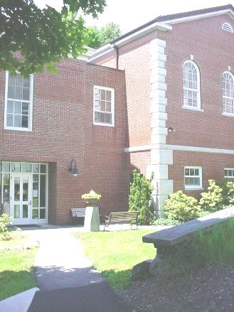

1997 Addition

Picture 3

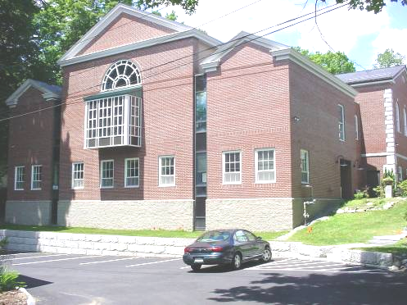

1997 Addition

Picture 4

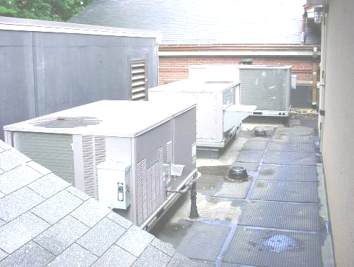

Rooftop AHUs
Picture 5

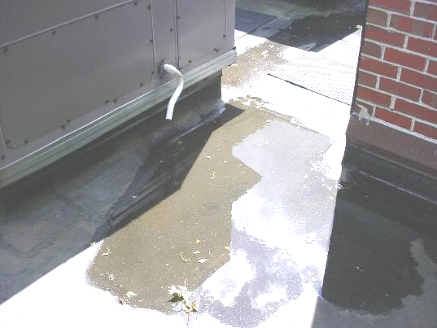

Accumulated Water on Roof of 1997 Addition

Picture 6

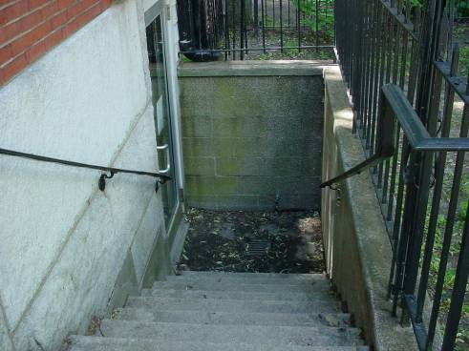

Below Grade Entrance, Note Drain at Bottom
Picture 7

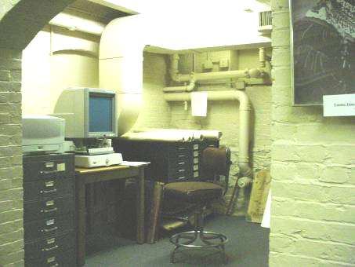

The Archive

Picture 8

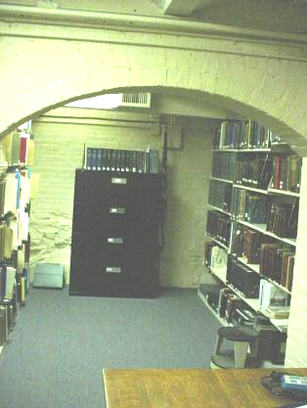

Fresh Air Diffuser of Archive HVAC System

Picture 9

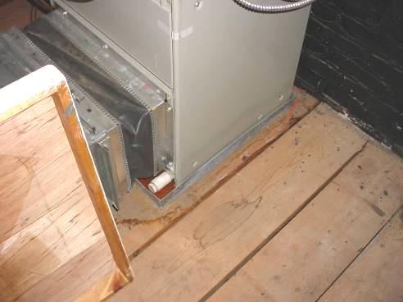

Drain Pans in Attic Crawlspace above 1940 Wing

Picture 10

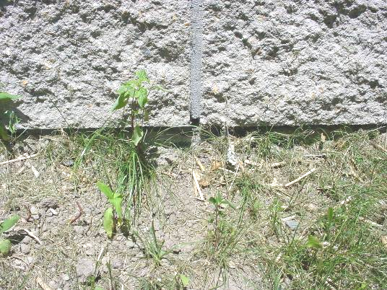

Weep Holes in Wall, 1997 Wing
Picture 11

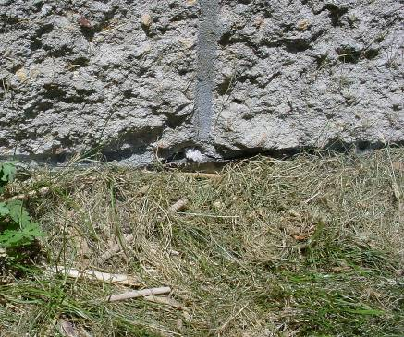

Weep Hole Plugged With Wick

Picture 12

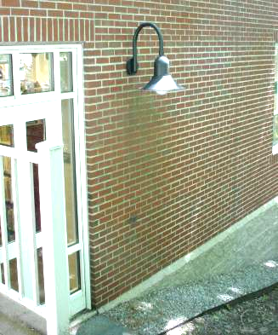

Water Damage/Moss Growth to Exterior Wall beneath Light Fixture
Location | Carbon  Dioxide  (ppm) | Temp  (°F) | Relative  Humidity  (%) | Occupants  in Room | Windows  Openable | Ventilation |  | Remarks
 |  |  |  |  |  | Supply | Exhaust | Remarks
Outside  (Background) | 355 | 70 | 53
Roger’s room | 468 | 73 | 43 | 0 | Y | Y | Y | Window open  Plaster repair
Front desk | 461 | 73 | 43 | 1 | N | N | N
Reference | 463 | 73 | 43 | 4 | Y | Y | Y | Plaster repair
Fiction | 487 | 76 | 42 | 1 | Y | Y | Y
Gallery | 537 | 75 | 41 | 2 | N | Y | Y | Supply off  Exhaust off
AV/Media | 504 | 74 | 41 | 0 | Y | Y | Y | 4 water damaged ceiling tiles
Non-fiction | 677 | 74 | 42 | 2 | Y | Y | Y
Young Adults | 500 | 74 | 40 | 1 | Y | Y | Y | 3 water damaged ceiling tiles
Reference Librarian Office | 525 | 71 | 40 | 0 | Y | N | N | Portable fan
Archive | 888 | 72 | 50 | 2 | N | Y | Y | Musty odor
Tech Services | 475 | 72 | 45 | 2 | Y | Y | Y | Water damaged carpet from flood
Conference Room | 426 | 71 | 51 | 0 | Y | Y | Y
Children’s Room | 501 | 71 | 46 | 5 | Y | Y | Y

