INDOOR AIR QUALITY ASSESSMENT

Ipswich Town Hall
25 Green Street
Ipswich, Massachusetts

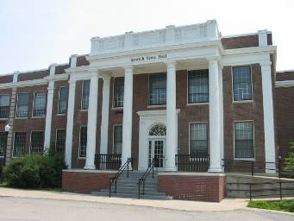

Prepared by:
Massachusetts Department of Public Health
Bureau of Environmental Health
Indoor Air Quality Program
September 2007

Background/Introduction
At the request of Coleen Fermon, Health Director for the Ipswich Board of Health (IBOH), the Massachusetts Department of Public Health (MDPH), Bureau of Environmental Health (BEH) conducted an indoor air quality assessment at the Ipswich Town Hall (ITH), 25 Green Street, Ipswich, Massachusetts. The request was prompted by concerns of mold growth in the computer room and reoccurring respiratory infections among staff in the Finance area.
On July 10, 2007, a visit to conduct an indoor air quality assessment was made to the ITH by Cory Holmes and Sharon Lee, Environmental Analysts in BEH’s Indoor Air Quality (IAQ) Program. BEH staff were accompanied by Rich Dorr, Ipswich Maintenance Department and Ms. Fermon during the assessment.
The ITH is a two-story, red brick building constructed in 1936, originally as a high school. The building also served as a middle school for a number of years. The building was renovated prior to occupancy by Ipswich municipal staff in 2001; renovations included the installation of a modern heating, ventilation and air conditioning (HVAC) system and a new roof. The building contains town offices and public meeting rooms. The basement consists of the Ipswich Council on Aging, Teen Center and storage rooms. Original wooden sash windows throughout the building are openable, but are reportedly difficult to operate in a number of areas.

Methods
BEH staff performed a visual inspection of building materials for water damage and/or microbial growth. Air tests for carbon dioxide, temperature and relative humidity were taken with the TSI, Q-Trak, IAQ Monitor.

Results
The ITH has an employee population of approximately 50 and can be visited by up to 100 members of the public on a daily basis. The tests were taken under normal operating conditions. Results appear in Table 1.

Discussion
Ventilation
It can be seen from Table 1 that carbon dioxide levels were below 800 parts per million (ppm) in all areas, indicating adequate air exchange the day of the assessment. Heating and air-conditioning in common areas and interior spaces is provided by air-handling units (AHUs) that are either located on the roof (Picture 1) or in mechanical rooms. AHUs draw fresh outside air through air intakes located directly on the unit (i.e., rooftop AHUs) or through vents located on the exterior of the building (Picture 2). Outside air is drawn through a bank of pleated air filters (Picture 3) and delivered to occupied areas via ducted ceiling or wall diffusers (Pictures 4 and 5). Return air is ducted back to the AHUs through ceiling or wall-mounted vents. Mr. Dorr reported that a preventive maintenance program for air-handling equipment had been established with a private HVAC vendor.
To maximize air exchange, the MDPH recommends that both supply and exhaust ventilation operate continuously during periods of occupancy. In order to have proper ventilation with a mechanical ventilation system, the systems must be balanced subsequent to installation to provide an adequate amount of fresh air to the interior of a room while removing stale air from the room. It is recommended that HVAC systems be re-balanced every five years to ensure adequate air systems function (SMACNA, 1994). The date of the last balancing of these systems was not available at the time of the assessment.
The Massachusetts Building Code requires that each room have a minimum ventilation rate of 20 cubic feet per minute (cfm) per occupant of fresh outside air or openable windows (SBBRS, 1997; BOCA, 1993). The ventilation must be on at all times that the room is occupied. Providing adequate fresh air ventilation with open windows and maintaining the temperature in the comfort range during the cold weather season is impractical. Mechanical ventilation is usually required to provide adequate fresh air ventilation.
Carbon dioxide is not a problem in and of itself. It is used as an indicator of the adequacy of the fresh air ventilation. As carbon dioxide levels rise, it indicates that the ventilating system is malfunctioning or the design occupancy of the room is being exceeded. When this happens a buildup of common indoor air pollutants can occur, leading to discomfort or health complaints. The Occupational Safety and Health Administration (OSHA) standard for carbon dioxide is 5,000 parts per million parts of air (ppm). Workers may be exposed to this level for 40 hours/week, based on a time-weighted average (OSHA, 1997).
The MPDH uses a guideline of 800 ppm for publicly occupied buildings. A guideline of 600 ppm or less is preferred in schools due to the fact that the majority of occupants are young and considered to be a more sensitive population in the evaluation of environmental health status. Inadequate ventilation and/or elevated temperatures are major causes of complaints such as respiratory, eye, nose and throat irritation, lethargy and headaches. For more information concerning carbon dioxide, please see Appendix A.
Temperature readings the day of the assessment ranged from 68º F to 76º F, which were within or close to the lower end of the MDPH recommended comfort range. The MDPH recommends that indoor air temperatures be maintained in a range of 70º F to 78º F in order to provide for the comfort of building occupants. In many cases concerning indoor air quality, fluctuations of temperature in occupied spaces are typically experienced, even in a building with an adequate fresh air supply.
Relative humidity measurements ranged from 44 to 65 percent, which were within or slightly above the upper end of the MDPH recommended comfort guidelines on the day of the assessment. The MDPH recommends that indoor relative humidity be maintained in a comfort range of 40 to 60 percent. While temperature is mainly a comfort issue, relative humidity in excess of 70 percent for extended periods of time can provide an environment for mold and fungal growth (ASHRAE, 1989). During periods of high relative humidity (late spring/summer months), windows and exterior doors should be closed to keep moisture out. Relative humidity levels in the building would be expected to drop during the winter months due to heating. The sensation of dryness and irritation is common in a low relative humidity environment. Low relative humidity is a very common problem during the heating season in the northeast part of the United States.

Microbial/Moisture Concerns
During the assessment, BEH staff observed what appeared to be visible mold growth on the surface of painted ceiling plaster surrounding a metal air diffuser in the computer room of the finance area (Picture 6). Plaster is a non-porous surface constructed of materials that are not likely to be colonized by mold. However, the paint covering the plaster is a carbon-based material that can support mold growth if exposed to moisture for extended periods of time. BEH staff removed a section of the peeling paint from the plaster ceiling. The suspected mold growth appeared to be limited to the surface of the paint.
In order for building materials to support mold growth, a source of moisture is necessary. Should building materials become wet, identifying and eliminating the water source moistening building materials is necessary to control mold growth. According to Mr. Dorr, the source of moisture wetting the ceiling of the computer room was likely condensation generated from heat blowing out of a supply vent and directly against the computer room AC vent, which operates year round (Picture 7). To prevent this reoccurrence, Mr. Dorr sealed the heat vent, which should eliminate the source causing condensation.
Water-damaged ceiling tiles were observed in a few areas (Picture 8), indicating evidence of historic leaks. Water damaged ceiling tiles can provide a source of mold and should be replaced after a water leak is discovered and repaired.
CEH staff observed a number of cardboard boxes and other porous items stored on the floor of basement storage room G-15 (Picture 9). These items should be elevated (e.g., placed on pallets, tables) to prevent moisture/water damage and potential mold growth. Such materials would be particularly prone to support mold growth during periods of elevated relative humidity (> 70%).
Several additional conditions identified along the building’s exterior may contribute to water penetration into the building. These include the following:
- Missing/damaged mortar and cracks in exterior brick/stone (Pictures 10 through 15);
- Damaged window frames (Picture 16);
- “Bowing” of exterior brick walls (Pictures 17 and 18);
- Open utility holes (Pictures 19 and 20);
- Plant growth in close proximity to air intakes and exterior walls (Pictures 11 and 21); and
- Clinging plant growth on exterior walls (Picture 22). Clinging plants can cause water damage to brickwork through insertion of tendrils into brick and mortar. Water can penetrate into the brick along the tendrils. Water trapped in brick can subsequently freeze and thaw during the winter. This freezing/thawing action can weaken bricks and mortar, resulting in wall damage.
Of particular note is the “bowing” of portions of the exterior wall at the rear of the building, which may raise questions regarding the building’s structural integrity. These breaches to the building envelope can allow water to penetrate the building. Repeated water penetration can result in the chronic wetting of building materials and potential microbial growth. In addition, these breaches may also provide a means of egress for pests/rodents into the building.
Breaches were observed between the counter and sink backsplashes in the lunchroom and in G-12 (Picture 23). If not watertight, water can penetrate through these seams. Water penetration and chronic exposure of porous and wood-based materials can cause these materials to swell and show signs of water damage.
Repeated water damage to porous building materials (e.g., gypsum wallboard, ceiling tiles, carpet) can result in microbial growth. The US Environmental Protection Agency (US EPA) and the American Conference of Governmental Industrial Hygienists (ACGIH) recommend that porous materials be dried with fans and heating within 24 to 48 hours of becoming wet (US EPA, 2001; ACGIH, 1989). If porous materials are not dried within this time frame, mold growth may occur.
Plants were observed in several areas. In one case plants were placed on top of a section of carpeting, which is a porous material that can absorb moisture (Picture 24). Plants should be properly maintained and equipped with drip pans. Plants should be located away from ventilation sources to prevent aerosolization of dirt, pollen or mold. Plants should not be placed on porous materials, since water damage to porous materials may lead to microbial growth.

Other IAQ Evaluations
A number of personal fans, supply and return vents and had accumulated dust (Pictures 4 and 25). Accumulated dust and cobwebs were observed in rooms G-12 and G-15. Fans can aerosolize dust and particulates when activated. Settled dust can provide a source of eye and respiratory irritation when re-aerosolized.

Conclusions/Recommendations
The source of moisture resulting in mold growth in the computer room was identified as most likely being condensation. Mitigation measures taken by Mr. Dorr to seal the heat vent so as not to direct hot air onto the air conditioning vent should eliminate the source of moisture, thus preventing further mold growth. In view of the findings at the time of the visit, the following recommendations are made:
- Remove mold-contaminated paint on ceiling of computer room. Mold should be remediated in a manner consistent with recommendations in “Mold Remediation in Schools and Commercial Buildings” published by the US Environmental Protection Agency (US EPA, 2001). Copies of this document can be downloaded from the US EPA website at: http://www.epa.gov/iaq/molds/mold_remediation.html.
- Replace any remaining water-stained ceiling tiles. Examine the areas above and around these areas for microbial growth.
- Seal breaches, seams and spaces between sink countertop and backsplash in lunchroom and G-12 to prevent water damage/mold growth.
- Remove clinging plants from exterior brick.
- Trim or relocate plant growth in close proximity to air intakes as needed to prevent the entrainment of mold, pollen and/or particulates into the ventilation system.
- Seal utility holes in exterior walls to eliminate paths of migration for drafts, moisture and pests into the building.
- Refrain from storing porous materials (e.g., cardboard boxes) directly on floor of storage rooms. Inspect and discard any water damaged cardboard boxes. Disinfect any areas of microbial growth with a mild detergent; wipe surfaces clean with soap and water after disinfection.
- Ensure all plants are equipped with drip pans. Examine drip pans for mold growth and disinfect areas of water leaks with an appropriate antimicrobial where necessary. Remove carpet from beneath plants (Picture 24).
- Consider balancing mechanical ventilation systems every 5 years, as recommended by ventilation industrial standards (SMACNA, 1994).
- For buildings in New England, periods of low relative humidity during the winter are often unavoidable. Therefore, scrupulous cleaning practices should be adopted to minimize common indoor air contaminants whose irritant effects can be enhanced when the relative humidity is low. To control for dusts, a high efficiency particulate arrestance (HEPA) filter equipped vacuum cleaner in conjunction with wet wiping of all surfaces is recommended. Avoid the use of feather dusters. Drinking water during the day can help ease some symptoms associated with a dry environment (throat and sinus irritations).
- Clean personal fans, supply and exhaust vents regularly of accumulated dust. Clean or change soiled ceiling tiles around these vents (e.g., Teen Center).
- Refer to resource manuals and other related indoor air quality documents for further building-wide evaluations and advice on maintaining public buildings. These materials are located on the MDPH’s website at: http://mass.gov/dph/indoor_air.

Due to structural integrity related issues observed on the exterior of the building, the following long-term recommendations are made:
- Consider having exterior walls re-pointed and waterproofed to prevent water intrusion.
- Contact a structural engineer/building envelope specialist for an examination of the exterior brick work of the building, especially in areas where the exterior wall is “bowing” outwards. This measure should include a full building envelope evaluation.
References
ACGIH. 1989. Guidelines for the Assessment of Bioaerosols in the Indoor Environment. American Conference of Governmental Industrial Hygienists, Cincinnati, OH.

ASHRAE. 1989. Ventilation for Acceptable Indoor Air Quality. American Society of Heating, Refrigeration and Air Conditioning Engineers. ANSI/ASHRAE 62-1989
BOCA. 1993. The BOCA National Mechanical Code-1993. 8th ed. Building Officials & Code Administrators International, Inc., Country Club Hills, IL. M-308.1

OSHA. 1997. Limits for Air Contaminants. Occupational Safety and Health Administration. Code of Federal Regulations. 29 C.F.R 1910.1000 Table Z-1-A.

SBBRS. 1997. Mechanical Ventilation. State Board of Building Regulations and Standards. Code of Massachusetts Regulations. 780 CMR 1209.0

SMACNA. 1994. HVAC Systems Commissioning Manual. 1st ed. Sheet Metal and Air Conditioning Contractors’ National Association, Inc., Chantilly, WV.

US EPA. 2001. Mold Remediation in Schools and Commercial Buildings. US Environmental Protection Agency, Office of Air and Radiation, Indoor Environments Division, Washington, D.C. EPA 402-K-01-001. March 2001.
Picture 1

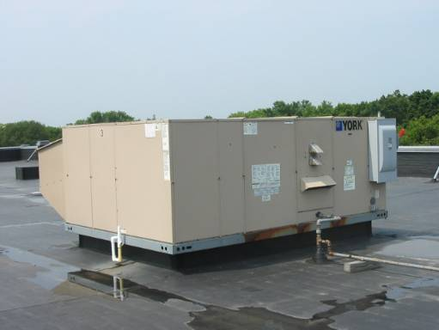

Rooftop AHU

Picture 2

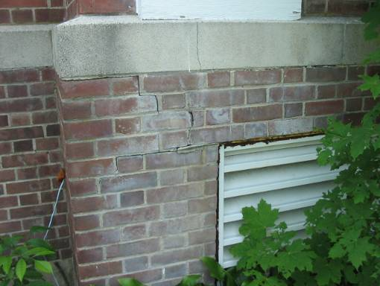

Fresh Air Intake for AHU in Mechanical Room

Picture 3

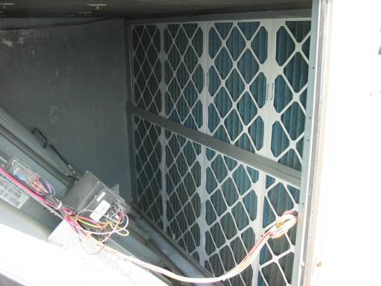

Bank of Pleated Air Filters in Rooftop AHU

Picture 4

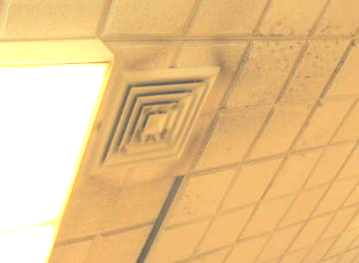

Ceiling-Mounted Air Diffuser, Note Dust/Debris on Vent Louvers and on Adjacent Ceiling Tiles
Picture 5

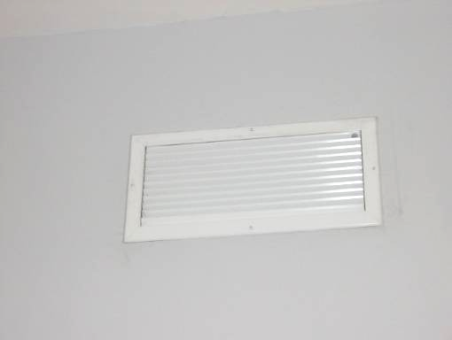

Wall-Mounted Air Diffuser

Picture 6

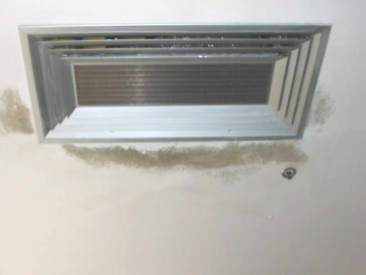

Suspected Mold Growth on Painted Ceiling Plaster in Computer Room 216
Picture 7

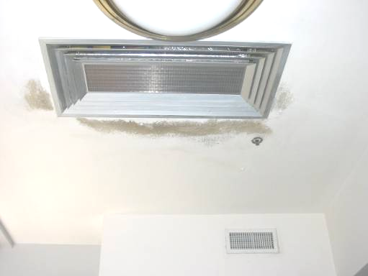

Proximity of Heat Vent (Background) to AC Vent (Foreground/Center)

Picture 8

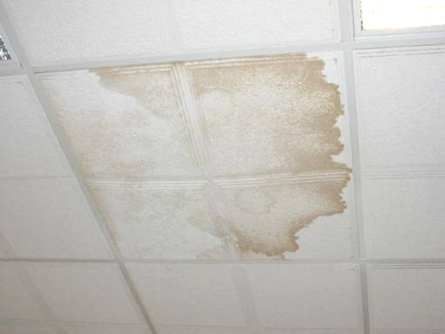

Water Damaged Ceiling Tiles
Picture 9

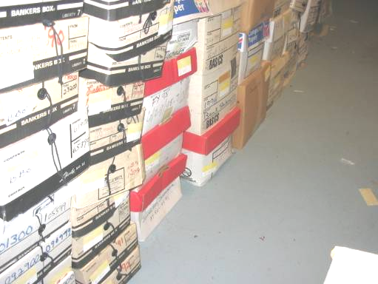

Cardboard Boxes Stored Directly on Concrete Floor

Picture 10

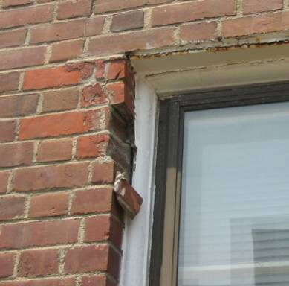

Damaged Brickwork around Window Frame
Picture 11

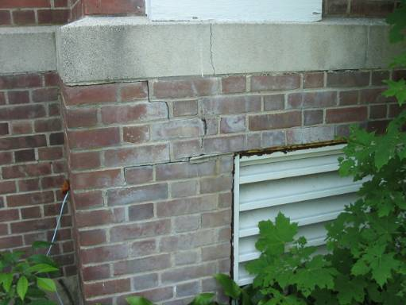

Damaged Brick, Missing/Damaged Mortar, Also Note Plant Growth near Air Intake

Picture 12

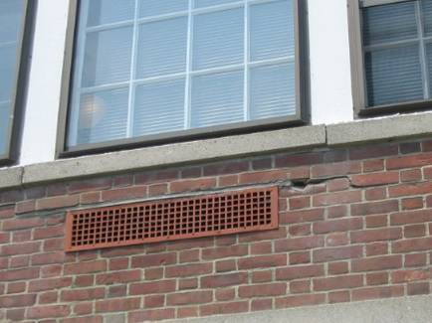

Damaged Brick near (Former) Intake Vent
Picture 13

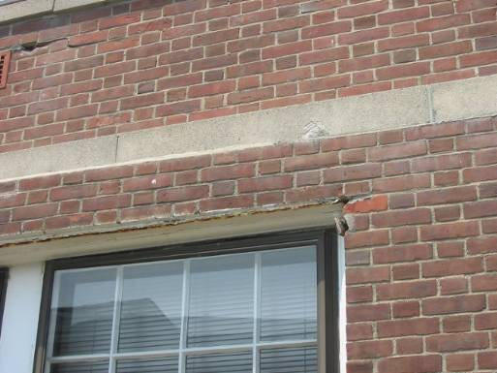

Damaged Brickwork

Picture 14

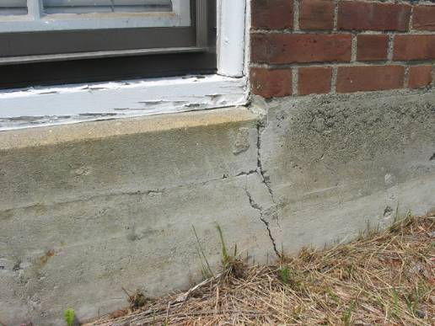

Damaged Cement Foundation
Picture 15

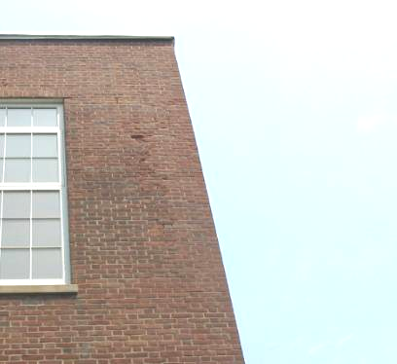

Damaged Brickwork

Picture 16

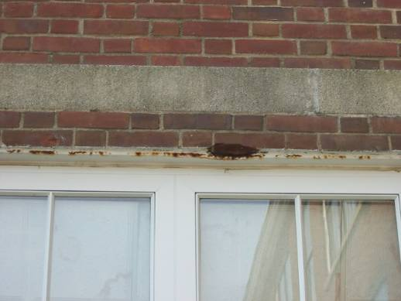

Damaged Brick/Window Frame
Picture 17

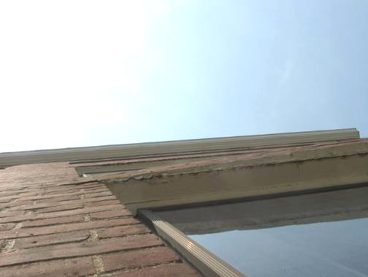

“Bowing” Exterior Brick Wall

Picture 18

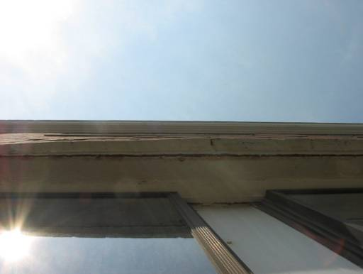

“Bowing” Exterior Brick Wall
Picture 19

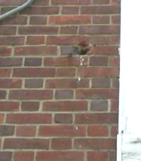

Open Utility Hole, Note Bird Waste (White Material) beneath Hole on Exterior Brick

Picture 20

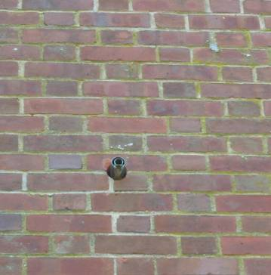

Open Utility Hole
Picture 21

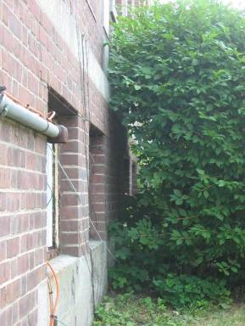

Plant Growth against Exterior Wall

Picture 22

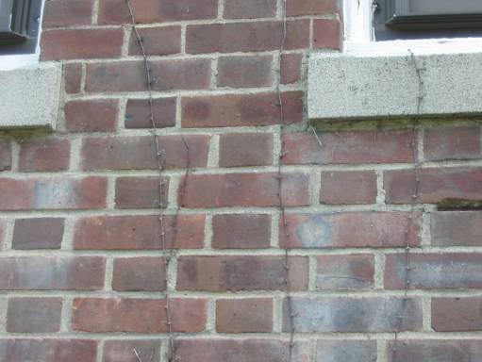

Clinging Plants on Exterior Wall
Picture 23

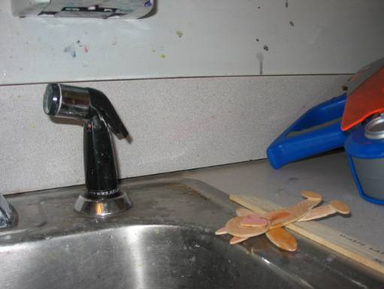

Spaces between Sink Countertop and Backsplash

Picture 24

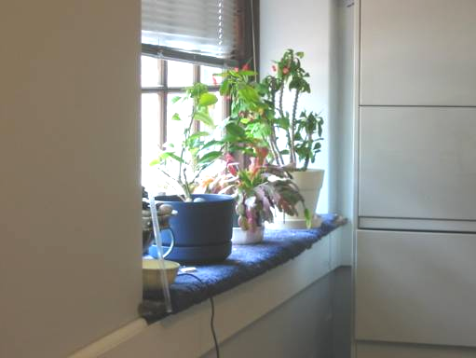

Plants on Carpeting
Picture 25

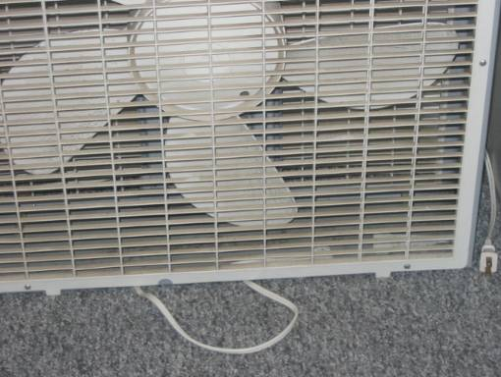

Accumulated Dust on Personal Fan Grates and Blades
Location |  | Carbon  Dioxide  (*ppm) |  | Temp  (°F) |  | Relative  Humidity  (%) |  | Occupants  in Room |  | Windows  Openable |  | Ventilation |  |  |  | Remarks
 |  |  |  |  |  |  |  |  |  |  |  | Supply |  | Exhaust
Background | 407 |  | 70 |  | 76 |  |  |  |  |  |  |  |  |  | Hot, hazy, humid
Computer Room 216 | 517 |  | 71 |  | 44 |  | 0 |  | Y |  | Y |  | N |  | Visible mold on surface of painted ceiling plaster around ceiling AC vent. Heat vent sealed to prevent condensation
215 | 586 |  | 71 |  | 54 |  | 0 |  | Y |  | Y |  | N |  | Window AC
Finance | 577 |  | 73 |  | 55 |  | 3 |  | Y |  | Y |  | Y |  | Plants
217-A | 503 |  | 73 |  | 52 |  | 1 |  | Y |  | Y |  | N |  | Personal fan, window AC
DPW | 510 |  | 73 |  | 53 |  | 0 |  | Y |  | Y |  | Y
210 | 611 |  | 74 |  | 52 |  |  |  |  |  | N |  | N
206 | 559 |  | 75 |  | 53 |  | 0 |  | Y |  | Y |  | Y
204 | 520 |  | 73 |  | 53 |  | 1 |  | Y |  | Y |  | N
203 | 536 |  | 74 |  | 55 |  | 1 |  | Y |  | Y |  | N |  | Plants
205 | 583 |  | 75 |  | 53 |  | 1 |  | Y |  | Y |  | N
201 | 400 |  | 71 |  | 64 |  | 0 |  | Y |  | Y |  | Y
2nd floor hallway |  |  |  |  |  |  |  |  |  |  |  |  |  |  | Water damaged ceiling tiles-heating system leak-no visible mold above CT system
Council on Aging (COA) | 466 |  | 76 |  | 65 |  | 6 |  | Y |  | Y |  | Y |  | Occasional leaks reported during heavy wind-driven rain, water-stained ceiling plaster
COA cafeteria | 558 |  | 74 |  | 60 |  | 0 |  | Y |  | Y |  | Y
Teen Center | 773 |  | 73 |  | 63 |  | 25 |  | Y |  | Y |  | Y
G-24 | 530 |  | 71 |  | 55 |  | 4 |  | Y |  | Y |  | Y |  | Dusty vents
G-21 | 503 |  | 71 |  | 55 |  | 1 |  | Y |  | Y |  | Y |  | Plants
G-22 | 502 |  | 72 |  | 56 |  | 1 |  | Y |  | Y |  | Y |  | Plants
Lunchroom | 608 |  | 71 |  | 55 |  | 3 |  | N |  | Y |  | Y |  | Spaces between countertop and sink
G-18 | 549 |  | 70 |  | 56 |  | 0 |  | Y |  | Y |  | Y
Veteran’s Office | 548 |  | 70 |  | 54 |  | 1 |  | Y |  | Y |  | Y |  | Dusty vents
Director of Veterans Affairs | 540 |  | 70 |  | 54 |  | 1 |  | Y |  | Y |  | Y
G-15 | 522 |  | 68 |  | 59 |  | 0 |  | Y |  | Y |  | Y |  | Dust/cobwebs-windowsills, boxes on concrete floor
G-12 | 543 |  | 68 |  | 62 |  | 2 |  | Y |  | Y |  | Y |  | Cobwebs/dust-windowsills, space countertop/sink
Lounge | 587 |  | 69 |  | 60 |  | 0 |  | N |  | Y |  | Y
Gym | 520 |  | 73 |  | 60 |  | 0 |  | Y |  | Y |  | Y |  | 16 water stained ceiling tiles
Assessors Conf Room | 540 |  | 74 |  | 54 |  | 1 |  | N |  | Y |  | Y
Assessors Office | 594 |  | 74 |  | 54 |  | 0 |  | Y |  | Y |  | N
Treasurer | 558 |  | 73 |  | 54 |  | 1 |  | Y |  | Y |  | Y
Treasurer’ Offices | 581 |  | 73 |  | 54 |  | 1 |  | Y |  | Y |  | N |  | Plants
Conservation 101 | 574 |  | 74 |  | 54 |  | 0 |  | Y |  | Y |  | Y
Conservation Clerk | 585 |  | 74 |  | 55 |  | 0 |  | Y |  | Y |  | N
Conservation Agent | 607 |  | 74 |  | 55 |  | 1 |  | Y |  | Y |  | Y |  | Window AC

