Requesting PELL and PRAMS data

We are excited that you are interested in our PELL and PRAMS data and have developed this guide to help you with the application process.

PELL and PRAMS are available through an IRB application, available at IRBnet.org

Please go to IRBNet.org and create an account.

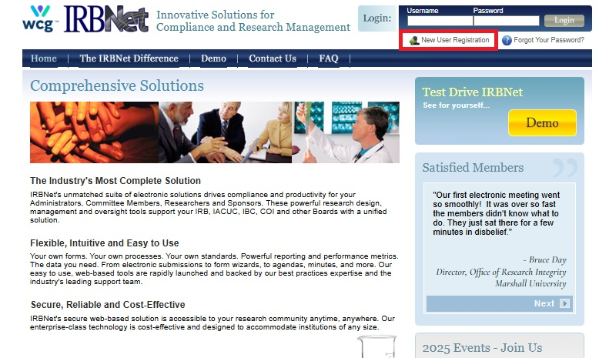

Affiliate with Massachusetts Department of Public Health,
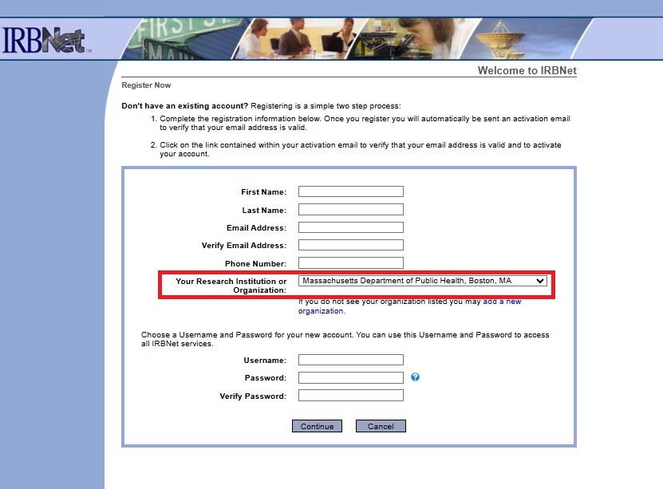

Accept the Terms
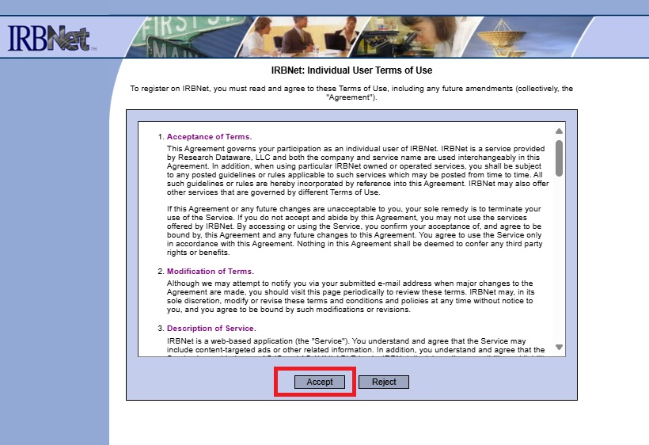

Check your email and activate your account
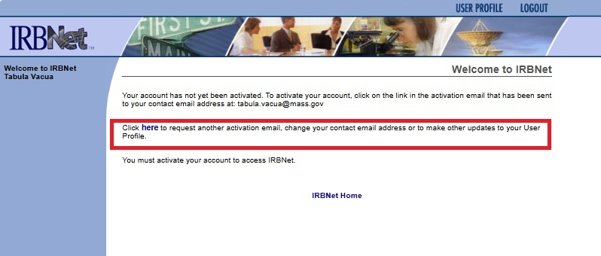

When you first log in, you will see your User Profile screen:
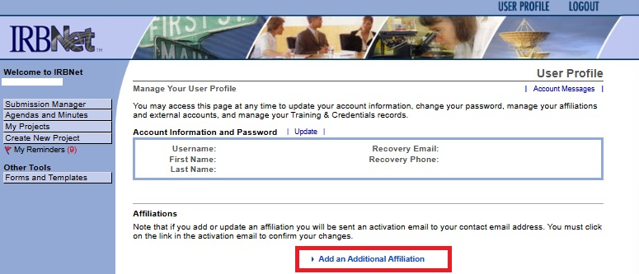

Select Forms and Templates under Other Tools on the left side of the screen.

Make sure to select the library for Massachusetts Department of Public Health IRB Office, Boston, MA - Documents for Researchers.

Please start with the Read Me First - Application Guide document at the top of the Document Description section. It will help guide you through the process.
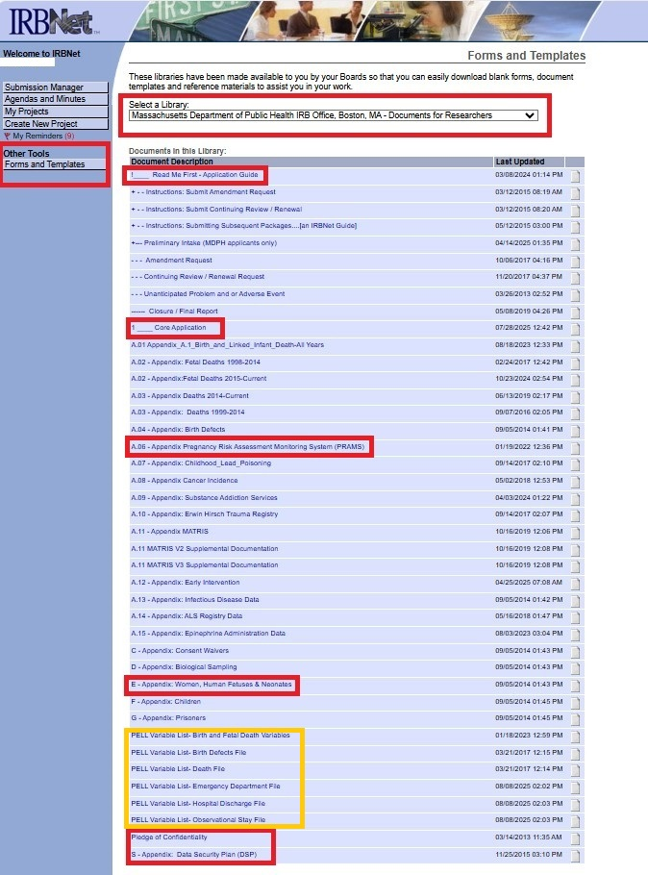

All PRAMS and PELL related studies will need the 1_Core Application (previously known as the 24A), Appendix E-Women, Human Fetuses & Neonates, the Pledge of Confidentiality, Data Security Plan, and proof of CITI training for Human Subjects Research or Biomedical Research, available at www.citiprogram.org. You can affiliate with MA Department of Public Health or your original institution. Additional Appendices are described below.

When you select Create New Project, an IRBNet # will be generated. Use this number throughout your application when asked for IRBNet #. Use the same title of your project throughout.
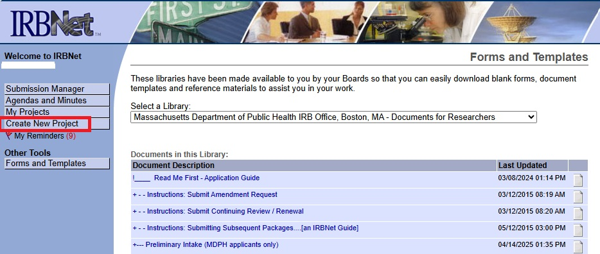

Compete all sections of the IRB/Data Access Core Application. Be sure to either include Appendix C or provide how consent to participate will be obtained. Please review Section 22 of the Core Application for likely attachments.

You will also need to complete all the relevant Appendices based on your study. These include the appropriate PELL Variable Lists if you are requesting PELL data, Appendix 06 if you are requesting PRAMS data, as well as any other datasets to which you want to link, and Appendix C if you are requesting a waiver of consent.

For all data requests, the minimum necessary requirement means that you can't ask for variables that you "might need later" or that do not directly relate to your study question. Each variable you ask for requires justification.

PRAMS: Please note that PRAMS data are designed for state-wide estimates and should not be used for regional analyses of counties, cities or other sub-state areas. Download the Appendix A.06 file and read the START HERE tab first. Please indicate which years and variables you are requesting and provide a brief justification for each variable. Instructions for requesting the CDC PRAMS Automated Research File (ARF) are included in Appendix A.06. If you also need to request variables from the birth certificate, please include A.01-Appendix_A.1 Birth and Linked Infant Death file for those variables.

PELL: Requests for PELL data use up to six (6) variable lists: Birth and Fetal Death Variables, Birth Defects File, Death File, Emergency Department file, Hospital Discharge file, and Observational Stay file, and any applicable programmatic variable lists (i.e., Early Intervention, Cancer Incidence, etc.)

Time until data file: After you submit your application, it can take several months before your application goes through IRB review. After the initial IRB review, the length of time for approval and obtaining data will depend on how many revisions are needed for IRB and what other projects the PRAMS or PELL programmers have in queue. Please plan on several months after applying.

FEES: We waive fees for students. For established researchers, our fees are based on the complexity of the work, and the timing and nature of the grant. Please contact us for more information.

Data are no longer transmitted via CD. We will work with you to set up a DPH-approved method to transfer data securely.

We encourage you to schedule a meeting with us prior to submitting your application if you are interested in PELL or PRAMS data. We are here to help you.

Please contact us after you have received approval from the IRB as there is no automatic notification to us. We will not prepare your data until you contact us with approval.

