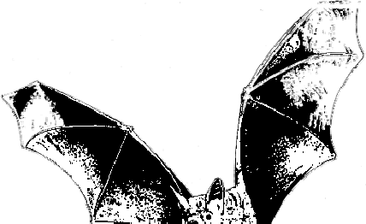 Massachusetts Department of Public Health, updated 2018

Attention Summer Camp Directors, Nurses and Maintenance Staff!

Is Your Summer Camp Bat Proof?
Bats are frequently found in summer camp settings for several reasons. First, summer camps are often located in areas that provide suitable habitat for bats and other wildlife. Second, bats are most active during the warm summer months. Finally, some camp buildings are not built to be weather-tight and bats may find ways to get inside.

Rabid bats may show abnormal behavior including: being on the ground, landing on someone, and/or flying during the day. However, there is no way to tell if an animal is rabid simply by looking at it. All contact with bats and other wild animals should be reported to the camp nurse.

Cabins used for sleeping should be inspected every spring before the camp opens.

- Inspect attic space, rafters, porches, and walls for signs of roosting (sleeping or resting) bats, such as bat guano (feces) and crystallized urine, or a musty odor.
- Look for openings that bats could get through, including spaces larger than 5/8 inch by 7/8 inch and long thin slots larger than 1/4 inch by 2 inches.
- If evidence of bats is found during an inspection, the cabin should not be used for sleeping until the animals have been removed and the building bat-proofed.

Camp buildings and cabins, particularly those used as sleeping quarters, should be bat-proofed.

- Bat proofing should take place during the month of May or from August 1 through mid-October when most bats will have left to hibernate or will have raised their young.
- Seal openings larger than 5/8 inch by 7/8 inch, or long thin slots larger than 1/4 inch by 2 inches.
- Use materials such as expanding spray-on foam, caulk, wire mesh, wood that fits tightly, steel wool (around pipes that enter buildings) etc., to seal gaps and holes.
- Make sure windows have screens, chimneys are capped, and electrical and plumbing openings are plugged.

For questions about bats and rabies, please contact your local board of health or the Massachusetts Department of Public Health, Division of Epidemiology and Immunization at 617-983-6800.

For more information about bats contact the Division of Fisheries and Wildlife at www.mass.gov/masswildlife or call 508-389-6300.

Text adapted with permission from the New York State Department of Health

