

# SCOPE OF ACCREDITATION TO ISO/IEC 17025:2017

MASSACHUSETTS STATE PUBLIC HEALTH LABORATORY

305 South Street Jamaica Plain, MA 02130

Dr. Nicolas Epie Phone: 617-983-4362 Email: [Nicolas.Epie@mass.gov](mailto:Nicolas.Epie@mass.gov)

# BIOLOGICAL

Valid To: September 30, 2026 Certificate Number: 4054.01

In recognition of the successful completion of the A2LA evaluation process, accreditation is granted to this laboratory to perform the following tests on food and dairy samples:

|  |  |
| --- | --- |
| **Test** | **Test Method** |
| Aerobic Plate Count - Petrifilm - Quantification | MA SPHL DL.005 |
| Alkaline Phosphatase - Screen | MA SPHL DL.002 |
| Antibiotic Residue - Charm EZ SLBL- Screen | MA SPHL DL.010 |
| Antibiotic Residue - Delvo - Screen | MA SPHL DL.004 |
| Coliform Plate Count - Petrifilm - Quantification | MA SPHL DL.005 |
| *Escherichia coli* O157:H7 - Confirmation | MA SPHL FD.002 |
| *E. coli* O157:H7 - Screen | MA SPHL FD.002 |
| *Listeria monocytogenes* - Confirmation | MA SPHL FD.004 |
| *L. monocytogenes* - Screen | MA SPHL FD.004 |
| Quantitative Sumithrin Analysis | MA SPHL AC.038 |
| *Salmonella* spp. - Confirmation | MA SPHL FD.001 |
| *Salmonella* spp. - Screen | MA SPHL FD.001 |

(A2LA Cert. No. 4054.01) 09/30/2024 Page 1 of 1

5202 Presidents Court, Suite 220, 
Frederic, MD 21703-8398  
Phone: 301-644-9449, 
www.A2LA.org


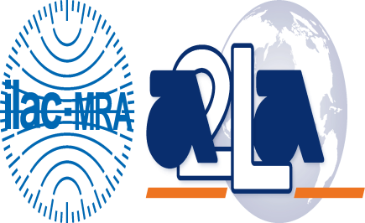

***Accredited Laboratory***

A2LA has accredited

**MASSACHUSETTS STATE PUBLIC HEALTH LABORATORY**

*Jamaica Plain, MA*

for technical competence in the field of

Biological Testing

This laboratory is accredited in accordance with the recognized International Standard ISO/IEC 17025:2017 *General requirements for the competence of testing and calibration laboratories*. This accreditation demonstrates technical competence for a defined scope and the operation of a laboratory quality management system

(*refer to joint ISO-ILAC-IAF Communiqué dated April 2017*).

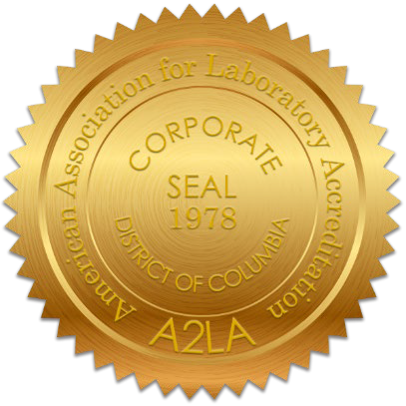

Presented this 30th day of September 2024.

Mr. Trace McInturff, Vice President, Accreditation Services For the Accreditation Council

Certificate Number 4054.01

Valid to September 30, 2026

*For the tests to which this accreditation applies, please refer to the laboratory’s Biological Scope of Accreditation.*