Commonwealth of Massachusetts
Executive Office of Health and Human Services

Virtual Gateway

ISP Assessments Module
User Guide
Lesson 1: ISP Module Overview
HCSIS Release 7.7

Contents
Getting Started 2
What is Virtual Gateway? 2
ISP Assessments Module Overview 4
What is the ISP Assessments module? 4
The ISP Assessments Process 5
ISP Assessments Module Implementation Overview 8
Basic ISP Assessments Module Navigation 9
Basic Module Navigation 9
Confirmatory Pop-up Message 11
Roles and Responsibilities in the ISP Assessments Module 13
Service Coordinator Roles and Responsibilities 14
Service Coordinator Supervisor Roles and Responsibilities 15
Area Office Director Data Entry Role 16
Service Provider Data Entry User Roles and Responsibilities 16
Service Provider Supervisor Roles and Responsibilities 17
Area Office Directors Read Only Role, Regional Directors and Commonwealth Users 19
ISP Year Selection 20
Making an ISP Year Selection for DDS Staff 20
Viewing ISP Year Selection for DDS Staff and Providers 23
The Individual Dashboard 24
Accessing the Individual Dashboard 24
Individual Dashboard for DDS Staff 26
Individual Dashboard for Provider Staff 31

Getting Started
The Home and Community Services Information System (HCSIS) is an online information system used by the Department of Developmental Services (DDS).

What is Virtual Gateway?
Virtual Gateway provides a central portal for accessing programs and services offered by the Executive Office of Health and Human Services (EOHHS).
The Goal of Virtual Gateway is to streamline service access and coordinate service delivery. It serves three important groups:
- Consumers
- Service Providers
- Internal Health and Human Services (HHS) staff

How to Access Virtual Gateway
- Obtain Virtual Gateway logins for new users in your organization. User Request Forms (URFs) are available through the HCSIS link under the “Administration” section. This URF contains the ISP roles to assign to new users.
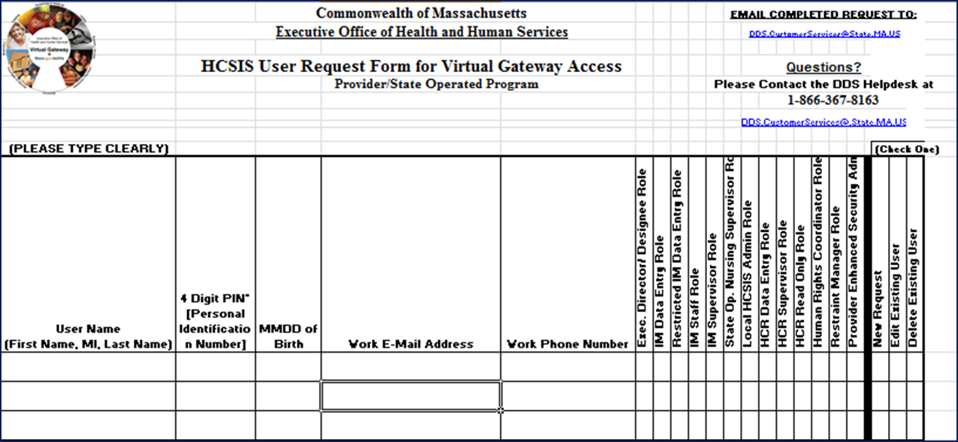

- Assign roles in HCSIS. Users can assign roles to new users and add/change roles for existing users. Roles must be assigned in order to start using the module.
  - Provider agencies can assign roles to new users once VG logins are obtained.
  - DDS Staff will automatically be assigned their specific roles.
- Virtual Gateway is the entry point for HCSIS end users to log into the HCSIS application.

ISP Assessments Module Overview

What is the ISP Assessments module?
The Individual Support Plan (ISP) Assessments module exists within the Home and Community Services Information System (HCSIS). It standardizes and streamlines the capture, submission and review of the required ISP Assessment documents. The required ISP Assessments documents include the individual’s Vision Statement, Goals, Assessments, Objectives and Support Strategies which are mapped to the Individual’s Goals, Current Supports, Safety and Risk, Financial/Legal/Benefit Status, and Successes and Challenges. Providers, Provider Supervisors, Service Coordinators and Service Coordinator Supervisors are the main users of the ISP Assessments module in HCSIS.

Implementing the ISP Assessments process into the MA HCSIS system promotes consistent standards for required ISP Assessments documents that clarify DDS’s expectations, reduce redundancy and encourage priorities that create an individual centric ISP document. Implementing required ISP Assessment documents into online forms in HCSIS and providing the tools to manage end users’ workflows will enable information sharing. Efficient workflow distribution will enhance Service Coordinators’ and Providers’ ability to prepare for and adhere to ISP Assessment timelines. Implementing the ISP Assessments module in HCSIS enables changes to the ISP Assessments process in a system that is familiar to end-users and will increase accountability, traceability and transparency at the organizational level.

Implementing components of the ISP Assessments process into MA HCSIS does not restrict or inhibit existing communication channels, but instead provides an efficient mechanism for capturing and solidifying offline discussions and enabling better information sharing between Service Coordinators and Providers.

The ISP Assessments Process
The ISP Assessments module has been developed to support waiver assurances and monitor regulatory requirements. The module itself is focused on system features that address the following business needs for Sub-process I, II and III of the ISP Assessments process.

A high level overview of the ISP Assessments process is below:

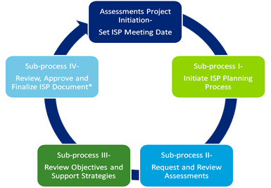
* This activity is related to implementing full ISP Module functionality into HCSIS and is not covered by the ISP Assessments module. The ISP Document is now part of HCSIS, but the review and approval process will continue to be in MEDITECH.

Following is a summary timeline for how these processes are defined in the ISP Assessments module in HCSIS: 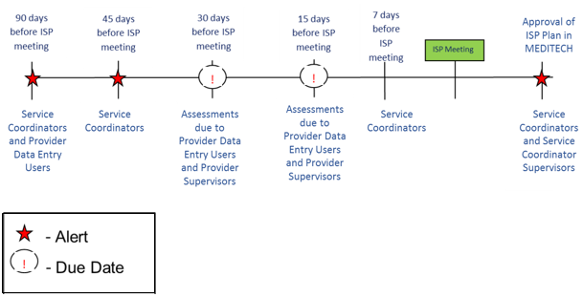

The actions in the table below correspond to the ISP timeline as per current regulations. Actions listed may or may not correspond with Alerts in the module.

Action | End User | Regulations | Alert?
Consult with Guardian and Individual on required Assessments, Vision, and Goals | Service Coordinator | 45-60 days  prior to the ISP meeting | No
Notification of ISP meeting and request for Assessments | Service Coordinator | 30 days  prior to the ISP meeting | Yes
Create and enter proposed Goals for the individual | Providers and DDS Staff | N/A | No
Assessments and Proposed Objectives & Support Strategies submitted  to Service Coordinator | Providers | 15 days  prior to the ISP meeting | Yes
Annual Progress Summary Due | Service Coordinators and Providers | 15 days prior to the ISP meeting | Yes
Review and approval or request for revision of submitted documents | Service Coordinator | 7 days  prior to the ISP meeting | Yes
Print documents for ISP meeting | Providers and DDS staff | N/A | No
Revise ISP documents if required | Providers and DDS staff | Up to 45 days  after the ISP meeting | Depends on the type of revision
ISP Mailed to ISP Team | Service Coordinator | 45 Days  after the ISP meeting | No
Semi-Annual Progress Summary Due | Service Coordinators and Providers | 180 Days after the ISP Meeting | Yes

ISP Assessments Module Implementation Overview
The ISP Implementation Team's vision for the module was to develop a system that accomplished two important Goals.
- Standardize the ISP Renewal Process
  - Develop ISP documents that increase clarity, reduce redundancy and promote priorities that will create an individual-centric ISP document.
  - Strengthen DDS’s focus on developing measurable and achievable objectives that promote on-going growth and development for the individual.
- Establish consistent standards that clarify DDS’s expectations and reinforce requirements
  - Build a module in HCSIS that enables electronic submission and review of required ISP documents including individual’s Vision, Goals, Assessments, and Objectives & Support Strategies.

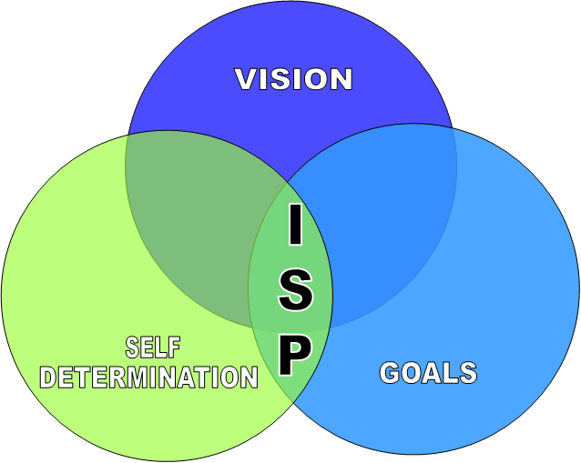

Basic ISP Assessments Module Navigation
The ISP Assessments module can be accessed through the Virtual Gateway.

Basic Module Navigation
- Access the Virtual Gateway using this link: https://gateway.hhs.state.ma.us/authn/login.do.
- Login to the Virtual Gateway with username and password.
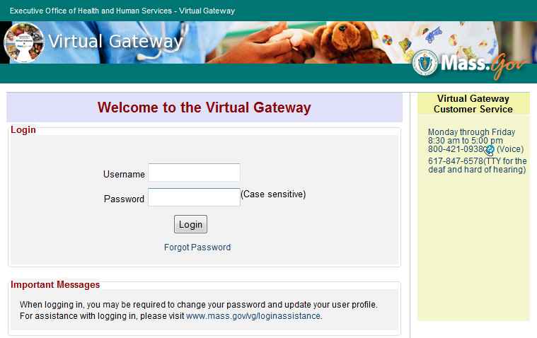

- Click the “Developmental Services Quality Management Reporting (HCSIS)” hyperlink to access HCSIS.
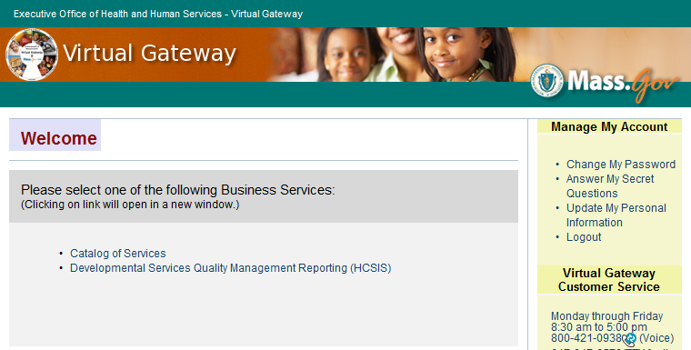

- This is the homepage for HCSIS. Click the “ISP” tab at the top of the page to access the ISP module.
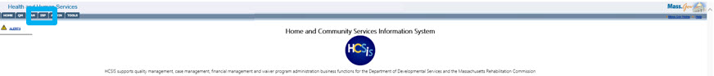

- After clicking the “ISP” tab, the system returns the page shown below.

Confirmatory Pop-up Message
The confirmatory pop-up message appears in the ISP Module in HCSIS if the user has unsaved information on the screen and attempts to navigate to a different screen within the Individual’s Plan.

Navigating within the ISP Module

Scenario Description:
The user has unsaved information in any section of an individual’s ISP and attempts to navigate away from the page without saving, prompting a confirmation pop-up to appear.

Note: The confirmatory pop-up window only appears when navigating within sections of the ISP module, i.e. while within any of the tabs as highlighted below. The confirmatory pop-up window does not appear when navigating to other modules, or to the second level menu options.

For DDS staff, the confirmatory pop-up window appears when clicking on the tabs below:

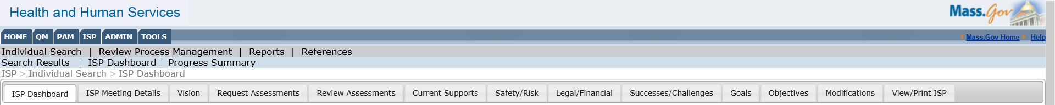

For Provider staff, the confirmatory pop-up window appears when clicking on the tabs below:

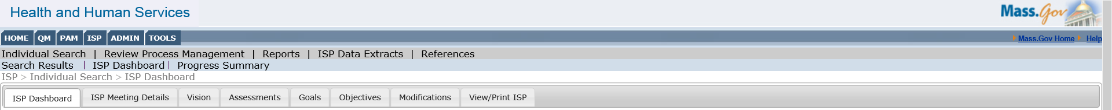

Note: For demonstration purposes, this scenario shows the functionality of the pop-up from the Goals screen, however please note that this is present on all screens within an Individual’s Plan. The below screenshots show the tabs visible to DDS users, but an identical navigating away pop-up functionality is available for Providers.
First Steps
- Search for an Individual
- View the Individual Dashboard
- Navigate to the Goals Screen

Roles and Responsibilities
- Service Coordinators: Enter information in the Individual’s Plan
- Service Coordinator Supervisors: Enter information in the Individual’s Plan
- Provider Data Entry User: Enter information in the Individual’s Plan
- Provider Supervisor: Enter information in the Individual’s Plan
.

- Enter information into a textbox on the Goals screen.

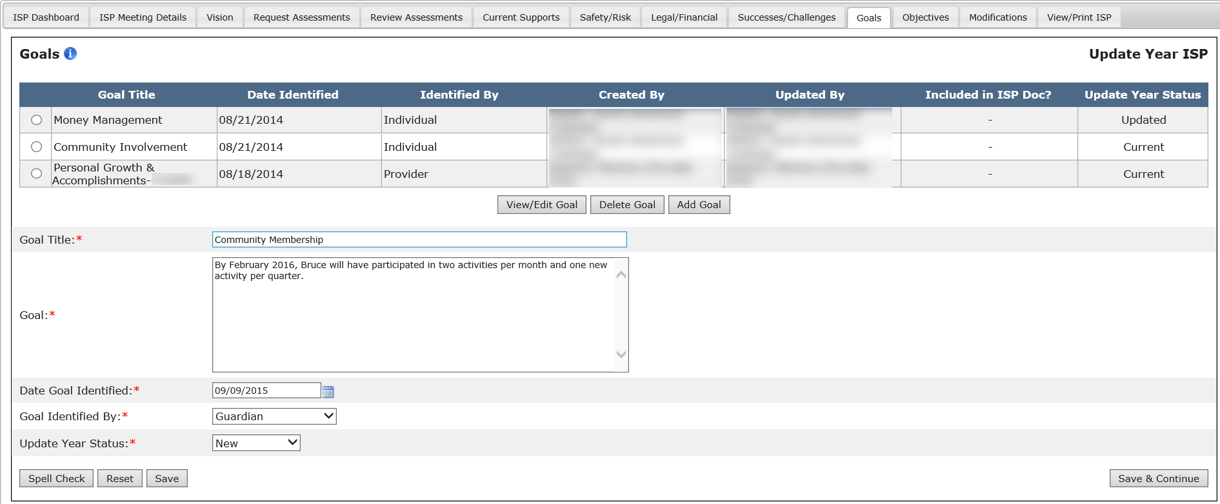

- Select the ISP Dashboard Tab from the menu tabs.

- A confirmation pop-up window message will read: “Entered information has not been saved. Leaving this page will cause unsaved information to be lost. Do you wish to leave this page?”

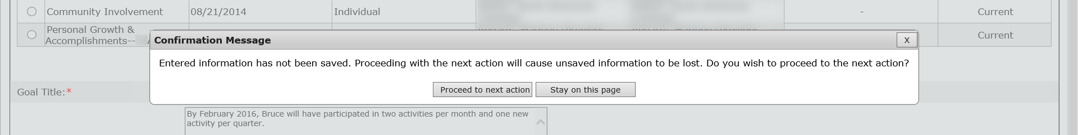

Note: Clicking “Leave this page” navigates the user to the ISP Dashboard without saving information on the current screen. Clicking “Stay on this page” or “X” at the top right corner of the pop up window keeps the user on the same page with the previously entered information, and user must select “Save” or “Save & Continue”.

Roles and Responsibilities in the ISP Assessments Module
Each process in the ISP Assessments Module is triggered or executed by one or more of the roles listed below. Roles may be people, groups, or systems that work together or individually to accomplish the actions required as part of the ISP Assessment renewal process. The following list provides an overview of the roles involved in the module, along with a brief description of each role.

Role | Role Description | Access
Individual | An individual with developmental disabilities who is receiving services provided by Massachusetts DDS. | N/A
Service Coordinator | Performs case management activities, and acts as a liaison between the Provider and Individual. | Create, review, approve, request revision
Service Coordinator Supervisor | Provides oversight for the Service Coordinators working with service plans. Supervisors can perform the functions of a case manager but have additional responsibilities relating to service planning that are more financially oriented. Clinical Managers and Service Coordinator Supervisors are both represented as Supervisors. | Create, review, approve, request revision
Provider | An agency or individual providing services to individuals served by DDS. | Create, edit, submit for internal review
Provider Supervisor | Provides oversight for the Providers working with individuals served by DDS. | Create, edit, submit for DDS review
Area Director Data Entry  User | Provides oversight for Service Coordinators and Service Coordinator Supervisors working with service plans. | Create, review, approve, request revision, unlock and relock plans
Area Office Director Read Only, Regional Directors and Commonwealth Users | Area Office Directors view ISP-related documents in Read-Only mode in the module. They are required to review Provider initiated or Service Coordinator initated modifications. | Read-only ISP documents; Review, approve or disapprove Modifications

Service Coordinator Roles and Responsibilities
Within the ISP Assessments module, Service Coordinators have the ability to:

- View and verify ISP meeting information (date, time, location, etc.).
- Enter, edit and share the vision statement with Providers.
- Create, edit, and delete Goals created by any member of the ISP Team.
- Create and edit ISP sections: Current Supports, Safety and Risk, Financial/Legal/Benefit Status, and Successes and Challenges.
- Request assessments from Providers.
- Delete assessments prior to their approval.
- Review Goals entered by Providers.
- Review assessments, Objectives and Support Strategies submitted by Providers. Approve these documents or request revision, if necessary.
- Delete Objectives and Support Strategies submitted by Providers.
- View Goals, assessments, Objectives and Support Strategies created by all members of the ISP Team.
- Print ISP components as well as the full ISP Document in PDF and Word.
- View the ISP Summary Report.
- View the Reference page documents.
- View and Print Historical ISP documents, Assessments and Objectives and Support Strategies
- Review Progress Summaries submitted by Providers. Approve or request revision, if necessary.
- Initiate Modifications to a locked ISP.
- Review Provider Initiated Modifications to a locked ISP. Accept, disapprove or request revision, if necessary.

The roles and responsibilities of the Service Coordinator begin when the Service Coordinator develops the Vision Statement with the individual. Service Coordinators should also expect to receive 3 to 9 different types of alerts related to the submission of ISP components for each individual in the Service Coordinator’s caseload; these alerts will start 90 days prior to the scheduled ISP meeting.

Below is a sample view of the ISP Assessments module for Service Coordinators, which depicts how Service Coordinators will be able to create, edit and view a Vision Statement for an individual.

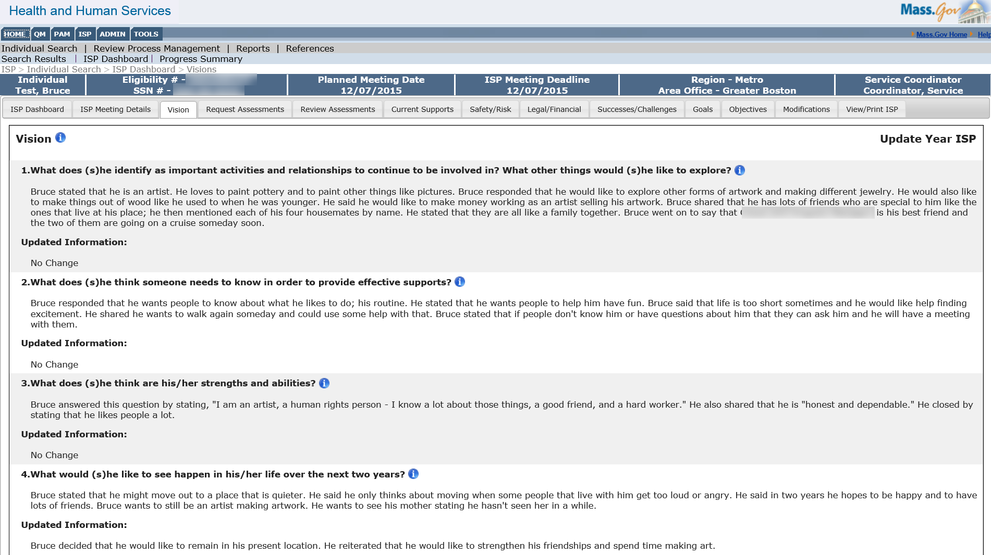

Service Coordinator Supervisor Roles and Responsibilities
Note: Service Coordinator Supervisors receive a reduced number of alerts. All of the information pertaining to Service Coordinator Supervisors also applies to Area Office Directors.
Within the ISP Assessments module, Service Coordinator Supervisors have the ability to:

- View and verify ISP meeting information (date, time, location, etc.).
- Enter, edit and share the vision statement with Providers.
- Create, edit, and delete Goals created by any member of the ISP Team.
- Create and edit ISP sections: Current Supports, Safety and Risk, Financial/Legal/Benefit Status, and Successes and Challenges.
- Request assessments from Providers.
- Delete approved and unapproved Assessments.
- Review Goals entered by Providers.
- Review Assessments, Objectives and Supports Strategies submitted by Providers. Approve these documents or request revision, if necessary.
- Delete Objectives and Supports Strategies submitted by any member of the ISP Team.
- View Goals, Assessments, Objectives and Supports Strategies created by all members of the ISP Team.
- Print ISP components and the full ISP Document in PDF and Word.
- View the ISP Summary Report.
- View the Reference page documents.
- View and Print Historical ISP documents, Assessments and Objectives and Support Strategies.
- Review Progress Summaries submitted by Providers. Approve or request revision, if necessary.
- Initiate Modifications to a locked ISP.
- Review Provider Initiated Modifications to a locked ISP. Accept, disapprove or request revision, if necessary.

While the Service Coordinator Supervisors can perform the same actions as Service Coordinators, Service Coordinator Supervisors’ primary responsibility is to monitor the ISP process for each Service Coordinator they oversee.

Below is a sample view of the ISP Assessments module for Service Coordinator Supervisors, which depicts how Service Coordinator Supervisors will be able to create, edit and view a Vision Statement for an individual.
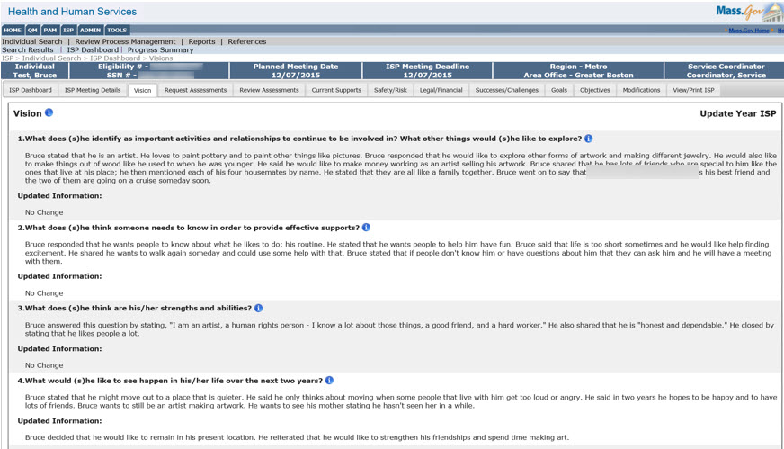

Area Office Director Data Entry Role
The Area Office Director Data Entry Role has the same responsibilities as the Service Coordinator Supervisor; Above and beyond these responsibilities, the Area Office Director Data Entry Role has the ability to unlock and re-lock and ISP plan after it has been locked and is responsible for approving Modifications.

Service Provider Data Entry User Roles and Responsibilities
Within the ISP Assessments module, Service Providers with the data entry role have the ability to:

- View the shared Vision statement.
- View ISP meeting details (date, time, location, etc.).
- Create Goals, Aassessments.
- Create Objectives and Support Strategies related to a Goal created by any of the ISP Team members.
- Save Assessments, Objectives and Support Strategies prior to internal review by a Provider Supervisor.
- Submit Assessments, Objectives and Support Strategies for internal review by Provider Supervisor.
- Edit Goals, Assessments, Objectives and Support Strategies created by the same Provider Agency.
- Delete Goals, Objectives and Support Strategies created by the same Provider Agency.
- View Goals, approved Assessments, approved Objectives and Supports Strategies created by all members of the ISP Team.
- Complete Progress Summaries for Objectives.
- Print all documents created by the same Provider Agency regardless of the status of the documents in PDF and Word.
- Print approved documents created by all members of the ISP Team in PDF and Word.
- View the ISP Summary Report.
- View the Reference page documents.
- View and print Historical Assessments and Objectives and Support Strategies.
- Request Data Extracts (with the Data Extract Role).

The Service Provider’s responsibilities begin with the development of Goals in relation to the Vision Statement that has been submitted by the Service Coordinator, in addition to completing assessments once they have been requested by the Service Coordinator. Providers can access the ISP Assessments module as early as 90 days prior to the ISP meeting after the SC has made the plan selection, to create Goals, Objectives and Support Strategies. It is not necessary for the Vision statement to be shared by the Service Coordinator to begin work on these documents. Service Providers should expect to receive between 6 and 12 alerts related to the submission of assessments and objectives per individual; these alerts will begin 90 days prior to the ISP meeting. Provider Agencies will determine how to manage required ISP Assessments tasks in HCSIS within their Agency.

Below is a sample view of the ISP Assessments module for Service Providers, which depicts the alerts for a Service Provider.

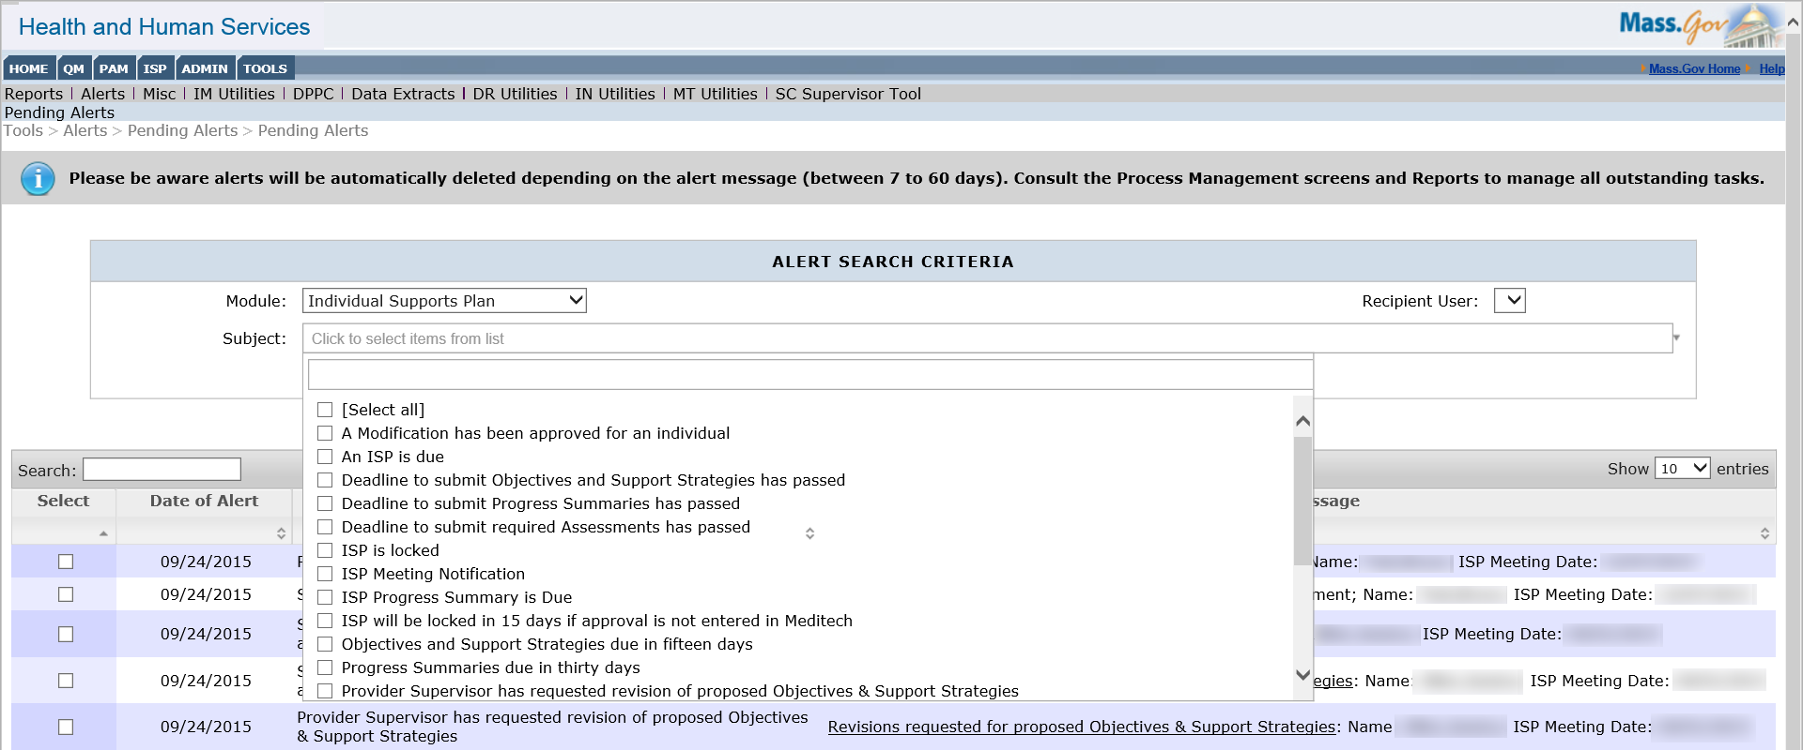

Service Provider Supervisor Roles and Responsibilities
The roles and responsibilities for Service Provider Supervisors are very similar to those for Service Providers. However, only Provider Supervisors can submit documents to DDS for review. Within the ISP Assessments module, Service Provider Supervisors have the ability to:

- View the shared vision statement.
- View ISP meeting details (date, time, location, etc.).
- Create Goals and assessments.
- Create Objectives and Support Strategies related to a Goal created by any of the ISP Team members.
- Save Goals, assessments, Objectives and Support Strategies.
- Edit Goals, assessments, Objectives and Support Strategies created by the same Provider Agency.
- Delete Goals, Objectives and Support Strategies created by the same Provider Agency.
- Review and submit assessments, Objectives and Support Strategies created by the same Provider Agency for DDS review.
- View Goals, approved assessments, approved objectives and supports created by all members of the ISP Team.
- Print all documents created by the same Provider Agency regardless of the status of the documents in PDF and Word.
- Print approved documents created by all members of the ISP Team in PDF and Word.
- View the ISP Summary Report.
- View the Reference page documents.
- View and print Historical Assessments and Objectives and Support Strategies
- Request Data Extracts (with the Data Extracts Role).
- Review Progress Summaries submitted for internal review by Provider Data Entry User. Request Revision or Submit for DDS Review.
- Initiate Modifications to a locked ISP. Revise if DDS Staff reviews the Modificaiton and requests revision.
- Review Provider Initiated Modifications to a locked ISP. Accept, disapprove or request revision, if necessary.

The Service Provider Supervisor’s roles and responsibilities can begin with the development of Goals, Objectives and Support Strategies or when the Service Coordinator has shared the vision and requests an assessment from a Provider. Service Provider Supervisors will receive 1 – 6 alerts (for additional information on alerts, please refer to the ISP Timeline and Alerts quick guide). Provider Agencies will determine how to manage required ISP Assessments tasks in HCSIS within their agency.

Area Office Directors Read Only Role, Regional Directors and Commonwealth Users
Area Office Directors Read Only Roles, Regional Directors and Commonwealth users may view ISP-related documents in Read-Only mode in the module. These roles will not receive alerts, nor will they be tasked with the completion of ISP documents in the module. The roles will not be able to view or print documents that have not been approved/ completed. They can also:
- View the ISP Summary Report
- View the Reference page documents
- View Historical ISP documents, Assessments, Objectives and Support Strategies and Modifications

ISP Year Selection
Upon accessing an individual’s plan for the first time, Service Coordinators, Service Coordinator Supervisors and Area Office Director Data Entry roles will see a pop-up message prompting them to make an ISP Year Selection as either a “Full Year ISP” or an “Update Year ISP”. No information can be entered for the individual’s plan by both Providers and DDS Staff until the ISP year has been selected. If the user does not wish to make a plan selection at that time, selecting “X” or “Cancel” will navigate away from the pop-up and Dashboard.

Providers do not have access to the individual’s plan until the selection has been made. It is important to make this selection as early as possible to allow sufficient time for Providers to work on the ISP. The following message is displayed when a Provider attempts to access a Dashboard before the ISP Year selection is made by the Service Coordinator: “The plan cannot be accessed as the Service Coordinator has not yet designated an Update Year or Full Year ISP. Please contact the Service Coordinator for details.”

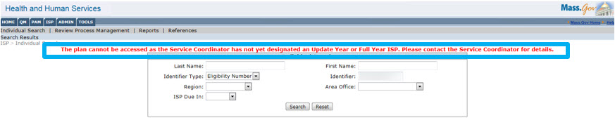

Making an ISP Year Selection for DDS Staff

Scenario Description:
- This scenario describes the steps required to select an ISP Year.
First Steps:
- Access the ISP Dashboard through the Individual Search, Review Process Management or Alerts screen (Refer to Accessing the Individual Dashboard section for detailed steps).
Roles and Responsibilities:
- Service Coordinators: Select the ISP Year
- Service Coordinator Supervisors: Select the ISP Year

- View the ISP Year selection pop-up for the selected individual.

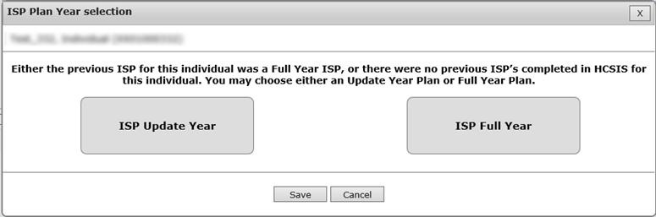

Note: The year selection process has been partially automated. If the plan type for the most recently completed plan is an update year, the system will automatically choose full year for the subsequent plan. If, on the other hand, the plan type for the most recently completed plan is a full year, the Service Coordinator is still required to manually make the year selection.

Note: If, on the other hand, the plan type for the most recently completed plan is a full year, The name of the individual, along with their eligibility number, will be displayed on the top left corner of the ISP Year selection pop-up window.The ISP Dashboard will be grayed out and the user will not be able to navigate to the individual’s plan until the ISP year has been selected.

- Select an ISP year (Full or Update) from the pop-up and click on “Save”.

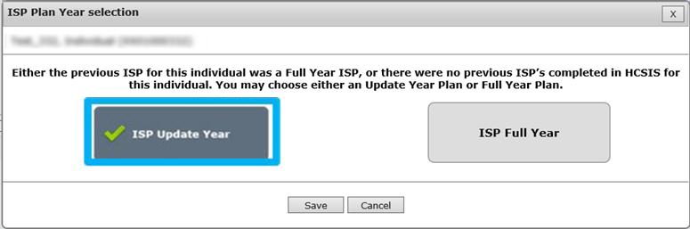

Note: When you select an individual and are prompted to make the year selection the pop-up screen will indicate what year selection was used in the previous plan.

The system will display a second pop-up window prompting you to confirm the selection. The pop-up message will read: “Are you sure you want to make this selection?” and the available options are “Yes” and “No”.

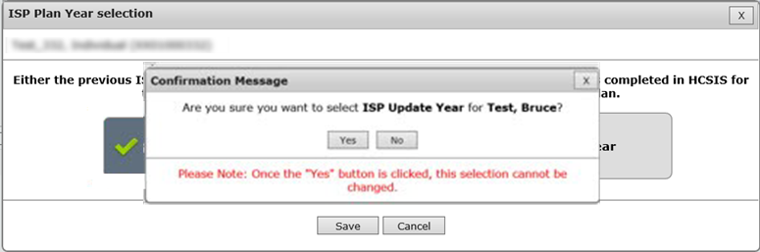

Note: Once the ISP Year has been confirmed, it cannot be reversed or re-selected. The following message will be displayed at the bottom of the box: “Please Note: Once the “Yes” button is clicked, this selection cannot be changed.”

- Review the selection and click on “Yes”.

Note: Clicking “Yes” will close both pop-up windows and display the ISP Dashboard. Clicking “No” or the “X” button will close the confirmatory pop-up and allow the user to change the ISP Year selection made in the first pop-up window.

Viewing ISP Year Selection for DDS Staff and Providers
Depending on the selected ISP year, either “Full Year ISP” or “Update Year ISP” will be displayed in the ISP Summary box. In this case, since the user selected Update Year ISP, “Update Year ISP” appears in bold in the Summary box.

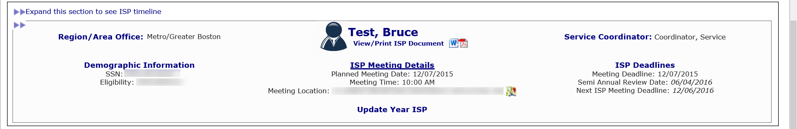

In the screenshot below, since the user selected Full Year ISP, “Full Year ISP” appears in bold in the Summary box and the following message is displayed: “Information recalled from past plans will not be truncated and could exceed the allowable character limit in a Full Year ISP. If recalled information exceeds the character limit of a text box, the information must be edited within the acceptance range prior to saving”
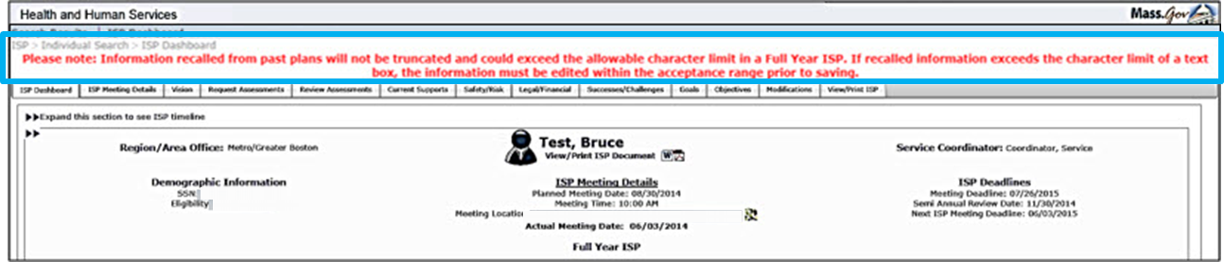 .
Next Steps

After confirming the ISP Year selection, users can begin working on the individual’s plan. Goals and Objectives can now be completed by Providers. SC’s should enter and share the Vision so that Providers can also complete Assessments.

The Individual Dashboard
The Individual Dashboard is a feature that provides a comprehensive snapshot (one stop shop) of an individual who is served by DDS. The Dashboard includes basic demographic information (SSN, Eligibility number), an individual’s Region and Area Office, planned meeting date, and ISP meeting deadline. Each of the links on this Dashboard will navigate the user to the corresponding detail level page.
The ISP Assessments module creates an ISP for each Ricci class member, as well as individuals enrolled in adult HCBS waiver programs, individuals receiving residential supports, individuals receiving day or employment supports, and individuals receiving Day Habilitation or Adult Day Health services.
Note
- For Individuals ages 18-21, ISPs will be created in HCSIS as long as a planned meeting date has been entered in MEDITECH.
- For individuals for whom a Death Report has been filed after an ISP plan is created in HCSIS and an ISP Meeting has been held, the plan will continue to be active in HCSIS allowing the Service Coordinator to complete work on the plan.
- If an ISP has been manually unlocked by the Area Office Director post 150 days after the ISP meeting, the plan must be manually re-locked by the Area Office Director for a following plan to be created in HCSIS.

Accessing the Individual Dashboard
The Individual Dashboard can be accessed by searching for an individual.
Note: This action can be completed by either DDS or Provider staff.
- Select the Individual Search screen.
- Users can search using any of the search fields displayed in the screen below. In the scenario below, the eligibility number has been entered after selecting the identifier type as Eligibility Number.
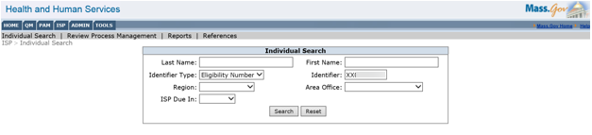
- Enter search criteria and click “Search”.
Eligibility or SSN numbers are unique identifiers so clicking on “Search” will direct the user to the ISP Dashboard of the individual. If the user were to search using a common Last Name, the user will see a list of all individuals with that last name. If there is only one individual with that last name the user is brought directly to the individual’s Dashboard. The Individual Dashboard will appear differently to DDS and Provider staff.

Individual Dashboard for DDS Staff
Service Coordinators can use the dashboard to monitor their progress on completing an ISP and access various components of an individual’s ISP including:
- Vision
- Goals
- Objectives and Support Strategies
- Request Assessments
- Review Assessments
- Other ISP Components

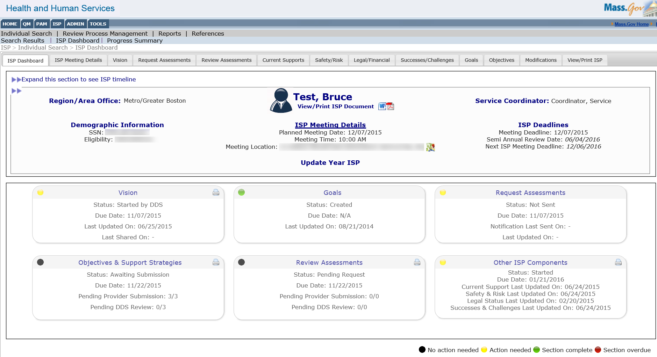

Summary information appears below each of the major sections – this information, specifically relating to reviewing assessments and the completion of Objectives and Support Strategies will change depending on how many assessments, Objectives and Support Strategies are pending Provider submissions or DDS review. Below each hyperlink, the user can view a summary of the information contained in that particular page.

The DDS staff user can view the following components and corresponding details:

- Vision: The Vision box tracks the status of all actions involved with completing an individual’s vision. This informs Service Coordinators of the status, the due date, the last updated on date, and the date the Vision was shared with providers. Clicking the box will navigate Service Coordinators to the Vision tab.

- Goals: The Goals box tracks the status of all actions involved with completing Goals. This informs Service Coordinators on the status and the last updated on date and Due Date (displayed as N/A). Clicking the box will navigate Service Coordinators to the Goals tab.

- Request Assessments: The Request Assessments box tracks the status of all actions involved with Requesting Assessments. This informs Service Coordinators on the status, the due date, and the date the notification was sent to Providers. Clicking the box will navigate Service Coordinators to the Request Assessments tab.

- Objectives & Support Strategies: The Objectives & Support Strategies box tracks the status of all actions involved with completing objectives. Since completing objectives are the responsibility of the Providers the purpose of this status update is to inform Service Coordinators on submission of objectives and objectives awaiting their review.

- Review Assessments: The Review Assessments box tracks the status of all actions involved with reviewing assessments. Since completing assessments are the responsibility of the Providers the purpose of this status update is to inform Service Coordinators on submission of assessments and assessments awaiting their review. As a Service Coordinator, clicking on this link will redirect the user to the Assessments Review Switchboard. The Service Coordinator can begin to review and approve assessments on this page, and view the status of assessments. The Review Assessments page allows the user to view assessments which are pending review either by DDS or that are pending submission/ revision by a Provider. SCs will be able to review completed assessments, but will not be able to make changes to the assessments themselves. The SC will need to request revision of the Provider for the documents to be edited.

- Other ISP Components: The Other ISP Components box tracks the status of all actions involved with completing sections on Current Supports, Safety/Risk, Legal/Financial Status and Successes/Challenges. This informs Service Coordinators of the status, the lock date the last updated on date for each additional ISP Component (Current Supports, Safety and Risk, Legal and Financial Status, Successes/Challenges). Clicking the box will navigate Service Coordinators to the Current Supports tab.

- Modifications: If there is a modification initiated in the system for the individual, a modification component will be added to the dashboard for the particular individual with the corresponding status information.

Status Icons and Text
A status icon along with a text status is displayed for each component of the ISP. The text and colored icon provide an update on the status of the document at any given point. The status is reflective of the user’s responsibility. A legend indicating the meaning of each color is available at the bottom of the page.

Below is the description of the legend displayed on the dashboard

Black – No action needed by the logged in user.
Yellow – Action needed by the logged in user.
Green – Section has been completed.
Red – Section is Overdue.

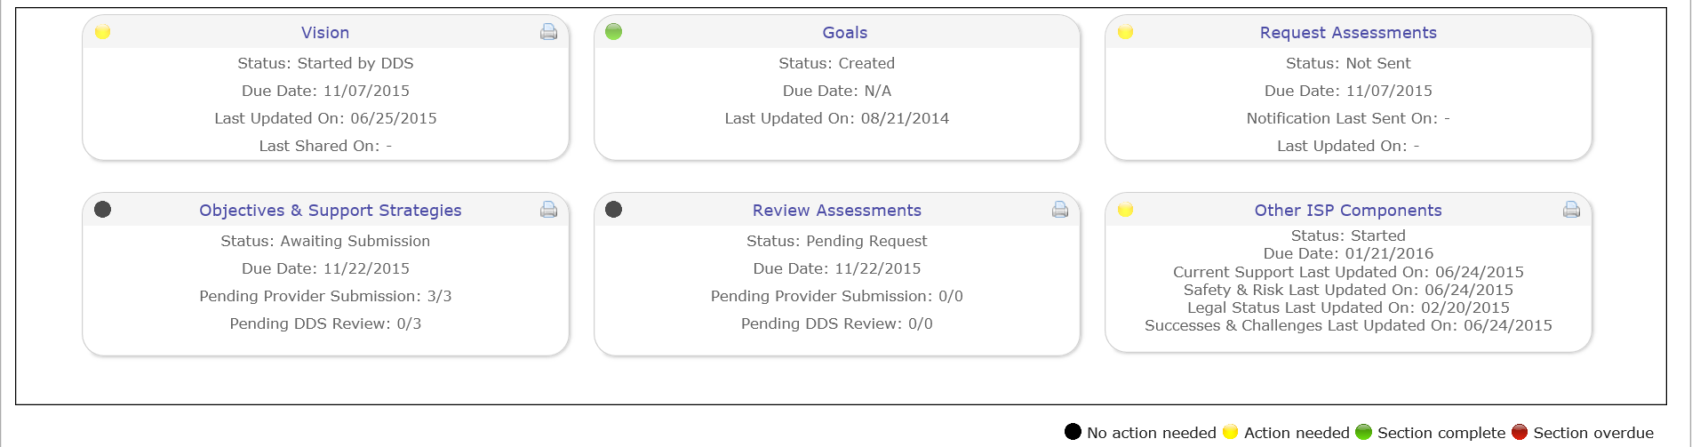

Note: In the example above, information from a past plan has been pulled forward into the newly created plan. Since HCSIS has pulled forward the Vision questions entered in a past plan, the Vision Status appears as “Started by DDS”. If there was no information to pull forward, the status would appear as “Not Started by DDS”. Similarly, as there are Goals pulled forward from a past plan, the Goals Status appears as “Created”. For more information on what information is pulled forward, please visit the respective chapter for each component.

Timeline

Above each individual's ISP dashboard details, there will be a personalized ISP timeline graph for that individual. The timeline will be collapsed by default. Click the expand arrows next to “Expand this section to see ISP timeline” to view the timeline.

- With Full and Update Year plan types, the timeline displays events related to an ISP plan including when the ISP was opened by the system and when the ISP Year was selected:
  - ISP Open reflects the date the ISP is created in HCSIS--90 days prior to the Planned ISP Meeting Date. If the ISP Planned Meeting Date has not been entered in MEDITECH, the ISP Meeting Deadline will be used
  - ISP Year Selected appears only when the Service Coordinator/ Service Coordinator Supervisor/ Area Office Director Data Entry role makes a selection in HCSIS to indicate if the plan is for an Update Year or a Full Year ISP.
- Hovering over an action will show the actual date it was completed
- The red vertical line represents the current date allowing users to track where they currently fall in the process
- Deadlines are marked bold

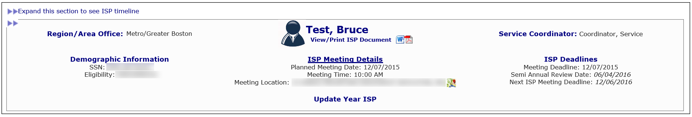

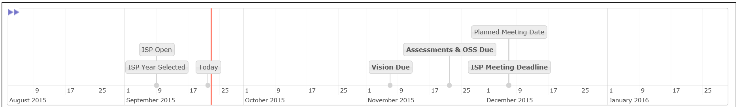

Summary Box
Demographic information for each individual will be displayed in a summary box on the dashboard. The summary box is below the timeline and it will be expanded by default.

- Summary box provides ISP Meeting details and deadlines
- Shows the Service Coordinator assigned to the individual
- Shows the ISP Year selection made for the individual (Update or Full Year)
- Allow the Service Coordinator to view and/or print the full ISP Document

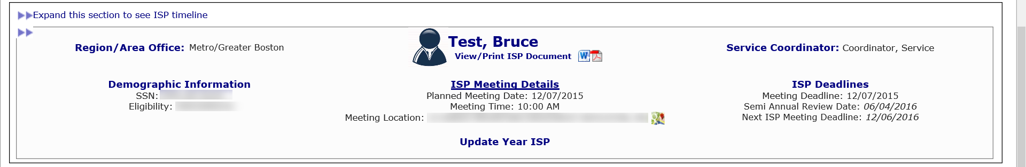

Clicking Google Maps icon on the ISP Meeting Details will bring the user to the ISP Meeting Details page. This page provides ISP Meeting Details including the planned meeting date, meeting time, and location as well as a Google Maps feature that will allow the user to pull up directions to the ISP meeting if a meeting location has been entered into MEDITECH.

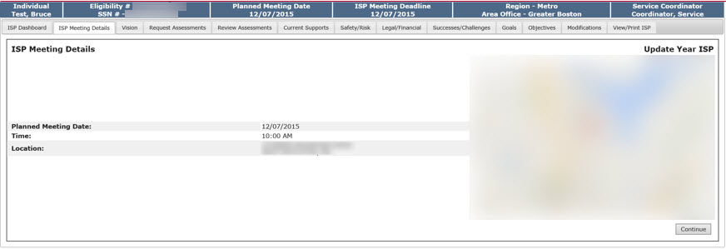

Tabs
Your role determines the tabs that are displayed as well as the order that those tabs are in. The view below is from a DDS view.

Individual Dashboard for Provider Staff
Service Providers can use the dashboard to monitor their progress on completing an ISP and access various components of an individual’s ISP including the individual’s:
- Vision
- Goals
- Objectives and Support Strategies
- Assessments

Note: Providers do not have access to the Individual Dashboard until the ISP Year Selection has been made by Service Coordinators, Service Coordinator Supervisors or Area Office Directors. If a Provider accesses the individual’s dashboard and the plan type has not been selected by DDS user, the following message is displayed on top of the screen: “The plan cannot be accessed as the Service Coordinator has not yet designated an Update Year or Full Year ISP. Please contact the Service Coordinator for details.”

Once the plan selection has been made and the Provider user can access the individual’s dashboard, “Update Year ISP” or “Full Year ISP” will be displayed in the summary information box.

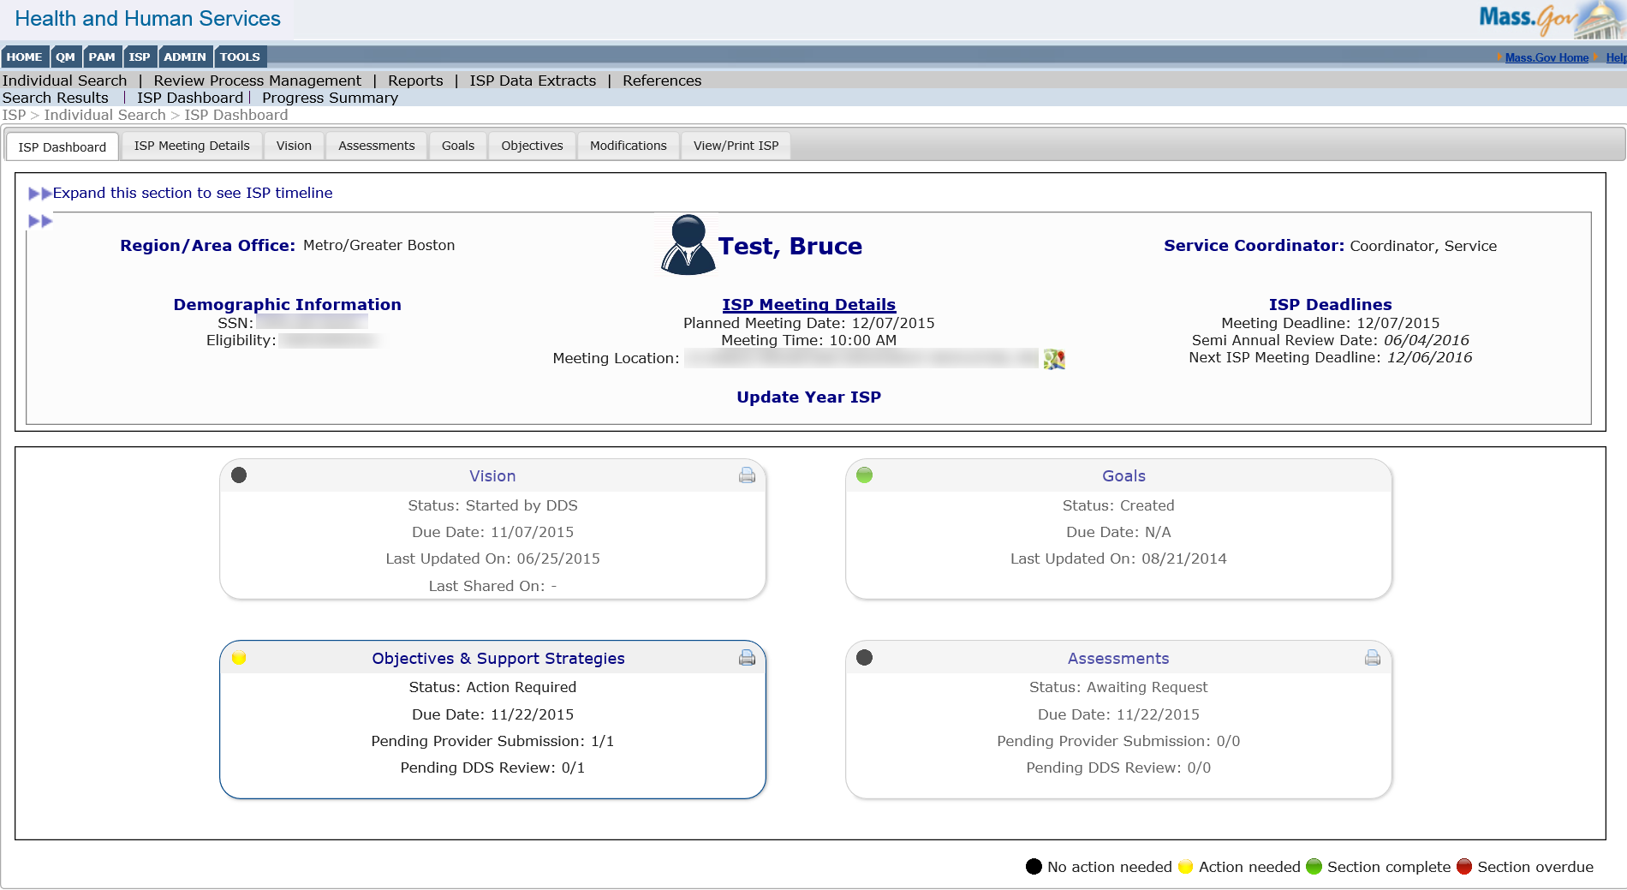

Modifications displays for Provider Data Entry Users in Read-Only mode.

Summary information appears below each of the major sections – this information, specifically relating to reviewing assessments and the completion of Objectives and Support Strategies will change depending on how many assessments, Objectives and Support Strategies are pending Provider submissions or DDS review. Below each hyperlink, the user can view a summary of the information contained in that particular page.

The Provider user can view the following components and corresponding details:

- Vision: The Vision box tracks the status of all actions involved with completing an individual’s vision. This informs Providers of the status, the due date, the last updated on date, and the date the Vision was shared with providers. Clicking the box will navigate Providers to the Vision tab.

- Goals: The Goals box tracks the status of all actions involved with completing Goals. This informs Providers on the status and the last updated on date. Clicking the box will navigate the providers to the Goals tab.

- Objectives & Support Strategies: The Objectives & Support Strategies box tracks the status of all actions involved with completing objectives. The purpose of this status update is to inform Providers on submission of objectives and objectives awaiting Service Coordinators review.

- Assessments: The Assessments box tracks the status of all actions involved with completing and submitting assessments. The purpose of this status update is to inform Providers on submission of assessments and assessments awaiting Service Coordinators review. As a Provider data entry user, clicking on this link will redirect the user to the Assessments Review Switchboard. The Provider data entry user can begin to complete and submit assessments to Provider Supervisors for Internal Review and view the status of the assessment. As a Provider Supervisor, clicking on this link will redirect the user to the Assessments Review Switchboard. The Provider Supervisor can review, edit and submit assessments to service coordinators, and view the status of assessments. The Assessments page allows the user to view assessments which are pending review either by DDS or that are pending submission/ revision by a Provider.

- Modifications: If there is a modification initiated in the system for the individual, a modification component will be added to the dashboard for the particular individual with the corresponding status information.

Status Icons and Text
A status icon along with a text status is displayed for each component of the ISP. The text and colored icon provide an update on the status of the document at any given point. The status is reflective of the user’s responsibility. A legend indicating the meaning of each color is available at the bottom of the page.

Below is the description of the legend displayed on the dashboard

Black – No action needed by the logged in user.
Yellow – Action needed by the logged in user.
Green – Section has been completed.
Red – Section is Overdue.

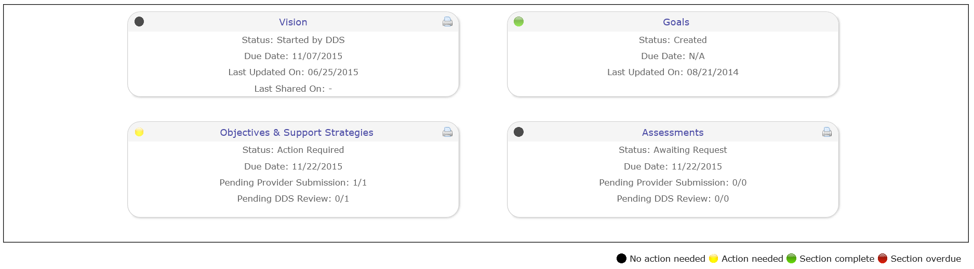

Note: In the example above, information from a past plan has been pulled forward into the newly created plan. Since HCSIS has pulled forward the Goals from a past plan, the Goals Status appears as “Created”. If there was no information to pull forward, the status would appear as “Not Started”. For more information on what information is pulled forward, please visit the respective chapter for each component.

Timeline

Above each individual's ISP dashboard details, there will be a personalized ISP timeline graph for that individual. The timeline will be collapsed by default. Click the expand arrows next to “Expand this section to see ISP timeline” to view the timeline.

- With Full and Update Year plan types, the timeline displays events related to an ISP plan including when the ISP was opened by the system and when the ISP Year was selected:
  - ISP Open reflects the date the ISP is created in HCSIS--90 days prior to the Planned ISP Meeting Date. If the ISP Planned Meeting Date has not been entered in MEDITECH, the ISP Meeting Deadline will be used.
  - ISP Year Selected appears only when the Service Coordinator/ Service Coordinator Supervisor/ Area Office Director Data Entry user makes a selection in HCSIS to indicate if the plan is for an Update Year or a Full Year ISP.
- Hovering over an action will show the actual date it was completed
- The red vertical line represents the current date allowing users to track where they currently fall in the process
- Deadlines are marked bold

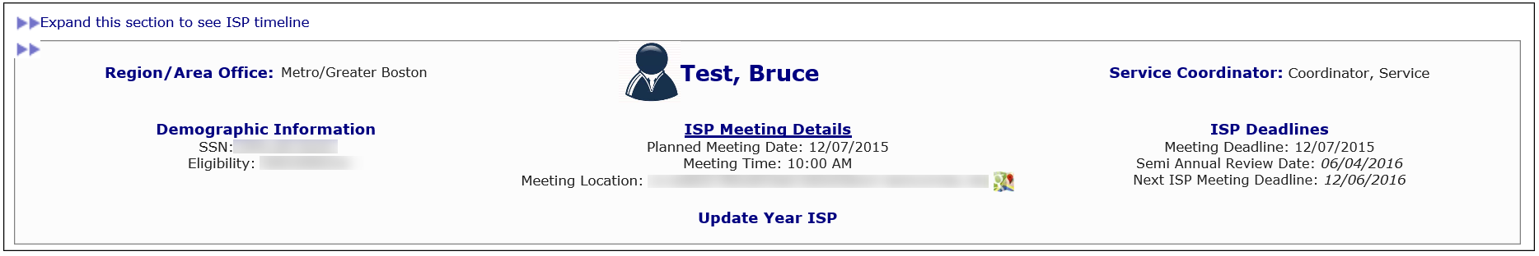

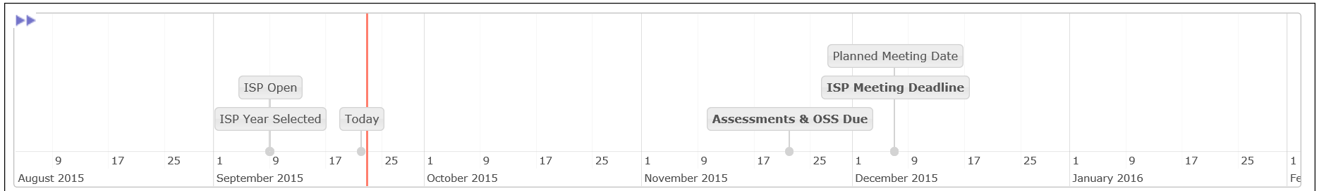

Summary Box
Demographic information for each individual will be displayed in a summary box on the dashboard. The summary box is below the timeline and it will be expanded by default.

- Summary box provides ISP Meeting details and deadlines
- Shows the Service Coordinator assigned to the individual
- Shows the ISP Year selection made for the individual (Update or Full Year)

Clicking Google Maps icon on the ISP Meeting Details will bring the user to the ISP Meeting Details page. This page provides ISP Meeting Details including the planned meeting date, meeting time, and location as well as a Google Maps feature that will allow the user to pull up directions to the ISP meeting if a meeting location has been entered into MEDITECH

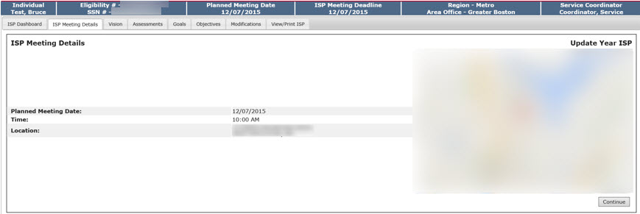

Tabs
The order of the tabs has been revised dependent on your role. For Provider staff, the Goals and Objectives tabs have been moved to the end as Objectives are associated to Goals in the system.

