Commonwealth of Massachusetts
Executive Office of Health and Human Services

Virtual Gateway

ISP Assessments Module
User Guide
Lesson 2: Vision and Goals
HCSIS Release 7.7

Contents
Vision Statement 2
Creating a Vision by DDS Staff in a Full Year 2
Updating a Vision by DDS Staff in an Update Year 8
Viewing a Vision by Provider Staff in a Full Year 13
Viewing a Vision by Provider Staff in an Update Year 16
Goals for DDS Staff 19
Creating a Goal in a Full or Update Year 19
Editing a Goal in a Full Year 24
Updating a Recalled Goal in an Update Year 28
Deleting a Goal in a Full or Update Year 33
Goals for Provider Staff 37
Creating a Goal in a Full or Update Year 37
Editing a Goal in a Full Year 41
Updating a Recalled Goal in an Update Year 45
Deleting a Goal in a Full or Update Year 50

Vision Statement

Creating a Vision by DDS Staff in a Full Year

When creating a Vision in a Full Year ISP, the system will pull information from the individual’s previous ISP. If the last plan created for an individual is an Update Year Plan, the system will display the Updated Information recorded in this plan in addition to the information from the previous Full Year ISP plan. Any recalled information from past plans will be editable during a Full Year. Providers will not be able to see the recalled information before the Vision is shared with them.

Scenario Description:
- A consultation has taken place between an individual, the individual’s guardian and the Service Coordinator, during which a new Vision Statement has been developed
- The Service Coordinator creates the Vision Statement for the individual in the module
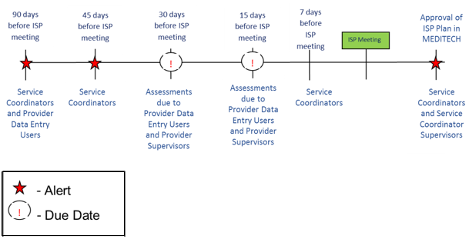
First Steps:
- Search for an individual
- View the Individual Dashboard

Roles and Responsibilities:
- Service Coordinators: Creates the Vision in the module and shares with Providers.
- Service Coordinator Supervisors: Creates the Vision in the module and shares with Providers.

Note: To prevent a loss of information for Service Coordinators and Service Coordinator Supervisors, Auto Save functionality is available when completing the Vision section. Auto Save is implemented for Vision, as well as Other ISP Components, due to the large text boxes and detailed information input into these fields. Auto Save will run after 15 minutes of inactivity. This feature saves documentation automatically to reduce the risk or impact of data loss in the event that the system logs the user out of HCSIS or the computer shuts down. Auto Saved information will be stored temporarily; upon returning to the page the user must click “Save” or “Save and Close” to permanently save the information. In the situation that the user does not want to save the recovered information the user can select “Reset” to delete the information. Auto Save does not apply for any screens other than the Other ISP Components or Vision Statement.
- Select "Vision" from the ISP components table on the ISP Dashboard or select the “Vision” tab.

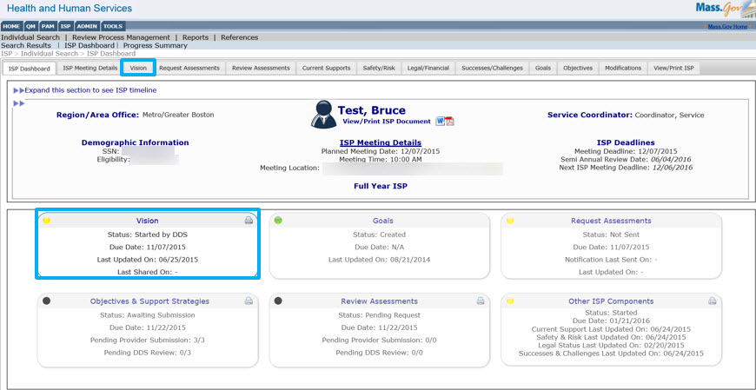

- The module redirects the Service Coordinator to the Individual’s “Vision” page.

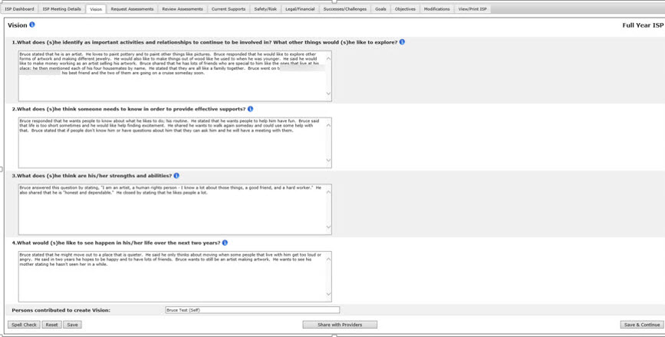
Note: Values from the past ISP are recalled along with any updates entered during the past update year and are displayed in the same text box. The character limit for all text boxes will remain the same, and recalled information will not be truncated. The user has to ensure that information does not exceed the allowed character limit in order to save changes.

- Complete the Vision Statement questions with valid responses. All questions must be answered and recalled values that exceed the character limit must be edited before the user can save or share the vision with Providers.

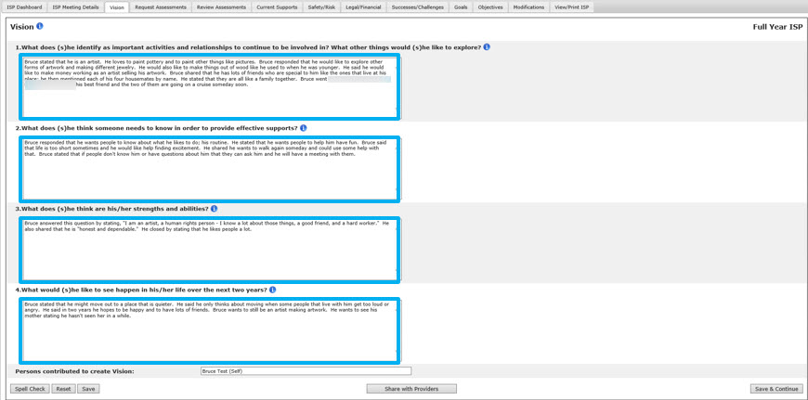

Note: If the user tries to navigate away prior to saving the information the system will display the “Navigate Away” pop up message. In order to save the recovered information entered for this section the user should select “Remain on this Page” and click “Save” before proceeding to the completing the next action.
- In the event that the user is inactive and the screen goes idle for 15 minutes, Auto Save will run. Auto save will temporarily save the information while the user is idle.
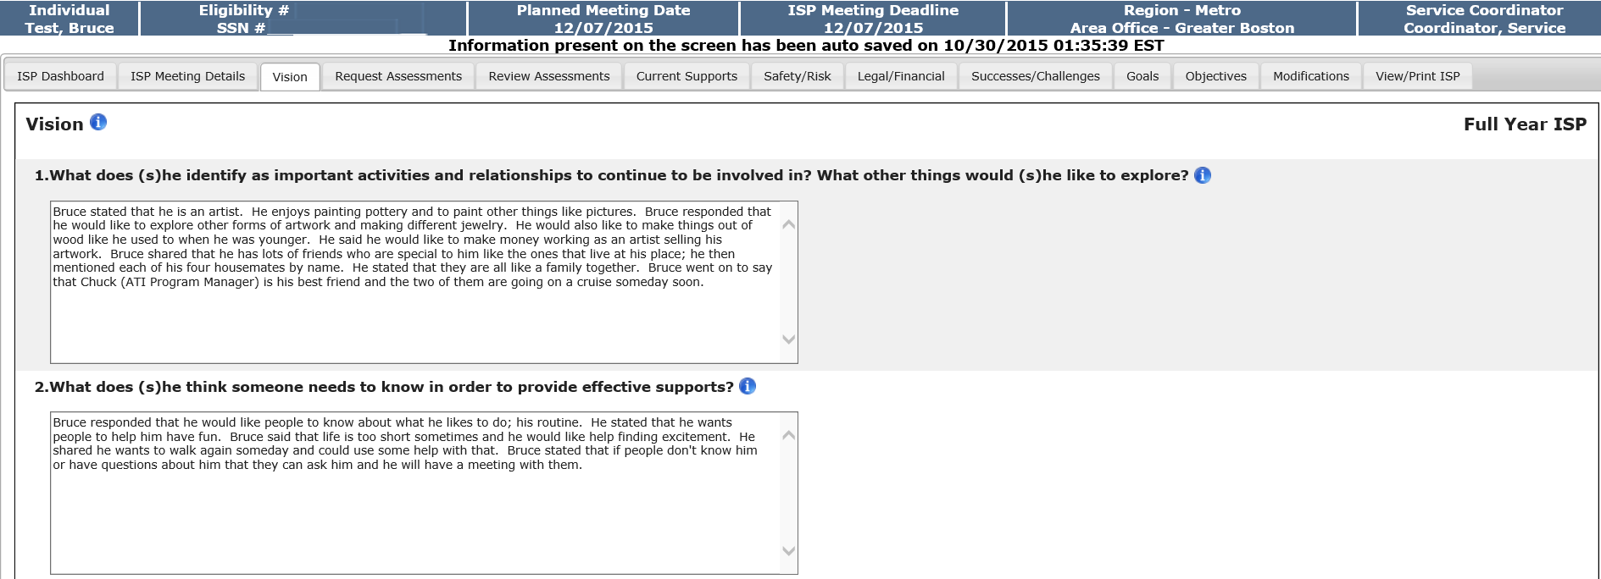

Note: Any information that is entered after auto save has run, in between the 15 minutes before the auto save runs again, will not be recovered.
- At a later time, if you return to the Vision tab, the screen will load the auto-saved information and a message will display that prompts you to determine which text to retain – the auto-saved information or the previously saved information.
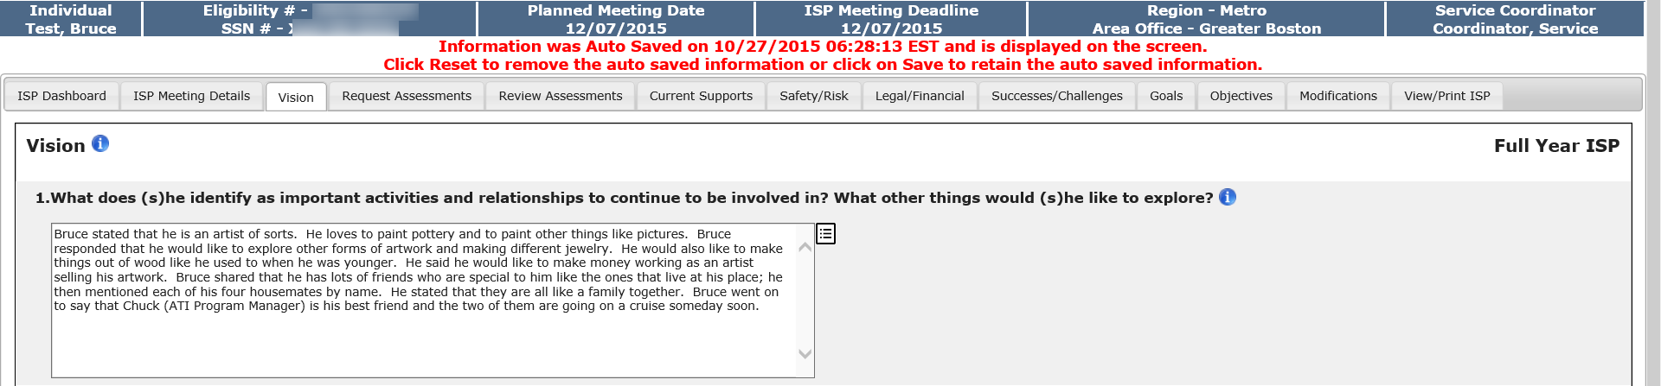
Note: An InfoTip displays next to the fields in which autosaved information has been loaded. Click the InfoTip to display and compare the text that was last saved by the Service Coordinator to the autosaved information.
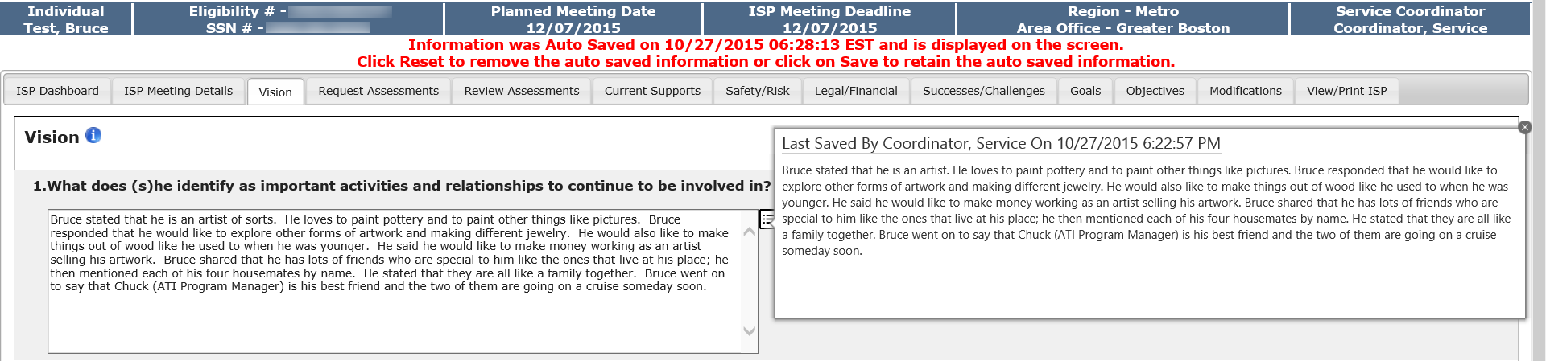
- To remove the auto saved information, click “Reset.” To retain the auto saved information and delete the manually entered information, click “Save”.
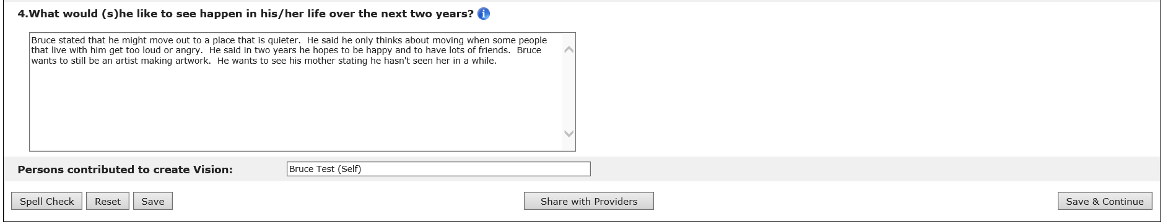
- Click “Share with Providers” to share the Vision Statement in the module.
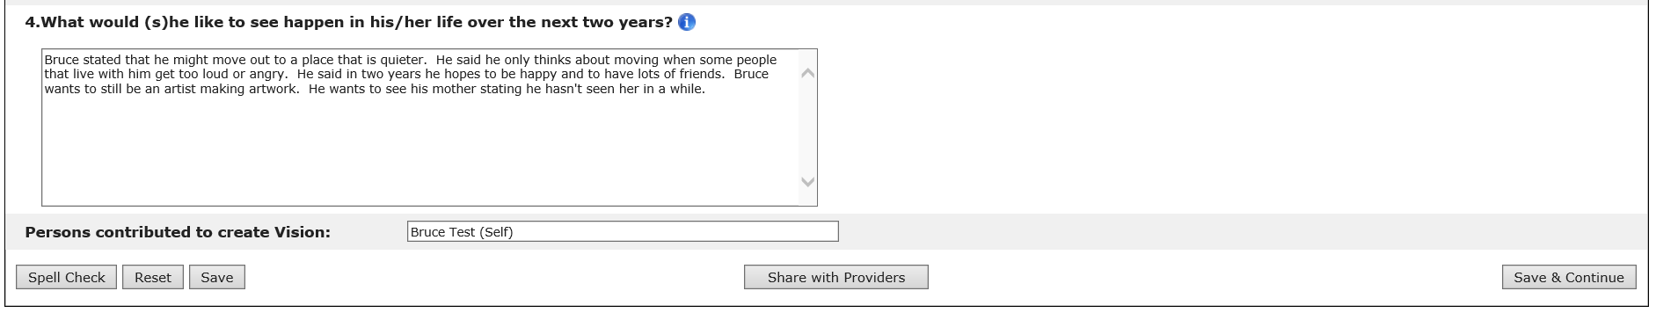

Note: The “Share with Providers” button turns into an “Edit” button once the Vision is shared and the screen will be displayed in read only mode. To make changes, simply click “Edit”. It will be necessary to share again with providers if changes are made. Please note that Providers will not see the updates unless the vision is re-shared with them. Also, Providers do not receive an alert when the Vision is shared or re-shared with them.

Next Steps

After the system saves the Vision Statement and makes it available to Providers, end users will be able to take the following actions:

- Service Coordinators can proceed to request assessments from Providers.
- Service Coordinators and Providers will have access to view the date on which the Vision Statement was last updated. This will be reflected on the Individual Dashboard.
- The “Edit” button will not be displayed to Providers and Provider Supervisors. However, Service Coordinators and Service Coordinator Supervisors can edit an individual’s vision by clicking on “Edit” after a Vision Statement has been shared with providers. The Vision would then need to be shared again for Providers to see those changes.

Other buttons are available on this screen. They are as follows:
- “Save”: The system will save the user’s work. Saved work can be accessed at a later date.
- “Reset”: The system will revert back to what was last saved. In the event that there are no saved data, “Reset” will clear the form.
- “Spell Check”: A proofreading tool that can be used prior to saving or sharing.
- “Save & Continue”: The system will redirect the user to the ISP Dashboard.

Updating a Vision by DDS Staff in an Update Year

When creating a Vision in an Update Year ISP, the system will pull information from the individual’s last ISP. The recalled information will be editable to allow users to enter any missing information from last year’s approved ISP. All updates to the original Vision must be entered using the process outlined in the below scenario. Providers will not be able to see the recalled information before the Vision has been shared with them.

Scenario Description:
- This scenario describes the steps required to update an individual’s Vision.

First Steps:

- Search for an individual
- View the Individual Dashboard

Roles and Responsibilities
- Service Coordinators: Updates the Vision in the module and shares with Providers
- Service Coordinator Supervisors: Updates the Vision in the module and shares with Providers

- Select "Vision" from the ISP components table on the ISP Dashboard or select the “Vision” tab.

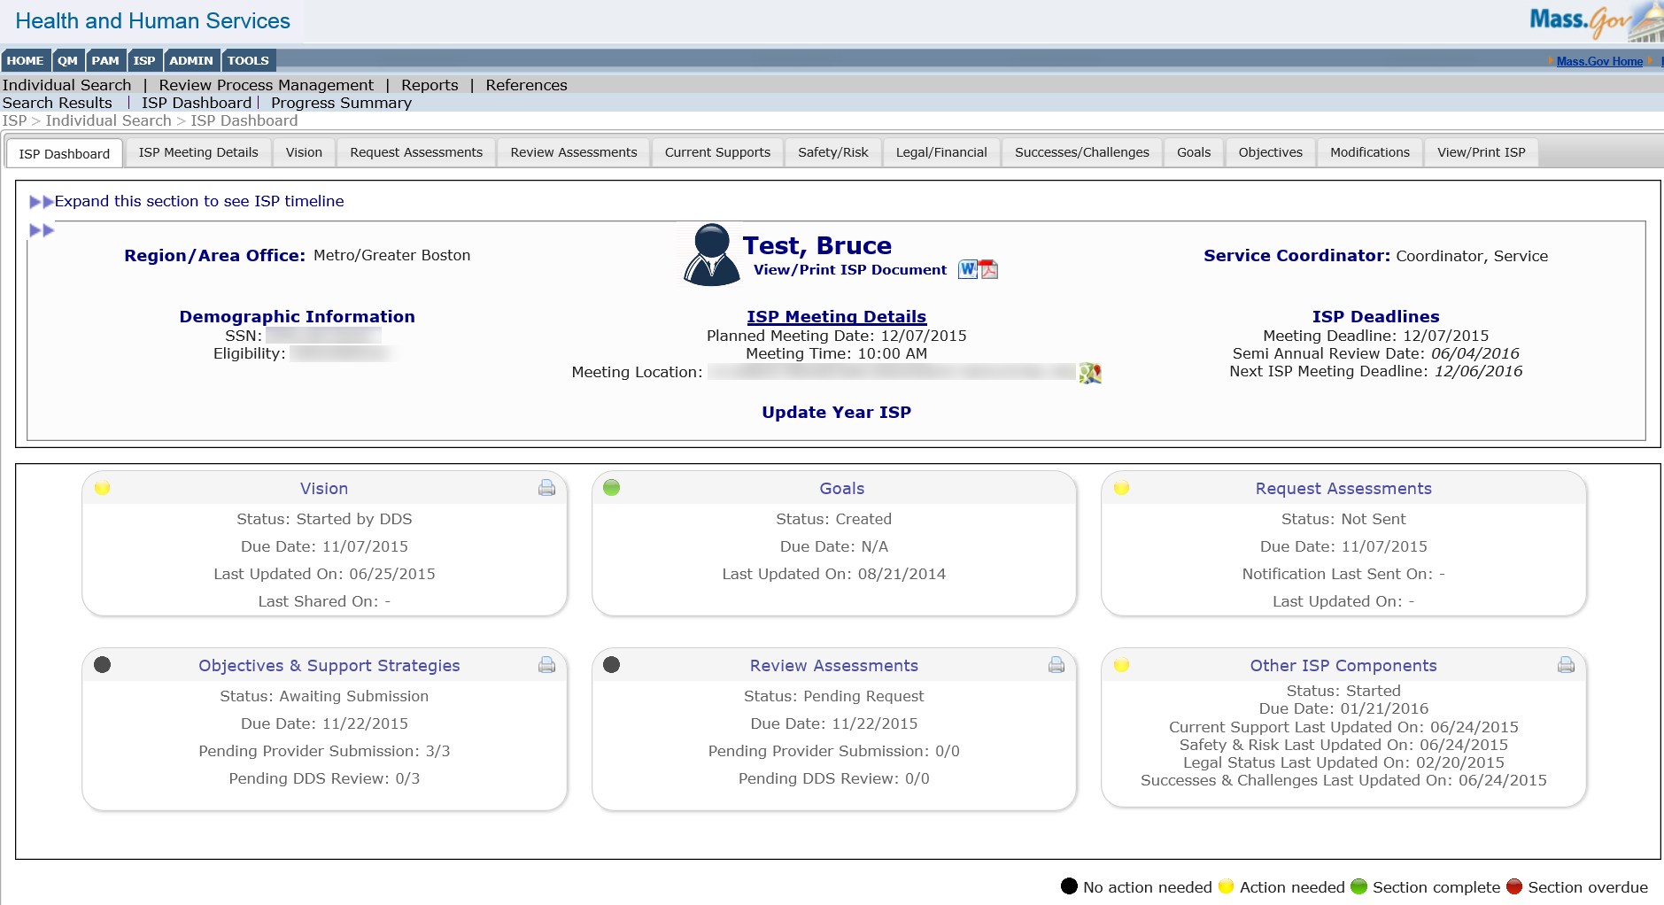

- The module redirects the Service Coordinator to the Individual’s “Vision” page.

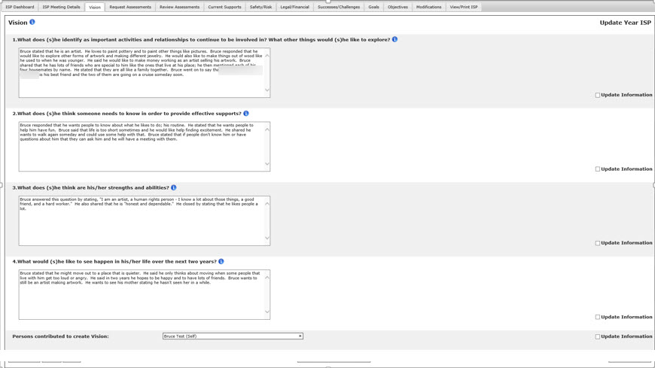

Note: The Vision from the last Full Year ISP plan will be displayed as editable to allow for entering missing information from last year’s approved ISP. If there is no information saved in HCSIS for a specific section, the system will display the following message: “No information recorded in HCSIS for this section.” In order to enter the missing information, the Service Coordinator must delete the message and then type or copy and paste the information from last year’s approved ISP. Updates are entered in the designated text boxes, as outlined by the steps below.

- Select the “Update Information” checkbox next to the sections of the Vision that require updating.

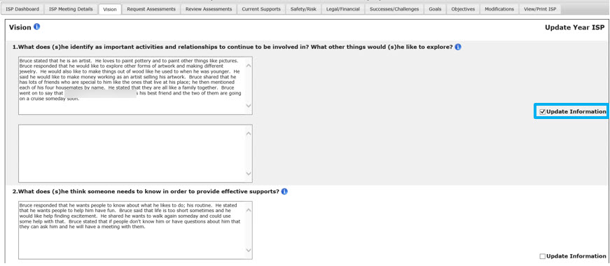

Note: The user may select any combination of sections to update in an update year, or may select to edit none of the sections.

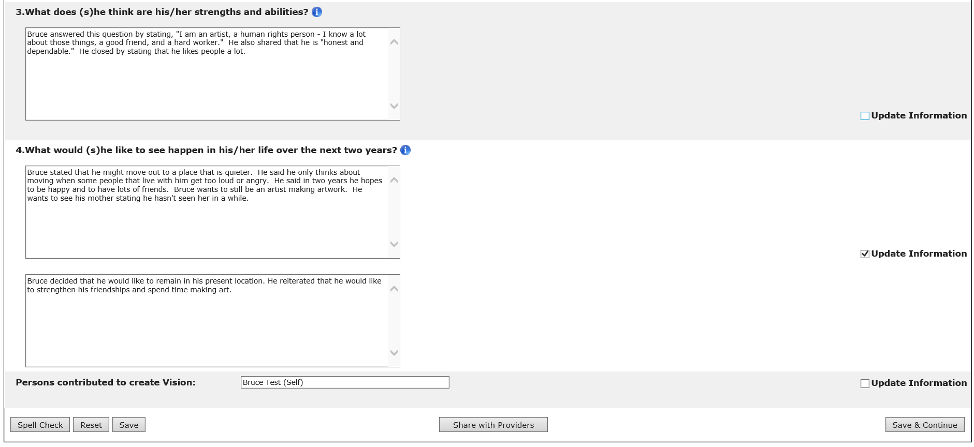

Note:
- All Updated Information text boxes will have a 2,000 character limit.
- If information is entered in the “Updated Information” text box and the “Update Information” checkbox is unchecked, the system displays the following pop-up window: “Information entered in this text box will not be saved. Do you wish to proceed?” If the user selects “Yes”, the system unchecks the checkbox and hides the “Updated Information” text box without saving the information entered in it.

- Select “Share With Providers.”

Note: The “Share with Providers” button turns into an “Edit” button once the Vision is shared and the screen will be displayed in read only mode. To make changes, simply click “Edit”. It will be necessary to share again with providers if changes are made. Providers do not receive an alert when the Vision is shared or re-shared with them.

Note: The system populates “No Change” for all instances when no updates were entered by the Service Coordinator for a certain section.

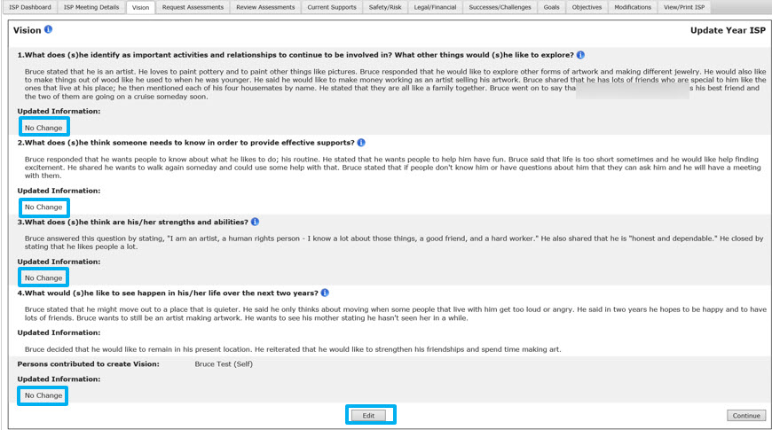

Next Steps

After the system saves the Vision Statement and makes it available to Providers, end users will be able to take the following actions:

- Service Coordinators should proceed to request assessments from Providers.
- Service Coordinators and Providers will have access to view the date on which the Vision Statement was last updated. This will be reflected on the Individual Dashboard.
- The “Edit” button will not be displayed to Service Providers and Service Provider Supervisors. However, Service Coordinators and Service Coordinator Supervisors can edit an individual’s vision by clicking on “Edit” after a Vision Statement has been shared with providers. The Vision would then need to be shared again for Providers to see those changes.

Other buttons are available on this screen. They are as follows:
- “Save”: The system will save the user’s work. Saved work can be accessed at a later date.
- “Reset”: The system will revert back to what was last saved. In the event that there are no saved data, “Reset” will clear the form.
- “Spell Check”: A proofreading tool that can be used prior to saving or sharing.
- “Save & Continue”: The system will redirect the user to the ISP Dashboard.

Viewing a Vision by Provider Staff in a Full Year
The Provider can view the Vision once the following conditions are met:
- The Service Coordinator has entered the Vision statement and clicked “Share with Providers”

When the Provider or Provider Supervisor accesses the Vision page, the screen is displayed in read-only mode.

Scenario Description:
- A consultation has taken place between an individual, the individual’s guardian and the Service Coordinator, during which a new Vision Statement has been developed and the Service Coordinator has created the Vision Statement for the individual in the module and shared with Providers.
First Steps:
- Search for an individual
- View the Individual Dashboard

Roles and Responsibilities:
- Providers: Views the Vision in Read-Only mode in the module
- Provider Supervisor: Views the Vision in Read-Only mode in the module

- Select "Vision" from the ISP components table on the ISP Dashboard or select the “Vision” tab.

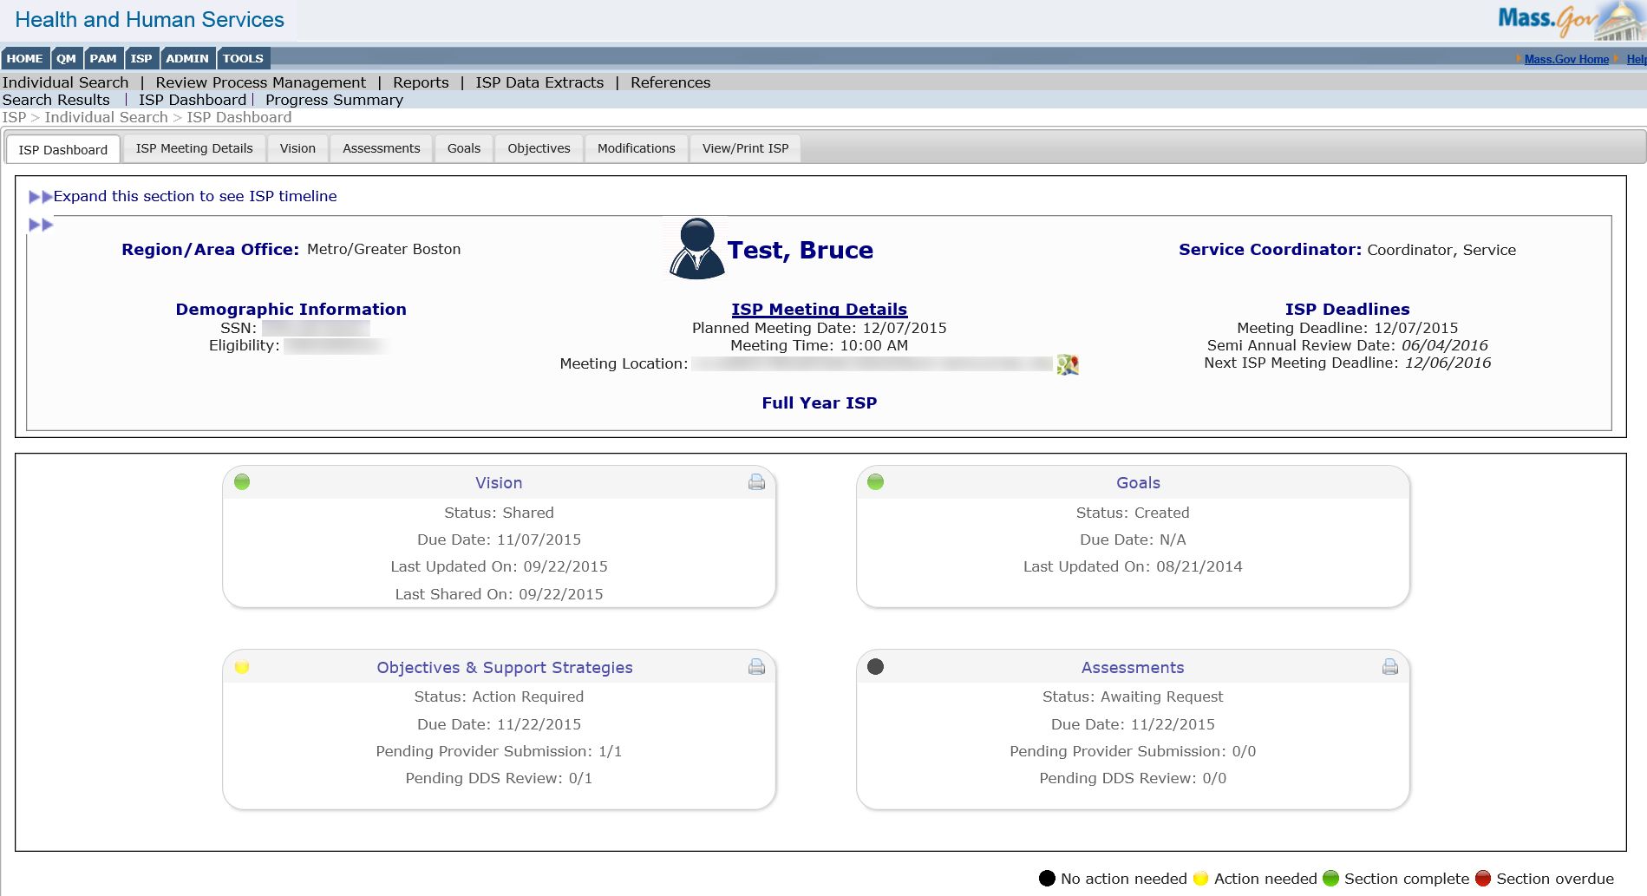

- The Vision Statement will display in Read-Only mode.

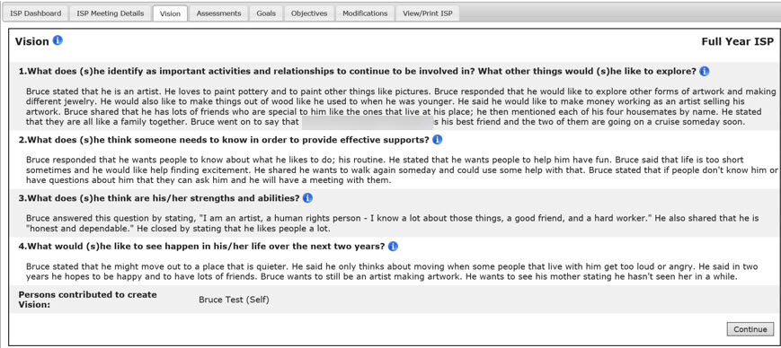

Next Steps

After the Providers view the shared Vision, they can continue working on an Individual’s plan by completing any of the following actions:

- Providers and Provider Supervisors can use the Vision Statement as a reference tool when completing assessments requested by the Service Coordinator, recording Goals, Objectives or Support Strategies.

Other buttons are available on this screen. They are as follows:
- “Continue”: The system redirect the user to individual Dashboard

Viewing a Vision by Provider Staff in an Update Year
The Provider can view the Vision once the following conditions are met:
- The Service Coordinator has entered the Vision statement and clicked “Share with Providers.”

When the Provider or Provider Supervisor accesses the Vision page, the screen is displayed in Read-Only mode. On an update year, the Vision from last year’s ISP will be displayed along with any updates entered by the Service Coordinator or Service Coordinator Supervisor.

Scenario Description:
- A consultation has taken place between an individual, the individual’s guardian and the Service Coordinator, during which a new Vision Statement has been developed and the Service Coordinator has created the Vision Statement for the individual in the module and shared with Providers.

Note: The Provider user will not be able to view the Vision answers if the Vision is “Started by DDS.” If the Provider user accesses the Vision screen when the Vision is “Started by DDS,” the following error message will be displayed, “The individual’s Vision is locked for editing. Please contact the Service Coordinator for details.”
First Steps:
- Search for an individual
- View the Individual Dashboard
Roles and Responsibilities:
- Providers: Views the Vision in Read-Only mode in the module
- Provider Supervisor: Views the Vision in Read-Only mode in the module

- Select "Vision" from the ISP components table on the ISP Dashboard or select the “Vision” tab.

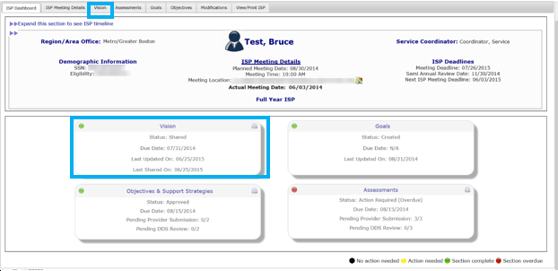

- View the original Vision Statement along with all updates in Read-Only mode.

Note: All updates entered by the Service Coordinator are displayed under last year’s ISP information and are labeled as “Updated Information”. If the Service Coordinator has not updated a certain question, the text that reads No Change” will be displayed.

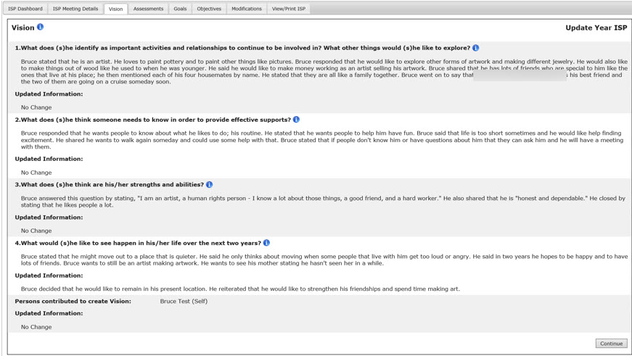

Next Steps

After the Providers view the shared Vision, they can continue working on an Individual’s plan by completing any of the following actions:

- Providers and Provider Supervisors can refer to the Vision Statement when completing assessments requested by the Service Coordinator, recording Goals, Objectives or Support Strategies.

Other buttons are available on this screen. They are as follows:
- “Continue”: The system redirects the user to the individual dashboard

Goals for DDS Staff

Creating a Goal in a Full or Update Year

Scenario Description
Service Coordinators and Service Coordinator Supervisors can create a Goal in the module starting at 90 days before the ISP meeting, once the plan selection has been made. Goals can be created as long as the ISP plan remains unlocked.

Note: For demonstration purposes, the scenario will show the Goals form in an Update Year, and any differences present in a Full Year will be noted.

First Steps
- Search for an Individual
- View the Individual Dashboard

Roles and Responsibilities
- Service Coordinators: Create Goals
Service Coordinator Supervisors: Create Goals
- Select “Goals” from the ISP components on the Individual Dashboard or menu tabs.

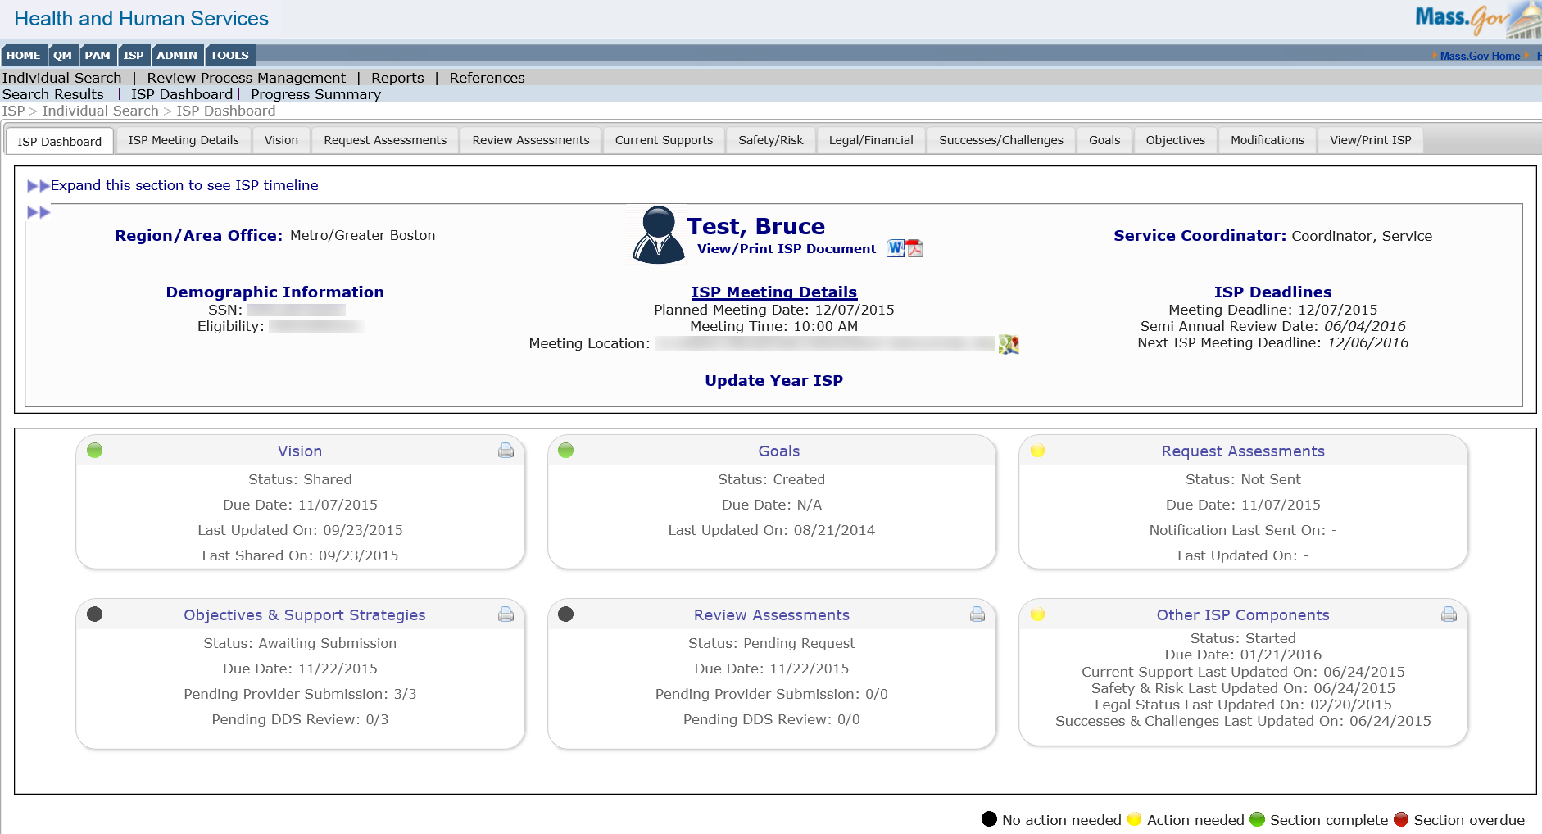

The system will display the Goals screen with a blank Goals form where a new Goal can be entered:

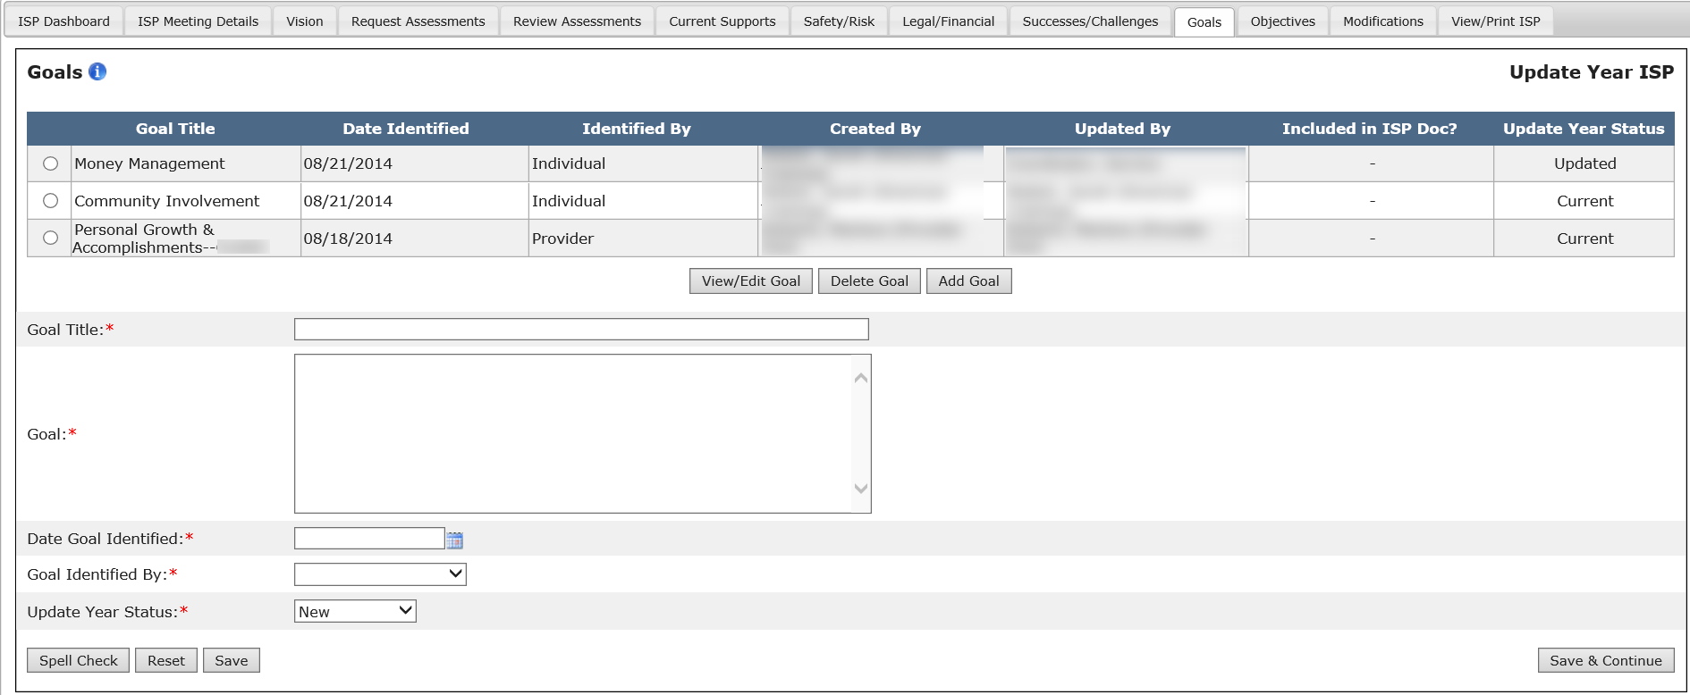

Note: If already viewing an existing Goal, clicking on “Add Goal” will provide the Goals form and allow the user to enter a new Goal.

- Complete mandatory fields. The Goal fields must be completed with accurate information in order to proceed.
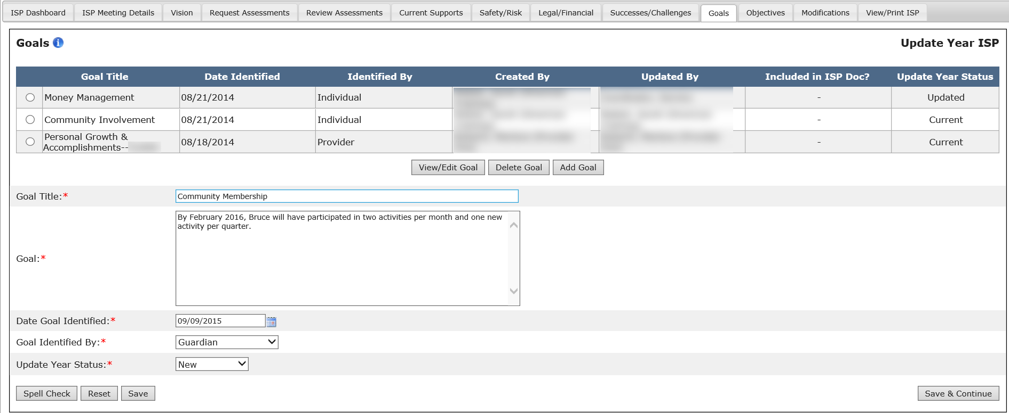

Note: The “Update Year Status” will be present only for an Update Year ISP. In a Full year, the Goals form will look similar with the exception of the “Update Year Status” field, which will not be displayed.

- Verify and/or change the “Update Year Status” for the Goal. This will be defaulted to “New” and will be editable.
Note: This step is applicable to Update Year only. There will be no “Update Year Status” when creating a Goal in a Full Year.

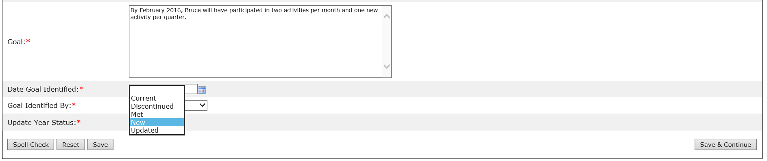

Note: Please see the table below for more information on Update Year Status.

Update Year Status | Description
Met | Used to describe a Goal or objective that has been achieved by the individual and no longer remains a Goal or objective for the Update Year ISP.
Discontinued | Used to identify a Goal or objective that is no longer relevant for the individual or has ended.
Current | Used to identify a Goal or objective from the previous year’s ISP that has not changed and continues into the update year ISP.  *All recalled Goals and objectives will be defaulted to current.  *If a current Goal or objective is updated, the status should be changed to updated.
Updated | Used to identify a Goal or objective from the previous year’s ISP that has been changed for the update year ISP.
New | Used to identify a newly added Goal or objective. *Newly added Goals and objectives will be defaulted to “new”.

- After completing the Goals form, click “Save” to save the Goal in the module.

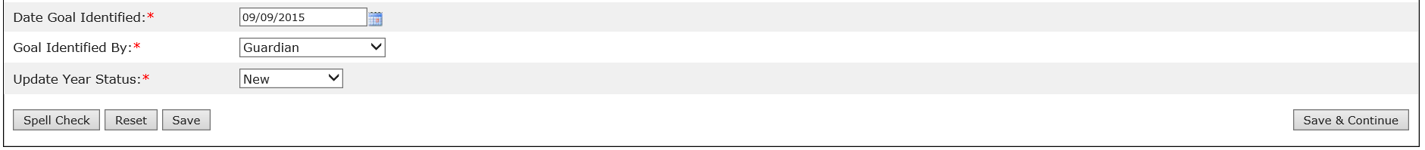

Other buttons are available on this screen. They are as follows:
- “Save & Continue”: The system will redirect the user to the ISP Dashboard.
- “Reset”: The system will revert back to what was last saved. In the event that there is no saved data, “Reset” will clear the form.
- “Spell Check”: A proofreading tool that can be used prior to saving or sharing.

- After saving the Goal, the system will update the Goals Summary table with the information saved by the user. The system will also display a message reading “Operation Successful.”

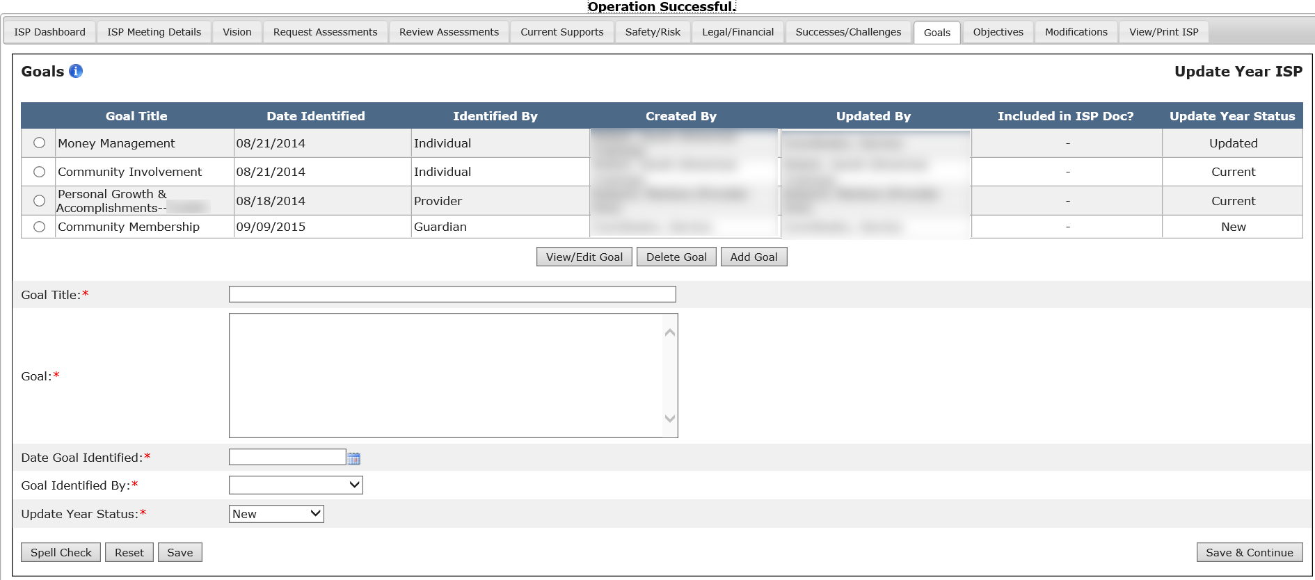

Note: The “Included in ISP Document?” column is visible only to DDS staff and will display a dash prior to the ISP Meeting. For more information on this column, please refer to the Post ISP Meeting Activities quick guide posted on the References page.

Next Steps

- The system will update the Goals Summary table with the information.
- Service Coordinators and Service Coordinator Supervisors can view and edit Goals submitted by themselves as well as those submitted by Providers.

Editing a Goal in a Full Year

Scenario Description
Service Coordinators and Service Coordinator Supervisors can edit an existing Goal in the module in a Full Year ISP once the plan has been created and Goals have been recalled, or new Goals have been created in the Full Year.

Recalled Information
- All Goals from the previous year’s Full or Update ISP will be recalled into a Full Year ISP. All fields will be in editable mode.
- If there is no Full Year ISP saved in HCSIS for the individual, the system will display the following message: “No information recorded in HCSIS for this section.”

First Steps
- Search for the Individual
- View the Individual Dashboard

Roles and Responsibilities
- Service Coordinators: Edit a Goal created by the Area Office or any Provider agency
- Service Coordinator Supervisors: Edit a Goal created by the Area Office or any Provider agency

- Select “Goals” from the ISP Dashboard or select “Goals” tab. The system redirects the user to the individual’s Goals page.

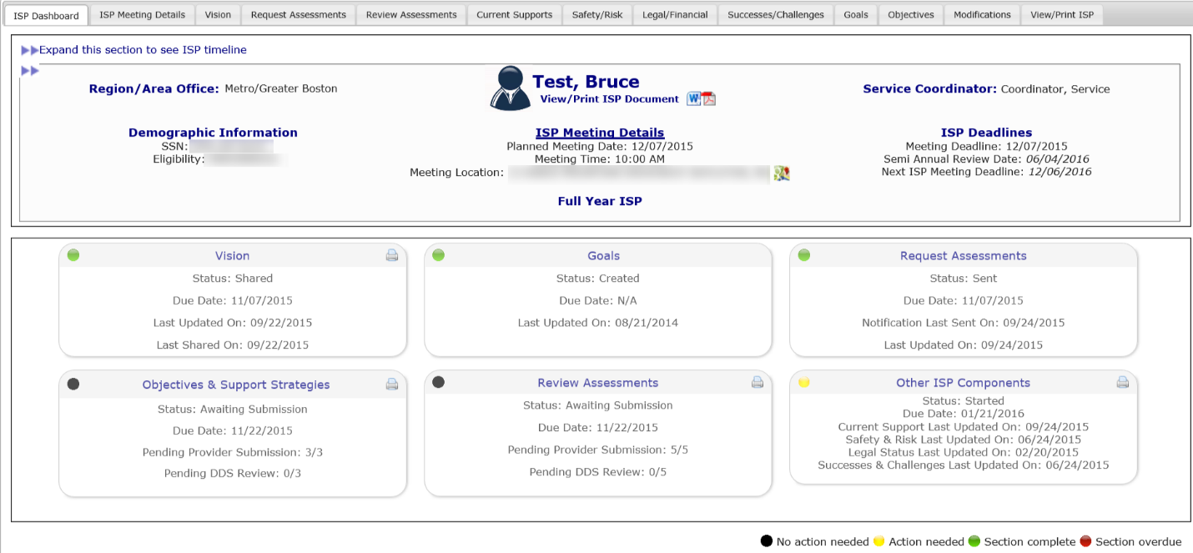

- Select a Goal to edit by clicking the corresponding radio button and then selecting “View/Edit Goal.”

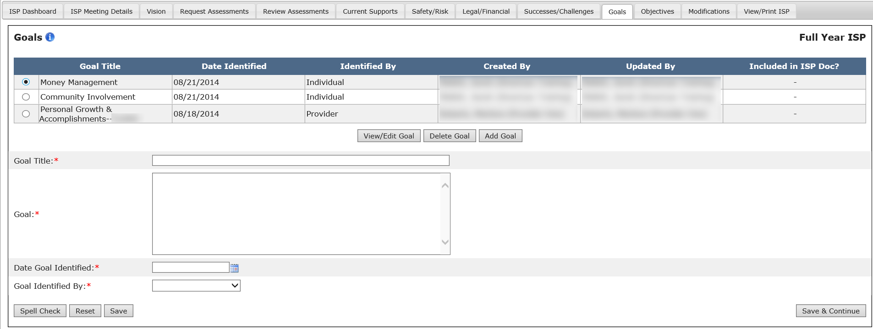

Note: The “Included in ISP Document?” column is visible only to DDS staff and will display a dash prior to the ISP Meeting. For more information on this column, please see Post ISP Meeting Activities.

- The system populates the text boxes with previously saved information for that Goal. All of the text boxes can now be edited.

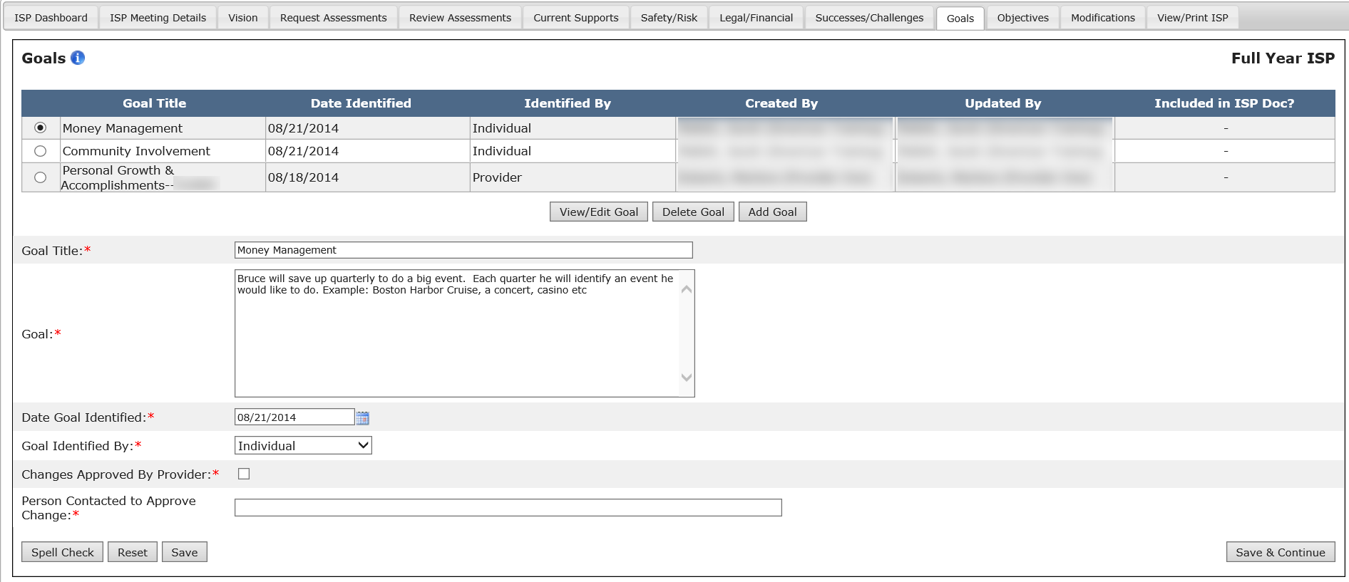

If the selected Goal is created by a Provider instead of the Service Coordinator, the Service Coordinator will see two additional fields on the bottom of the screen when viewing/editing the Goal:

- To finish editing a Goal, select “Save.”

Note: Other buttons are available on this screen. They are as follows:
- “Save & Continue”: The system will redirect the user to the ISP Dashboard.
- “Reset”: The system will revert back to what was last saved. In the event that there are no saved data, “Reset” will clear the form.
- “Spell Check”: A proofreading tool that can be used prior to saving or sharing.

After saving the Goal, the system will update the Goal Summary table with the information saved by the user. The system will also display a message reading “Operation Successful.”

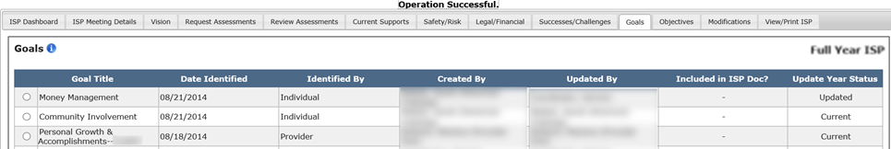
Next Steps
- The system will save the changes made to the Goal and redirect the user to the ISP Dashboard.
- Service Coordinators, Service Coordinator Supervisors can create additional Goals or edit Goals that have been previously submitted.

Updating a Recalled Goal in an Update Year

Scenario Description
Service Coordinators and Service Coordinator Supervisors can update a recalled Goal in the module in an Update Year once the Update Year plan has been created, and if there was a Goal in the previous Full Year ISP plan that was recalled.

Recalled Information
- All Goals from the previous year’s full ISP will be recalled into an Update Year ISP. The fields will not be editable.

First Steps
- Search for an individual
- View the Individual Dashboard

Roles and Responsibilities
- Service Coordinators: Update a Goal created by the Area Office or any Provider agency
- Service Coordinator Supervisors: Update a Goal created by the Area Office or any Provider agency

- Select “Goals” from the ISP Dashboard or select the “Goals’ tab. The system redirects the user to the individual’s Goals page.
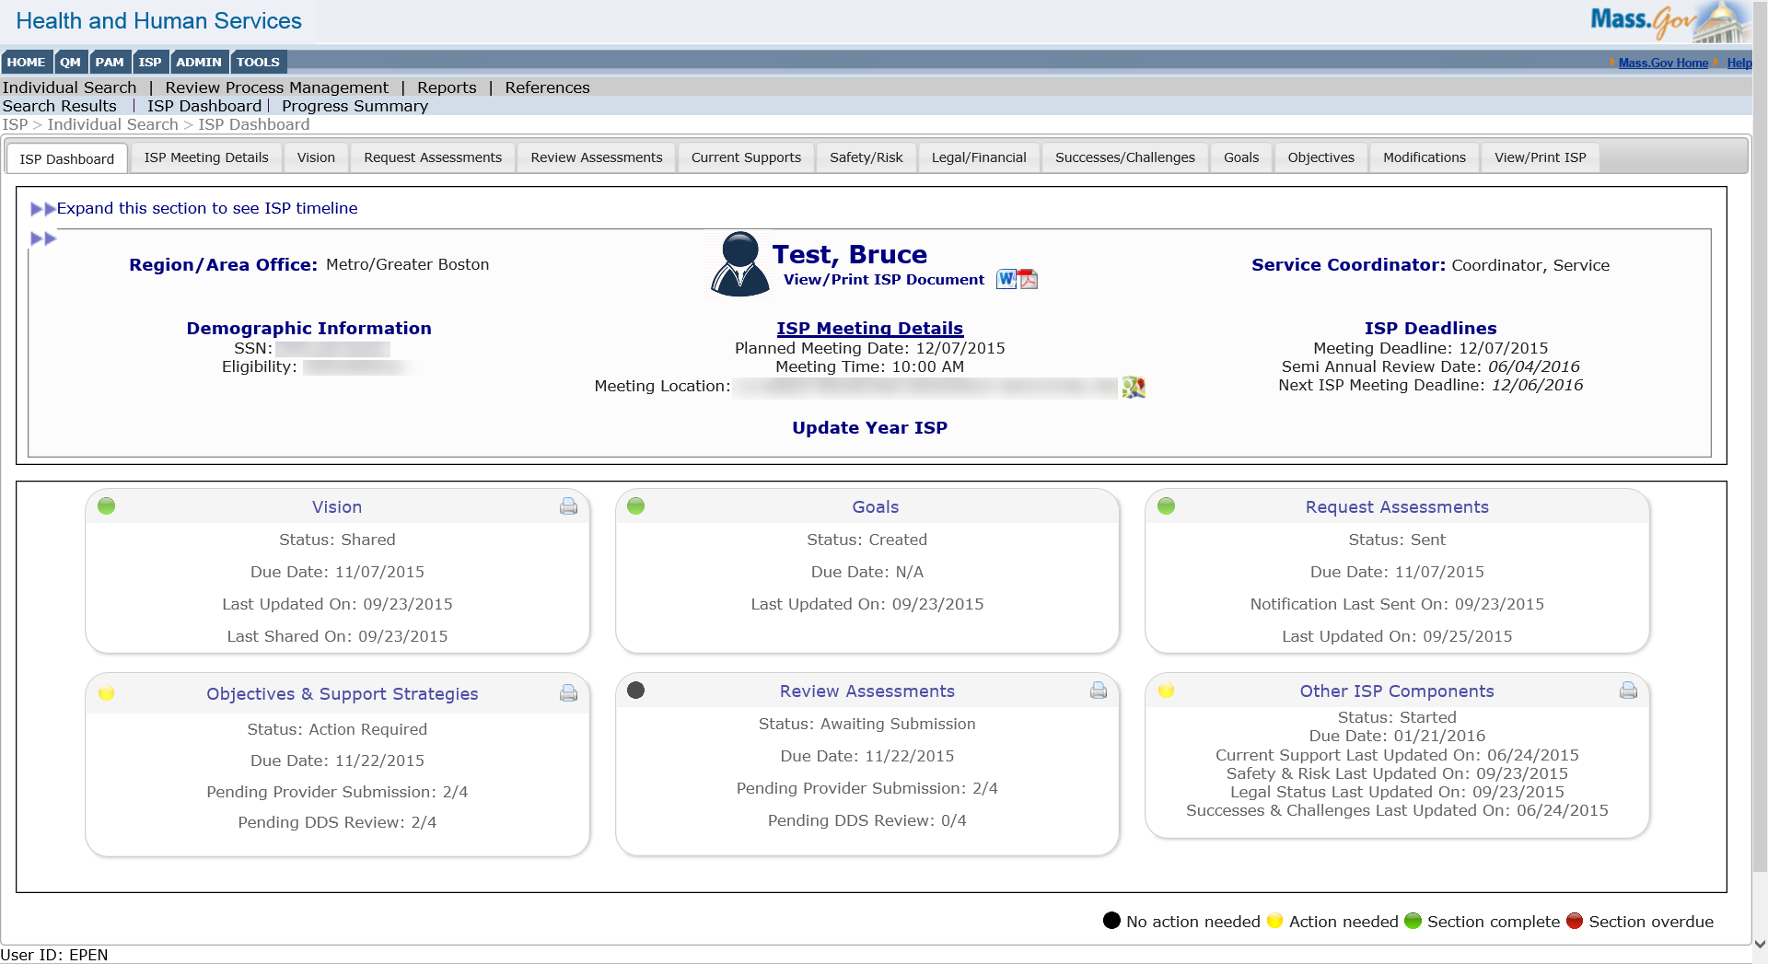

- Select a recalled Goal to update by clicking the corresponding radio button and then selecting “View/Edit Goal.”

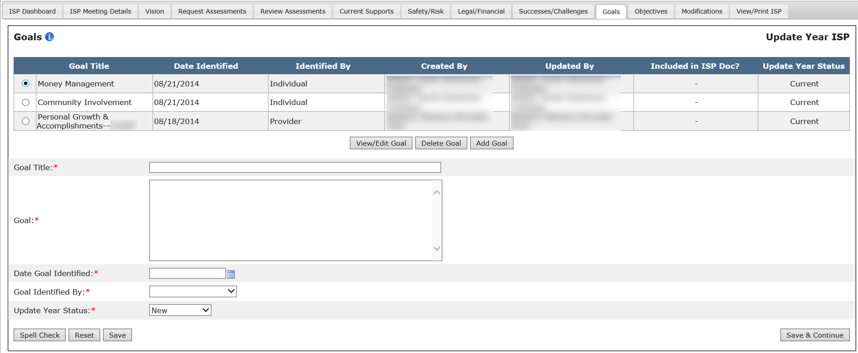

Note: The system returns the recalled Goal in read-only mode with an “Updated Information” check box and Goal Status dropdown that are editable.

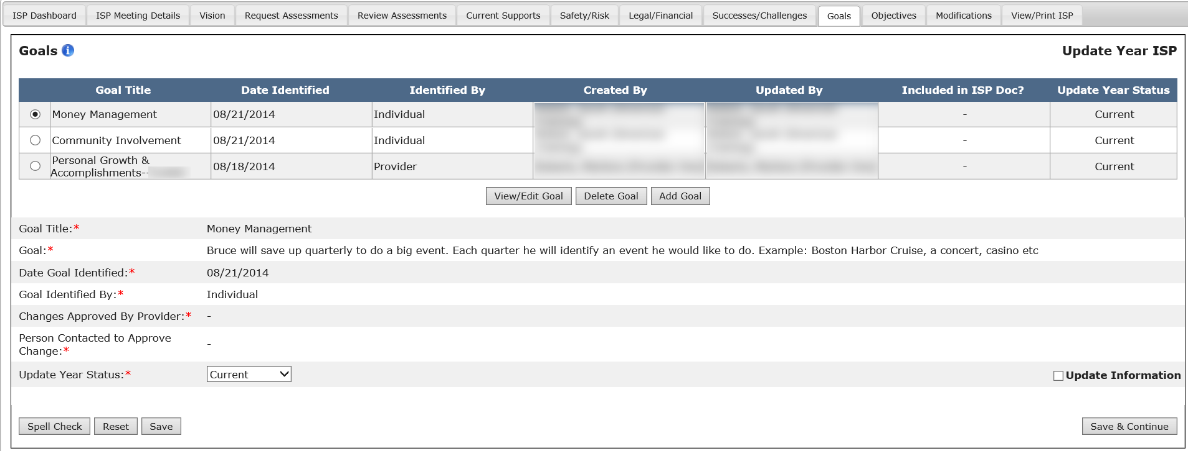

- Select the Update Information checkbox. Enter updates for the Goal in the Updated Information text box that appears.

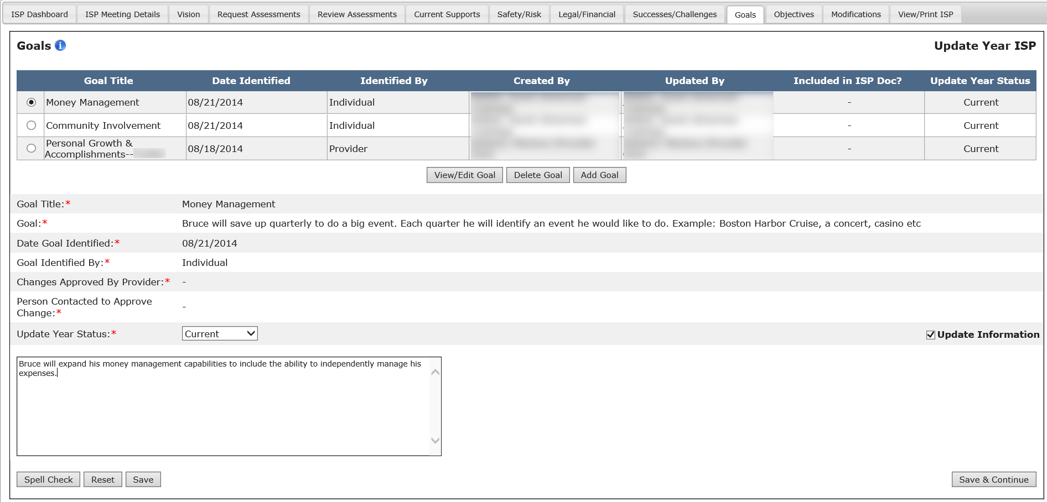

Note: One Updated Information checkbox will appear for each recalled Goal and will be displayed at the end of the form. This field will NOT appear for new Goals added as part of an update year.

Note: The Updated Information text box will have a 2,000 character limit.

- Select a status for the Goal from the Update Year status dropdown.

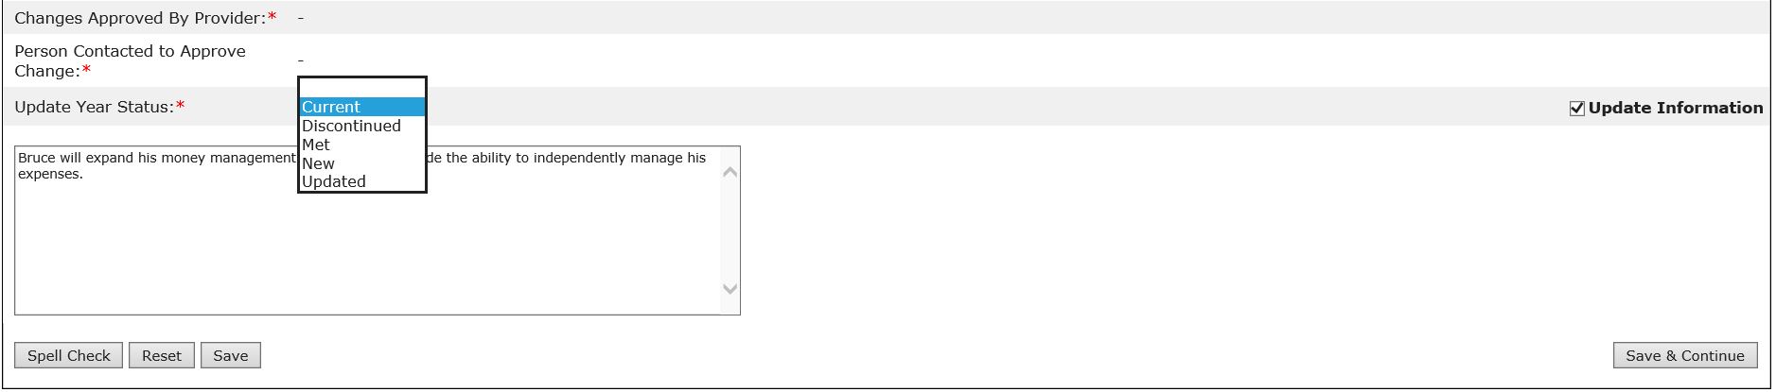

Note: This field is mandatory for all Goals pulled forward from a previous full year ISP plan. The dropdown value will have the following options: Met, Discontinued, Current, Updated, and New. The Goals status is pre-populated to “Current” for all recalled Goals and will be editable.

Note: Please see the table below for more information on Update Year Status.

Update Year Status | Description
Met | Used to describe a Goal or objective that has been achieved by the individual and no longer remains a Goal or objective for the Update Year ISP.
Discontinued | Used to identify a Goal or objective that is no longer relevant for the individual or has ended.
Current | Used to identify a Goal or objective from the previous year’s ISP that has not changed and continues into the update year ISP.  *All recalled Goals and objectives will be defaulted to current.  *If a current Goal or objective is updated, the status should be changed to updated.
Updated | Used to identify a Goal or objective from the previous year’s ISP that has been changed for the update year ISP.
New | Used to identify a newly added Goal or objective. *Newly added Goals and objectives will be defaulted to “new”.

- To finish updating a Goal, select “Save”.

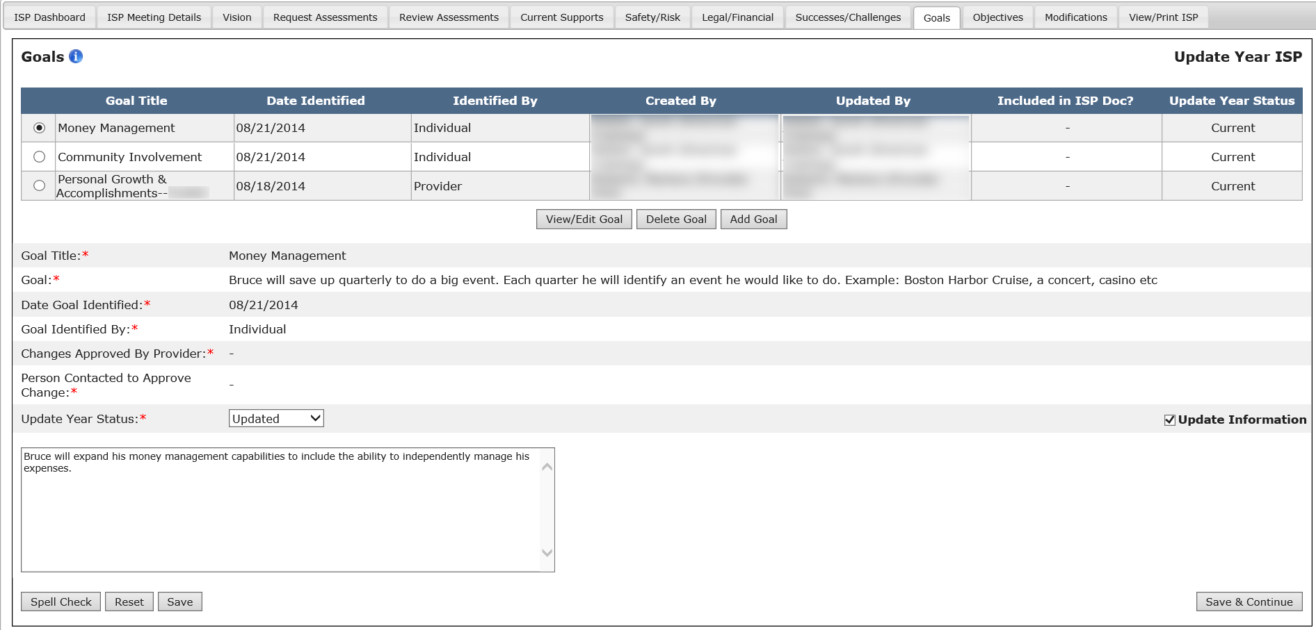

Note: Other buttons are available on this screen. They are as follows:
- “Save & Continue”: The system will redirect the user to the ISP Dashboard.
- “Reset”: The system will revert back to what was last saved. In the event that there are no saved data, “Reset” will clear the form.
- “Spell Check”: A proofreading tool that can be used prior to saving or sharing.

- After saving the Goal, the system will update the Goal Summary table with the information saved by the user. The system will also display a message reading “Operation Successful.”

Next Steps
- The system will save the changes made to the Goal and display a cleared Goals form.
- Service Coordinators and Service Coordinator Supervisors will be able to create additional Goals or update Goals that they have previously submitted.

Deleting a Goal in a Full or Update Year
Scenario Description
Service Coordinators, Service Coordinator Supervisors and Area Office Directors can delete a Goal in both a Full Year and Update Year ISP, given the following restrictions:
- A recalled Goal cannot be deleted during an Update Year. Only new Goals added during the Update Year can be deleted.
- A Goal cannot be deleted if there are any Objectives and Support Strategies associated to the Goal. The associated Objectives and Support Strategies must be deleted prior to deleting the Goal.
- A Service Coordinator may delete Goals created by the DDS staff or the Provider agency.

Note: For demonstration purposes, the scenario will show the Goals form in an Update Year, and any differences present in a Full Year will be noted.

First Steps
- Search for an Individual
- View the Individual Dashboard

Roles and Responsibilities

- Service Coordinators: Delete Goals created by SC or any Provider agency
- Service Coordinator Supervisors: Delete Goals created by SC or any Provider agency

- Select “Goals” from the ISP Dashboard or select “Goals” tab.

- Select a Goal to delete by clicking the radio button that corresponds to the Goal.

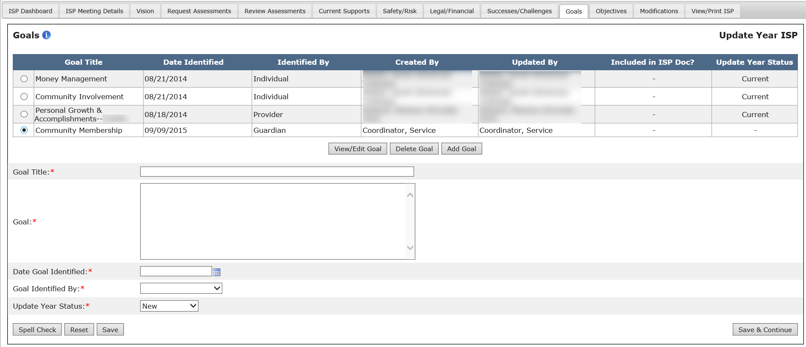

- Click on “Delete Goal”.

Note: It is recommended that all users click “View/Edit Goal” to view Goal content before proceeding to delete the Goal.

- The system will display a confirmation pop-up screen:

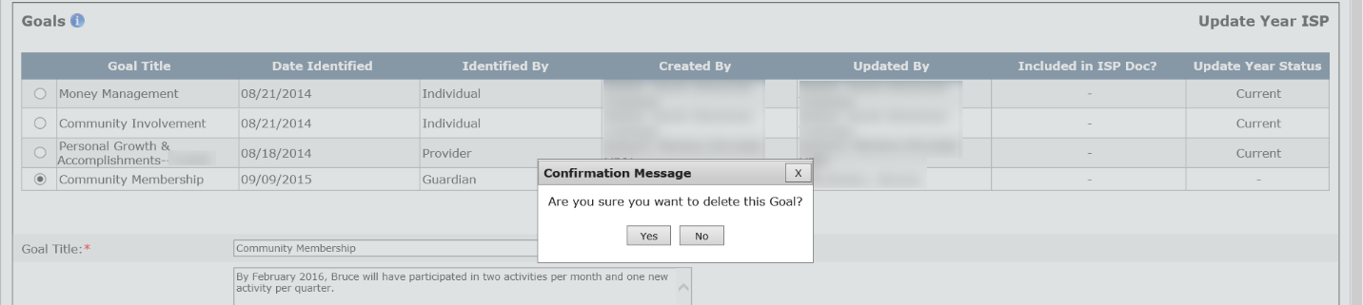

- Click “Yes.”

- After clicking “Yes”, the system will delete the Goal and update the Goal Summary table with the information saved by the user. The system will also display a message reading “Operation Successful.”
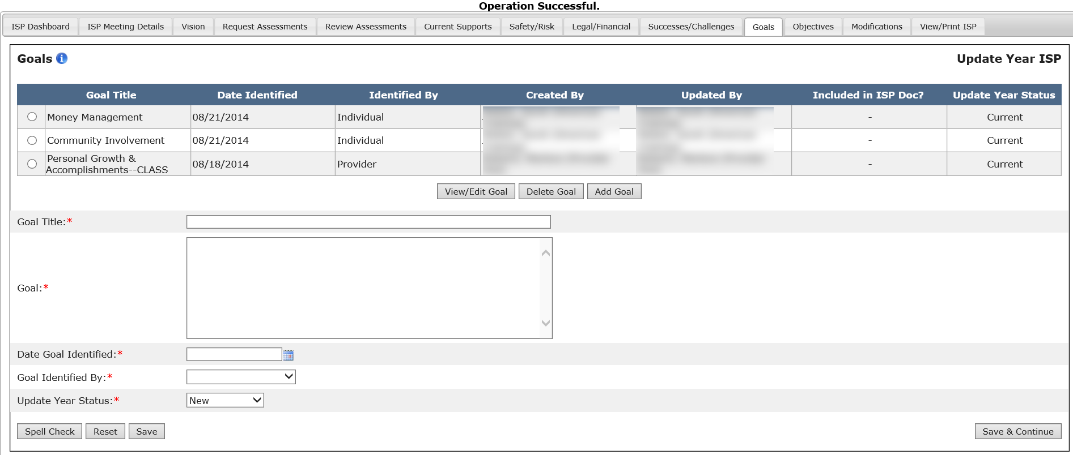

Note: If the Goal that the user is trying to delete has any associated Objectives and Support Strategies, then the user will be prompted to delete the associated Objectives and Support Strategies before deleting the Goal.
Next Steps
The system will update the Goal Summary table to reflect the changes made by the user.

- Service Coordinators and Service Coordinator Supervisors can create new and edit existing Goals

Goals for Provider Staff

Creating a Goal in a Full or Update Year
Scenario Description
Providers and Provider Supervisors can create a Goal in the module once the SC user has made the ISP year selection. Goals can be created as long as the ISP plan remains unlocked. It is not necessary for the Vision to be shared by the Service Coordinator in order to start work on creating Goals.

Note: For demonstration purposes, the scenario will show the Goals form in an Update Year, and any differences present in a Full Year will be noted.

First Steps
- Search for an Individual
- View the Individual Dashboard

Roles and Responsibilities
- Providers: Create Goals
- Provider Supervisors: Create Goals

The below steps are completed by either a Data Entry User or a Provider Supervisor.

- Select “Goals” from the ISP components on the Individual Dashboard or select “Goals” tab.

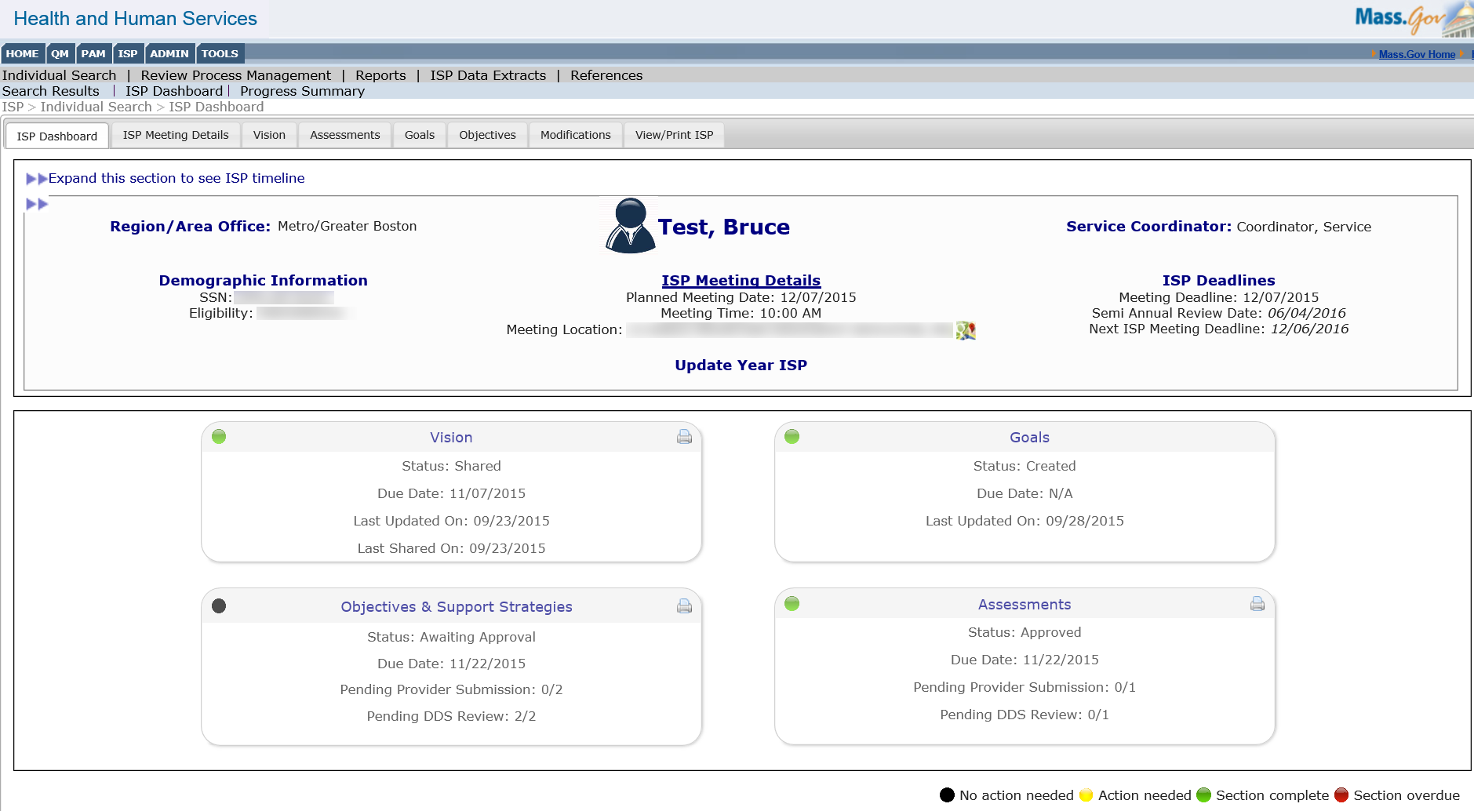

- Complete mandatory fields. The Goal fields must be completed with accurate information in order to proceed.
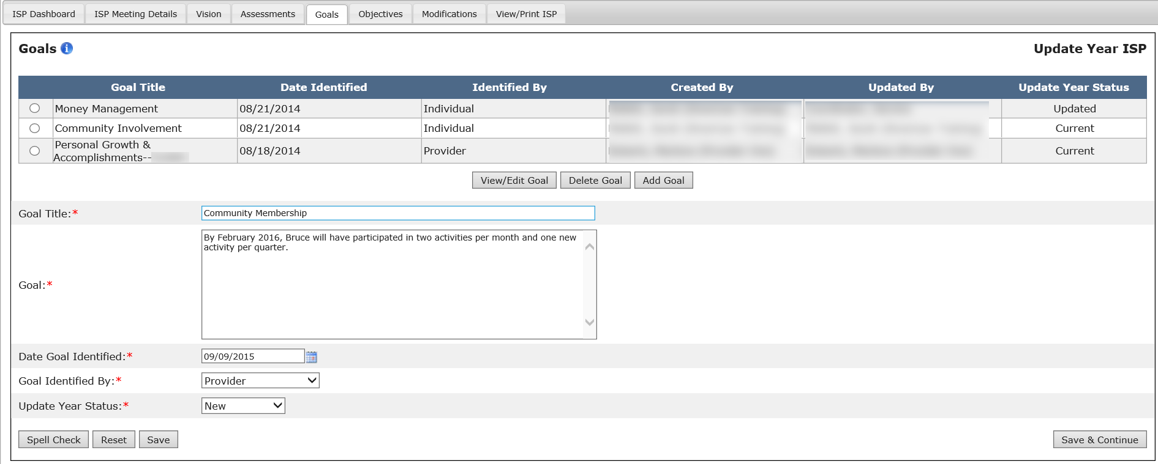

- Verify and/or change the “Update Year Status” for the Goal. This will be defaulted to “New” and will be editable.

Note: This step is applicable to Update Year only. There will be no “Update Year Status” when creating a Goal in a Full Year.

Note: Please see the table below for more information on Update Year Status.

Update Year Status | Description
Met | Used to describe a Goal or objective that has been achieved by the individual and no longer remains a Goal or objective for the Update Year ISP.
Discontinued | Used to identify a Goal or objective that is no longer relevant for the individual or has ended.
Current | Used to identify a Goal or objective from the previous year’s ISP that has not changed and continues into the update year ISP.  *All recalled Goals and objectives will be defaulted to current.  *If a current Goal or objective is updated, the status should be changed to updated.
Updated | Used to identify a Goal or objective from the previous year’s ISP that has been changed for the update year ISP.
New | Used to identify a newly added Goal or objective. *Newly added Goals and objectives will be defaulted to “new”.

- After completing the Goals form, click “Save” to save the Goal in the module.

Note: Other buttons are available on this screen. They are as follows:
- “Save & Continue”: The system will redirect the user to the ISP Dashboard.
- “Reset”: The system will revert back to what was last saved. In the event that there are no saved data, “Reset” will clear the form.
- “Spell Check”: A proofreading tool that can be used prior to saving or sharing.

- After saving the Goal, the system will update the Goal Summary table with the information saved by the user. The system will also display a message reading “Operation Successful.”
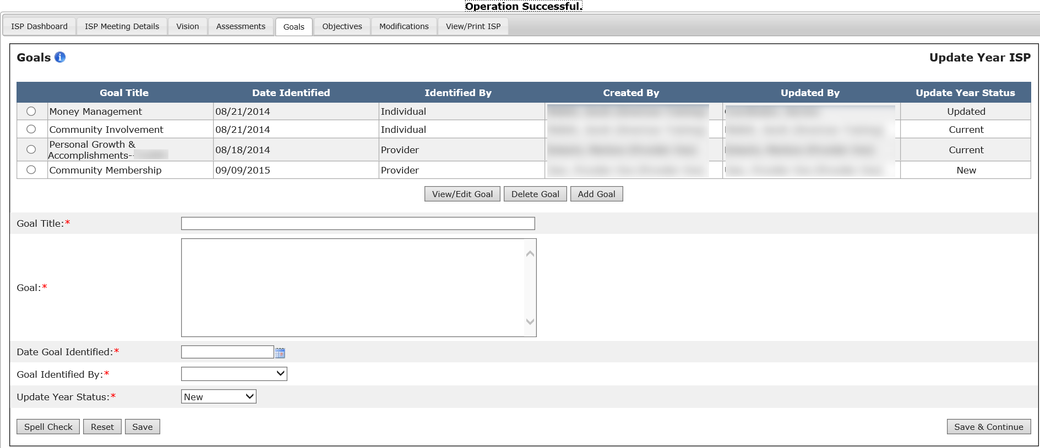

Next Steps

- Providers and Provider Supervisors can view and edit Goals created by their own Provider Agency
- Providers and Provider Supervisors can view Goals created by any user
- Provider and Provider Supervisors can associate an Objective to any previously created Goal (also for Goals created by Service Coordinators or by Providers from Other Agencies)

Editing a Goal in a Full Year
Scenario Description
Providers and Provider Supervisors can edit an existing Goal in the module in a Full Year ISP once the plan has been created and Goals have been recalled, or new Goals have been created in the Full Year.
Recalled Information
- All Goals from the previous year’s full or Update ISP will be recalled into a Full Year ISP. All fields will be in editable mode.
- If there is no Full Year ISP plan saved in HCSIS for the individual, the system will display the following message: “No information recorded in HCSIS for this section.”

First Steps:
- Search for the Individual
- View the Individual Dashboard
Roles and Responsibilities:
- Providers: Edit a Goal created by his/her own agency
- Provider Supervisors: Edit a Goal created by his/her own agency

The below steps are completed by either a Data Entry User or a Provider Supervisor.

- Select “Goals” from the ISP Dashboard. The system redirects the user to the individual’s Goals page.

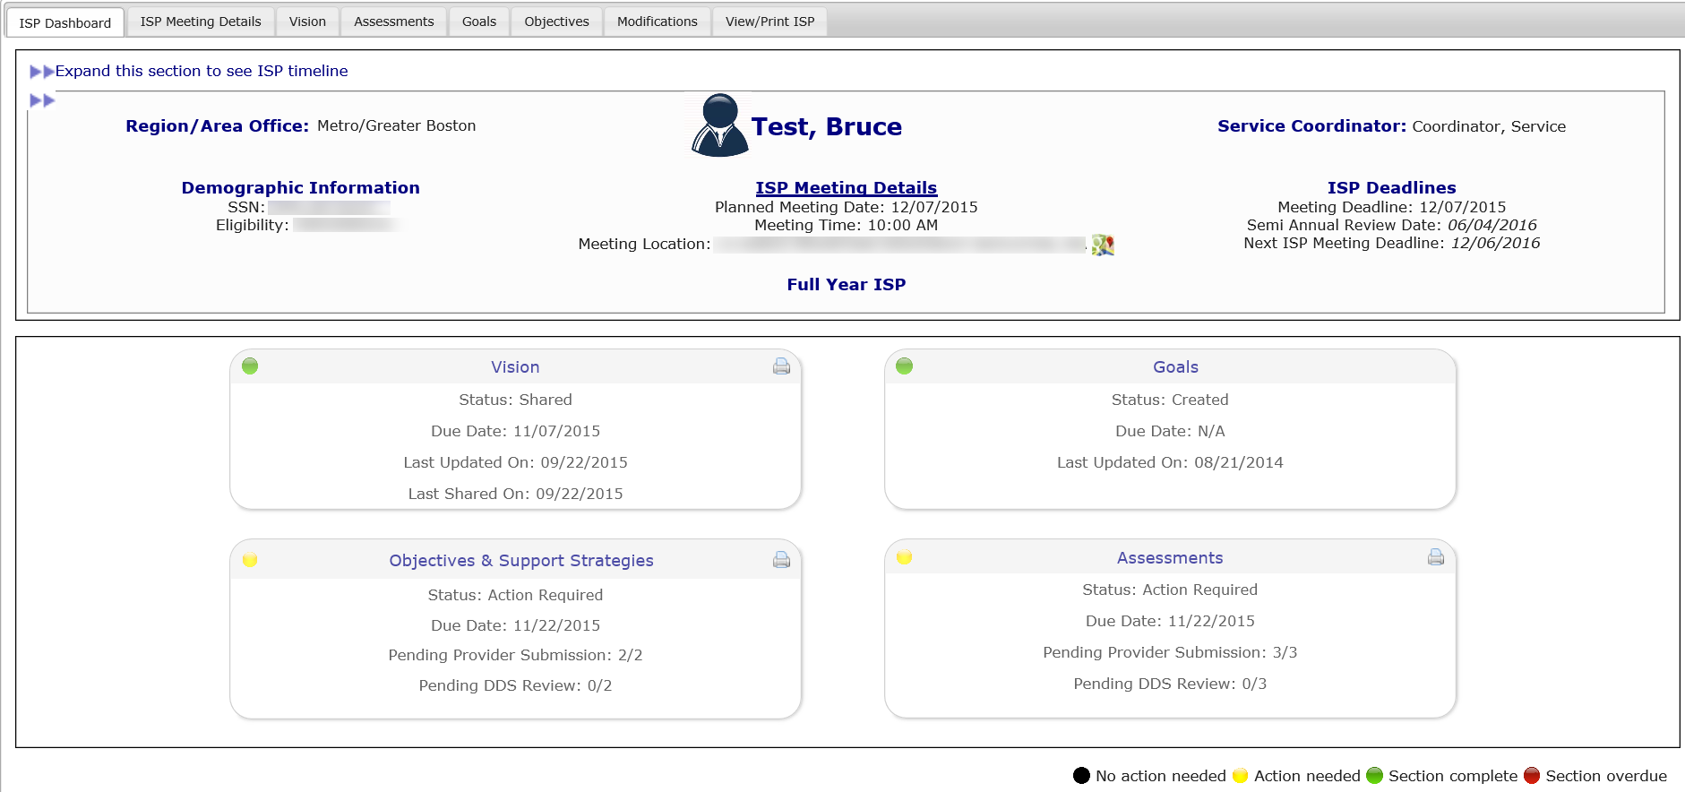

- Select a Goal to edit by clicking the corresponding radio button and then selecting “View/Edit Goal.”

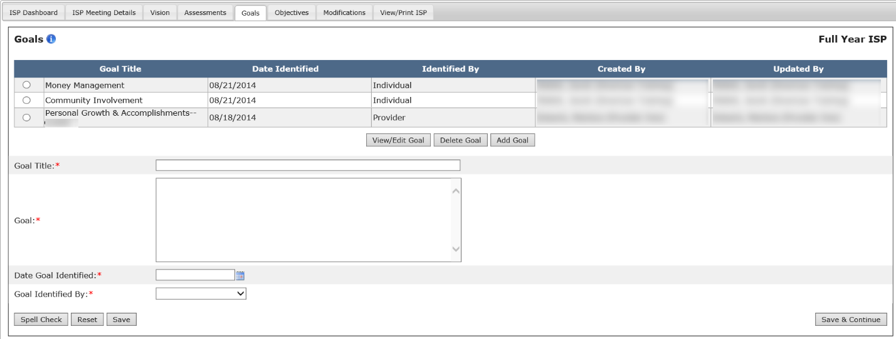

The system populates the text boxes with previously saved information for that Goal. All of the text boxes can now be edited.

- Make necessary changes to the Goal. If the Goal needs to be deleted, please refer to the section on deleting Goals.

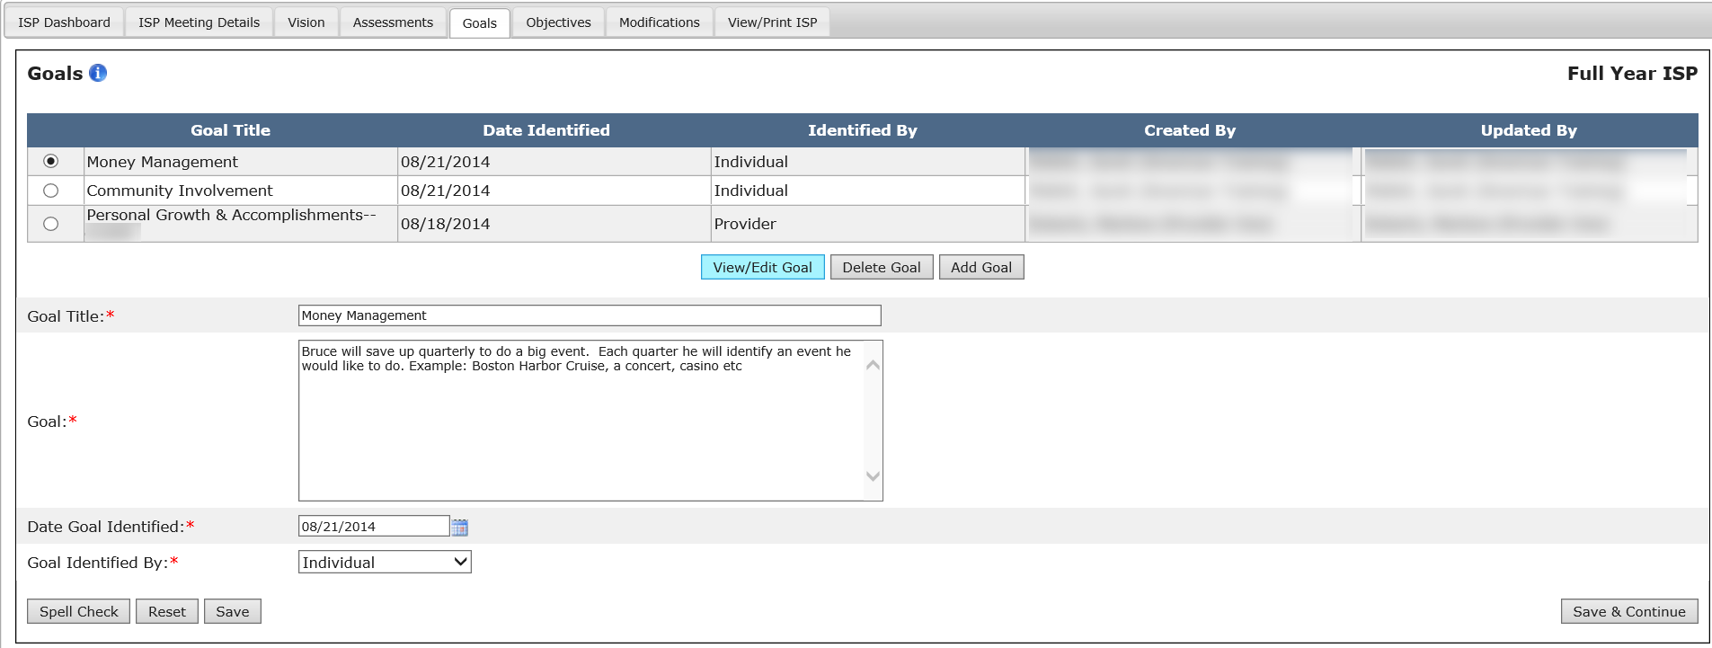

- To finish editing a Goal, select “Save”.

Note: Other buttons are available on this screen. They are as follows:
- “Save & Continue”: The system will redirect the user to the ISP Dashboard.
- “Reset”: The system will revert back to what was last saved. In the event that there are no saved data, “Reset” will clear the form.
- “Spell Check”: A proofreading tool that can be used prior to saving or sharing.

- After saving the Goal, the system will update the Goal Summary table with the information saved by the user. The system will also display a message reading “Operation Successful.”

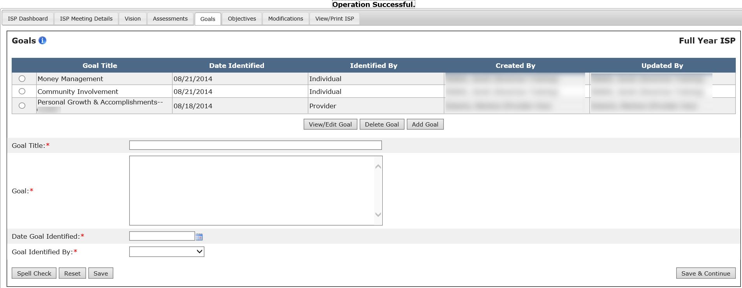
Next Steps

- Providers and Provider Supervisors can create Objectives and Support Strategies associated to Goals that have been created in the module, as well as create additional Goals.
- Providers and Provider Supervisors can create additional Goals or edit Goals that have been previously submitted by the same agency.

Updating a Recalled Goal in an Update Year
Scenario Description
Providers and Provider Supervisors can update a recalled Goal in the module in an Update Year once the Update Year plan has been created, and if there was a Goal in the previous Full Year ISP plan created by the same agency that was recalled.

Recalled Information
- All Goals from the previous year’s full ISP will be recalled into an Update Year ISP. The fields will not be editable.

First Steps
- Search for an individual
- View the Individual Dashboard

Roles and Responsibilities
- Provider Data Entry User: Update a Goal created by the same Provider agency
- Provider Supervisor: Update a Goal created by the same Provider agency

The below steps are completed by either a Data Entry User or a Provider Supervisor.

- Select “Goals” from the ISP Dashboard or select “Goals” tab. The system redirects the user to the individual’s Goals page.
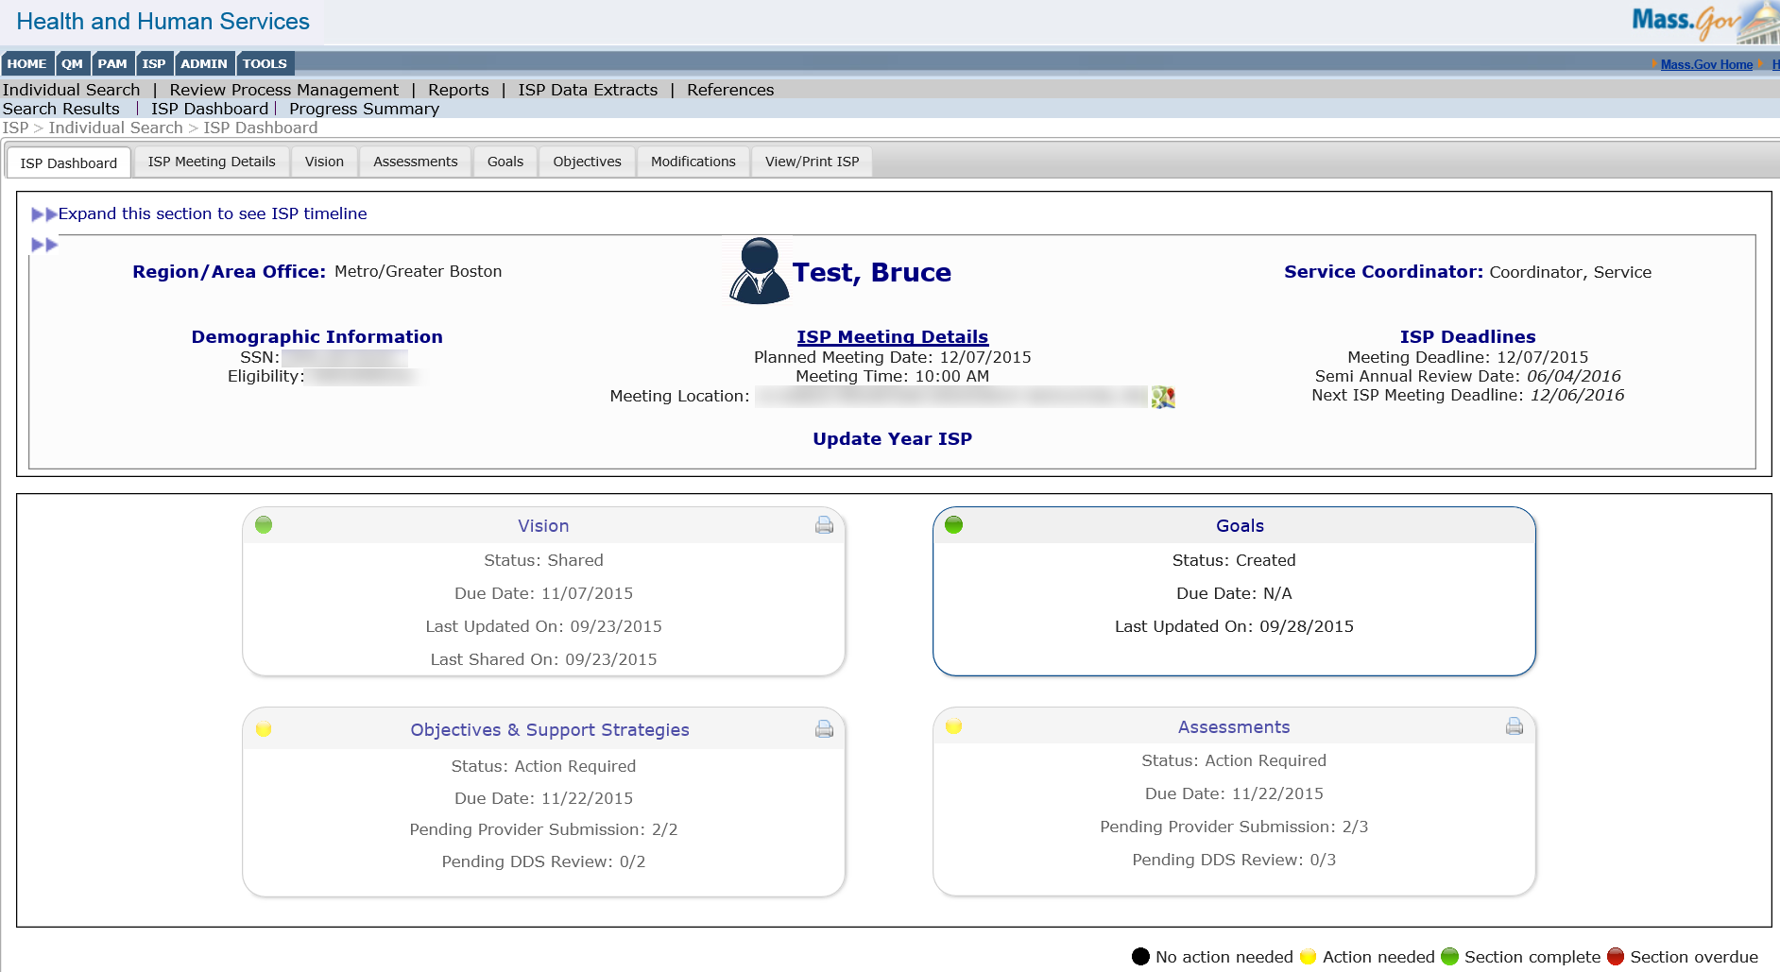

- Select a recalled Goal to update by clicking the corresponding radio button and then selecting “View/Edit Goal.”

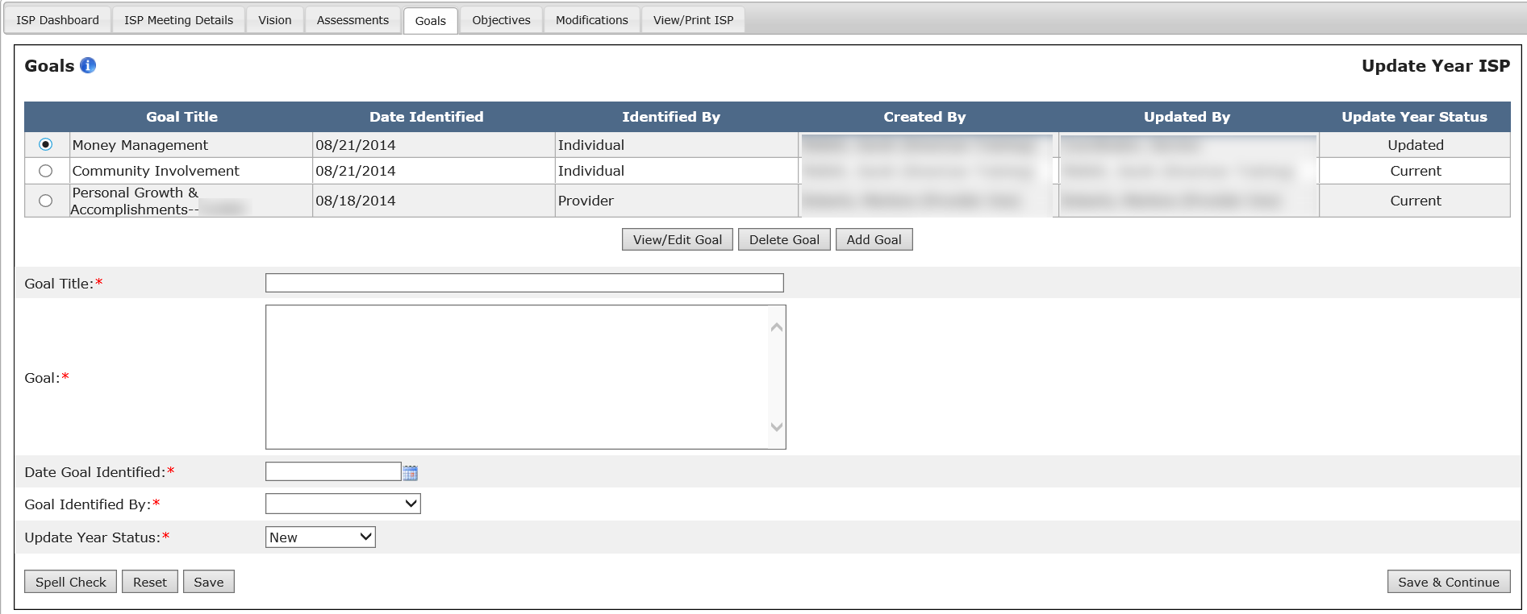

Note: The system returns the recalled Goal in read-only mode with an “Updated Information” check box and Update Year Status dropdown that are editable.

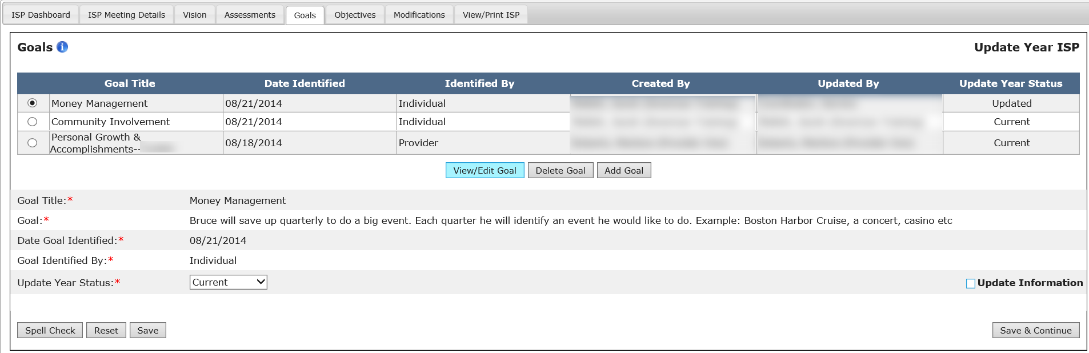

- Select the Update Information checkbox. Enter updates for the Goal in the Updated Information text box that appears.
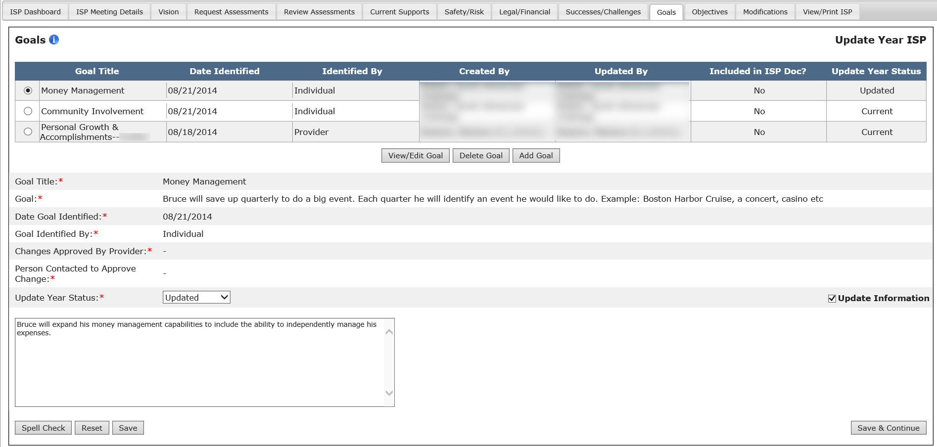

Note: One Updated Information checkbox will appear for each recalled Goal and will be displayed at the end of the form. This field will NOT appear for new Goals added as part of an update year.

Note: The Updated Information text box will have a 2,000 character limit.

- Select a status for the Goal from the Update Year status dropdown.

Note: This field is mandatory for all Goals pulled forward from a past full year ISP plan. The dropdown value will have the following options: Met, Discontinued, Current, Updated, and New. The Goals status is pre-populated to “Current” for all recalled Goals and will be editable.

Note: Please see the table below for more information on Update Year Status.

Update Year Status | Description
Met | Used to describe a Goal or objective that has been achieved by the individual and no longer remains a Goal or objective for the Update Year ISP.
Discontinued | Used to identify a Goal or objective that is no longer relevant for the individual or has ended.
Current | Used to identify a Goal or objective from the previous year’s ISP that has not changed and continues into the update year ISP.  *All recalled Goals and objectives will be defaulted to current.  *If a current Goal or objective is updated, the status should be changed to updated.
Updated | Used to identify a Goal or objective from the previous year’s ISP that has been changed for the update year ISP.
New | Used to identify a newly added Goal or objective. *Newly added Goals and objectives will be defaulted to “new”.

- To finish updating a Goal, click “Save”.

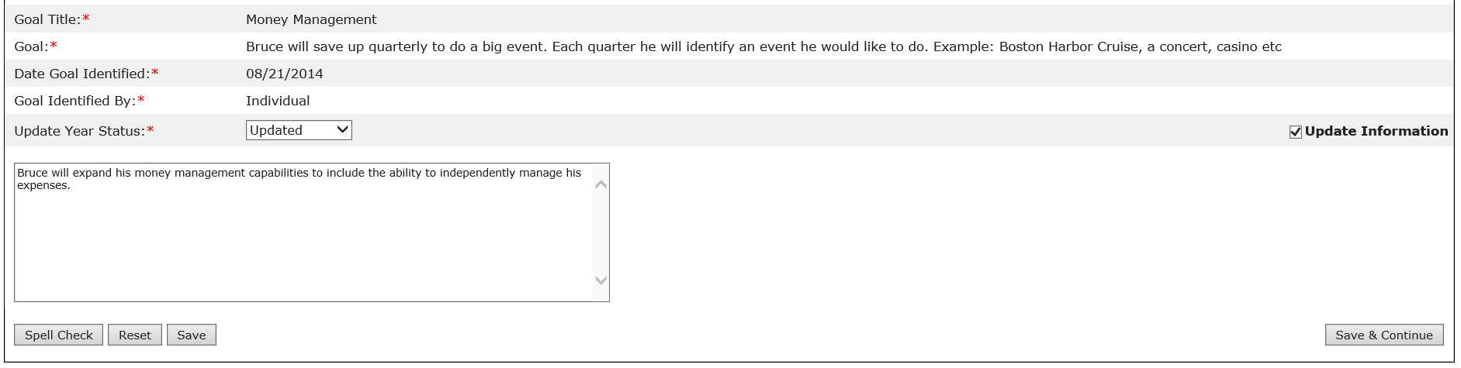

Note: Other buttons are available on this screen. They are as follows:
- “Save & Continue”: The system will redirect the user to the ISP Dashboard.
- “Reset”: The system will revert back to what was last saved. In the event that there are no saved data, “Reset” will clear the form.
- “Spell Check”: A proofreading tool that can be used prior to saving or sharing.

- After saving the Goal, the system will update the Goal Summary table with the information saved by the user. The system will also display a message reading “Operation Successful.”

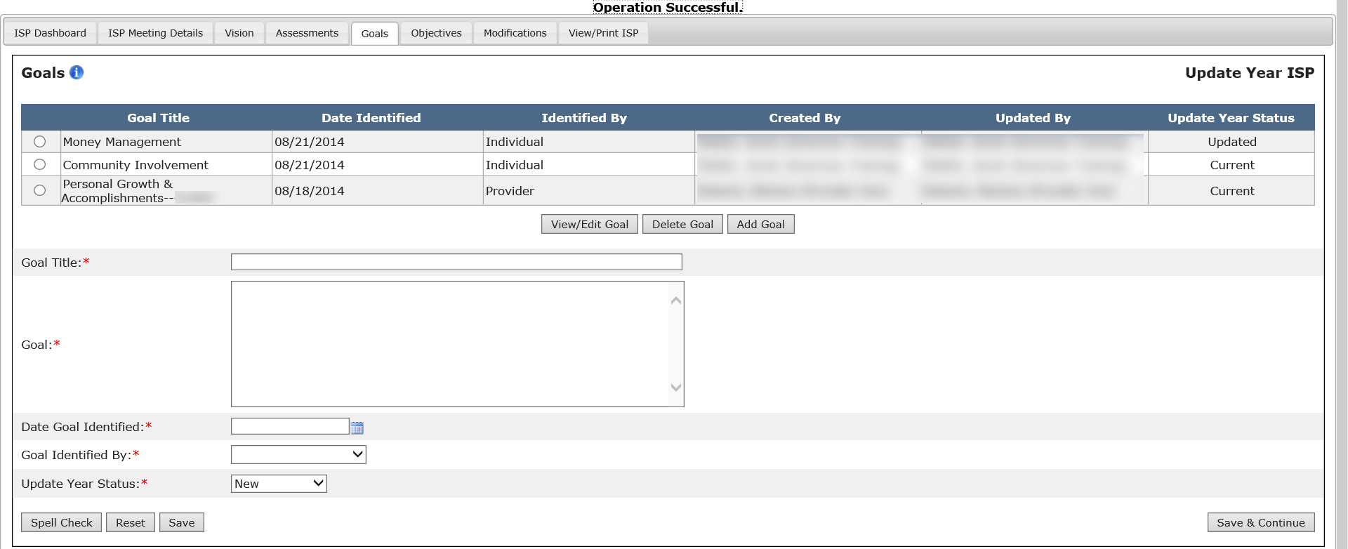

Next Steps
- Providers and Provider Supervisors will be able to create additional Goals or update Goals that they have previously submitted

Deleting a Goal in a Full or Update Year
Scenario Description
Providers and Provider Supervisors can delete a Goal in both a Full Year and Update Year ISP, given the following restrictions:
- A recalled Goal cannot be deleted during an Update Year. Only new Goals added during the Update Year can be deleted.
- A Goal cannot be deleted if there are any Objectives and Support Strategies associated to the Goal. The associated Objectives and Support Strategies must be deleted prior to deleting the Goal.
- A Provider user may delete Goals created by the same Provider agency.

Note: For demonstration purposes, the scenario will show the Goals form in an Update Year, and any differences present in a Full Year will be noted.

First Steps
- Search for an Individual
- View the Individual Dashboard

Roles and Responsibilities

- Providers: Delete Goals created by his/her Agency
- Provider Supervisors: Delete Goals created by his/her own agency

The below steps are completed by either a Data Entry User or a Provider Supervisor.

- Select “Goals” from the ISP Dashboard or select “Goals” tab.

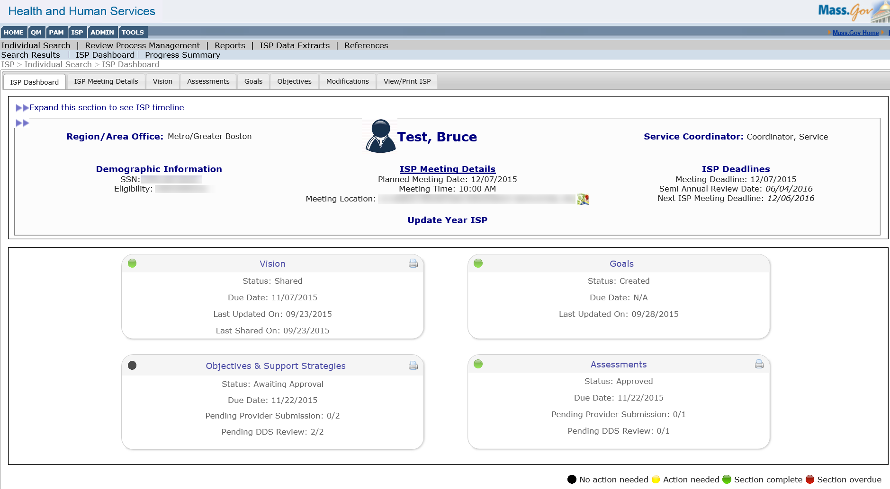

- Select a Goal to delete by clicking the radio button that corresponds to the Goal.

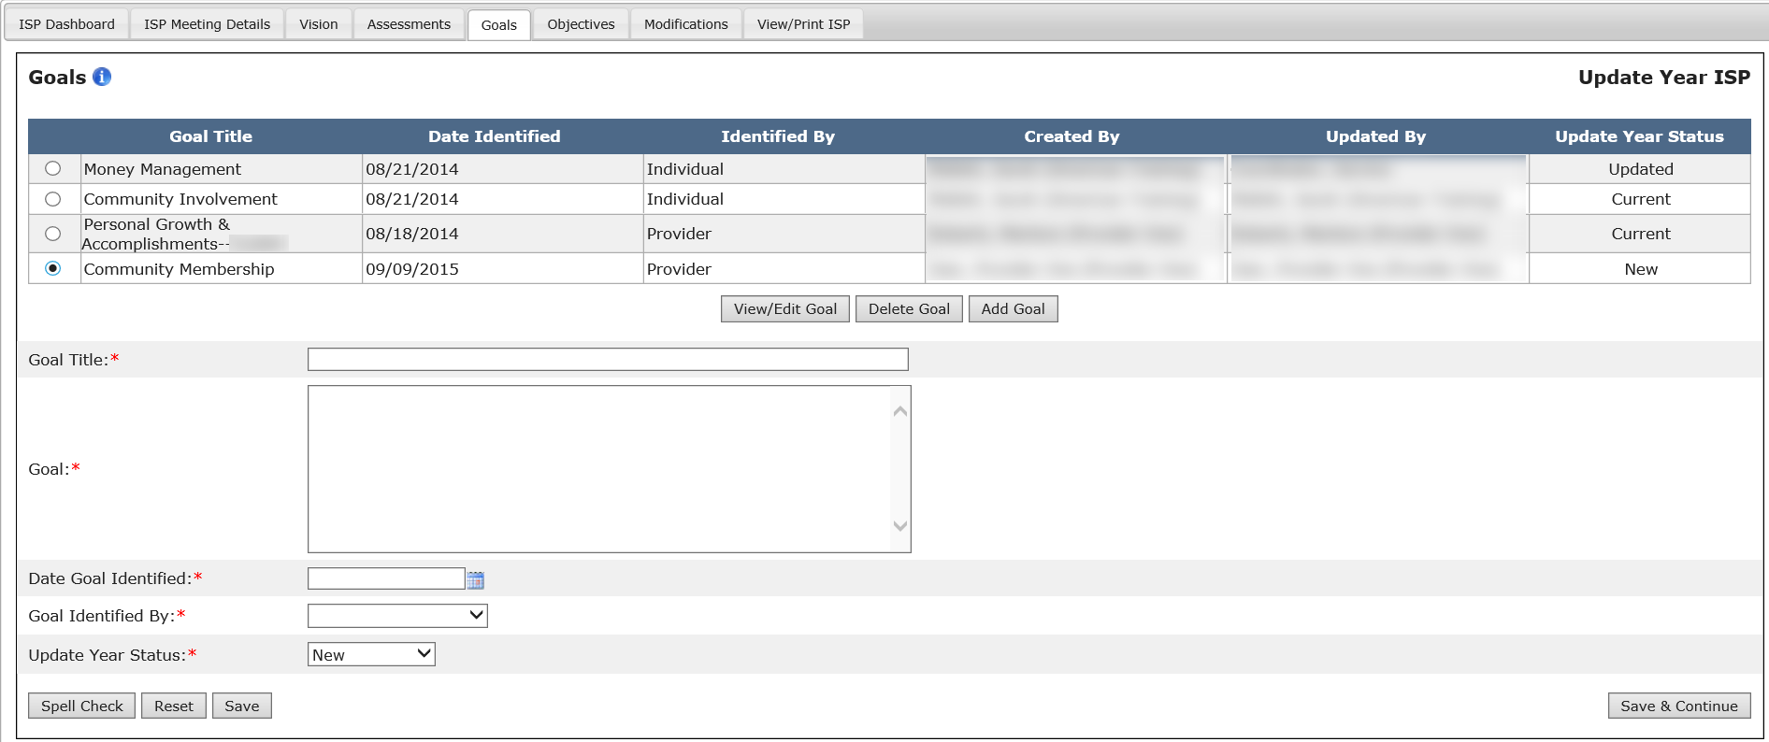

Note: The “Update Year Status” column is displayed only on Update Year.

- Click on “Delete Goal” button.

Note: It is recommended that all users click “View/Edit Goal” to view Goal content before proceeding to delete the Goal.

- The system will display a confirmation pop-up screen.

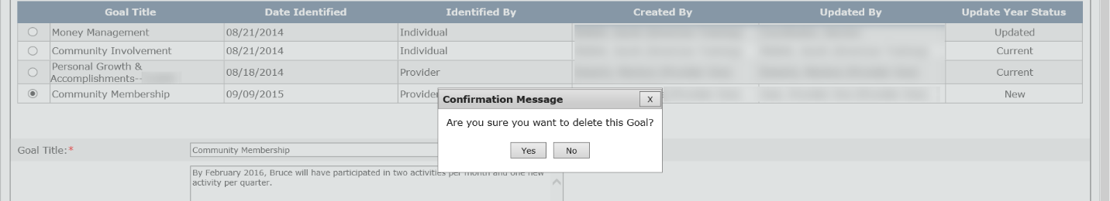

- Click “Yes”.

Note: If the Goal that the user is trying to delete has an associated Objectives and Support Strategy, then the user will be prompted to delete the associated Objectives and Support Strategy before deleting the Goal.

Note: Other buttons are available on this screen. They are as follows:
- “Save & Continue”: The system will redirect the user to the ISP Dashboard.
- “Reset”: The system will revert back to what was last saved. In the event that there are no saved data, “Reset” will clear the form.
- “Spell Check”: A proofreading tool that can be used prior to saving or sharing.

- After clicking “Yes”, the system will delete the Goal and update the Goal Summary table with the information saved by the user. The system will also display a message reading “Operation Successful.”

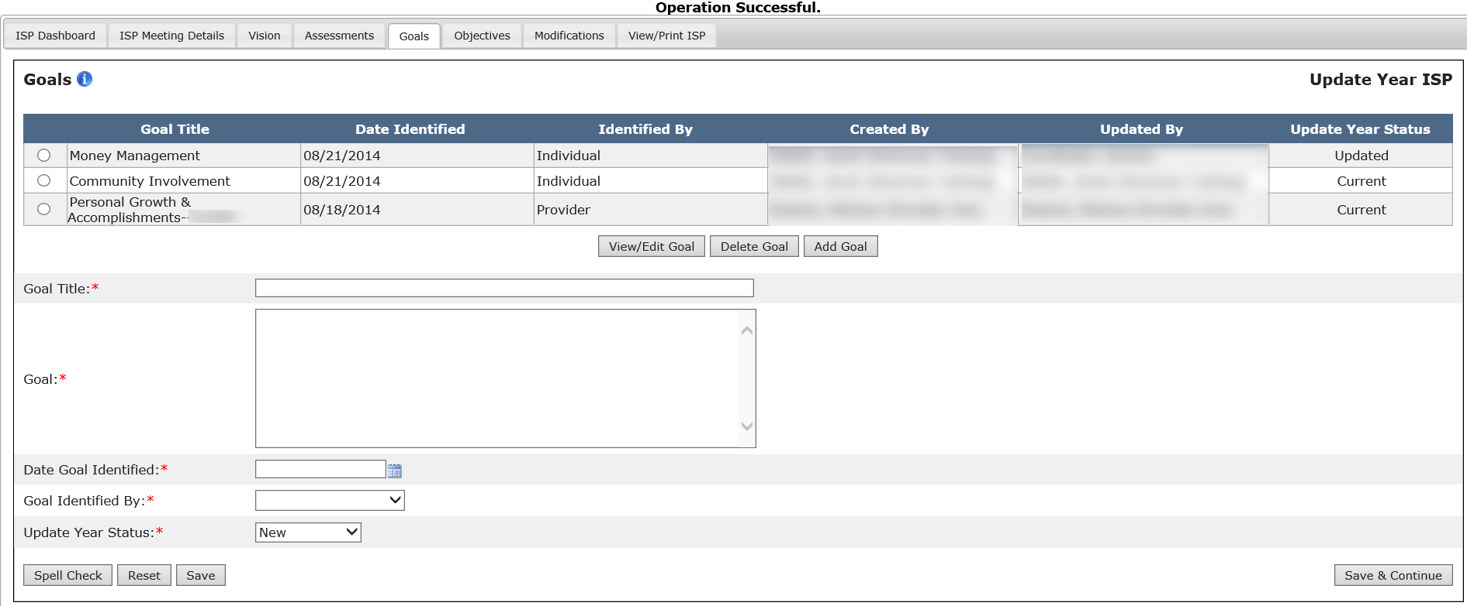
Next Steps
- Providers and Provider Supervisors will be able to create new and edit existing Goals created by their agency.

