Commonwealth of Massachusetts
Executive Office of Health and Human Services

Virtual Gateway

ISP Assessments Module
User Guide
Lesson 3: Objectives & Support Strategies
HCSIS Release 7.7

Contents
Objectives and Support Strategies 2
Creating a New Objective and Support Strategy by Provider Staff in a Full or Update Year 4
Updating an Existing Objective and Support Strategy by Provider Staff in an Update Year 12
Reviewing and Approving an Objective and Support Strategy by DDS Staff in a Full or Update Year 16
Reviewing and Requesting Revision of an Objective and Support Strategy by DDS Staff in a Full or Update Year 21
Reviewing and Revising an Objective and Support Strategy by Provider Staff in a Full or Update Year 26

Objectives and Support Strategies
Objectives may relate to the Vision Statement and/or assessed needs to promote independence and self-reliance to the greatest degree possible and desired. Objectives are often necessary to address functional limitations in skills or adaptive behavior including but not limited to:

- Conceptual Skills—language; reading and writing; money, time, and number concepts.
- Social Skills—interpersonal skills, social responsibility, self-esteem, gullibility, naïveté (i.e., wariness), follows rules/obeys laws, avoids being victimized, and social problem solving.
- Practical Skills—activities of daily living (personal care), occupational skills, use of money, safety, health care, travel/transportation, schedules/routines, and use of the telephone.

Objectives should be developed based on the Vision Statement and Goals identified by the individual and/or guardian as well as assessed needs identified by Service Providers. Objectives will identify the first step(s) in the plan toward achieving the individual’s Vision and Goals. Objectives should be written in person-centered, behavioral terms, with one measurable action and specific performance criteria that will be used to determine whether or not the individual has successfully met the Objective.

Document Statuses
Below are all the statuses an Objective and Support Strategy goes through along with which user group has access to viewing and/or editing the document:

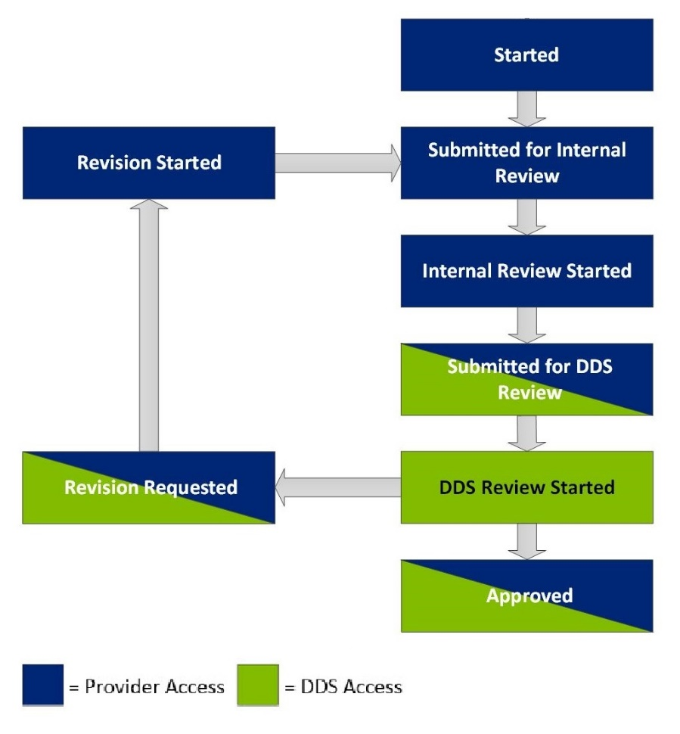

Below table describes the Objective and Support Strategies document statuses for DDS and Providers:

Status | Definition
Started | An Objective and Support Strategy has begun to be completed/ Objective and Support Strategy is recalled from a previous ISP
Submitted for Internal Review | An Objective and Support Strategy has been submitted by a Provider to a Provider Supervisor for review and approval prior to being submitted to the Service Coordinator
Internal Review Started | The Provider Supervisor has started his/her review of the Objective and Support Strategy
Submitted for DDS Review | The Provider Supervisor has approved the Objective and Support Strategy, and has submitted the documents to the Service Coordinator for review
DDS Review Started | The Service Coordinator has started their review of Objective and Support Strategy
Revision Requested | The Service Coordinator has requested revision to an Objective and Support Strategy. The Service Coordinator will provide the reason for the request for revision
Revision Started | The Provider has started to revise the Objective and Support Strategy based on the Service Coordinator’s feedback
Approved | The Service Coordinator has approved the submitted Objective and Support Strategy

Note:
- When a document is submitted for Internal Review to the Provider Supervisor, the Provider has read only access to it.
- When the document is submitted for DDS review, both the Provider and Provider Supervisor have read only access to it.
- When the document is approved, all users have read only access to it.

Creating a New Objective and Support Strategy by Provider Staff in a Full or Update Year
Scenario Description
Providers and Provider Supervisors can create an Objective and Support Strategy (OSS) once the plan selection has been made.

Note: For demonstration purposes, the scenario will show the OSS form in an Update Year, and any differences present in a Full Year will be noted.

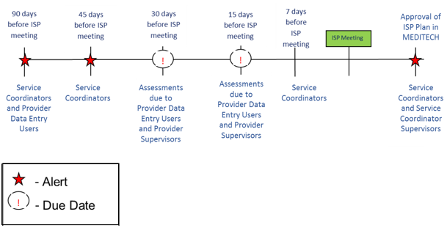

First Steps
- Search for an individual
- View the Individual Dashboard

Roles and Responsibilities
- Provider: Creates and submits the Objectives and Support Strategies for internal review.
- Provider Supervisor: Creates, reviews and submits the Objectives and Support Strategies for DDS review.

Part I – Creating a New Objective and Support Strategy and Submitting for Internal Review

The following steps are completed by a Data Entry User.

- Select “Objectives & Support Strategies” from the individuals’ ISP Dashboard or select the “Objectives” tab.

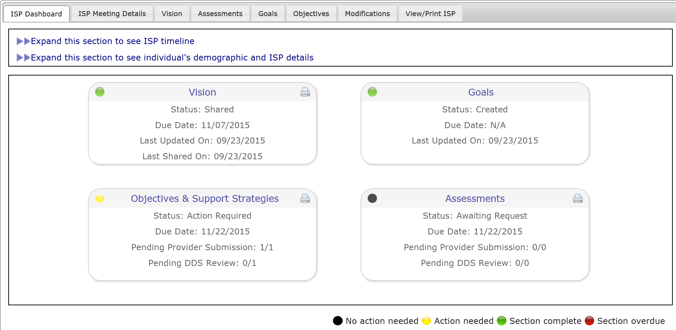

- From the Objectives and Support Strategies Review Switchboard, click “Add Objective”.

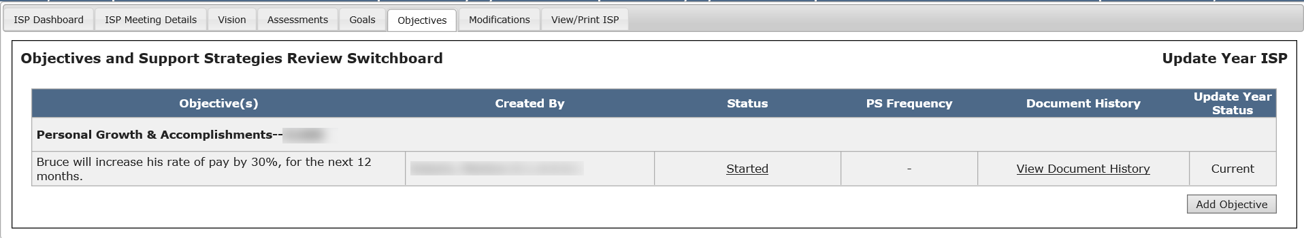

- Select a Goal to associate the OSS.

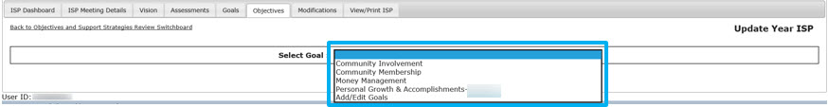

Note: Providers and Provider Supervisors will have the option to add a new Goal if the Goal they are looking for has not been created yet, as well as the option to edit an existing Goal that has been created by their agency. Clicking “Add/Edit Goals” will redirect the user to the Goals page where the Provider or Provider Supervisor can make changes.

- Complete the required sections of the OSS form.
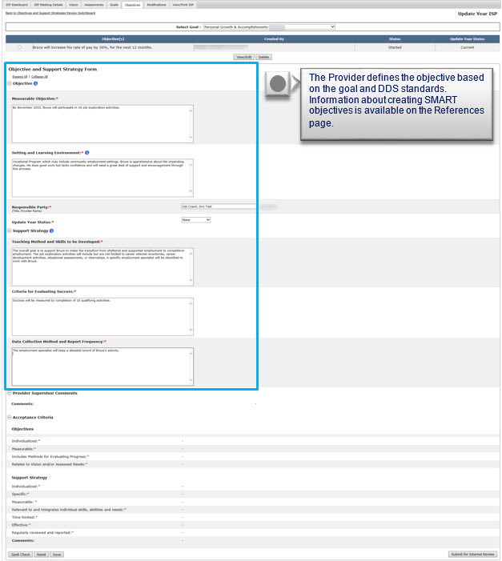
The Provider defines the objective based on the Goal and DDS standards. Information about creating SMART objectives is available on the References page.

- Verify and/or change the “Update Year Status” for the OSS. This will be defaulted to “New” and will be editable.

Note: This step is applicable to Update Year only. There will be no “Update Year Status” when creating an OSS in a Full Year.

Note: Please see the table below for more information on Update Year Status.

Update Year Status | Description
Met | Used it describe a Goal or objective that has been achieved by the individual and no longer remains a Goal or objective for the Update Year ISP.
Discontinued | Used to identify a Goal or objective that is no longer relevant for the individual or has ended.
Current | Used to identify a Goal or objective from the previous year’s ISP that has not changed and continues into the update year ISP.  *All recalled Goals and objectives will be defaulted to current.  *If a current Goal or objective is updated, the status should be changed to updated.
Updated | Used to identify a Goal or objective from the previous year’s ISP that has been changed for the update year ISP.
New | Used to identify a newly added Goal or objective. *Newly added Goals and objectives will be defaulted to “new”.

- Click the “Submit for Internal Review” button.

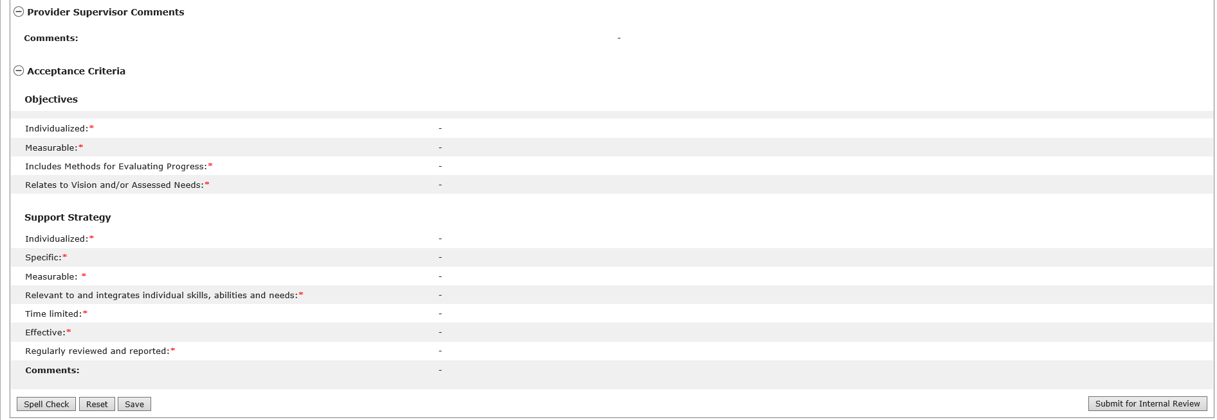

The status for the Objective and Support Strategy will read “Submitted for Internal Review” on the Objectives and Support Strategies Review Switchboard.

Part II – Reviewing a New Objective and Support Strategy Submitted for Internal Review and Requesting Internal Revision

The following steps are completed by a Provider Supervisor.

The Provider Supervisor will receive an alert notifying them that an Objective and Support Strategy has been submitted for internal review.

- Click on the link within the alert in order to access the individual’s Objective and Support Strategy Review Switchboard and review the assessment submitted by the Provider.

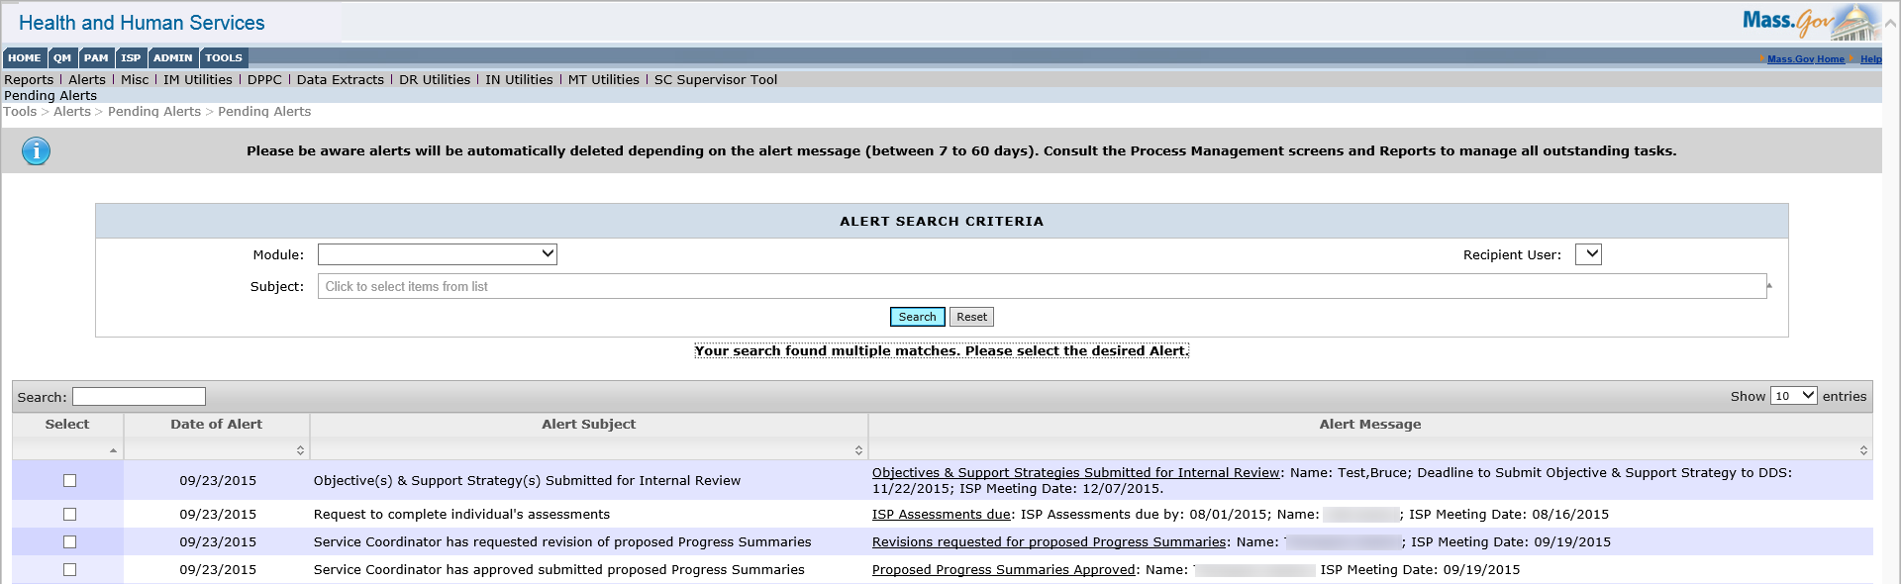

- Click on the status of “Submitted for Internal Review” to open and review the OSS

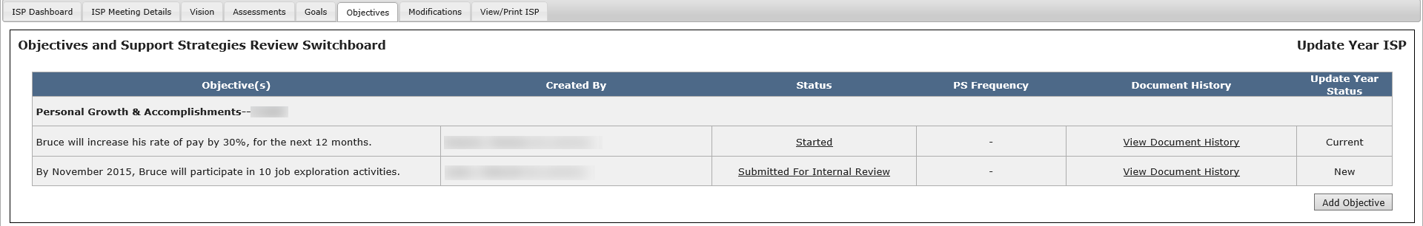

- Review and make changes to the content of the OSS if necessary.

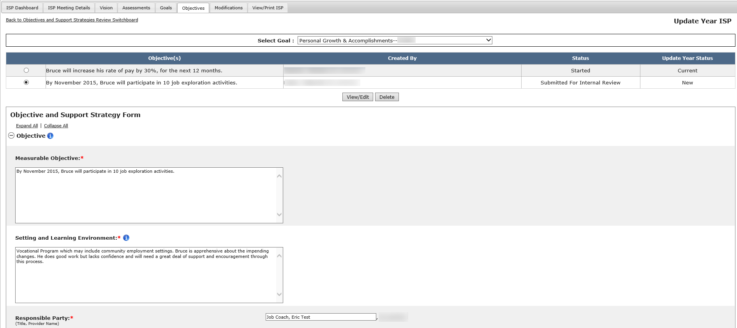

- Insert text in to the “Provider Supervisor Comments” textbox.
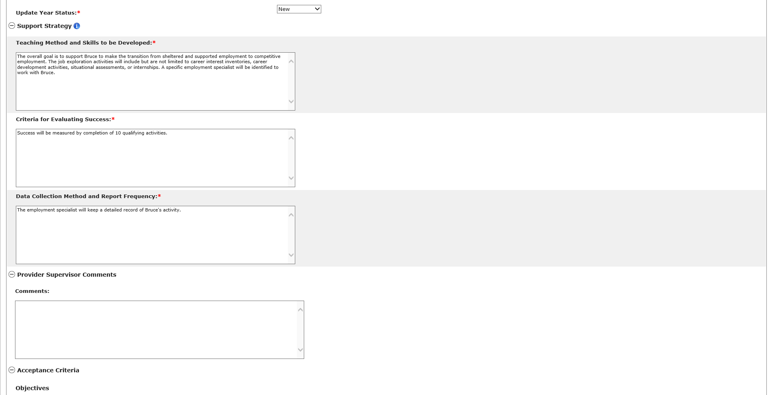

- Click “Request for Internal Revision Review.”

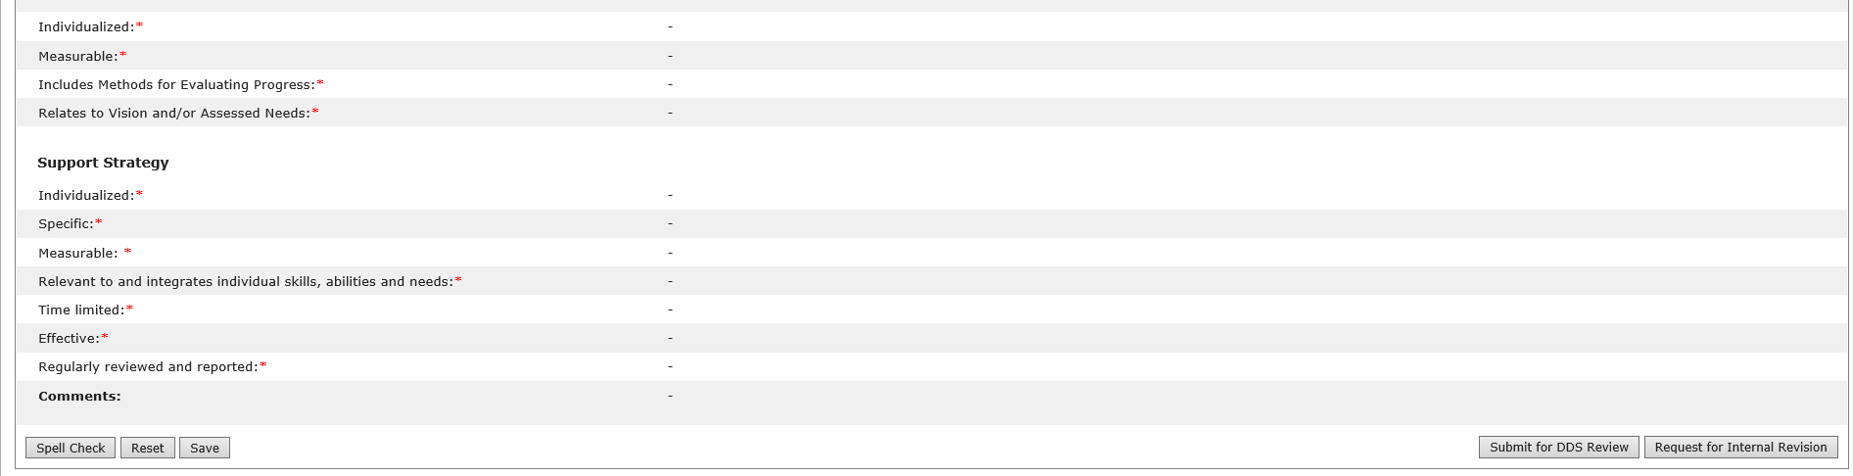

The Data Entry User will receive an alert indicating that the Objective has been submitted for Internal Revision.

Part III – Revising a New Objective and Support Strategy Returned for Internal Revision and Submitting for Internal Review

The following steps are completed by a Provider Data Entry User.

The Provider Data Entry User will receive an alert notifying them that an Objective and Support Strategy has been returned for internal revision. Clicking on the alert will redirect the system to the Objectives and Support Strategies Review Switchboard. This process is identical to the steps in Part I.

Part IV – Reviewing a New Objective and Support Strategy Submitted for Internal Review and submitting it for DDS Review

The following steps are completed by a Provider Supervisor.

The Provider Supervisor will receive an alert notifying them that an OSS has been submitted for internal review.

- Click on the link within the alert in order to access the individual’s Objective and Support Strategy Review Switchboard and review the assessment submitted by the Provider.

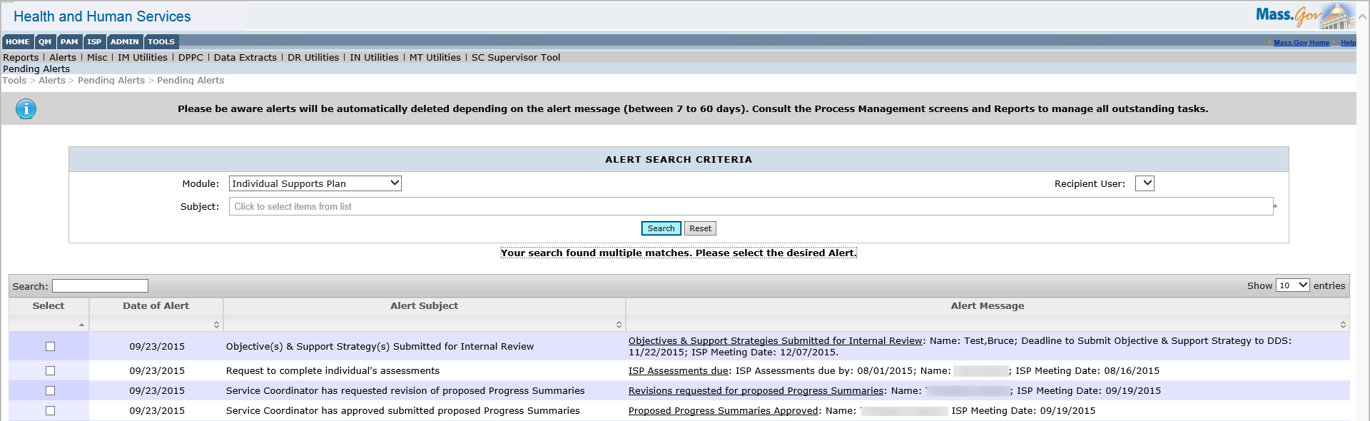

- Click on the status of “Submitted for Internal Review” to open and review the OSS.

- Review and make changes to the content of the OSS if necessary.

- Submit the content to be reviewed by the Service Coordinator by clicking “Submit for DDS Review.”

Next Steps

- Service Coordinators will receive an alert notifying them of any Objectives and Support Strategies that have been submitted and are pending review.
- Service Coordinators are not required to approve any Objectives and Support Strategies until after the ISP Meeting has been held.
- Providers and Provider Supervisors will receive an alert once all Objectives and Support Strategies have been approved by the Service Coordinators.

Updating an Existing Objective and Support Strategy by Provider Staff in an Update Year
Scenario Description
Providers and Provider Supervisors can update a recalled Objective and Support Strategy (OSS) in the module in an Update Year once the Update Year plan has been created, and if there was an OSS in the previous Full Year ISP plan that was recalled. The recalled OSS must be resubmitted for DDS review in an update year.

In an Update Year, all existing OSS will be recalled from the previous Full and/or Update Year ISP and will appear under the Objectives and Support Strategies Review Switchboard in “Started” status. Objectives and Support Strategies recalled on an Update Year will not be editable. Updated information can be added to an OSS to reflect changes, if any, prior to submitting for approval. New OSS can also be added on an update year. For more information on how to add and Objective, refer to the previous chapter.

First Steps
- Search for an individual
- View the Individual Dashboard

Roles and Responsibilities
- Provider: Updates and submits the Objectives and Support Strategies for internal review.
- Provider Supervisor: Updates, reviews and submits the Objectives and Support Strategies for DDS review.

Part I – Updating an Existing Objective and Support Strategy and Submitting for Internal Review

The following steps are completed by a Data Entry User.

- Select “Objectives and Support Strategies” from the individual’s ISP Dashboard or select “Objectives” tab. The system redirects the user to the individual’s Objectives and Support Strategies Review Switchboard.
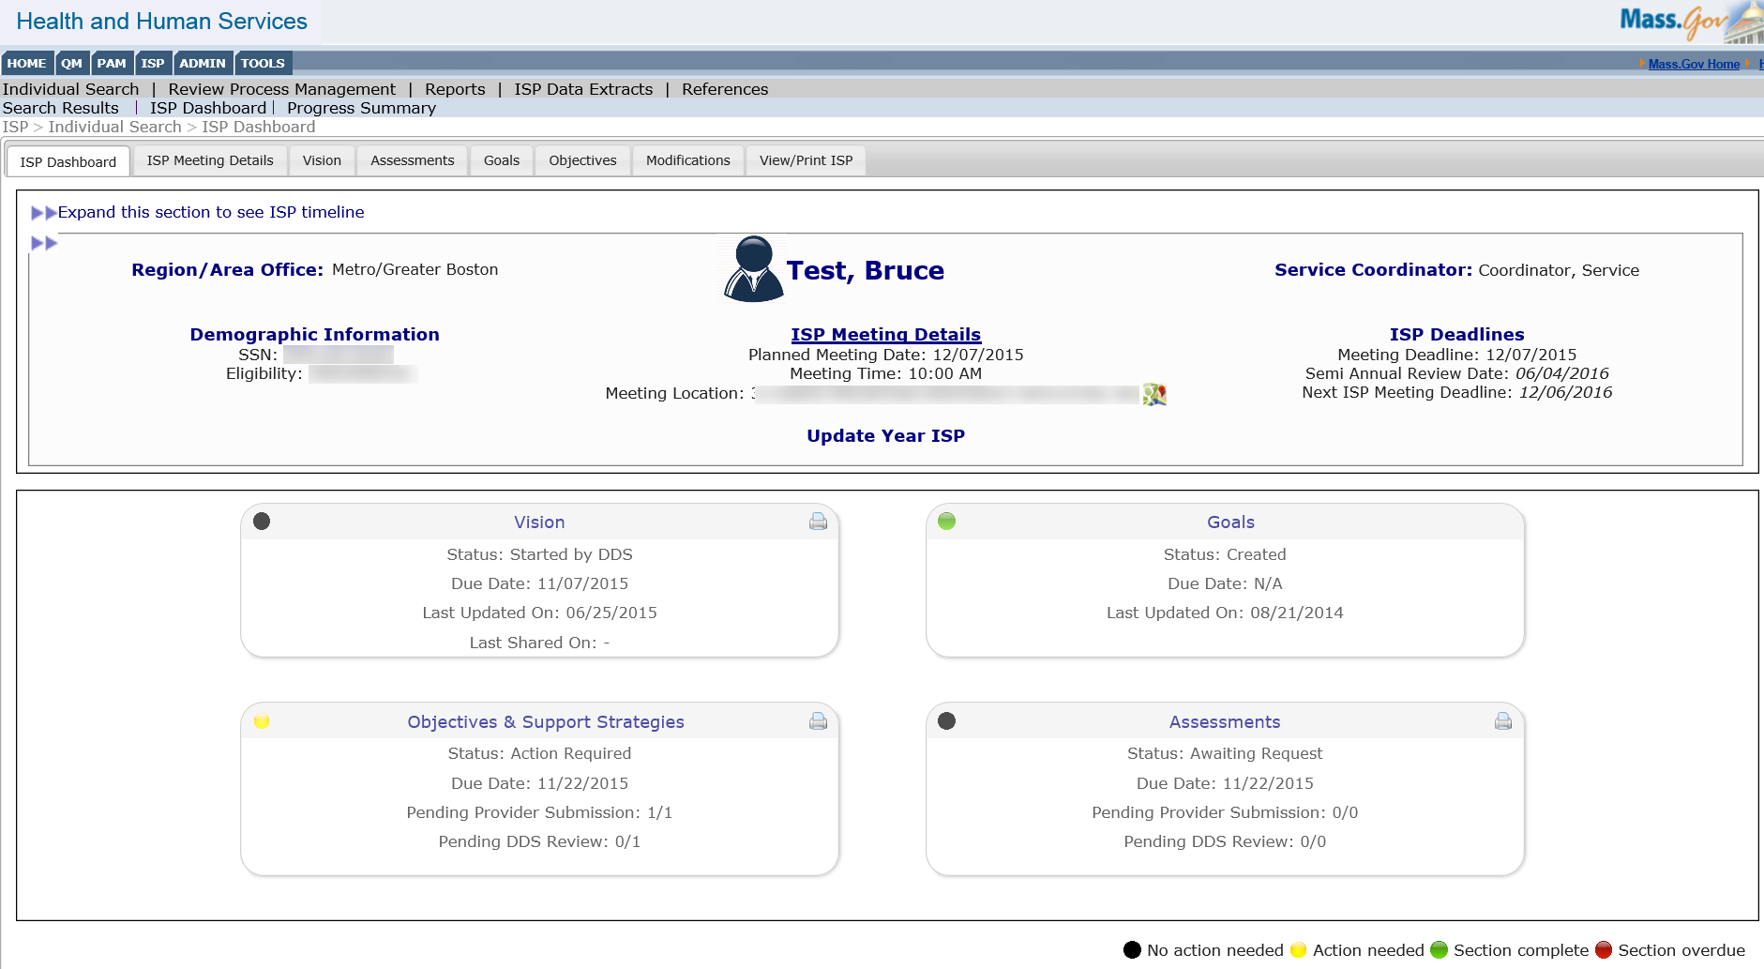

- Click on the “Started” status of a recalled OSS.

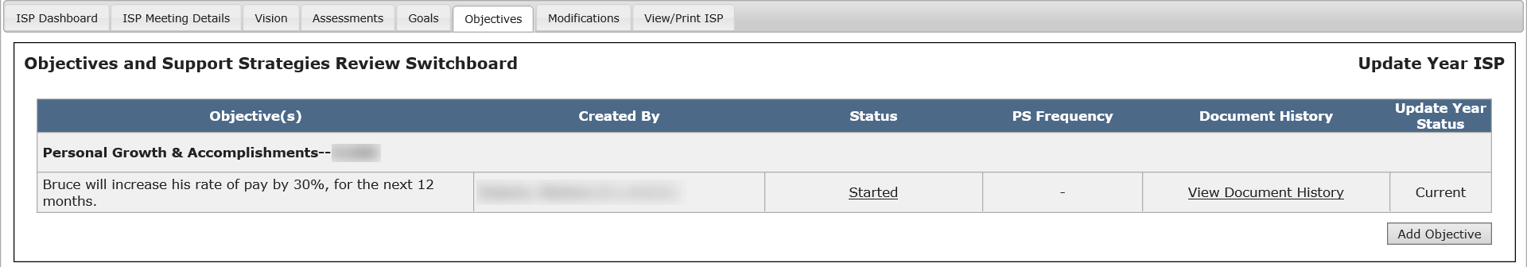

Note: The system returns the recalled OSS in read-only mode with “Updated Information” checkboxes for each section and an Update Year Status dropdown that are editable.

- Select the “Update Information” checkbox for all fields that need to be updated and enter values in the updated information text box that appears for each of the selected sections.

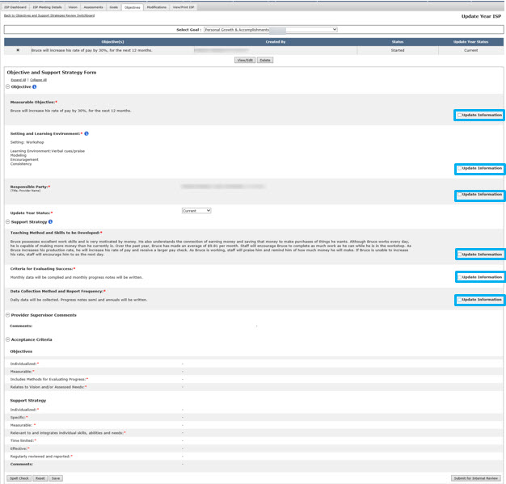

Note: Each “Updated Information” text box has a 2,000 character limit.

- Select a status for the OSS from the Update Year Status dropdown.

Note: This field is mandatory for all OSS pulled forward from a past full year ISP plan. The dropdown value will have the following options: Met, Discontinued, Current, Updated, and New. The Update Year Status is pre-populated to “Current” for all recalled OSS and will be editable.

Note: Please see the table below for more information on Update Year Status.

Update Year Status | Description
Met | Used it describe a Goal or objective that has been achieved by the individual and no longer remains a Goal or objective for the Update Year ISP.
Discontinued | Used to identify a Goal or objective that is no longer relevant for the individual or has ended.
Current | Used to identify a Goal or objective from the previous year’s ISP that has not changed and continues into the update year ISP.  *All recalled Goals and objectives will be defaulted to current.  *If a current Goal or objective is updated, the status should be changed to updated.
Updated | Used to identify a Goal or objective from the previous year’s ISP that has been changed for the update year ISP.
New | Used to identify a newly added Goal or objective. *Newly added Goals and objectives will be defaulted to “new”.

- Click “Submit for Internal Review” (Provider Data Entry User) or “Submit for DDS Review” (Provider Supervisor). For more information on how to review an Objective as a Provider Supervisor and submit it to DDS, please refer to the section “Completing an Objective and Support Strategy by Providers”.

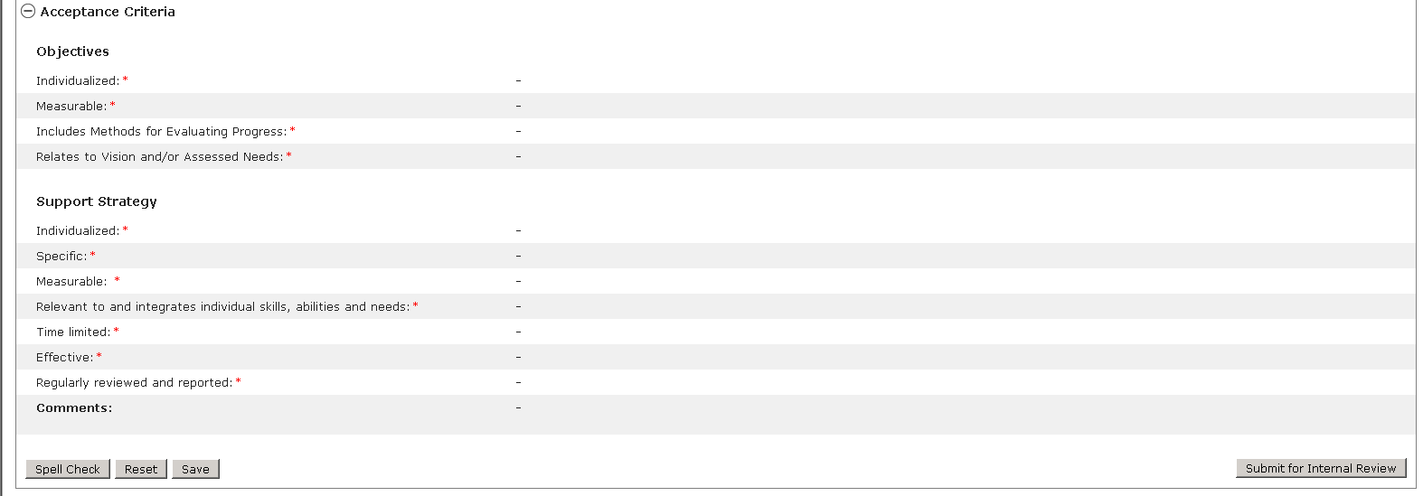

Next Steps
- The page is refreshed; the values are saved and reflected in the Objectives Summary grid and “Operation Successful” message appears at the top of the screen. Fields are cleared to allow adding of new objective.

Reviewing and Approving an Objective and Support Strategy by DDS Staff in a Full or Update Year
Scenario Description
Service Coordinators and Service Coordinator Supervisors must review all Objective and Support Strategy (OSS) submitted by a provider agency and may either approve or request revision to each Objective. The process for reviewing OSS does not change between a Full Year and Update Year ISP.

Note: For demonstration purposes, the scenario will show the OSS form in an Update Year, and any differences present in a Full Year will be noted.

First Steps
- Search for an individual
- View the Individual Dashboard

Roles and Responsibilities
- Service Coordinator: Reviews, approves or requests revisions to the Objectives and Support Strategies
- Service Coordinator Supervisor: Reviews, approves or requests revisions to the Objectives and Support Strategies

- Select “Objectives & Support Strategies” from the individual’s ISP Dashboard or select the “Objectives” tab.

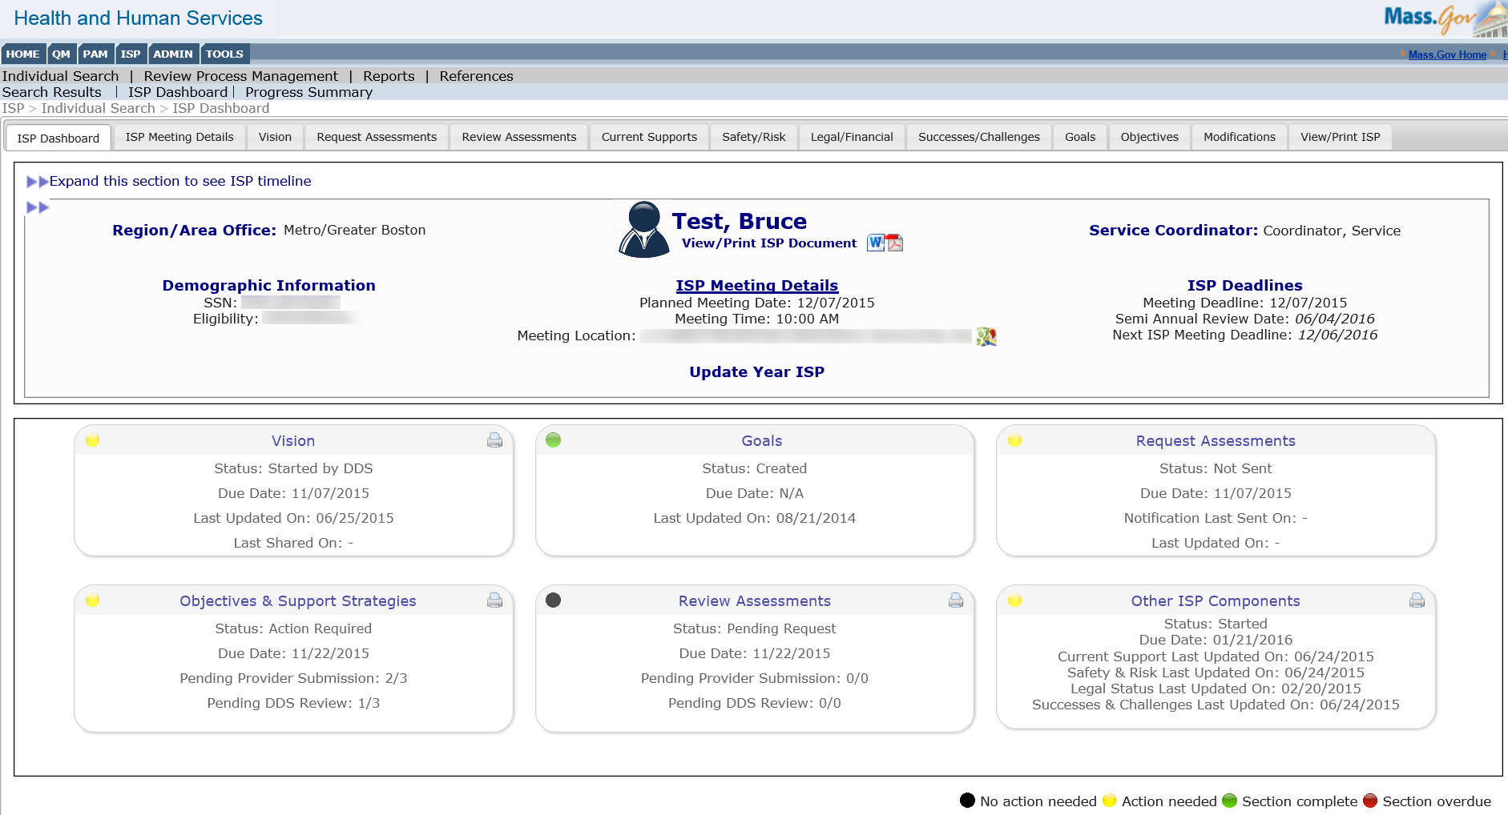

Note: The Service Coordinator or Service Coordinator Supervisor will be able to see that at least one (1) Objective and Support Strategy is pending DDS review from the Dashboard.

- Select the objective in the status of “Submitted for DDS Review”. The OSS will appear in read-only mode.

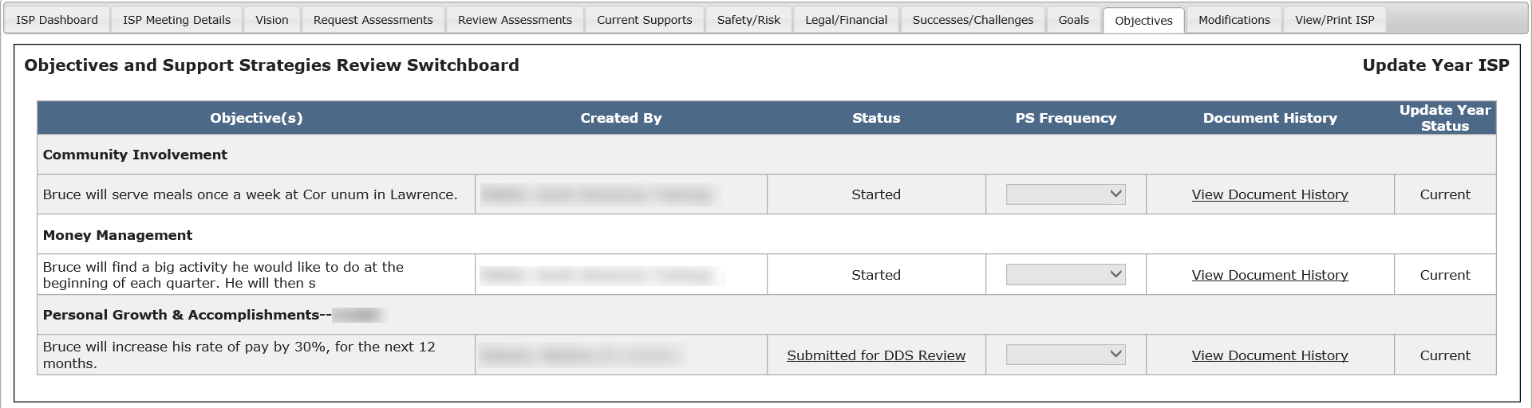

- Review the OSS.

Note: The Updated Information sections for each part of the OSS will appear only during an Update Year.

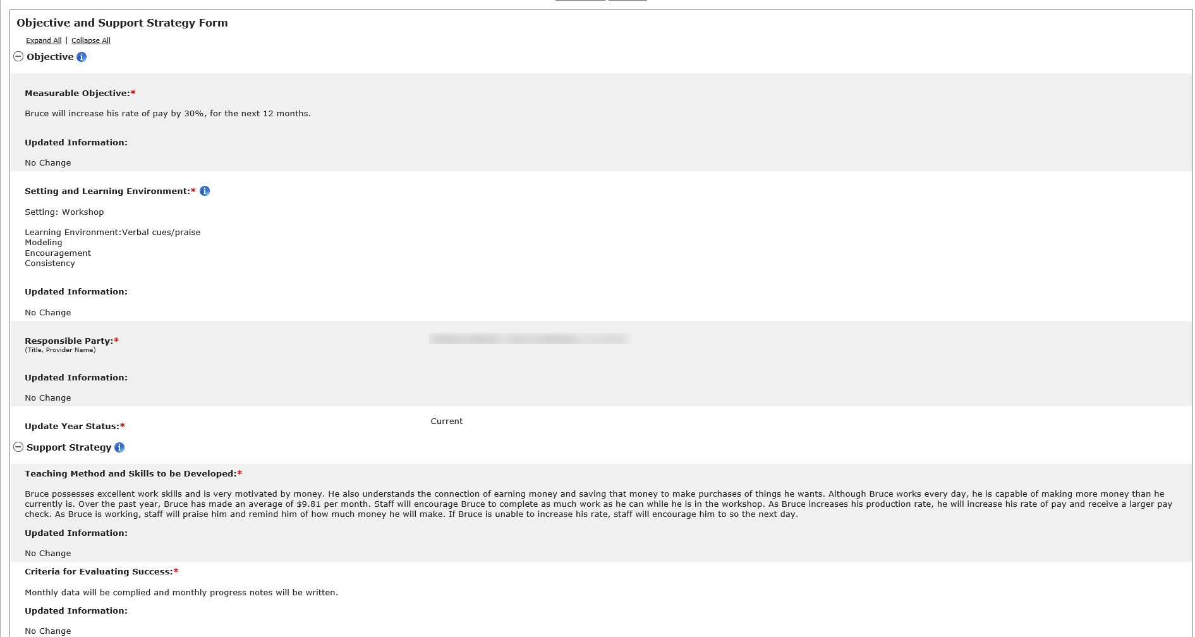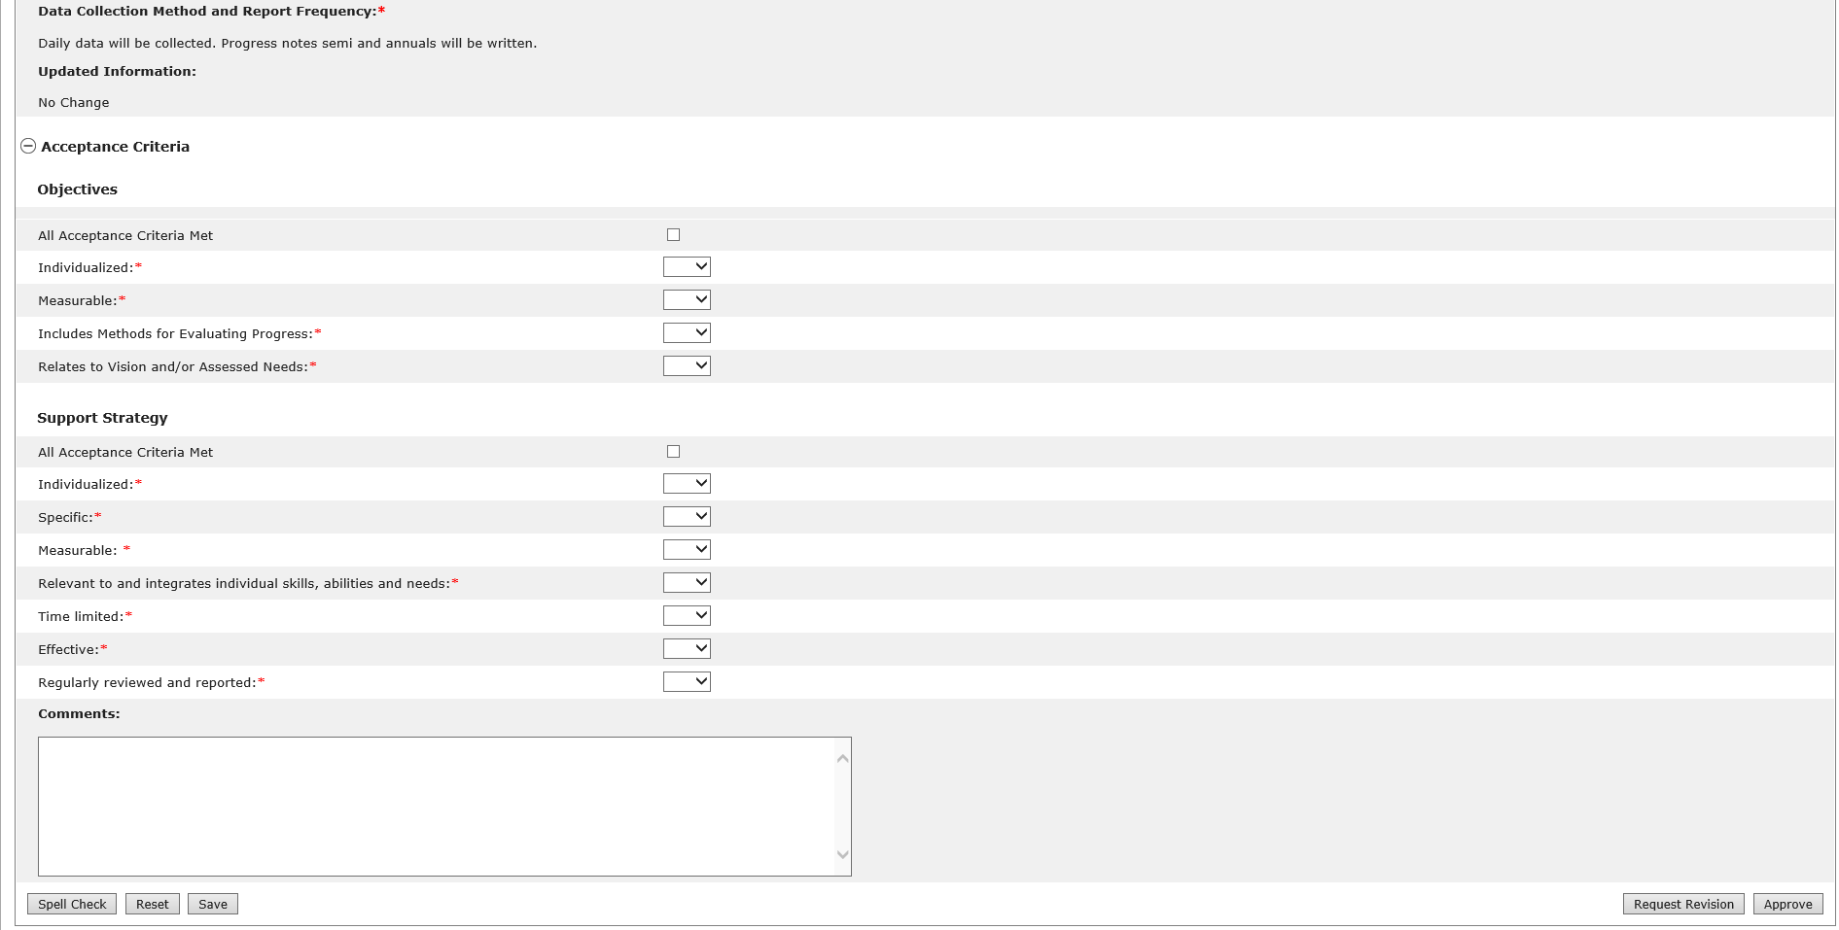

- Determine if the document meets DDS standards, and click on the “All Acceptance Criteria Met” check boxes for both the Objective and Support Strategy.

Note: Selecting the “All Acceptance Criteria Met” checkboxes will automatically populate the drop down menus below to read “Yes”.

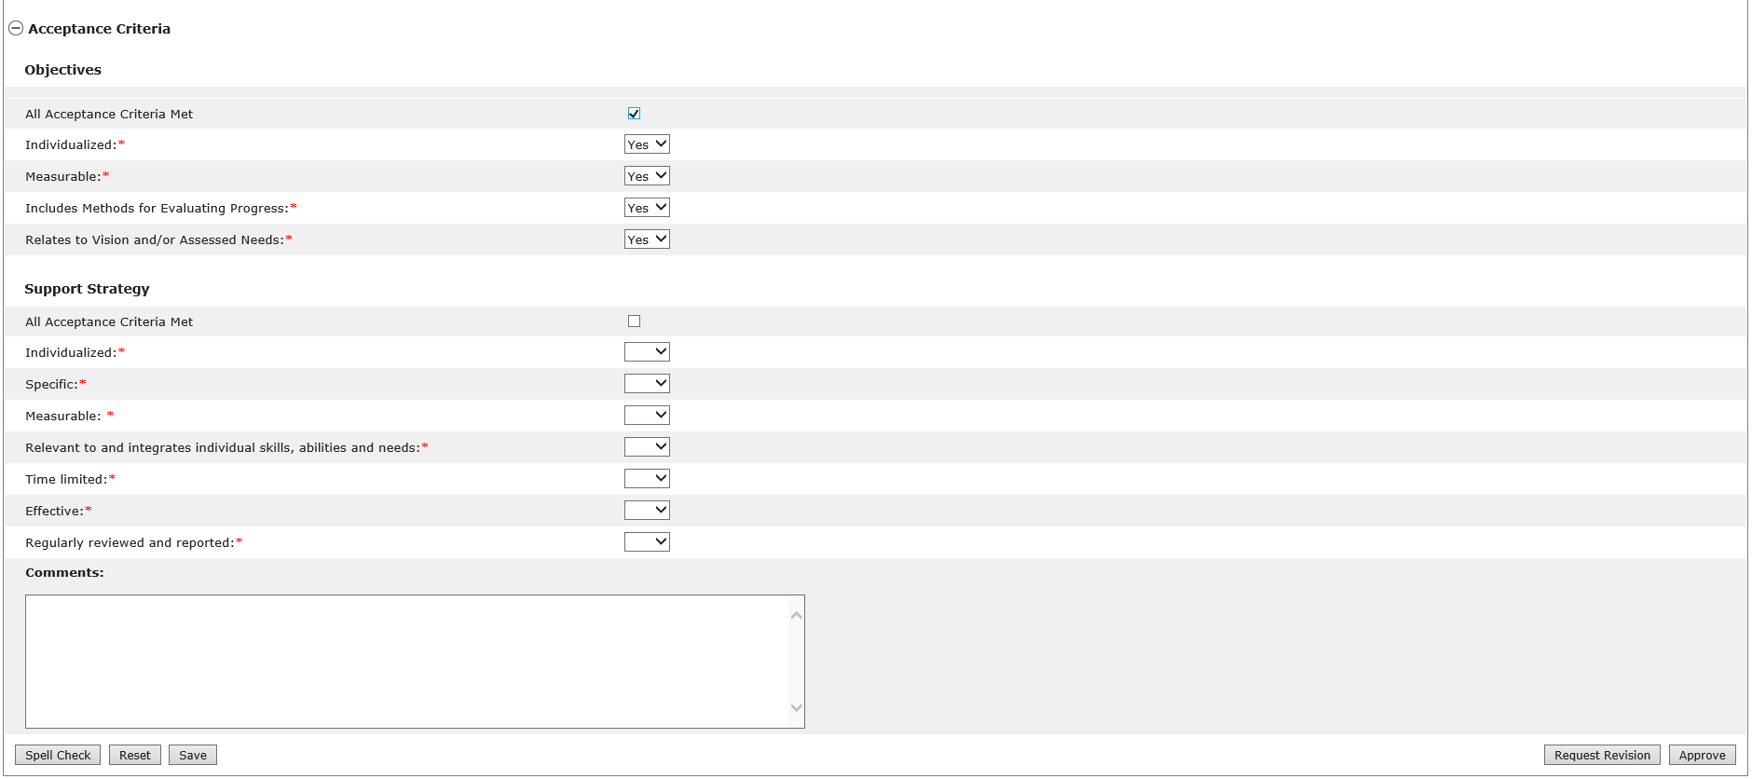

Note: The OSS cannot be approved unless all drop down boxes for the Objectives section and Support Strategy section read “Yes”.

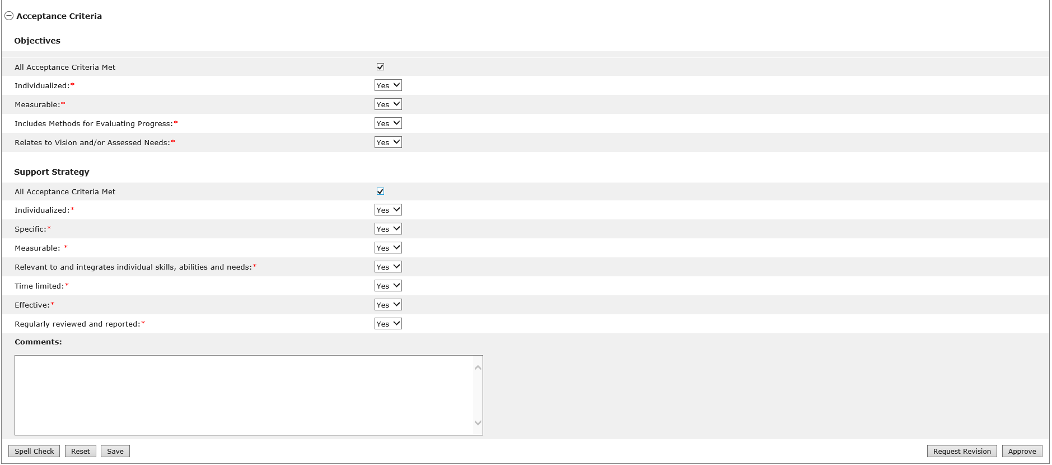

- To approve the OSS, click “Approve”.

After approving the OSS, the status of the OSS will read “Approved.” The “Operation Successful” message will be displayed.

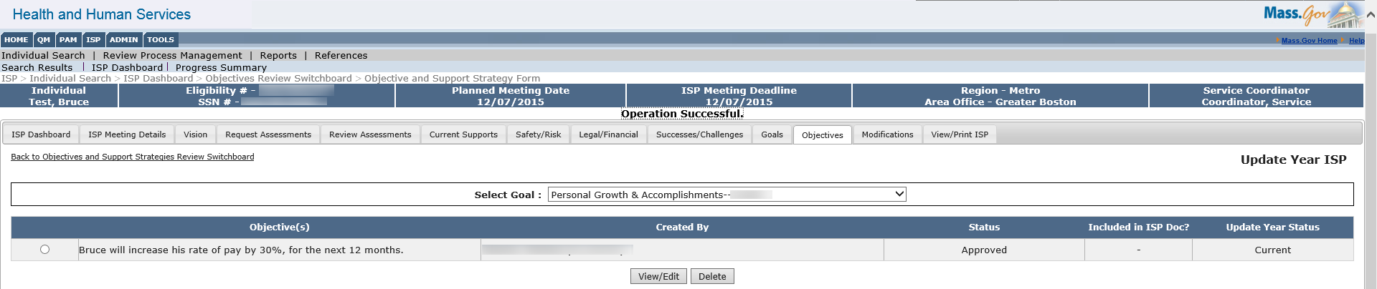

Note: The Service Coordinator can decide to hold off from approving an OSS until after the ISP Meeting has been held.

Next Steps

- After all OSS submitted by a Provider Agency are approved, the Provider and Provider Supervisor will receive an alert informing them of the approval.
- Service Coordinators or Service Coordinator Supervisors can request revision to a previously approved OSS at any point in time as long as the plan remains unlocked.
- Providers and Provider Supervisors can also submit additional OSS at any point in time as long as the plan remains unlocked.

Reviewing and Requesting Revision of an Objective and Support Strategy by DDS Staff in a Full or Update Year
Scenario Description
Service Coordinators and Service Coordinator Supervisors must review all Objective and Support Strategy (OSS) submitted by a provider agency and may either approve or request revision to each OSS. The process for reviewing OSS does not change between a Full Year and Update Year ISP.

Note: For demonstration purposes, the scenario will show the OSS form in an Update Year, and any differences present in a Full Year will be noted.

First Steps
- Search for an individual
- View the Individual Dashboard

Roles and Responsibilities
- Service Coordinator: Reviews, approves or requests revisions to OSS
- Service Coordinator Supervisor: Reviews, approves or requests revisions to OSS

- Select “Objectives & Support Strategies” from the individual’s ISP Dashboard or select the “Objectives” tab.

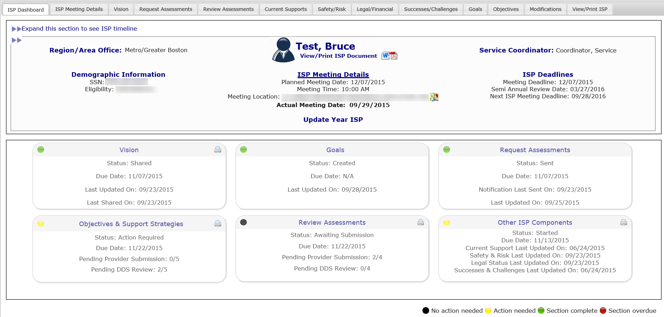

Note: The Service Coordinator or Service Coordinator Supervisor will be able to see that at least one (1) OSS is pending DDS review from the Dashboard.

- Select the radio button for the objective with the status of “Submitted to DDS Review.”

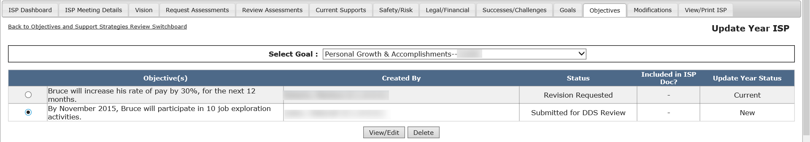

- Click “View / Edit.” The OSS will appear in read-only mode.

- Review the Objective section and the Support Strategy section.

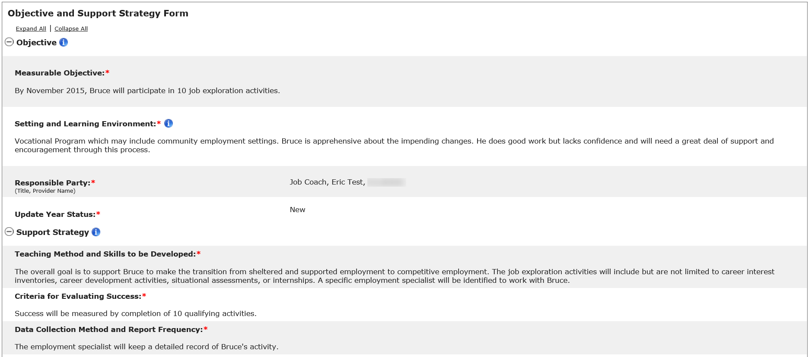

Note: The Updated Information sections for each part of the OSS, along with the Update Year Status, will appear only during an Update Year ISP.

- Determine if the document meets DDS standards, and if it does not, fill out the Acceptance criteria accordingly, selecting “No” for at least one dropdown.

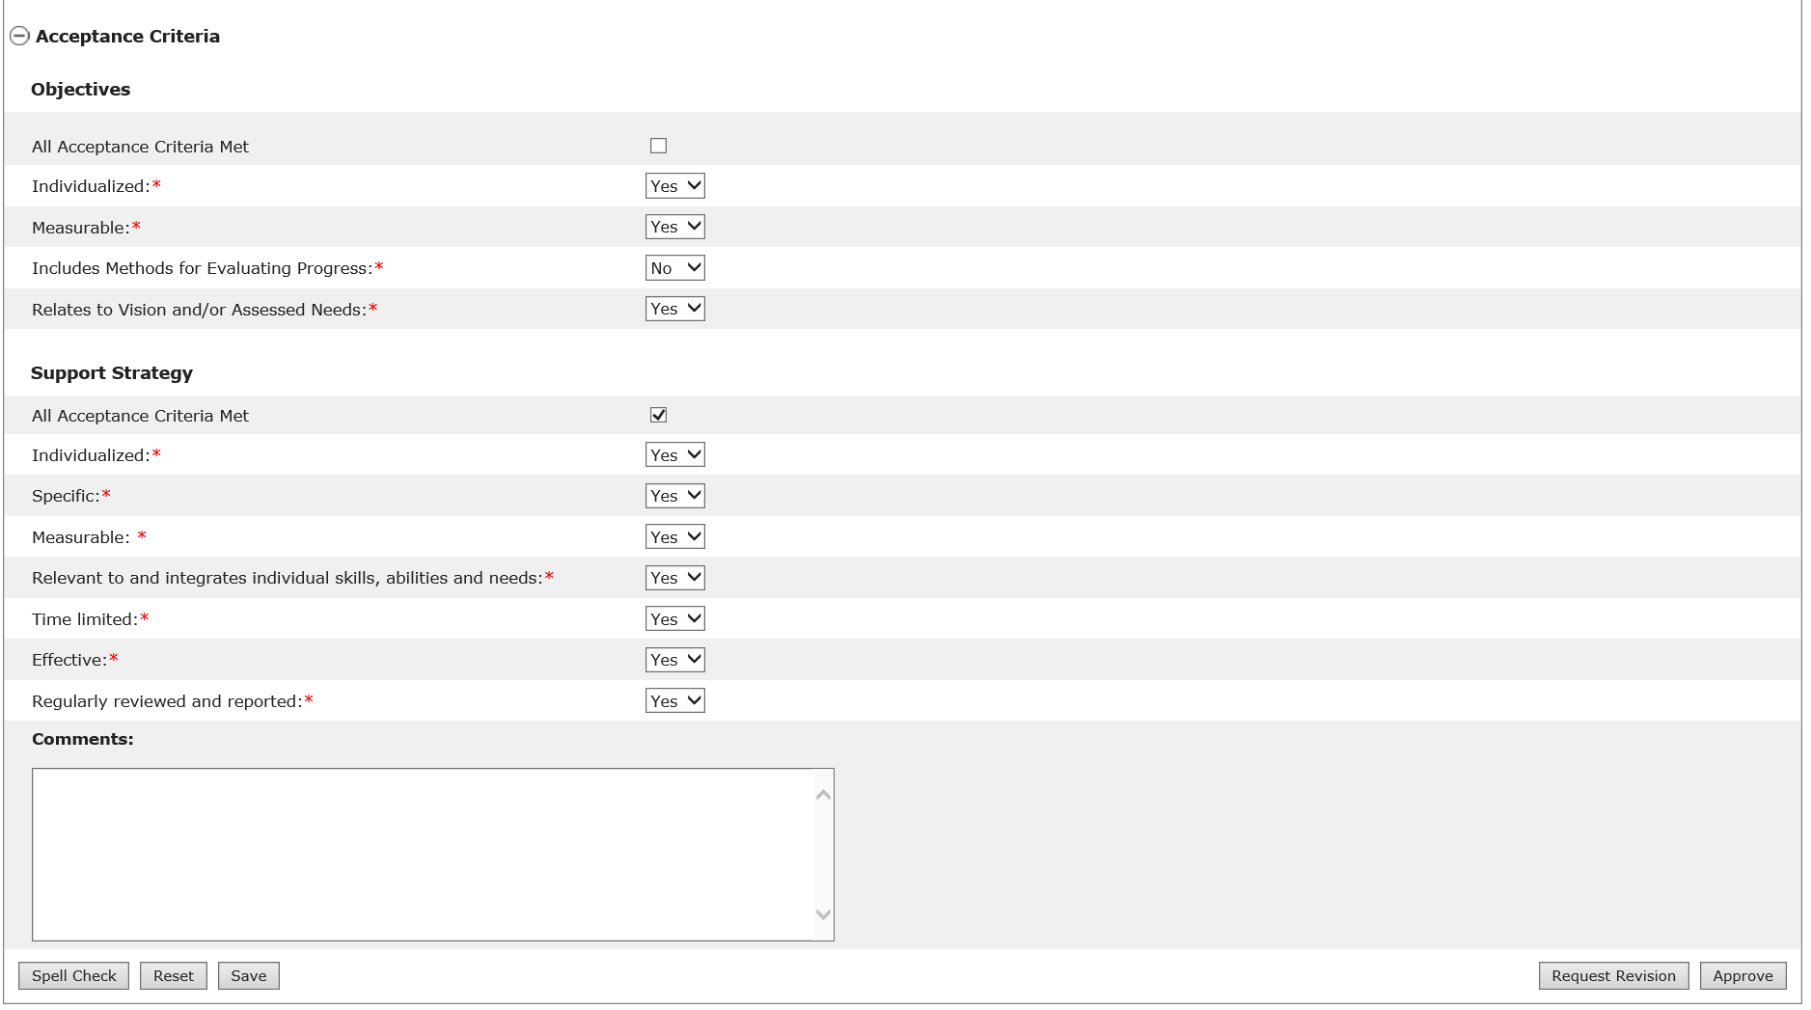

- Provide comments as to what revisions need to be made to the OSS that would meet the acceptance criteria.

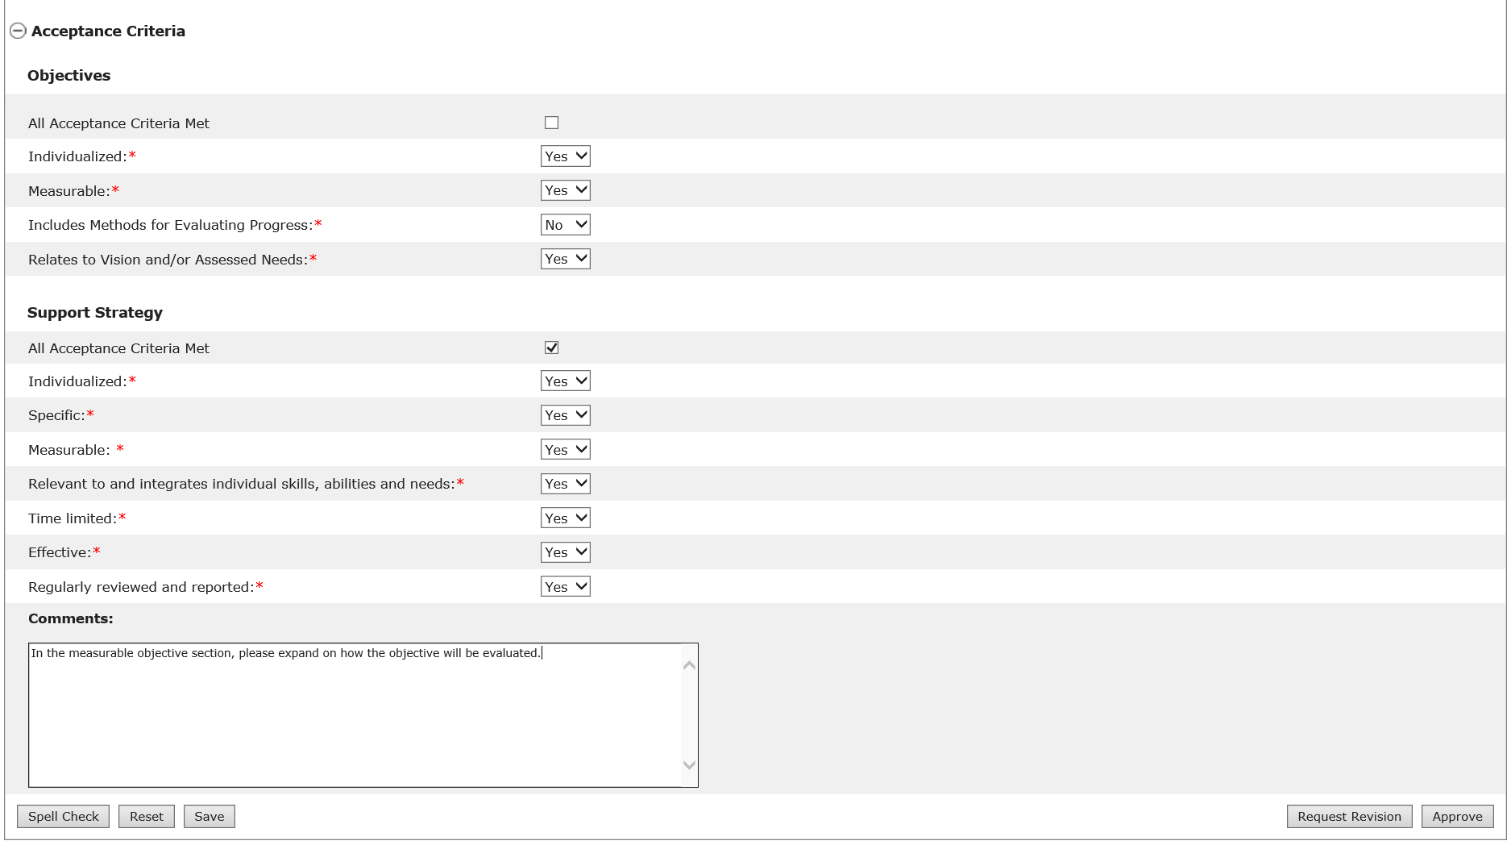
- Click “Request Revision” to return the OSS to the Provider and Provider Supervisor.

Note: The Service Coordinator or Service Coordinator Supervisor will not be able to click “Request Revision” if comments have not been provided.

Next Steps
- Service Coordinators or Service Coordinator Supervisors can continue reviewing other OSS.
- Providers will receive an alert to revise the OSS.
- Service Coordinators should repeat this process for any OSS that do not meet the Acceptance Review Criteria.

Reviewing and Revising an Objective and Support Strategy by Provider Staff in a Full or Update Year
Scenario Description
If revision is requested for an Objective and Support Strategy (OSS), the Provider user must make the necessary edits and resubmit for DDS review.

First Steps:
- Search for an individual
- View the Individual Dashboard

Roles and Responsibilities

- Provider: Address Service Coordinator feedback by revising OSS and submitting for internal review to the Provider Supervisor
- Provider Supervisor: Review, revise, or approves changes made to OSS by Provider staff and submits the documents for DDS review

Part I - Submitting a Revised Objective and Support Strategy for Internal Review

The below steps are completed by a Provider Data Entry User

The Provider will receive an alert when revisions have been requested by Service Coordinators.

- Click on the alert to navigate to the Objective and Support Strategy Review Switchboard.

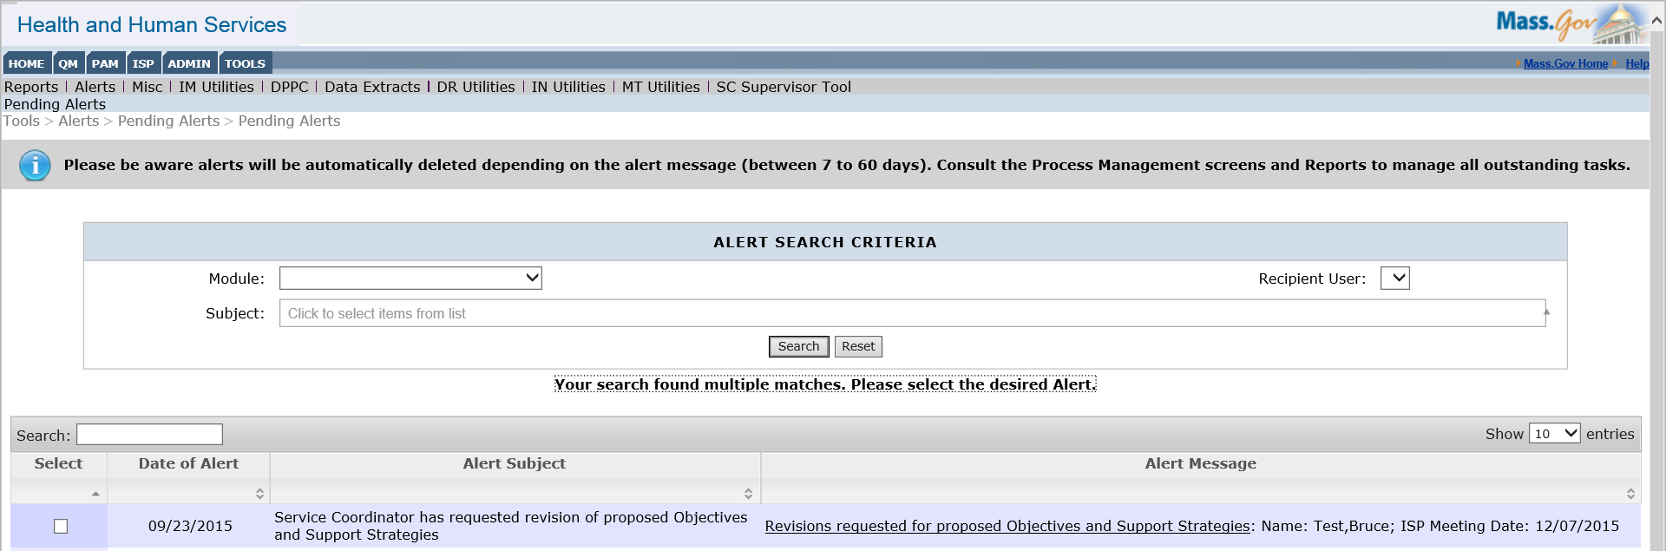

- Click on the status of “Revision Requested” to review the feedback from the Service Coordinator.

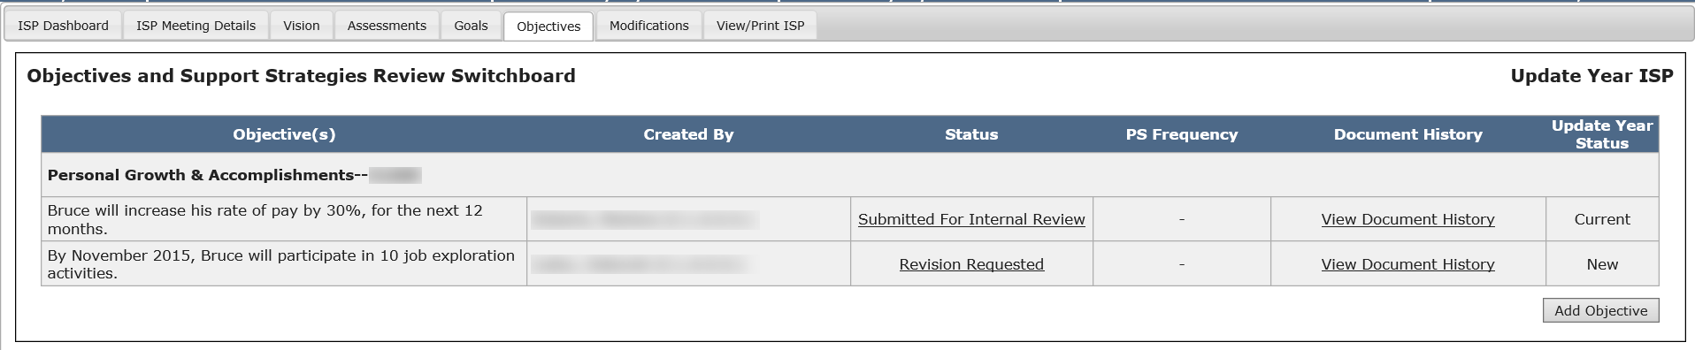

- Modify the Objective and/or Support Strategy based on the feedback from the Service Coordinator. The Provider will be able to review the feedback from the Service Coordinator before modifying the OSS.

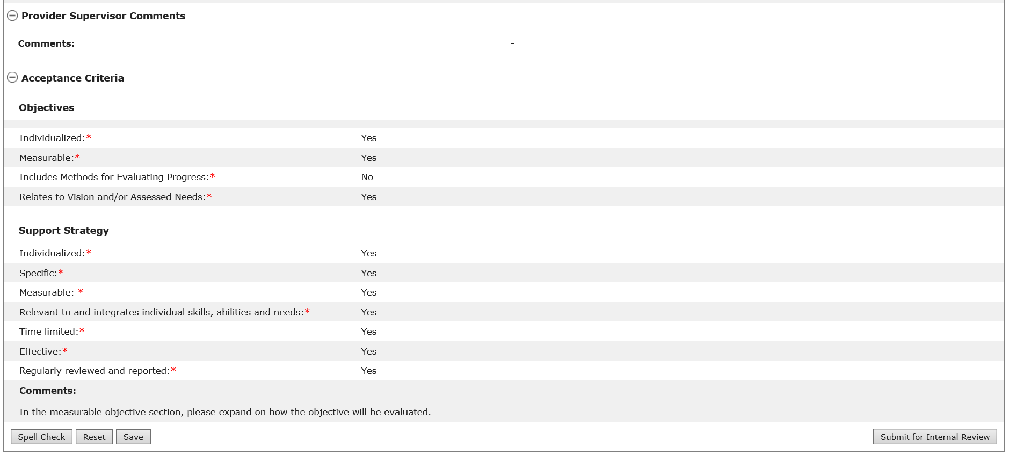

- Click on the “Submit for Internal Review” button to submit the revised document to the Provider Supervisor.

Part II – Reviewing a Revised Objective and Support Strategy Submitted for Internal Review and submitting it for DDS Review

The below steps are completed by a Provider Supervisor.

The Provider Supervisor will then receive an alert notifying them that an objective has been submitted for review.

- Click on the link within the alert in order to access the individual’s Objectives and Support Strategies Review Switchboard and review the assessment submitted by the Provider.

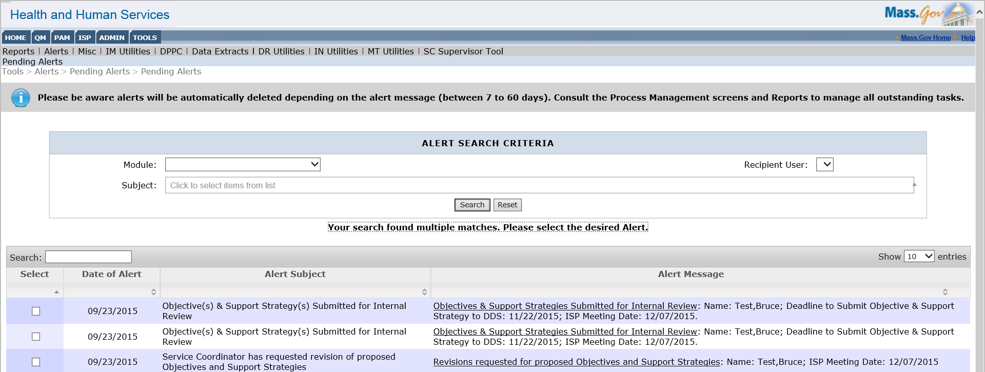

- To open the OSS, click the status of “Submitted for Internal Review.”

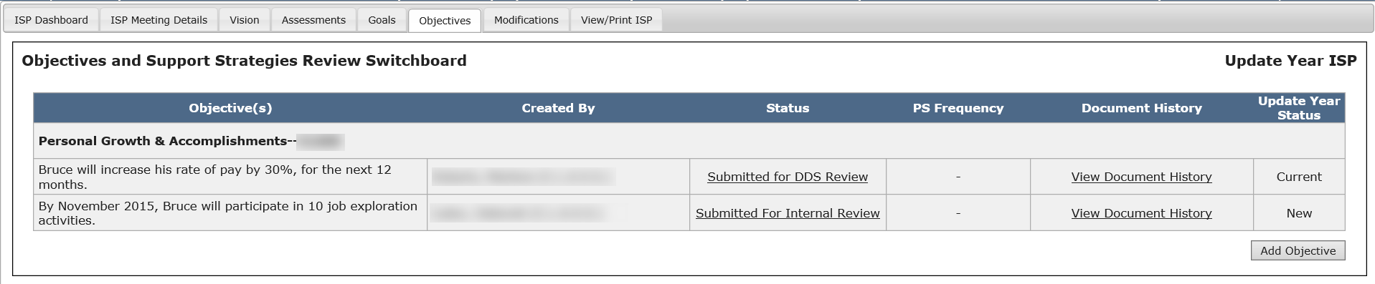

- After reviewing the document and making any necessary changes, click “Submit for DDS Review” to submit the revised document to the Service Coordinators.

The status for the OSS will change to “Submitted for DDS Review” on the Objectives and Support Strategies Review Switchboard.

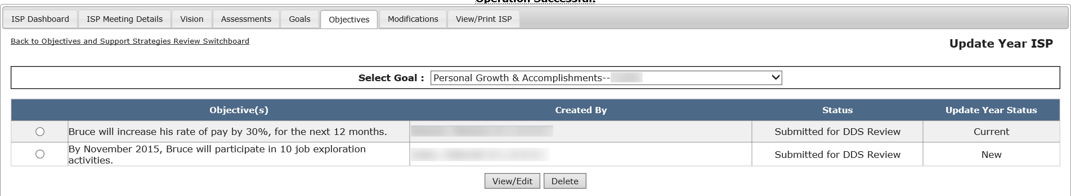

Next Steps

- If OSS have been re-submitted, the Service Coordinator and Service Coordinator Supervisor will receive an alert informing him or her to review the re-submitted documents.
- The Provider and Provider Supervisors will receive an alert once all OSS for their agency have been approved by the Service Coordinator or Service Coordinator Supervisor.

