Commonwealth of Massachusetts
Executive Office of Health and Human Services

Virtual Gateway

ISP Assessments Module
User Guide
Lesson 4: Assessments
HCSIS Release 7.7

Contents
Assessments 2
Requesting Assessments by DDS Staff 4
Completing an Assessment by Provider Staff 8
Completing a Health and Dental Assessment by Provider Staff 18
Reviewing and Approving an Assessment by DDS Staff 29
Reviewing and Requesting Revision of an Assessment by DDS Staff 34
Reviewing and Revising an Assessment by Provider Staff 39
Deleting an Assessment by DDS Staff 44

Assessments
The purpose of ISP assessments is to obtain specific information that will assist the ISP Team in identifying the individual's capabilities, support needs, and opportunities for skill development. The content of the assessments will support the ISP Team in establishing Goals, Objectives and Support Strategies that are the least restrictive and most likely to be effective in assisting the individual to attain his or her Goals. Below is an example that depicts the standardized assessments required by regulation for Group or Center-based Day (CBDS) service. For a full list of services and regulations on required assessments, please see the document named “Services and Assessments Matrix” posted on the ISP References page.
Activity Code | Service Name | Safety Assessment | Financial  Assessment | Health and Dental Assessment
3163 | Group or Center-based Day (CBDS) | Always | Sometimes | Never

Additional Assessments

Additional non-standardized assessments can no longer be requested from HCSIS since June 27th, 2014. These assessments should be requested and completed outside of the system. Additional non-standardized assessments that have been requested prior to June 27th, 2014, will continue to be available on the Review Assessments screen for completion and submission.

If no additional assessments have been previously requested from the system, the Review Assessments screen will display a message that reads “No assessments have been requested” for the Additional Assessments table. Service Coordinators may use the comment box on the Request Assessments screen to request additional assessments and other relevant ISP documents that need to be submitted outside of HCSIS.

The table below includes all of the current assessments available in the ISP module.

# | Assessment Name | Category
1 | Safety | Standardized
2 | Financial
3 | Health and Dental

Assessments and the ISP timeline

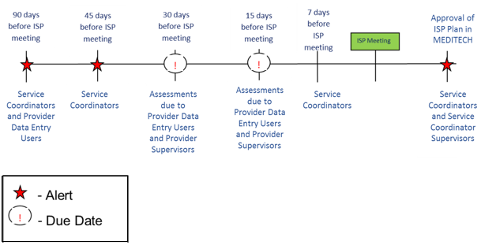
Assessments must be requested no later than 30 days prior to the ISP meeting. The process for requesting Assessments is identical for both a Full and an Update Year ISP. If the Service Coordinator has not requested assessments by the 30-day mark, the ISP Assessments module will send the Service Coordinator an alert informing him or her that this deadline has passed. Note that assessments should be available to the individual and guardian upon request seven days prior to the ISP meeting.

Providers who are part of the ISP Meeting, but are not required to submit any assessments (Providers providing only activity code 3164, 3700 or 6700) or Providers from whom the SC may sometimes request assessments, but none have been requested by the 30-day mark, will receive an ISP Meeting Notification Alert generated by the system. Providers providing only services with activity code 3164, 3700 or 6700 will have read only access to the ISP of the individual.

Requesting Assessments by DDS Staff
These steps must be completed by DDS staff – a Service Coordinator or a Service Coordinator Supervisor. Service Coordinators and Service Coordinator Supervisors can request an assessment in the module once the following conditions have been met:

- The individual is receiving one or more services that require an assessment to be completed
- A Vision Statement has been created for the individual and shared with Providers

Scenario Description:
This scenario describes the steps required to request an Assessment by DDS Staff.

Note: For demonstration purposes, the scenario will show screenshots from a Full Year ISP, but the steps are identical between Full and Update Year ISP.

First Steps:
- Search for an individual
- View the Individual Dashboard

Roles and Responsibilities

- Service Coordinator: Requests the assessment(s) from the Service Providers.
- Service Coordinator Supervisor: Requests the assessment(s) from the Service Providers
- Provider: No action is required to complete this scenario. Once the assessment is requested, provider completes the assessment and submits to the Provider Supervisor for Internal Review.
- Provider Supervisor: No action is required to complete this scenario. Once the assessment is requested, reviews, completes and submits the assessment.

- Select “Request Assessments” from the individual’s Dashboard or select the “Request Assessments” tab.

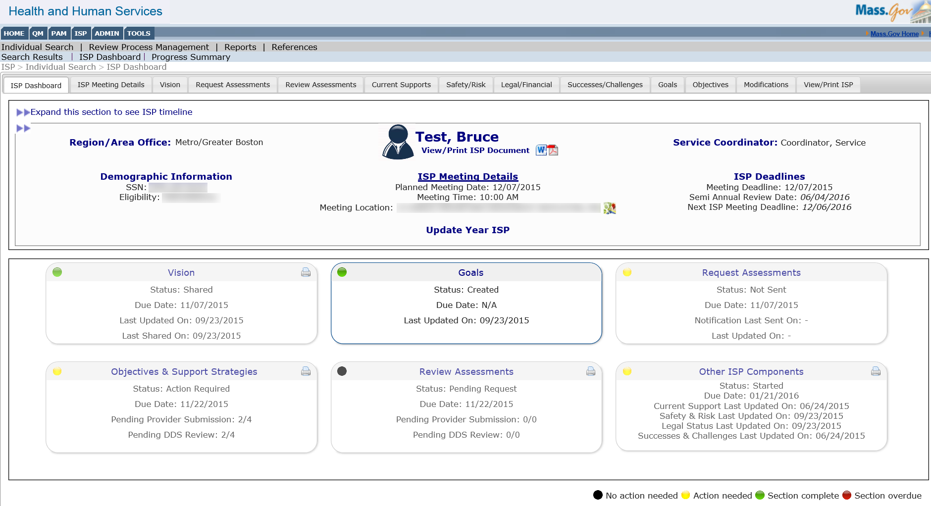

- View the Request Assessments page and click the boxes to select assessments to be requested for each service enrollment.
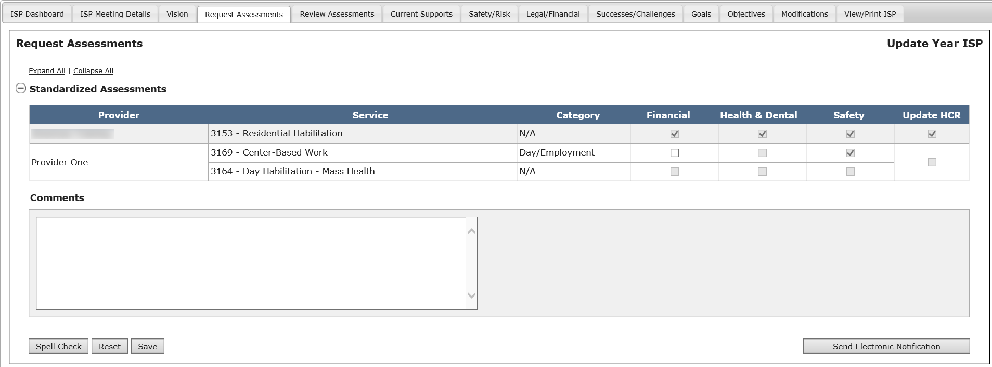

Some boxes will be greyed out as those assessments cannot be requested for that particular service enrollment. Other boxes will be greyed out with a check in them: these assessments are required and must be requested for that particular service enrollment.

Certain service codes fall within one of two categories: Day/Employment or Supports. For all services that do fall in one of those two categories, the request for assessment would be specific to the service code category. Providers will complete one assessment for any services within these categories as opposed to completing an assessment for each service within a category. For example, if the same Provider Agency is providing service code 3168 (Supported Employment) and service code 3181 (Group Supported Employment), the agency will be required to fill out only one Safety assessment for both service and there will be only one checkbox for Safety assessments on the Request Assessments screen. Please see the tables below for more information on the two categories:

Day/Employment Category
Activity Code | Waiver Service Title
3168 | Supported Employment
3169 | Center-based work
3180 | CIES - Competitive Employment
3181 | Group Supported Employment
3681 | Group Supported Employment Partnership

Supports Category
Activity Code | Waiver Service Title
3701 | Respite - Adult - In recipient's home-Daily
3702 | Respite - Adult - in caregiver's home
3703 | Individual Home Supports
3707 | Adult Companion
3731 | Respite - Adult - in recipient's home-hourly

Note: For all services that are not listed in one of the categories above, assessments will be service-specific, not category-specific and one assessment will be requested/ completed for each service that requires that assessment.

Note: As of June 27th, 2014 additional non-standardized assessments can no longer be requested from HCSIS. Additional assessments that have previously been requested will continue to be available on the Review Assessments screen

- Enter comments in the Comments box to note any documents or additional assessments that need to be submitted by the Providers outside of HCSIS and click on “Save”.
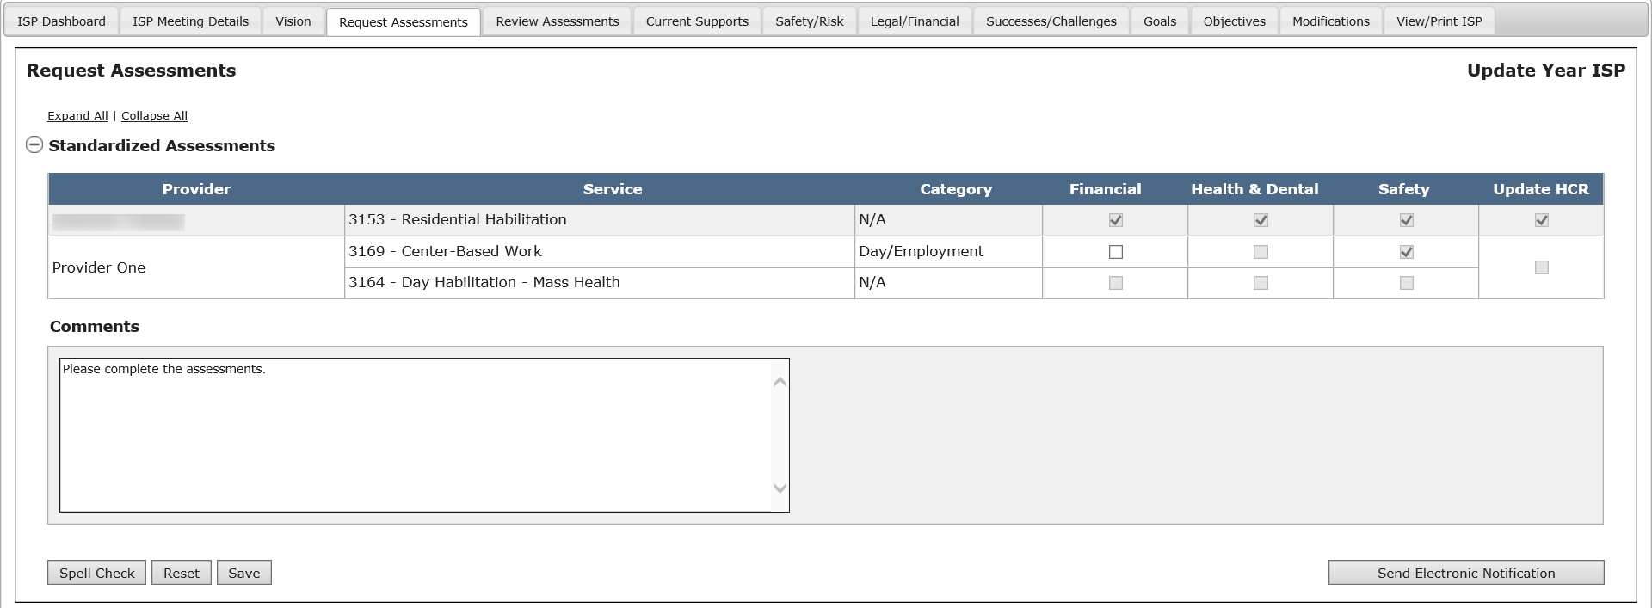

The system will display a message reading “Operation Successful” once comments have been saved. The Providers will then be able to view the comments on the Assessments page.

- Click “Send Electronic Notification” to request the Assessments.

Note: The system will not automatically request these pre-selected assessments to Providers. The Service Coordinator is still required to click “Send Electronic Notification.”

- The system will update the Assessments Review Switchboard with the information saved by the user. The system will also display a message reading “Operation Successful.”

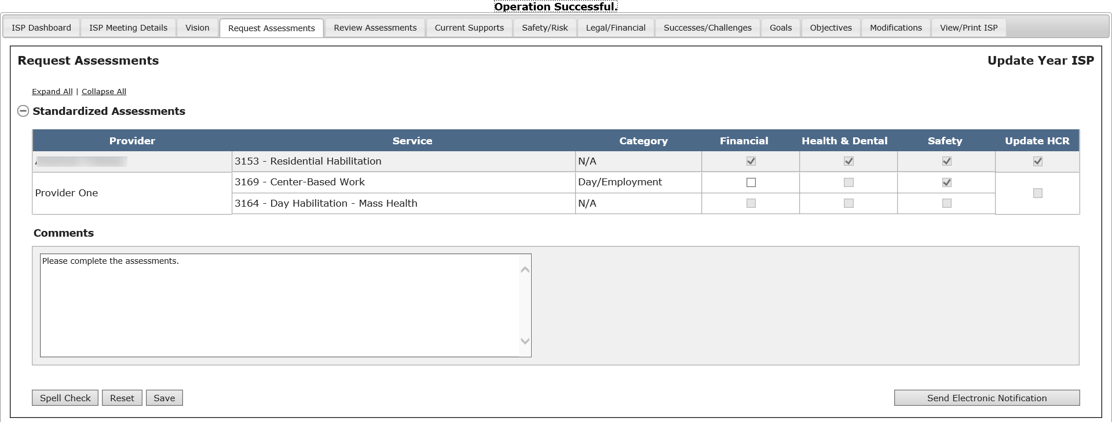
Providers and Provider Supervisors cannot begin to work on the assessments until Service Coordinators request them via this process.
Next Steps
The system will update the Assessments Review Switchboard to reflect the request and any comments that have been saved by the Service Coordinator.

- Providers will receive an alert that the assessments have been requested.
- Providers and Provider Supervisors can begin working on assessments.
- Service Coordinators can request more assessments at a later date.
- Service Coordinators will need to review the assessments as they are submitted.

Completing an Assessment by Provider Staff
These steps must be completed by Provider Agency area office staff – a Provider or a Provider Supervisor. Providers and Provider Supervisors can complete an assessment in the module once the following conditions have been met:

- The individual is receiving one or more services that require an assessment to be completed
- A Vision Statement has been created for the individual and shared with Providers
- The Service Coordinator or Service Coordinator Supervisor has requested the assessment

The process for completing Assessments is identical for Full Year ISPs and Update Year ISPs. Information from past assessments can be pulled forward or recalled for any of the requested assessments, provided the following conditions are met:
- The Assessment was previously created by the same Provider Agency
- The Assessment is of the same type (Safety, Financial, Health & Dental)
- The Assessment is for the same service/bundle, if applicable
- The Assessment was previously approved

Scenario Description:
This scenario describes the steps required to complete an Assessment by Provider Staff.

First Steps:
- Search for an individual
- View the Individual Dashboard

Roles and Responsibilities

- Provider: Completes the assessment and submits it for internal review.
- Provider Supervisor: Completes reviews and submits the assessment for DDS review.

Document Statuses
Below are all the statuses an Assessment goes through along with which user group has access to viewing and/or editing the document:
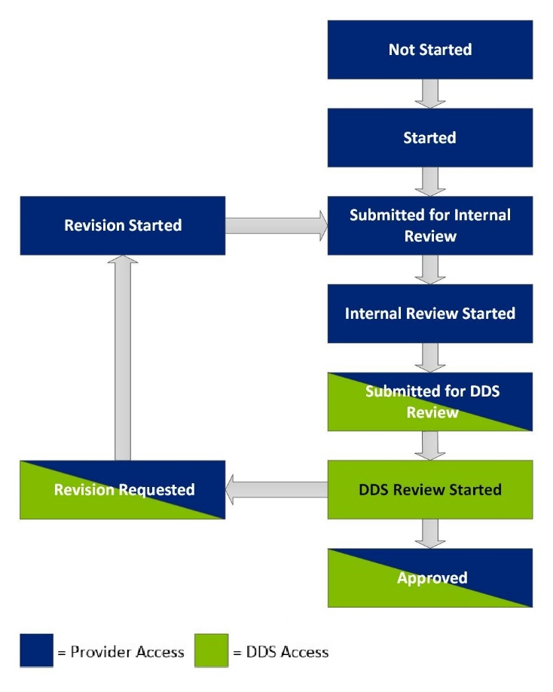
Below are the Assessments Document statuses for DDS and Providers

Status | Definition
Not Started | An assessment has not begun to be completed, after being requested by the Service Coordinator
Started | An assessment has begun to be completed/ information from a past assessment has been pulled forward
Submitted for Internal Review | An assessment has been submitted by a Provider to a Provider Supervisor for review and approval prior to being submitted to the Service Coordinator
Internal Review Started | The Provider Supervisor has started his/her review of an assessment
Submitted for DDS Review | The Provider Supervisor has approved the assessment, and has submitted the document to the Service Coordinator for review
DDS Review Started | The Service Coordinator has started their review of the assessment
Revision Requested | The Service Coordinator has requested revision to one or more assessments. The Service Coordinator will provide the reason for the request for revision
Revision Started | The Provider has started to revise the assessment based on the Service Coordinator’s feedback
Approved | The Service Coordinator has approved the submitted assessments and Objectives and Support Strategies

Note:
- When a document is submitted for Internal Review to the Provider Supervisor, the Provider has read only access to it.
- When the document is submitted for DDS review, both the Provider and Provider Supervisor have read only access to it.
- When the document is approved, all users have read only access to it.

Part I - Submitting an Assessment for Internal Review

The following steps are completed by a Data Entry User.

After the Service Coordinator requests an assessment, the system will send an alert to the Provider Data Entry User, prompting them to complete the assessment.

- Click on the link within the alert in order to access the individual’s Assessments Review Switchboard and address the alert.

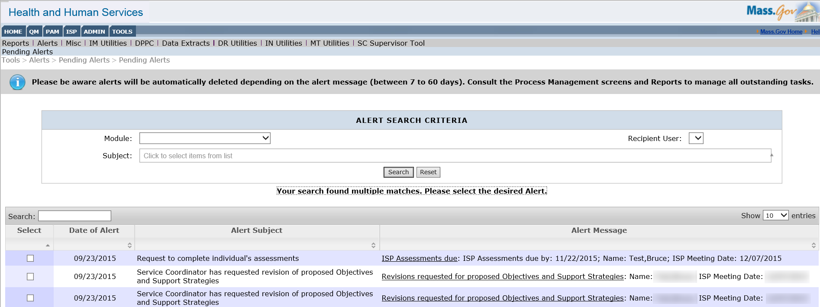

This will bring the Provider to the Assessments Review Switchboard.

- Click on the status “Not Started” to begin completing an assessment.

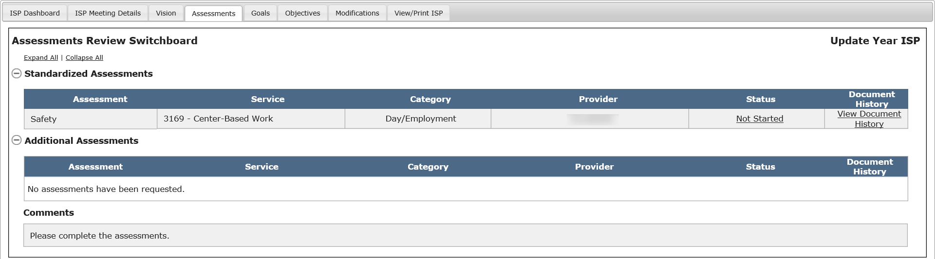

Note: In this scenario, we will walk through completing a Safety assessment that meets all criteria for values from a past assessment to be pulled forward. The screenshots represent a Full Year ISP, but the process for recalling information from a past assessment on an Update Year ISP is identical.

Only the assessments that have been requested will be shown on the Assessments Review Switchboard. Clicking the status of the assessment will redirect to the beginning of the assessment. It is important to keep in mind that Service Coordinators do not need to request all assessments at once. Assessments may be requested at later dates. Regardless of when assessments are requested, Providers will receive an alert for the request.

Note: In case there is no information to be pre-populated from a past assessment, the following pop-up message will be displayed: “No values available to pre-populate the selected assessment.” With “Ok” and “X” as the options. Clicking “Ok” will open the blank assessment form. Clicking “X” will close the pop-up and leave the user on the Assessment Review Switchboard.

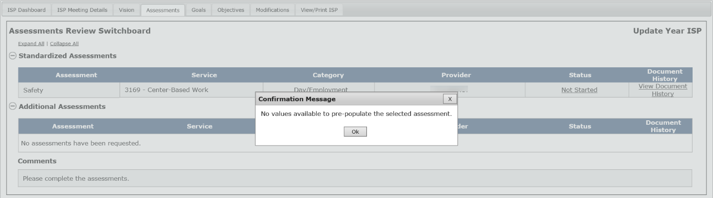

Note: In this scenario, there is data to pre-populate the Safety assessment.

- Select “Yes” from the “Do you wish to pre-populate this assessment with values from a previous year?” pop-up.
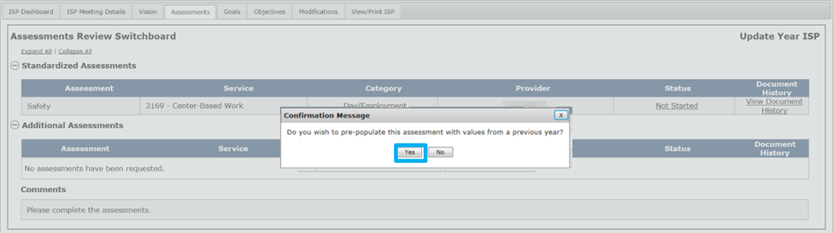

The system navigates to Part I of the Standardized Assessment where all valued form the past Full Year ISP plan have been recalled and are editable and the status of the assessment changes to “Started”.

Note: If the user clicks “No” on the above pop-up and then saves values in the assessment, the user will no longer have the option to recall values from the previous year’s assessment.

- Complete the mandatory fields and all relevant sections of the assessment using the drop down menus and text boxes.

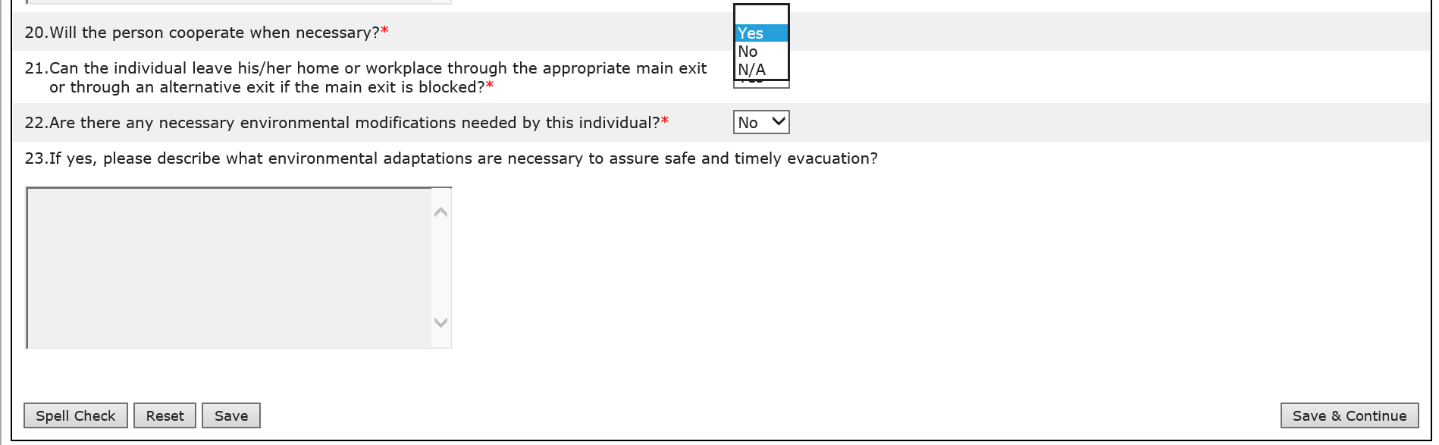

Note: All assessments, irrespective of whether a Full or an Update Year ISP, have conditionally mandatory fields; meaning that a response can be entered in certain prompts only if the condition is met by the response entered in the prior prompt. For example, the prompt 23 on the safety assessment in the screenshot above is conditional based on response to prompt 22 on the safety assessment.

- Click “Save & Continue” to save progress and move to the next section of the assessment. Other options available for the Provider and Provider Supervisor are “Spell Check,” “Reset,” and “Save.” “Reset” will revert the assessment to the last saved version.

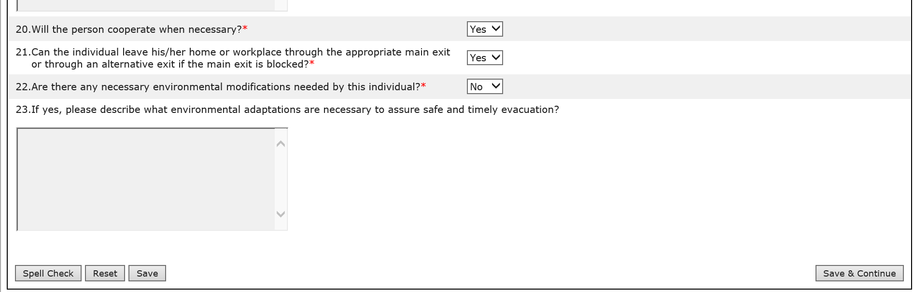

- Click “Save & Continue” to save progress and move to the final section of the assessment. Once the assessment is complete, click on “Submit for Internal Review” in order to submit the assessment to the Provider Supervisor.

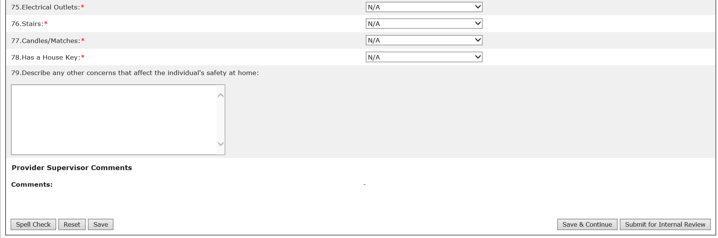

User will be navigated back to the Assessments Review Switchboard where the status of the assessment will be “Submitted for Internal Review”:

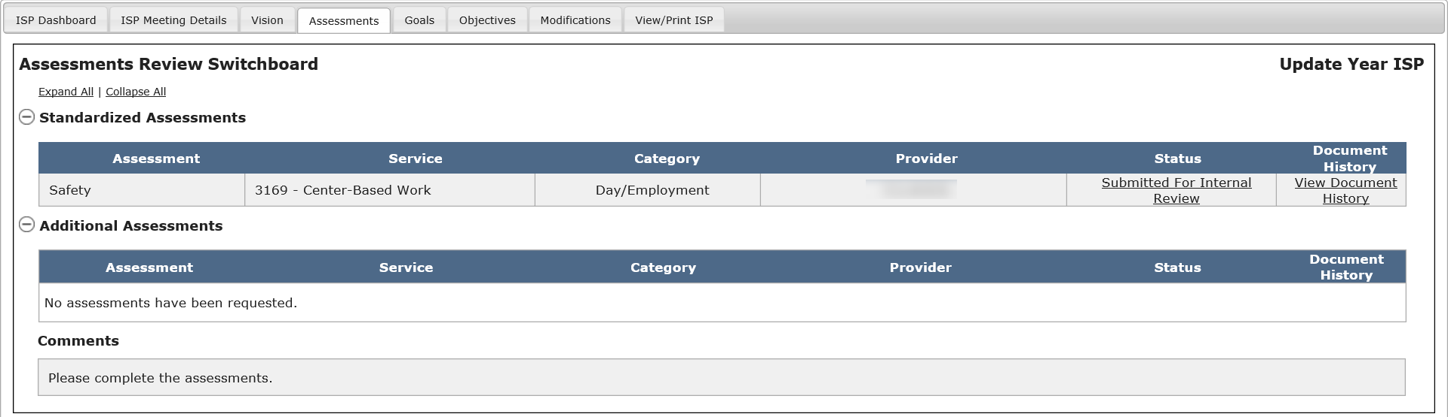

Part II – Reviewing an Assessment Submitted for Internal Review and Requesting Internal Revision

The following steps are completed by a Provider Supervisor.

- The Provider Supervisor will receive an alert notifying them that a Safety assessment has been submitted for internal review. Click on the link within the alert in order to access the individual’s Assessments Review Switchboard and review the assessment submitted by the Provider.

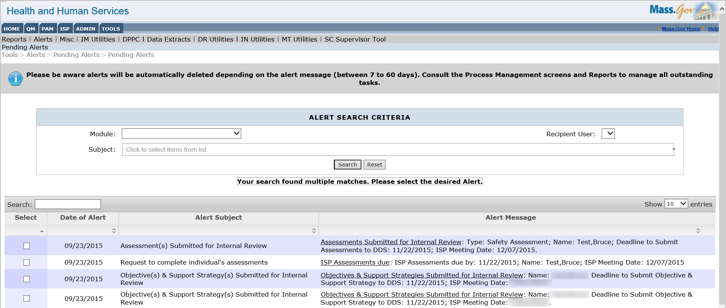

Note: The alert will specify what type of assessment has been submitted – Safety, Financial or Health & Dental.

- Click on the status of “Submitted for Internal Review” to open and review the assessment.

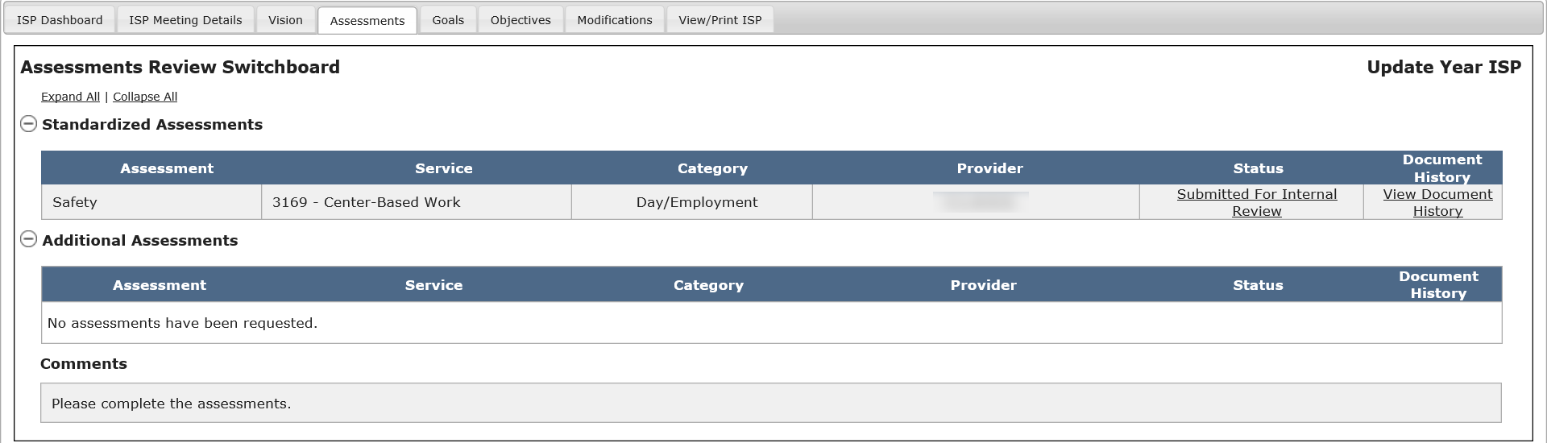

- Insert comments in the “Provider Supervisor Comments” textbook

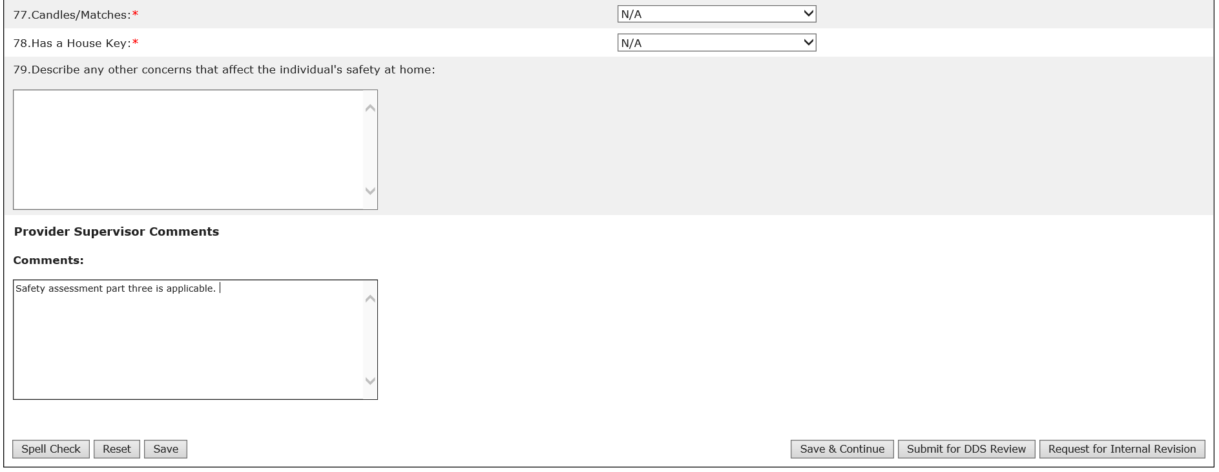

- Click “Request Internal Revision”

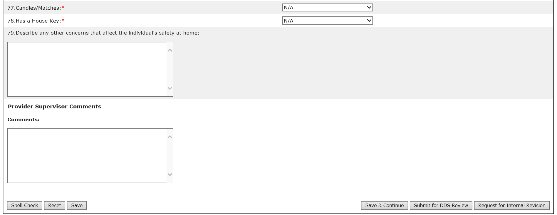

- After clicking “Request Internal Revision”, the system will update the Assessments Review Switchboard with the information saved by the user and the status of the assessment will read “Internal Revision Requested”

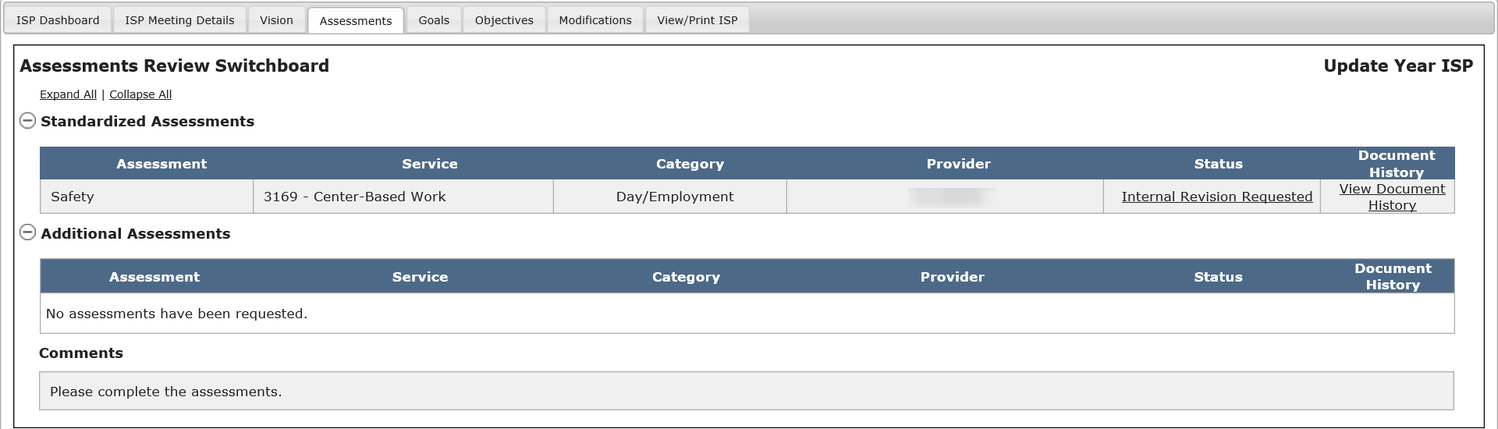

Part III – Revising an Assessment Submitted for Internal Revision and Submitting for Internal Review

The following steps are completed by a Provider Data Entry User.

The Provider Data Entry User will receive an alert notifying them that internal revision has been requested on an assessment. The process for revising an assessment is identical to that of submitting an assessment. Please refer to Part I.

Part IV – Reviewing an Assessment Submitted for Internal Review and Submitting to DDS

The following steps are completed by a Provider Supervisor.

The Provider Supervisor will then receive an alert notifying them that an assessment has been submitted for internal review.

- Click on the link within the alert in order to access the individual’s Assessments Review Switchboard and review the assessment submitted by the Provider.

Note: The alert will specify what type of assessment has been submitted – Safety, Financial or Health & Dental.

- Click on the status of “Submitted for Internal Review” to open and review the assessment.

- Click “Submit for DDS Review”

Note: If the Provider Supervisor saves the assessment with some changes, but does NOT submit it for DDS review, the assessment status will remain “Internal Review Started”.

Note: Other buttons are available on this screen. They are as follows:
- “Save & Continue”: The system will redirect the user to the ISP Dashboard.
- “Reset”: The system will revert back to what was last saved. In the event that there are no saved data, “Reset” will clear the form.
- “Spell Check”: A proofreading tool that can be used prior to saving or sharing.

- After clicking “Submit for DDS Review”, the system will update the Assessments Review Switchboard with the information saved by the user and the status of the assessment will read “Submitted for DDS Review.”

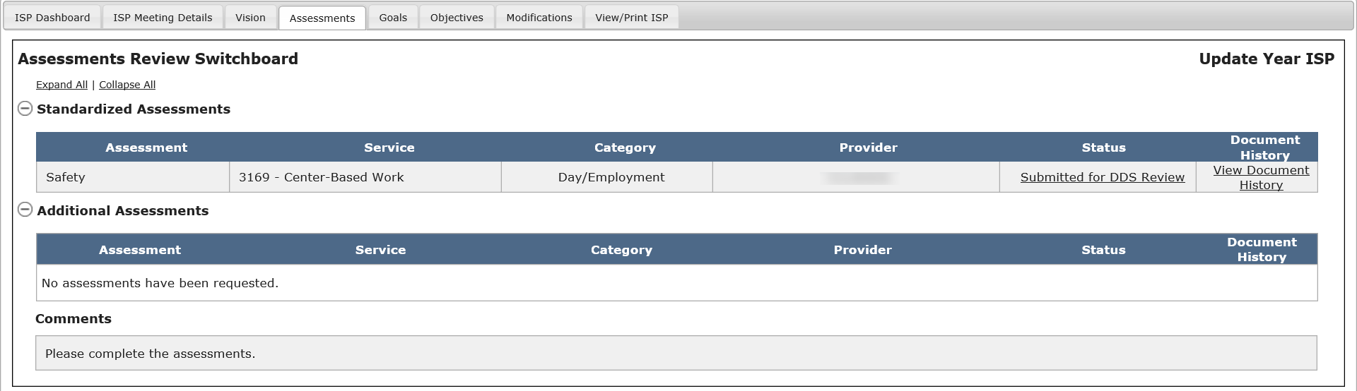

Note: If the assessment requires attachments, these must be provided to the Service Coordinators separately from HCSIS.

Next Steps

- The Service Coordinator will receive an alert every Tuesday and Friday for any assessments that have been submitted by one or more Provider agencies.
- Service Coordinators will be responsible for reviewing the assessments, as covered in the next two sections.
- Providers and Provider Supervisors should continue completing any requested assessments.
- Providers and Provider Supervisors can monitor the individual’s ISP Dashboard, the Assessments Review Switchboard or use the Review Process Management screen to view the progress of any revisions.

Completing a Health and Dental Assessment by Provider Staff
The ISP Assessments Module draws data from the HCSIS QM Module’s Health Care Record (HCR) to populate the Health and Dental assessment. The below table represents the fields on the Health & Dental Assessment that are pulled from the latest finalized HCR. This information will automatically be pulled onto a Health & Dental assessment in “Not Started” status. Refreshing from HCR functionality in the ISP Assessments Module allows the user to update fields on an already started Health & Dental Assessment after making the desired changes on the individual’s Health Care Record and finalizing the modified record.

Information on the Health & Dental Assessment pulled from the Health Care Record

Prompt number on H&D | Prompt Description on the Health & Dental Assessment | HCR Details
1 | Individual’s Name | Basic Information Screen
2 | Date of Birth | Basic Information Screen
3 | Height | Current Medical Problem and Diagnoses Screen  Field – ‘Height’
4 | Date Height Recorded | Current Medical Problem and Diagnoses Screen  Field – ‘Date Height Recorded’
5 | Weight (lbs) | Current Medical Problem and Diagnoses Screen  Field – ‘Weight (lbs)
6 | Date Weight Recorded | Current Medical Problem and Diagnoses Screen  Field – ‘Date Weight Recorded  (MM/DD/YYYY format)
7 | Identify any current medical problems, diagnoses, treatments and medications: (All diagnoses must be supported by documentation from a licensed and qualified medical and/or mental health professional. DO NOT include HIV diagnosis and medications used to treat HIV. Attach any relevant protocols including but not limited to Seizure, Dining, PICA.) | Current Medical Problem and Diagnoses Screen  Field - ‘Medication Name’  Medications List Screen  Field – ‘Reason for Prescription’
36 | List all supportive device needs | Functional Status Screen  Field – ‘Supportive Devices’, ‘If Other, please specify’
38 | List all augmentative communication needs | Functional Status Screen  Field - Communication from MEDITECH (Able to Communicate, Communication Difficulties/Uses Verbalizations, Communication Difficulties/Uses Gestures, Not able to Communicate Needs, Unable to use Call Bell, Only Speaks/Understands a foreign language, Utilizes Communication Devices)
39 | Does the individual manage his/ her own medications? | Functional Status Screen  Field - Medication Administration from MEDITECH (Independent/Self Medicates, Medication Administered by Staff)
42 | Does the individual require sedation for medical or dental appointments? | Special Needs Screen  Field – ‘Sedation for clinical visits’
49 | Annual Physical Examination Date (Editable in the Health and Dental Assessment) | Past Medical History - Evaluations Screen  Field - ‘PHYSICAL EXAM Status’  (MM/DD/YYYY or YYYY allowed in HCR)
51 | Dental Examination Date (Editable in the Health and Dental Assessment) | Past Medical History - Evaluations Screen  Field - ‘DENTAL EXAM Status’  (MM/DD/YYYY or YYYY allowed in HCR)
53 | Colonoscopy/ Sigmoidoscopy | Past Medical History - Evaluations Screen  Field - ‘SIGMOIDOSCOPY or COLONSCOPY Status’  (Only Year is stored in HCR. No Date)
54 | Bone Density | Past Medical History - Evaluations Screen  Field - ‘BONE DENSITOMETRY EXAM Status’  (Only Year is stored in HCR. No Date)
55 | Prostate | Past Medical History Screen  Field - ‘PSA (Prostate Cancer Screening) Status’  (Only Year is stored in HCR. No Date)
56 | Pap smear | Past Medical History - Gynecologic Screen  Field - ‘PAP Smear Status’  (MM/DD/YYYY or YYYY allowed in HCR)
57 | Mammogram | Past Medical History - Gynecologic Screen  Field - ‘Mammogram Status’  (MM/DD/YYYY or YYYY allowed in HCR)
58 | Lipid Panel | Past Medical History - Evaluations Screen  Field - ‘Lipid Panel Status’  (Only Year is stored in HCR. No Date)
59 | EKG | Past Medical History - Evaluations Screen  Field - ‘EKG’  (Only Year is stored in HCR. No Date)
60 | Blood Drug Level | Past Medical History - Evaluations Screen  Field - ‘Blood Level’  (Only Year is stored in HCR. No Date)

The following services require a Health and Dental assessment to be completed:
- Placement Services (also referred to as Shared Living)
- 24-hour Residential Supports
- Community Living Supports
- State Operated Residential Supports

The following services require a Health and Dental assessment if the supports are relevant to health care needs:
- Community Based Day Supports
- Day Habilitation Supplement
- Supplemental Adult Supports (for individuals enrolled in Adult Foster Care)

The following services require a health and dental assessment if the contractual obligation necessitates:
- Emergency Stabilization Residence
- Individual Supports and Community Habilitation

The steps to create a Health and Dental assessment must be completed by Provider Agency staff – a Provider or a Provider Supervisor. Providers and Provider Supervisors can complete an assessment in the module once the following conditions have been met:

- The individual is receiving one or more services that require a Health and Dental assessment to be completed (see above)
- A Vision Statement has been created for the individual
- The Service Coordinator or Service Coordinator Supervisor has requested the assessment

Scenario Description:
This scenario describes the steps required to complete a Health and Dental Assessment by Provider Staff.

First Steps:
- Search for an individual
- View the Individual Dashboard

Roles and Responsibilities

- Provider: Completes the assessment and submits for internal review.
- Provider Supervisor: Completes reviews and submits the assessment for DDS review.

Part I: Completing a Health and Dental Assessment and Submitting for Internal Review

The below steps are completed by a Data Entry User.

- After the Service Coordinator requests an assessment, the system will send an alert to the Provider Data Entry User, prompting them to complete the assessment. Click on the link within the alert in order to access the individual’s Assessments Review Switchboard and address the alert.

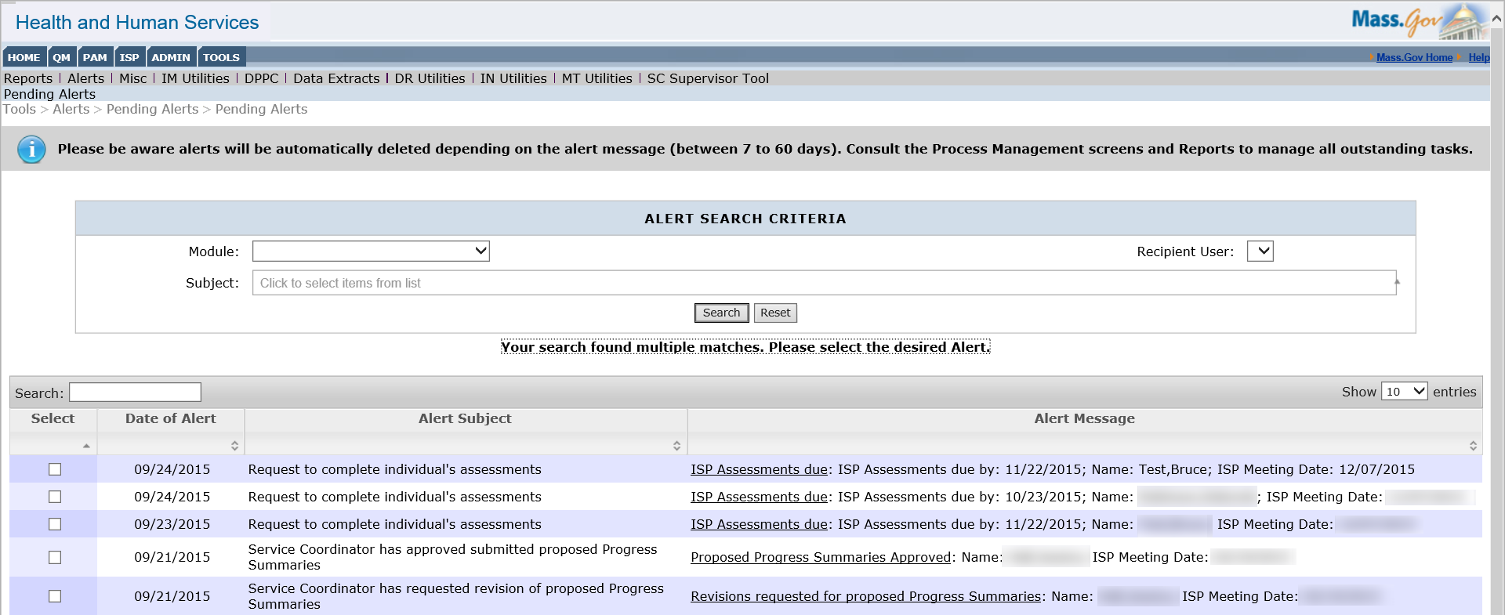

- Click “Access HCR” to view a list of the latest Health Care Records and to submit an updated Health Care Record.

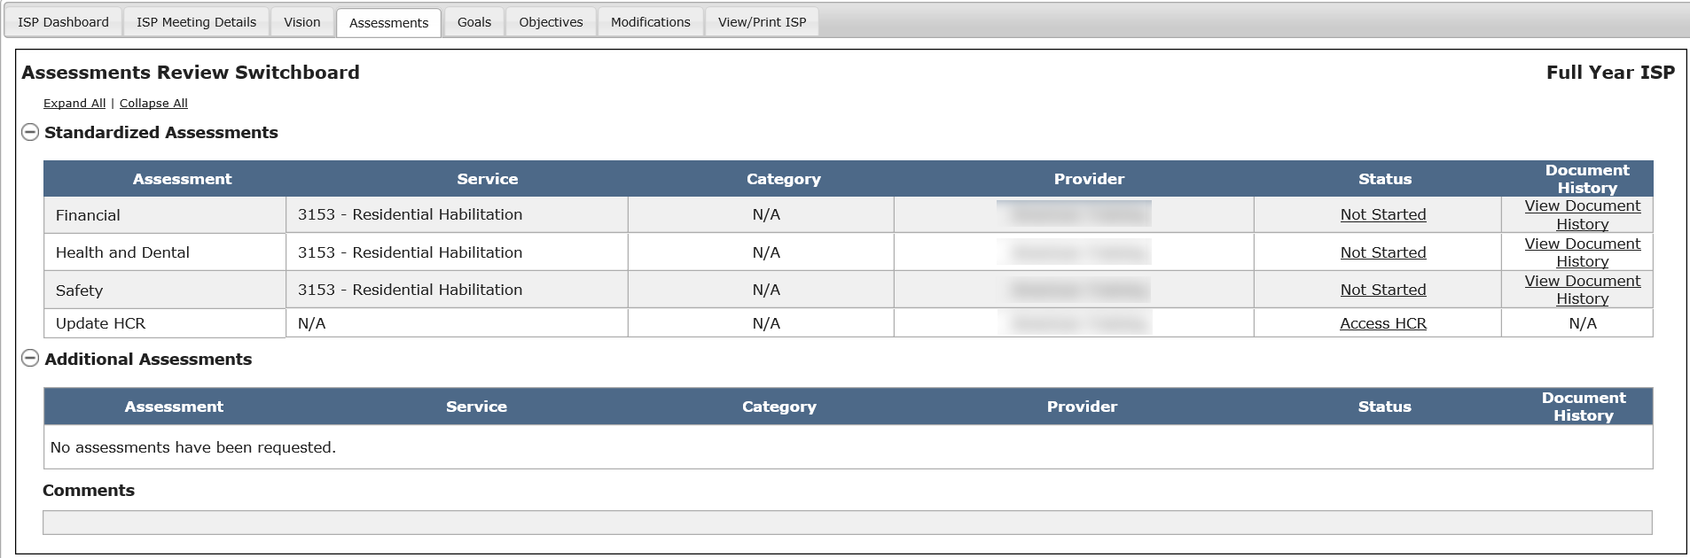

- Click “Create A New HCR”.

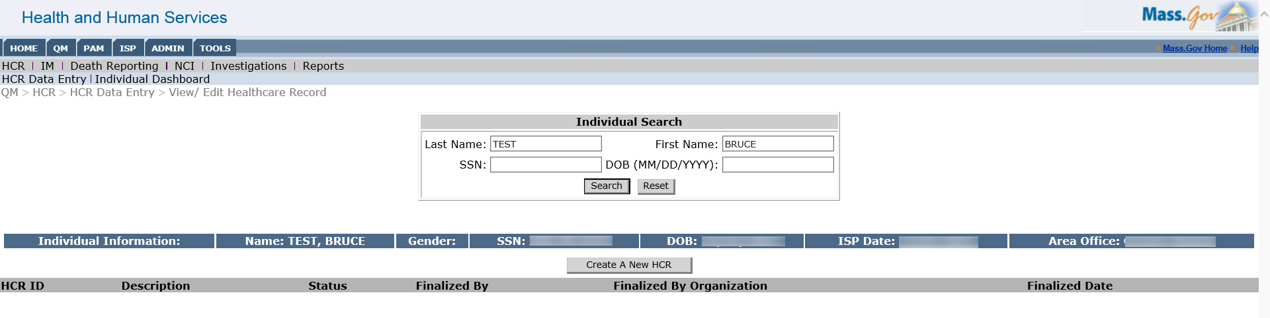

- Enter relevant information into the Health Care Record.

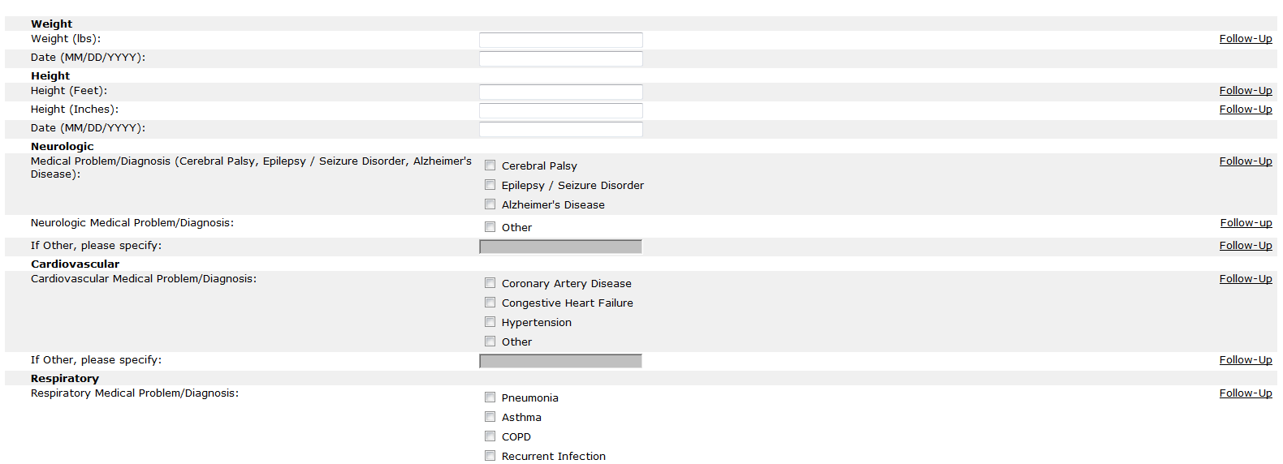

Note: A static element “Has Standing Orders For” is added to the drop list for “Reason for Prescription” on Medication List screen. “Other Reason for Prescription” is changed to “Specific Reason for Prescription” and is a non-mandatory field.

- After completing all sections, click “Finalize”.

- Return to the Assessments Review Switchboard and click on the status of “Not Started” to complete the Health and Dental assessment.

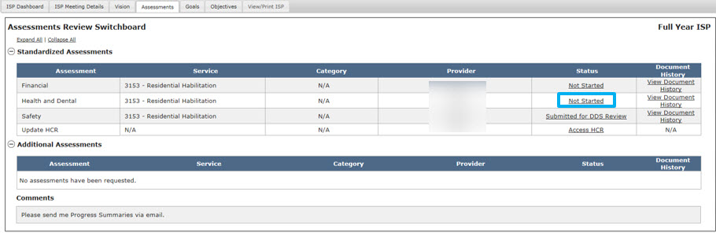

If the criteria for pulling information from a past assessment are satisfied, the system will display the “Do you wish to pre-populate this assessment with values from a previous year?” pop-up. Clicking “Yes” will pre-populate the new assessment with values from last year’s assessment.

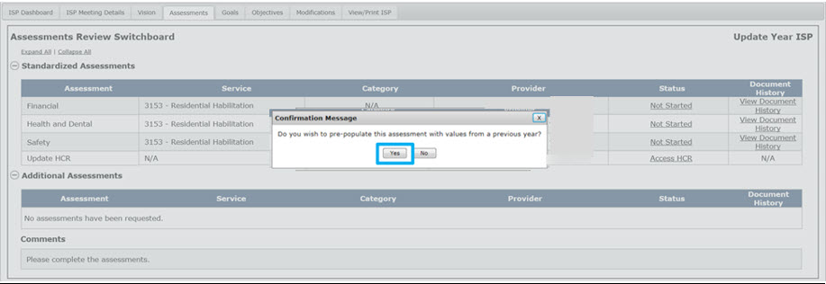

The below example shows what steps are taken when there is no information to pre-populate from last year’s assessments.

- Select “Ok” from the “No values available to pre-populate the selected assessment” pop-up.

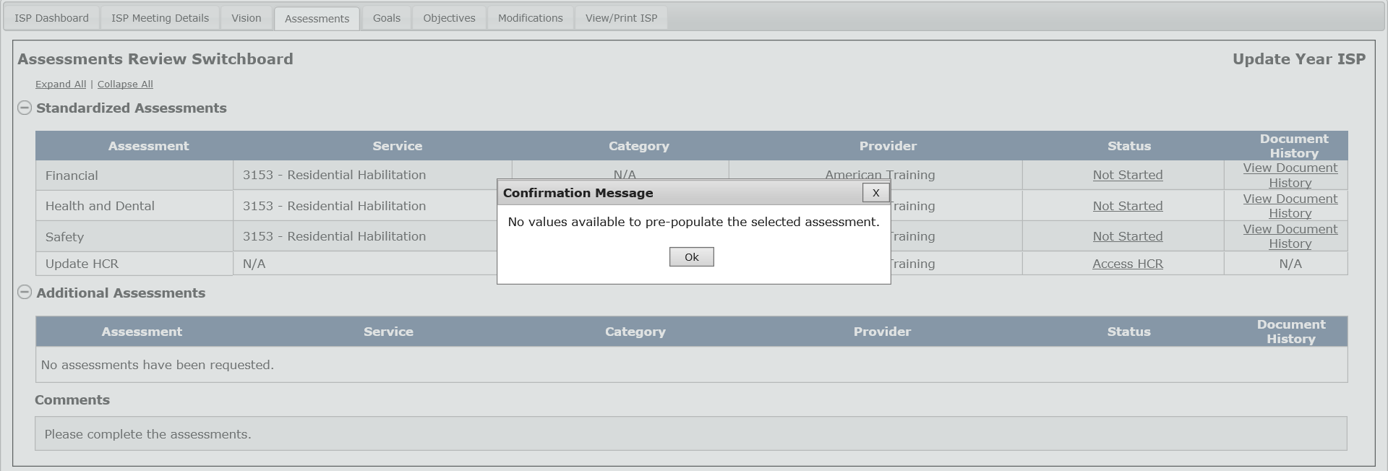
The system navigates to Part I of the Health and Dental Assessment.

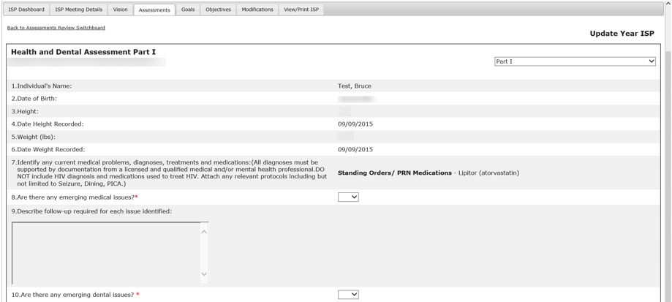

This will open up the assessment. Several fields in the Health and Dental assessment will automatically populate from the Health Care Record. Please refer to the table at the beginning of this section. The information will be pulled from the last finalized Health Care Record.

Note: In the scenario when information from a past assessment is pulled forward by selecting “Yes” on a “Do you wish to pre-populate this assessment with values from a previous year?” pop-up, the fields automatically populated from the HCR will be pre-populated from last year’s assessment instead of being pulled from the finalized Health Care Record. The user will have to click on “Refresh from HCR” link that appears under the assessment status on the Assessments Review Switchboard (once the Assessment is in “Started” status) to pull the latest HCR information into a recalled assessment.

- Click “Save & Continue” to save progress and move through the sections of the assessment.
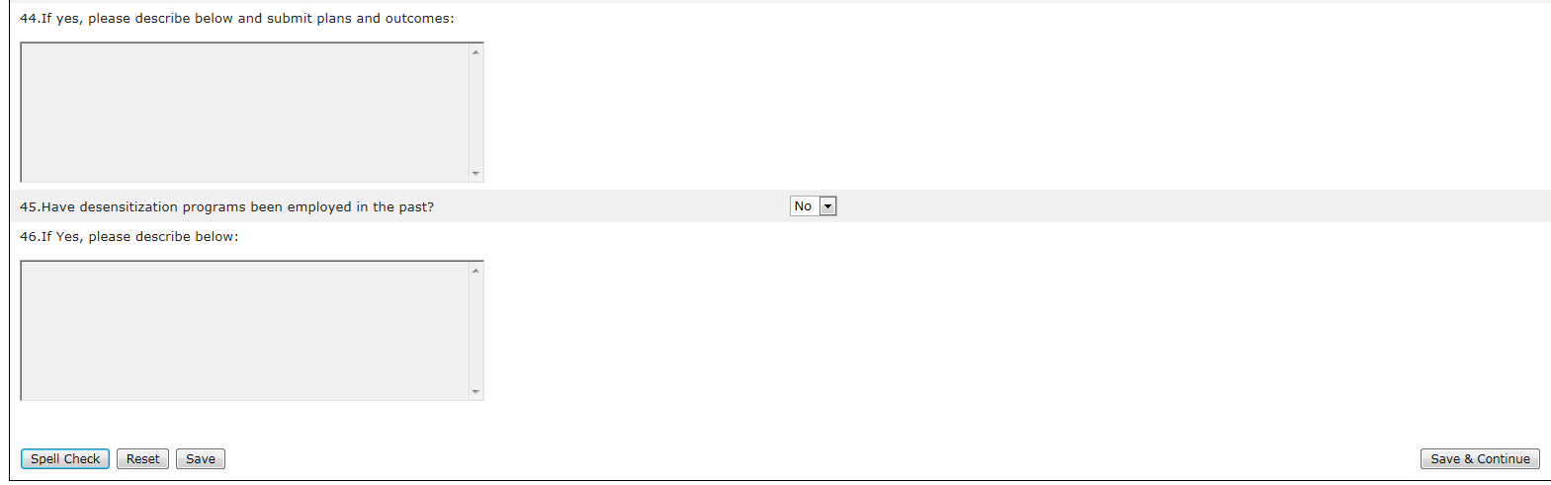

Note: All assessments, irrespective of Full or Update Year ISP, have conditionally mandatory fields, meaning that a response can only be entered only if the condition is met by the response entered in the prior question.

- Click “Save & Continue” to save progress and move to the final section of the assessment. Once the assessment is complete, click on “Submit for Internal Review” in order to submit the assessment to the Provider Supervisor.

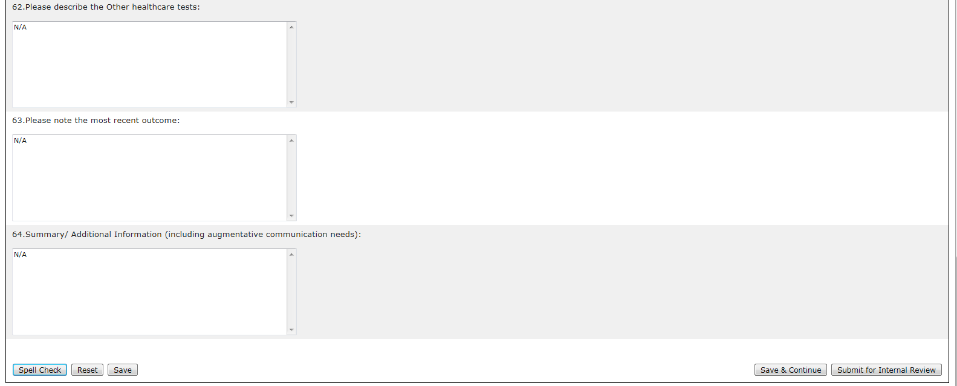

- After clicking “Submit for Internal Review”, the system will update the Assessments Review Switchboard with the information saved by the user and the status of the assessment will read “Submitted for Internal Review”.

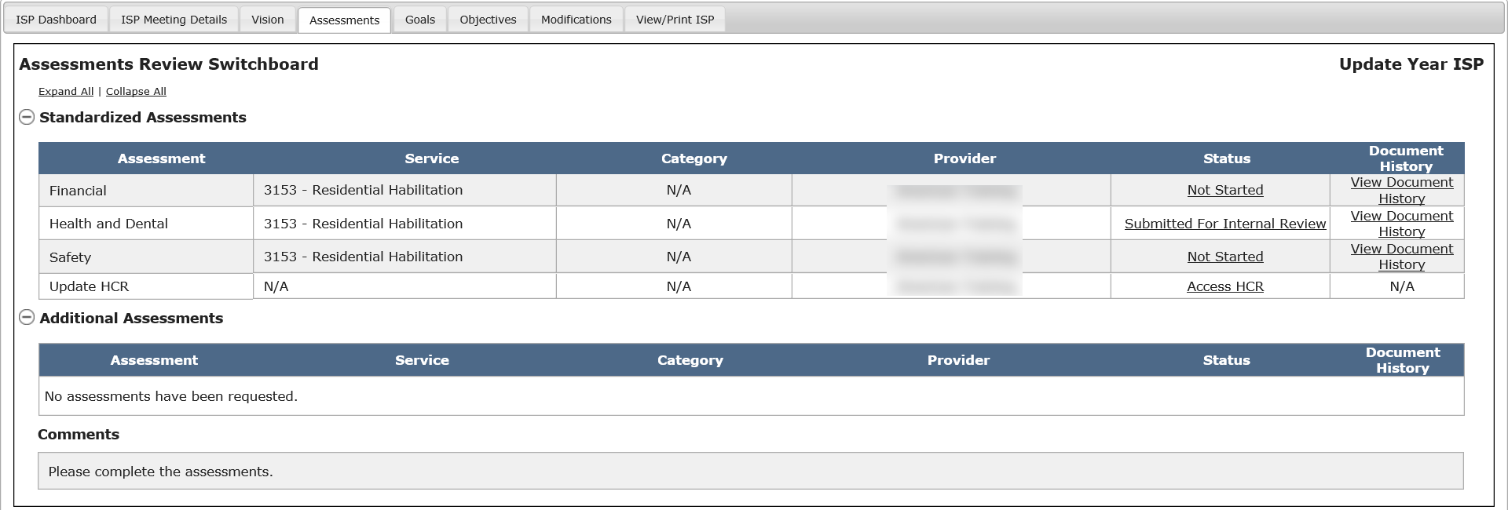

The ISP Assessments Module will send an alert to the Provider Supervisor to notify them that a Health & Dental assessment has been submitted by the Provider.

Part II: Reviewing a Health and Dental Assessment and Submitting to DDS

The below steps are completed by a Provider Supervisor.

- Click on the link within the alert in order to access the individual’s Assessments Review Switchboard and review the assessment submitted by the Provider.

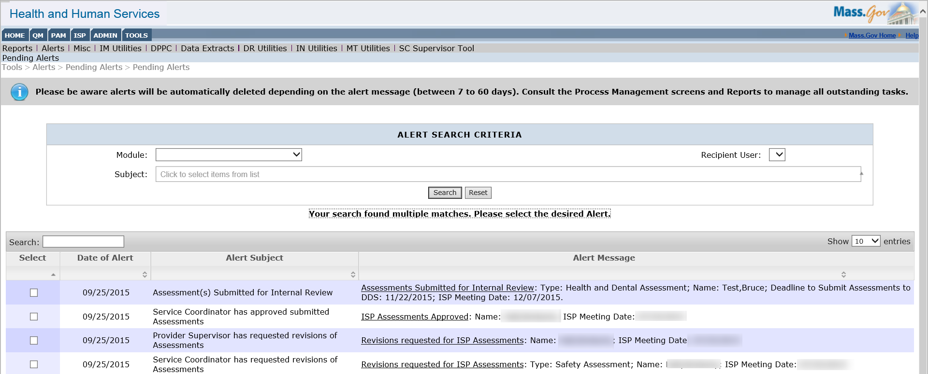

- To open the assessment, click the status of “Submitted for Internal Review.”

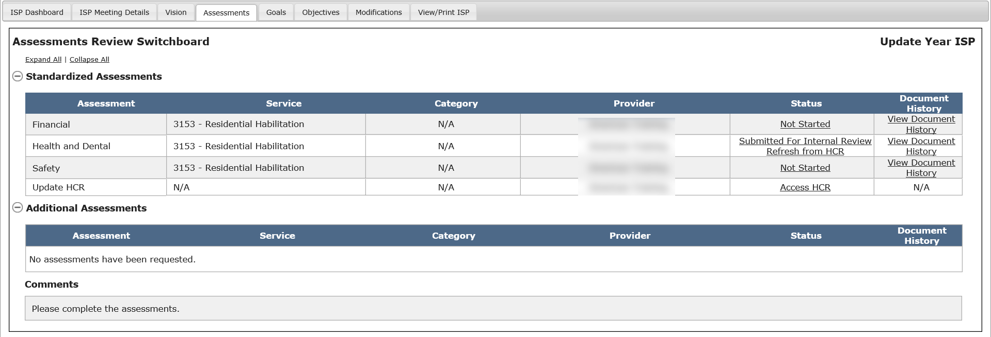

Providers and Provider Supervisors will also be able to refresh the HCR data in the Health and Dental assessment if the HCR has been re-finalized after the assessment has already been started by clicking “Refresh from HCR.” If a HCR is re-finalized, but the “Refresh from HCR” button is not clicked, the information will not be updated on the Health and Dental assessment.

“Refresh from HCR” is a separate link directly below the assessment status. Clicking on it will refresh all Health and Dental Assessments available for the individual. For additional details on Health Care Record and information pulled into Health & Dental Assessments, please refer to following guides on the Reference Page – HCR Instructions, HCR Quick guide and Refresh HCR Data in Health & Dental Assessments.

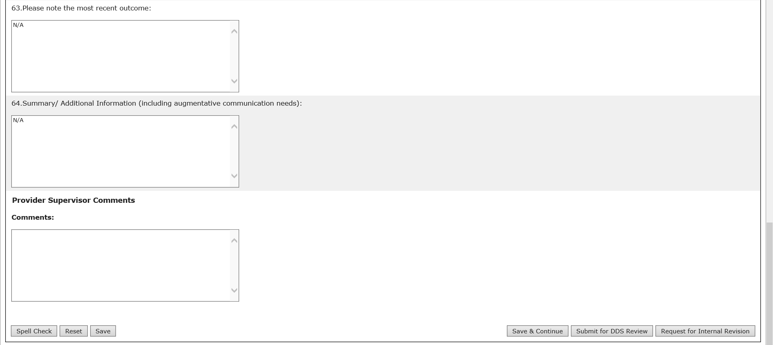

Note: Other buttons are available on this screen. They are as follows:
- “Request for Internal Revision”: The system will initiate the revision process. For details on this process, see the “Completing an Assessment by Provider Staff” workflow.
- “Save & Continue”: The system will redirect the user to the ISP Dashboard.
- “Reset”: The system will revert back to what was last saved. In the event that there are no saved data, “Reset” will clear the form.
- “Spell Check”: A proofreading tool that can be used prior to saving or sharing.

Note: The character limit on the last three comments fields on Part III (#62, 63 and 64) of the Health & Dental Assessment has been increased to 4,000 characters.

After clicking “Submit for DDS Review”, the system will update the Assessments Review Switchboard with the information saved by the user and the status of the assessment will read “Submitted for DDS Review.”

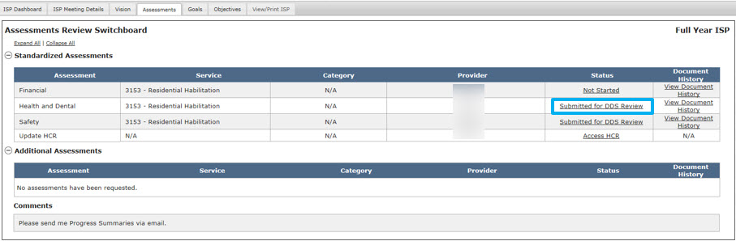

Note: If the Health and Dental Assessments requires additional attachments, these must be submitted to the Service Coordinator outside of HCSIS.

Note: Service Coordinators will receive a twice-weekly alert on Tuesday and Friday of any assessments that have been submitted; Providers, on the other hand, will receive an alert once all assessments have been approved by the Service Coordinator.

Next Steps

- Service Coordinators will receive an alert every Tuesday and Friday of any submitted assessments from each Provider Agency.
- Service Coordinators will be responsible for reviewing the assessments, as covered in the next two sections.
- Providers and Provider Supervisors should continue completing any requested assessments.
- Providers and Provider Supervisors can monitor the individual’s ISP Dashboard, the Assessments Review Switchboard or use the Review Process Management screen to view the progress of any revisions.

Reviewing and Approving an Assessment by DDS Staff
These steps must be completed by a Service Coordinator or a Service Coordinator Supervisor. Assessments must be revised, if needed, and approved prior to the ISP meeting. Service Coordinators and Service Coordinator Supervisors can review and approve an assessment in the module once the following conditions have been met:

- The individual is receiving one or more services that require an assessment to be completed.
- A Vision Statement has been created and shared for the individual.
- The Service Coordinator or Service Coordinator Supervisor has requested the assessment.
- The Provider Supervisor has submitted the assessment and the assessment is in one of the following statuses: “Submitted for DDS Review” or “DDS Review Started”.

Note: Service Coordinators do not have to re-approve documents after the meeting. The documents will continue to be in approved status and the Service Coordinator can request revision at any time (pre or post ISP Meeting).

Scenario Description:
This scenario describes the steps required to review and approve an assessment by DDS Staff.

First Steps:
- Search for an individual
- View the Individual Dashboard

Roles and Responsibilities

- Service Coordinator: Reviews and approves the assessment. Requesting revisions to the assessment will be covered in the next scenario.
- Service Coordinator Supervisor: Reviews and approves the assessment.

- Select “Review Assessments” from the individual’s ISP Dashboard or click on the “Review Assessments” tab.

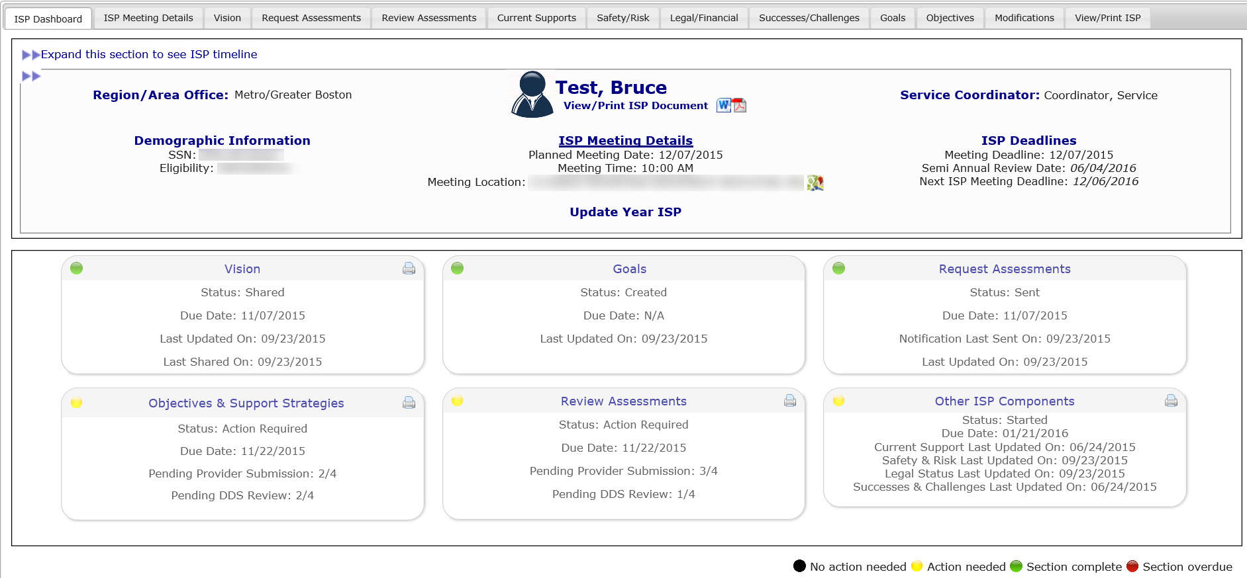

- Click on the assessment status of “Submitted for DDS Review” to review the assessment.

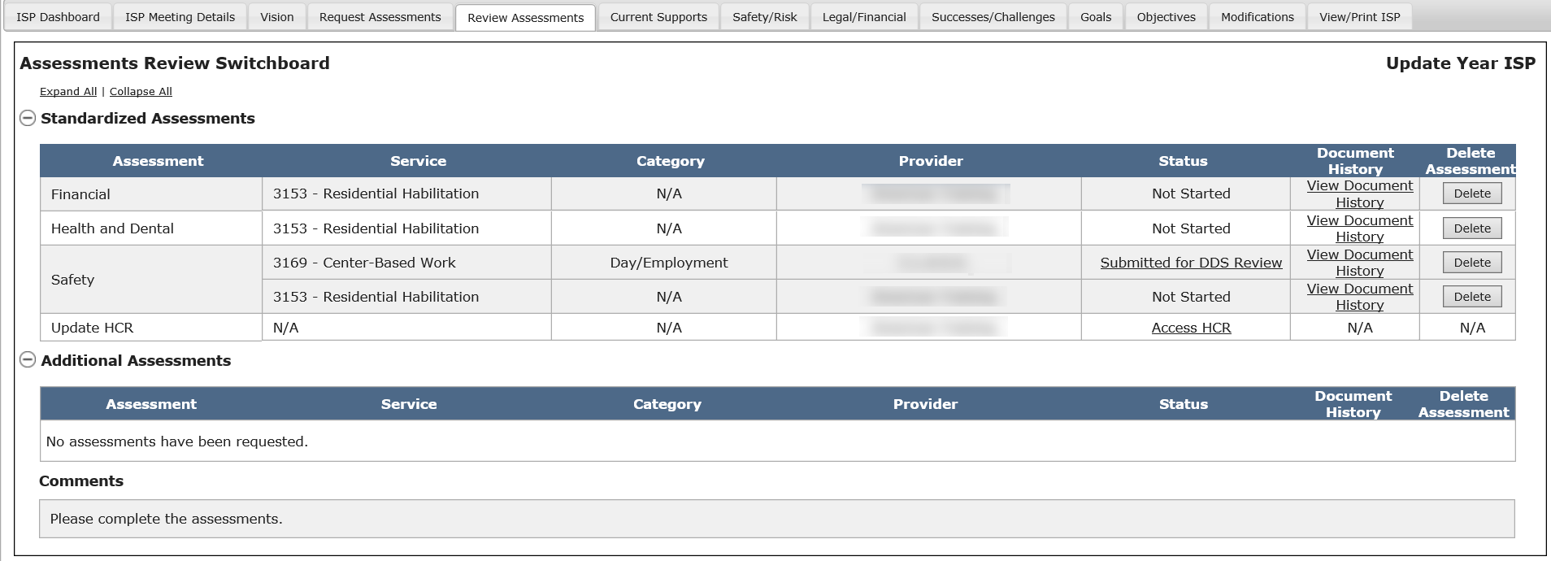

- Review the assessment content, which will be in read-only mode, to determine whether or not revisions need to be made. The assessment acceptance criteria can be found at the bottom of the page for reference when reviewing the assessment.
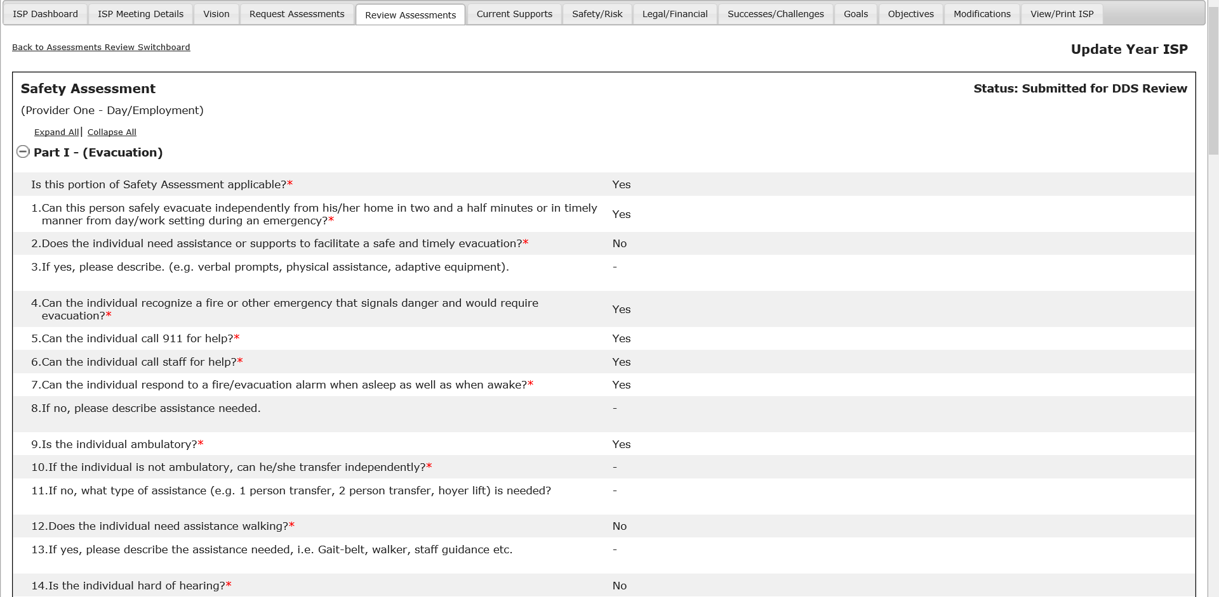

Note: For standard assessments, each part of the assessment can be expanded or collapsed by clicking on the + or – sign next to the heading for that part.

- To approve the assessment, click the “All Assessment Criteria Met” checkbox.

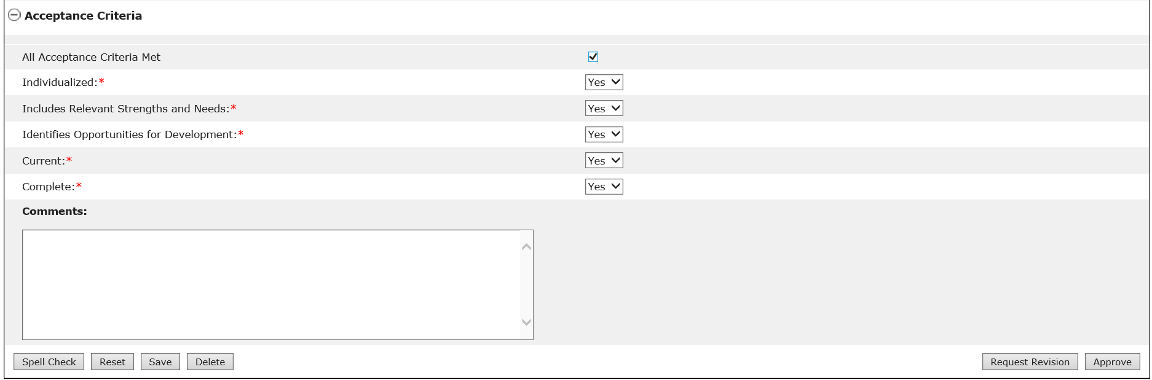

Note: Clicking “All Assessment Criteria Met” will populate the drop-down menus below with “Yes.”

- Click “Approve”.

Note: Once all assessments for any given Provider Agency are approved, will send an alert to that Provider Agency.

Note: Other buttons are available on this screen. They are as follows:
- “Request Revision”: The system will send an alert to the Provider indicating that revision is requested. See the “Reviewing and Requesting Revision of an Assessment by DDS Staff” section.
- “Save”: The system will save the changes made to the assessment form.
- “Reset”: The system will revert back to what was last saved. In the event that there are no saved data, “Reset” will clear the form.
- “Spell Check”: A proofreading tool that can be used prior to saving or sharing.

- After clicking “Approve,” the system will update the Assessments Review Switchboard with the information saved by the user and the status of the assessment will read “Approved.”

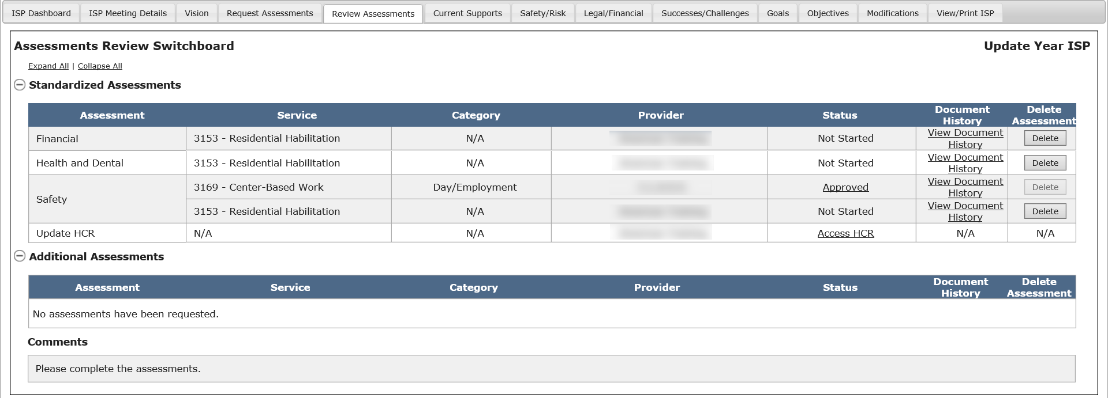

Note: Service Coordinators are not required to re-approve documents after the meeting. The documents will continue to be in approved status and the Service Coordinator can request revision at any time (pre or post ISP Meeting).

Next Steps

- Service Coordinators or Service Coordinator Supervisors can request revisions to assessments in all statuses they have access to, including “Approved”. Revisions can be requested before and after the ISP meeting has been held.
- Providers will receive an alert when all submitted assessments have been approved.
- Service Coordinators should follow the approval process for all assessments that meet the Acceptance Criteria.
- Service Coordinators should follow the Revision Request process for all assessments that do not meet the acceptance criteria.
- Service Coordinators or Service Coordinator Supervisors can request revision to a previously approved Assessment at any point in time as long as the plan remains unlocked

Reviewing and Requesting Revision of an Assessment by DDS Staff
These steps must be completed by DDS staff – a Service Coordinator or a Service Coordinator Supervisor. Service Coordinators and Service Coordinator Supervisors can review and request revisions to an assessment in the module once the following conditions have been met:

- The individual is receiving one or more services that require an assessment to be completed.
- A Vision Statement has been created and shared for the individual.
- The assessment is in one of the following statuses: “Submitted for DDS Review”, “DDS Review Started” or “Approved”.
- Service Coordinator selects “Review Assessments” from the individual’s ISP Dashboard.

Scenario Description:
This scenario describes the steps required to review and request revision of an assessment by DDS Staff.

First Steps:
- Search for an individual
- View the Individual Dashboard

Roles and Responsibilities

- Service Coordinator: Reviews the assessment and requests revisions according to the acceptance criteria.
- Service Coordinator Supervisor: Reviews the assessment and requests revisions based to the acceptance criteria.

- Select “Review Assessments” from the individual’s ISP Dashboard or click on the “Review Assessments” tab.

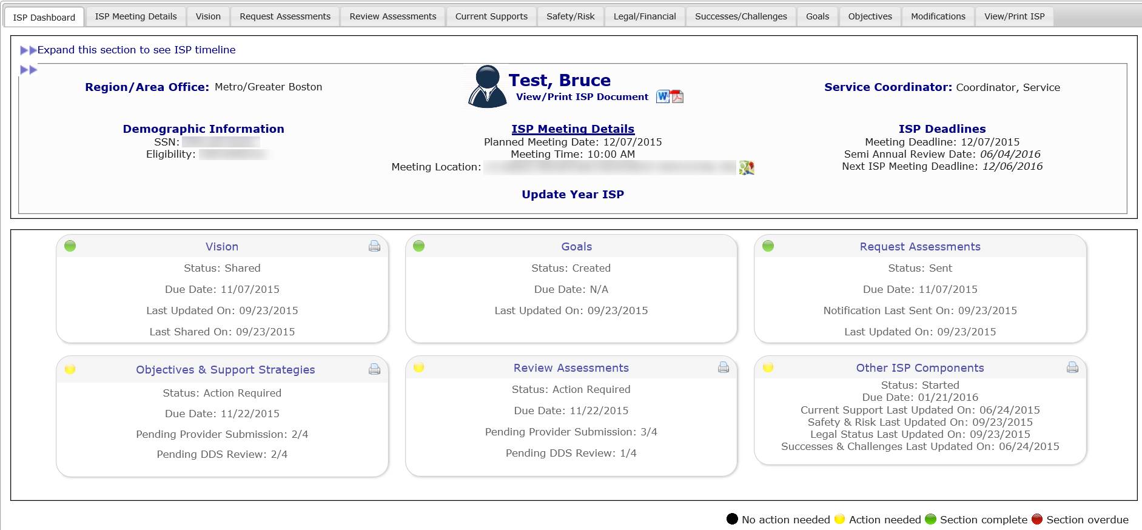

- Click on the assessment status of “Submitted for DDS Review” on the Assessments Review Switchboard to review the assessment.

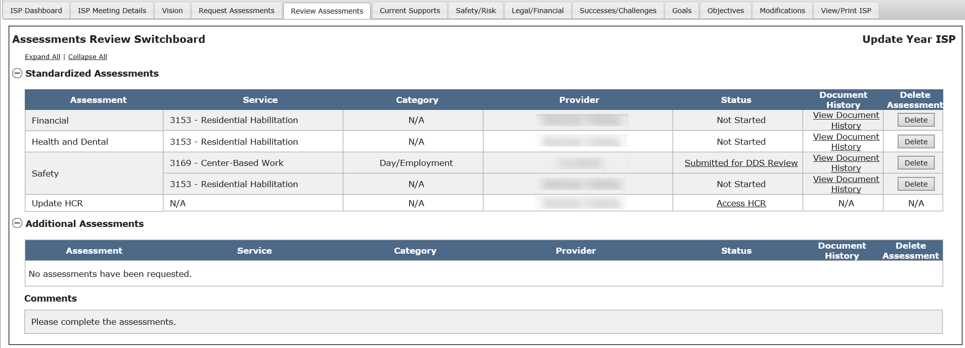

- Review the assessment content, which will be in read-only mode, to determine whether or not revisions need to be made. The assessment acceptance criteria is available at the bottom of the page for reference when reviewing the assessment.

Note: For standard assessments, each part of the assessment can be expanded or collapsed by clicking on the + or – sign next to the heading for that part.

- Service Coordinator selects “Yes” and/or “No” for the acceptance criteria. In order to return an assessment for revision, at least one acceptance criteria must not be met and reflect at status of “No”.

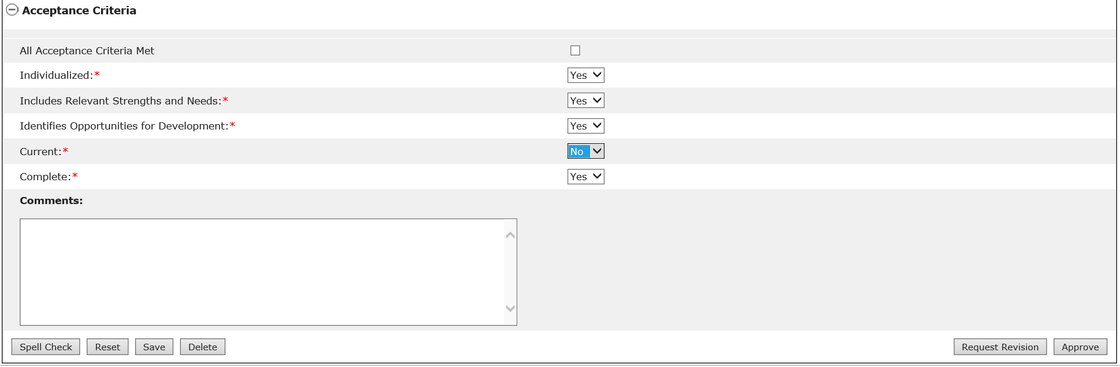

Note: If you are requesting a revision to a previously approved assessment, the Acceptance Criteria will be pre-populated to “Yes” when the user accesses the assessment. In any other case, the steps for requesting the revision and for revising the assessment are the same.

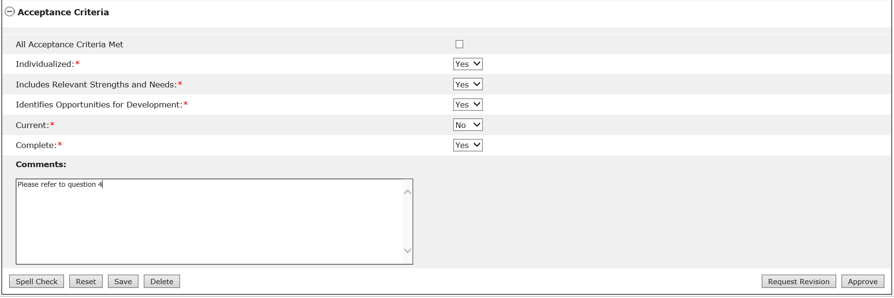

Note: The assessment prompts are numbered in the system so the Service Coordinator can easily make a reference to an answer that needs to be revised by the Provider.

Note: If you are requesting revision to a previously approved assessment, the “Approve” button will be disabled.

- Click “Request Revision” to notify the Provider Agency that revisions have been requested.

Note: Other buttons are available on this screen. They are as follows:
- “Approve”: The system will approve the assessment. See the “Reviewing and Approving an Assessment by DDS Staff” section.
- “Save”: The system will save the changes made to the assessment form.
- “Reset”: The system will revert back to what was last saved. In the event that there are no saved data, “Reset” will clear the form.
- “Spell Check”: A proofreading tool that can be used prior to saving or sharing.

- After clicking “Request Revision”, the system will update the Assessments Review Switchboard with the information saved by the user and the status of the assessment will read “Revision Requested”.

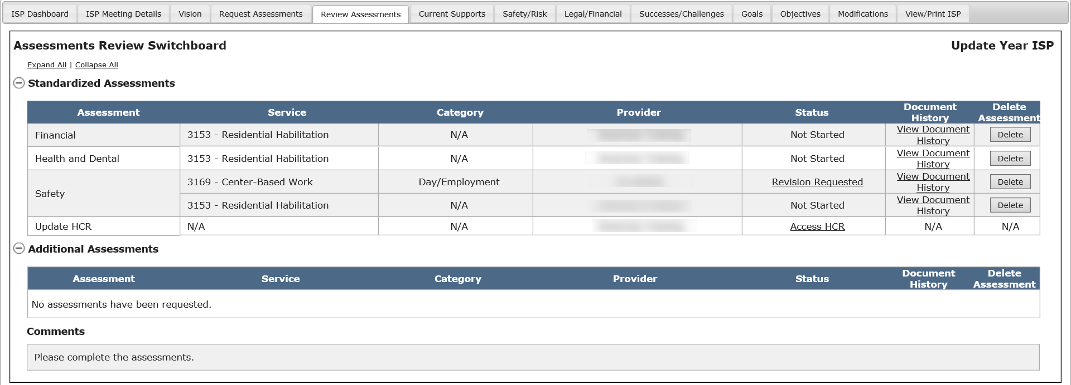

Note: The status for the assessment will read “Revision Requested” for both the Service Coordinator and Provider in the Assessments Review Switchboard.

Next Steps

- Service Coordinators or Service Coordinator Supervisors can continue reviewing other assessments.
- Providers will receive an alert to revise the assessments.
- Service Coordinators should follow the revision request process for any assessments that do not meet the Acceptance Review Criteria.

Reviewing and Revising an Assessment by Provider Staff
These steps must be completed by Providers. The Provider and Provider Supervisor can make revisions to the assessment once the following criteria are met:

- The individual is receiving one or more services that require an assessment to be completed
- A Vision Statement has been created for the individual
- The Service Coordinator or Service Coordinator Supervisor have requested the assessment
- The Provider and/or Provider Supervisor have submitted the assessment
- The Service Coordinator has requested revisions to the assessment

Scenario Description:
This scenario describes the steps required to review and revise an assessment by Provider Staff.

First Steps:
- Search for an individual
- View the Individual Dashboard

Roles and Responsibilities

- Provider: Reviews the acceptance criteria and updates the assessment accordingly.
- Provider Supervisor: Reviews the acceptance criteria, updates the assessment accordingly and submits the revised assessment.

Part I: Revising an Assessment and Submitting for Internal Review

The below steps are completed by a Data Entry User

- The Provider Data Entry User will receive an alert when revisions have been requested by Service Coordinators. Click on the alert to navigate to the Assessment Review Switchboard.

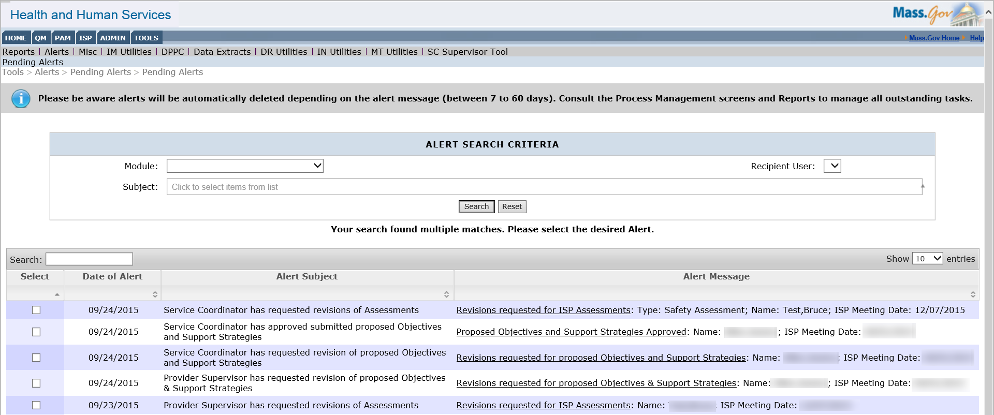

- From the Assessments Review Switchboard, click on the status of “Revision Requested” to review the requested changes and update the assessment.

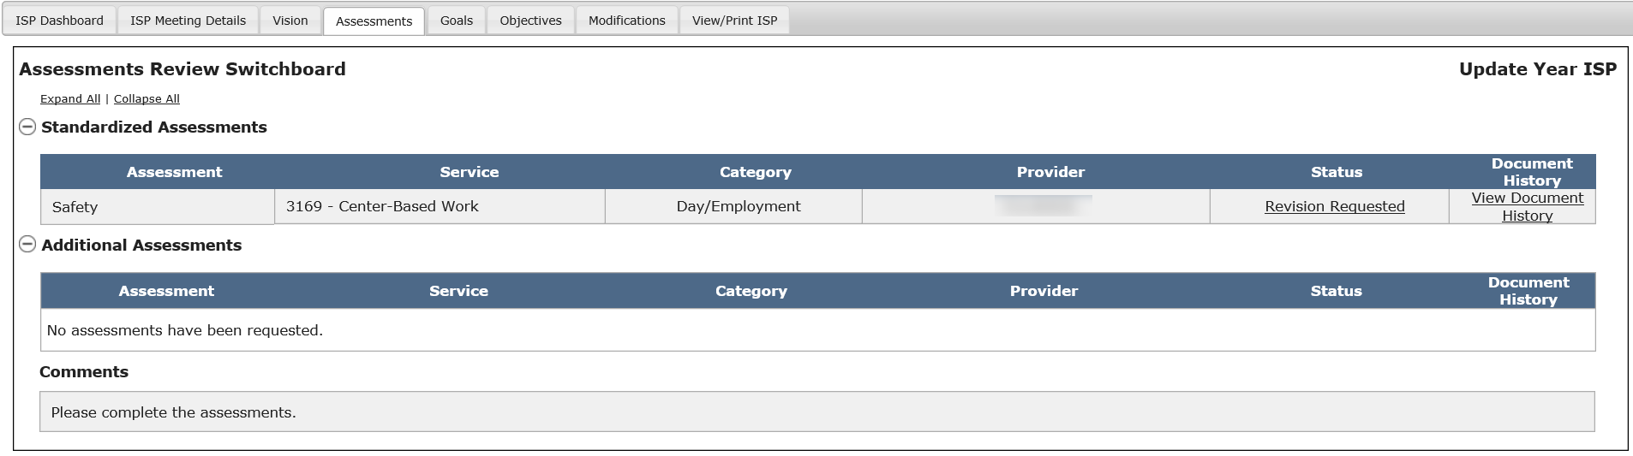

The system will redirect to the acceptance criteria section of the assessment. The Data Entry User should review the comments provided by the Service Coordinator prior to updating the assessment.

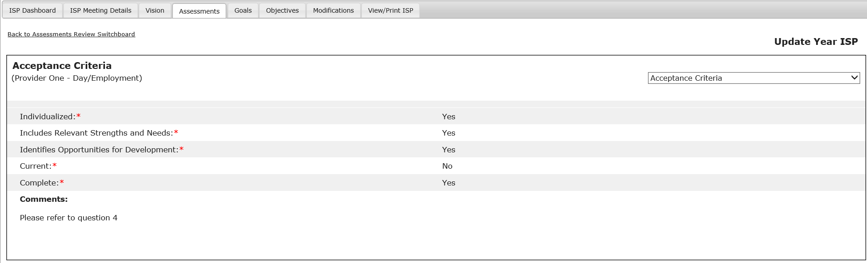

- Provider can review the comments provided by the Service Coordinator and update the assessment to address the comments by navigating to the appropriate section(s) of the assessment.

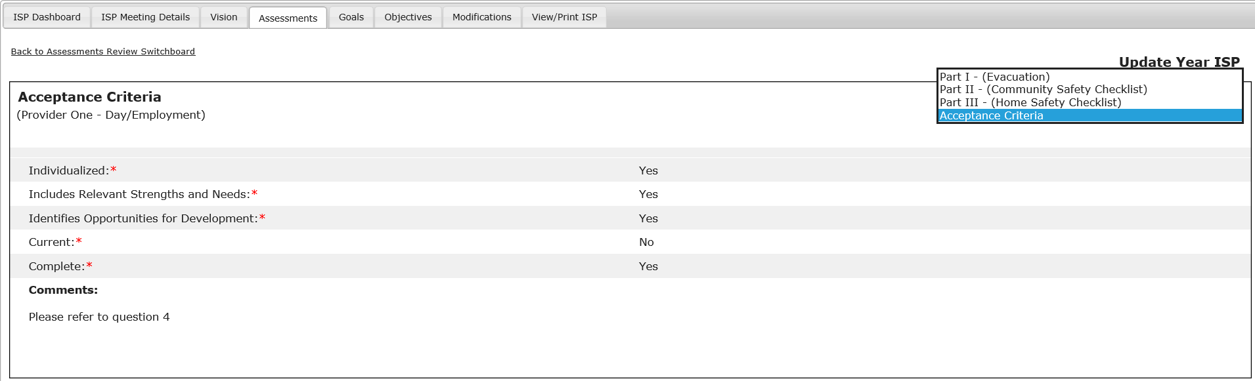

- Make any necessary revisions.

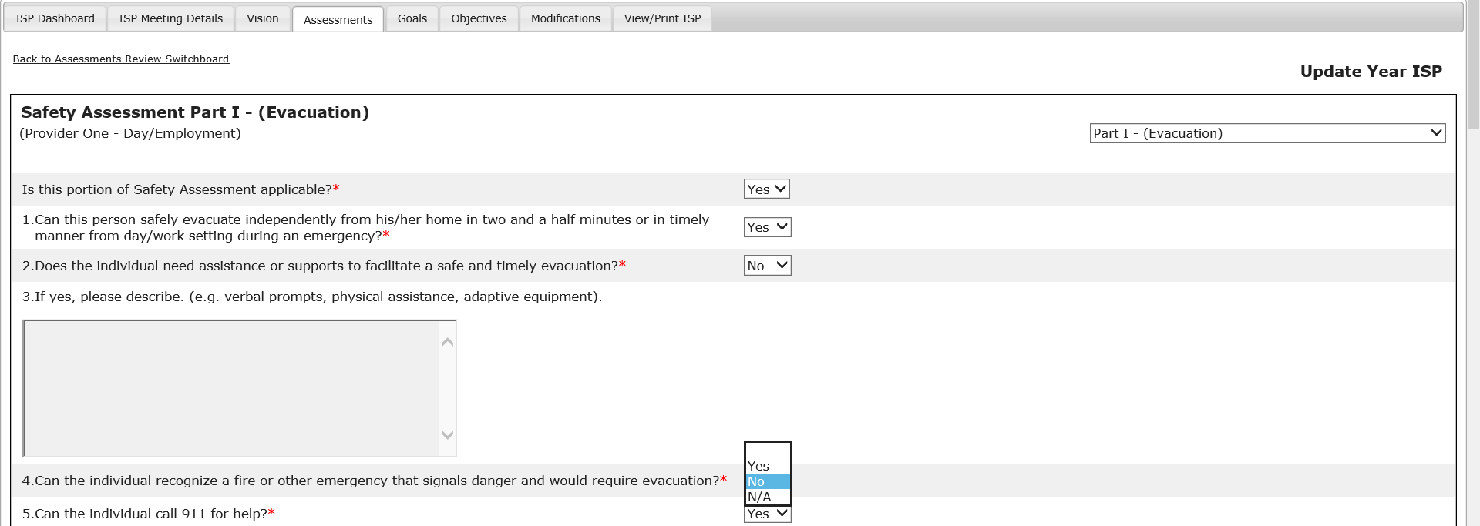

- Navigate to Part III and click “Submit for Internal Review”

Note: Once the assessment has been submitted, the status of the assessment will change to “Submitted for Internal Review” and the Provider Supervisor will receive an alert notifying them what type of assessment has been submitted for their review.

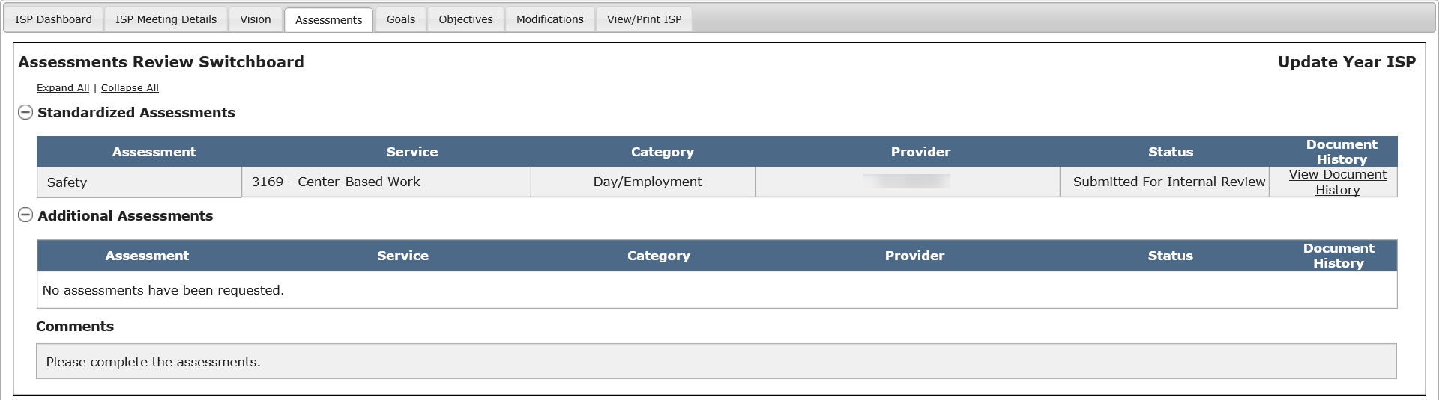

Part II: Reviewing an Assessment Submitted for Internal Review and Submitting to DDS

The below steps are completed by a Provider Supervisor.

- Click on the link within the alert in order to access the individual’s Assessments Review Switchboard and review the assessment submitted by the Provider.

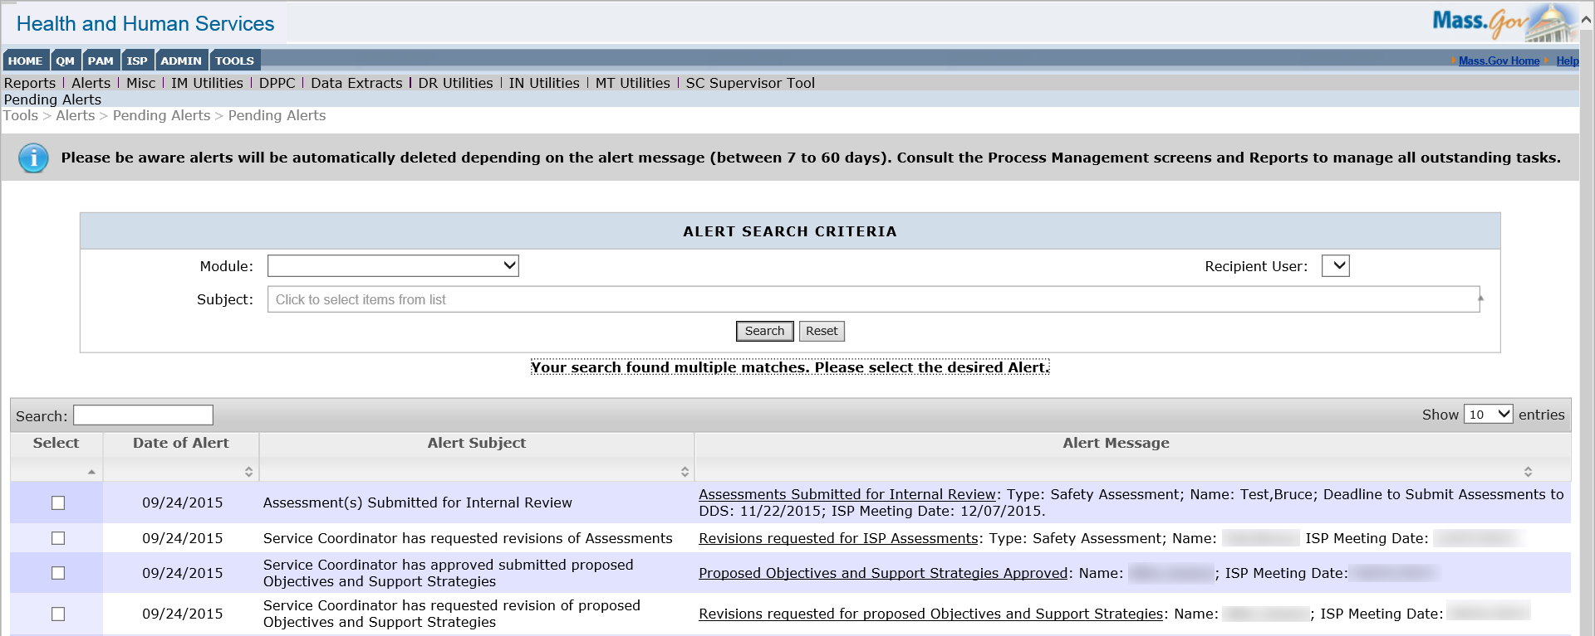

- To open the assessment, click the status of “Submitted for Internal Review.”

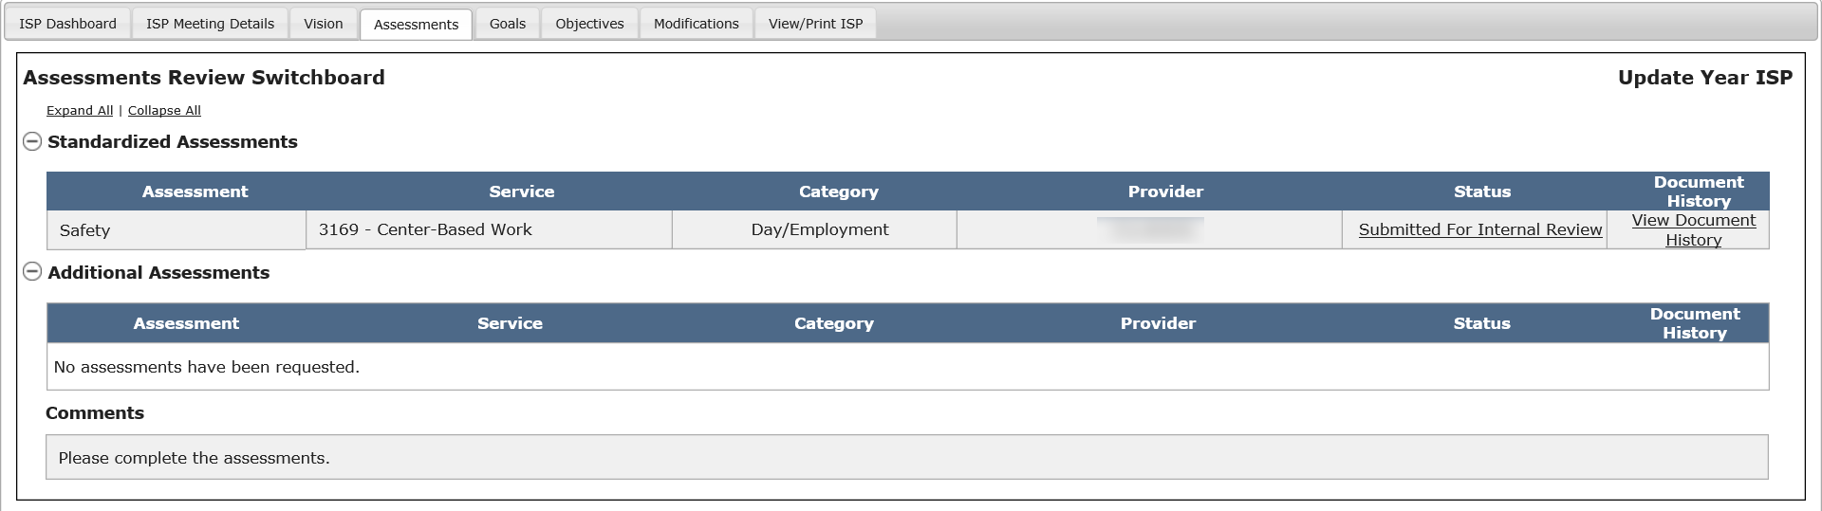

Clicking “Submitted for Internal Review” will bring the Provider Supervisor to Page 1. The Provider Supervisor can then review the assessment and make changes if necessary.

- Click “Submit for DDS Review” to submit the revised assessment to the Service Coordinators.

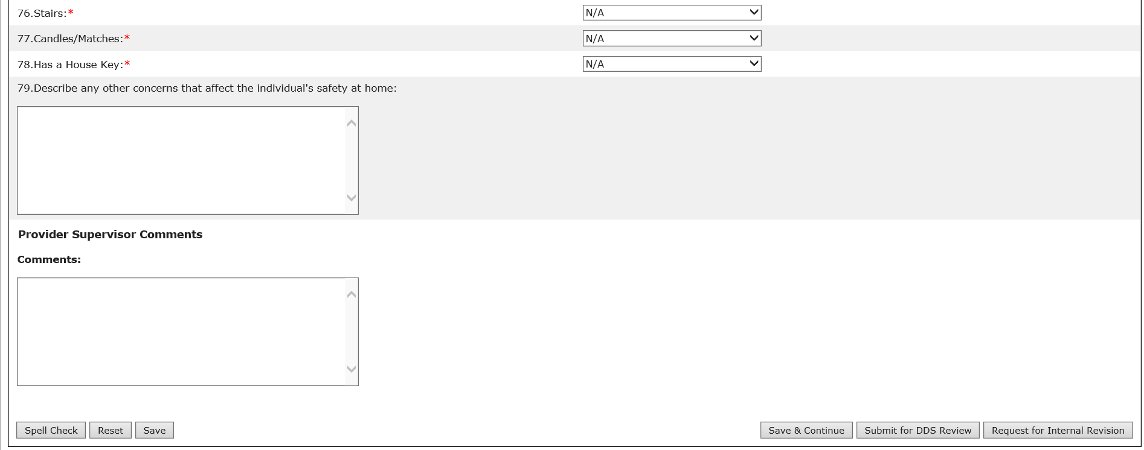

Note: Other buttons are available on this screen. They are as follows:
- “Approve”: The system will approve the assessment. See the “Reviewing and Approving an Assessment by DDS Staff” section.
- “Save”: The system will save the changes made to the assessment form.
- “Reset”: The system will revert back to what was last saved. In the event that there are no saved data, “Reset” will clear the form.
- “Spell Check”: A proofreading tool that can be used prior to saving or sharing.

- After clicking “Submit for DDS Review”, the system will update the Assessments Review Switchboard with the information saved by the user and the status of the assessment will read “Submitted for DDS Review.”

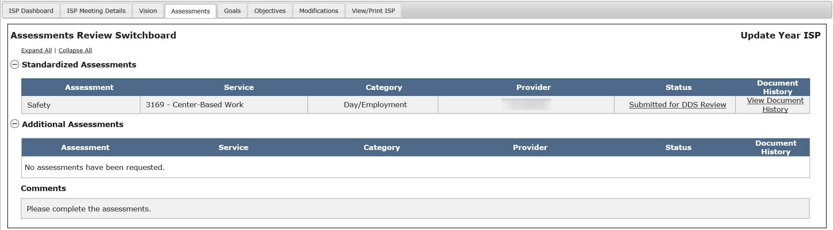

Next Steps

- Service Coordinators will receive an alert every Tuesday and Friday that will include a list of any assessments submitted by Provider agencies. If no assessments have been submitted, the Service Coordinator will not receive this alert.
- Service Coordinators and Service Coordinator Supervisors repeats this process if additional revisions are required. If not, the approval process of an assessment can be followed.
- Providers will receive an alert when all submitted assessments have been approved by DDS.

Deleting an Assessment by DDS Staff
DDS staff are able to delete an assessment if the following conditions have been met:
- The individual is receiving one or more services that require an assessment to be completed
- A Vision Statement has been created for the individual and shared with Providers
- The Service Coordinator or Service Coordinator Supervisor has requested the assessment
- The assessment is in one of the following statuses: “Not Started”, “Submitted for DDS Review”, “DDS Review Started”, and “Revision Requested”
- The assessment is not a mandatory assessment

Note: The Service Coordinator will not be able to delete an assessment in status “Approved”. The Service Coordinator will have to reach out to their Supervisor or Area Office Director to have the assessment deleted.

Note: Assessments can be deleted by Service Coordinators if they are in any of the following statuses: “Not started”, “Submitted for DDS Review,” “DDS Review Started” or “Revision Requested.”

Scenario Description:
This scenario describes the steps required to delete an Assessment by DDS Staff.

First Steps:
- Search for an individual
- View the Individual Dashboard

Roles and Responsibilities

- Service Coordinator: Notifies the Provider outside of HCSIS prior to deleting an assessment, then selects and deletes the assessment (excluding approved or required assessments).
- Service Coordinator Supervisor: Notifies the Provider outside of HCSIS prior to deleting an assessment, then selects and deletes the assessment (including approved assessments).

- Service Coordinator selects “Review Assessments” from the individual’s ISP Dashboard or on the “Review Assessments” tab.

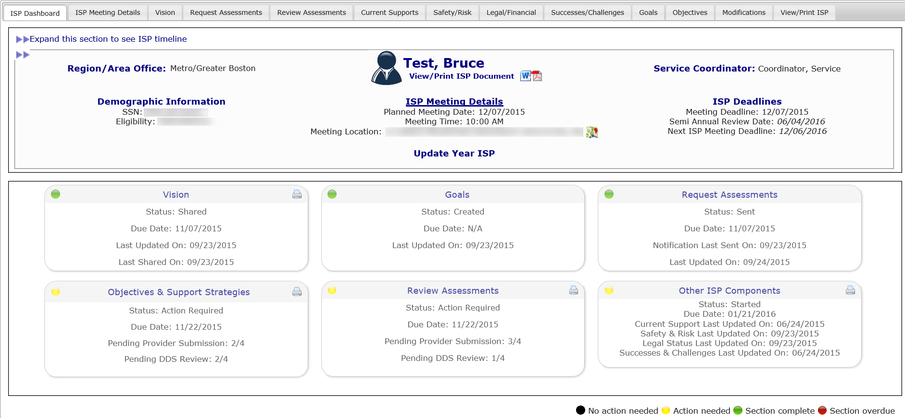

- Click on the “Delete” button for the assessment that needs to be deleted from the HCSIS system.

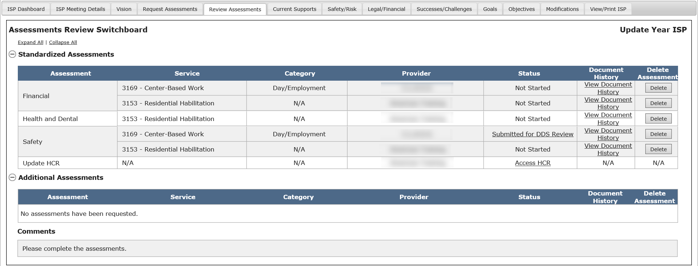

Service Coordinators can delete assessments in “Not Started”, “Submitted for DDS Review”, “DDS Review Started” and “Revision Requested” statuses. Service Coordinator Supervisor and Area Office Director Data Entry Role can delete assessments in all statues the Service Coordinator can delete as well as “Approved” status.

Note: Required assessments cannot be deleted from HCSIS. If an assessment for a bundled service is deleted, the assessment for all the bundled services is deleted.

Note: The Service Coordinator needs to notify the Provider offline before deleting an assessment.

- Select “Yes” from the confirmation pop-up that is displayed upon clicking “Delete”.

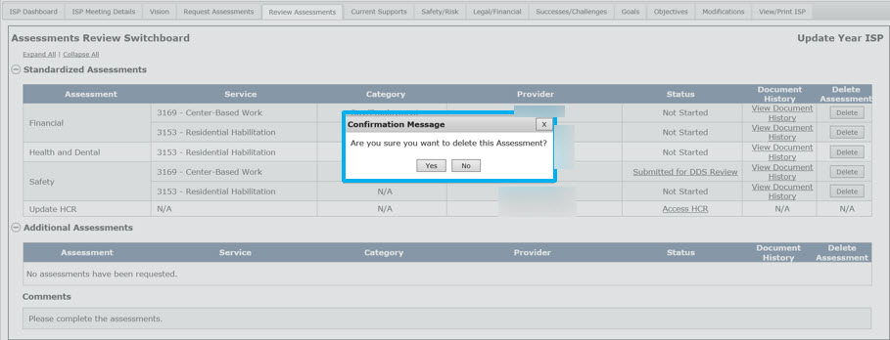

Note: The assessment will be permanently deleted from the system.

- After clicking “Yes”, the system will delete the assessment and update the Assessments Review Switchboard. The system will also display a message reading “Operation Successful.”
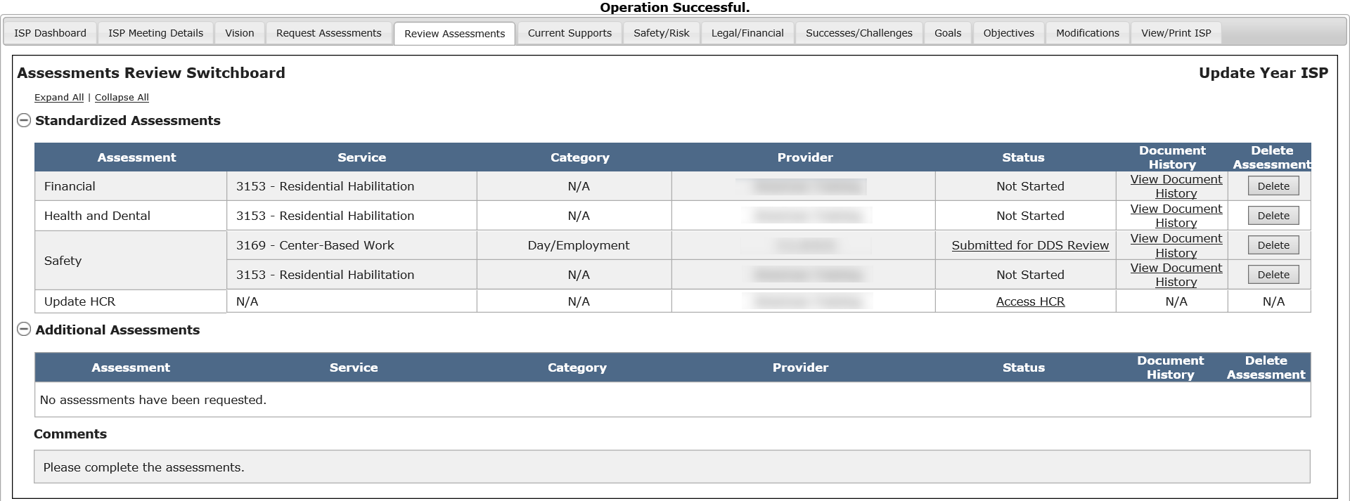

Note: The Assessment can also be deleted by opening the assessment, reviewing the details and clicking on the “Delete” button available at the bottom of the assessment form:

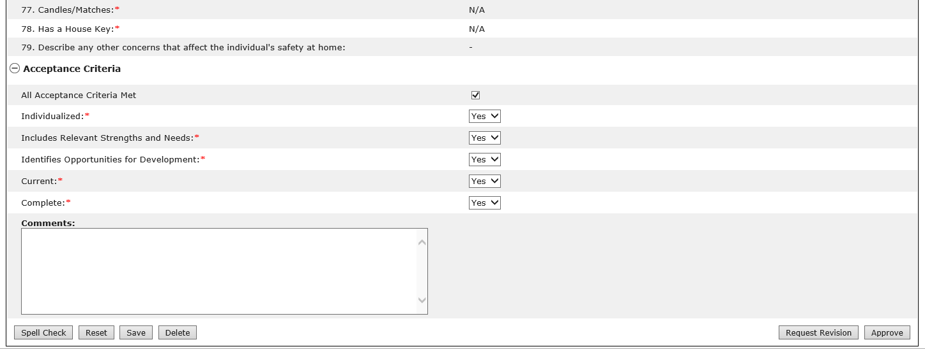

Once the Service Coordinator confirms the deletion of an assessment, the document will be permanently deleted from HCSIS.

Next Steps

- Service Coordinators, Service Coordinator Supervisors, Providers and Provider Supervisors will no longer be able to locate the deleted assessment.
- If the Service Coordinator would like to request an assessment that was previously deleted, they will have to go to the “Request Assessments” page and follow the same steps they would have to take for requesting a new assessment.

