Commonwealth of Massachusetts
Executive Office of Health and Human Services

Virtual Gateway

ISP Assessments Module
User Guide
Lesson 5: Other ISP Components and Post-ISP Meeting Activities
HCSIS Release 7.7

Contents
Other ISP Components 2
Completing Other ISP Components by DDS Staff in a Full Year 3
Updating Other ISP Components by DDS Staff in an Update Year 21
Post ISP Meeting Activities 31
Post ISP Meeting Activities Overview 33
Selecting Objectives to Include in the ISP Document by DDS Staff in Full or Update Year 34

Other ISP Components
To complete the full ISP Document in HCSIS, Service Coordinators and Service Coordinator Supervisors will be responsible for completing the four additional sections of the ISP document in the module. These include the following:
- Current Supports
- Safety and Risk
- Legal/Benefit/Financial Status
- Successes and Challenges

Clipboard Functionality
The Clipboard functionality is available to reduce the amount of time it takes for Service Coordinators and Service Coordinator Supervisors to complete the Additional ISP Components. The Clipboard, which is available for the Current Supports, Safety and Risk, and Legal/Benefit/Financial Status screens, will pull relevant information from requested assessments that the Service Coordinator can utilize to complete sections of the ISP Components. The content of the Clipboard will change based on the section of the ISP that the Service Coordinator or Service Coordinator Supervisor is working on. The clipboard content will draw from the various sources outlined in the table below. The user will also be able to access select assessments and utilize information from them. The links to assessments listed below will be active only if the assessments are in a status the Service Coordinator has access to.
ISP Component | Source for Clipboard Content | Links to Assessments Available for
Current Supports | Health Care Record and Health & Dental Assessments | Safety, Financial, and Health & Dental Assessments
Safety and Risk | N/A – No information is pulled | Safety Assessments
Financial/ Legal/ Benefit Status | N/A – No information is pulled | Financial Assessments
Successes and Challenges | N/A – No information is pulled | N/A – No links to assessments

Note: The source for clipboard content includes current assessments from the most recent ISP plan. No historical records of assessments are available in the clipboard. This is true for both a Full Year and Update Year.
Note: To prevent a loss of information for Service Coordinators and Service Coordinator Supervisors, Auto Save functionality is available when completing the Other ISP Components sections. Auto Save is implemented Other ISP Components, as well as for Vision, due to the large text boxes and detailed information input into these fields. Auto Save will run after 15 minutes of inactivity. This feature saves documentation automatically to reduce the risk or impact of data loss in the event that the system logs the user out of HCSIS or the computer shuts down. Auto Saved information will be stored temporarily; upon returning to the page the user must click “Save” or “Save and Close” to permanently save the information. In the situation that the user does not want to save the recovered information the user can select “Reset” to delete the information. Auto Save does not apply for any screens other than the Other ISP Components or Vision Statement.

Completing Other ISP Components by DDS Staff in a Full Year
Scenario Description
The Service Coordinator or Service Coordinator Supervisor is responsible for completing the four additional sections within the ISP module in order for the full ISP to be completed in HCSIS. The components can be completed beginning after the ISP Plan Selection is made.

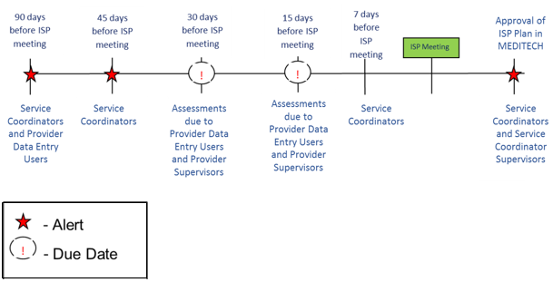
First Steps:
- The user searches for an individual
- The user views the Individual Dashboard

Roles and Responsibilities:
- Service Coordinators: Can create, edit, and save content
- Service Coordinator Supervisors: Can create, edit, and save content
Part I: Completing Current Supports
- Click the “Other ISP Components” from the Individual’s Dashboard or click on the “Current Supports” tab.
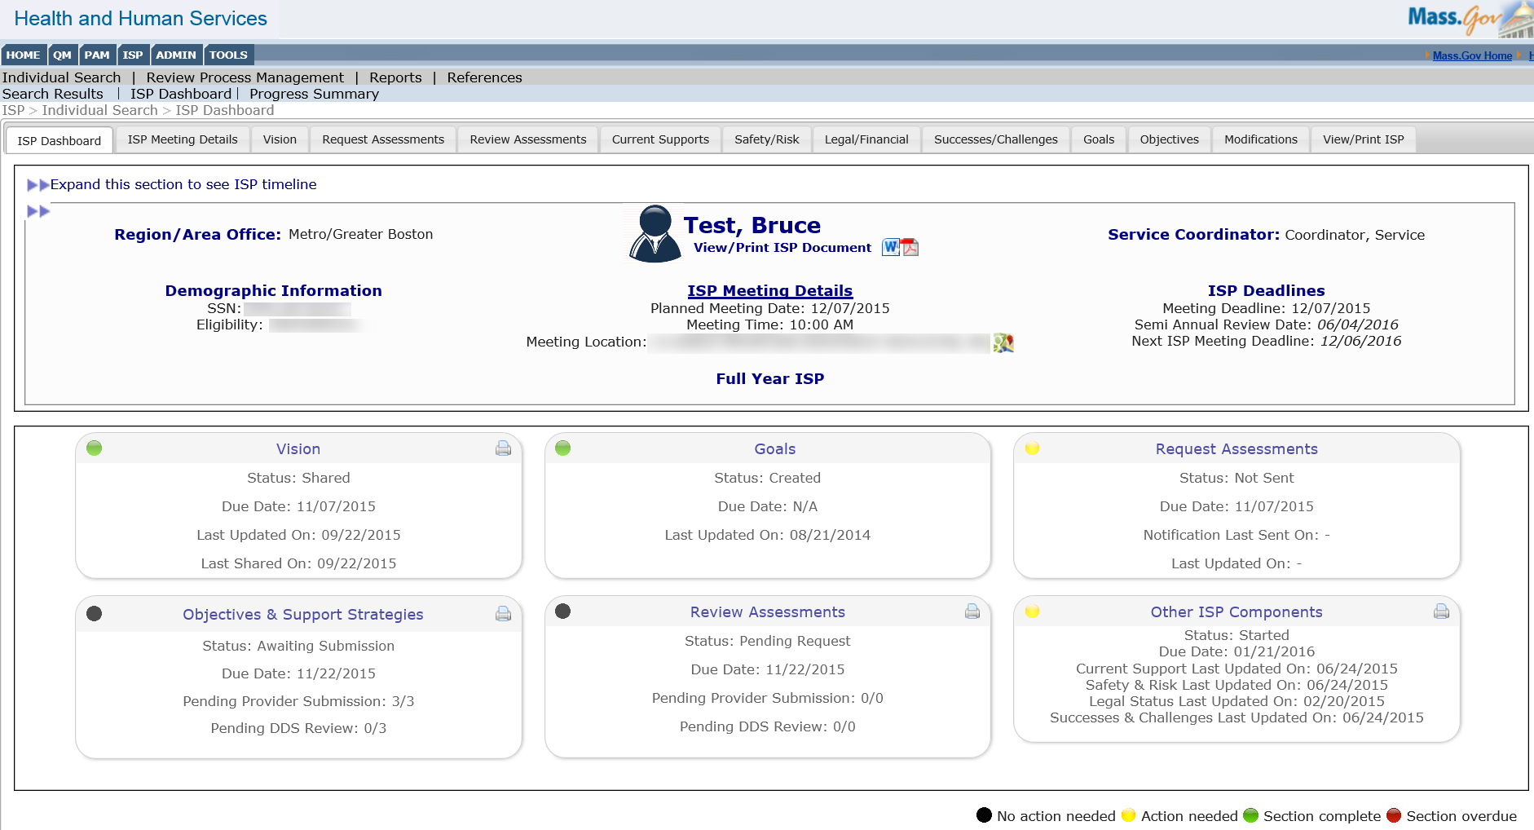
The module redirects the Service Coordinator to the Individual’s “Current Supports” page.
- Expand the clipboard for Current Supports. The clipboard contains links to the Safety, Financial, and Health and Dental Assessments. Click the PDF icon to open the desired Assessment in a pop-up window.
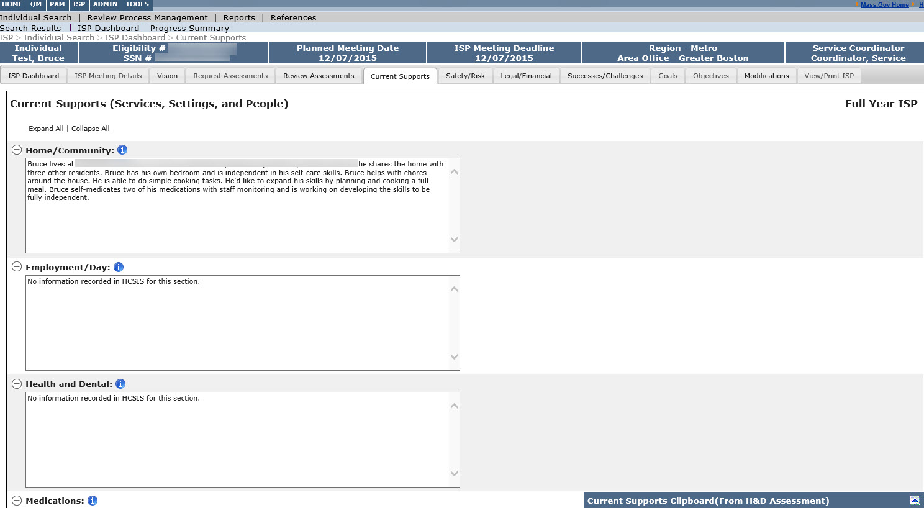

Note: Values from the past ISP are recalled along with any updates entered during the past update year and are displayed in the same text box. The character limit for all text boxes will remain the same, and recalled information will not be truncated. The user has to ensure that information does not exceed the allowed character limit in order to save changes. If there was no information entered in a previous plan to recall, the system will display, “No information recorded in HCSIS for this section” in the applicable text box and it will be editable.
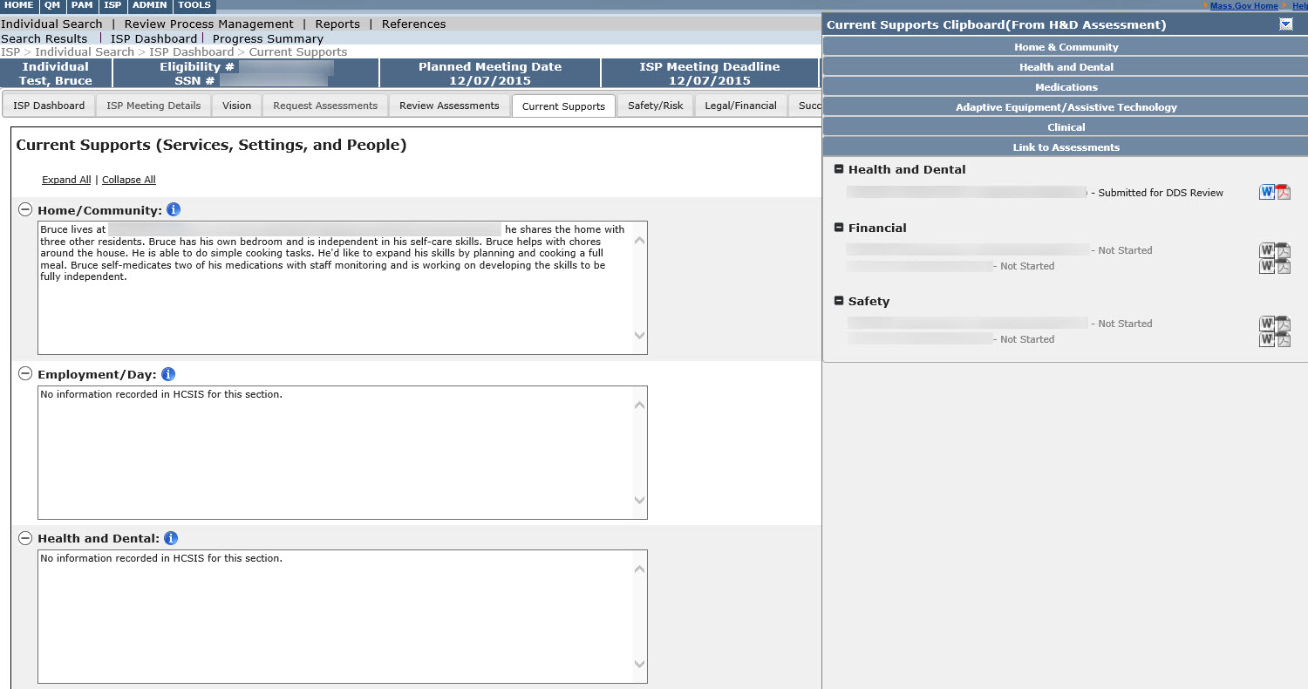
- Click “Open” to view the file.
Note: The popup window may look different depending on your browser.
The assessment is displayed.
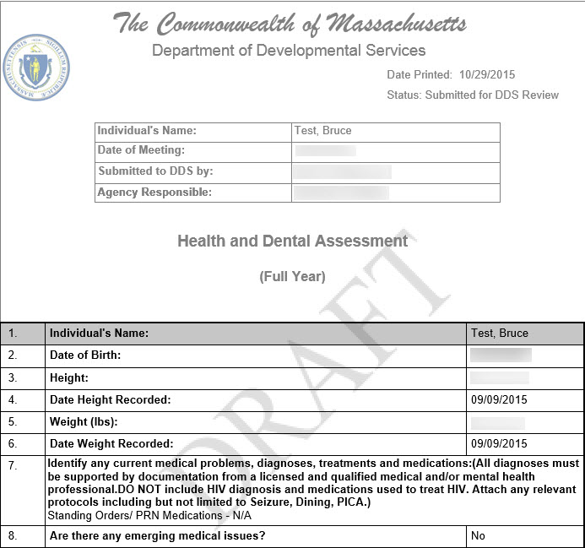
Note: With the Assessment open, you can view, reference, or copy and paste information directly from the Assessment into the fields in HCSIS for Current Supports.
- Complete the Current Supports section by editing recalled information, referencing or copying information from the clipboard or assessments, or adding additional information.
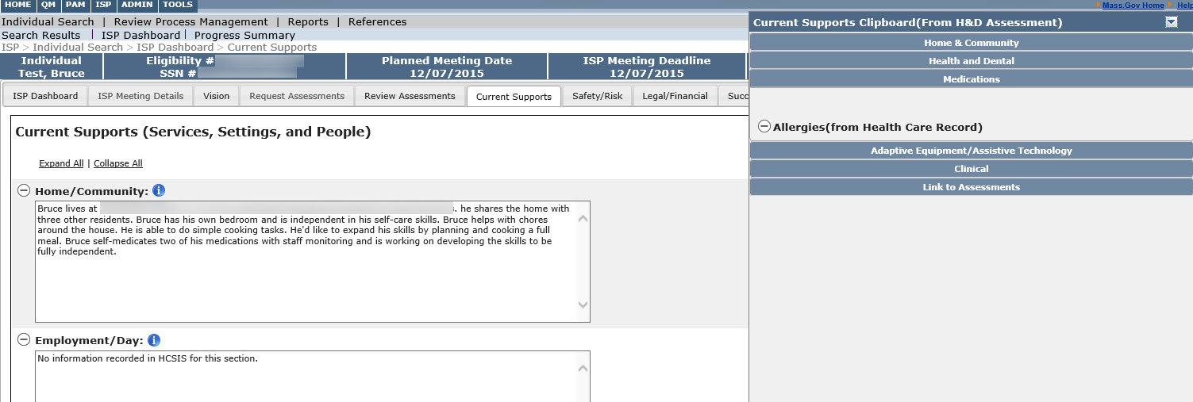
Note: Clipboard tabs are readily available to copy and paste information into the current supports section without going into the assessment. To copy and paste from the clipboard expand the section you would like to pull information from. Highlight the information in that section of the clipboard and paste the information into the relevant text box.
- In the event that the user is inactive and the screen goes idle for 15 minutes, Auto Save will run. Auto save will temporarily save the information while the user is idle.
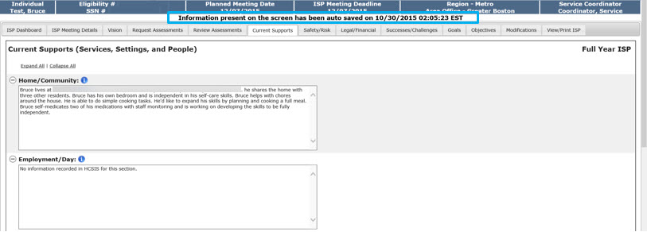

- At a later time, if you return to the Current Supports tab, the screen will load the auto-saved information and a message will display that prompts you to determine which text to retain – the auto-saved information or the previously saved information.
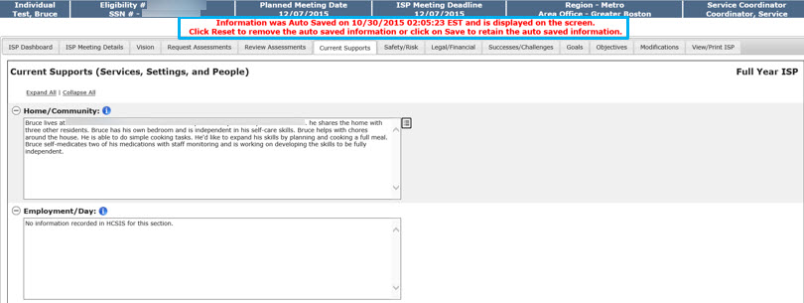
Note: An infotip displays next to the fields in which autosaved information has been loaded. Click the icon to the display and compare the text that was last saved by the Service Coordinator to the autosaved information.
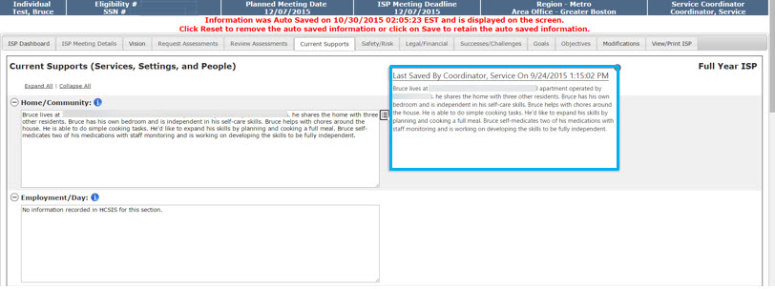
Note: Any information that is entered after auto save has run, in between the 15 minutes before the auto save runs again, will not be recovered. Additionally in the user does not want to save the recovered information click “reset”.
- To remove the auto saved information, click “Reset.” To retain the auto saved information and delete the manually entered information, click “Save”.

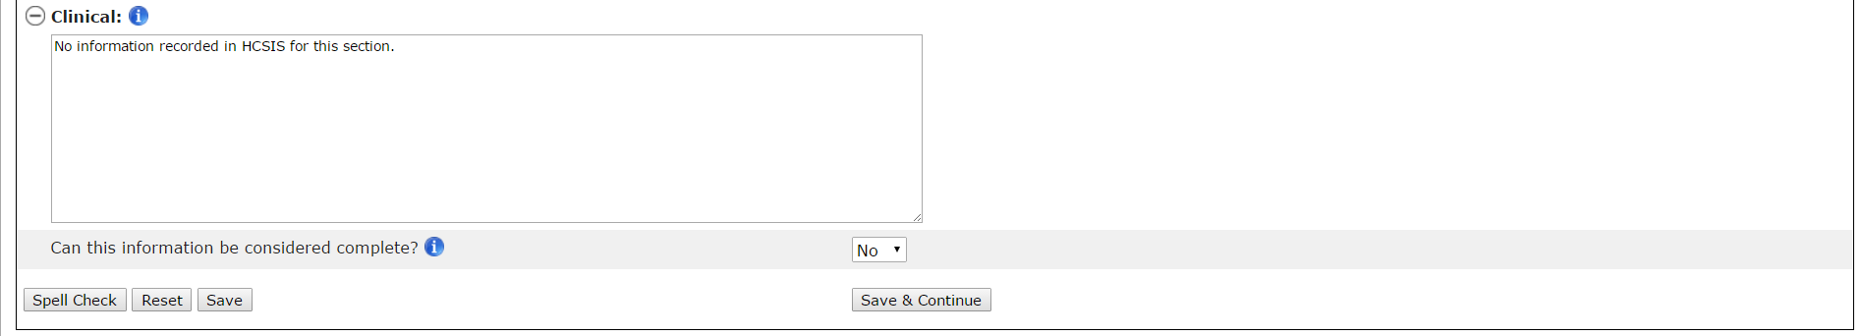
`

- After entering text into the Current Supports fields, scroll to the bottom of the page. Answer the question “Can this information be considered complete?” by selecting “Yes” or “No”.
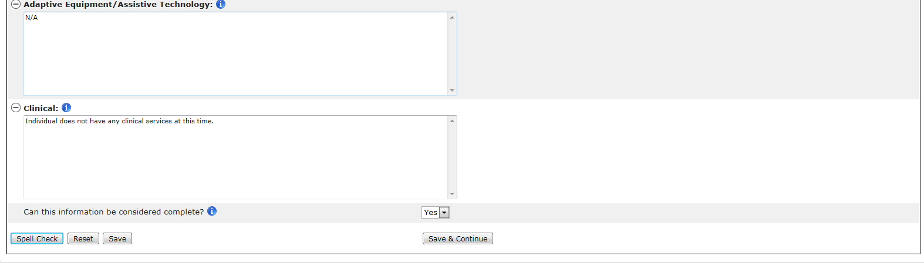
Note: “No” will be pre-selected. As long as the answer to this prompt is “No”, the Current Supports section will print with a “Draft” watermark.
If you have finished working on the section, selecting “Yes” will change the status of the component to “Completed by Service Coordinator” on the Dashboard, View/Print Screen, and RPMS. Service Coordinators and those with DDS read-only roles will be able to view and print this component without a draft watermark.
If you have not finished working on the section, keeping the pre-selected answer “No” and clicking “Save” or “Save & Continue” will change the status of the component to “Started” on the Dashboard, View/Print Screen, and RPMS. Service Coordinators can print the ISP component with a draft watermark; however, read only roles will not have access to view and print.
You must click “Save” or “Save & Continue” in order for information to be saved on the ISP screens. If you do not click “Save” or “Save & Continue,” data entered will be lost, as data is not saved automatically in HCSIS. If you do not save the information on the screen, then the status of the component will remain “Not Started” on the Dashboard, View/Print Screen, and RPMS. When navigating from one ISP component tab to another, please remember to save your work.
- Click “Save & Continue” to move to the next section.
Clicking “Save” will bring the user back to the Dashboard. Clicking “Save & Continue” will bring the user to the Safety/Risk section.
Part II: Completing Safety and Risk
- Since the user has selected “Save & Continue” the user is brought directly to the Safety/Risk page. The user can also navigate to Safety/Risk by clicking the Safety/Risk tab.
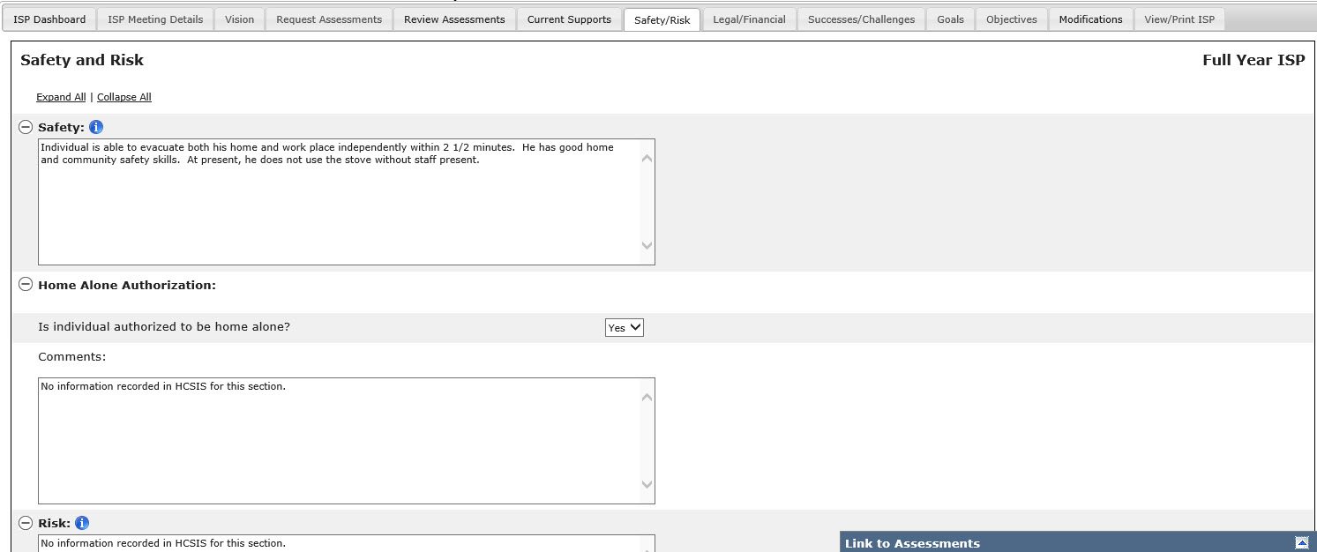
- Expand the clipboard for Safety/Risk. The clipboard contains links to the Safety Assessments. Click the icon to open the Assessment in a pop-up window.
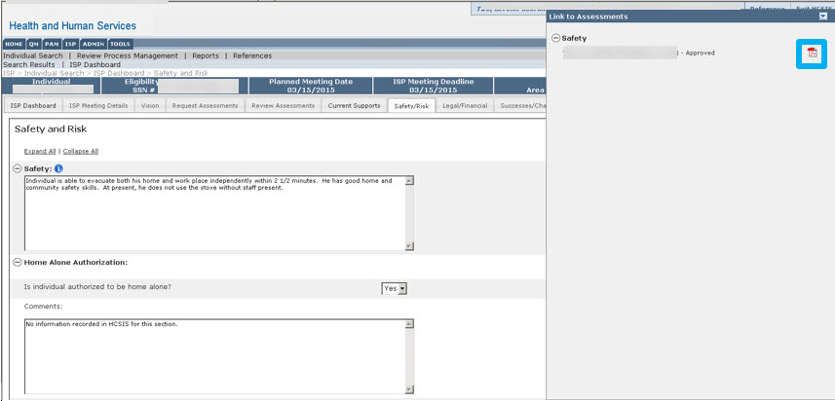
Note: Values from the past ISP are recalled along with any updates entered during the past update year and are displayed in the same text box. The character limit for all text boxes will remain the same, and recalled information will not be truncated. The user has to ensure that information does not exceed the allowed character limit in order to save changes. If there was no information entered in a previous plan to recall, the system will display, “No information recorded in HCSIS for this section” in the applicable text box and it will be editable.
- Click “Open” to download the file.
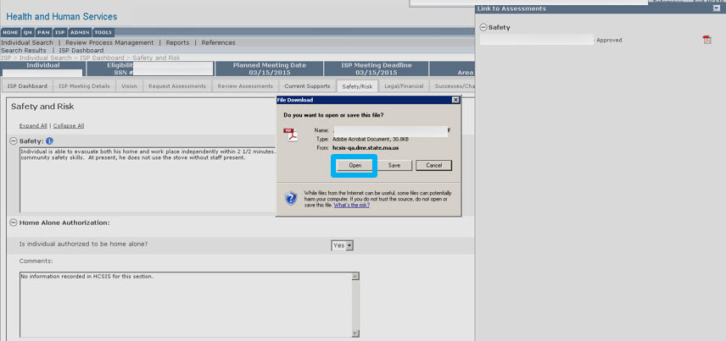Note: The popup window may look different depending on your browser.
The assessment is displayed. 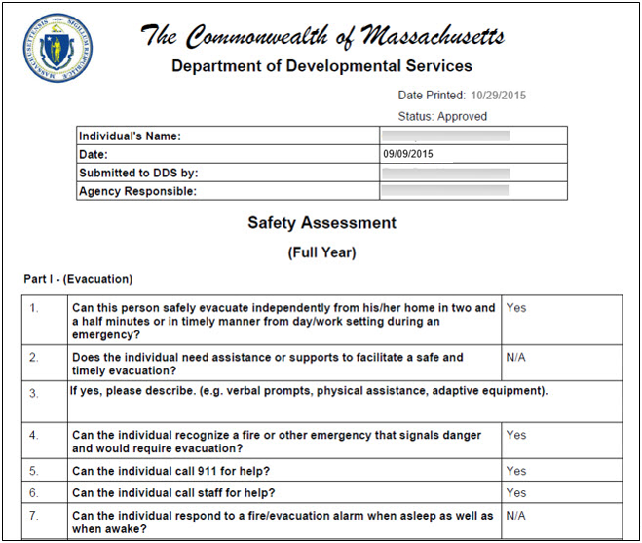
Note: With the Assessment open, you can view, reference, or copy and paste information directly from the Assessment into the fields in HCSIS for Current Supports.
- Complete Safety/Risk section by editing recalled information, referencing or copying information from the clipboard or assessments, or adding additional information (Remove the “No information recorded in HCSIS for this section”).

Note: Auto Save will run after 15 minutes of inactivity. Information will be temporarily saved for Safety and Risk section to avoid losing data. The steps are the same as describe for the Current Supports section.
- After entering text into the Safety/Risk fields, scroll to the bottom of the page. Answer the question “Can this information be considered complete?” by selecting “Yes” or “No”.
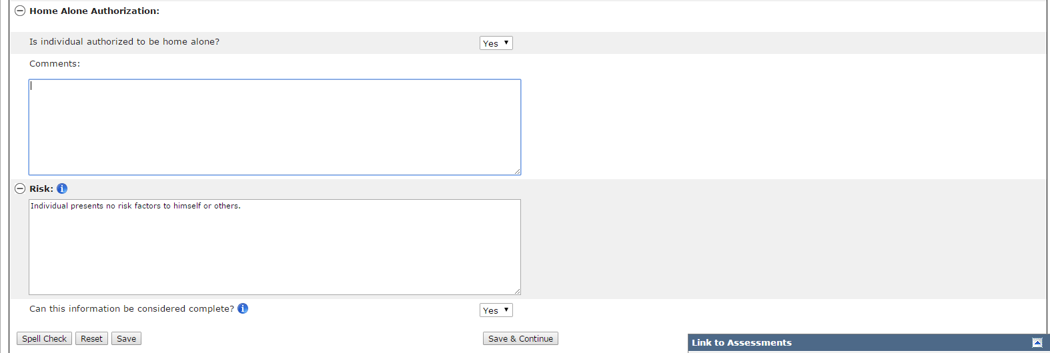

Please note that “No” will be pre-selected.
If you have finished working on the section, selecting “Yes” will change the status of the component to “Completed by Service Coordinator” on the Dashboard, View/Print Screen, and RPMS. Service Coordinators and those with read-only roles will be able to view and print this component without a draft watermark.
If you have not finished working on the section, keeping the pre-selected answer “No” and clicking “Save” or “Save & Continue” will change the status of the component to “Started” on the Dashboard, View/Print Screen, and RPMS. Service Coordinators can print the ISP component with a draft watermark; however, read only roles will not have access to view and print.
You must click “Save” or “Save & Continue” in order for information to be saved on the ISP screens. If you do not click “Save” or “Save & Continue,” data entered will be lost, as data is not saved automatically in HCSIS. If you do not save the information on the screen, then the status of the component will remain “Not Started” on the Dashboard, View/Print Screen, and RPMS. When navigating from one ISP component tab to another, please remember to save your work.
- Click “Save & Continue” to move to the next section.
Clicking “Save” will bring the user back to the Dashboard. Clicking “Save & Continue” will bring the user to the Legal/Benefit/Financial section.

Part III: Completing Legal/Benefit/Financial Status
- Since the user has selected “Save & Continue” the user is brought directly to the Legal/Benefit/Financial page. The user can also navigate to Legal/Benefit/Financial by clicking the Legal/Financial tab.
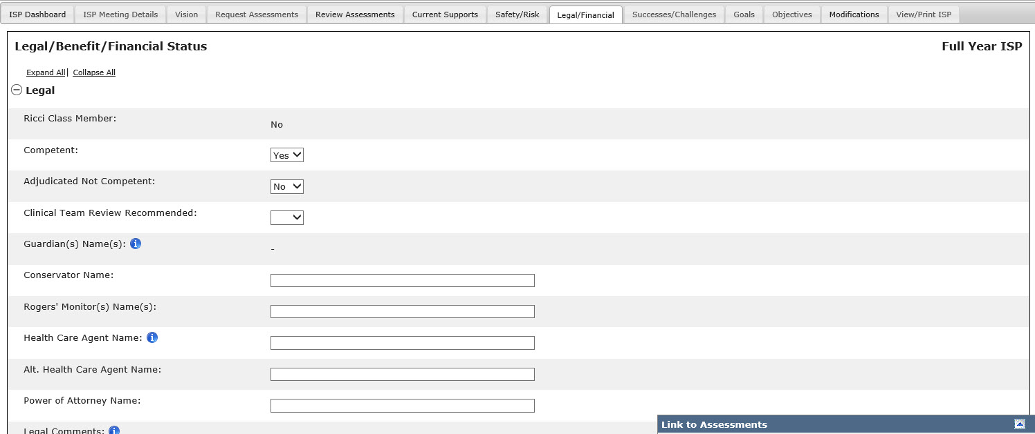
Note: Values from the past ISP are recalled along with any updates entered during the past update year and are displayed in the same text box or drop down. The character limit for all text boxes will remain the same, and recalled information will not be truncated. The user has to ensure that information does not exceed the allowed character limit in order to save changes. If there was no information entered in a previous plan to recall, the system will display, “Data for one or more elements for this section was not recorded in HCSIS” will appear in each text box and will be editable.” in the applicable Comments box. For example, if a value for “Competent” has not been recorded in last year’s plan, the above message will be displayed in the Legal Comments text box below any recalled comments. In order to enter the missing information, the Service Coordinator must delete the message and then type or copy and paste the information from last year’s approved ISP or select the appropriate value from the drop down.
Note: On a Full Year, Ricci Class member and Guardian Name information is populated from MEDITECH. The guardian name is pulled from the Demographics screen in MEDITECH. In case of multiple guardians, this field will display all guardian names. (For additional information please refer to the MEDITECH ISP Workflow quick guide on the reference page) On an Update Year, Ricci Class member and Guardian Name information is populated from last year’s ISP.
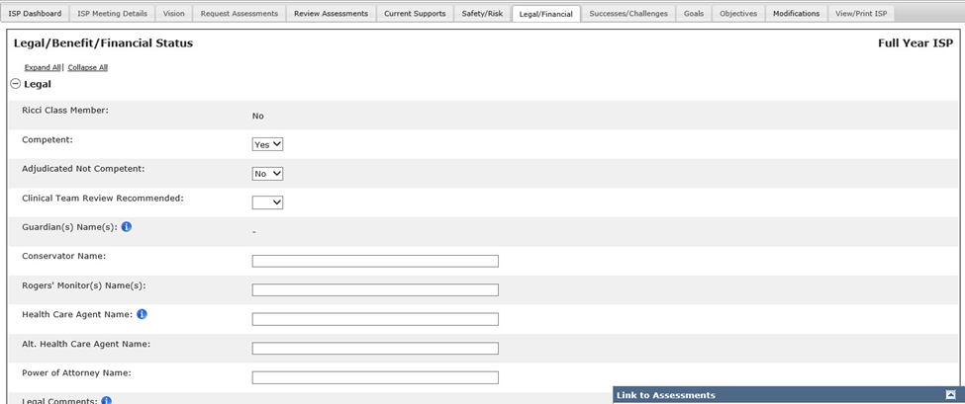
Note: Certain fields on the Legal/Financial/Benefit sections are prepopulated from the financial assessment of the individual, if the individual has only one financial assessment requested in the system. If the individual has multiple financial assessments, a message that reads “Please note: Refer to the multiple financial assessments of the individual to complete this section” is displayed.
- Expand the clipboard for Legal/Benefit/Financial Status. The clipboard contains links to the Financial Assessment.
- Click the icon to open the Assessment in a pop-up window.
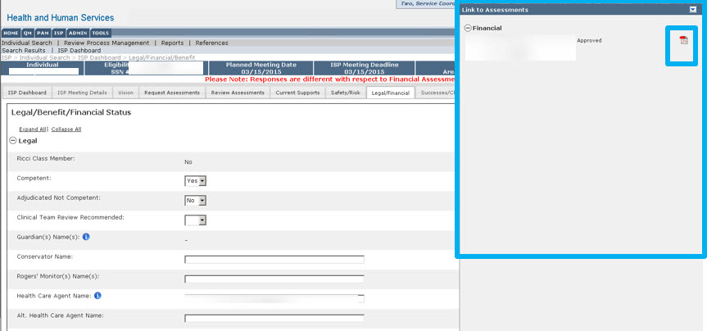
- Click “Open” to download the file.
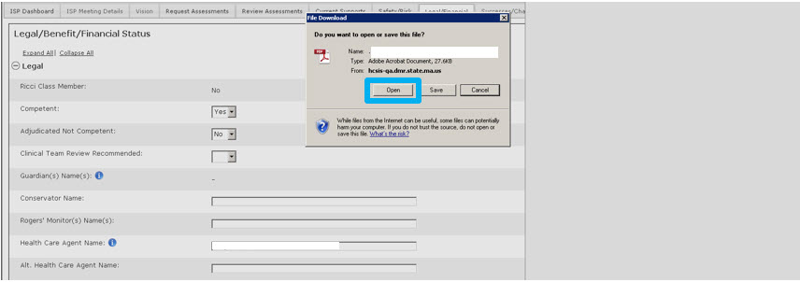
Note: The popup window may look different depending on your browser.
The Assessment will open.
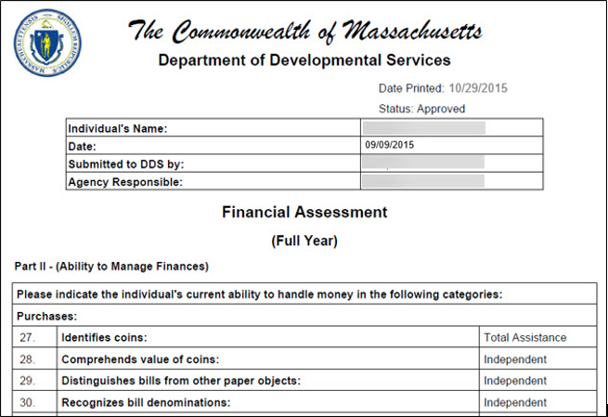
Note: With the Assessment open, you can view, reference, or copy and paste information directly from the Assessment into the fields in HCSIS for Current Supports.
- Complete Legal/Benefit/Financial section by editing recalled information, referencing or copying information from the clipboard or assessments, or adding additional information.

Note: Auto Save will run after 15 minutes when the screen is idle. Information will be temporarily saved for Legal/Benefit/Financial status section to avoid losing data. This applies to both drop downs as well as text fields. The steps are the same as described for the Current Supports section.
- After entering text into the Legal/Benefit/Financial Status fields, scroll to the bottom of the page. Answer the question “Can this information be considered complete?” by selecting “Yes or “No”.
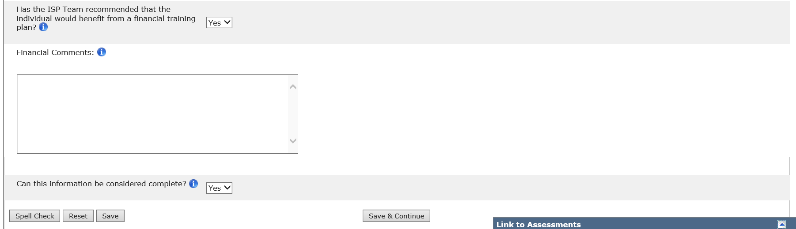
Please note that “No” will be pre-selected.
If you have finished working on the section, selecting “Yes” will change the status of the component to “Completed by Service Coordinator” on the Dashboard, View/Print Screen, and RPMS. Service Coordinators and those with read-only roles will be able to view and print this component without a draft watermark.
If you have not finished working on the section, keeping the pre-selected answer “No” and clicking “Save” or “Save & Continue” will change the status of the component to “Started” on the Dashboard, View/Print Screen, and RPMS. Service Coordinators can print the ISP component with a draft watermark, however, read only roles will not have access to view and print.
You must click “Save” or “Save & Continue” in order for information to be saved on the ISP screens. If you do not click “Save” or “Save & Continue,” data entered will be lost, as data is not saved automatically in HCSIS. If you do not save the information on the screen, then the status of the component will remain “Not Started” on the Dashboard, View/Print Screen, and RPMS. When navigating from one ISP component tab to another, please remember to save your work.
- Click “Save & Continue” to move to the next section.
Clicking “Save” will bring the user back to the Dashboard. Clicking “Save & Continue” will bring the user to the Successes/Challenges section.
Part IV: Completing Successes/Challenges
To complete the Safety/Risk section the Service Coordinators can copy and paste information into HCSIS. Service Coordinators can copy and paste information from a previous ISP Word Document where they have previously tracked successes or challenges for individuals.
- Since the user has selected “Save & Continue” the user is brought directly to the Successes/Challenges page. The user can also navigate to Successes/Challenges by clicking the Successes/Challenges tab.
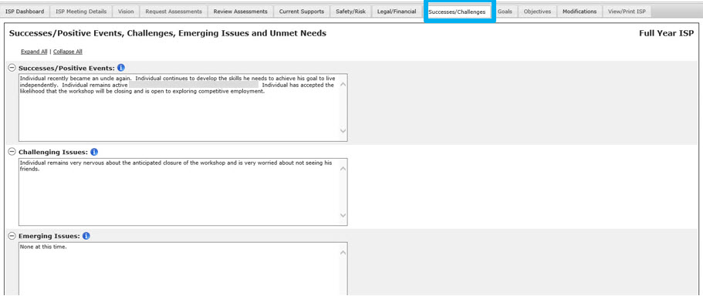
Note: Values from the past ISP are recalled along with any updates entered during the past update year and are displayed in the same text box. The character limit for all text boxes will remain the same, and recalled information will not be truncated. The user has to ensure that information does not exceed the allowed character limit in order to save changes. If there was no information entered in a previous plan to recall, the system will display, “No information recorded in HCSIS for this section” in the applicable text box and it will be editable.
- Complete Successes/Challenges section by editing recalled information or typing additional information directly into the text box. (Remove the “No information recorded in HCSIS for this section).
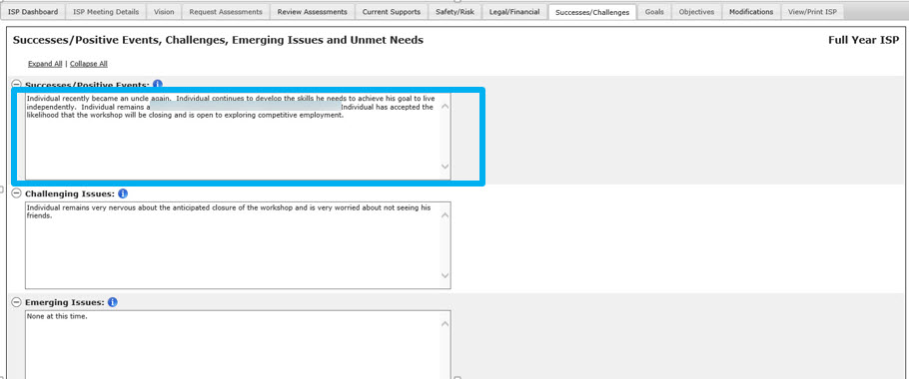

Note: The Successes/Challenges section does not have a clipboard or link to assessments.
Note: Auto Save will run after 15 minutes of inactivity when the screen is idle. Information will be temporarily saved for Successes and Challenges section to avoid losing data. The steps are the same as describe for the Current Supports section.
- After entering text into the Successes/Challenges fields, scroll to the bottom of the page. Answer the question “Can this information be considered complete?” by selecting “Yes or “No”.
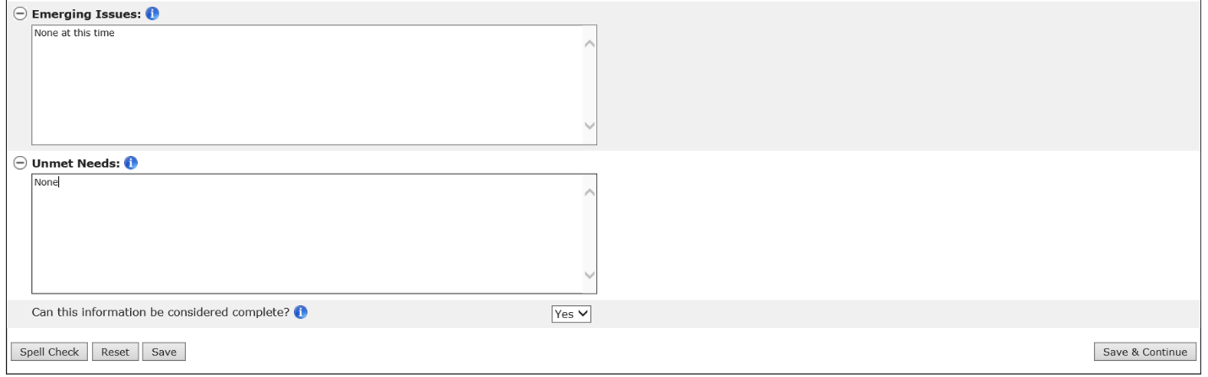
Please note that “No” will be pre-selected.
If you have finished working on the section, selecting “Yes” will change the status of the component to “Completed by Service Coordinator” on the Dashboard, View/Print Screen, and RPMS. Service Coordinators and those with read-only roles will be able to view and print this component without a draft watermark.
If you have not finished working on the section, keeping the pre-selected answer “No” and clicking “Save” or “Save & Continue” will change the status of the component to “Started” on the Dashboard, View/Print Screen, and RPMS. Service Coordinators can print the ISP component with a draft watermark, however, read only roles are not able to print.
You must click “Save” or “Save & Continue” in order for information to be saved on the ISP screens. If you do not click “Save” or “Save & Continue,” data entered will be lost, as data is not saved automatically in HCSIS. If you do not save the information on the screen, then the status of the component will remain “Not Started” on the Dashboard, View/Print Screen, and RPMS. When navigating from one ISP component tab to another, please remember to save your work.
- Click “Save & Continue” will redirect the user to the Dashboard.
Next Steps:
User can navigate to any section of the ISP by directly clicking on the tabs. Please click on “Save” button before navigating from a screen or section.
While completing the other ISP components, the Service Coordinator and Service Coordinator Supervisor can continue to:
- Edit the Vision Statement
- Create Goals
- Review Objectives and Support Strategies
- Request or Review Assessments
- Print Various ISP components

Updating Other ISP Components by DDS Staff in an Update Year
Scenario Description
The Service Coordinator or Service Coordinator Supervisor is responsible for updating the four additional sections within the ISP module in order for the full Update ISP to be completed in HCSIS. The components can be updated beginning after the ISP Plan Selection is made.

First Steps:
- The user searches for an individual
- The user views the Individual Dashboard

Roles and Responsibilities:
- Service Coordinators: Can create, edit, and save content
- Service Coordinator Supervisors: Can create, edit, and save content

Part I: Updating Current Supports

- Select the Other ISP Components section on the dashboard or select “Current Supports” tab.
The module redirects the Service Coordinator to the Individual’s “Current Supports” Page.
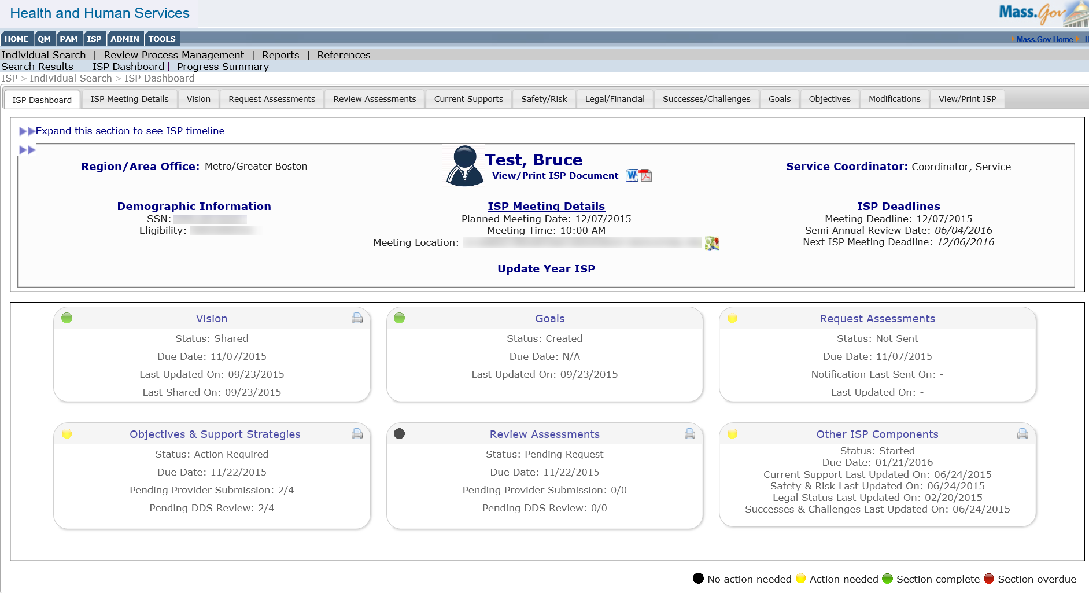

- Select the “Update Information” checkbox next to the sections of the Current Supports.

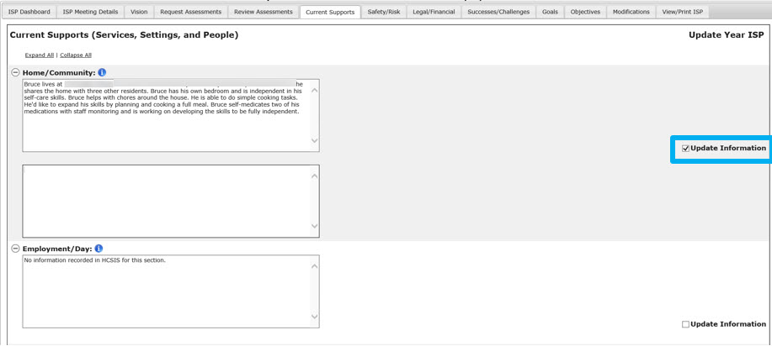
Note: The recalled information from the last Full Year plan will be displayed as editable to allow for entering missing information from last year’s approved ISP. If there is no information saved in HCSIS for a specific section, the system will display the following message: “No information recorded in HCSIS for this section.” In order to enter the missing information, the Service Coordinator must delete the message and then type or copy and paste the information from last year’s approved ISP. Updates are entered in the designated text boxes, as outlined by the steps below.
Note: Updated Information checkboxes will appear for the following sections:
  - Home/Community
  - Employment/Day
  - Health and Dental
  - Medication(s)
  - Adaptive Equipment/Assistive Technology
  - Clinical

- Enter a valid value into the text box that appears below each section.

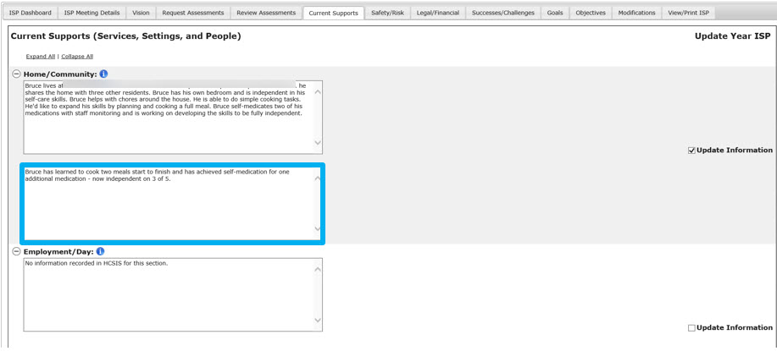

Note: All Updated Information text boxes will have a 5,000 character limit.

- Select “Yes” to the question “Can this information be considered complete?”

- Select “Save & Continue”.

Next Steps
- The values are saved and the user is navigated to the Safety & Risk Page.

Part II: Updating Safety & Risk

- Since the user has selected “Save & Continue”, the user is brought directly to the Safety/Risk page. The user can also navigate to Safety/Risk by clicking the Safety/Risk tab.
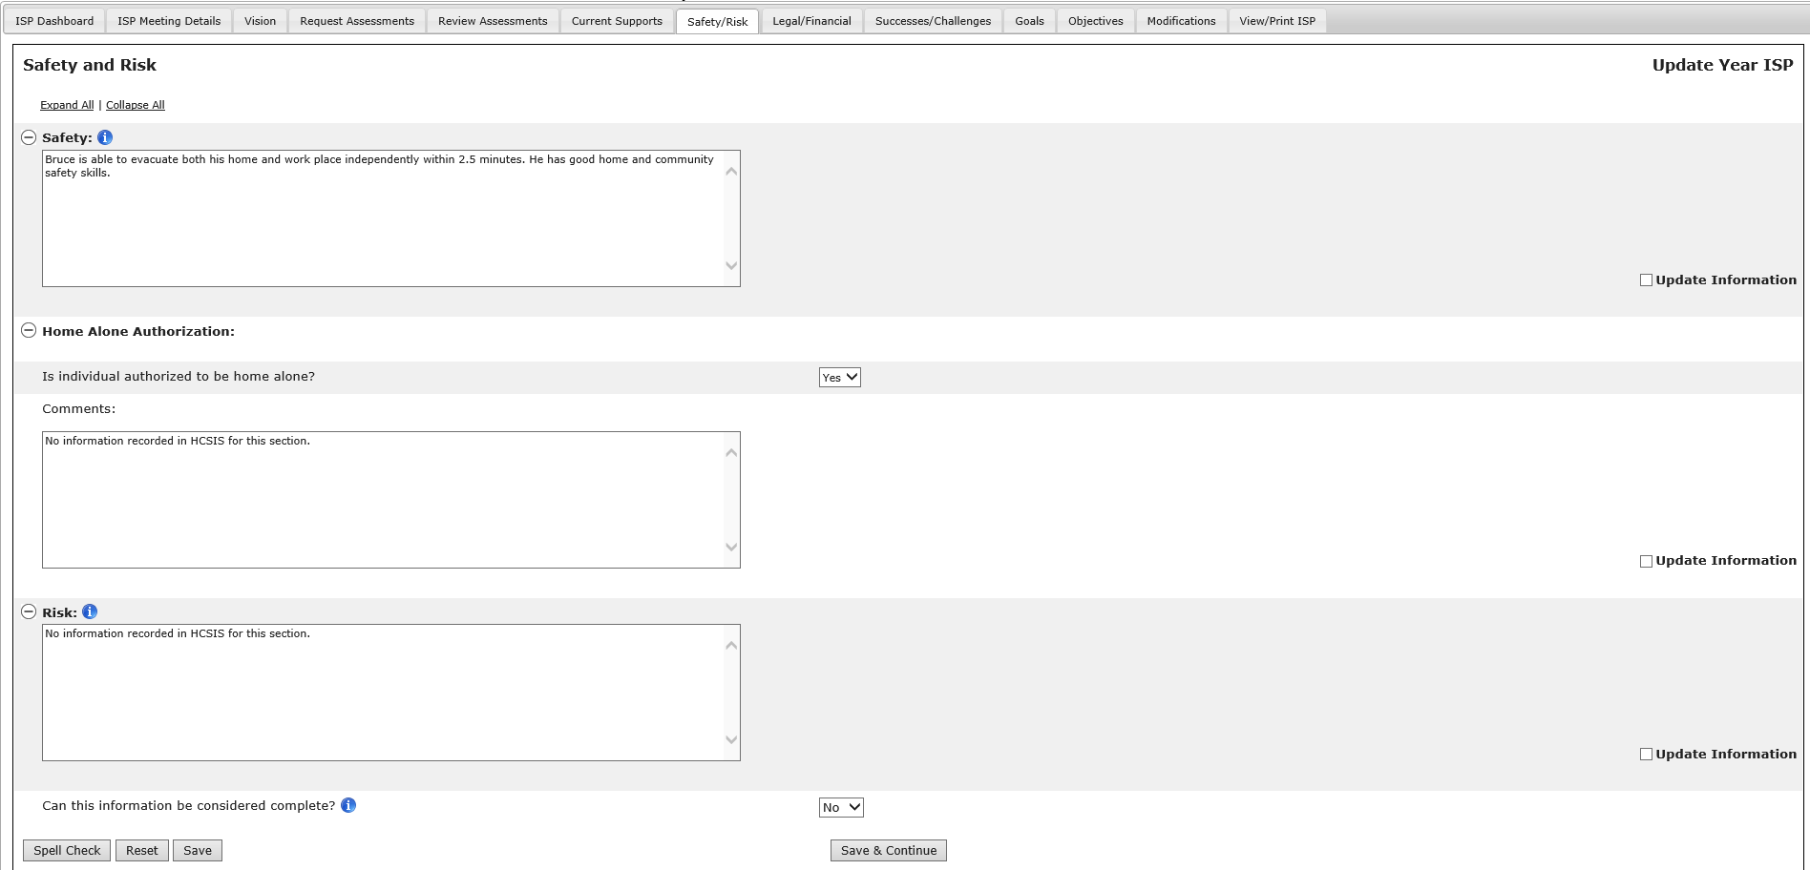
Note: The recalled information from the last Full Year ISP plan will be displayed as editable to allow for entering missing information from last year’s approved ISP. If there is no information saved in HSCSIS for a specific section, the system will display the following message: “No information recorded in HCSIS for this section.” In order to enter the missing information, the Service Coordinator must delete the message and then type or copy and paste the information from last year’s approved ISP. Updates are entered in the designated text boxes, as outlined by the steps below.
- Select the “Update Information” checkbox next to the sections of the Safety and Risk page.

Note: Updated Information check boxes will appear for the following sections:
  - Safety
  - Home Alone Authorization
  - Risk

- Enter a valid value into the text box that appears below each section.

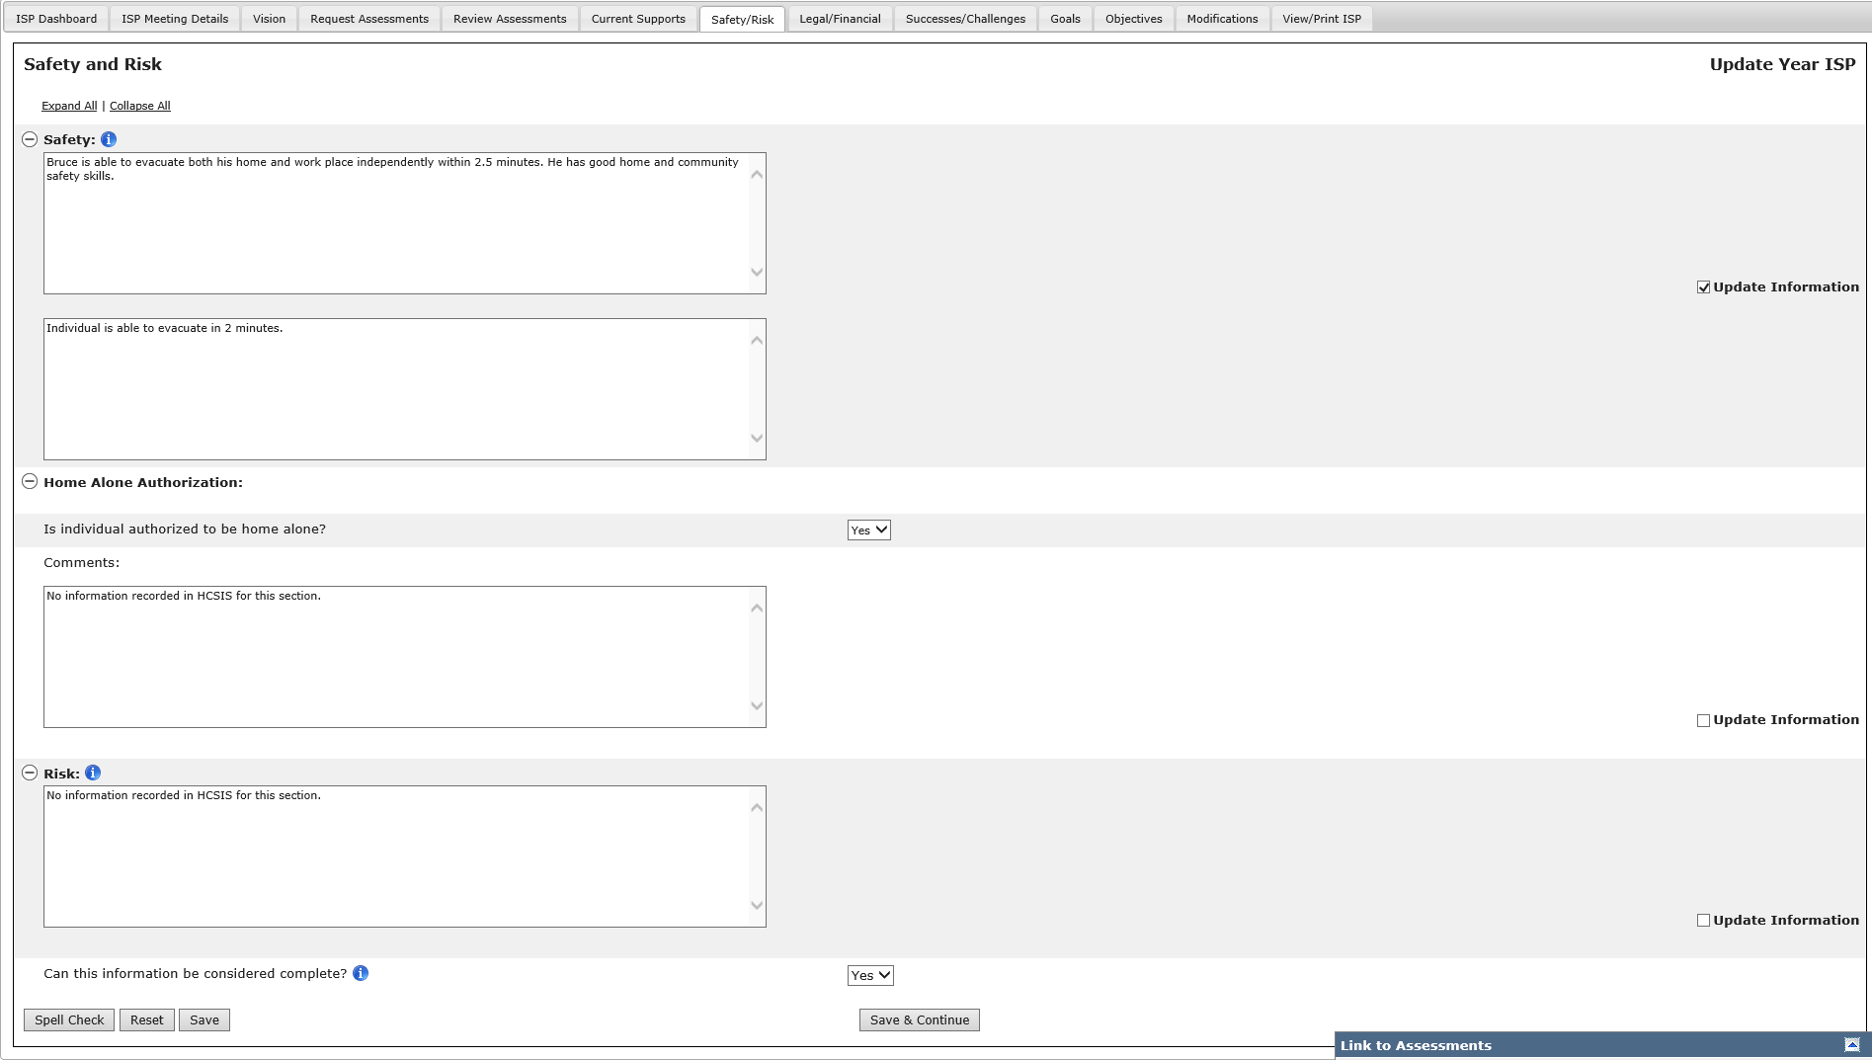

- Select “Yes” to the “Can this information be considered complete?” question.

- Select “Save & Continue.”

Next Steps
- The values are saved and the user is navigated to the Legal/Financial/Benefit Status Page.

Part III: Updating Legal/Financial/Benefit/Financial Status

- Since the user has selected “Save & Continue”, the user is brought directly to the Legal/Financial/Benefit Status page. The user can also navigate to Legal/Benefit/Financial by clicking the Safety/Risk tab.
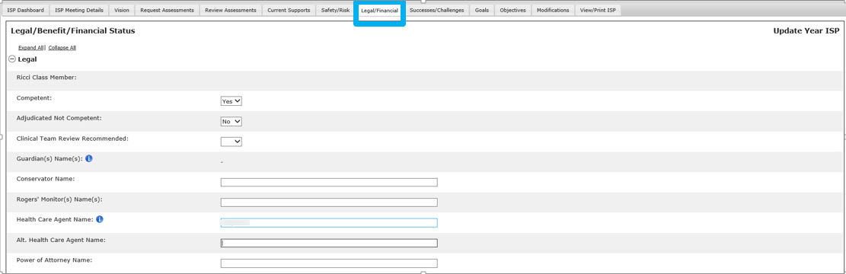
Note: The recalled information from the last Full Year ISP plan will be displayed as editable to allow for entering missing information from last year’s approved ISP. If there is no information saved in HSCSIS for any field within a specific section, the system will display the following message in the applicable comments box: “Data for one or more of these elements for this section was not recorded in HCSIS”. For example, if a value for “Competent” has not been recorded in last year’s plan, the above message will be displayed in the Legal Comments text box below any recalled comments. In order to enter the missing information, the Service Coordinator must delete the message and then type or copy and paste the information from last year’s approved ISP or select the appropriate value from the drop down. Updates are entered in the designated text boxes, as outlined by the steps below.

Note: Guardian Name and Ricci Class Member information will be pulled from the previous ISP and will not be editable. Any updates to these fields will need to be recorded in the “Updated Information” text box available for the section.

- Select the “Update Information” checkboxes next to each of the three sections of the Legal/Benefit/Financial Status page. (Remove the “Data for one or more of these elements for this section was not recorded in HCSIS”).

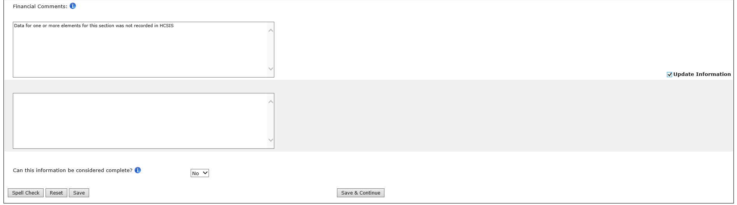

- Enter all updates for the section into the text box that appears below the section.

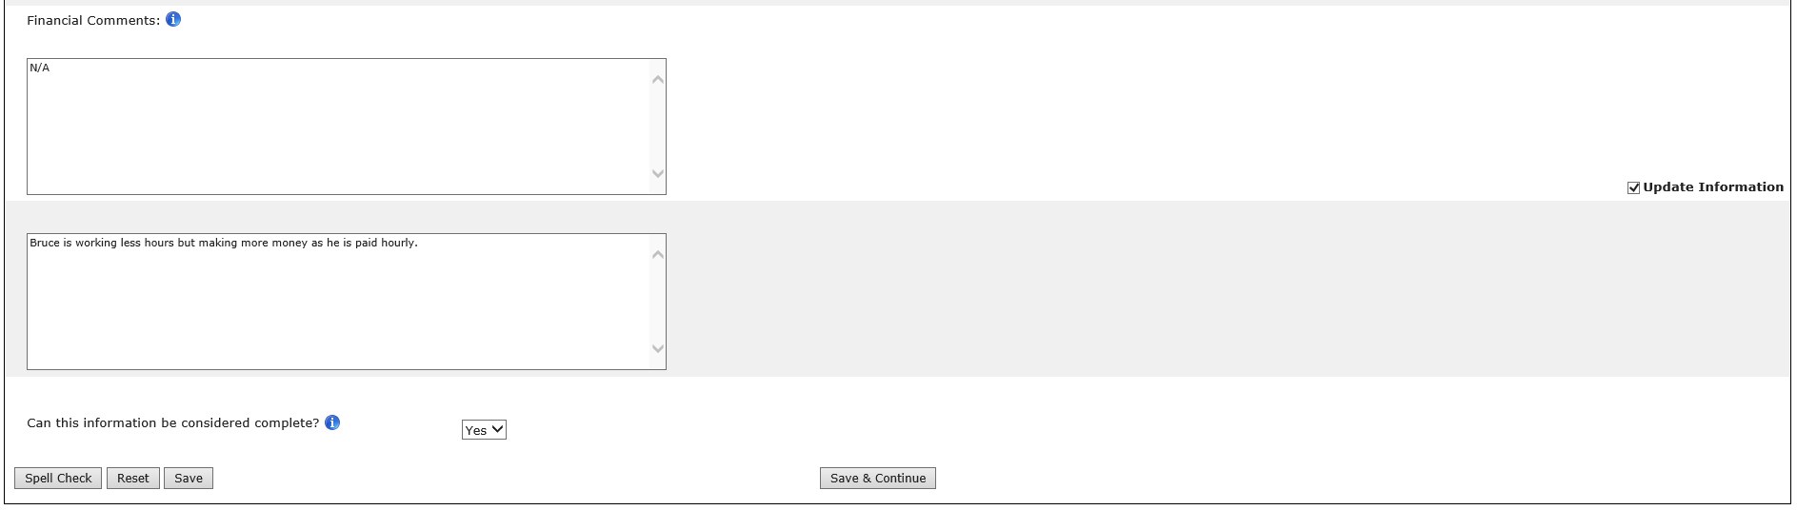

Note: Updated Information text boxes will appear only if the “Update Information” checkbox for a field is checked. All Updated Information text boxes will have a 5,000 character limit.

- Select “Yes” to the “Can this information be considered complete?” question.

- Select “Save & Continue.”

Next Steps:
- The values are saved and the user is navigated to the Successes/Challenges Page.

Part IV: Updating Successes/Challenges

- Since the user has selected “Save & Continue”, the user is brought directly to the Successes/Challenges page. The user can also navigate to Successes/Challenges by clicking the Successes/Challenges tab.
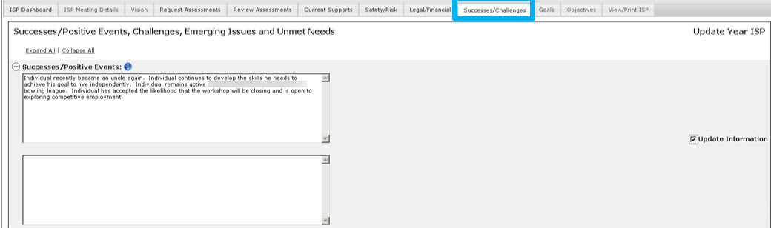
Note: The recalled information from the last Full Year ISP plan will be displayed as editable to allow for entering missing information from last year’s approved ISP. If there is no information saved in HSCSIS for a specific section, the system will display the following message: “No information recorded in HCSIS for this section.” In order to enter the missing information, the Service Coordinator must delete the message and then type or copy and paste the information from last year’s approved ISP. Updates are entered in the designated text boxes, as outlined by the steps below.
- Selects the “Update Information” checkbox next to the sections of the Safety and Risk.

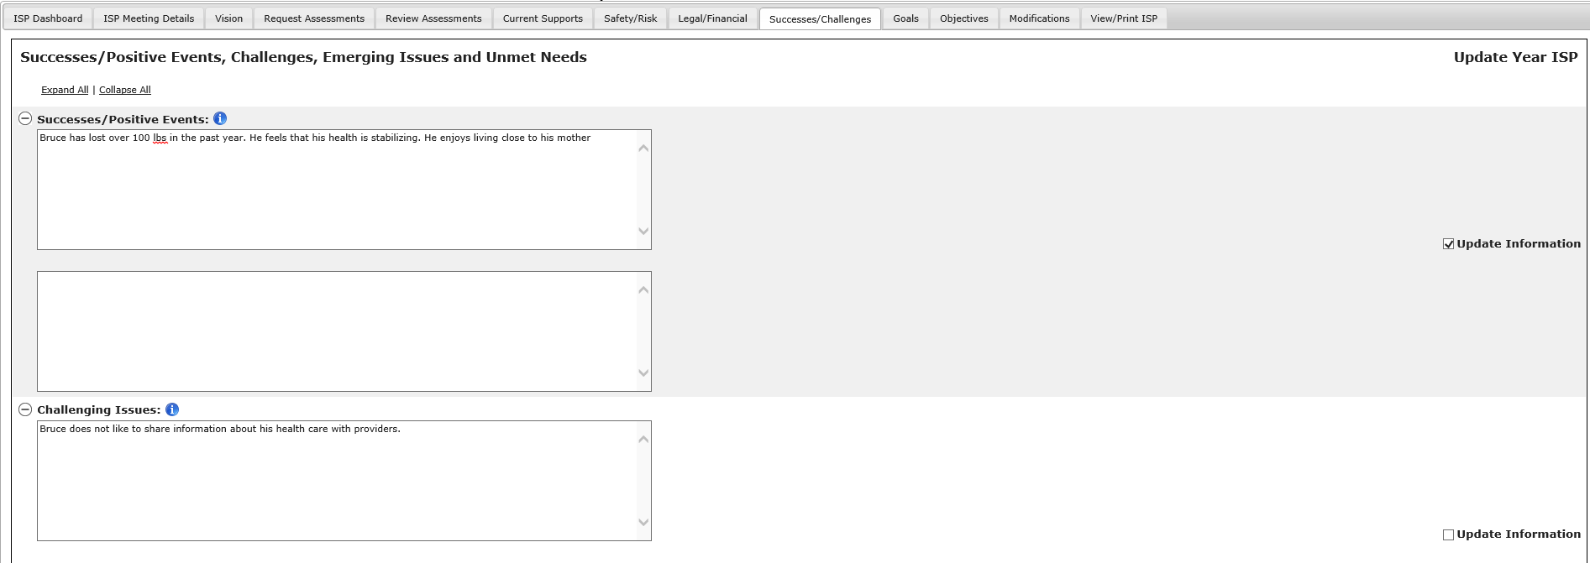

Notes: Updated Information check boxes will appear for the following sections:
  - Positive Events
  - Challenging Issues
  - Emerging Needs
  - Unmet Needs

- Enter a valid value into the text box that appears below each section.

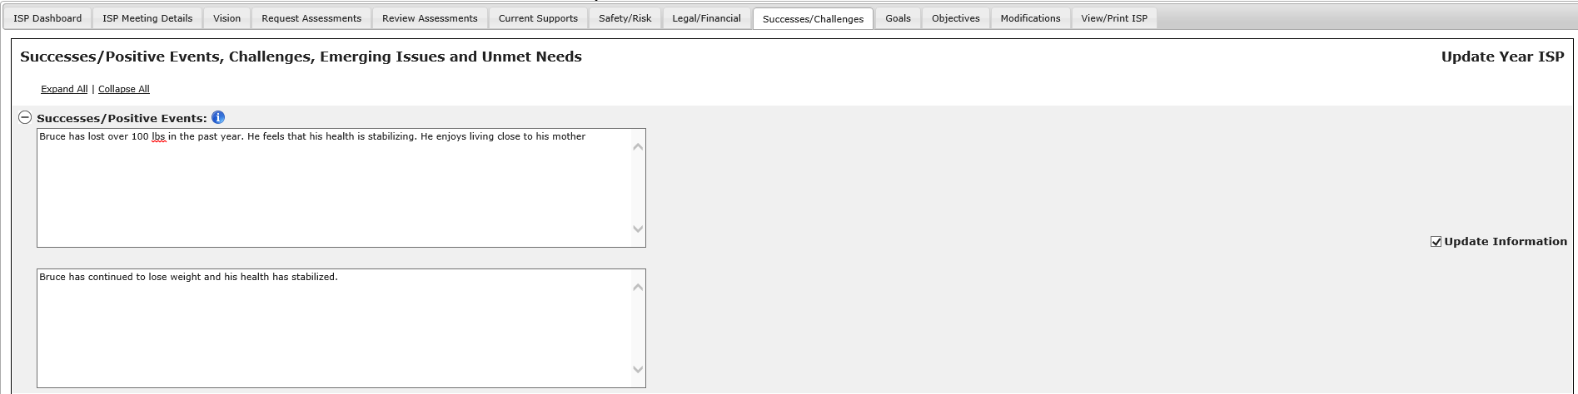

Note: Updated Information text boxes will appear only if the “Update Information” checkbox for a field is checked. All Updated Information text boxes will have a 5,000 character limit.

- Select “Yes” to the “Can this information be considered complete?” question.

- Select “Save & Continue.”

Next Steps
- The page is refreshed, the values in each of the updated information text boxes are saved, and the “Operation Successful” message appears at the top of the screen.

Post ISP Meeting Activities
This section provides an overview of activities that take place after the ISP Meeting has been conducted. Below is a summary of these activities:
- Documents are revised as per the outcomes of the meeting.
- All documents that have been revised need to be approved.
- Objectives and Support Strategies are approved and saved as part of the ISP Document.
- The ISP Document is created and mailed to the Individual, Guardian and Providers by 45 days after the meeting.
- Revisions to any documents can be made up to 150 post the ISP Meeting.
- Once all documents are locked, the Area Office Director/ Designee can manually unlock them if they need to be revised more than 150 days past the ISP Meeting. The Area Office Director / Designee is also responsible for re-locking once tasks are completed. The plan must be manually re-locked for the next plan to be created in HCSIS.

Note: In order for these system activities to be triggered in HCSIS, the Service Coordinator must have recorded the actual ISP meeting date in MEDITECH’s ISP Meeting and Status screen.
Roles and Responsibilities

- Service Coordinator:
  - Reviews all ISP materials, makes necessary updates to the Vision Statement and Goals as agreed upon at the ISP Meeting.
  - Requests revisions to previously approved Assessments if needed.
  - Approves or requests revision to previously submitted Objectives and Support Strategies that need to be modified as a result of the ISP Meeting discussions.
  - Continues to review and approve or request further revisions to Assessments and Objectives and Support Strategies as they are submitted after the ISP Meeting.
  - Can also request new Assessments per the ISP Meeting discussions.
  - Completes the Current Supports, Safety and Risk, Legal/Benefit/Financial Status, and Successes/Challenges sections of the ISP document.
- Service Coordinator Supervisor:
  - Reviews all ISP materials, makes necessary updates to the Vision Statement and Goals as agreed upon at the ISP Meeting.
  - Requests revisions to previously approved Assessments if needed.
  - Approves or requests revision to previously submitted Objectives and Support Strategies that need to be modified as a result of the ISP Meeting discussions.
  - Continues to review and approve or request further revisions to Assessments and Objectives and Support Strategies as they are submitted after the ISP Meeting.
  - Can also request new Assessments per the ISP Meeting discussions.
  - Completes the Current Supports, Safety and Risk, Legal/Benefit/Financial Status, and Successes/Challenges sections of the ISP document.
  - Oversees all ISP materials are completed post meeting period in the system and that the ISP Document is completed and mailed out by 45-days post the meeting.
- Provider:
  - Makes necessary updates to the Goals created by their Provider Agency.
  - Revises Assessments or Objectives and Support Strategies as requested by the Service Coordinator in accordance with the ISP Meeting discussions.
- Provider Supervisor:
  - Makes necessary updates to the Goals created by their provider agency.
  - Reviews, revises and submits Assessments or Objectives and Support Strategies as requested by the Service Coordinator in accordance with the ISP Meeting discussions.
- Area Office Directors:
  - Have the ability to unlock the ISP plan past 150 days.

Note: After the ISP meeting Service Coordinators and Service Coordinator Supervisors will be able to select documents which require revisions while the other documents remain approved.

Post ISP Meeting Alerts

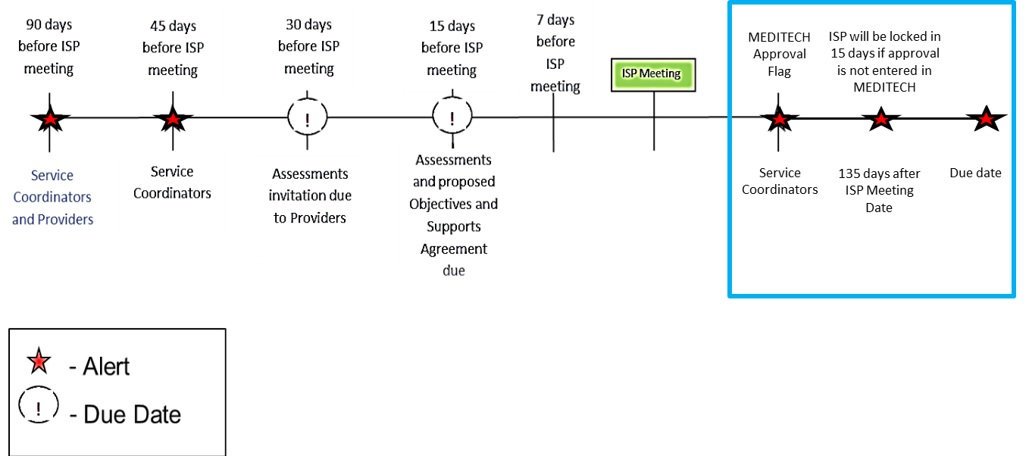

- “ISP is locked” - triggered when a plan has been locked in HCSIS based on the Approval flag in MEDITECH.
- “ISP will be locked in 15 days if approval is not entered in MEDITECH” – triggered 135 days after the ISP Meeting Date if the approval flag has not yet been pulled from MEDITECH.

Note: If the ISP is not approved within 150 days, the plan automatically locks. There is no alert associated with this action.

Post ISP Meeting Activities Overview
During the 150-day period after the ISP Meeting has taken place, the system will display the date of the meeting as a message on the Individual Dashboard, as seen in the screenshot below:
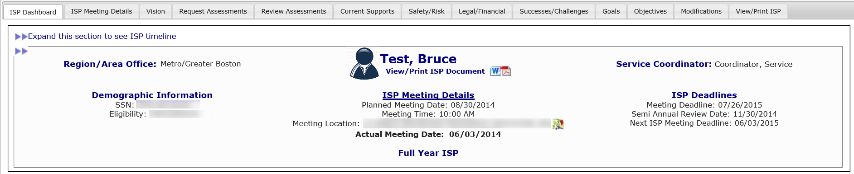

During the post meeting period, all documents will continue to be in a status they were in prior to the meeting. The Service Coordinator will have to go in and request revision to all previously approved documents that need to be revised as a result of the ISP Meeting. Documents that have not been approved prior to the ISP Meeting will maintain the status they had prior to the ISP Meeting (e.g. If an Assessment had been returned to a provider for revisions and the revisions had not been made in advance of the meeting, the status for that Assessment would still be “Revision Requested” or if an Objective and Supports Strategy had been submitted but the Service Coordinator had not approved the materials before the ISP meeting, the status would still be “Submitted for DDS Review”).
Note: The Service Coordinator is responsible for approving Objectives & Support Strategies as well as Assessments to which he or she has requested a revision within the 150 day post meeting period.
Next Steps
The system will lock all documents 150 days after the ISP Meeting has taken place. In the event that further changes need to be made to the ISP materials related to that year’s ISP, the Service Coordinator or Supervisor can request the Area Office Director/Designee to unlock the ISP in HCSIS. Provider staff and Service Coordinators will need to coordinate with the Service Coordinator Supervisor to submit this request outside of the system.

If an ISP has been manually unlocked by the Area Office Director/ Designee, it must be re-locked for the next plan can be created in HCSIS.

Selecting Objectives to Include in the ISP Document by DDS Staff in Full or Update Year
As the full ISP document is included in the ISP module, Service Coordinators and Service Coordinator Supervisors will now be able to select which Goals and corresponding Objective and Support Strategies will be included in the final ISP document after the ISP meeting has occurred. Once objectives have been included in the ISP document, the progress summary process will be initiated
Scenario Description
- The ISP Meeting has taken place and Objectives and Goals are in “Approved” Status.
- To complete the final ISP document, Objectives and Goals will need to be selected for inclusion in the ISP document prior to printing.
First Steps:
- The user searches for an individual
- The user views the Individual Dashboard
- The user navigates to the Objectives and Support Strategies Review Switchboard

Roles and Responsibilities:
- Service Coordinators: Selects Objectives and Goals
- Service Coordinator Supervisors: Selects Objectives and Goals
Note: The below screenshots are taken from an Update Year ISP plan, but the process for including Objectives in the ISP Document is identical for Full and Update Year.

Selecting Objectives to Include in the ISP Document

Objectives that need to be modified after the meeting must have revision requested by the Service Coordinator and must be approved prior to inclusion in the ISP document. Only those objectives which have been approved can be selected to be included in the ISP document.

- Select Objectives to be included in the ISP Document

From the Objectives Review Switchboard, the Service Coordinator and Service Coordinator Supervisors are able to select the Objective and corresponding Goal that has been approved post ISP meeting to include in the final ISP document.

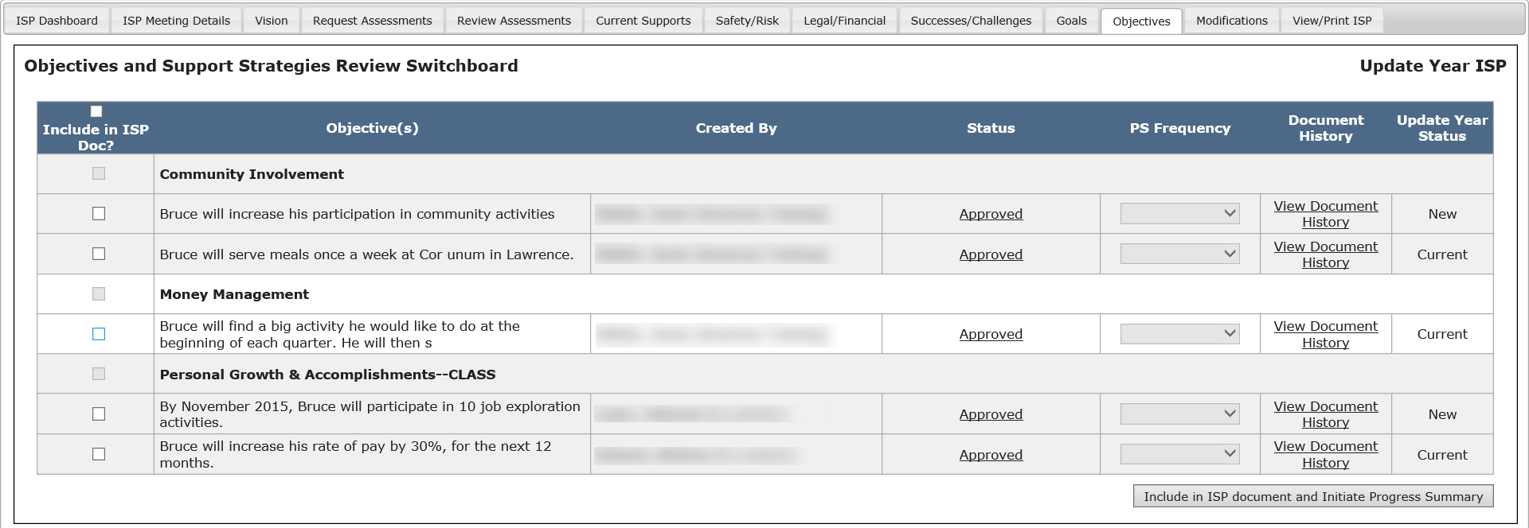

Note: By selecting an Objective the underlying Goal will automatically be selected by the system.

- Click “Include in ISP document and Initiate Progress Summary”

These Objectives, along with the associated Goals will now be included in the ISP Document.

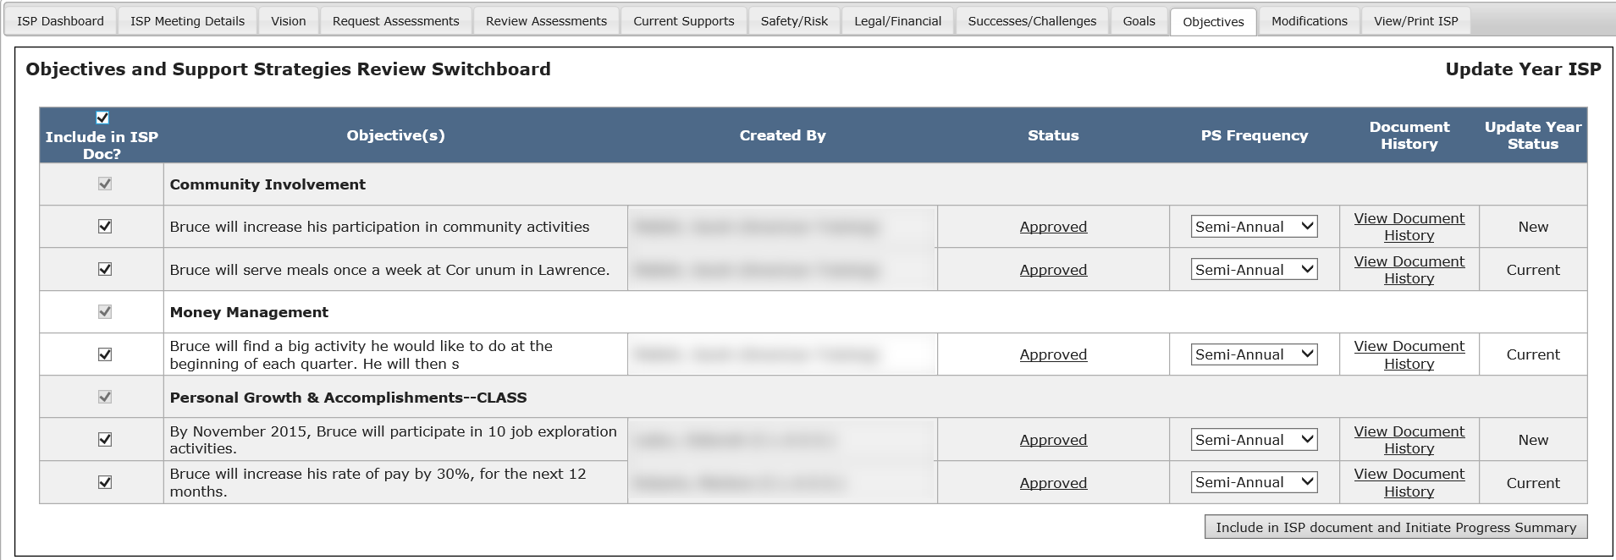

- View Goals included in the ISP Document

A new column is visible on the Goals screen. The column indicates whether a Goal has been selected for inclusion as part of the ISP document.
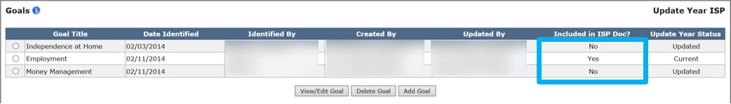

To change or remove an Objective from inclusion in the ISP document, navigate back to the Objectives and Support Strategies Review Switchboard and uncheck the Objective. Removing an Objective automatically deletes the associated Goal, assuming there are no other Objectives linked to that Goal.

Next Steps:
- Service Coordinators or Service Coordinator Supervisors can view and/or print the ISP Document.
- Service Coordinators or Service Coordinator Supervisors can continue working on the Other components of the ISP (Vision, Goals, Assessments, Objectives and Support Strategies, Current Support, Safety/Risk, Legal/Financial, Successes/Challenges).
- Provider Data Entry Role can access the Progress Summary Switchboard and view the Progress Summary forms – although they can not submit the forms unitl 30 days prior to the due date.

