Commonwealth of Massachusetts
Executive Office of Health and Human Services

Virtual Gateway

ISP Assessments Module
User Guide
Lesson 6: Progress Summaries
HCSIS Release 7.7

Contents
Progress Summaries 2
Initiate Progress Summaries by DDS Staff 5
Complete a Progress Summary by Provider 10
Reviewing and Requesting Revision of a Progress Summary by DDS Staff 23
Reviewing and Revising a Progress Summary by Provider Staff 29
Reviewing and Approving an ISP Progress Summary by DDS Staff 36

Progress Summaries
Progress Summaries, which track the progress of Objectives following the ISP Meeting, were previously completed outside of the system. As an enhancement for the current release, the Progress Summary submission and review process is now included on HCSIS as part of the ISP module.

Per DDS regulations, two progress summaries are required each year – the semi-annual and annual forms. The due dates for Progress Summary are as follows:

- Semi Annual Progress Summary - 180 days after the ISP Meeting
- Annual Progress Summary–15 days prior to the next planned meeting date or, if no planned meeting date has been entered in the system, 15 days prior to the ISP meeting deadline.

When the due date for an ISP Progress Summary is within 30 days, Service Coordinator Supervisors, Service Coordinators, and Provider Data Entry Users will receive an Alert indicating that the provider is able to complete the Progress Summaries.

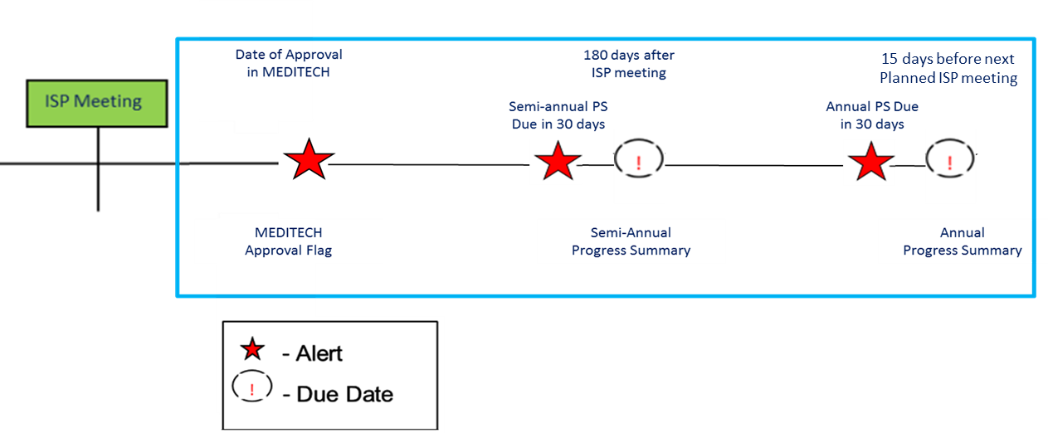

In some circumstances, it is more appropriate to complete a Progress Summary quarterly. This option will only be taken after a discussion between the Providers and DDS Staff. If the decision is made to complete progress summaries quarterly, four progress summaries are required –quarter 1, semi-annual, quarter 3 and annual forms. The due dates are as follows:

- Quarter 1 – 90 days after the ISP meeting
- Semi-Annual – 180 days after the ISP meeting
- Quarter 3 – 270 days after the ISP meeting
- Annual – 15 days prior to the next planned meeting date or the deadline

When the due date for a Progress Summary is within 30 days, Service Coordinators and Provider Data Entry Users will receive an Alert indicating that the Provider is able to complete the Progress Summaries.
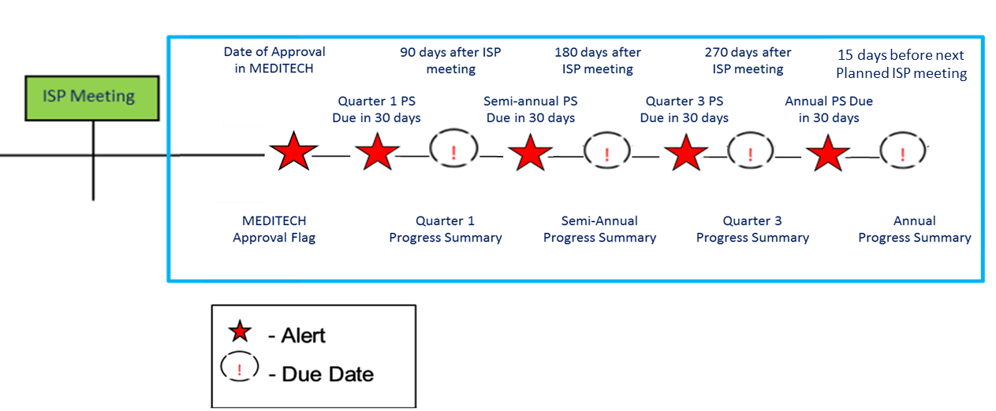

Note: The due date for the annual Progress Summary is calculated differently from the other deadlines. The quarter 1, semi-annual, and quarter 3 progress summaries due date are calculated based on the actual ISP meeting date. For example, the deadline for the semi-annual form is 180 days after actual ISP meeting date. The annual Progress Summary, on the other hand, is calculated based on the next planned meeting date or if no planned meeting date is entered, the ISP meeting deadline. To remind you of this difference, an info tip is located next to the “Annual” Progress Summary in the Progress Summary switchboard which covers these details. When hovering over the info tip the following text appears, “The Annual Progress Summary is due 15 days before the deadline date for the next year’s plan, which is 350 days after the last Actual Meeting date. However, once the next plan is opened (90 days prior to the Planned Meeting Date/Deadline Date), the due date will update and appear as 15 days prior to the new Planned Meeting Date. If there is no Planned Meeting Date entered, the due date will remain as 15 days prior to the deadline date.”

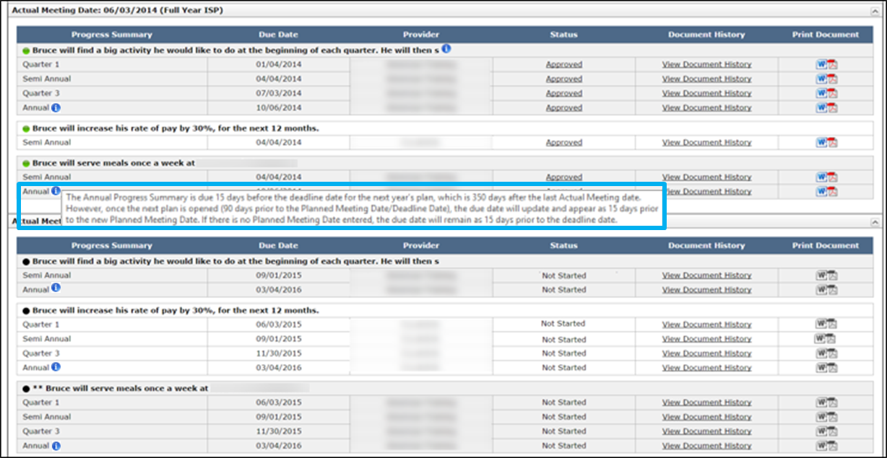
It is also important to note the following:
- If plan creation is delayed because previous plan is unlocked, the due date will remain the deadline date – 15 days (or 350 days after the last Actual Meeting Date) until the plan is opened.
- The due date of an Approved annual Progress Summary will remain the deadline date- 15 days if the Progress Summary is approved prior to the new plan being opened. If revision is requested and the new plan is opened, the due date may be out of sync with the Planned Meeting Date as the due to the Annual Progress Summary will continue to be deadline date – 15 days (or 350 days after the last Actual Meeting Date). The reason the Annual Progress Summary due is not updated if the Progress Summary is in approved status is because, the due date was updated after the Progress Summary was approved, the due date of an approved progress summary may appear in the future if the Planned Meeting Date is in the future, and alerts may be triggered again.
- When the Planned Meeting Date is entered between 6 and 12 months after the last Actual Meeting Date, the due date for the Annual Progress Summary may change to be prior to the due date for Quarter 3, or will limit the reporting period time for the annual progress summary. The user will ask the Help Desk to delete any outstanding PS that are due past the annual Progress Summary.
- The Planned Meeting Date is entered over 12 months after the last Actual Meeting Date, the Annual PS will change to be due greater than 6 months after the Semi-Annual.
- If the user does not enter next year’s Planned Meeting Date until close to the date OR the Planned Meeting Date is moved forward or backwards once the due dates are calculated, the due date of the Progress Summary will shift from the deadline date to the Planned Meeting Date. This may impact the ability of a Provider to submit a Progress Summary that has been started, or that revision has been requested on, if the date moves out past the 30 day submission deadline.
- The alert for Annual Progress Summaries will go out 45 days prior to the Planned Meeting Date (or deadline date if there is no Planned Meeting Date), letting the user know that the PS are due in 30 days.
- Annual Progress Summaries will be due at the same time the objectives and assessments are due for the ISP.

Initiate Progress Summaries by DDS Staff
Scenario Description:
With the addition of the Progress Summaries process to the system, DDS staff are now required to complete steps on the system to initiate the Progress Summary process. Specifically, DDS staff are required to select Objectives to include in the ISP Document. Until Progress Summaries have been initiated by the DDS user, Providers will be unable to access and complete the forms.

- DDS staff is required to initiate the Progress Summary process. Until the process has been initiated, Providers are unable to access the form to complete Progress Summaries.
- Progress Summaries are initiated after the Actual Meeting Date has been entered in MEDITECH and is pulled into HCSIS, while selecting Approved Objectives for inclusion in the ISP Document
- These Objectives must be approved to be selected for inclusion in the ISP Document and for Progress Summaries to be triggered.
- When initiating Progress Summaries, the DDS user can also select the frequency for submission of the Progress Summaries related to each Objective as Semi- Annual or Quarterly. The default frequency is Semi-Annual.

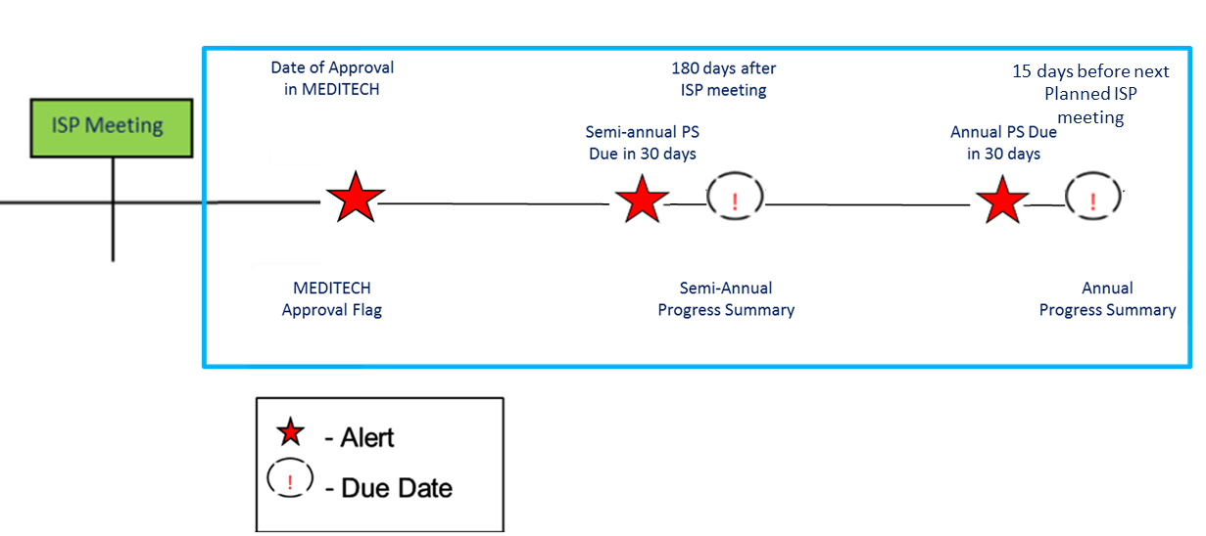

First Steps:

- Search for an individual
- View the Individual Dashboard

Roles and Responsibilities:
- Service Coordinator: Initiate Progress Summaries
- Service Coordinator Supervisor: Initiate Progress Summaries

- Click on the “Objectives” tab from the Individual’s Dashboard or the Objectives and Support Strategies box on the Individual Dashboard to be redirected to the Objectives and Support Strategies Review Switchboard.

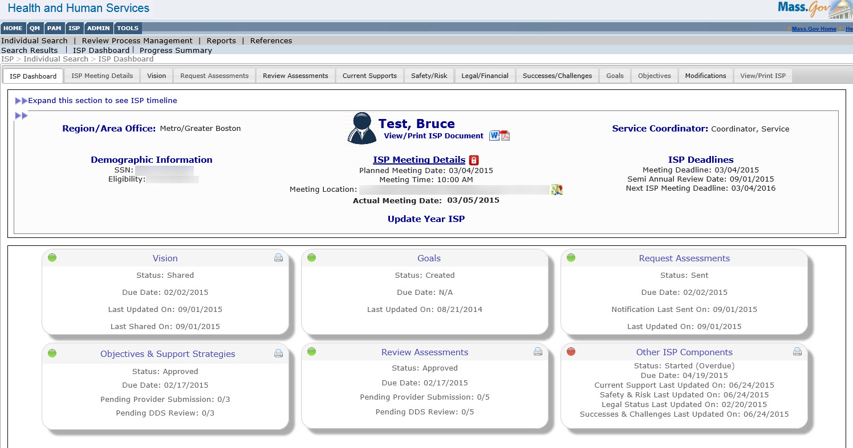

- On the Objectives and Support Strategies Review Switchboard, select the Objectives that you would like to include in the ISP Document using the checkboxes in the column titled, “Include in ISP Doc?”

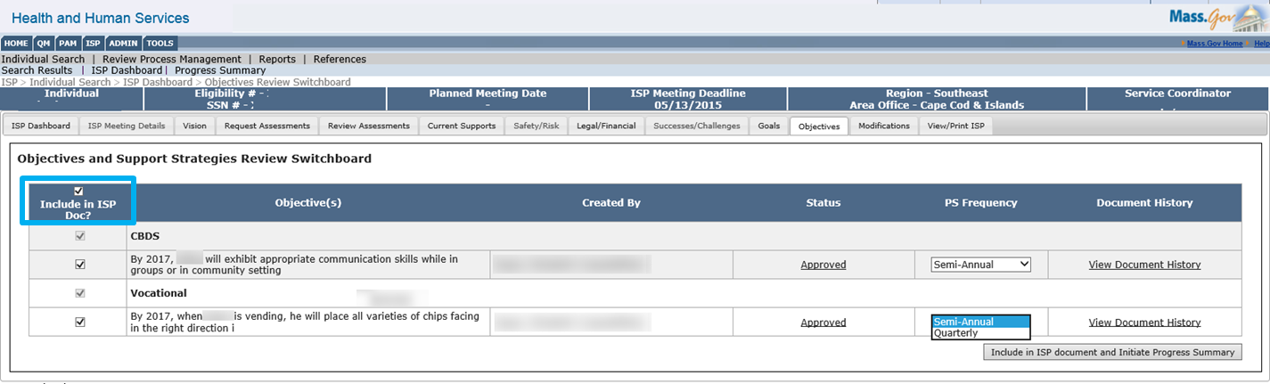

Note: Two conditions must exist for you to include Objectives in the ISP Document. The Actual Meeting Date needs to be entered in MEDITECH and the Objective needs to be in an Approved status. If either of these conditions is not met, the checkboxes will be greyed out and it is not possible to select Objectives for inclusion.

- If desired, change the Progress Summary Frequency for an Objective by selecting one of the two options in the “PS Frequency” drop down, Semi-Annual or Quarterly.

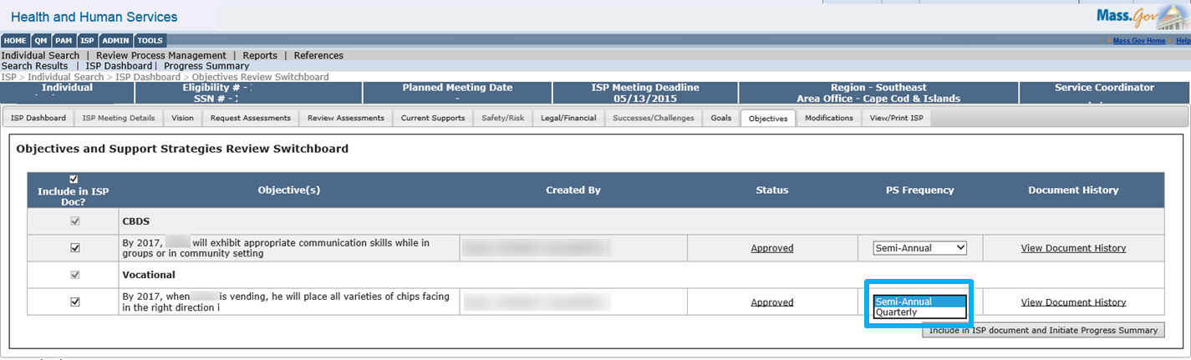

Note: The system defaults to “Semi-Annual.” If Semi-Annual is selected, Providers will be required to complete two Progress Summaries– a semi-annual Progress Summary and an annual Progress Summary. If Quarterly is selected, Providers will be required to complete four Progress Summaries throughout the year – Quarter 1, Semi-Annual, Quarter 3 and Annual.

Note: The due date for the annual Progress Summary is calculated differently from the other deadlines. The quarter 1, semi-annual, and quarter 3 progress summaries due date are calculated based on the actual ISP meeting date. For example, the deadline for the semi-annual form is 180 days after actual ISP meeting date. The annual Progress Summary, on the other hand, is calculated based on the next planned meeting date or if no planned meeting date is entered, the ISP meeting deadline.

Note: Should the user change the Progress Summary frequency after Progress Summaries have been started, no previously worked on Progress Summaries will be affected by the change, as it will only be implemented moving forward. Additionally, should the user increase the frequency of the Progress Summaries from semi-annual to quarterly, no Progress Summaries with a due date that has already passed will be initiated. For example, if the frequency is changed to quarterly after the due date of Quarter 1, no Progress Summary will be required for Quarter 1, but one will be required semi-annual and for Quarter 3.

Note: The DDS user will also be able to make changes to the frequency of future Progress Summaries when reviewing Progress Summaries.

- Click the “Include in ISP document and Initiate Progress Summary” button.
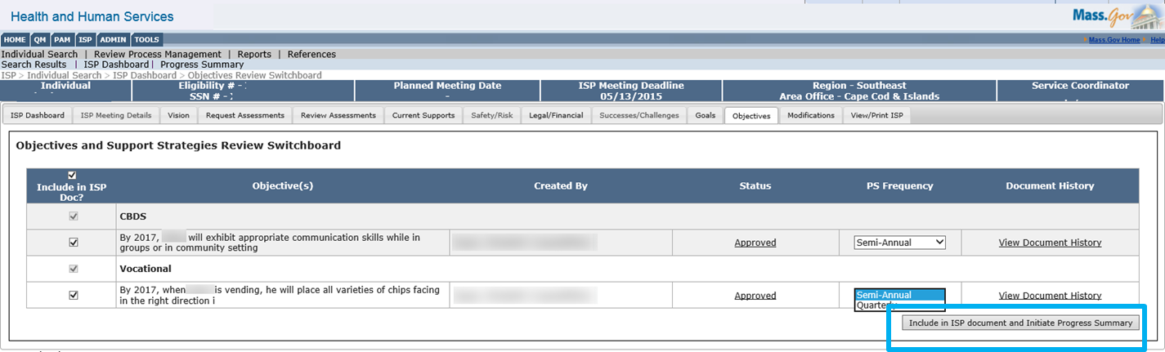

An Operation Successful message will display

- Click the “Progress Summary” third level menu link to navigate to the Progress Summary Review Switchboard and view the initiated Progress Summaries.
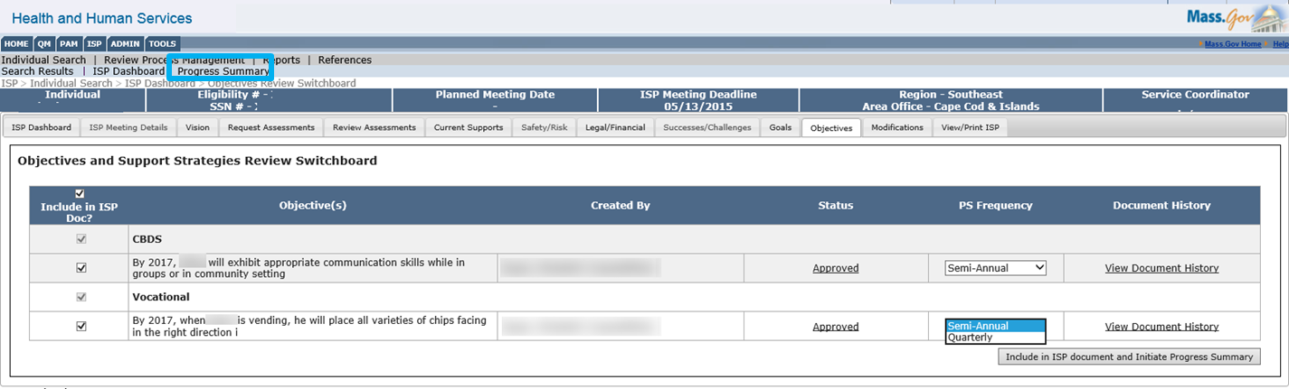

The system will display the Progress Summary Review Switchboard. The Progress Summary Bar graph, located at the top of the switchboard, and the Progress Summary Details Table, located beneath the bar graph, will both populate. The Progress Summary Bar Graph, which is a visual representation of the status for progress summaries, will be updated to account for the newly initiated Progress Summaries. The Progress Summary Details Table, which displays the details for all of the progress summaries that were required in the prior year as well as those required in the current year, will display all of the newly initiated Progress Summaries in "Not Started" status.

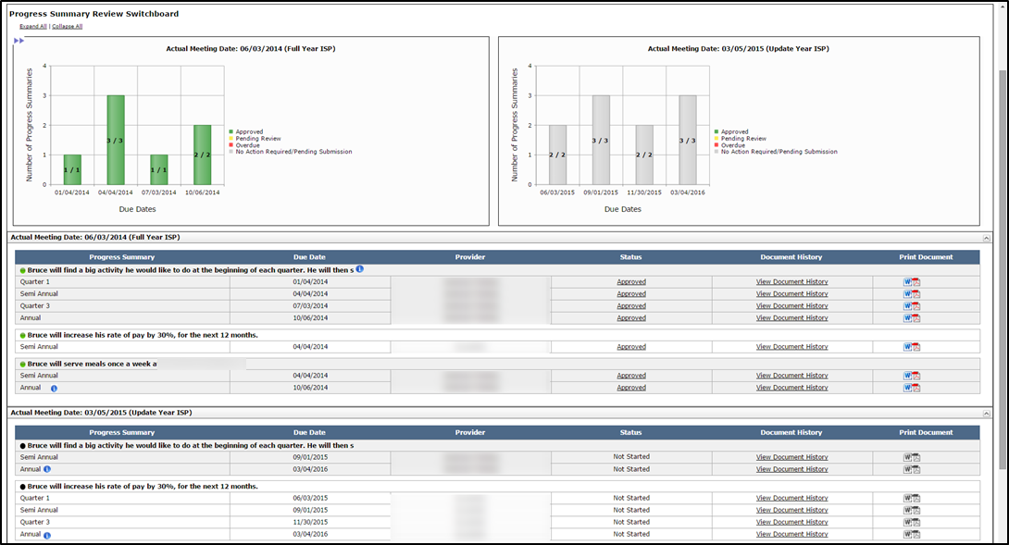

Next Steps:

- Progress Summary Review Switchboard will display Progress Summaries for the objectives included in the ISP document.
- The status of all newly requested Progress Summaries is in “Not Started” status.
- Providers can access the Progress Summary in not started status and complete the Progress Summary but they cannot submit to a Service Coordinator until it is 30 days prior to the due date.
- Providers and SCs will receive an Alert 30 days prior to the due date of the Progress Summary,
- On Tuesdays and Fridays, SCs will receive an Alert that lists the Progress Summaries submitted (if any) by Providers
- On Tuesdays and Fridays, SCs will receive an Alert that indicates if the due date for any Progress Summary has passed without the provider submitting the form.
- Service Coordinators can change the frequency of a Progress Summary up to the point the plan is locked. Please note that Area Office Director have the ability to unlock the plan If frequencies are changed, only those Progress summaries due going forward will be required.
- Once the provider has begun work on a Progress Summary, Service Coordinators cannot unselect the associated objective and remove it from the ISP document. If the objective was included in error, however, Service Coordinators can call the helpdesk to have the “Started” Progress Summary deleted prior to unselecting the objective from inclusion in ISP document.
- If a service has ended prior to the ISP meeting, and a Progress Summary has not yet been completed, the Progress Summary must be completed off-line on paper. The ending of a service removes the ability for the provider to enter this information in HCSIS. However, the Progress Summary is still required. We will address this issue in a future release.

Complete a Progress Summary by Provider
Scenario Description:
Once the due date for a Progress Summary is within 30 days, Provider Data Entry Users will receive an alert indicating that they are able to complete and submit the Progress Summary. In order to submit a Progress Summary, Provider Data Entry Users need to submit the form to Provider Supervisors who need to review the document and determine if it is ready to submit to DDS. While both roles can work on these forms prior to 30 days before the due date, as long as the Service Coordinators has initiated the Progress Summary process, they cannot submit the form until 30 days prior to the deadline.

First Steps:
- Navigate to Alerts
Roles and Responsibilities:
- Provider Data Entry User: Submit a Progress Summary for Internal Review
- Provider Supervisor: Review a Progress Summary; Submit a Progress Summary to DDS Staff

Part I: Completing a Progress Summary and Submitting for Internal Review by a Provider Data Entry User

The following steps are completed by a Provider Data Entry User

- Data Entry Users will receive an alert 30 days prior to the Progress Summary Due Date. Click the “Progress Summaries due” link in the Alert message.
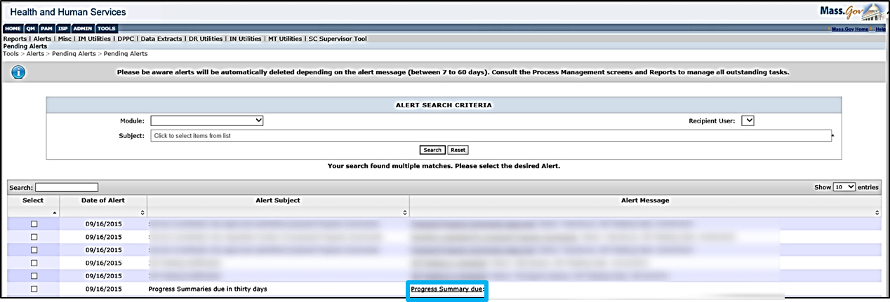

Note: The system will redirect to the Progress Summary Switchboard.

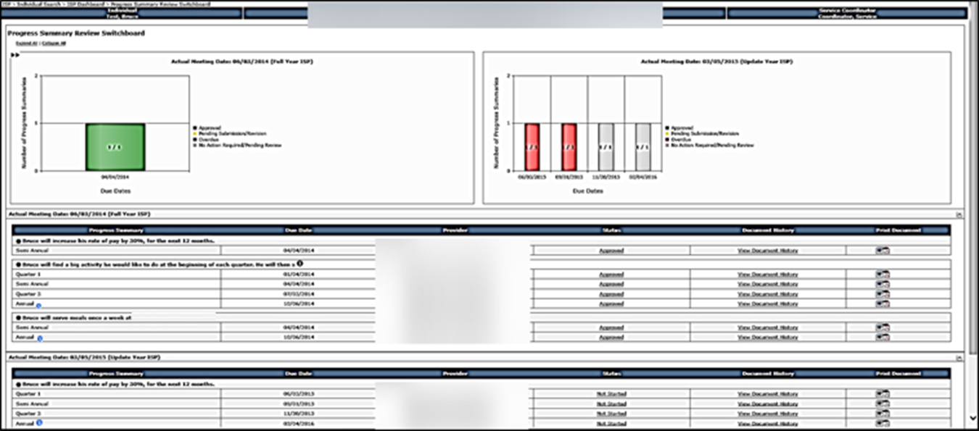

Note: Providers will have access to the switchboard and will have the ability to begin work on any initiated Progress Summaries at all times. Providers will not, however, be able to submit the forms until it is 30 days before the Progress Summary Due Date. This is to ensure that the information remains up to date.

Note: Annual Progress Summaries are due at the same time as Assessments and Objectives. The annual due date for a Progress Summary is 15 days prior to the next year's planned meeting date. The due date from the Annual Progress Summary is calculated when the next year’s plan opens. Until that time, the annual Progress Summary due date will be calculated as 15 days prior to the deadline or Actual Meeting date +350 days.

- To navigate to the Progress Summary form, click on the “Not Started” link in the Status column on the Progress Summary Review switchboard.

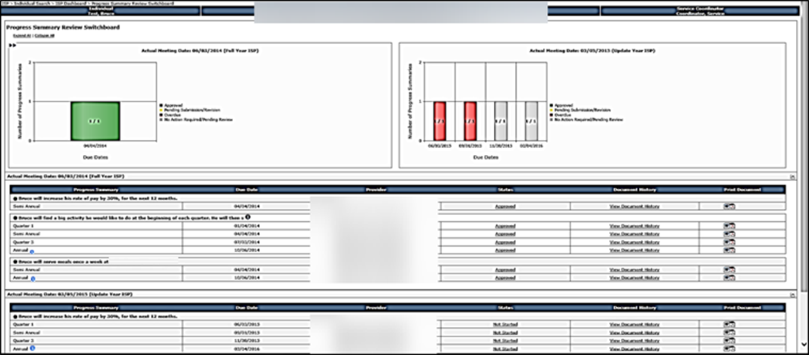

- The system will display the Progress Summary Form. By default all fields are expanded but these sections can be collapsed and expanded as required, using the (+) and (–) signs.

Note: The “Goal”, “Objective” and “Support Strategy” for the identified objective are available for reference on the Progress Summary Form.

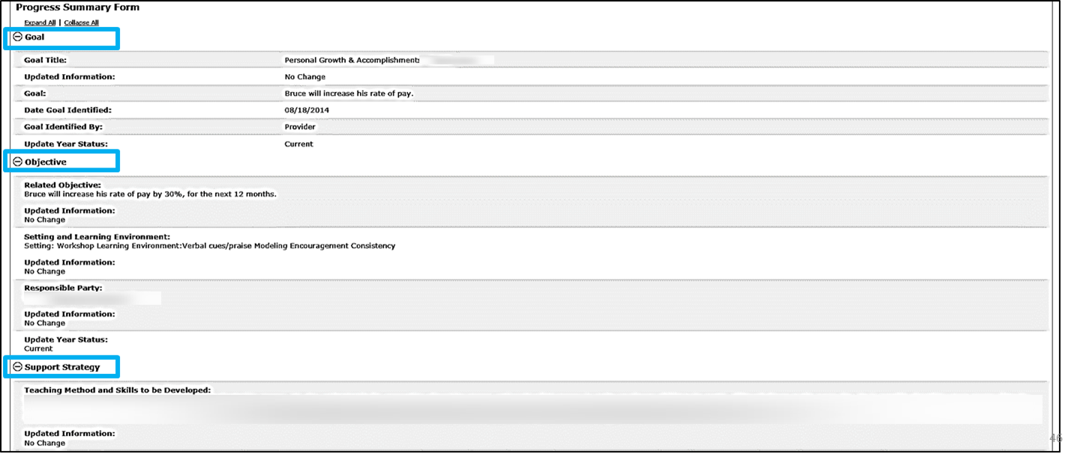

Note: Previous Progress Summaries completed for the same Objective & Support Strategy are available for reference on the Progress Summary Form.
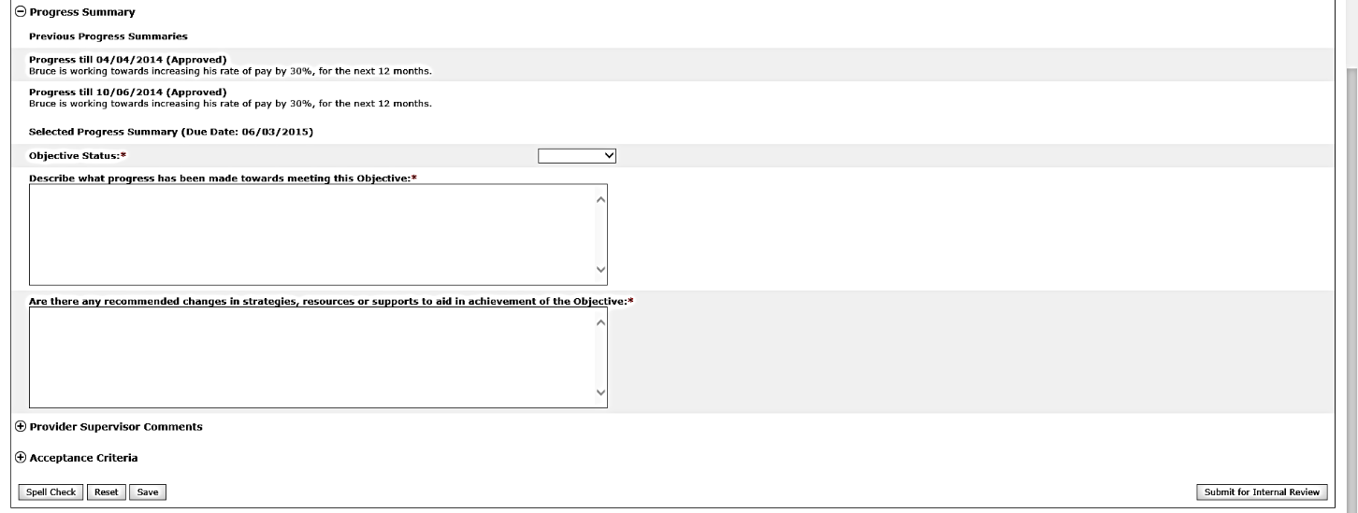

- Select the status of the objective from the drop-down list from Met, Partially Met, and Discontinued.
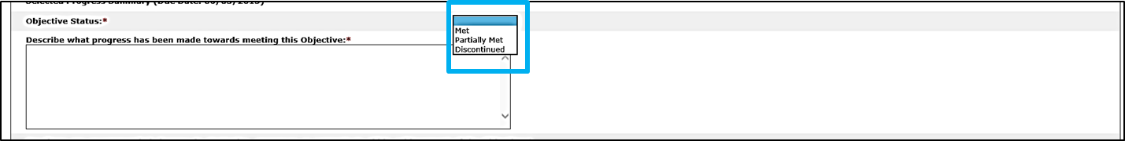

Note: The table below explains the Progress Summary status types.

Objective Status | Description
Met | Use to describe an objective that has been achieved by the individual
Partially Met | Use to describe an objective that has been partially completed but continues to remain open
Discontinued | Use to identify an objective that is no longer relevant for the individual or has ended.

Note: If a Provider either chooses Met or Discontinued status for a Progress Summary in a Semi-Annual Progress Summary, no future Progress Summary will be required. For example if a Progress Summary with a quarterly frequency is deemed Met in the Semi-Annual Progress Summary, the Quarter 3 and Annual Progress Summary are no longer required and will no longer display on the Progress Summary Switchboard.

- Respond to the required questions by entering comments into the text boxes. The first question is “Describe what progress has been made towards meeting this Objective.” The second question is “Are there any recommended changes in strategies, resources or supports to aid in achievement of the Objective.”
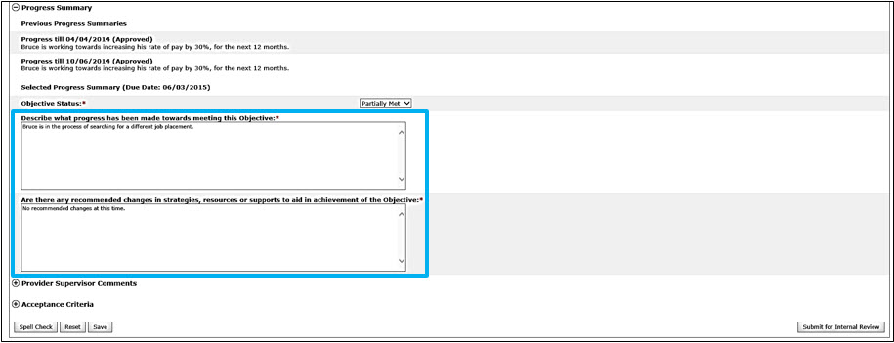

- Once all mandatory fields have been completed, click “Submit for Internal Review” to submit the Progress Summary to the Provider Supervisor for review.
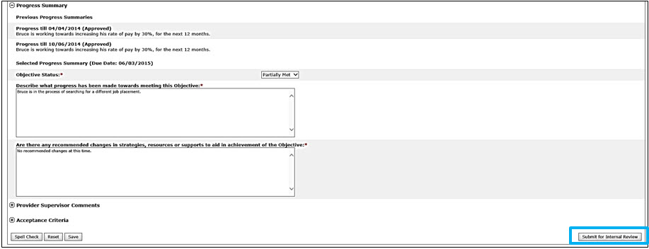

Note: Another option is to click “Save.” This will save your progress and allow you to return at a later time to complete the form.
Note: In some Provider agencies, the same individual has the Data Entry User role and the Provider Supervisor role. Such individuals are able to complete a Progress Summary using the Provider Supervisor role and have the option of submitting directly to DDS.
Part II: Reviewing Progress Summary Submitted for Internal Review and Requesting Internal Revision by a Provider Supervisor

The following steps are completed by a Provider Supervisor

- Provider Supervisors will receive an alert when a Progress Summary has been submitted for internal review. Click the “Progress Summaries Submitted for Internal Review” link in the Alert message.
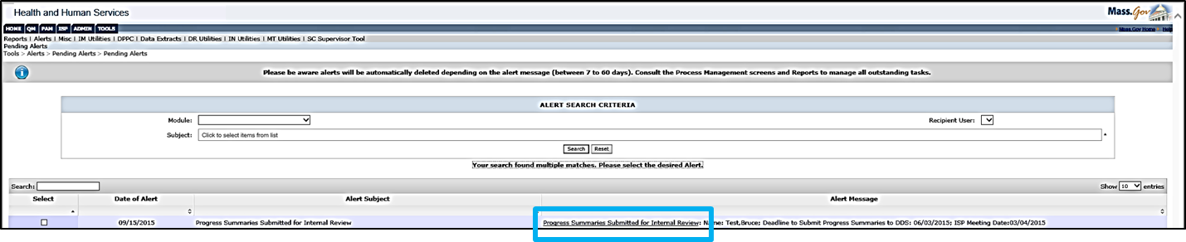

The system redirects to the Progress Summary Switchboard.

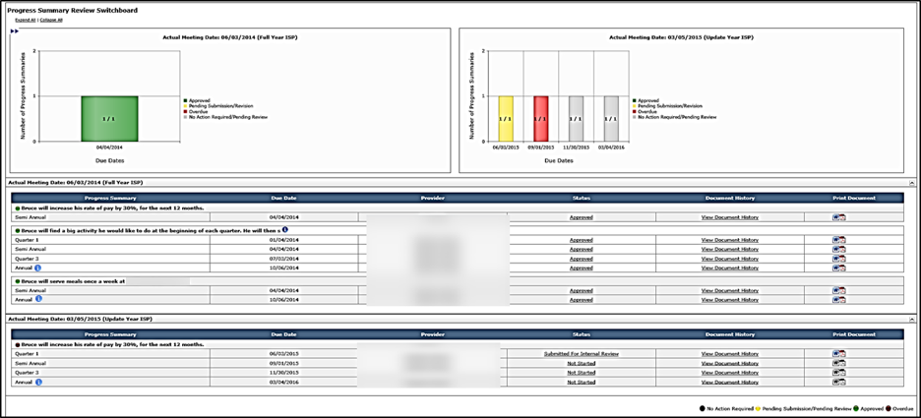

Note: The Progress Summary Bar Graph will update to account for changes in the status of Progress Summaries.

- To navigate to the Progress Summary form, click the “Submitted for Internal Review” link in the Status column.

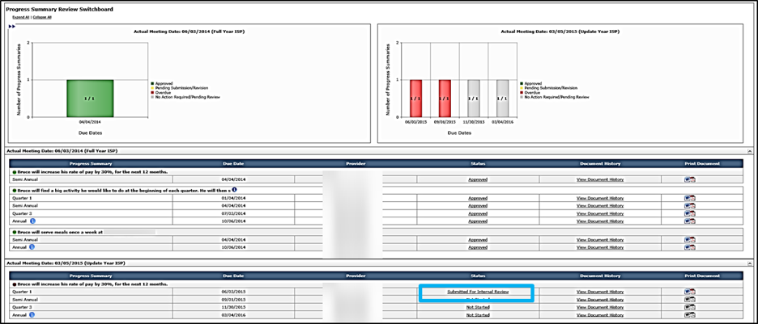

- Review the content that the Data Entry User has entered.
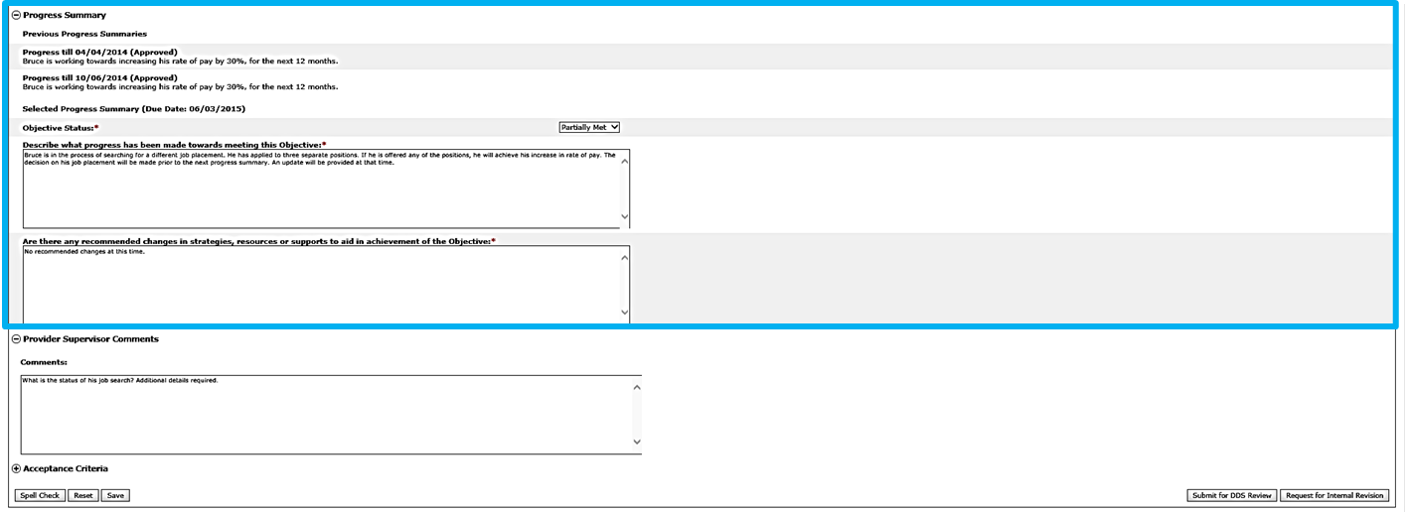

Note: The “Goal”, “Objective,” “Support Strategy” and previous Progress Summaries for the identified objective are available for reference on the Progress Summary Form.

- If any changes are required or information needs to be added, insert text in the Provider Supervisor Comments field to explain the required revisions

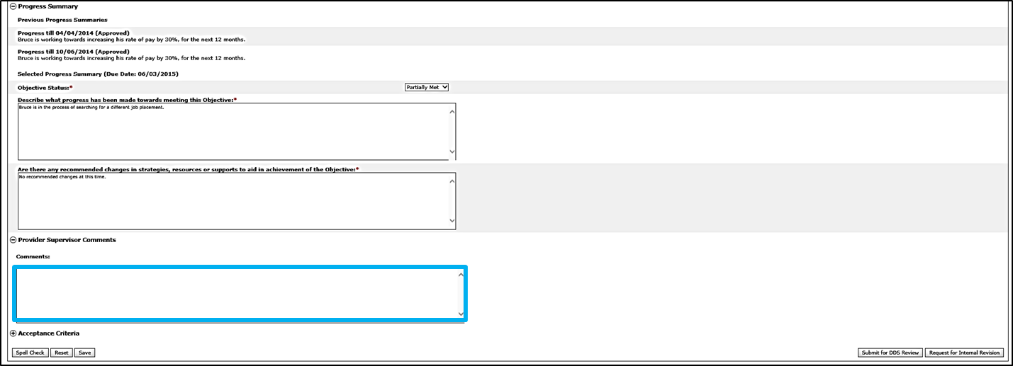

Note: Provider Supervisors now also have the ability to request internal revisions from Data Entry Users on Objectives and Assessments.

- Click “Request Internal Revision.”

This action will send an alert to the Data Entry User that revision was requested and the status on the Progress Summary Switchboard will change to “Revision Requested.”

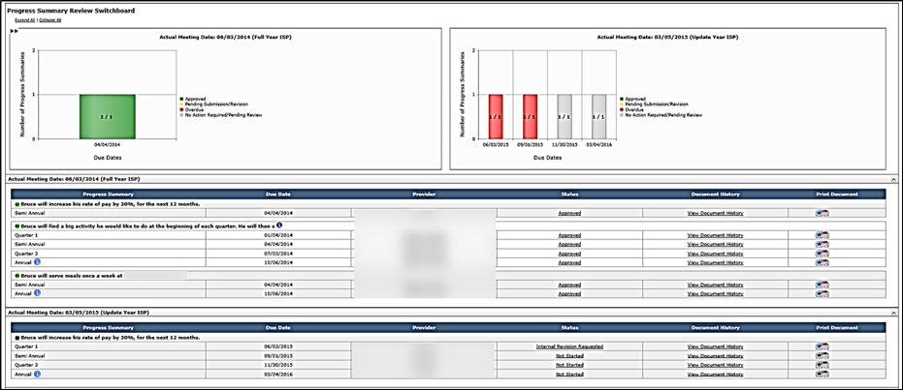

Part III: Revising and Submitting a Progress Summary for Internal Review by a Provider Data Entry User

The following steps are completed by a Provider Data Entry User

- Once a form is returned for revision, Provider Data Entry Users will receive an alert. Click the “Revisions Requested for Proposed Progress Summaries” link in the Alert message.
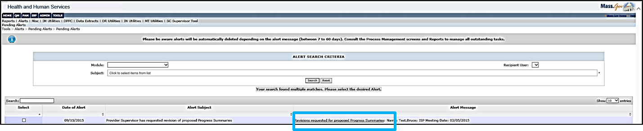

The system will redirect to the Progress Summary Switchboard and the Progress Summary will display in “Internal Revision Requested” status.

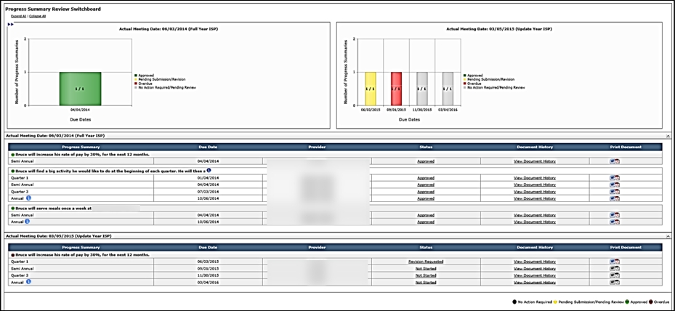

- To navigate to the Progress Summary Form, click the “Internal Revision Requested” link in the Status column.
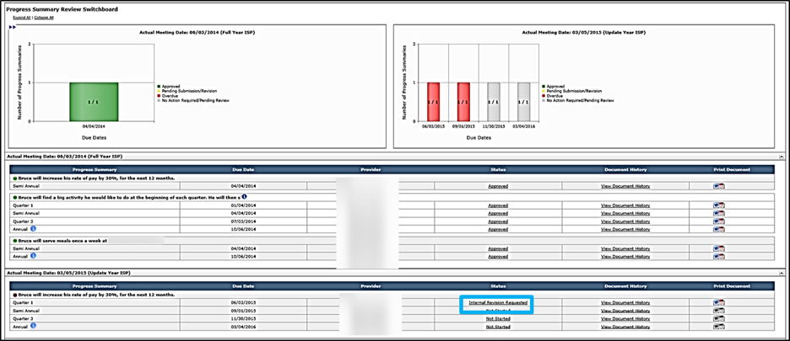

- Review the “Provider Supervisor Comments” entered by the Provider Supervisor user during the internal review.

- Revise the Progress Summary sections in response to the comments made by the Provider Supervisor.
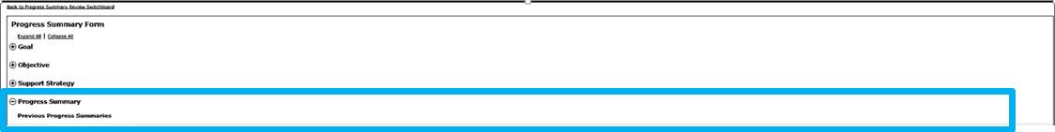

- Click “Submit for Internal Review” to resubmit to the Provider Supervisor.

- The system redirects to the Progress Summary Switchboard and the status of the Progress Summary changes to “Submitted for Internal Review.”

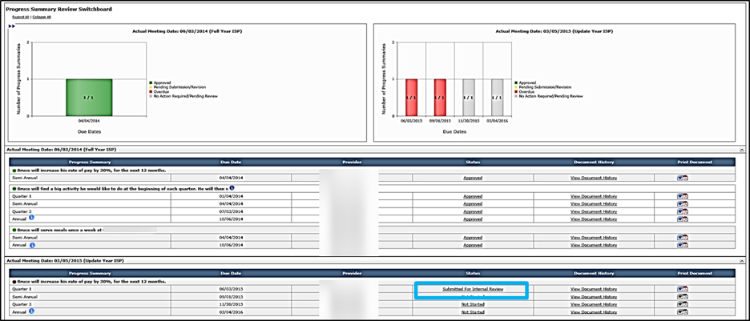

Part IIII: Reviewing a Progress Summary Submitted for Internal Review and Submitting to DDS by a Provider Supervisor

The following steps are completed by a Provider Supervisor:

- Provider Supervisor will receive an alert when a Progress Summary has been submitted for internal review. Click the “Progress Summaries Submitted for Internal Review” link in the Alert message.

The system redirects to the Progress Summary Switchboard with the Progress Summary in “Submitted for Internal Review” status.

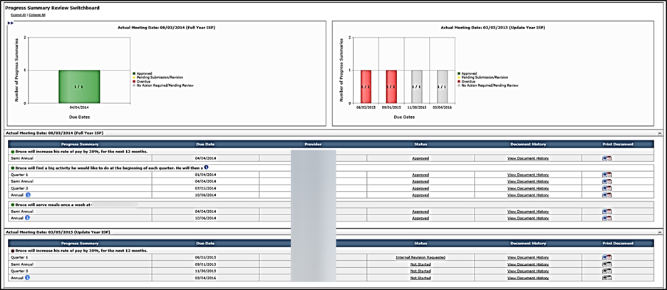

- To navigate to the Progress Summary Form, click the “Submitted for Internal Review” link in the Status column.

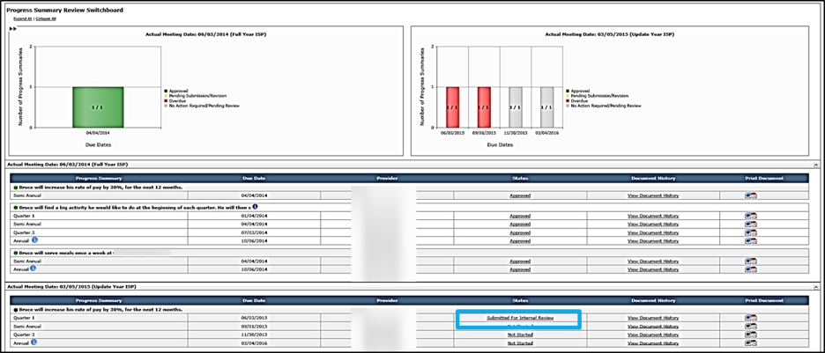

- Review the Progress Summary Form. This section is editable, and the Provider Supervisor user may make edits to the form prior to submitting for DDS review.

Note: When approving a Progress Summary, there is no action required in the “Provider Supervisor Comments” textbox. They are not visible to DDS in the submitted form.

- Click “Submit for DDS Review.”
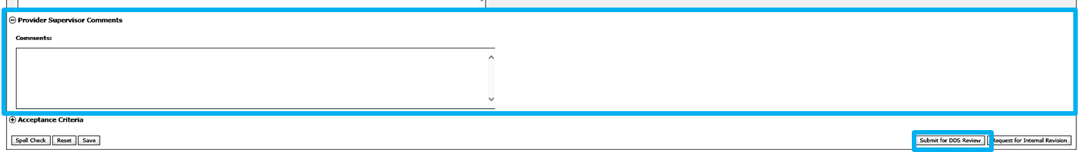

- The system will redirect to the Progress Summary Switchboard. The status of the Progress Summary will change to “Submitted for DDS Review.”

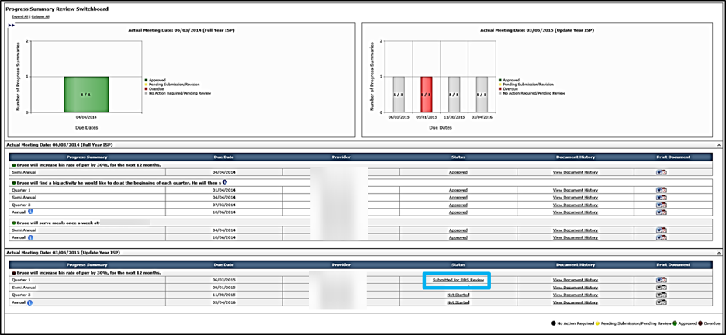

Next Steps:

- Provider Data Entry Users and Provider Supervisors should continue tracking progress of the Objective and Support Strategies off-line in progress notes. They may also begin entering data into later Progress Summaries, but will not be able to submit until 30 days prior to the due date.
- Service Coordinators will be responsible for reviewing the Progress Summary. They will have the options to approve or request revision to the Progress Summary based on acceptance criteria.
- Provider Data Entry Users and Provider Supervisors can monitor the individual’s ISP Progress Summary Switchboard to view the status of the Progress Summary.
- Provider Data Entry Users and Provider Supervisors will receive an alert if the Service Coordinator has approved a submitted Progress Summary.
- Provider Data Entry Users and Provider Supervisors will receive an alert if the Service Coordinator requests revision of proposed Progress Summaries
- The availability of Progress Summaries in the system is the responsibility of the Service Coordinator. The Progress Summary will only display in the system after the Service Coordinator has marked the objectives as included in the ISP. If a Progress Summary is not yet available to you, please contact the Service Coordinator.
- The Service Coordinator has the ability to change the frequency of Progress Summaries for an objective, after consulting with the provider staff. If the Service Coordinator changes the frequency from quarterly to semi-annual, only the semi-annual and annual Progress Summaries are required.
- If a service has ended prior to the ISP meeting, and a Progress Summary has not yet been completed, the Progress Summary must be completed off-line on paper. The ending of a service removes the ability for the provider to enter this information in HCSIS. However, the Progress Summary is still required. We will address this item in a future release.

Reviewing and Requesting Revision of a Progress Summary by DDS Staff
Scenario Description:
Once a Provider Agency has submitted a Progress Summary for DDS review, Service Coordinators or Service Coordinator Supervisors are responsible for reviewing the Progress Summary and determining whether the form meets the acceptance criteria or requires revisions.
First Steps:
- Navigate to Alerts

Roles and Responsibilities:
- Service Coordinators: Review Form, Request Revision, Approve
- Service Coordinator Supervisors: Review Form, Request Revision, Approve

- Service Coordinators will receive an alert every Tuesday and Friday for any Progress Summary submitted for review by Provider agencies.Click on the “Progress Summaries submitted for review” link in the alert message.

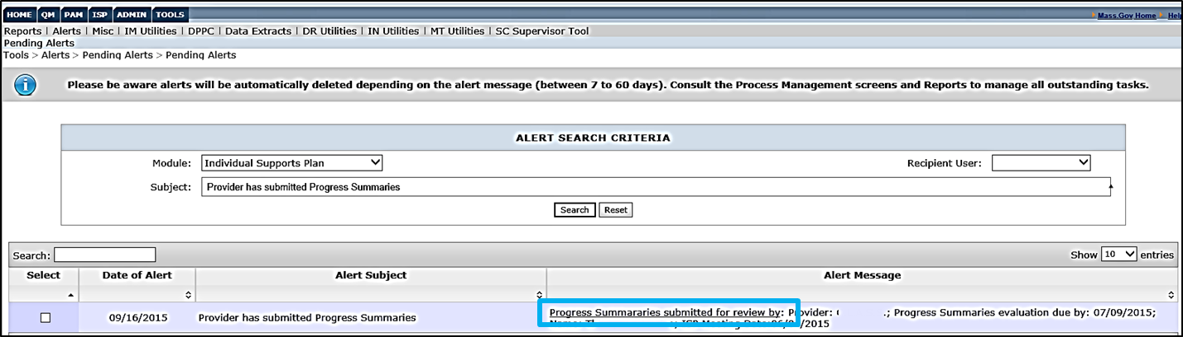

The system will redirect to the Progress Summary Review Switchboard. The submitted Progress Summaries will appear in “Submitted for DDS Review” status.
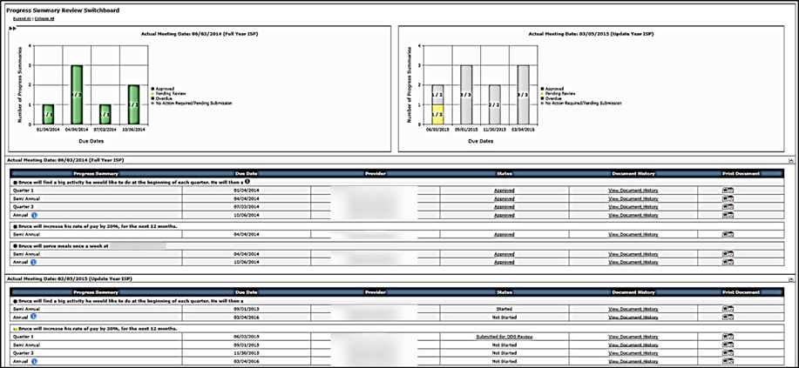

- To navigate to the Progress Summary Form, click the “Submitted for DDS Review” link in the Status column.

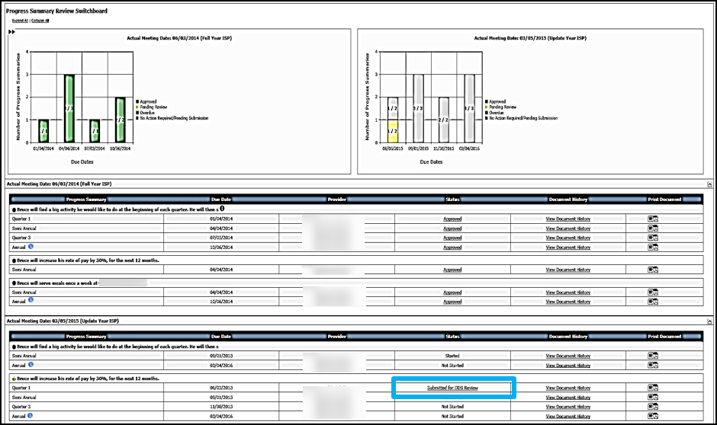

- The system will display the Progress Summary Form. By default all fields are expanded but these sections can be collapsed and expanded as required, using the (+) and (–) signs.

Note: The “Goal”, “Objective” and “Support Strategy” for the identified objective are available for reference on the Progress Summary Form.

Note: Previous Progress Summaries completed for the same Objective & Support Strategy are available for reference on the Progress Summary Form.

- Review the Progress Summary information submitted by the Provider.
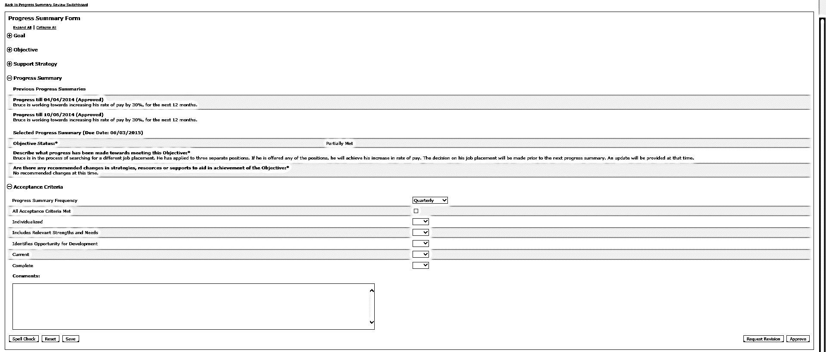

- Complete the “Acceptance Criteria” Section by selecting values from the dropdown, or selecting the checkbox for “All Acceptance Criteria Met” to populate the dropdowns below.

- If desired, use the drop down to change the Progress Summary Frequency

Note: If you opt to change the frequency, this will modify the progress summaries displayed in the Progress Summary Review Switchboard. Changing the frequency will not have an impact on previously started or submitted Progress Summaries, or on Progress Summaries for which the due dates have passed. This change in frequency will only be applied for Not Started Progress Summaries with future due dates.

- If there is a need to return a Progress Summary for revision, at least one acceptance criteria must not be met and reflect a status of “No.” Select the “No” dropdown for the category that requires revision.
- Insert text in the “Comments” text box to explain why the acceptance criteria was not met.

Note: If you have indicated that at least one of the acceptance criteria is not met, you are then required to enter text in the Comments text box to explain why the acceptance criteria was not met and to explain what revisions are required.

- Click “Request Revision.”

The system will redirect to the Progress Summary Review Switchboard. The status of the form will change to “Revision Requested.”

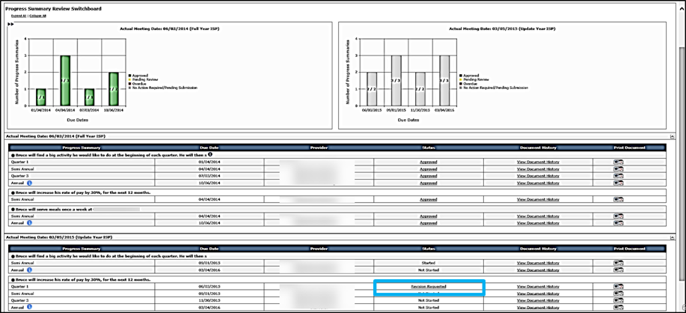

Note: The Progress Summary Bar Graph has changed colors. The yellow indicates that activity needs to be performed by the logged on user.

Reviewing and Revising a Progress Summary by Provider Staff
Scenario Description:
After DDS reviews and requests revision of a Progress Summary, Providers are responsible for making revisions and resubmitting the form to DDS for review.

First Steps:
- Navigate to Alerts

Roles and Responsibilities:
- Provider Data Entry Role : Submit a Progress Summary for Internal Review
- Provider Supervisor: Review a Progress Summary; Return a Progress Summary for Internal Revision; Submit a Progress Summary to DDS Staff

Part I: Revising a Progress Summary Returned for Revision by DDS and Submitting for Internal Review by a Provider Data Entry User

The following steps are completed by a Data Entry User

- Provider Data Entry Users will receive an alert indicating that DDS has returned a Progress Summary for revision. Click the “Revisions requested for proposed Progress Summaries” link in the Alert message.

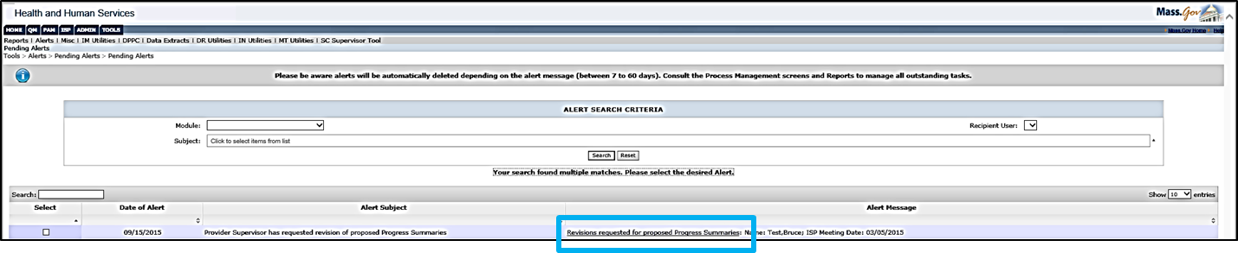

The system redirects to the Progress Summary Switchboard.

- To navigate to the Progress Summary Form, click the “Revision Requested” link in the Status column.
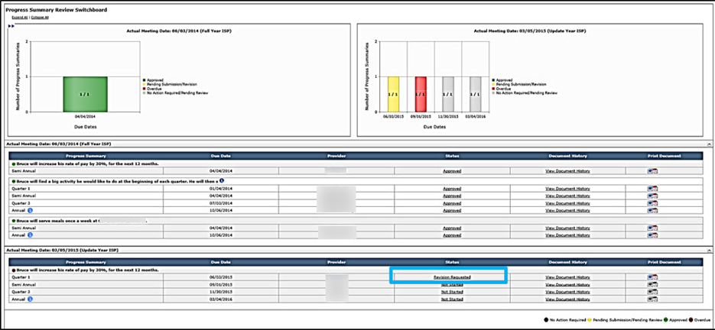

- Review the Acceptance Criteria section and comments from DDS to identify the requested revisions.

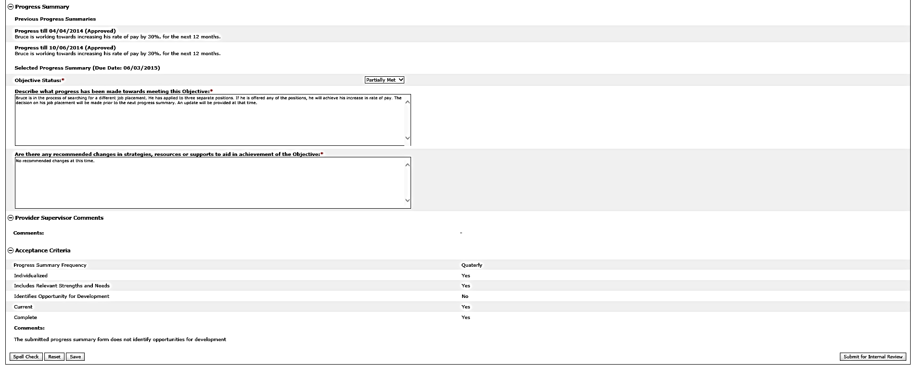

- Revise the Progress Summary Form to incorporate the suggested revisions.

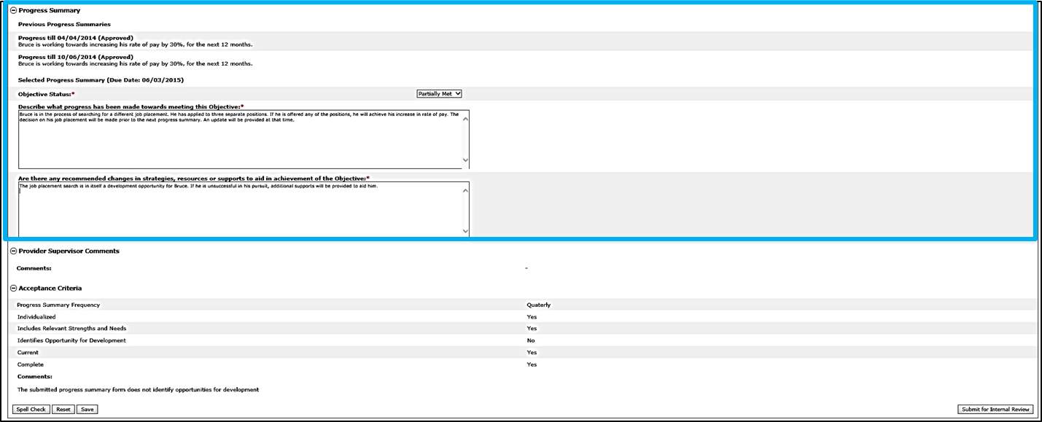

- Click “Submit for Internal Review.”

Note: The Provider Supervisor can Request Internal Revision again if needed.

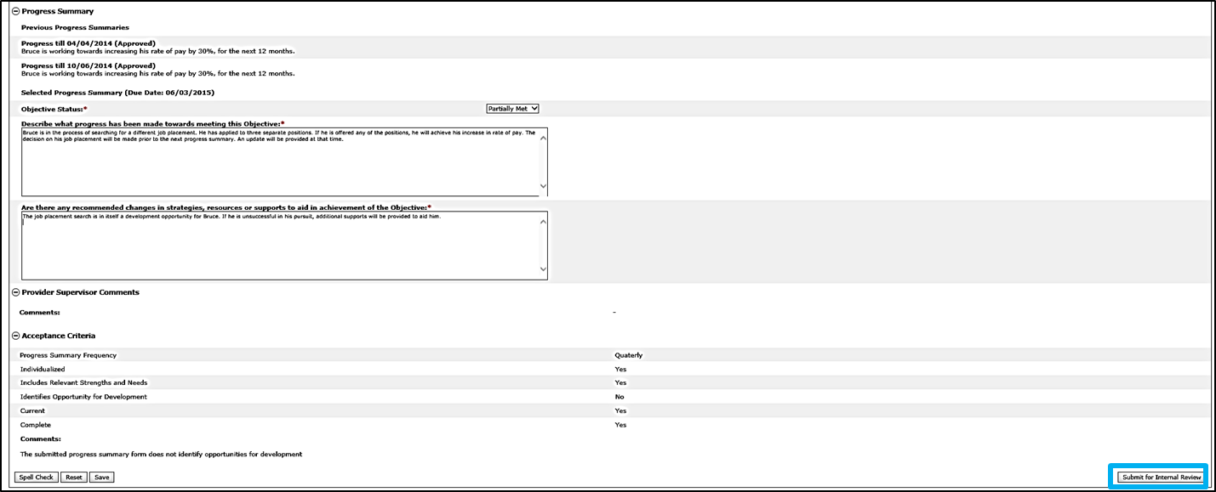

The system will redirect to the Progress Summary Switchboard. The status of the Progress Summary will change to “Submitted for Internal Review.”
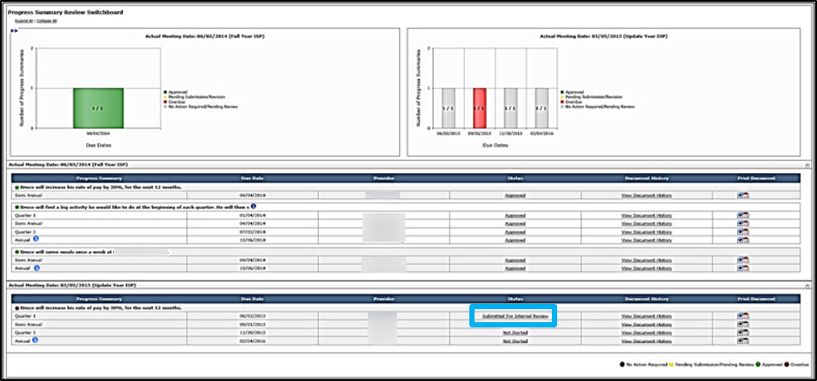

Part II: Reviewing a Progress Summary Submitted for Internal Review and Submitting for DDS Review by a Provider Data Entry User

The following steps are completed by a Provider Supervisor

- Provider Supervisor receives an alert when Data Entry User submits a Progress Summary for internal review. Click on “Progress Summaries Submitted for Internal Review” in the Alert message.

The system will redirect to the Progress Summary Switchboard with the Progress Summary in status “Submitted for Internal Review.”

- To navigate to the Progress Summary Form, click the “Submitted for Internal Review” link in the Status column.
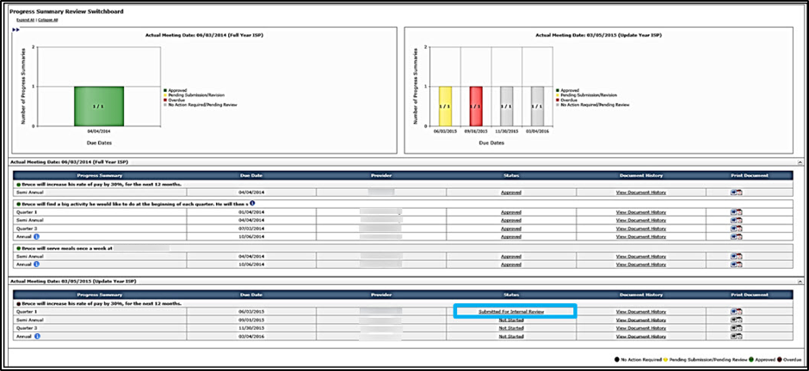

- The system will display the Progress Summary form. By default all fields are expanded.

- Review the “Acceptance Criteria” section to identify what revisions had been requested.

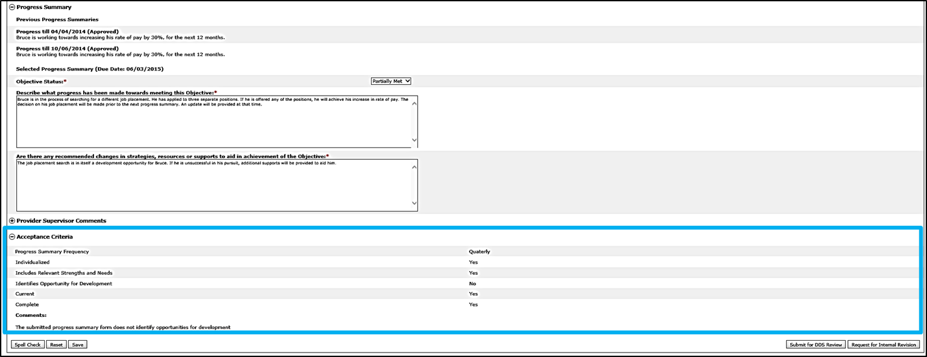

- Review the Progress Summary Form to validate that the requested revisions have been made.

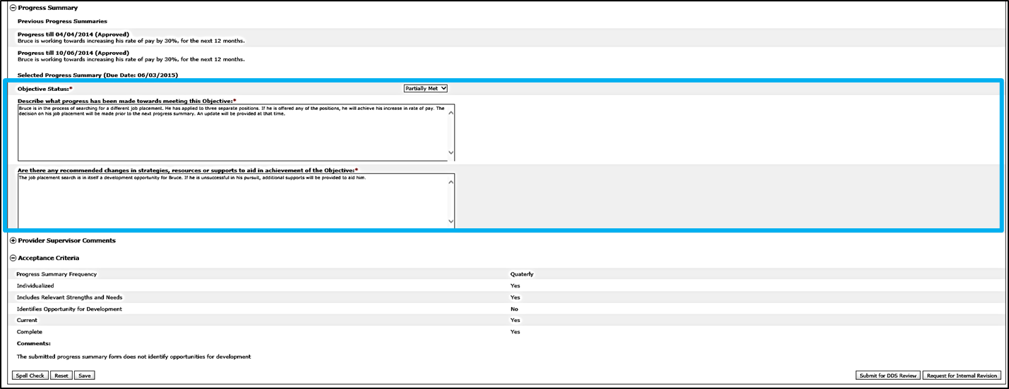

- If all the requested revisions have been applied, click “Submit for DDS Review.”

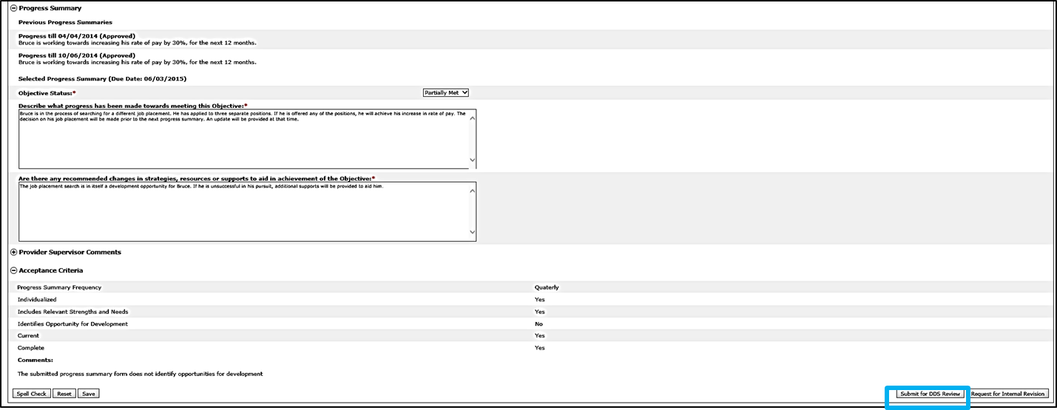

Note: Provider Supervisor can Request Internal Revision again if needed.

The system redirects to the Progress Summary Switchboard and the status of the Progress Summary changes to “Submitted for DDS Review.”
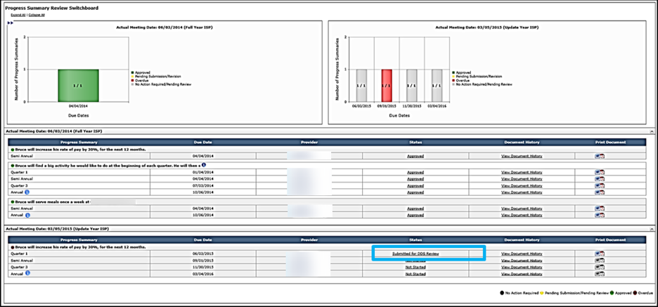

Note: To Print the Progress Summary, click either the Word or PDF icon. Until the Service Coordinator approves the Progress Summary, it will print with a watermark.

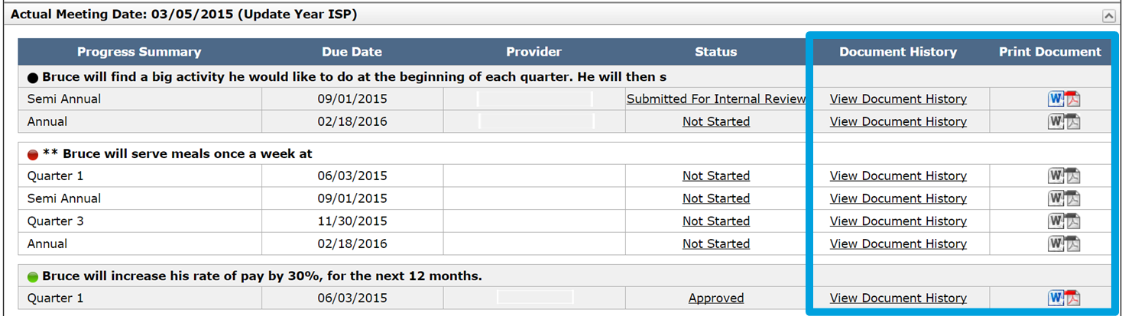

Next Steps

- Provider Data Entry Users and Provider Supervisors should continue tracking progress. If desired, it is possible to access the next Progress Summary and record information in it. It is not possible, however, to submit a Progress Summary until 30 days prior to the due date.
- DDS Staff will be responsible for reviewing the Progress Summary, and approving or requesting additional revision.
- Provider Data Entry Users and Provider Supervisors are able to monitor the individual’s Progress Summary Switchboard to view the progress of any revisions.
- The status of a Progress Summary changes to “Approved” when DDS Staff has approved the Progress Summary.
- Provider Data Entry Users and Provider Supervisors receive an alert when a Service Coordinator approves all of an individual’s proposed Progress Summaries.
- If an OSS is identified as in Met or Discontinued status in a Progress Summary during an ISP update year, the objective will be recalled in the subsequent year.
- If an objective is determined to be met or discontinued as a part of a Semi-annual or Annual Progress Summary, subsequent Progress Summaries for that objective will not be required.

Reviewing and Approving an ISP Progress Summary by DDS Staff
Scenario Description:
Once a Provider submits a Progress Summary, Service Coordinators or Service Coordinator Supervisors are responsible for making revisions and resubmitting the form.

First Steps:
- Navigate to alerts
Roles and Responsibilities:
- Service Coordinators: Review Progress Summary, Request Revision of Progress Summary, Approve Progress Summary
- Service Coordinator Supervisors: Review Progress Summary, Request Revision of Progress Summary, Approve Progress Summary

Once the Provider Agency completes revision, they will submit the Progress Summary back for DDS review. Service Coordinators will receive an alert every Tuesday and Friday for any Progress Summary submitted for review by Provider agencies.

- Click on the “Progress Summaries submitted for review” link in the alert message.

The system will redirect to the Progress Summary Review Switchboard and the resubmitted Progress Summaries will display in “Submitted for DDS Review” status.

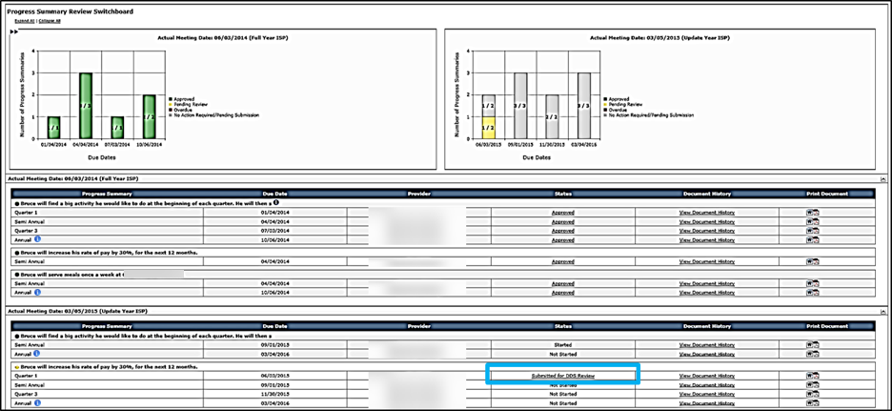

- To navigate to the Progress Summary Form, click the “Submitted for DDS Review” link the Status column.
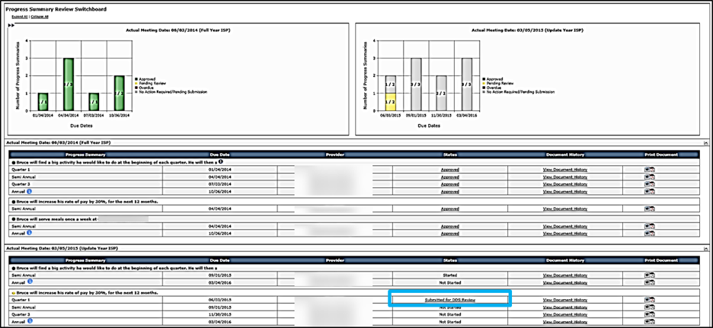

- Review the Progress Summary Form to validate that the requested revisions have been made.

- Complete the “Acceptance Criteria” Section by selecting values from the dropdown. If all revisions have been applied, click “All Acceptance Criteria Met.”

Note: This will convert all of the drop-down fields to “Yes.”

- If no longer applicable, delete or revise the notes in the “Comments” the text box.
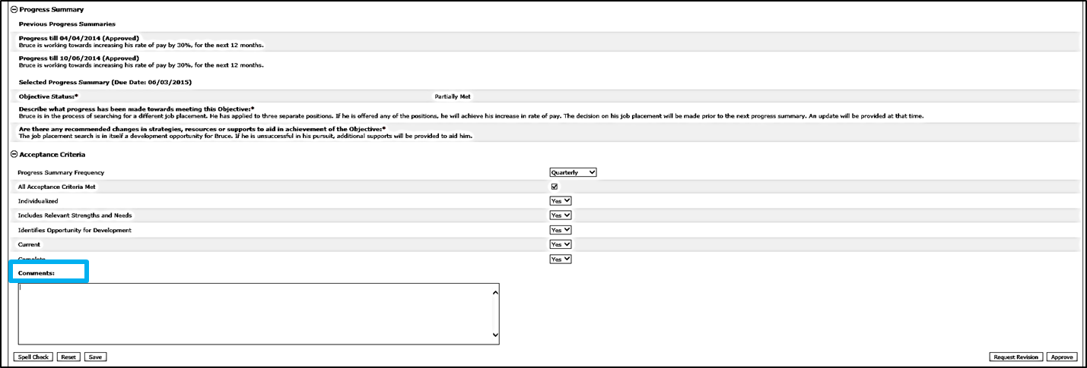
- Click “Approve” to approve the Progress Summary.

The system will redirect to the Progress Summary Review Switchboard and the status of the Progress Summary will change to “Approved.”

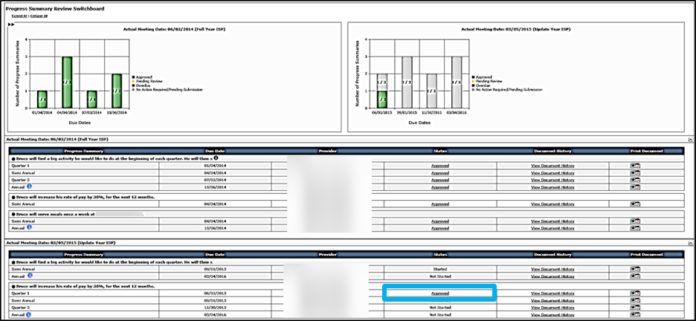

Note: The Progress Summary Bar Graph will update to reflect the change in status.

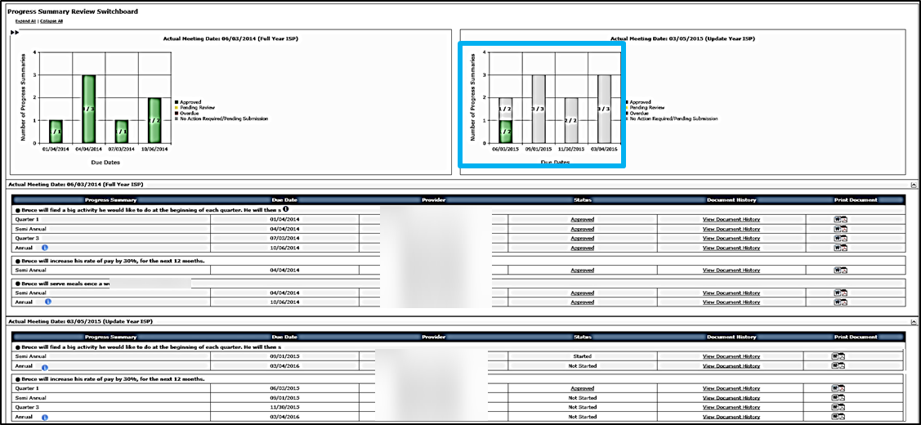

Note: To print a completed Progress Summary, click the PDF or Word icon in the Print Document column. The Progress Summary Form will print with a draft watermark until it has been approved.

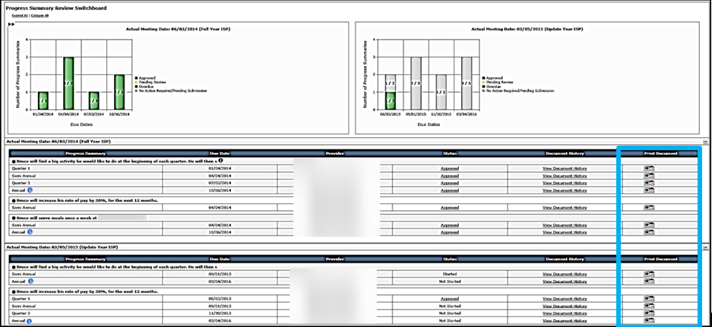

Next Steps

- Providers will receive an Alert to revise the Progress Summaries.
- Service Coordinators or Service Coordinator Supervisors can continue reviewing other Progress Summaries.
- An objective that is met or discontinued in the Progress Summary will still be recalled in an ISP update year.
- If an objective is determined to be met or discontinued as a part of a Semi-annual Summary, subsequent Progress Summaries for that objective will not be required unless that objective is included again as part of the ISP.
- If an objective is determined to be met or discontinued as a part of a Semi-annual Summary, subsequent Progress Summaries for that objective will not be required unless that objective is included again as part of the ISP.
- If a Service Coordinator mistakenly includes an objective in the ISP document and the Provider initiates work on the Progress Summary, the objective cannot be unselected. In this scenario, the Progress Summary must be deleted by the Help Desk. Once the Progress summary is deleted, the SC can then unselect the objective.
- If a service ends, a Service Coordinator needs to contact help desk to request deletion of the Progress Summary. In this scenario, because providers lose access to that individual when a service ends, providers are required to complete next Progress Summary off-line.

