Commonwealth of Massachusetts
Executive Office of Health and Human Services

Virtual Gateway

ISP Assessments Module
User Guide
Lesson 7: Modifications
HCSIS Release 7.7

Contents
Modifications 2
Completing a Modification by DDS Staff 4
Completing a Modification by Provider Staff 23
Reviewing and Accepting of a Modification by DDS Staff 51
Reviewing and Disapproving of a Modification by DDS Staff 55
Reviewing and Requesting Revision on a Modification by DDS Staff 58
Reviewing and Revising a Modification by Provider Staff 61
Reviewing and Approving a Modification by Area Office Directors 66
Reviewing and Disapproving a Modification by Area Office Directors 69

Modifications
Modifications are used to make changes to a locked ISP document. The complete Modification workflow is now included on HCSIS as part of the ISP module. Provider and DDS staff are now able to coordinate the review, revision, acceptance and approval of a Modification to a locked ISP document.

Modifications Regulation
Modifications are required to be created in accordance with the following DDS regulations.
- A Modification to an ISP may include one or any combination of the following elements all under the same Reason for Modification. Changes in an individual’s life that would substantially change the ISP content should be considered for a full ISP meeting.
  - Any change in the Goals for an individual.
  - Any change in the types of supports or services that will be used to help the individual to attain his or her outcomes or in the duration and frequency of such supports.
  - A change in the strategies that will be used to meet unmet support needs.
  - A change in the priority for services or supports assigned to the individual’s needs where such a change will affect the services or supports provided and available to the individual.
  - Initiation of a behavior Modification plan or Modification of any part of a behavior Modification plan involving the use of an aversive or intrusive technique.
  - A change in the location of an individual’s home, from a home operated by the Department or a provider certified by the Department to another such home.

Modification Timeline
- Once a plan is locked it can be modified at any point up and until 90 days prior to next year’s planned meeting date.
- If a Modification is outstanding at the 90 days mark, the new ISP is not opened.
- Once a Modification is submitted, the AOD has 45 days to approve or disapprove the Modification. If the AOD has not approved or disapproved at 45 days, the AOD will receive an overdue alert.

Modification Workflow
Modifications can be completed on both Full Year and Update Year plans. Modifications can be only completed once an Individual Support Plan has been locked. A plan is locked in HCSIS once one of the following conditions has been met.

- The Area Director’s approves the ISP in MEDITECH. The system has been enhanced so that HCSIS pulls the approval flag from MEDITECH and locks the plan.
- The Area Director has not approved the ISP within 150 days of the Actual Meeting Date, and the plan is locked automatically.

Once the plan is locked, a red lock icon is visible on the Individual Dashboard.

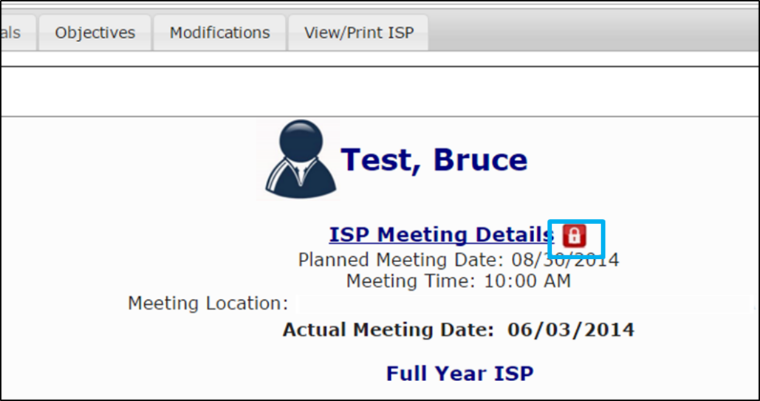

Completing a Modification includes three steps - Initiating a Modification, Adding Elements to a Modification, and Submitting a Modification.
- Initiating a Modification: Opt to complete Modification and identify overall reason for initiating process.
- Adding Elements: Select which elements of ISP need to be modified and indicate what changes are required.
- Submitting a Modification: Entering the submission details and submitting for review.

Once a Modification has been completed, the review process is activated. The review workflow depends on whether the Modification is initiated by the Provider or by the Service Coordinator. The respective review processes are detailed in the graphic below:

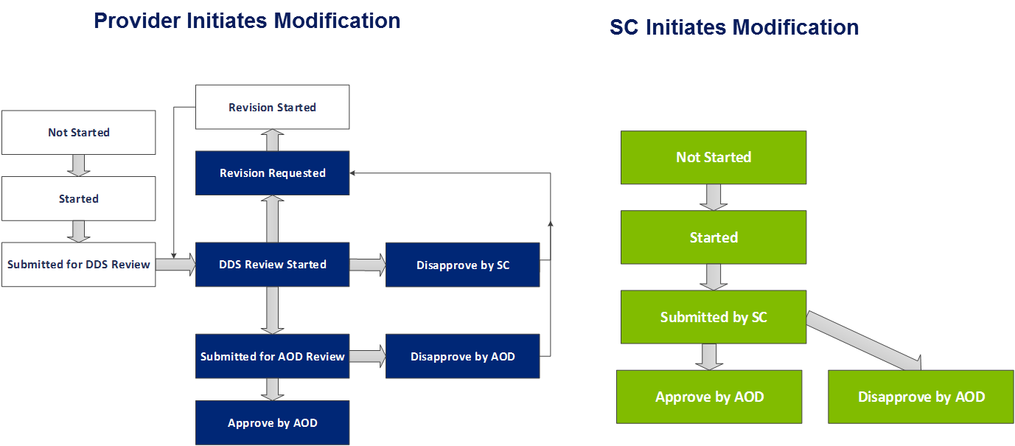

Completing a Modification by DDS Staff

Initiating a Modification by DDS Staff
Scenario Description:
Service Coordinators can create a Modification once a Full or Update Year ISP has been completed and the plan is locked in HCSIS. There are two methods by which an ISP is locked. If the approval is entered in MEDITECH by an Area Office Director, the plan will be locked automatically or, if the approval is not completed within 150 days, the plan will be locked per the current process. Once the plan is locked, a red lock icon is visible on the Individual Dashboard. Once the icon is visible and the plan is locked, DDS Staff can initiate a Modification. A single Modification form can include any combination of the following elements: Goals, Residential Support / Other.
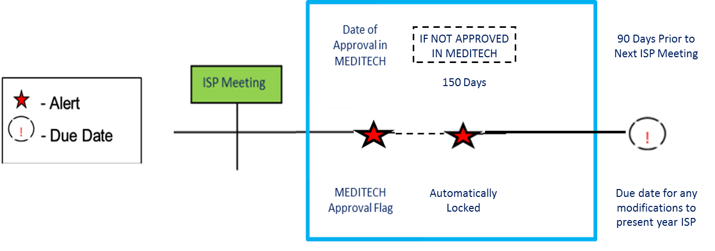
First Steps
- Search for an Individual
- View the Individual Dashboard

Roles and Responsibilities:
- Service Coordinators: Initiate a Modification
- Service Coordinator Supervisors: Initiate a Modification

- Select “Modifications” from the tabs on the Individual Dashboard.

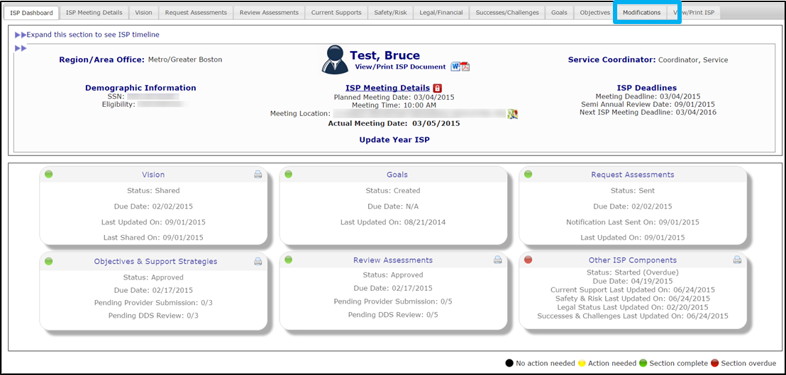

- Select “Add New Modification” on the Modifications Review Switchboard

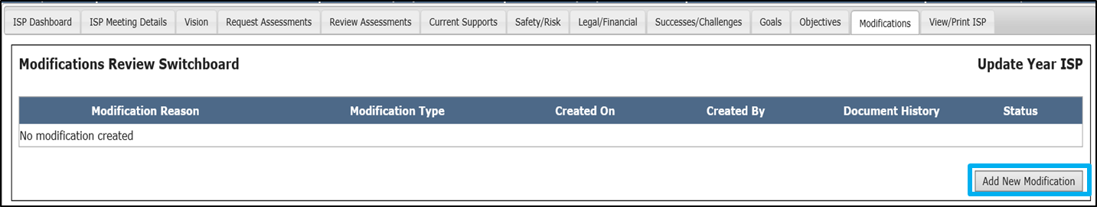

Note: If any Modifications to the individual’s current plan have already been submitted or are in progress, the existing Modifications display on the Modifications Review Switchboard

- Insert comments into the Modification Reason text box and explain the reason a Modification is required.

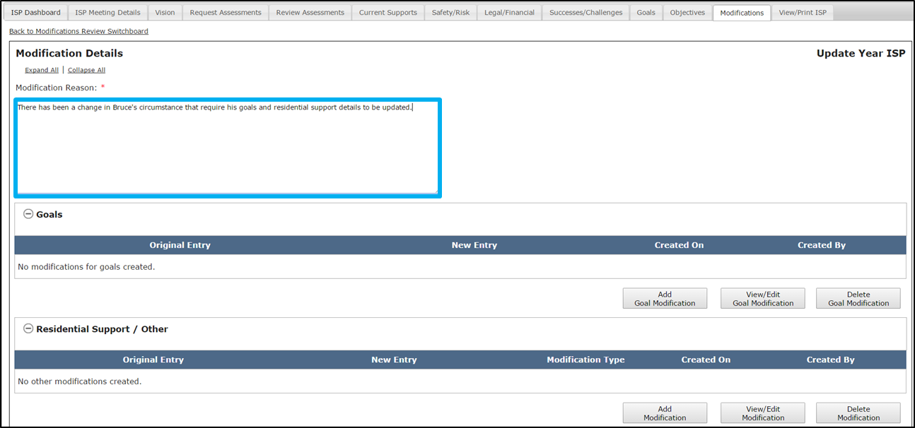

- Decide which elements require Modification: A.) Goal or B.) Residential Support / Other. All of these elements fall under the previously entered “Reason for Modification”.

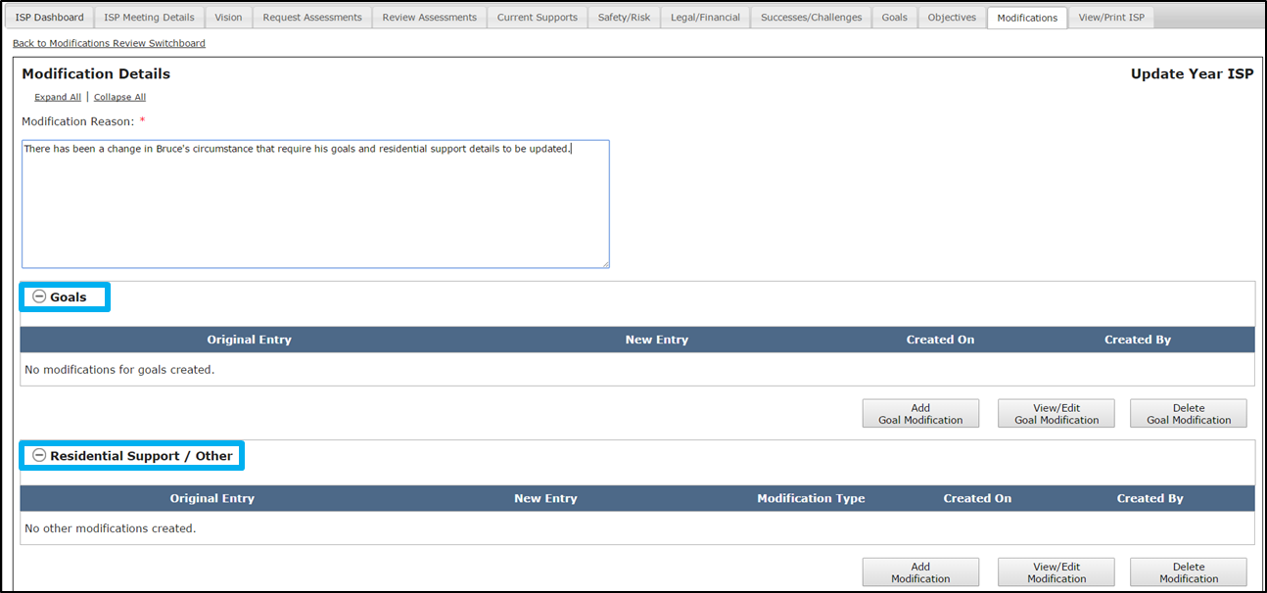

- For instructions on how to add an element to the Modification, refer to the “Adding an Element to a Modification by DDS” section.

Note: If either a Provider Supervisor or DDS staff initiates a Modification for an element and the Modification is in Started status, it is not possible for another user to initiate a Modification on the same element. It is only possible to initiate a modification for that element after the modification in process has been approved or disapproved by an Area Office Director.

Note: 90 days prior to the next ISP meeting date, next year’s ISP document is generated by the system. After this has happened, it is not possible to initiate, complete or submit Modifications to the prior year’s ISP. Instead, any change that occurs in that timeframe should be included as part of the upcoming individual’s ISP meeting.

Adding Elements to a Modification by DDS Staff
Scenario Description:
Service Coordinators can add an element to an Modification once the following conditions have been met:
- The ISP has been locked. There are two methods by which an ISP is locked. The plan locks when a Full or Update Year ISP has been completed and the approval has been entered in MEDITECH by the Area Director, locking the plan in HCSIS. Alernatievly, if the approval is not completed within 150 days, the plan will be locked automatically per the current process.
- The Serivce Cooridinator / Serivce Coordinator Supervisor has initiated a Modification.

First Steps
- Navigate to the Modifications Review Switchboard

Roles and Responsibilities
- Service Coordinators: Add Elements to a Modification
- Service Coordinator Supervisors: Add Elements to a Modification

Addition of a New Goal
- On the Modifications Review Switchboard, select “Add Goal Modification” to initiate a Modification to Goals.

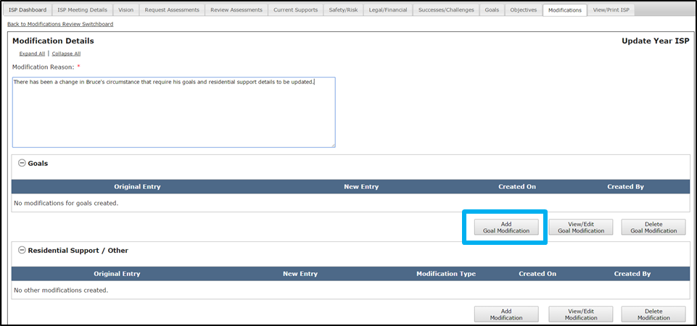

- The system redirects to the Modify Goals pop-up screen. It displays all of the existing Goals included in the ISP document.

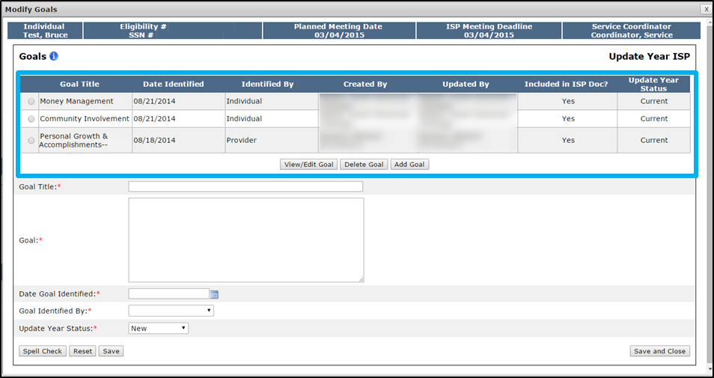

- Enter the title of the Goal in the “Goal Title” text box.

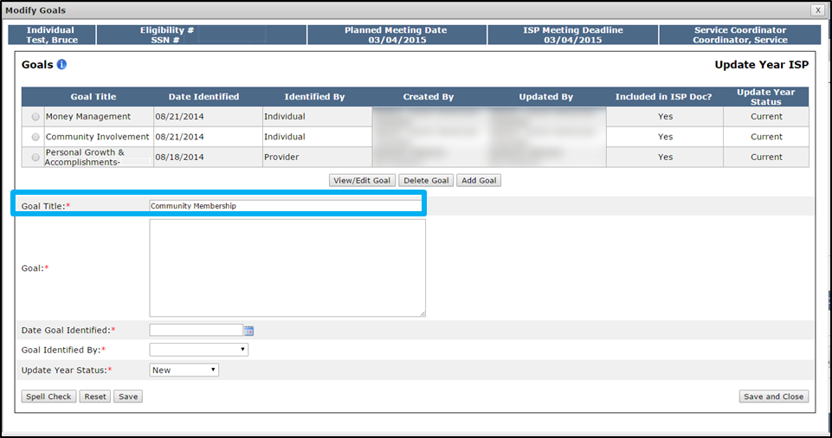

- Enter the Goal description in the “Goal” text box.

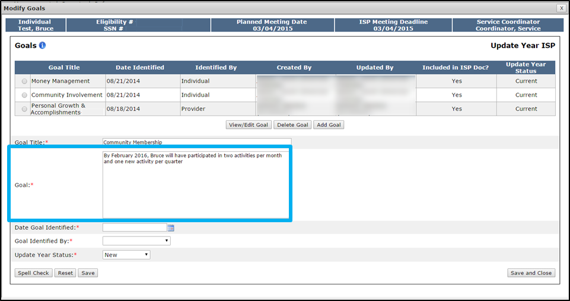

- Select a date in the “Date Goal Identified” calendar drop down.

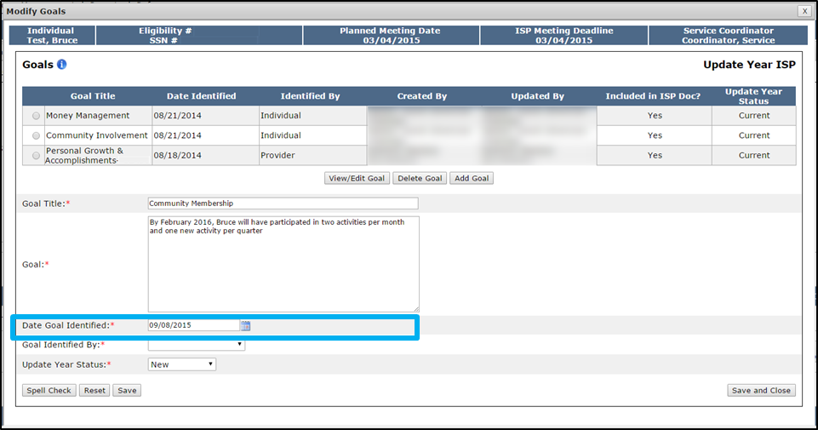

- Select an option from the “Goal Identified by” drop down.

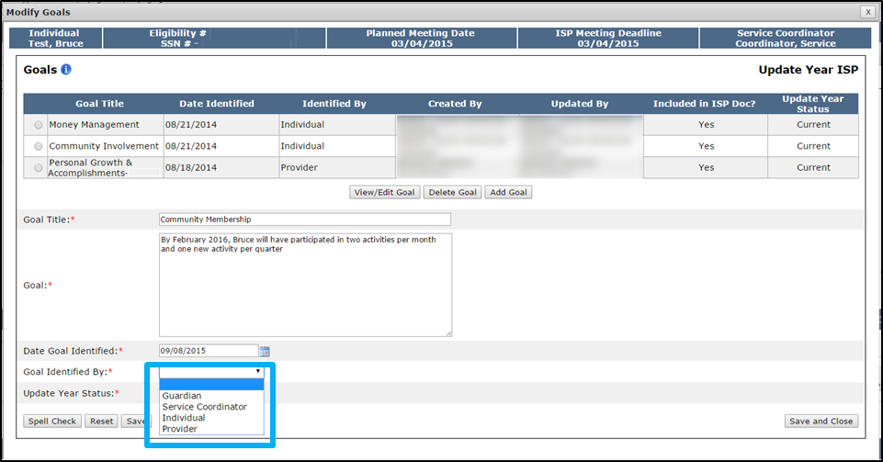

- Click “Save and Close.”

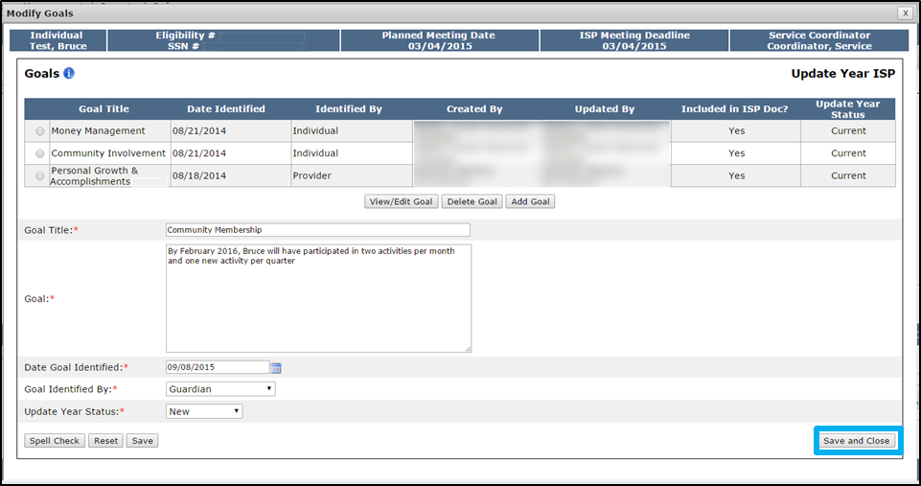

Upon selecting “Save and Close” the system will return to the Modification Details screen and will display the original entry, new entry, date and the individual who created the Modification. In the image below, the original entry displays N/A because it is a newly added Goal.

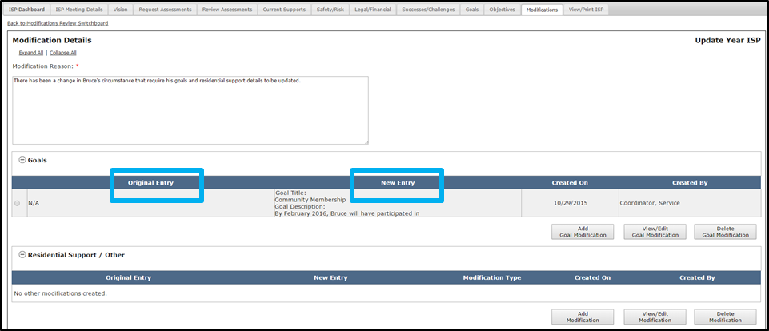

Note: It is also possible to select “Delete a Goal,” on the same pop-up accessed from the “Add Goal Modification” button. To do so, select the radio button for the newly added Goal that requires deletion and click “Delete Goal.” Please note that the delete function operates differently for newly added Goals and existing Goals. Deleting a newly added Goal will remove the entire Goal from the Modification. Deleting an existing Goal Modification will only remove the modified information. The Goal will remain a part of the ISP. It is not possible to delete an unmodified existing Goal.

Note: The addition of a new goal will likely require the addition of a new objective.

Note: If there are multiple elements that require a Modification and that are required for the same reason, it is best practice to submit a single Modification that includes multiple elements rather than submit multiple Modifications.
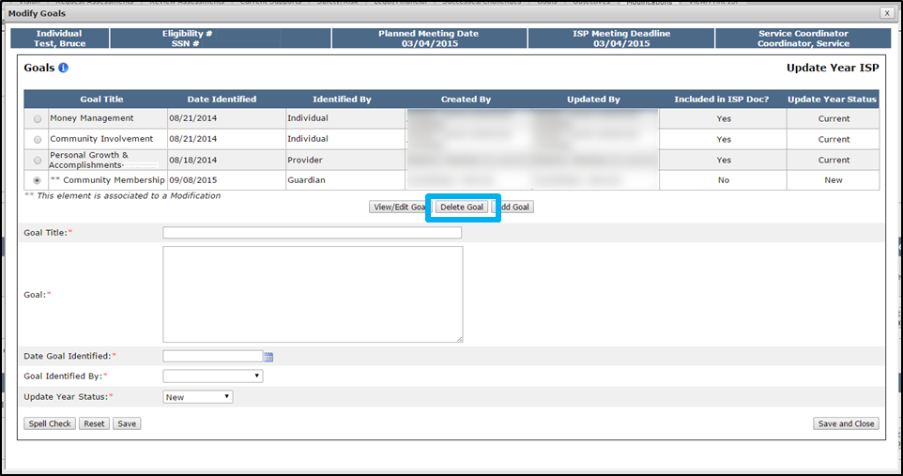

Modification of an Existing Goal
- On the Modifications Review Switchboard, select “Add Goal Modification” to initiate a Modification to Goals.

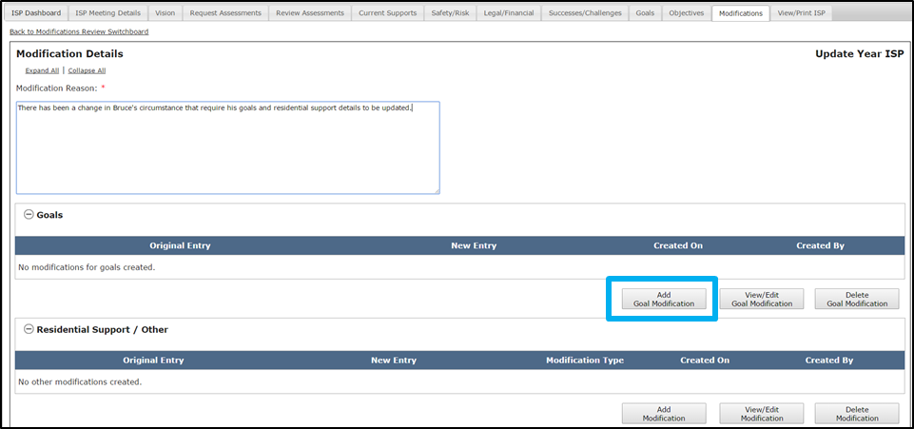

- The system will display the Modify Goals pop-up screen. It displays all of the existing Goals included in the ISP document. Select the radio button next to the desired Goal and click “View/Edit Goal.”

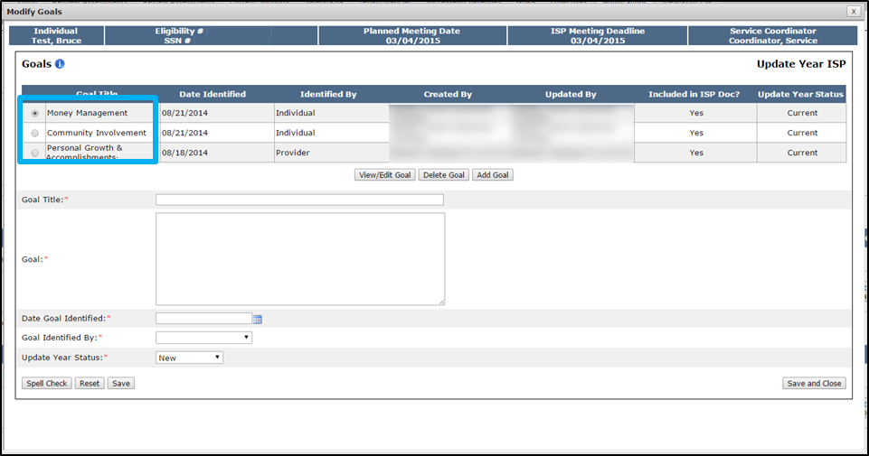

The system will display the existing Goal details for the selected Goal.

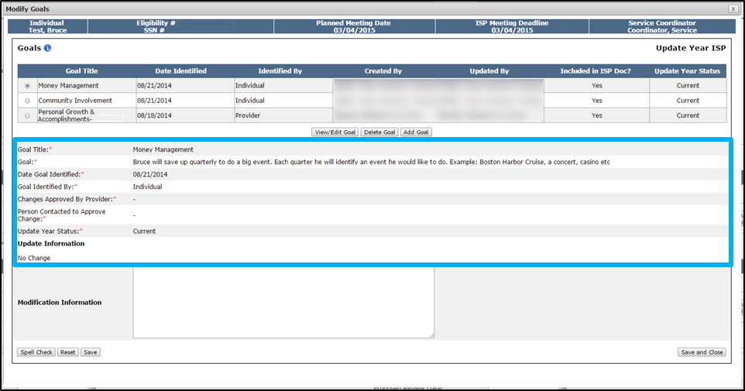

- Enter text in the “Modification Information” textbox to explain the required Modification to the Goal.

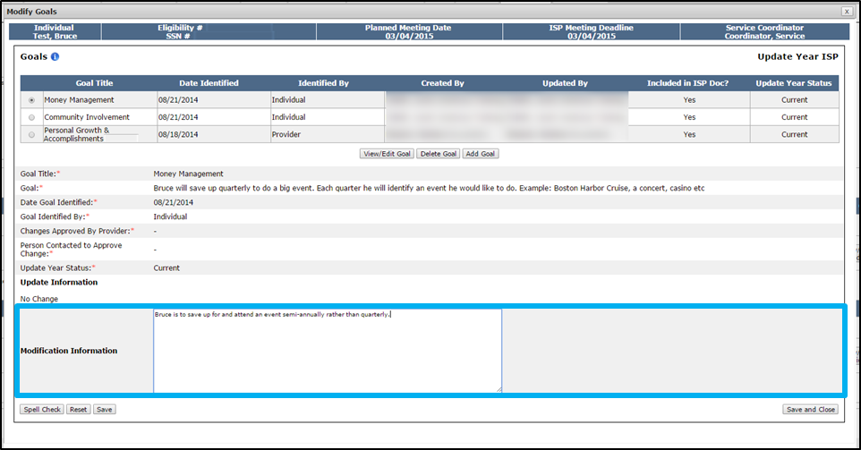

- Select “Save and Close.”

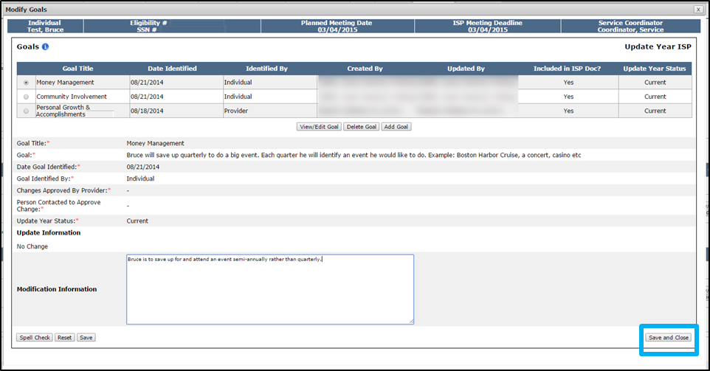

The system will return to the Modification Details screen and will display the original entry, new entry, date and the individual who created the Modification. In the image below, the Original Entry column displays the original Goal description and the New Entry displays the modified information.

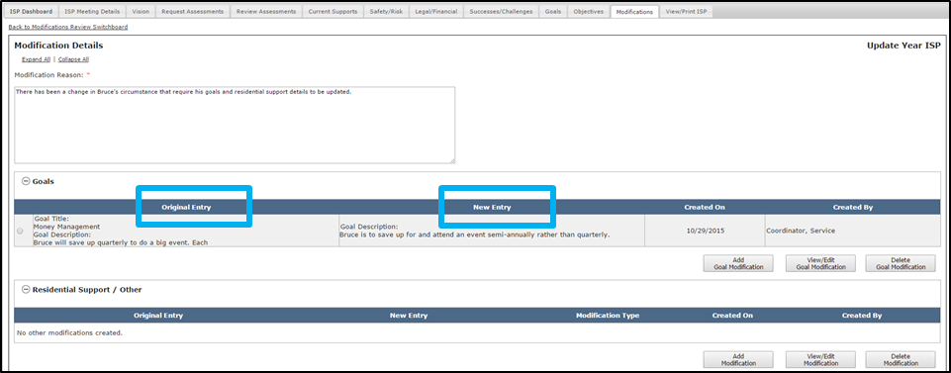

Note: It is also possible to select “Delete a Goal,” on the same pop-up accessed from the “Add Goal Modification” button. To do so, select the radio button for the newly added Goal that requires deletion and click “Delete Goal.” Please note that the delete function operates differently for newly added Goals and existing Goals. Deleting a newly added Goal will remove the entire Goal from the Modification. Deleting an existing Goal Modification will only remove the modified information. The Goal will remain a part of the ISP. It is not possible to delete an unmodified existing Goal.

Note: The modification of a goal may also require modification of an associated objective.
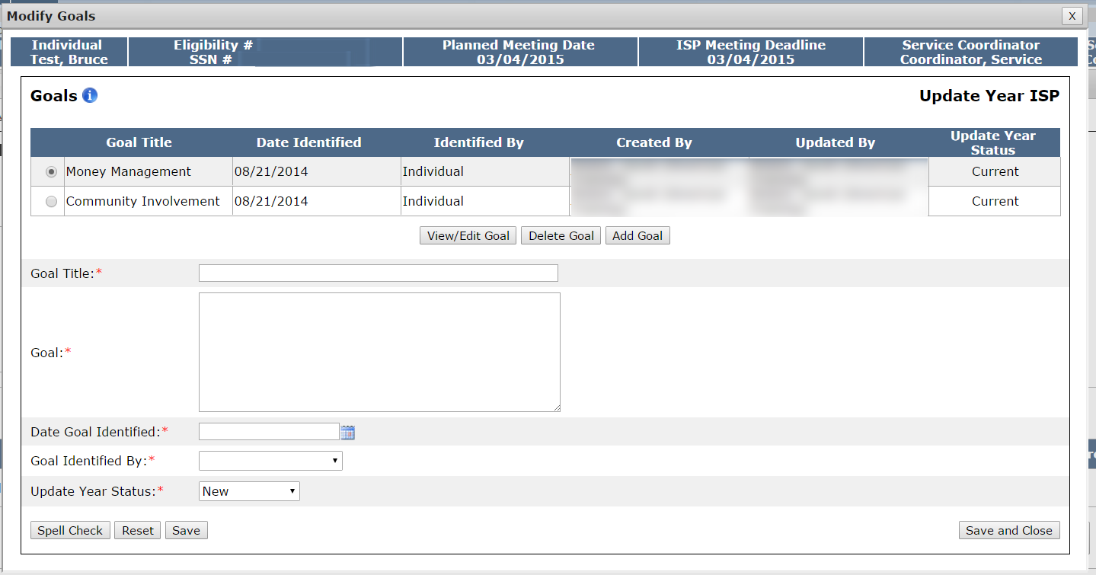

Note: All modified information will display with an asterisk on the system. For example, if an existing goal is modified, an asterisk displays next to the goal on the Goal tab for the individual.

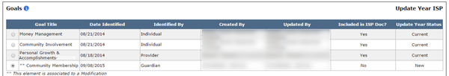

Addition or Modifying Residential Supports or Other
- Click “Add Modification.”
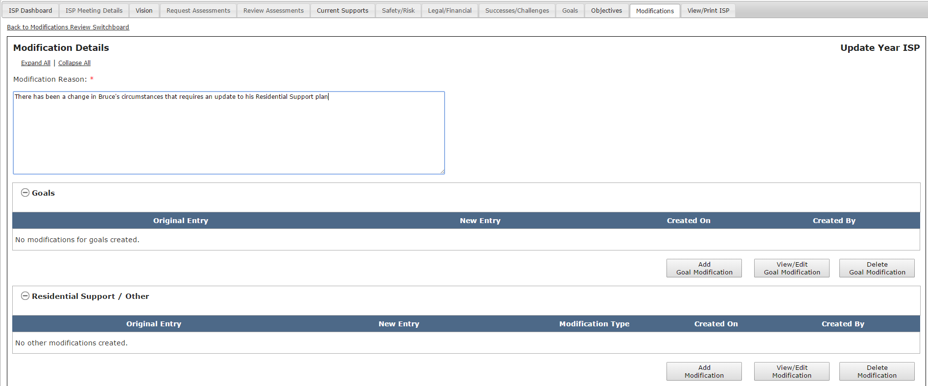
The system will display the Residential Support / Other pop-up screen.
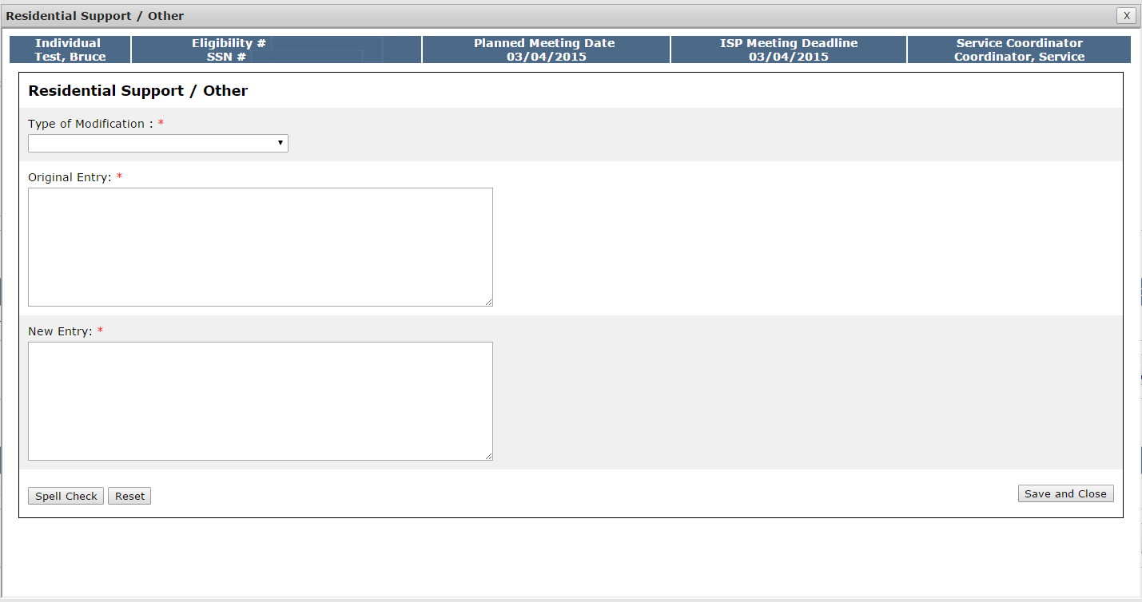
- Select the Type of Modification drop-down and indicate which type of Modification will be submitted: “Residential Supports or Types of Supports” or ‘Other.”
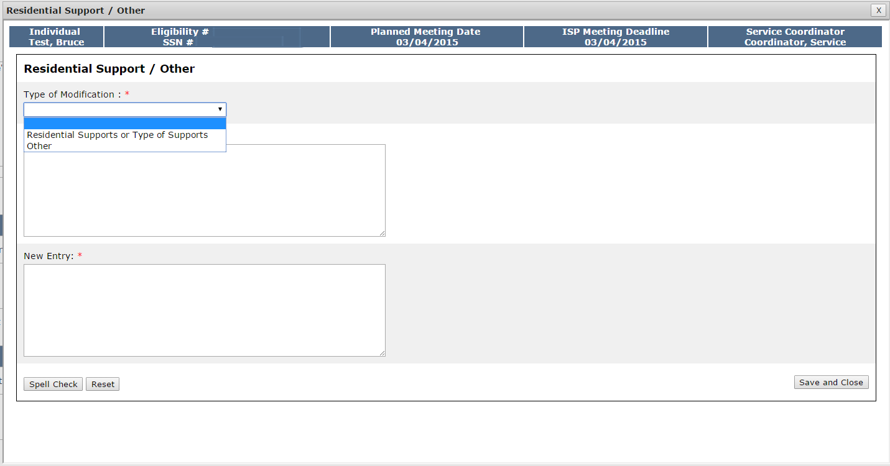
- Fill out the “Original Entry” and “New Entry” text boxes.
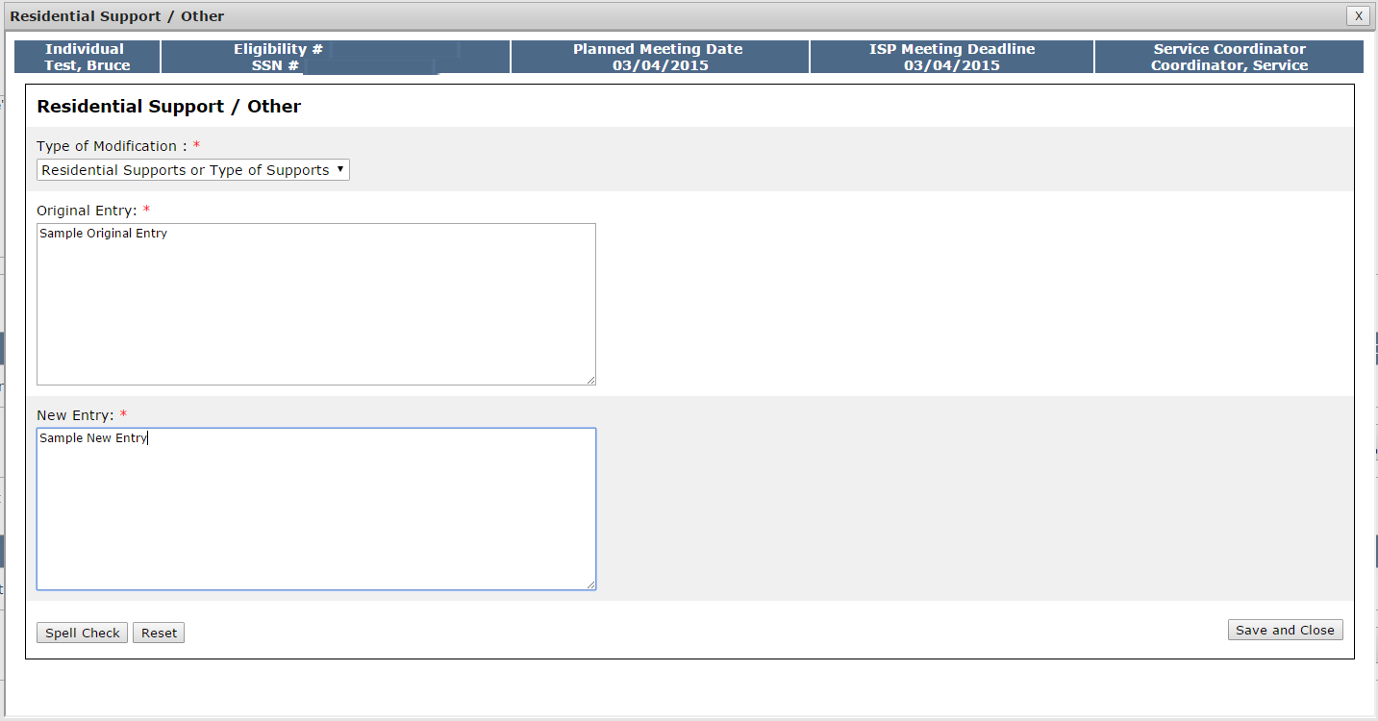
Note: As these elements are paper-processes and not completed in the system, no information will be prepopulated into the “Original Entry” field. Both the “Original Entry” and “New Entry” fields will be completed by the user.
- Click “Save and Close.”
The system will return to the Modification Details screen and will display the original entry, new entry, Modification type, date and the individual who created the Modification. In the image below, the Original Entry column displays the original Goal description and the New Entry displays the modified information.

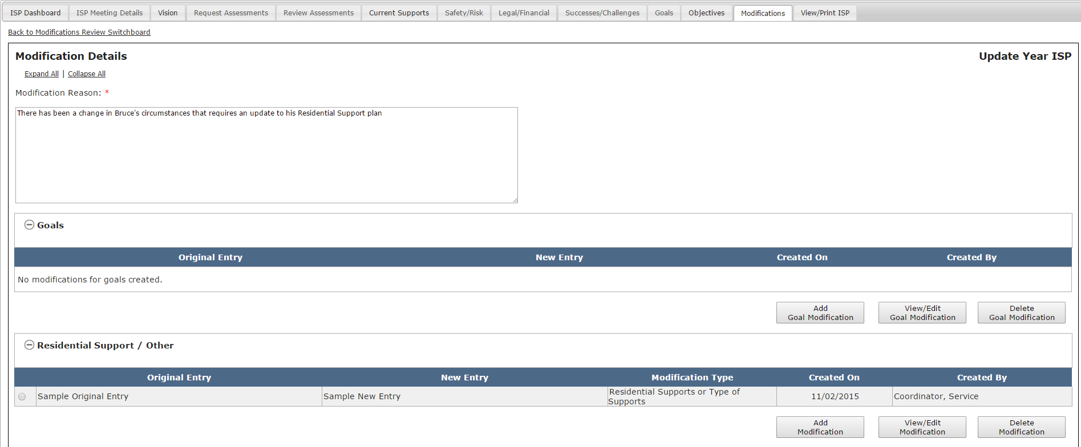

Submitting a Modification by DDS Staff
Scenario Description:
Service Coordinators can submit an Modification once the following conditions have been met

- The ISP has been locked. There are two methods by which an ISP is locked. The plan locks when a Full or Update Year ISP has been completed and the approval has been entered in MEDITECH by the Area Director, locking the plan in HCSIS. Alernatievly, if the approval is not completed within 150 days, the plan will be locked automatically per the current process.
- The Modification has been initiated and at least one element has been added
- All mandatory fields are completed.

First Steps
- Initiate a Modification
- Add Elements to a Modification

Roles and Responsibilities
- Service Coordinator: Submit Modification for review
- Service Coordinator Supervisors: Submit Modification for review

- Once you have added elements to a Modification, navigate to the Review Section.

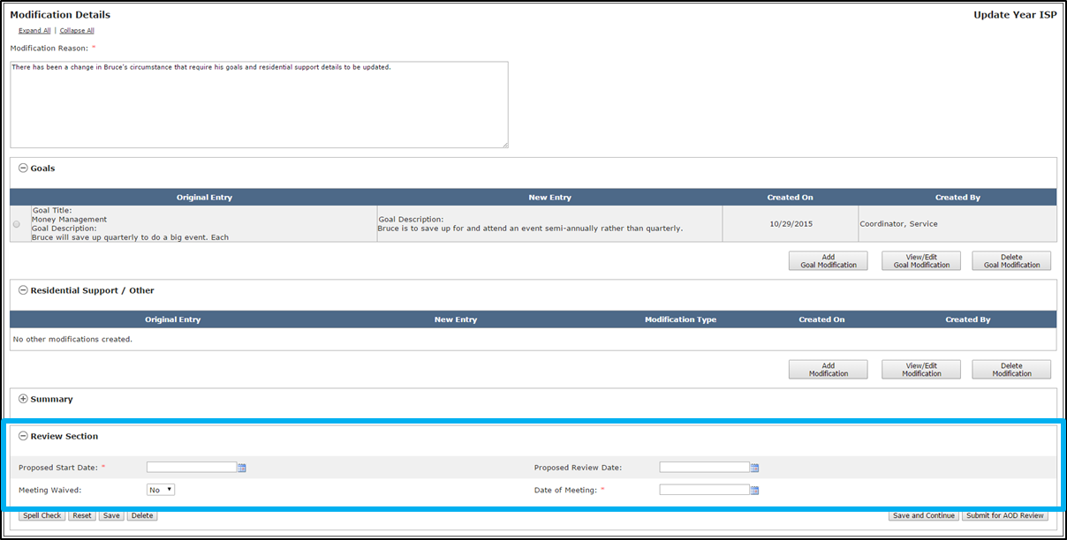
- Enter a “Proposed Start Date.” If desired, add in a “Proposed Review Date” as well.

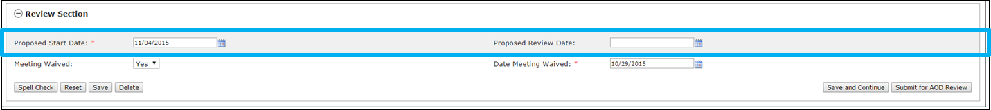
Note: The only restriction on the dates selected is that the date selected for the Proposed Review Date must occur after the date selected for the Proposed Start Date.

- If the Modification meeting has occurred, select “No” in the “Meeting Waived” drop-down and select the date from the Date of Meeting calendar drop down. If the meeting did not occur, select “Yes” and select a date from the calendar drop down.
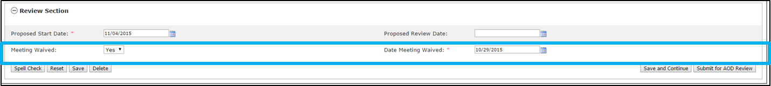
- Click “Submit for AOD Review”. Alternatively, click on the “Save” or “Save and Continue” buttons to save this information so that it can be worked on at a later time.

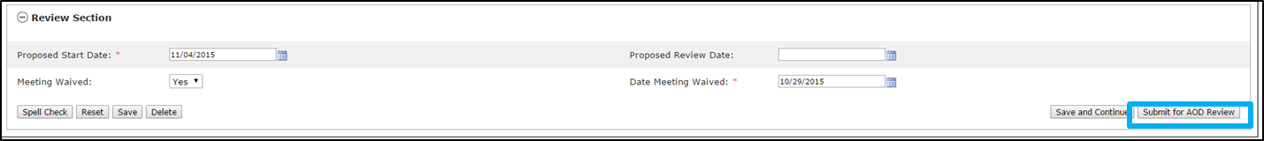
Note: Service Coordinator’s retain the ability to edit a submitted Modification until an Area Office Director approves the Modification. Service Coordinator’s retain these editing rights because Area Office Director’s only have the ability to approve or disapprove a Modification. In the scenario that an Area Office Director disapproves of a Modification because it requires revision, the Area Office Director will explain the reason for disapproving in an offline discussion with the Service Coordinator. The Service Coordinator will be responsible for making any necessary revisions and resubmitting for Area Office Director review.

Reason for Disapproval | Next Step  (DDS Initiated) | Next Step  (Provider Initiated)
Revision Required | SC to Make Revisions | SC to Request Revision by Provider
Modification Not Required | No Action Required | No Action Required

Note: If the Area Office Director disapproves the Modification, the status is changed to disapproved in the Modifications Review Switchboard and no further action is required. The Modification content, however, is not deleted and the Area Office Director has the option of changing the status of the Modification to approved or requesting revision on the form at a later date if circumstances require it.

Completing a Modification by Provider Staff

Initiating a Modification by Provider Staff
Scenario Description:
Provider Supervisors can initiate an Modification once a Full or Update Year ISP has been completed and the plan is locked in HCSIS There are two methods by which an ISP is locked. If the approval is entered in MEDITECH by an Area Office Director, the plan will be locked automatically or, if the approval is not completed within 150 days, the plan will be locked per the current process. Once the plan is locked, a red lock icon is visible on the Individual Dashboard. Once the icon is visible and the plan is locked, Provider Supervisor Staff can initiate a Modification. A single Modification initiated by a Provider can include any combination of the following elements: Goal, Objective & Support Strategy (OSS), Residential Support / Behavior Plan/Other

First Steps
- Search for an Individual
- View the Individual Dashboard

Roles and Responsibilities
- Provider Data Entry User: N/A
- Provider Supervisors: Initiate a Modification

- Select “Modification” from the tabs on the Individual Dashboard.
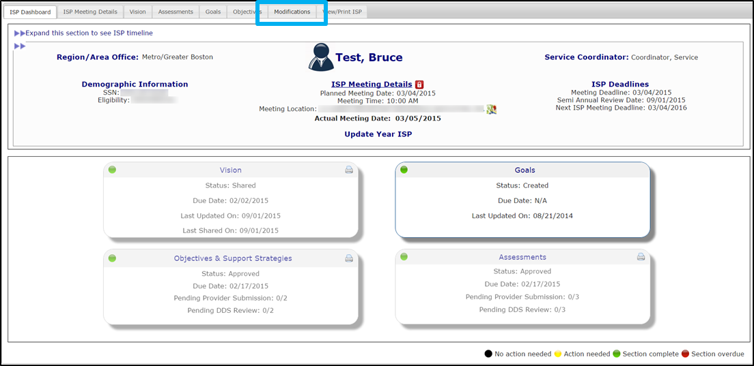

- Select “Add New Modification” on the Modifications Review Switchboard.

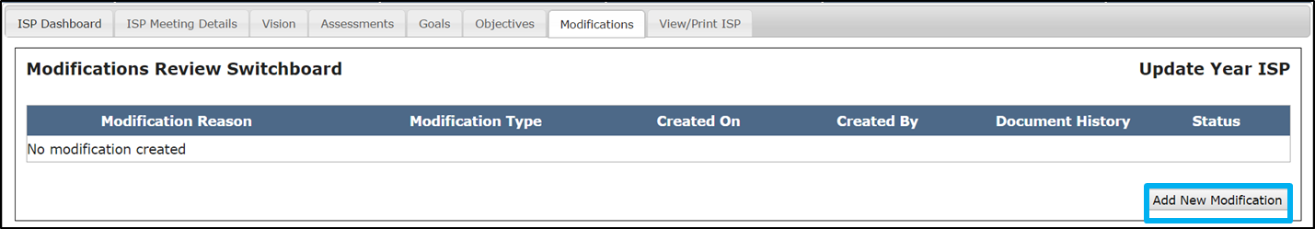

Note: If any Modifications to the individual’s current plan have already been submitted or are in progress, the existing Modifications display on the Modifications Review Switchboard

The system will redirect to the Modification Details page.

- Insert comments into the Modification Reason text box and explain the reason that a Modification is required.

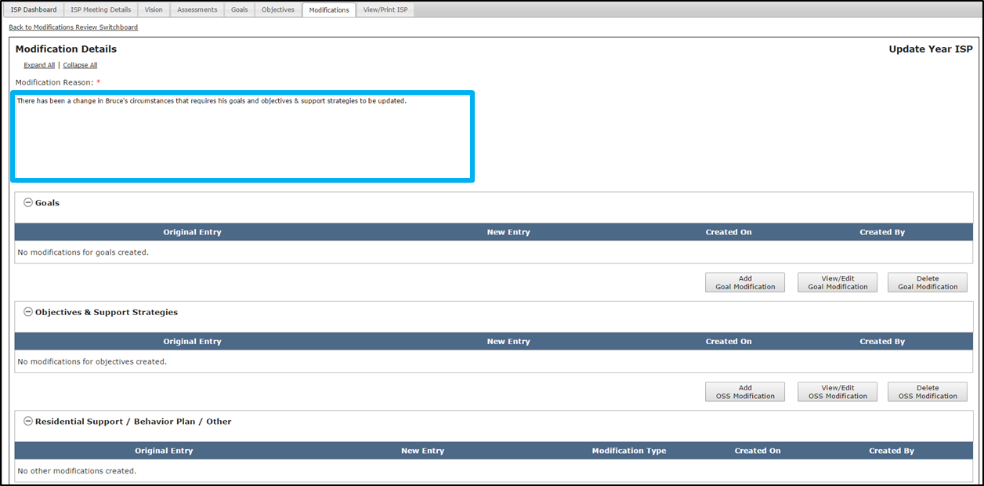

- Decide which elements require Modification: A.) Goal and/or B.) Objective & Support Strategy (OSS) and/or C.) Residential Support / Behavior Plan / Other. All of these elements fall under the previously entered “Reason for Modification”. In this scenario, you will initiate a Modification for a Goal.

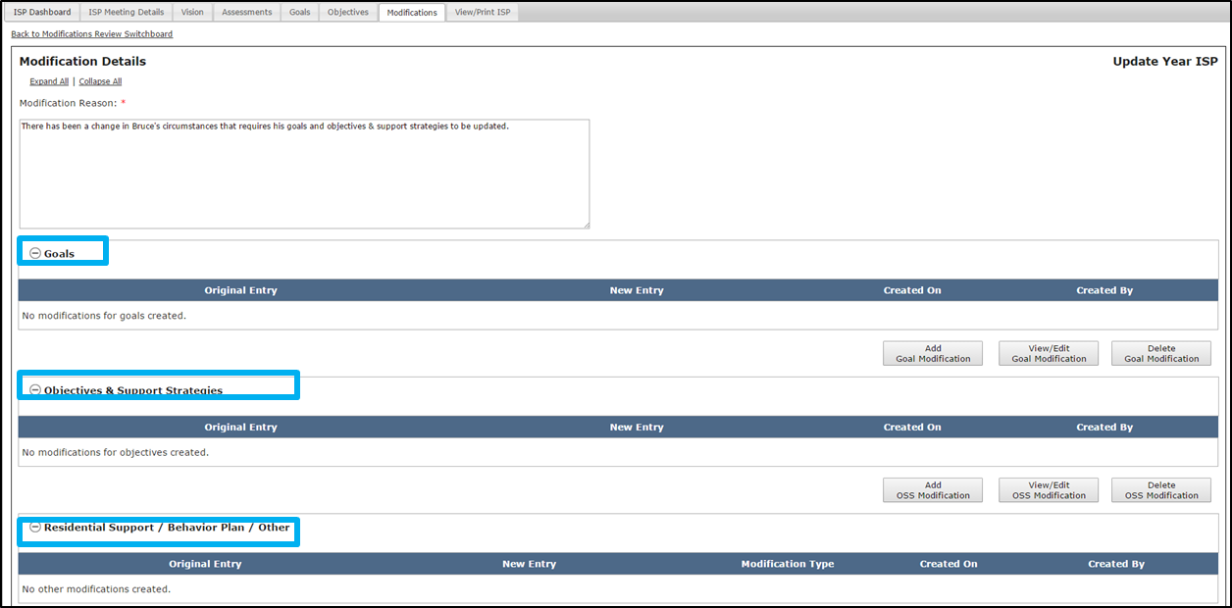

Note: 90 days prior to the next ISP meeting date, next year’s ISP document is generated by the system. After this has happened, it is not possible to initiate, complete or submit Modifications to the prior year’s ISP. Instead, any change that occurs in that timeframe should be included as part of the upcoming individual’s ISP meeting.

For instructions on how to add an element to the Modification, refer to the “Adding an Element to a Modification by Provider” section.

Adding Elements to a Modification by Provider Staff
Scenario Description:
Provider Supervisors can add an element to an Modification once the following conditions have been met:
- The ISP has been locked. There are two methods by which an ISP is locked. The plan locks when a Full or Update Year ISP has been completed and the approval has been entered in MEDITECH by the Area Director, locking the plan in HCSIS. Alernatievly, if the approval is not completed within 150 days, the plan will be locked automatically per the current process.
- The Provider Supervisor has initiated a Modification.

First Steps
- Navigate to the Modifications Review Switchboard

Roles and Responsibilities
- Provider Data Entry User: N/A
- Provider Supervisors: Add Elements to a Modification

Addition of a New Goal
- On the Modifications Review Switchboard, select “Add Goal Modification” to initiate a Modification to Goals.

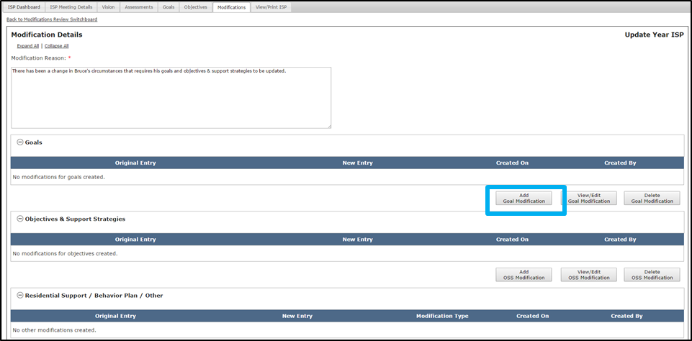

- The Modify Goals pop-up screen will display. It displays all of the existing Goals included in the ISP document.

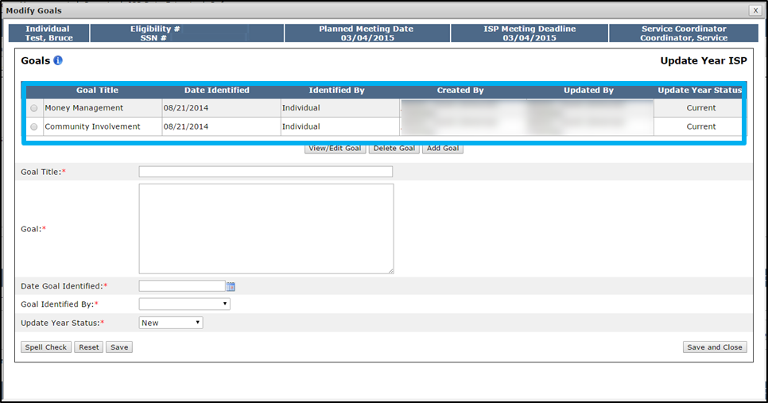

- Enter the title of the Goal in the “Goal Title” text box.

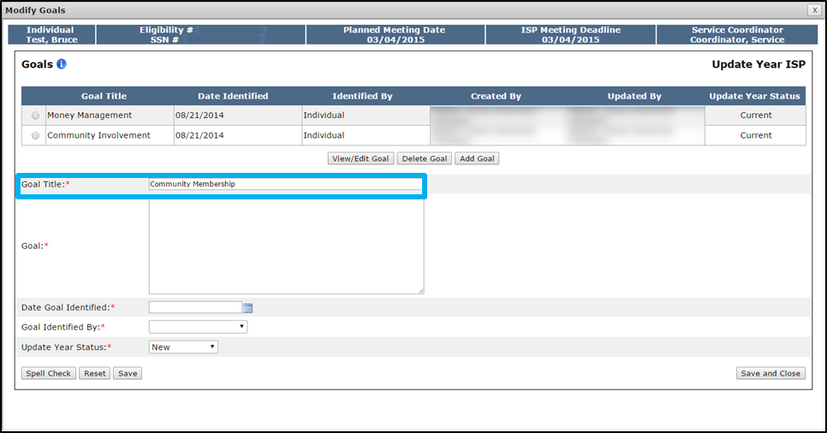

- Enter the Goal description in the “Goal” text box.

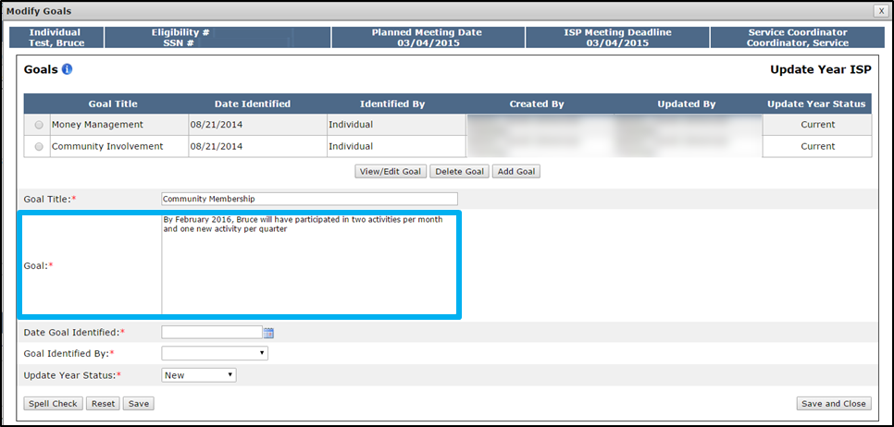

- Select a date in the “Date Goal Identified” calendar drop down.

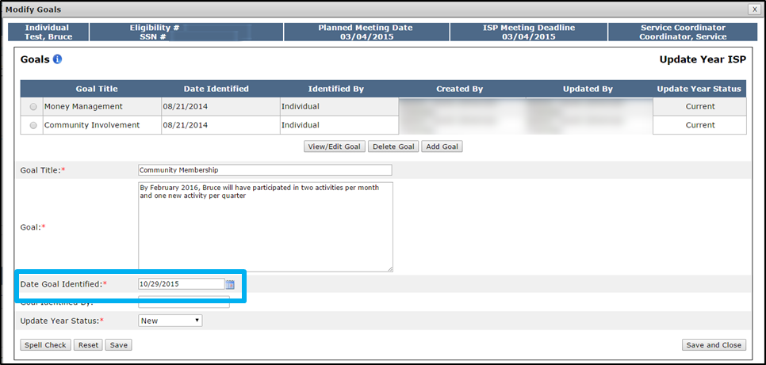

Note: The date selected for the “Date Goal Identified” needs to be in the past.

- Select an option from the “Goal Identified by” drop down.

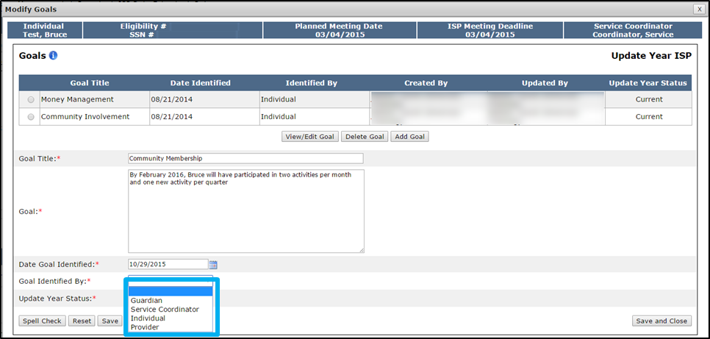

- Click “Save and Close.”

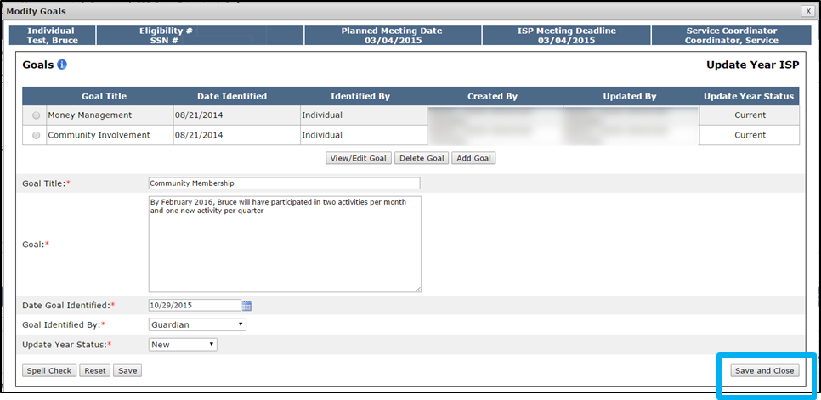

The system will return to the Modification Details screen and will display the original entry, new entry, Modification type, and the date and individual who created the Modification for the completed Modification. In the image below, the original entry displays N/A because it is a newly added Goal.

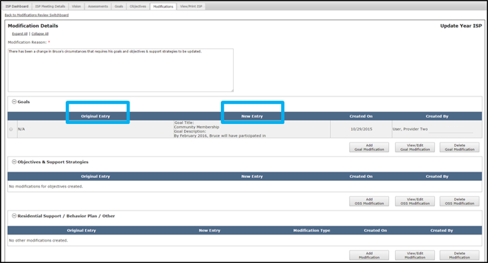

Note: It is also possible to select “Delete a Goal,” on the same pop-up accessed from the “Add Goal Modification” button. To do so, select the radio button for the newly added Goal that requires deletion and click “Delete Goal.” Please note that the delete function operates differently for newly added Goals and existing Goals. Deleting a newly added Goal will remove the entire Goal from the Modification. Deleting an existing Goal Modification will only remove the modified information. The Goal will remain a part of the ISP. It is not possible to delete an unmodified existing Goal.

Modification of an Existing Goal
- On the Modifications Review Switchboard, select “Add Goal Modification” to initiate a Modification to Goals.

- The system will display the Modify Goals pop-up screen. The form includes all existing Goals which were included in the ISP document. Select the radio button next to the desired Goal and click “View/Edit Goal.”

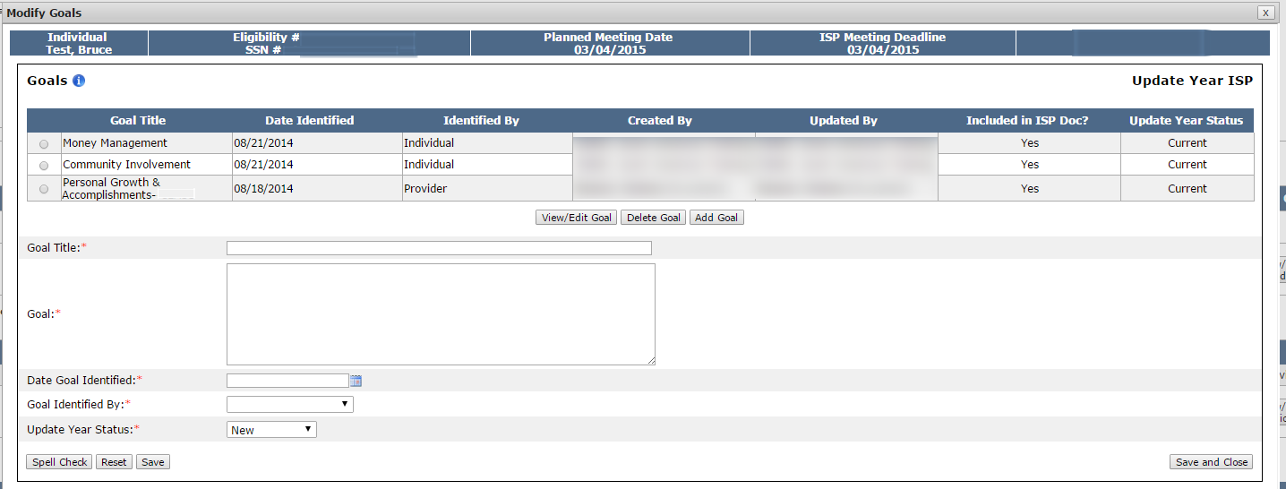

The system will display the details for the selected Goal.

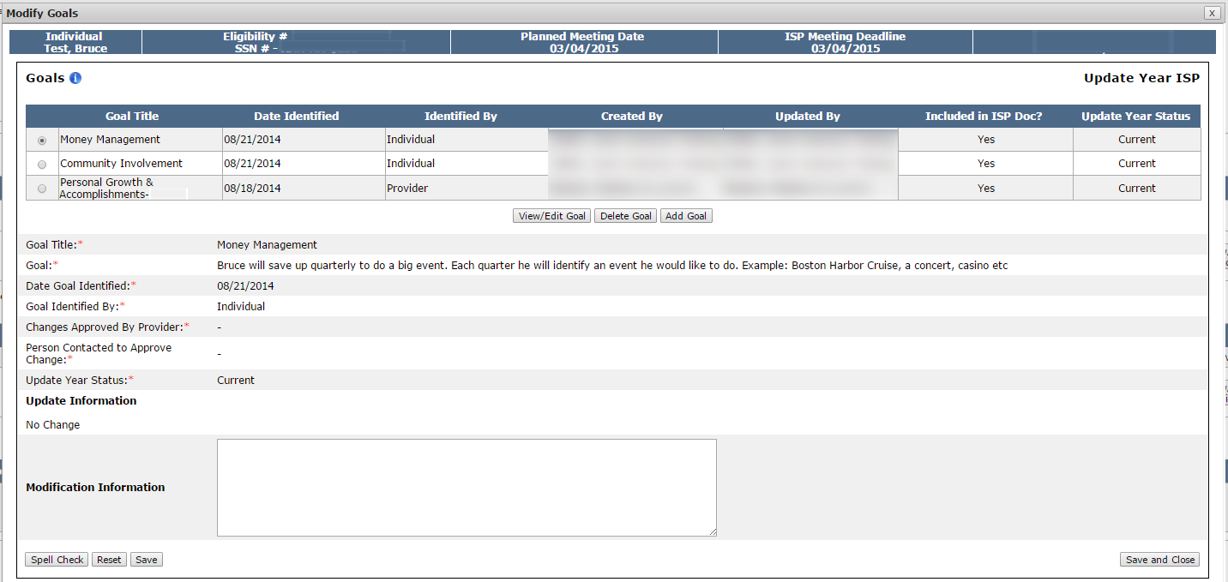

- Enter text in the Modification Information textbox and explain what changes are required to the Goal.

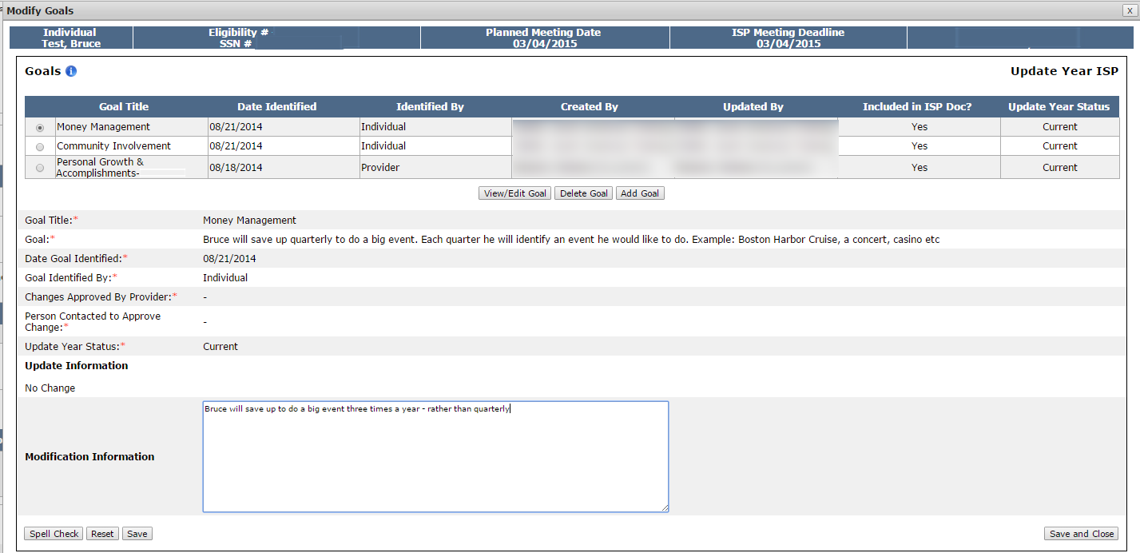

- Click “Save and Close.” Alternatively, click on the “Save” buttons to save this information so that it can be worked on at a later time.

Once, “Save and Close” has been selected, the system will return to the Modification Details screen and will display the original entry, new entry, Modification type, and the date and individual who created the Modification for the completed Modification. In the image below, the Original Entry column displays the original Goal description and the New Entry displays the modified information.

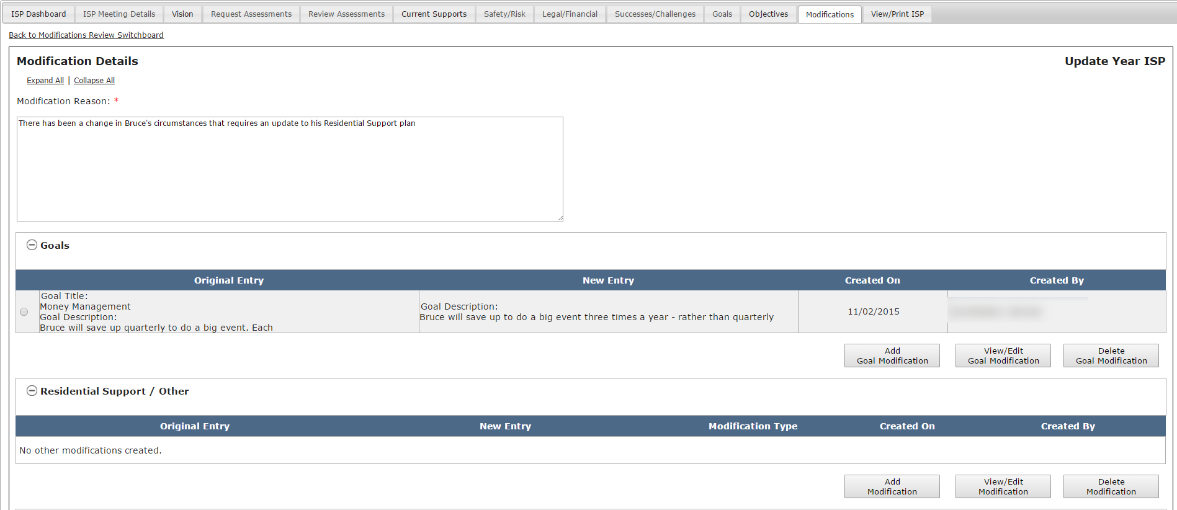

Note: It is also possible to select “Delete a Goal,” on the same pop-up accessed from the “Add Goal Modification” button. To do so, select the radio button for the newly added Goal that requires deletion and click “Delete Goal.” Please note that the delete function operates differently for newly added Goals and existing Goals. Deleting a newly added Goal will remove the entire Goal from the Modification. Deleting an existing Goal Modification will only remove the modified information. The Goal will remain a part of the ISP. It is not possible to delete an unmodified existing Goal.

Note: If an existing Goal is modified, two asterisks display next to the Goal on the Goal tab for the individual.

Addition of a New Objective & Support Strategy (OSS)
- Click “Add OSS Modification.”
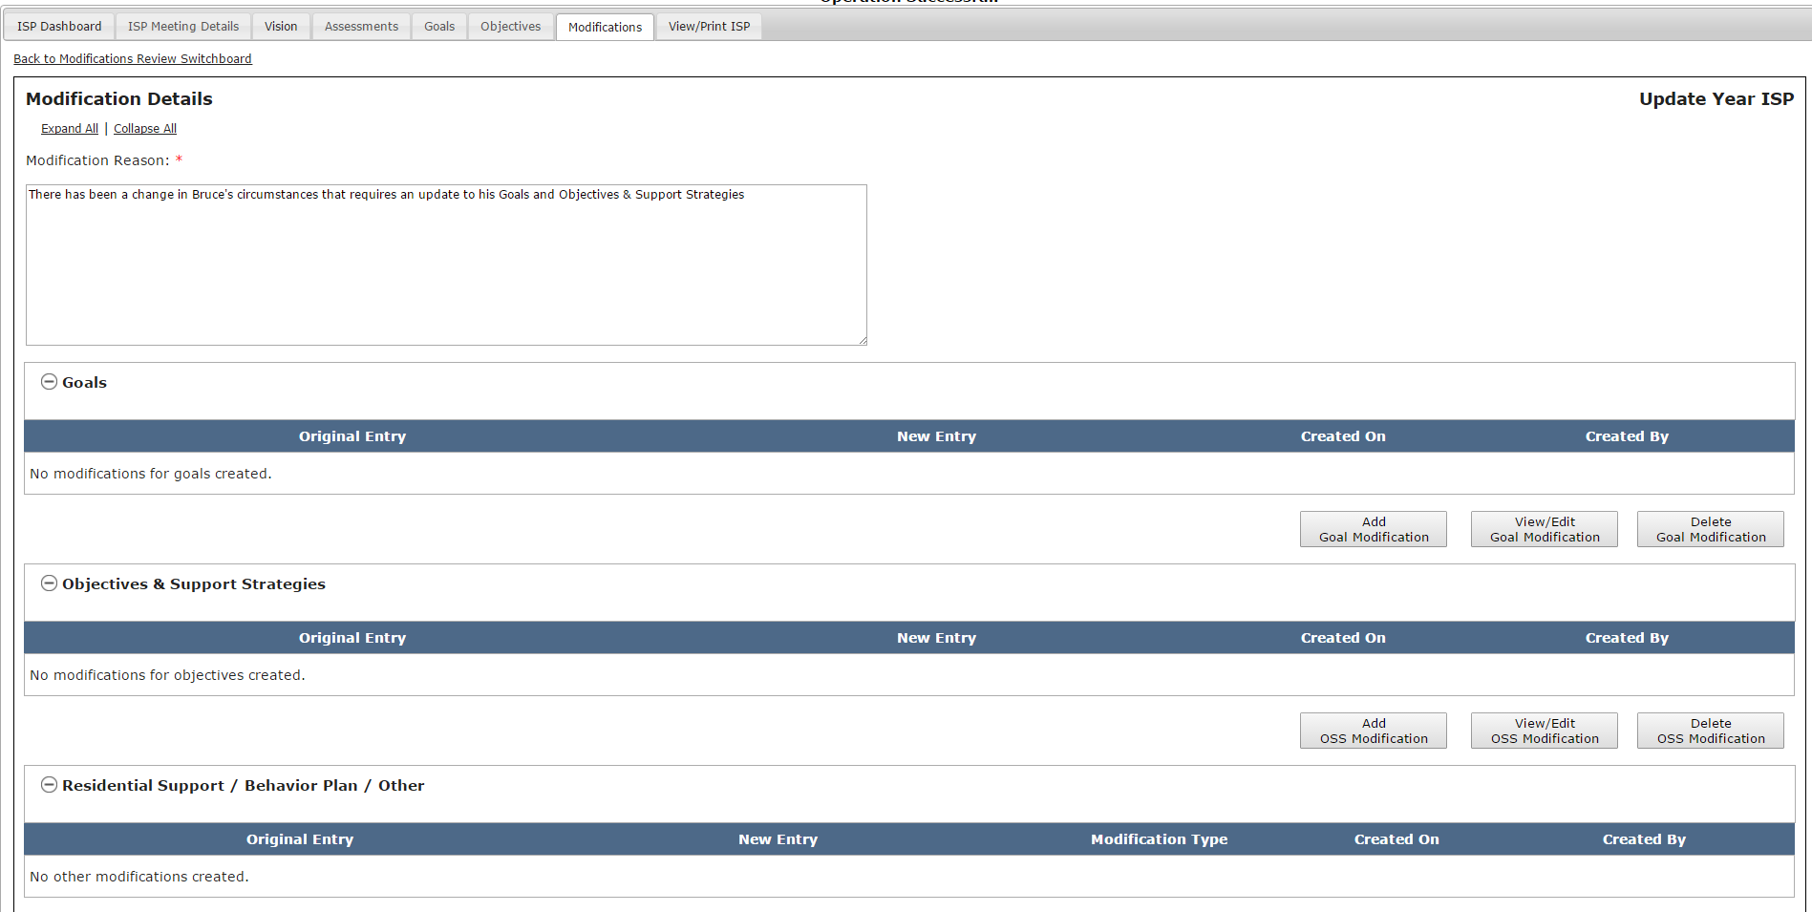

- The system will display the Modify Objectives pop-up screen. Select a Goal from the drop-down.

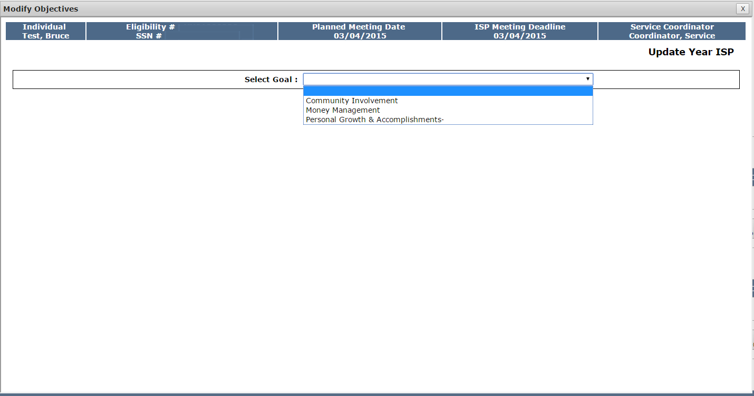
- Begin filling in the Objective section by entering comments in the “Measurable Objective” and “Setting and Learning Environment” text boxes.
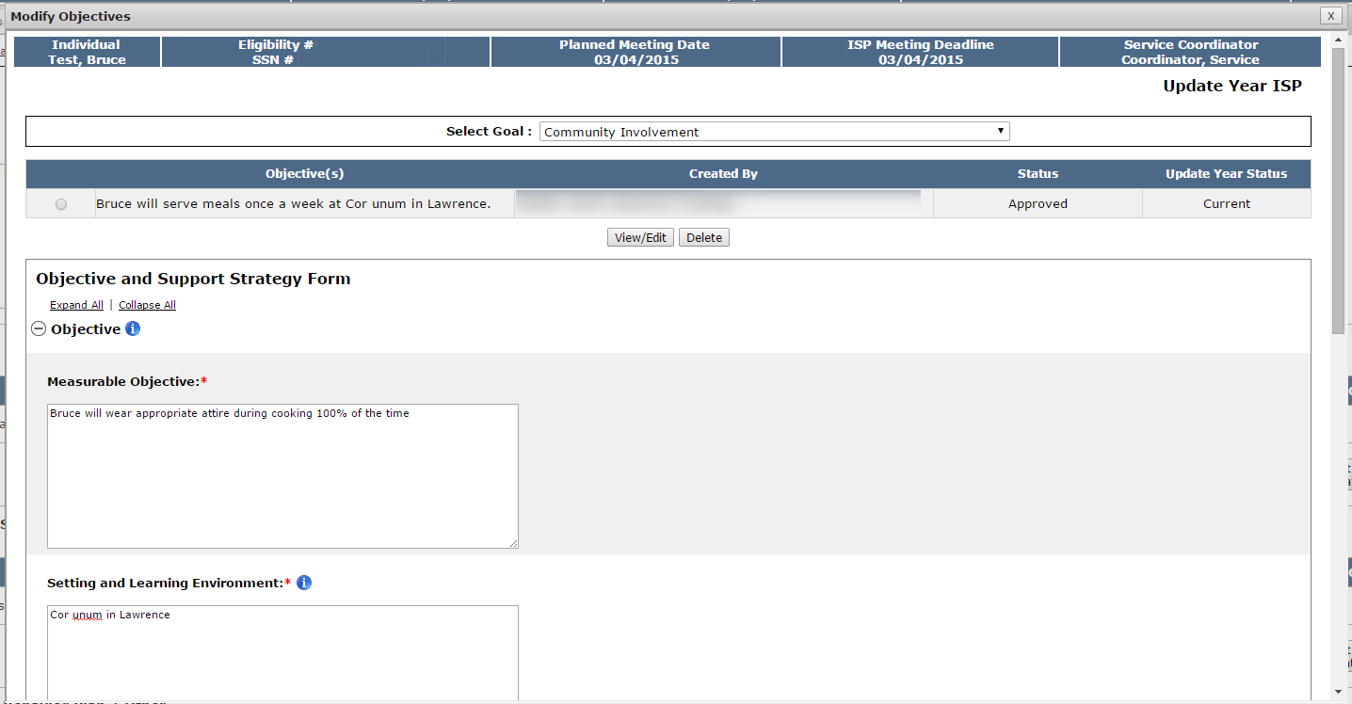
- Identify the Responsible Party.
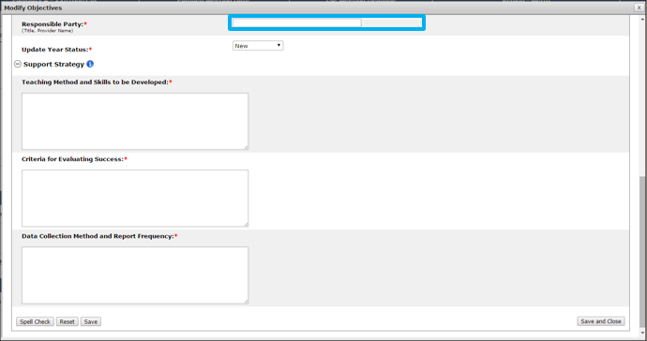
- If the Modification is submitted in an Update Year, select the Update Year status from the drop-down.
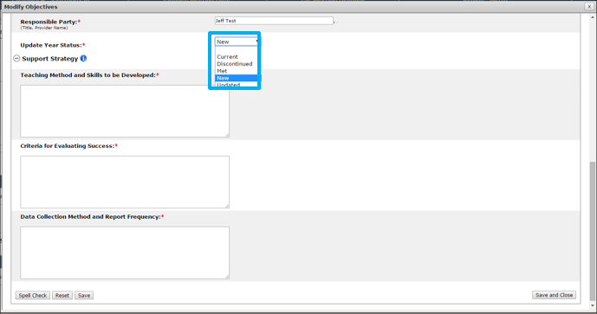
- Fill in the Support Strategy section, by entering comments in the “Teaching Method and Skills to be Developed,” “Criteria for Evaluating Success” and “Data Collection Method and Report Frequency” text boxes.
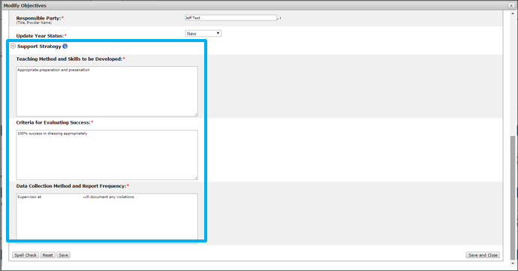
- When all sections are complete, click “Save and Close”.
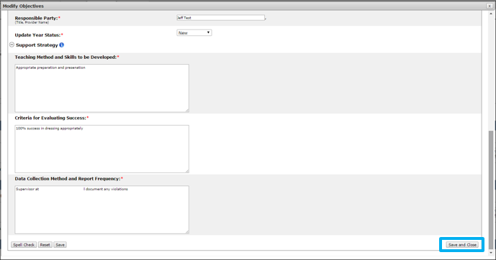

The system will return to the Modification Details screen and will display the original entry, new entry, date and individual who completed the Modification. In the image below, the Original Entry column displays the original OSS description and the New Entry displays the modified information.

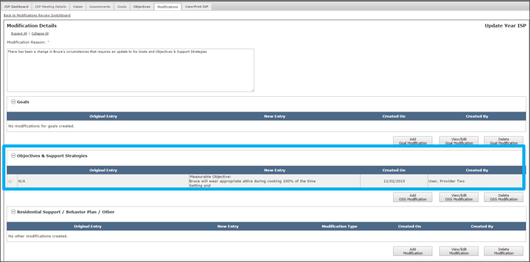
Note: A new OSS that is added as part of a Modification does not need to follow the approval process that OSS usually require. Rather the approval of the Modification is recognized as an implicit approval of the OSS and its status displays as approved.

Note: It is possible to delete an OSS Modification on the same pop-up accessed from the “Add OSS Modification” button. To do so, select the radio button for the newly added OSS that requires deletion and click “Delete.” Please note that the delete function operates differently for newly added OSS and existing OSS. Deleting a newly added Goal will remove the entire Goal from the Modification. Deleting an existing Goal Modification will only remove the modified information. The Goal will remain a part of the ISP. It is not possible to delete an unmodified existing Goal.

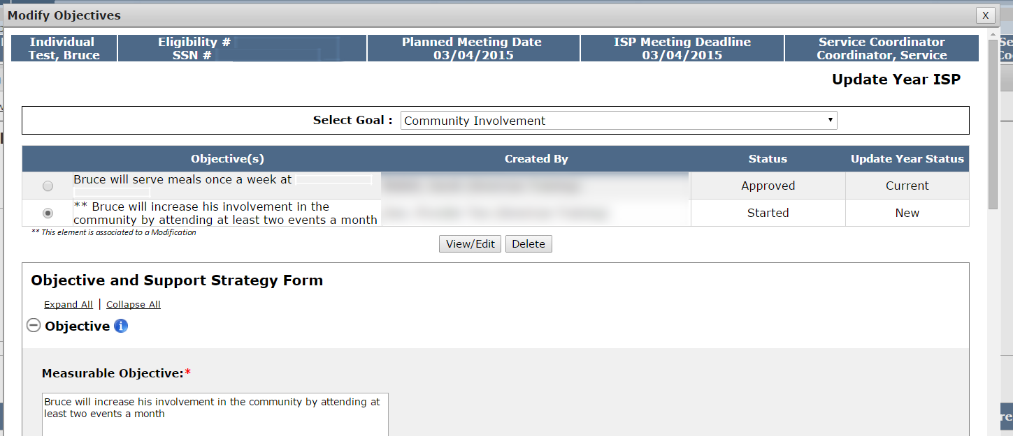

Modification of an Existing Objective & Support Strategy (OSS)

- Click “Add OSS Modification”.

- The system will display the Modify Objectives pop-up screen. Select a Goal from the drop-down.

- Select the radio button next to the Objective that you would like to modify.
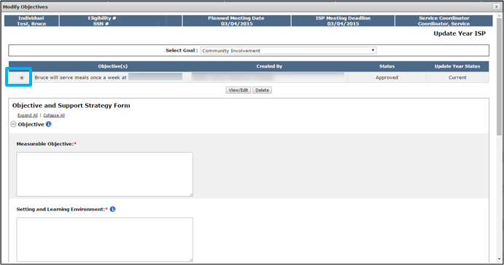
- Click “View/Edit.”
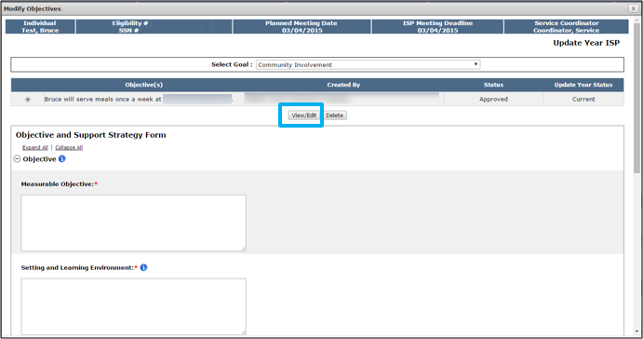
The Objective and Support Strategy form for the selected Objective will display.
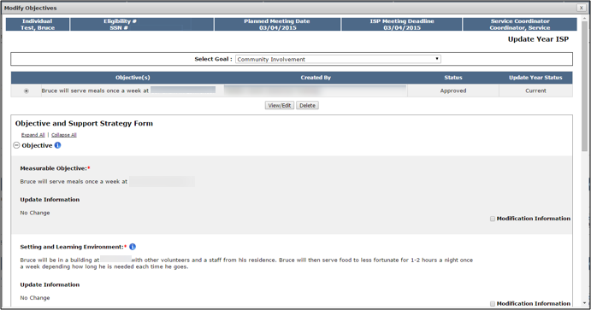
- Select the Modification Information checkboxes for each section of the Objective and Support Strategy form that requires Modification. Textboxes will appear below a section after you select the checkbox. Enter Modification information in the desired text boxes.
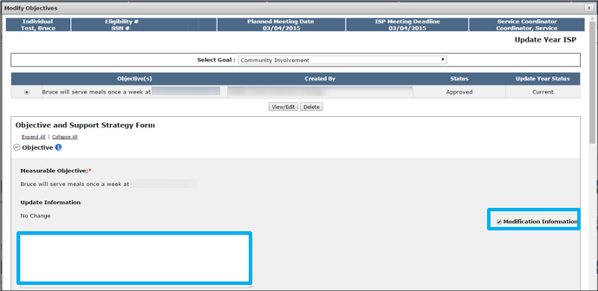
- Click “Save and Close”.
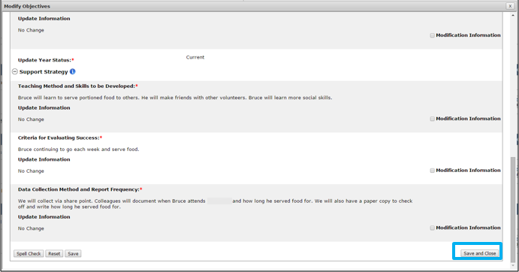
The system will return to the Modification Details screen and will display the original entry, new entry, Modification type, the date and individual who created the Modification. In the image below, the Original Entry column displays the original Goal description and the New Entry displays the modified information.

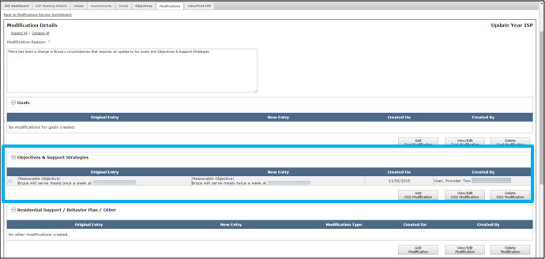
Note: A new OSS that is added as part of a Modification does not need to follow the approval process that OSS usually require. Rather the approval of the Modification is recognized as an implicit approval of the OSS and it status display as approved.
Note: It is possible to delete an OSS Modification on the same pop-up accessed from the “Add OSS Modification” button. To do so, select the radio button for the newly added OSS that requires deletion and click “Delete.” Please note that the delete function operates differently for newly added OSS and existing OSS. Deleting a newly added Goal will remove the entire Goal from the Modification. Deleting an existing Goal Modification will only remove the modified information. The Goal will remain a part of the ISP. It is not possible to delete an unmodified existing Goal.

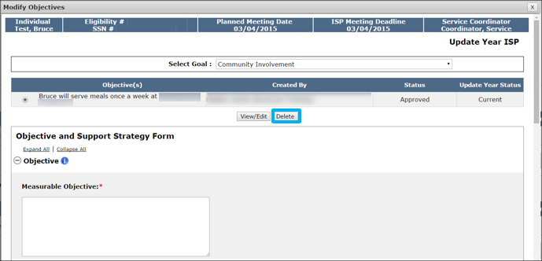

Note: If an existing OSS is modified, an asterisk displays next to the OSS on the Goal tab for the individual.
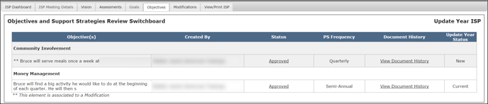

Addition or Modifying a New Behavior Plan, Residential Support, or Other
- Click “Add Modification”.
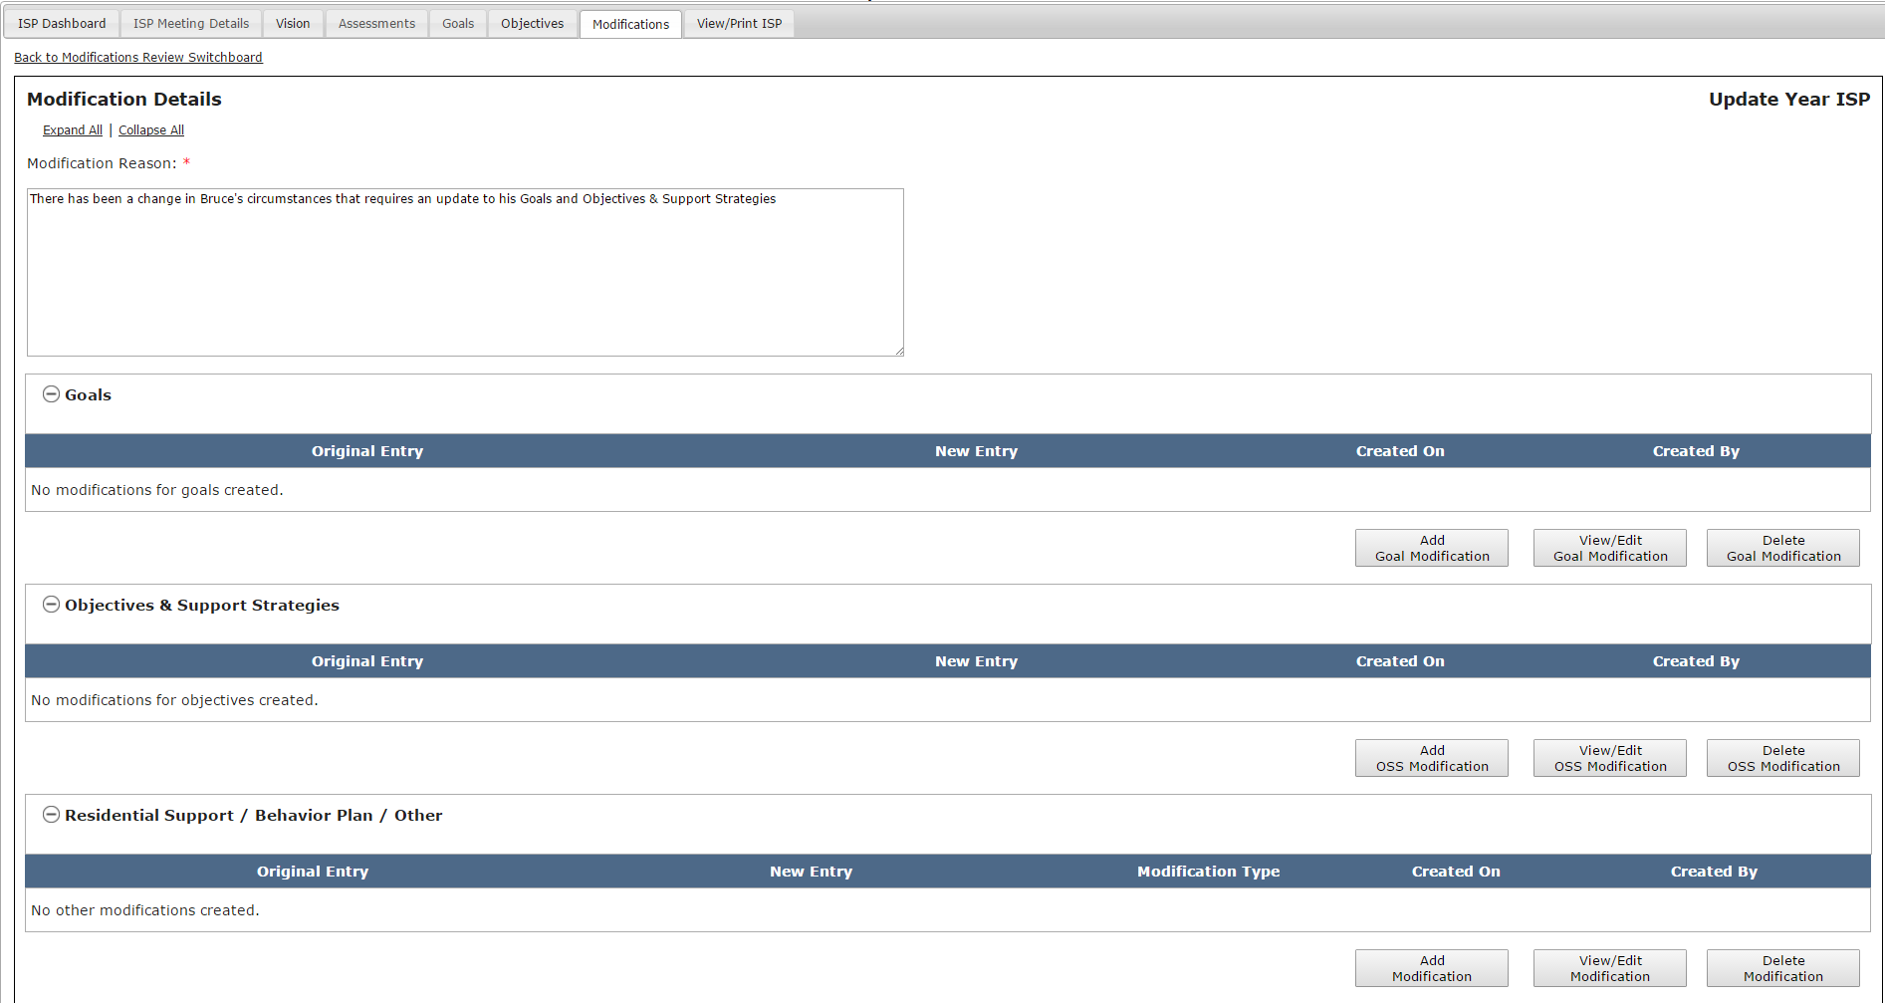
The system will display the Residential Support / Behavior Plan / Other pop-up screen.
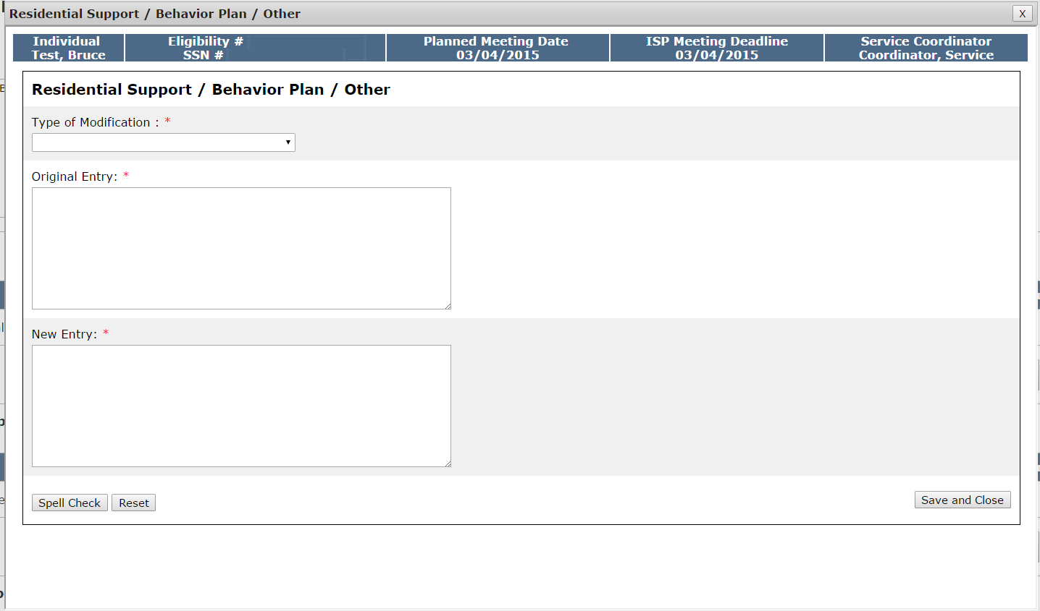
- Select the Type of Modification drop-down and identify which type of Modification will be submitted: Residential Supports of Types of Supports, Behavior Plan Modification or Initiation, Other.
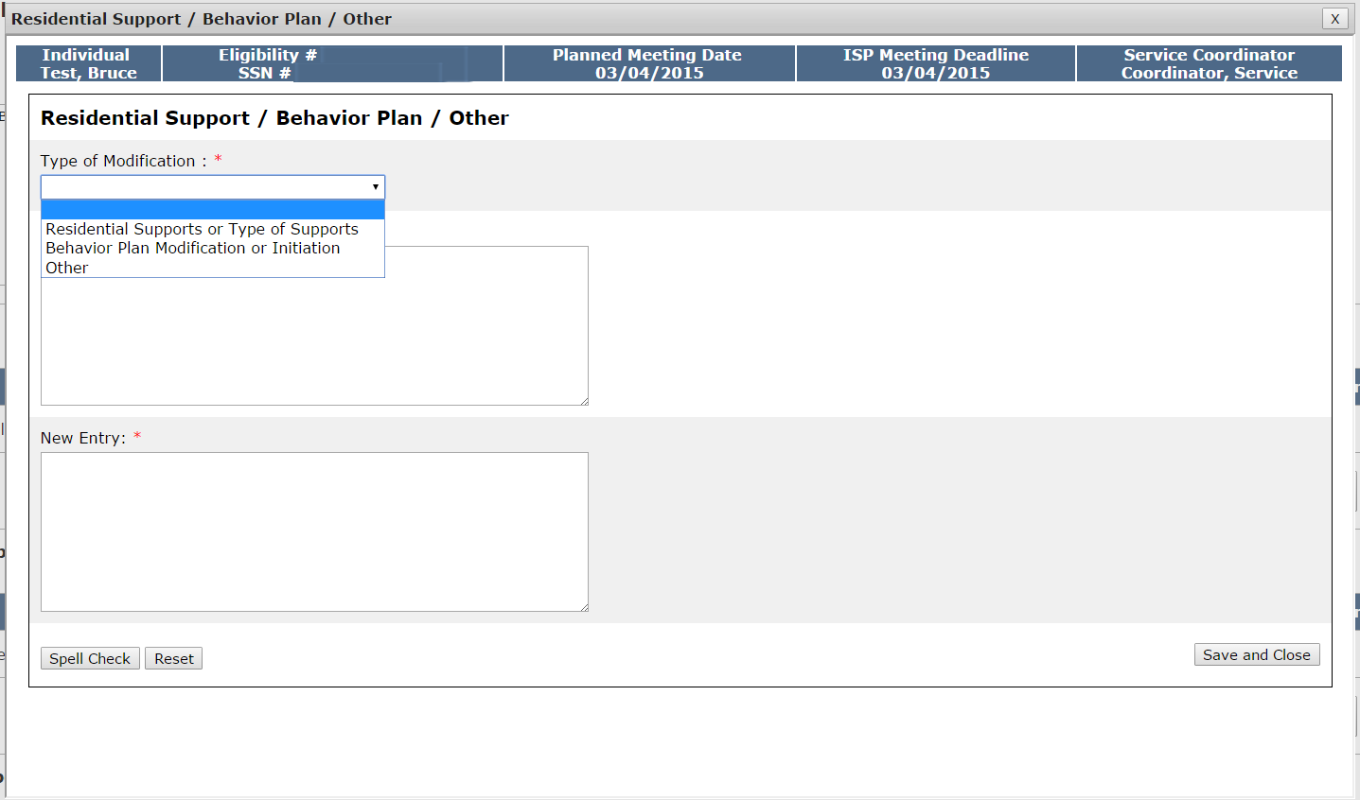
- Fill out the “Original Entry” and “New Entry” text boxes.
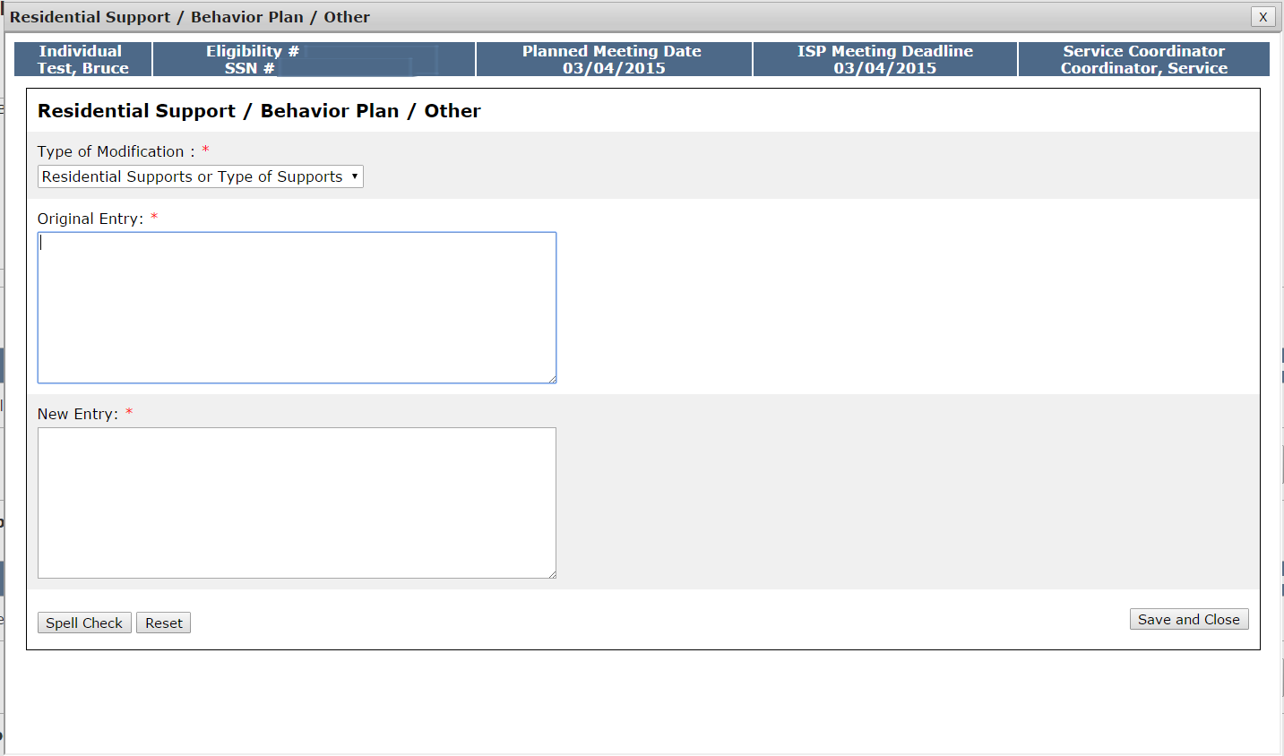
Note: As these elements are paper-processes and not completed in the system, no information will be prepopulated into the “Original Entry” field. Both the “Original Entry” and “New Entry” fields will be completed by the user.
- Click “Save and Close.”
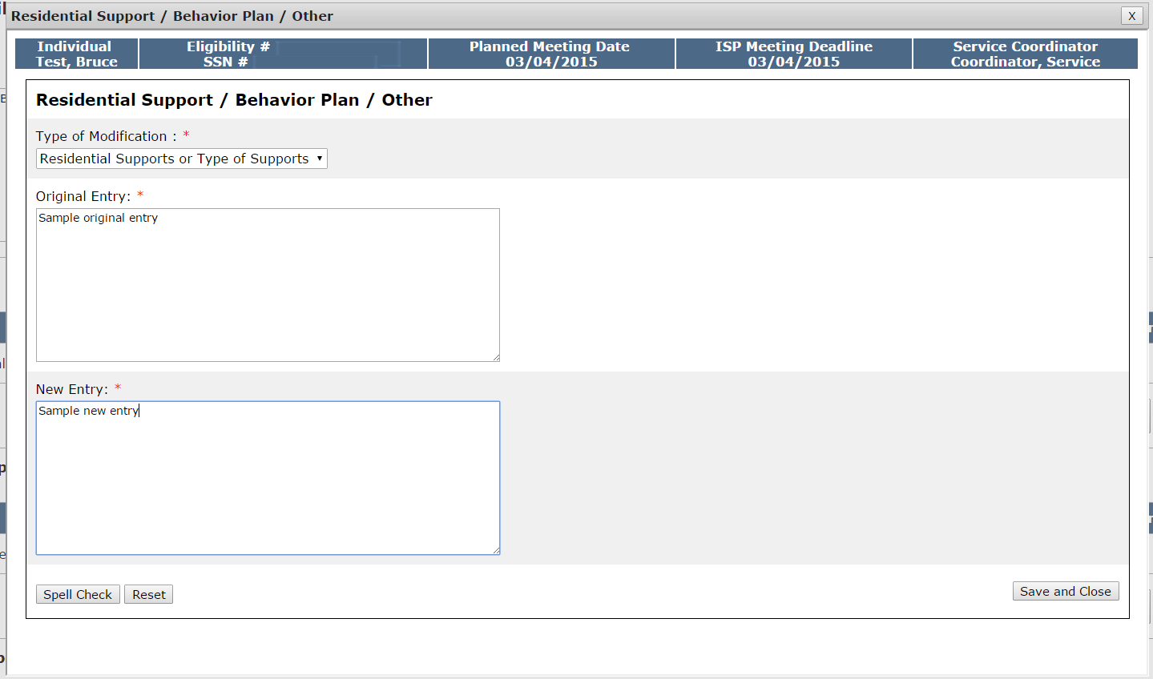
The system will return to the Modification Details screen and will display the original entry, new entry, Modification type, date and the individual who created the Modification.

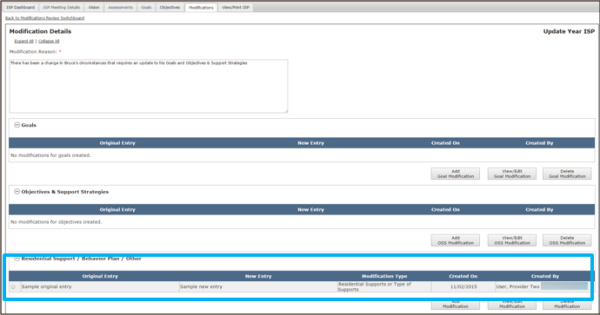

Submitting a Modification by Provider Staff
Scenario Description:
Provider Supervisors can submit an Modification once the following conditions have been met

- The ISP has been locked. There are two methods by which an ISP is locked. The plan locks when a Full or Update Year ISP has been completed and the approval has been entered in MEDITECH by the Area Director, locking the plan in HCSIS. Alernatievly, if the approval is not completed within 150 days, the plan will be locked automatically per the current process.
- The Modification has been initiated and at least one element has been added
- All mandatory fields are completed.

Note: The Provider Supervisor will submit a Modification to the Service Coordinator for Acceptance, before it is sent to the Area Office Director for Approval. The Service Coordinator may accept, disapprove, or request revision of a proposed Modification submitted by a Provider.
First Steps
- Initiate a Modification
- Add Elements to a Modification
- Navigate to Modifications form

Roles and Responsibilities
- Provider Data Entry User: N/A
- Provider Supervisors: Submit Modifications

- Once you have added elements to a Modification, navigate to the Review Section.

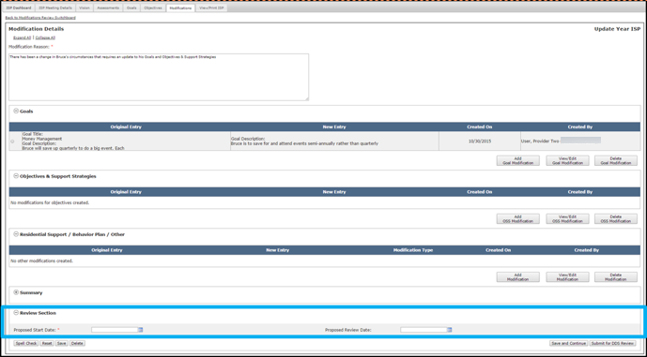

- Enter a “Proposed Start Date.” If desired, add in a “Proposed Review Date” as well.

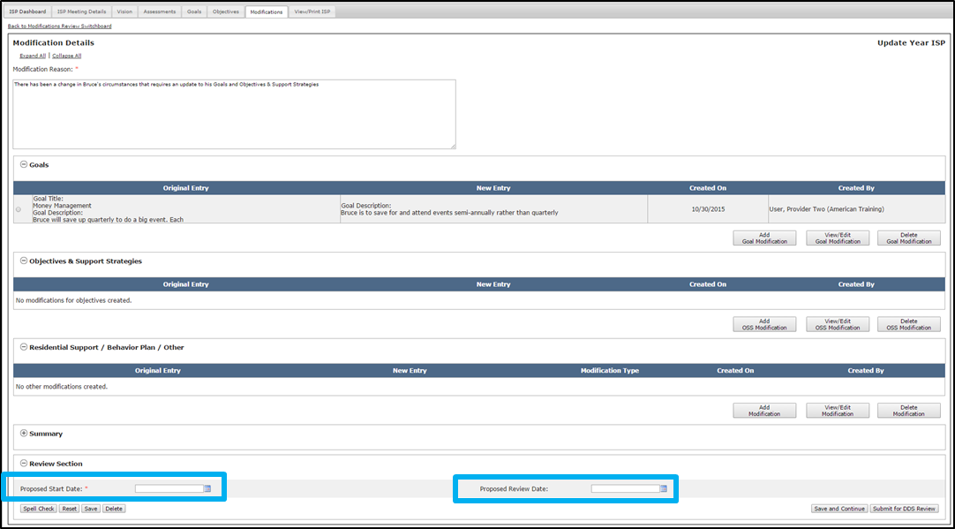

Note: The only restriction on the dates selected are that the date selected for the Proposed Review Date occur after the date selected for the Proposed Start Date.

- Click “Submit for DDS Review.” Alternatively, click on the “Save” or “Save and Continue” buttons to save this information so that it can be worked on at a later time.

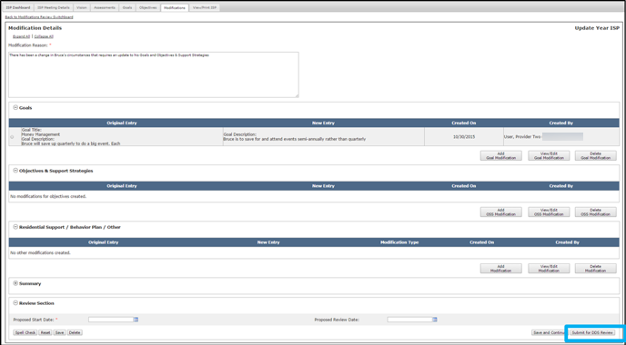

Next Steps

- Once a Modification has been submitted to DDS, the Service Coordinator or Service Coordinator Supervisor is responsible for reviewing the Modification. They can either Disapprove, Accept, or Request Revision on the Modification.
- If the Service Coordinator or Service Coordinator Supervisor determines that the Modification has been submitted in error or is not required, they will disapprove the Modification. In this case, the Provider Supervisor will receive an alert indicating that it has been disapproved. No additional action is required.
- If the Service Coordinator or Service Coordinator Supervisor determines that the Modification requires revision, the Provider Supervisor will receive an alert and will be tasked with revising the Modification.
- If the Service Coordinator or Service Coordinator Supervisor determines that the Modification is acceptable, they will submit the Modification for Area Office Director review. The Provider Supervisor will receive an alert indicating that the proposed Modification has been accepted by DDS.
- If the Area Office Director approves the Modification, the status of the Modification changes to approved in the Modifications Review Switchboard and the Modification can be printed without a draft watermark.
- If the Area Office Director disapproves the Modification, the status of the Modification is changed to disapproved in the Modifications Review Switchboard and no further action is required. The Modification content, however, is not deleted and the Area Office Director has the option of changing the status of the Modification to approved or requesting revision on the form at a later date if circumstances require it.
- Once a Modification for a newly added OSS is submitted and approved, Progress Summaries will be triggered for the objective.
- All Modifications for a plan need to be approved or disapproved for next years plan to open.

Reviewing and Accepting of a Modification by DDS Staff

Scenario Description:
Service Coordinators or Service Coordinator Supervisors are responsible for reviewing a Modification once a Provider Supervisor has submitted it to DDS for review. A Provider initiated Modification can include any combination of the following elements: Goals, Objective &Support Strategy (OSS), Residential Support / Other. Service Coordinators or Service Coordinator Supervisors can accept, disapprove, or request revision to a Provider initiated Modification. This scenario covers the process of accepting a Modification.

First Steps
- Navigate to Alert Dashboard
Roles and Responsibilities
- Service Coordinators: Review a Modification, Request Revision of a Modification, Disapprove of a Modification, Accept Modification and Submit for AOD Review
- Service Coordinator Supervisors: Review a Modification, Request Revision of a Modification, Disapprove of a Modification, Accept Modification and Submit for AOD Review

- Service Coordinators will receive an alert indicating that Modifications have been submitted by Provider agencies. Click the “Modification submitted by” link in the alert message.
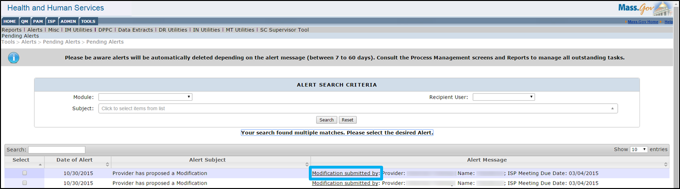
- The system will navigate to the Modifications Review Switchboard and display the Modification that has been submitted. Click the “Submitted for DDS Review” link.
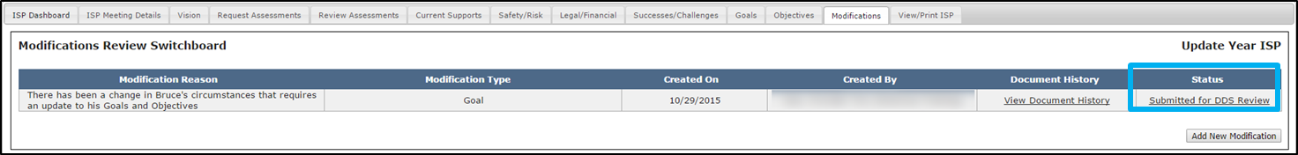
- Review the Goals, Objectives & Support Strategies and Residential Support / Other Sections on the Modification Details page.

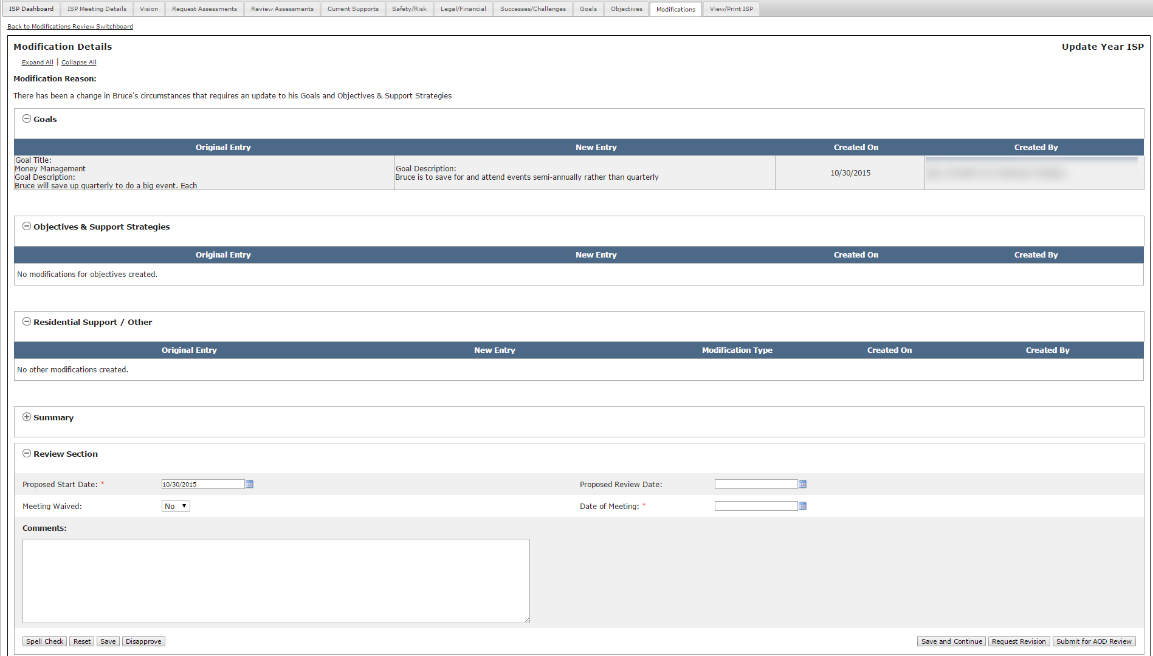
- Complete all of the mandatory sections in the Review Section on the Modification Details page.
- If the Modification is complete and ready for Area Office Director review, click “Submit for AOD Review.”

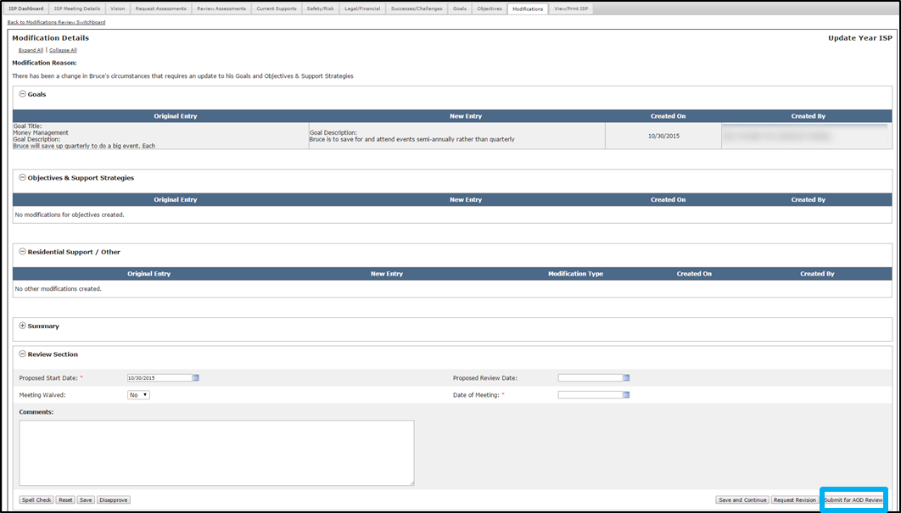

The system redirects to the Modifications Review Switchboard and the status of the Modification displays as “Submitted for AOD Review.”
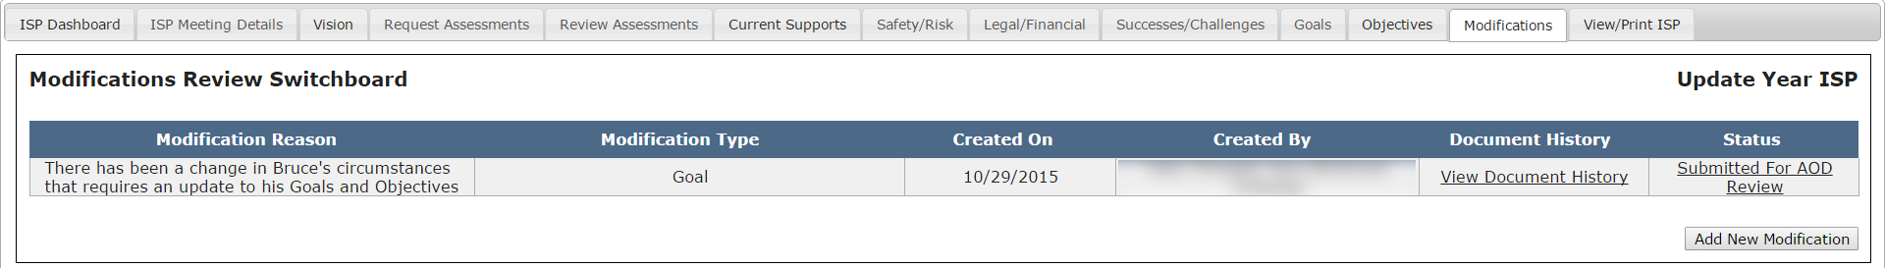
Note: When a Service Coordinator reviews a Provider initiated modification and opts to submit it for Area Office Director review, it constitutes acceptance of the Modification. It does not, however, constitute approval of the modification. A modification is only approved after a Area Office Director reviews the document and decides to approve the document. With that in mind, after you submit a modification for Area Office Director review, Providers will receive an alert indicating that the modification has been accepted but they still must wait for approval by the Area Office Director.

Reviewing and Disapproving of a Modification by DDS Staff

Scenario Description:
Service Coordinators or Service Coordinator Supervisors are responsible for reviewing a Modification once a Provider Supervisor has submitted it to DDS for review. A Provider initiated Modification can include any combination of the following elements: Goals, Objective &Support Strategy (OSS), Residential Support / Other. Service Coordinators or Service Coordinator Supervisors can accept, disapprove, or request revision to a Provider initiated Modification. This scenario covers the process of disapproving a Modification.

First Steps
- Navigate to Alert Dashboard
Roles and Responsibilities
- Service Coordinators: Review a Modification, Request Revision of a Modification, Disapprove of a Modification, Accept Modification
- Service Coordinator Supervisors: Review a Modification, Request Revision of a Modification, Disapprove of a Modification, Accept Modification

- Service Coordinators will receive an alert indicating that a Modification has been submitted by a Provider agency. Click the “Modification submitted by” link in the alert message.
- The system will redirect to the Modifications Review Switchboard and display the Modification that has been submitted. To navigate to the Modifcation Details screen, click the “Submitted for DDS Review” link.
- Review the content on the Modification Details screen.
- If the Modification was submitted in error or is not required, click “Disapprove.”
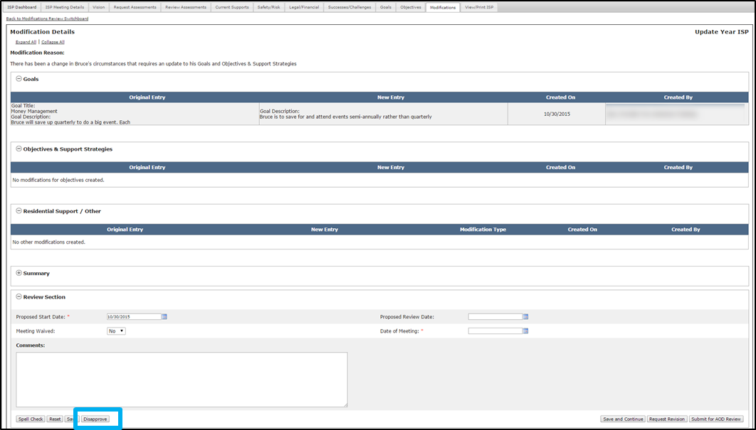
The system redirects to the Modifications Review Switchboard and the status of the Modification displays as “Disapproved by SC.”
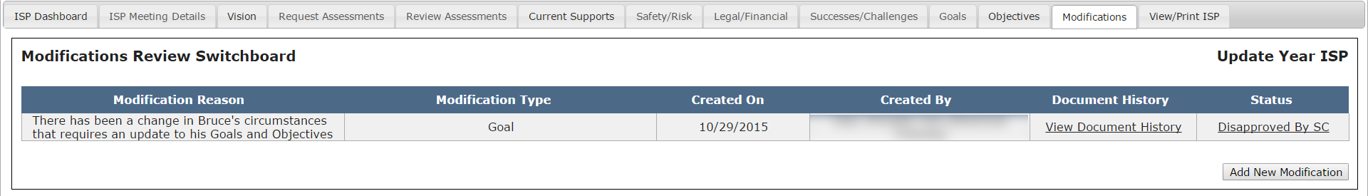

Reviewing and Requesting Revision on a Modification by DDS Staff

Scenario Description:
Service Coordinators or Service Coordinator Supervisors are responsible for reviewing a Modification once a Provider Supervisor has submitted it to DDS for review. A Provider initiated Modification can include any combination of the following elements: Goals, Objective &Support Strategy (OSS), Residential Support / Other. Service Coordinators or Service Coordinator Supervisors can accept, disapprove, or request revision to a Provider initiated Modification. This scenario covers the process of requesting revision on a Modification.
First Steps
- Navigate to Alert Dashboard
Roles and Responsibilities
- Service Coordinators: Review a Modification, Request Revision of a Modification, Disapprove of a Modification, Accept Modification
- Service Coordinator Supervisors: Review a Modification, Request Revision of a Modification, Disapprove of a Modification, Accept Modification

- Service Coordinators will receive an alert indicating that Modifications have been submitted by Provider agencies. Click the “Modification submitted by” link in the alert message.
- The system will navigate to the Modifications Review Switchboard and display the Modification that has been returned. To navigate to the Modification Details screen, click the “Submitted for DDS Review” link.
- Review the content on the Modification Details screen.
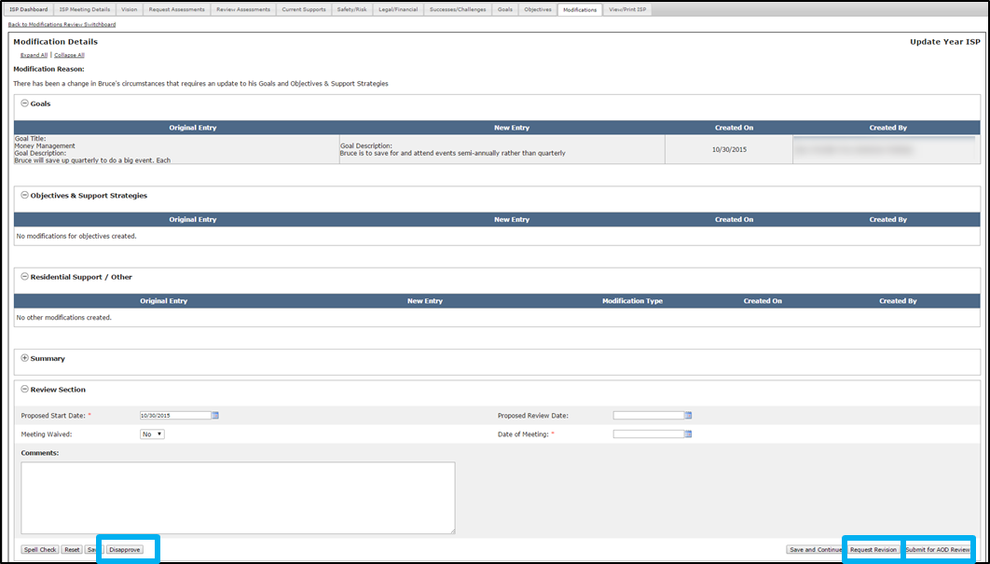
- If the Modification is required but is either incomplete or requires changes, enter an explanation in the “Comments” text box and click “Request Revision.”

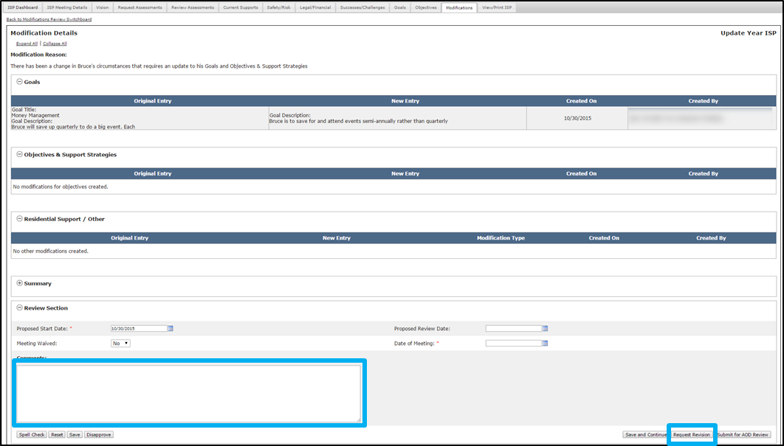
The system redirects to the Modifications Review Switchboard and the status of the Modification displays as “Revision Requested.”

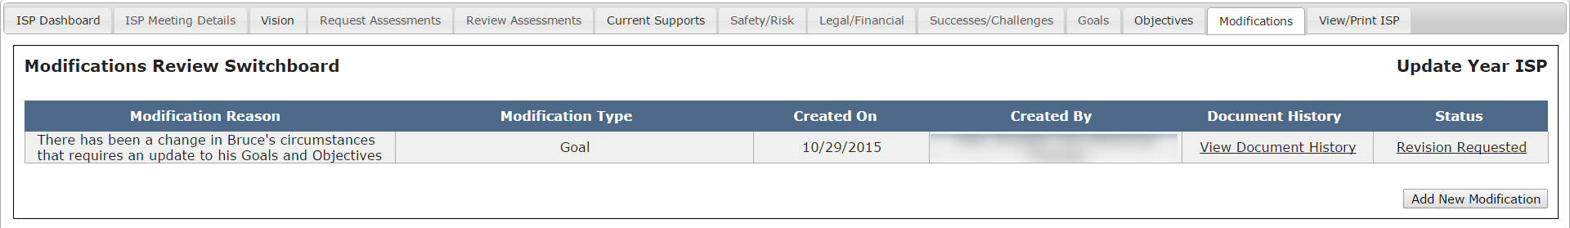

Reviewing and Revising a Modification by Provider Staff
Scenario Description:
Providers Supervisors are responsible for revising and re-submiting a Modification once DDS has returned a Modification for revision.
First Steps
- Navigate to the Alert Dashboard
Roles and Responsibilities:
- Provider Data Entry User: N/A
- Provider Supervisor: Revise a Modification, Submit for DDS Review

- Provider Supervisors will receive an alert indicating that DDS has requested revision on submitted Modifications. Click the “Revision Requested for Proposed Modification” link in the alert message.
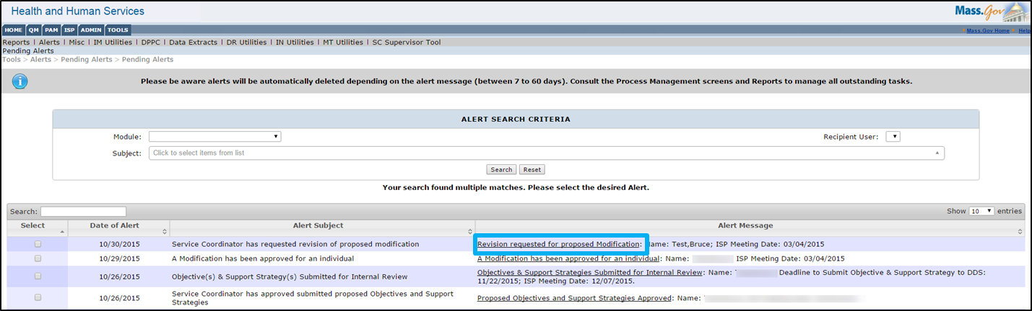
- The system will redirect to the Modifications Review Switchboard and display the Modification that has been returned. Click “Revision Requested”
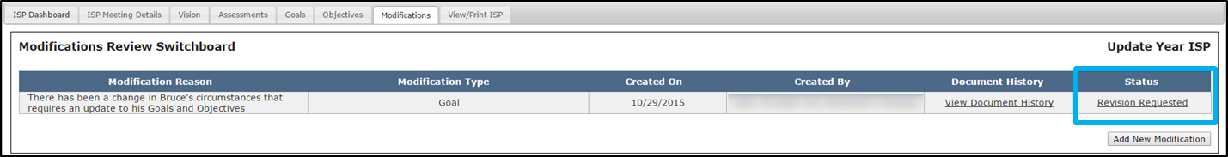
- The Modification Details screen will display. Review the comments section to identify the requested revisions.
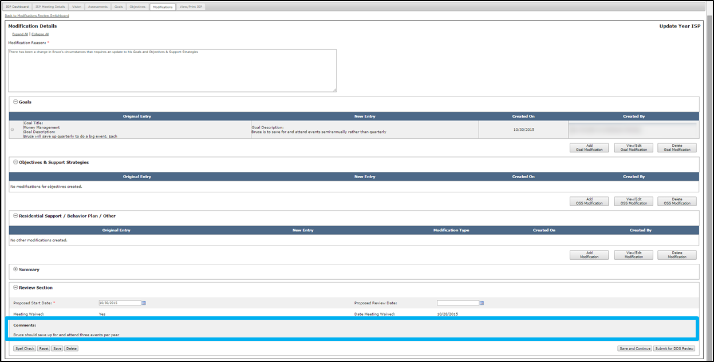
- Select the Radio Button next to the element you would like to edit.
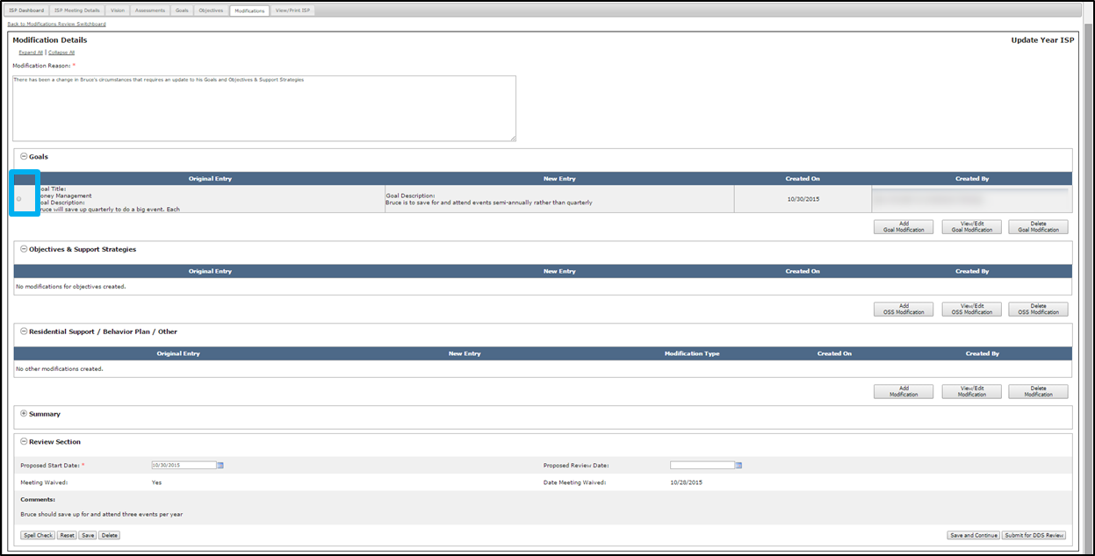
Note: The review process is identical for all of the elements. This scenario demonstrates an example of how to revise a Modification to a Goal.
- Click “View / Edit Goal Modification.”
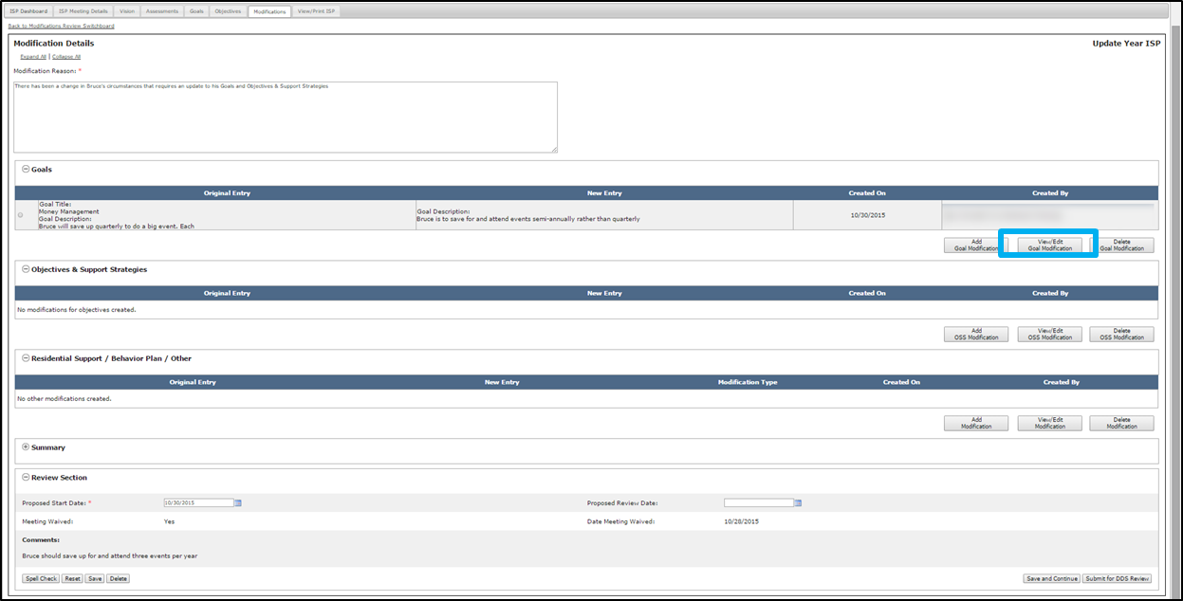
- The “Modify Goals” screen will display. Modify the Goal as requested.
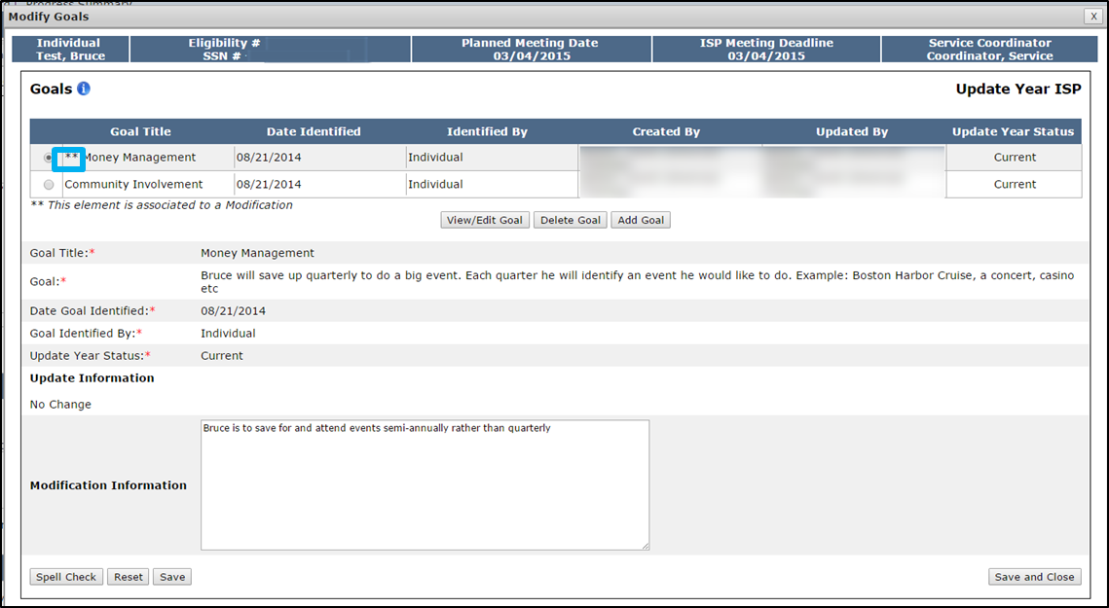
Note: Elements associated with the Modification will display with two asterisks.
- Click “Save and Close.” The system will return to the Modification Details screen.
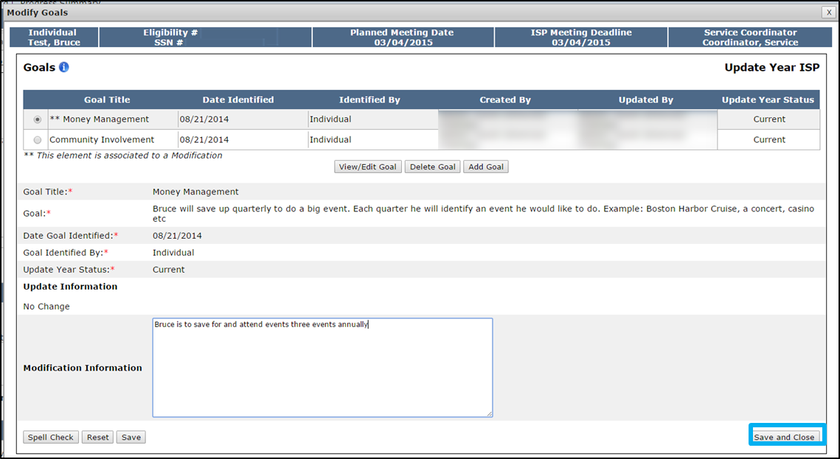
Note: The user also has the ability to add additional elements once a Modification is returned for revision, in addition to making changes to the previously added elements.
- Once all requested changes have been addressed, return to the Modification Details page and click “Submit for DDS Review.”

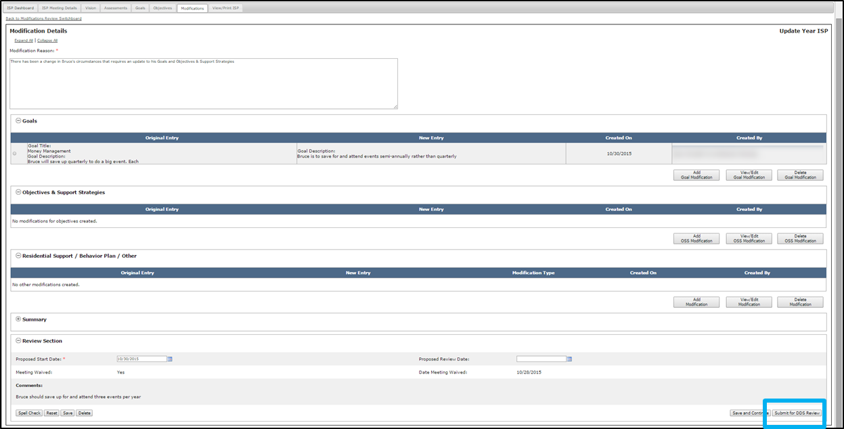
The system redirects to the Modifications Review Switchboard and the status of the Modification displays as “Submitted for DDS Review.”
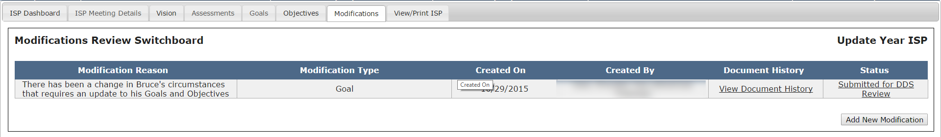

Reviewing and Approving a Modification by Area Office Directors
Scenario Description:
Once DDS has submitted a Modification for review, Area Office Directors are responsible for reviewing the Modification. The Area Office Director has two options – to “Approve” or “Disapprove” the Modification. This scenario covers the process of approving a Modification.

First Steps
- Navigate to Alerts Dashboard
Roles and Responsibilities
- Area Office Director: Review Modification, Approve Modification, Disapprove Modification

- Area Office Director receive an alert when a Modification has been submitted for review. Click the “A Modification has been accepted for an individual” link in the alert message.

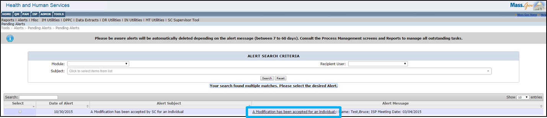

- The system will redirect to the Modifications Review Switchboard. Click the “Submitted for AOD Review” link.

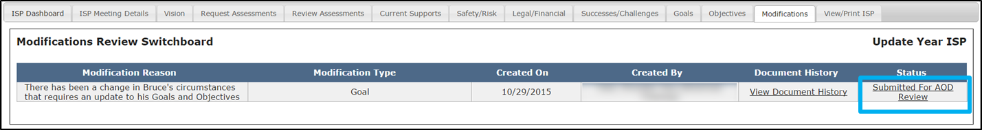

Note: Until the Area Office Director completes their review and approves the document, the SC remains able to edit a Modification. If the SCs opts to edit the Modification after it is been submitted, the status of the Modification changes to “Started.”

- The system will display the Modification Details page. Review the content on the page.
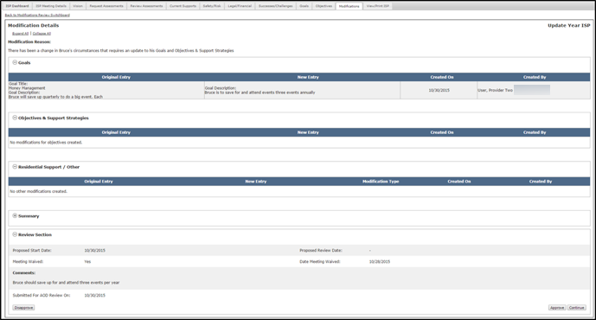
- If the Modification is complete and required, click “Approve.”
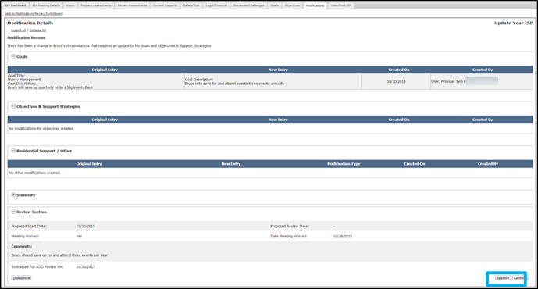
- The system will redirect to the Modifications Review Switchboard. The status of the Modification will read “Approved by AOD.”

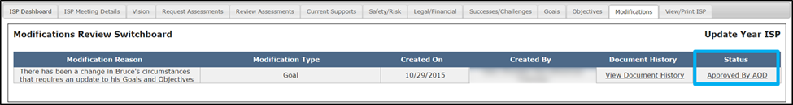

Note: The Area Office Director is not able to approve part of a modification. If the Area Office Director decides to click “Approve,” the entire modification is approved, including all the elements included in it.

Note: Once a Modification has been approved, the modified information will display in the individual’s plan.

Note: After an Area Office Director approves a Modification that includes changes to either Goals or OSS, the Provider Service Agreement is updated and all users are able to print an updated copy of the Provider Service Agreement.

Note: An new objective that is added as part of a Modification does not follow the approval process that objectives usually require in a typical ISP year. Rather, the approval of the Modification is recognized as an implicit approval of the objective and its status display as approved. Once approved, the objective will appear on the Objectives and Support Strategies Review Switchboard and, by default, the check mark will be selected in the Include in ISP? Column.

Reviewing and Disapproving a Modification by Area Office Directors
Scenario Description:
Once DDS has submitted a Modification for review, Area Office Directors review the Modification. The Area Office Director has two options – to either “Approve” or “Disapprove” the Modification. This scenario covers the process of disapproving a Modification.

First Steps
- Navigate to Alerts Dashboard
Roles and Responsibilities
- Area Office Director: Review Modification, Approve Modification, Disapprove Modification

- Area Office Director receives an alert when a Modification has been submitted for review. Click the “A Modification has been accepted for an individual” link in the alert message.

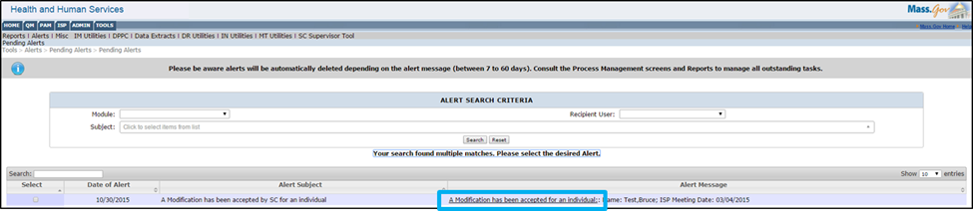

Note: Until the Area Office Director completes their review and approves the document, the SC remains able to edit a Modification.

- The system will redirect to the Modifications Review Switchboard. Click the “Submitted for AOD Review” link.

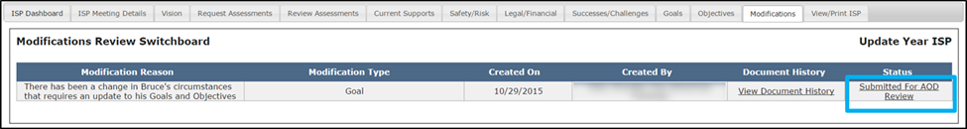

- The system will display the Modification Details page. Review the content on the page.

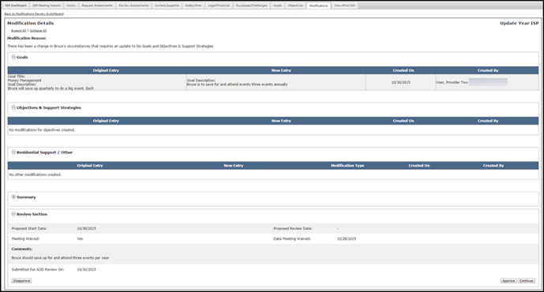
- If the Modification is either incomplete or not required, click “Disapprove.”
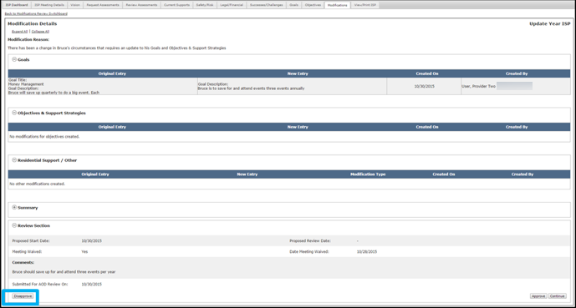
Note: In an offline discussion with the SC, the Area Office Director will explain the reason for disapproving. The Area Office Director will either indicate that the Modification requires revision or that it is not required altogether. The reason will determine the next steps.
Note: If the Area Office Director disapproves the Modification, the status is changed to disapproved in the Modifications Review Switchboard and no further action is required. The Modification content, however, is not deleted and the Area Office Director has the option of changing the status of the Modification to approved at a later date if circumstances require it.

Reason for Disapproval | Next Step  (DDS Initiated) | Next Step  (Provider Initiated)
Revision Required | SC to Make Revisions | SC to Request Revision by Provider
Modification Not Required | No Action Required | No Action Required
- The system will redirect to the Modifications Review Switchboard. The status of the Modification will read “Disapproved by AOD”.

