Commonwealth of Massachusetts
Executive Office of Health and Human Services

Virtual Gateway

ISP Assessments Module
User Guide
Lesson 8: Additional Functionality
HCSIS Release 7.7

Contents
Additional Functionalities 2
Alerts in the ISP Assessments Module 2
InfoTips 11
Document History 12
Unchecking the Update Information Checkbox 15
Review Process Management 17
Summary Report for DDS Staff 20
Summary Report for Provider Staff 31
Progress Summary Report for DDS Staff 39
Progress Summary Report for Provider Staff 44
Viewing and Printing ISP Materials for DDS Staff 49
Viewing and Printing Historical ISP Materials Access for DDS Staff 60
Viewing and Printing ISP Materials for Provider Staff 64
Viewing and Printing Historical ISP Materials Access for Provider Staff 74
Enhanced Security for Providers 77

Additional Functionalities
There are several additional system functionalities that are available to all end users in the module. The functionalities described in this section will demonstrate the following features to end users:
- InfoTips
- Document History
- Unchecking the Update Information Checkbox
- Saving and Printing ISP Documents
- Accessing Historical ISP Materials
- Summary Report
- Alerts in the ISP Module
- How to utilize the Review Process Management tool

Alerts in the ISP Assessments Module
The ISP Assessments module in HCSIS enables electronic submission and review of required ISP documents including an individual’s Vision, Goals, Assessments, Objectives and Support Strategies. There are alerts associated with each of these events. Alerts in the ISP Assessments module can be seen by Providers, Provider Supervisors, Service Coordinators and Service Coordinator Supervisors, and in some cases the Area Office Director. Service Coordinator Supervisors and Provider Supervisors receive a reduced number of alerts. Commonwealth users and Regional Office Directors do not receive alerts.

Alerts are notifications that are generated either automatically by the ISP module or as a result of an action taken by the users in the module. Regardless of what triggers the alert, alerts reference milestones in the ISP Assessments planning process according to DDS standards and policies.

The presence of alerts allows the module to achieve its objective of enabling electronic submission and review of required ISP documents. The alerts are a valuable tool to streamline the submission, review, and approval of documents and eliminate the duplication of effort throughout the process of planning the ISP meeting.

Alert Timeline
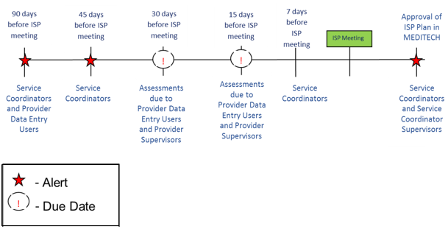

- The ISP renewal process is initiated 90 days prior to the ISP meeting deadline with a reminder alert. From the time this alert is generated, the SC and SC Supervisor may make an ISP Year Selection.
- Approximately 45 days prior to the ISP meeting deadline, the Service Coordinator consults with the individual and guardian to draft a preliminary Vision Statement for the individual.
- At least thirty days prior to the planned ISP meeting date, the Service Coordinator will send an electronic notification to Providers that includes the ISP meeting plan and the required assessments.
- Providers will also receive a reminder alert about Objectives and Support Strategies 15 days before they are due.
- Assessments and Objectives and Support Strategies are due fifteen days prior to the planned ISP meeting date.
- Once the Service Coordinator receives required documents, he/she will begin reviewing them.
- The final step is for the ISP team to meet and finalize the ISP documents.
- By regulation, the ISP Document and supporting documents need to be mailed out by 45 days after the ISP Meeting.
- Documents will remain open for editing up to 150 days after the meeting.

ISP Assessments Module Alerts by Event
Below is a table of the alerts in the ISP assessments module by the trigger event and corresponding recipient of the alert.

# | Alert Subject | Alert Recipient | Trigger
1. | An ISP is due | Service Coordinator role and Provider Data Entry role | System Generated Alert: 90 days prior to ISP Meeting Due Date
2. | ISP Meeting notification due to providers in fifteen days. Verify the service enrolments in MEDITECH before requesting Assessments from Providers | Service Coordinator role | System Generated Alert: 45 days prior to ISP Meeting Date
3. | ISP Meeting Notification | Provider Data Entry role and Provider Supervisor role | System Generated Alert: 30 days prior to ISP Meeting Date to select providers from whom assessments are not requested from the system
4. | Request to complete individual’s assessments | Provider Data Entry role | User Generated Alert:  Service Coordinator sends notification to Providers
5. | ISP Meeting Notification and/or Request for Assessments have not yet been sent to Providers | Service Coordinator role and  Service Coordinator Supervisor role | System Generated Alert:  Service Coordinator did not submit in invitation to the Providers prior to the due date.
6. | Assessment(s) Submitted for Internal Review | Provider Supervisor role | User Generated Alert: Provider submits an assessment for internal review
 | Provider Supervisor has requested revision of Assessments | Provider Data Entry Role | User Generated Alert:  Provider Supervisor requests revision for Assessments submitted by Provider Data Entry
7. | Provider has completed requested Assessments | Service Coordinator role | System Generated Alert:  Provider submits assessments for review
8. | Service Coordinator has requested revisions of Assessments | Provider Data Entry role | User Generated Alert:  Service Coordinator request revisions of assessments submitted by Provider
9. | Service Coordinator has approved submitted Assessment | Provider Data Entry role | User Generated Alert:  Service Coordinator approves all assessments submitted by Provider
10. | Deadline to submit required Assessments has passed | Provider Data Entry role and Provider Supervisor role | System Generated Alert:  Provider does not submit assessments by the due date
11. | Objectives and Support Strategies due in fifteen days | Provider Data Entry role | System Generated Alert:  30 days prior to ISP Planned Meeting Date
12. | Objective(s) And Support Strategy(s) Submitted for Internal Review | Provider Supervisor role | User Generated Alert: Provider submits an Objective and Support Strategy for internal review
 | Provider Supervisor has requested revision of proposed Objectives and Support Strategies | Provider Data Entry Role | User Generated Alert:  Provider Supervisor requests revision for proposed Objectives and Support Strategies submitted by Provider Data Entry
13. | Provider has submitted Objectives & Support Strategies | Service Coordinator role | User Generated Alert:  Provider submits Objectives & Support Strategies
14. | Deadline to submit Objectives & Support Strategies has passed | Provider Data Entry role and Provider Supervisor role | System Generated Alert:  Provider does not submit Objectives & Support Strategies by due date
15. | Service Coordinator has requested revision of proposed Objectives & Support Strategies | Provider Data Entry role | User Generated Alert:  Service Coordinator requests revision for proposed Objectives & Support Strategies submitted by Provider
16. | Service Coordinator has approved submitted proposed Objectives & Support Strategies | Provider Data Entry role | User Generated Alert:  Service Coordinator approves all proposed Objectives & Support Strategies submitted by Provider
17. | ISP will be locked in 15 days if approval is not entered in MEDITECH | Service Coordinator, Service Coordinator Supervisor, Provider and Provider Supervisor roles | System Generated Alert:  135 Days after the ISP Meeting Due Date if the approval flag has not yet been pulled from MEDITECH
18 | ISP is locked | Service Coordinator role  Service Coordinator Supervisor | System Generated Alert: Plan locked based on the Approval flag in MEDITECH
19. | A manually unlocked ISP Plan has not been re-locked | Service Coordinator, Service Coordinator Supervisor, Area Office Director Data Entry Role | System Generated Alert:  30 Days after an ISP plan has been manually unlocked by the Area Office Director Data Entry Role
20. | Progress Summaries due in thirty days | Provider Data Entry role  Service Coordinator | System Generated Alert:  30 days prior to ISP Progress Summary Due Date
21. | Progress Summaries Submitted for Internal Review | Provider Supervisor role | User Generated Alert: Provider submits a Progress Summary for internal review
 | Provider Supervisor has requested revision of proposed Progress Summaries | Provider Data Entry Role | User Generated Alert:  Provider Supervisor requests revision for proposed Progress Summaries submitted by Provider Data Entry
22. | Provider has submitted Progress Summaries | Service Coordinator role | User Generated Alert:  Provider submits Progress Summaries  Batch alert (Tuesday and Friday)
23 | Deadline for provider to submit Progress Summaries has passed | Service Coordinator Role | System Generated Alert:  Provider does not submit Progress Summaries by due date
24. | Deadline to submit Progress Summaries has passed | Provider Data Entry role  Provider Supervisor role | System Generated Alert:  Provider does not submit Progress Summaries by due date
25. | Service Coordinator has requested revision of proposed Progress Summaries | Provider Data Entry role  Provider Supervisor role | User Generated Alert:  Service Coordinator requests revision for proposed Progress Summaries submitted by Provider
26. | Service Coordinator has approved submitted proposed Progress Summaries | Provider Data Entry role  Provider Supervisor Role | User Generated Alert:  Service Coordinator approves all proposed Progress Summaries submitted by Provider
27. | Provider has proposed a Modification | Service Coordinator role | User Generated Alert:  Provider proposes Modification
28. | Service Coordinator has accepted proposed Modification | Provider Supervisor role | User Generated Alert:  Service Coordinator accepts Modification proposed by Provider
29. | Service Coordinator has disapproved proposed Modification | Provider Supervisor role | User Generated Alert:  Service Coordinator disapproves proposed Modification initiated by Provider
30. | AOD has approved your proposed Modification | Provider Supervisor role  Service Coordinator role  Service Coordinator supervisor | User Generated Alert:  AOD approves Modification initiated by Provider
31. | AOD has disapproved Modification | Provider Supervisor role  Service Coordinator role  Service Coordinator supervisor | User Generated Alert:  AOD disapproves Modification initiated by Provider
32. | A Modification has been approved for an individual | Provider Supervisor role for all Providers who are providing services for the individual | User Generated Alert:  AOD approves Modification for an individual
33. | Deadline to approve or disapprove proposed Modification has passed | Service Coordinator role  Service Coordinator Supervisor  Area Office Director Role | System Generated Alert:  AOD does not approve or disapprove a Modification by the due date
35. | Service Coordinator has requested revision of proposed Modification. | Provider Supervisor | User Generated Alert:  Service Coordinator requests revision for proposed Modification submitted by Provider
36. | A Modification has been accepted for an individual | Area Office Director | User Generated Alert:  SC accepts Modification for an individual

Accessing Alerts in the ISP Assessments Module
Note: This action can be completed by either Area Office staff or Provider staff.
- Access alerts by clicking “Alerts” hyperlink on the top left hand side of the screen.

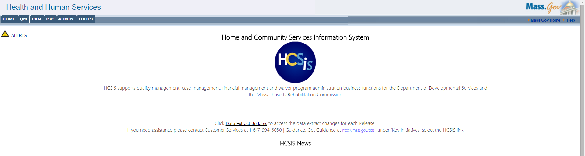
- Filter the ISP-specific alerts by using the Module drop-down menu to select Individual Support Plan. Users may also search by Alert Subject.

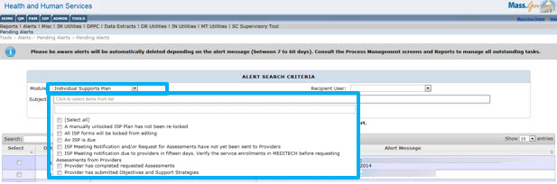

Search Alerts by Recipient User
Service Coordinators may search by Recipient User. The names that populate in this drop-down allow users to search by SC caseload. The Recipient User drop down menu is only available to Service Coordinators.
When Service Coordinators search for alerts, the results will look similar to those in the following screenshot.

The “Search” box on the top left allows the user to search for a word within the displayed alerts subjects or messages.

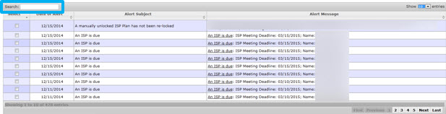

Responding to Alerts in the ISP Assessments Module
Note: This action can be completed by either DDS staff or Provider staff.
In this particular example, the Provider Supervisor responds to the alert.
- Provider Supervisor clicks on the hyperlink in the Alert message which explains the nature of the alert. An alert with the subject “Request to complete individual’s assessments” is an alert only seen by Providers.
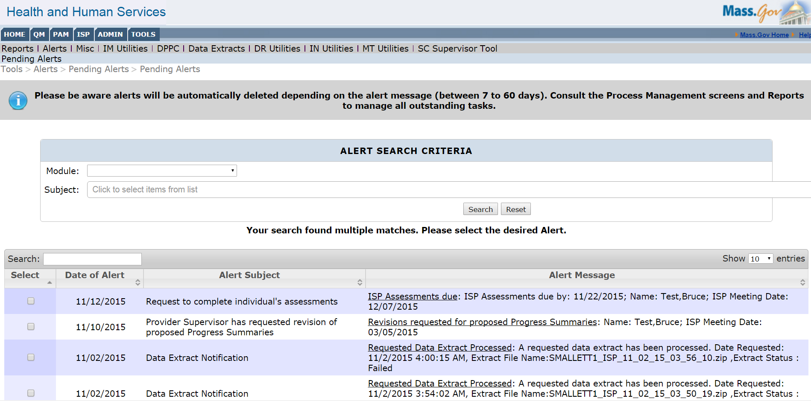
- Click the alert status to begin completing the required next steps to respond to the alert.

The system redirects the Provider Supervisor to the Assessments Review Switchboard page. This page gives Providers and Provider Supervisors a detailed snapshot of which Assessments are required for the individual. On the far right, there is a status provided for each of the assessments. The Provider can begin to complete the assessment by clicking on the hyperlink that reads “Not Started”.

Next Steps

- The alert has been resolved.
- Users may manually delete alerts, or they will be deleted by the system automatically after 15 days, with the exception of the re-lock ISP alert, which does not expire until after the plan is manually relocked.

InfoTips
InfoTips are available across the module and are shared between Providers and DDS staff, meaning the same information is available in the InfoTips regardless of which user has logged in. InfoTips are marked with the following icon:
InfoTips display information relevant to the field they are placed next to when the user hovers over it with their cursor (without clicking).

Below is an example of the InfoTips available on the Vision page:

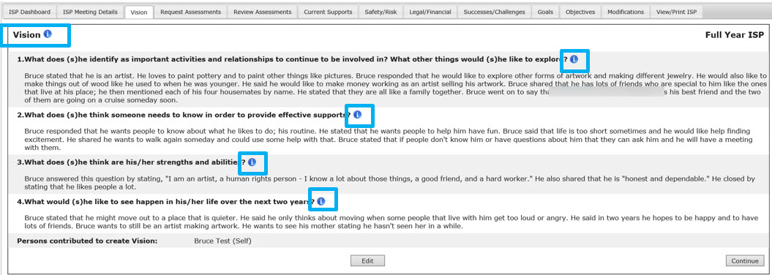

Below is a screenshot of how the text is displayed when the user hovers their mouse over the InfoTip icon:

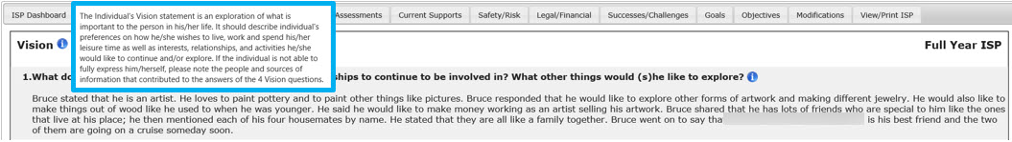

Document History
These steps must be completed by both DDS staff – a Service Coordinator or a Service Coordinator Supervisor – and Provider Agency staff – a Provider and a Provider Supervisor. Users can view the document history for each assessment once the following conditions have been met:

- The individual is receiving one or more services that require an assessment to be completed
- The Service Coordinator or Service Coordinator Supervisor have requested at least one assessment and/or
- The Provider or Provider Supervisor has created at least one Objective and Support Strategy

For each Assessment and Objective that is created in HCSIS, the system will display a Document History that details the review process specific to that Assessment or Objective. Document History will capture the request (if applicable), submission, review, revision, and approval dates for both DDS and Providers.

In both a Full Year and an Update Year, the document history will only display the data for the current year.

Roles and Responsibilities

- Service Coordinator: Views the Document History for any of the available Assessments or Objectives & Support Strategies.
- Service Coordinator Supervisor: Views the Document History for any of the available Assessments or Objectives & Support Strategies.
- Provider: Views the Document History for any of the available Assessments or Objectives & Support Strategies.
- Provider Supervisor: Views the Document History for any of the available Assessments or Objectives & Support Strategies.

Note: For demonstration purposes, this scenario shows the document history pop-up from the Assessments screen, however please note that this is present on Objectives, Progress Summary and Modifications screen within an Individual’s ISP Plan.

- Service Coordinator or Provider selects “View Document History” from the individual’s Assessments Review Switchboard, Objectives & Support Strategies Review Switchboard, Modifications Review Switchboard or Progress Summary Review Switchboard.

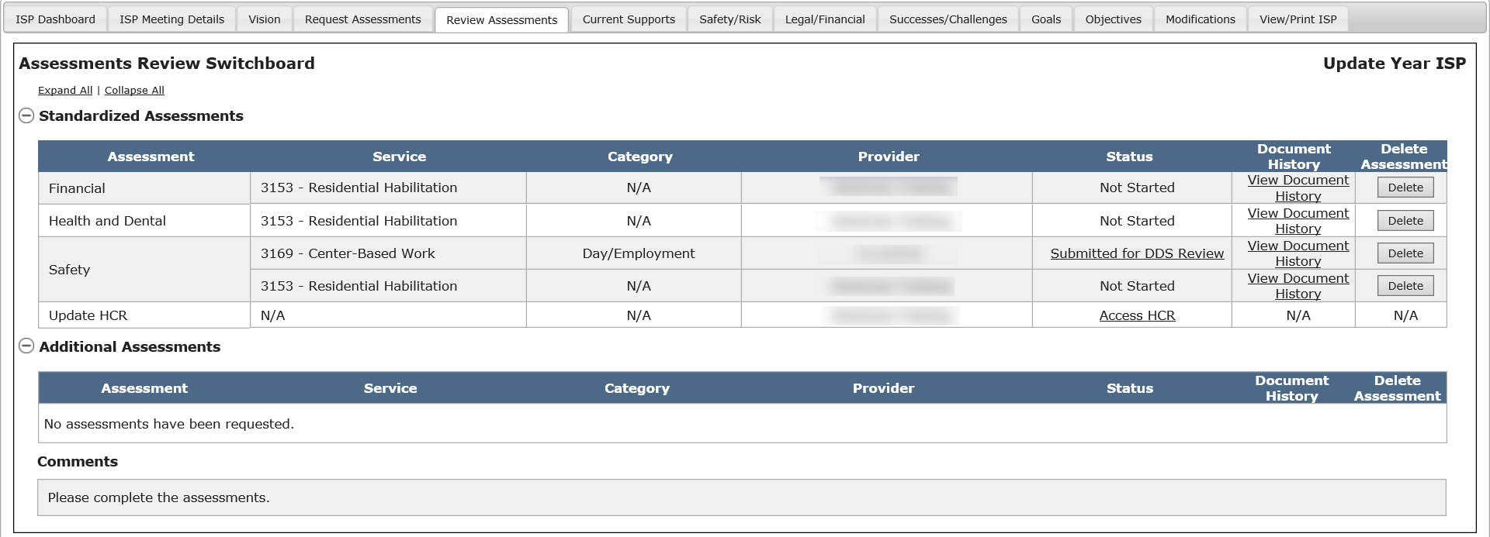

- The system displays the document history for the selected document.

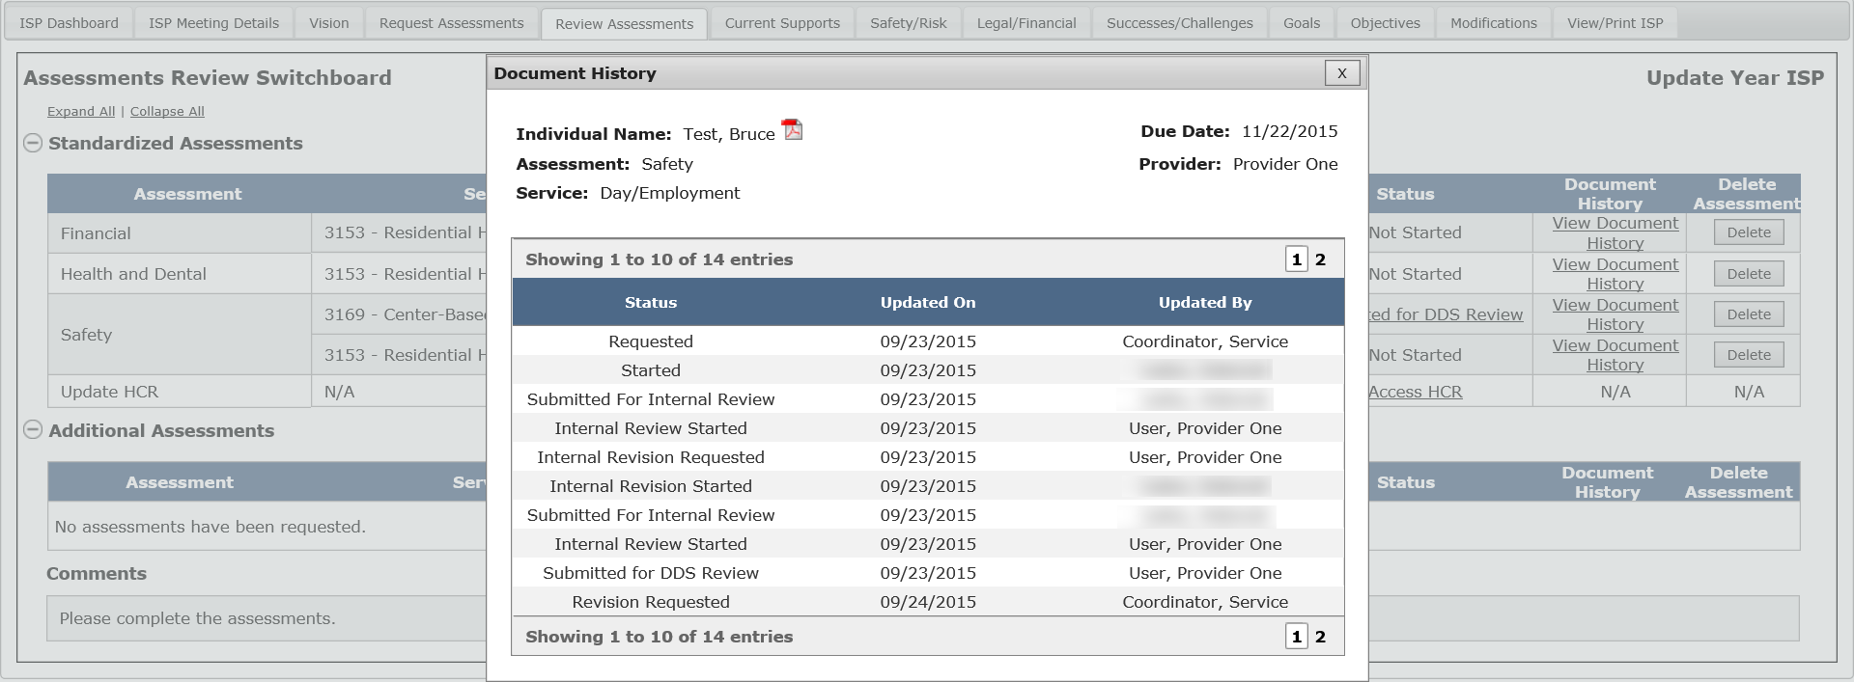

- If desired, it is possible to print the document history. To print the document, click the PDF icon.

- Service Coordinator or Provider clicks on the “X” button to close the document history pop-up window.

Unchecking the Update Information Checkbox

Scenario Description:
The user has entered information into an Update Information textbox, and attempts to uncheck the corresponding checkbox, prompting a confirmation pop-up to appear.

Note: For demonstration purposes, this scenario shows the functionality of the pop-up from the Goals screen, however please note that this is present on all screens within an Individual’s ISP Plan.
First Steps
- Search for an Individual with an Update Year ISP created
- View the Individual Dashboard
- Navigate to the Goals Screen
- Select a radio button for a Goal and click “View/Edit Goal”
Roles and Responsibilities
- Service Coordinators: Enter information in the individual’s ISP Plan
- Service Coordinator Supervisors: Enter information in the individual’s ISP Plan
- Provider Data Entry User: Enter information in the individual’s ISP Plan
- Provider Supervisor: Enter information in the individual’s ISP Plan

- Select an “Update Information” checkbox on the Goals screen and enter information into the corresponding textbox that appears.

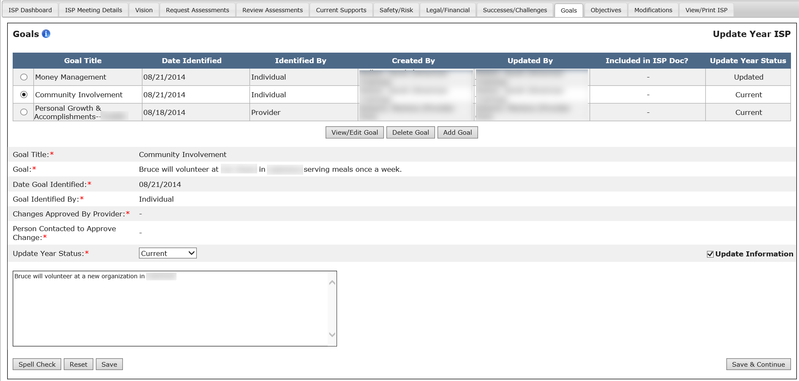

- Uncheck the “Update Information” checkbox.

- The system displays the following message, “Update information entered for this text box will be cleared. Do you wish to proceed?”

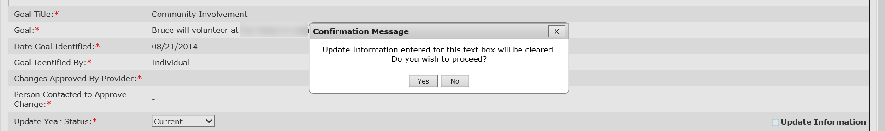

Clicking “Yes” removes the updated information text box without saving information in the text box.

Clicking “No” or “X” at the top right corner of the window keeps the “Updated Information” text box with the previously entered information.

Review Process Management
The Review Process Management screen provides users with resources to manage workload as components associated with the ISP Assessments module are completed. As the alerts expire after 14 days, both provider and DDS staff can use the Review Process Management screen as a reference to monitor all outstanding activities for individual’s ISP meetings.
The Review Process Management screen (RPMS) will allow the user to search for ISPs that have been created within a certain time period. It is a great tool for monitoring pre-ISP meeting to ensure that documentation is received and approved prior to the ISP meeting. RPMS can also be used to monitor post-meeting activities and ensuring all documents are completed and approved before the ISP is locked. Users can search for ISPs by date, Region, Area Office, or Provider. Providers and Provider Supervisors will also have a “Security Group” filter that can be used if Enhanced Security is implemented for their agency.
- Click the “ISP” tab at the top of the page to access the ISP module.
After clicking the “ISP” tab, the system returns the page shown below:
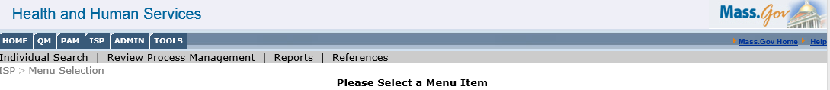
- Click the “Review Process Management” menu item.
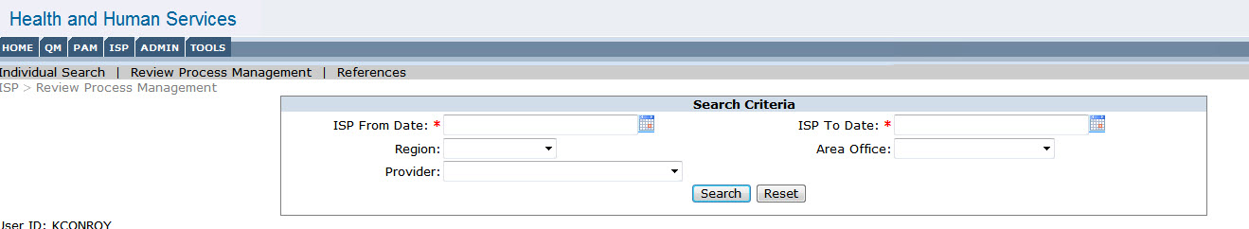
- Enter the Search Criteria. The “ISP From” and “ISP To” dates are required in order to search. The remaining drop-down search features are optional.
Note: This tool could be used to monitor post-meeting activities for meetings that have taken in place in the last two weeks. The user can enter “ISP From Date” as any date in the past and ‘ISP To Date’ as today’s date. This search result will include all ISP’s that have been held in the past. In the example below, the user has chosen a date 2 weeks in the past if today’s date were 12/10/2015.

Note: For planning purposes, the user would use future dates.

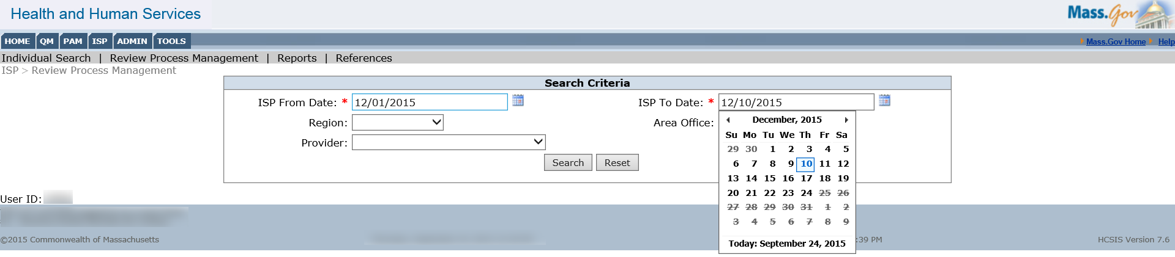

Note: Providers will have an additional Security group filter in the RPMS screen to filter results based on the site/security group, if Enhanced Security is implemented.

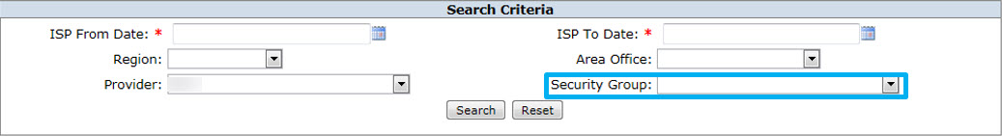

- Click “Search”

The screen shot below shows the format in which the Review Process Management search results appear. The Review Process Management search results can be sorted alphabetically by name, region, area office, planned meeting date, meeting deadline, status of assessments and Objectives and Support Strategies, by Service Coordinator/Provider name and by ISP Year (Update or Full Year). A hyphen is displayed for plans with Planned Meeting Date less than 5/22/2015 as no plan selection was available for them. “Not Selected” appears for plans with Planned Meeting Date greater than 5/22/2015 where DDS staff have not yet made a selection. In the Service Coordinator’s view, the SC name will appear in the column on the far right for each individual in the search results. For Providers, the Provider’s name appears in the column on the far right. A new column, Modificaitons, has been added.
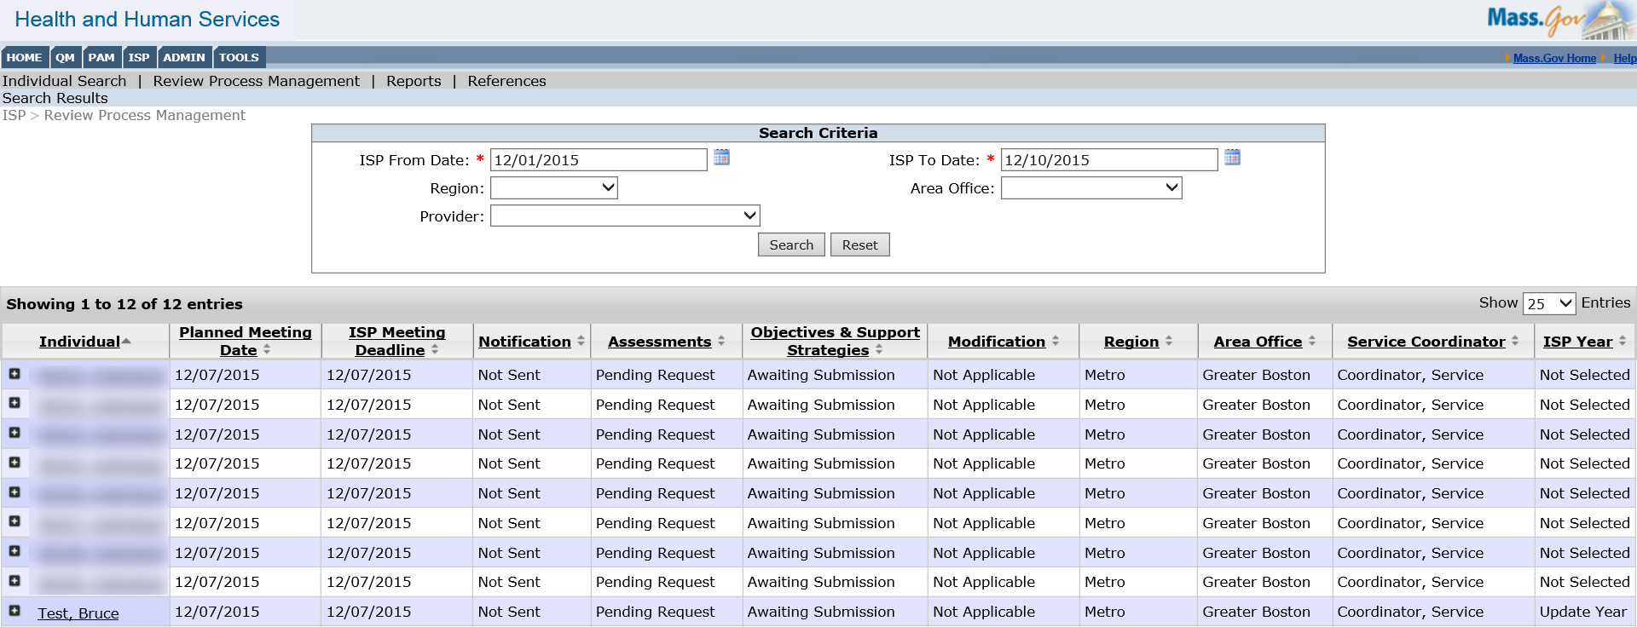

- Clicking on the “+” button to the left of the individual’s name will allow the user to view ISP details about the individual. The system lists all of the activities associated with the ISP document, along with corresponding due dates and status for each activity. Clicking on the Individual’s name will redirect the user to the Individual Dashboard.

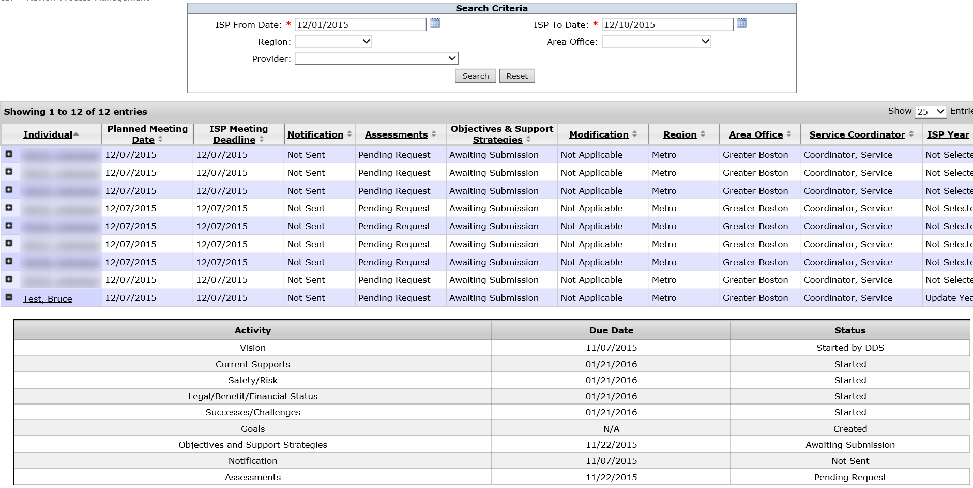

- If the user has navigated to an individual’s dashboard and then wants to come back to the search results, user can do that by clicking on “Search Results” in the top left corner of the screen. The system will then navigate the user to the Review Process Management Screen and retain the previous search criteria.

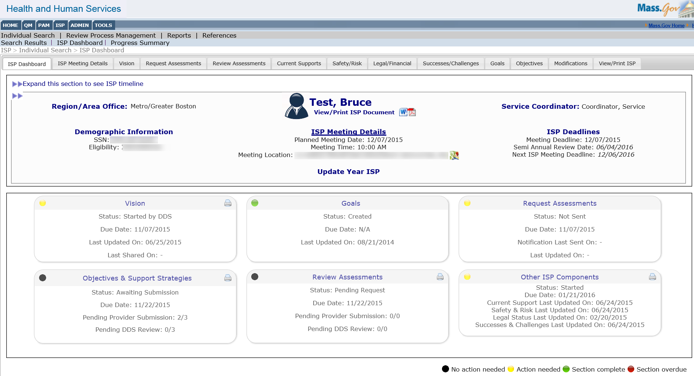

Summary Report for DDS Staff
The Summary Report is available to all users who have access to the ISP Module. The report displays information about actions that took place leading up to the ISP Meeting. The report displays all activities for individuals whose ISP Meeting has been held. An individual will be displayed in the report results once the following conditions have been met:
- An ISP meeting has taken place between an individual/guardian, Service Coordinator, and Providers.
- The Service Coordinator has entered the Actual Meeting Date into MEDITECH.

First Steps:
- The user selects reports
- The user searches for an individual

Roles and Responsibilities:
- Service Coordinators: Generate and view a report.
- Service Coordinator Supervisors: Generate and view a report.

Accessing the Summary Report
- From the ISP module, select the “Reports” menu.
- Select search parameters.
Select “ISP From Date” and “ISP To Date” on the calendar controls. These are mandatory fields. The ISP “from” and “to” dates must be in the past as the report only shows pre-meeting activities for individuals for whom the ISP meeting has been held. The date range selected refers to the Actual Meeting Date (AMD), where plans with an AMD in that date range are included in the report results. Should the date range entered span across more than one Actual Meeting Date for an individual, all plans of the individual between the selected Actual Meeting Dates will be included in separate lines of the report.
Users may narrow their search further by using the additional filters. In the event that the user is a Service Coordinator, Service Coordinator Supervisor, or Area Office Director, the Area Office filter will be pre-populated based on the Area Office the logged in user is assigned to. For users with access to more than one Area Office this will be a multiselect dropdown. For central office users, all Area Offices will be displayed in the dropdown.
After selecting the appropriate Area Office the report will only show individuals in the selected Area Office who have plans with Actual Meeting Date specified in the date range.
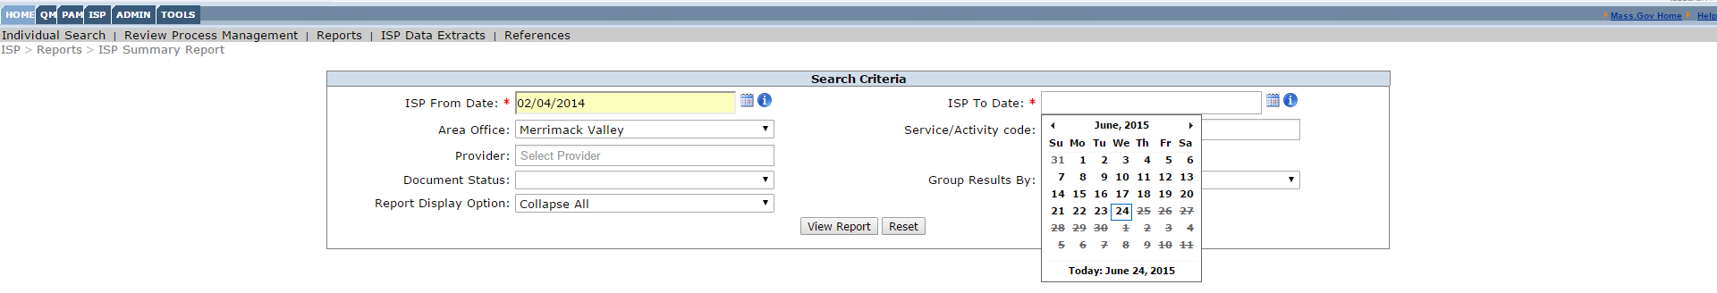
Additional Filters Available:
Provider:
- DDS staff can filter the Provider dropdown using partial search or the drop-down menu to select Providers. Within the drop-down menu, multiple checkboxes can be selected. An auto-complete feature has also been enabled when using the partial search function.
- When using the Provider dropdown, the report will show all individuals who received those services that have mandatory assessments when the plan was created regardless of whether there are assessments or Objectives and Support Strategies created for that individual.
- If the services that the provider is providing do not have any mandatory assessments and no assessments are requested prior to the Actual Meeting Date, the individuals will not be displayed on the report.
Document Status:
- DDS staff can filter by Document Status by selecting “Deadline Not Met Only”, to view only individuals for whom one or more documents have been requested/ submitted past the deadline.
Service Code:
- DDS staff can filter the Service Code dropdown using partial search or the drop-down menu to select one or more Service Codes.
- The report will show only individuals in that user’s scope who were enrolled in the specified service or activity code(s).
- If the services specified did not have any mandatory assessments and no assessments were requested prior to the AMD, the individuals will not be displayed in the report.
- The filter display options will display all service codes. If, however, the user selects a service code in which no individuals are enrolled, the report will not generate results.
Group Results By:
- DDS staff can select a value: Provider or Area Office from the “Group Results By” dropdown.
- This is defaulted to Area Office and will group results by Area Office, Service Coordinator, Individual, and then by date. The Provider filter groups results by Provider then by Individual.
Report Display Option:
- DDS staff will use the drop-down menu to select the Report Display Option. The choices are either “Expand All” or “Collapse All”. “Expand All” will show all of the individuals with the assessment and objective details expanded. Please note that choosing “Expand All” will increase the amount of time it takes to render the report. “Collapse All” will show all of the individuals with the assessment and objective details collapsed.

- Click “View Report”
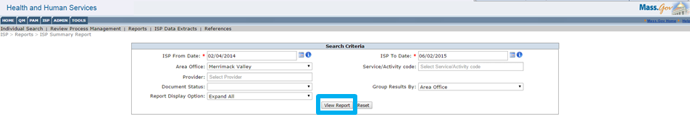
The report organizes data for individuals by Area Office or Provider depending on the selection made in the search criteria. If Area Office is selected, the report sorts the results within an Area Office by Service Coordinator name. For each Area Office there is a separate summary box evaluating overall timeliness. Only individuals who are part of the Service Coordinator’s scope will appear in the search results. Additionally, only those individuals with an Actual Meeting Date defined in MEDITECH will be returned in the search results.
The search criteria selected to generate the report will be shown on the screen at the top of the report, and will be included in the printable version of the report.
The Summary Report includes a Results Summary Box for the individuals displayed in the results. The Results Summary box above the individual details displays an overview of Assessments and Objectives and Support Strategies for all individuals in the date range selected. The Results Summary Box displays results summary for:
- “Requested On Time” records timeliness in requesting assessments
- “Submitted for DDS Review On Time” records Providers’ timeliness in submitting assessments
- “Met DDS Criteria on Initial Submission” measures whether or not the Assessments met the DDS acceptance criteria – i.e. Approved or Revision Requested the first time they were reviewed. If the criteria were not met the Service Coordinator recommended a revision.

Note: The report provides a list of individuals. Only those individuals with an Actual Meeting Date will be returned in the search results. There is no limit to the date range for which the report can be run. Should there be more than one plan per individual for the time period selected, they will show up as separate search results on distinct lines of the report.
- Summary Report Details
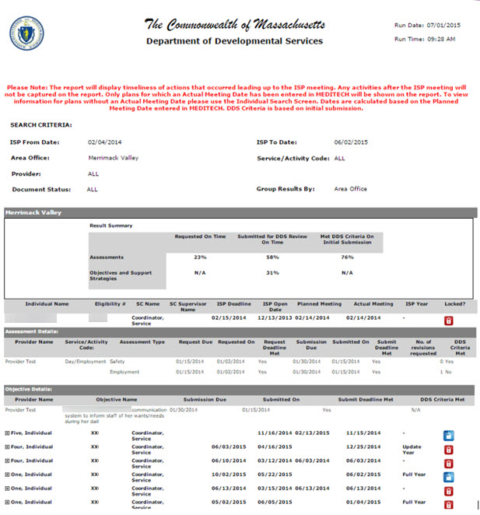
The Report is sorted by Service Coordinator Name and it displays the Individual Name, Eligibility number, Service Coordinator Name, Service Coordinator Supervisor Name, ISP Deadline, Planned Meeting and Actual Meeting Date, ISP Year and Lock Status.
ISP Year shows either “Update Year” or “Full Year” for plans where the Service Coordinator has made a year selection. A hyphen is displayed for plans with Planned Meeting Date less than 3/15/2015 as no plan selection was available for them. “Not Selected” appears plans with Planned Meeting Date greater than 3/15/2015 where DDS staff have not yet made a selection.
The Lock Status indicates whether the Individual’s ISP is within the 150 days post ISP Meeting. The blue lock symbol means the plan can still be updated and is unlocked. The red lock symbol means the plan has been locked and is over 150 days past the ISP Meeting Date.
- Click the “+” sign to expand and view Individual’s ISP details.
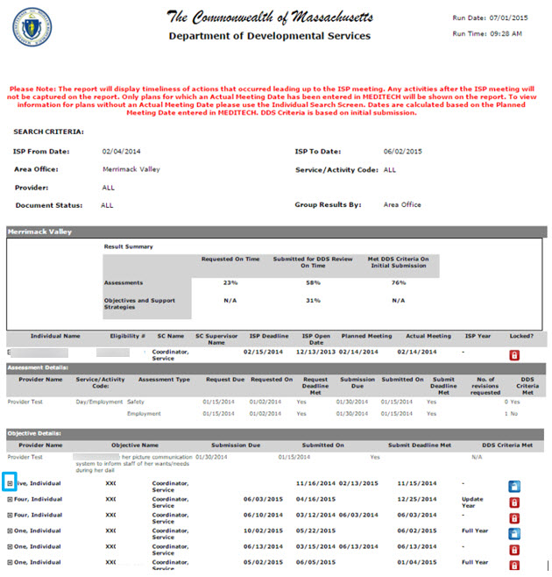
Assessment Details
Assessment Details provides details on the Assessment type and represents actions of both Service Coordinators and Providers. The highlighted section of the Summary Report below represents actions of Service coordinators. Utilizing the report allows Service Coordinators to record the timeliness of requesting Assessments for an individual.
- “Requested Due” column is the date on which the assessment is due to the Provider. The request is due to the provider 30 days prior to the ISP Meeting.
- “Requested On” column is the actual date the Service Coordinator sent the assessment to the Provider.
- “Request Deadline Met” column reads either “yes” or “no”. “Yes” means the deadline was met, “No” means the deadline was not met and the assessment was requested after the due date.

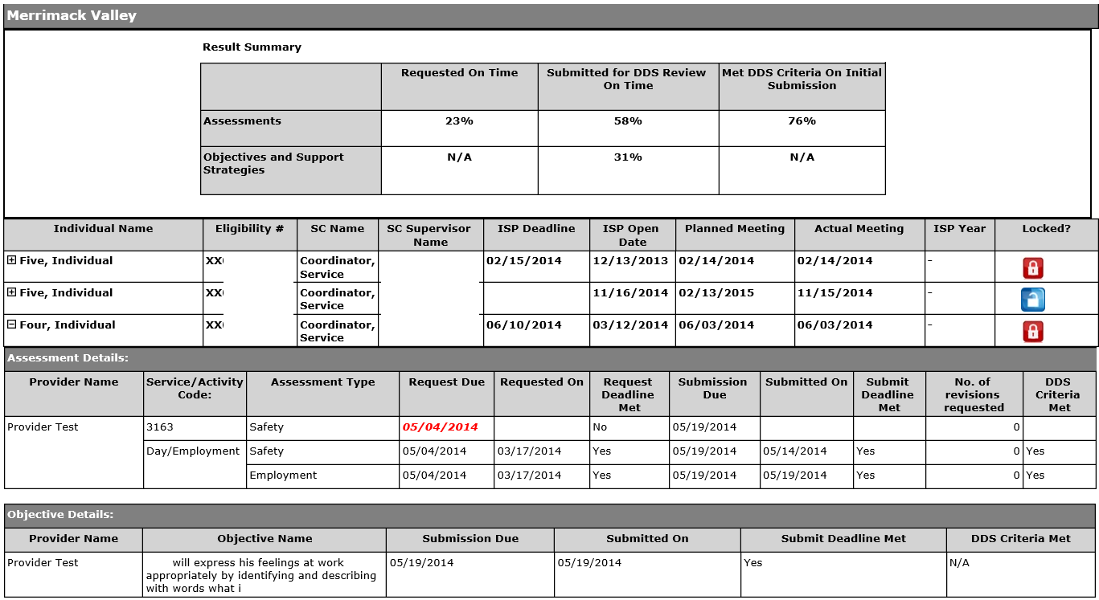
The highlighted section of the Summary Report below represents actions of Providers
- “Submission Due” column is the date the assessment is to be submitted by.
- “Submitted On” column is the actual date the assessment was submitted.
- “Submit Deadline Met” column measures whether the assessment was submitted prior to the due date. If the Assessment was submitted before the due date the column reads “Yes”. If the assessment was submitted past the due date the column reads “No”.
- “No. of Times Revision Requested” column measures the number of times revision was requested for an Assessment.
- “DDS Criteria Met” column measures whether or not the assessment met DDS criteria with initial submission or if revisions were requested to the assessment. If revisions were requested the column reads “No.”

Note: Red, bolded and italicized text indicates that the actions were not performed on time.

Note: If there are no standardized assessments requested for the individual either because the Service Coordinator did not request them before the meeting or the individual does not require any assessments, the message “No standardized assessments have been requested and/or no assessments are required for the individual” is displayed in the event that there are no mandatory assessments required for that individual.

However, mandatory assessments will always appear on the report. Therefore, even if the Service Coordinator has not requested mandatory assessments, they will appear on the report, but there will be no date in the “requested on” column and the Request Due date will be displayed in Red.
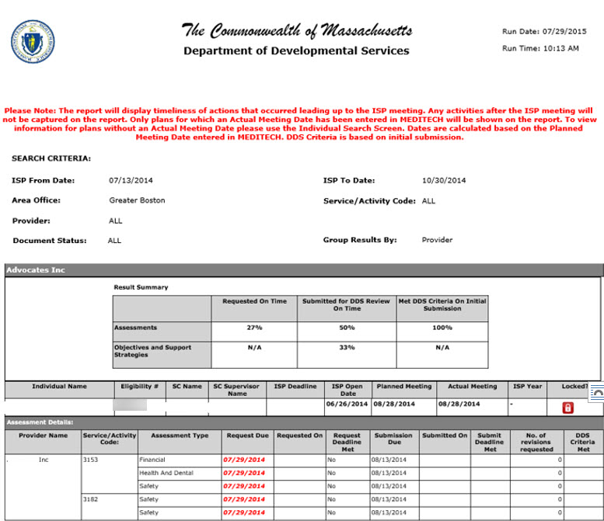
Note: Additional Assessments may be visible on the report in scenarios where these assessments were requested for a plan prior to the removal of additional assessments from the system in June 2014.
Objective Details
The highlighted section of the Summary Report provides details on the Individual’s Objectives and Support Strategies.
- “Submission Due” column is the date the Objective was to be submitted by
- “Submitted On” column is the actual date the Objective was submitted.
- “Submission Deadline Met” column measures whether or not the Objective was submitted before the due date. If the Objective was submitted before the due date the column reads “Yes.” If the Objective was submitted after the due date the column reads “No.”
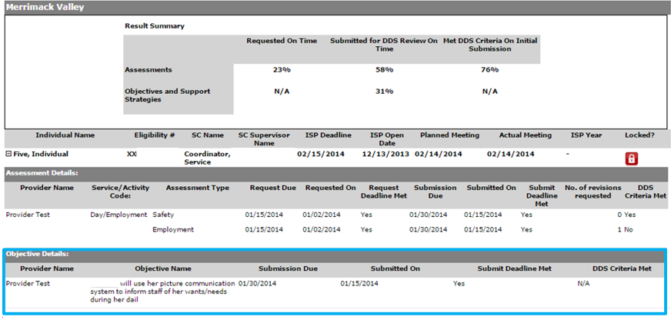
Note: Red, bolded and italicized text indicates that the actions were not performed on time

Exporting the Summary Report
- Expand the individual details by clicking on the “+” sign next to each individual.
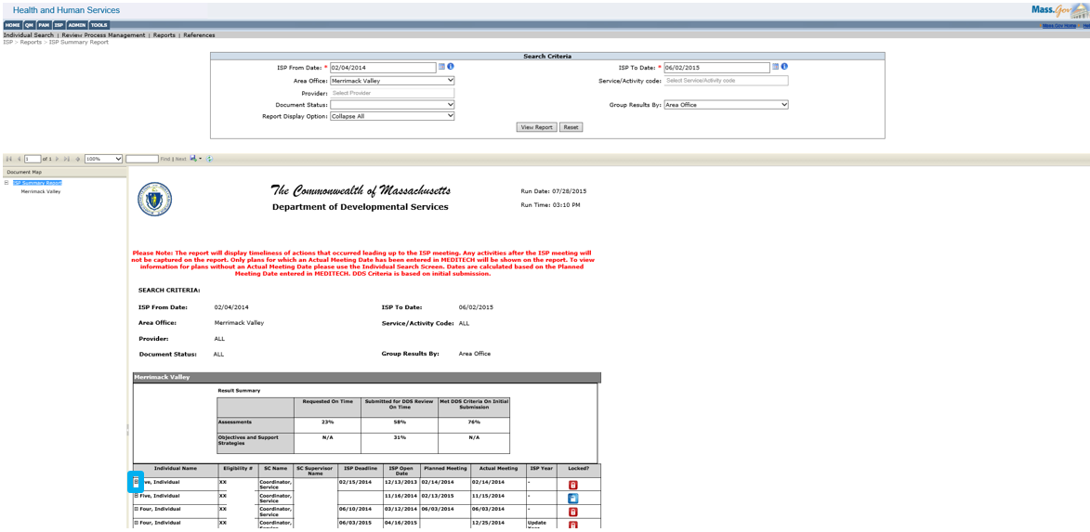
- Service Coordinators can export the data into either a PDF or Word document. Select either “PDF” or word from Save drop down.
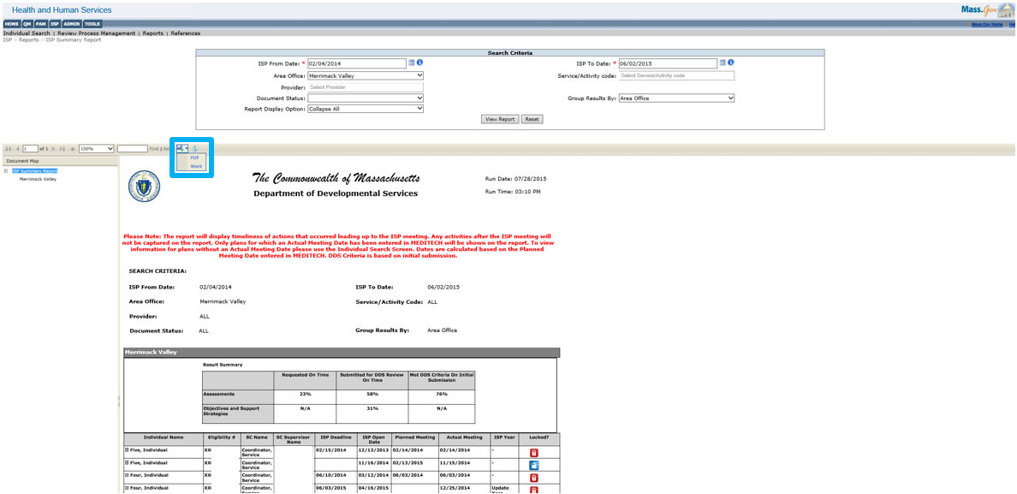
- A pop up-window will appear. Click “Open” to view the report in PDF form.
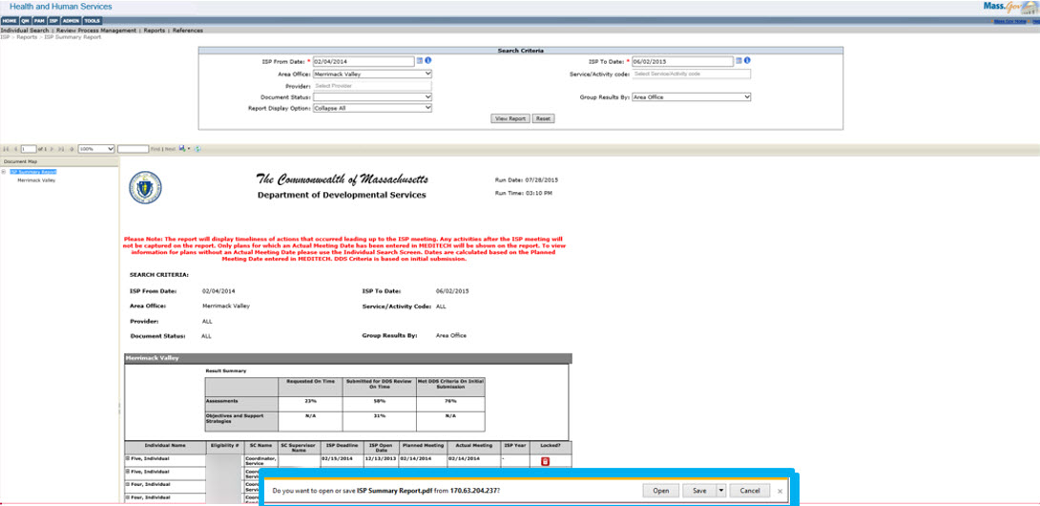
- View the Summary Report in the selected format and continue to print the report using the file print options.
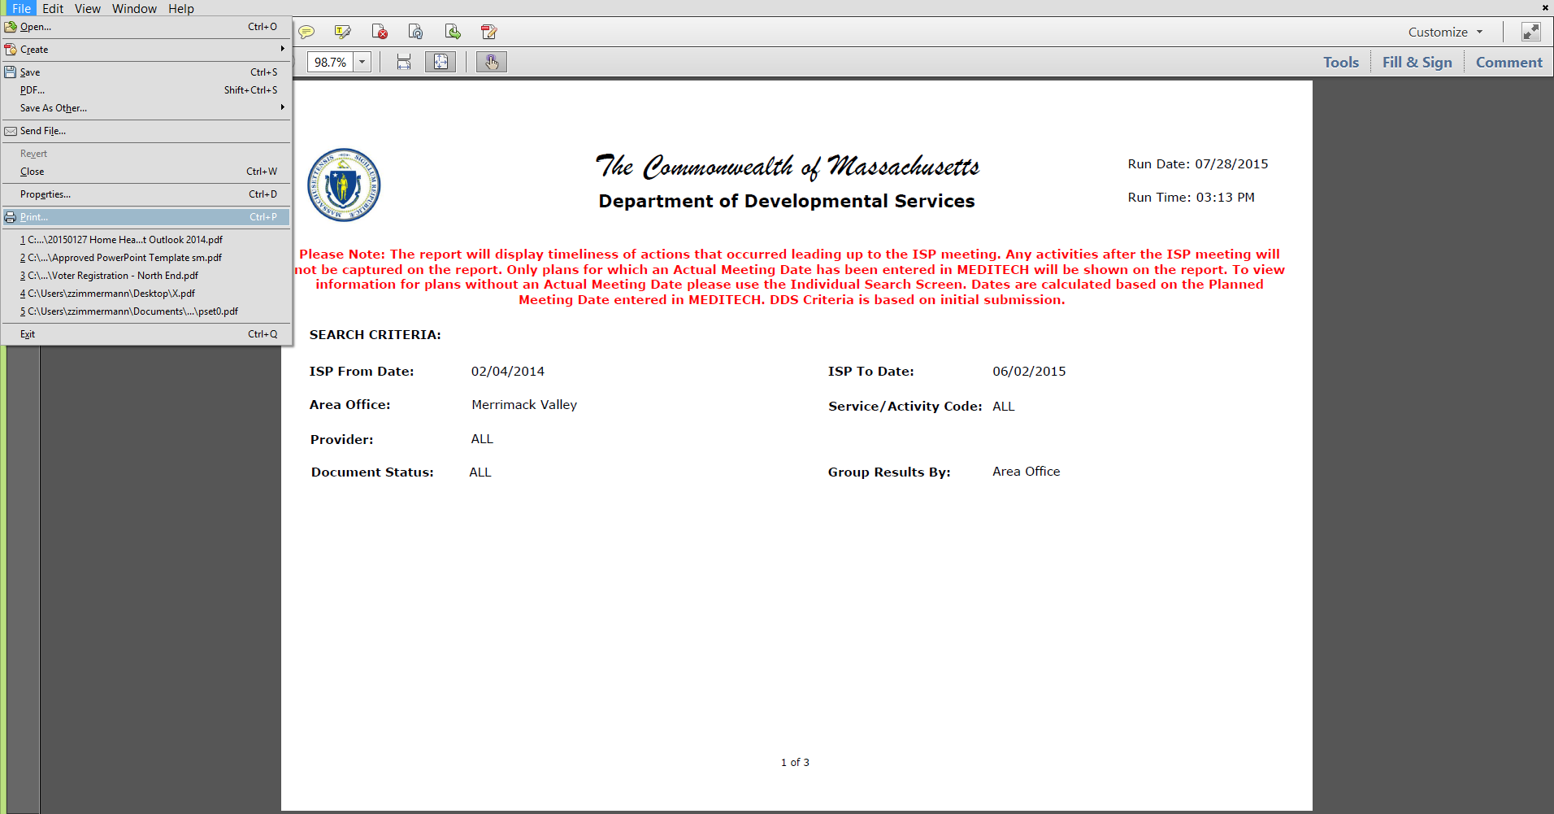
Next Steps:
- Print the exported report.
- Generate another report for a different time frame.

Summary Report for Provider Staff
The Summary Report is available to all users who have access to the ISP Module. The report displays information about actions that took place leading up to the ISP Meeting. The report displays activities for individuals whose ISP Meeting has been held. An individual will be displayed in the report results once the following conditions have been met:
- An ISP meeting has taken place between an individual/guardian, Service Coordinator, and Providers.
- The Service Coordinator has entered the Actual Meeting Date into MEDITECH.

First Steps:
- The user selects reports
- The user searches for an individual

Roles and Responsibilities:
- Providers: Generate and view a report.
- Provider Supervisors: Generate and view a report.
Accessing the Summary Report
- From the ISP module, select the “Reports” menu.
- Select the search parameters.
Select “ISP From Date” and “ISP To Date” on the calendar controls. These are mandatory fields. The ISP “from” and “to” dates must be in the past as the report only shows pre-meeting activities for individuals for whom the ISP meeting has been held.

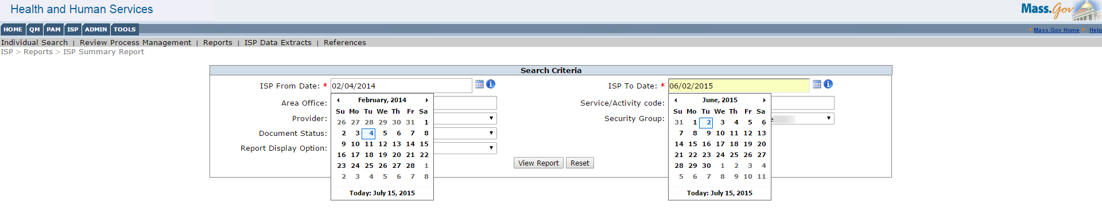
Note: If the services provided to an individual in the selected timeframe have a mandatory assessment, the individual will be displayed in the report whether or not assessments or OSS have been submitted. If, however, the services provided to the individual by the provider did not require a mandatory assessments and no assessments were requested prior to the Actual Meeting Date (AMD), the individuals will not be displayed on the report.
Note: Should the date range entered span across more than one Actual Meeting Date (AMD) for an individual, all plans of the individual between the selected AMD will be included in separate lines of the report.
Users may narrow their search further by using the additional filters. The Provider filter will be pre-populated based on the Provider Agency.
Additional Filters Available:
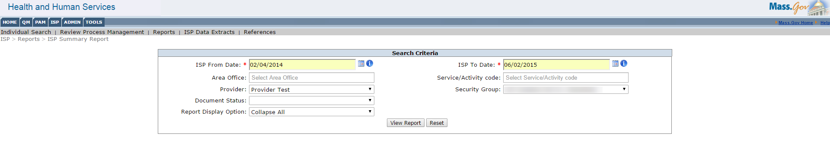
Area Office
- Provider staff can filter the Area Office dropdown using either partial search or the drop-down menu to select Area Offices. Within the drop-down menu, multiple checkboxes can be selected. An auto-complete feature has also been enabled when using the partial search function. The filter will only display the Area Offices associated to the individuals to which the provider is providing services. Additionally, if the services provided to an individual in the selected timeframe have a mandatory assessment, the individual will be displayed in the report whether or not assessments or OSS have been submitted. If the services that the provider was providing did not have any mandatory assessments and no assessments were requested prior to the AMD, the individuals will not be displayed in the report.

Provider
- The Provider filter will be pre-populated based on the Provider Agency.

Document Status
- Provider staff can filter by Document Status by selecting “Deadline Not Met Only”, to view only individuals for whom one or more documents have been requested/submitted past the deadline

Report Display Option
- Provider staff will use the drop-down menu to select the Display Options. The choices are either “Expand All” or “Collapse All”. “Expand All” will show all of the individuals with the assessment and objective details expanded. Please note that choosing “Expand All” will increase the amount of time it takes to render the report. “Collapse All” will show all of the individuals with the assessment and objective details collapsed.

Service / Activity Code
- Provider staff can filter the Service / Activity Code dropdown using partial search or the drop-down menu to select one or more Service Codes.
- The report will show those individuals enrolled in the specified service or activity code(s) if the services provided to an individual in the selected timeframe have a mandatory assessment regardless of whether assessments or OSS have been submitted.
- If the service specified did not have any mandatory assessments and no assessments were requested prior to the AMD, the individuals will not be displayed on the report.
- The filter display options will display all service codes. If, however, the user selects a service code that no individuals were enrolled in during that date range the report will not generate results.

Security Group
- If enhanced security is not abled, the security group filter will not display, If enhanced security is enabled, however, providers can filter by Security Groups. Security groups are used to designate and restrict access for certain provider staff. Site security groups are set up through the provider agency.

- Click “View Report”
Note: Only individuals who are part of the Provider’s or Provider Supervisors’ scope will appear in the search results. Only those individuals with an Actual Meeting Date defined in MEDITECH will be returned in the search results. There is no limit to the date range for which the report can be run. Should there be more than one plan per individual for the time period selected, they will show up as separate search results on distinct lines of the report.
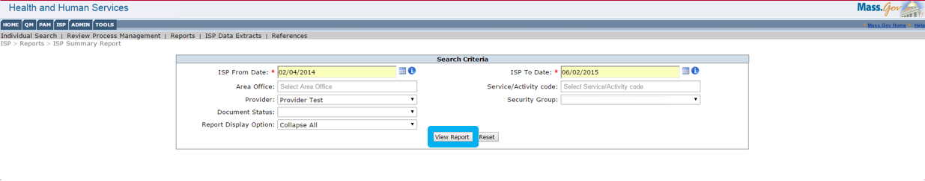
- Summary Report Details
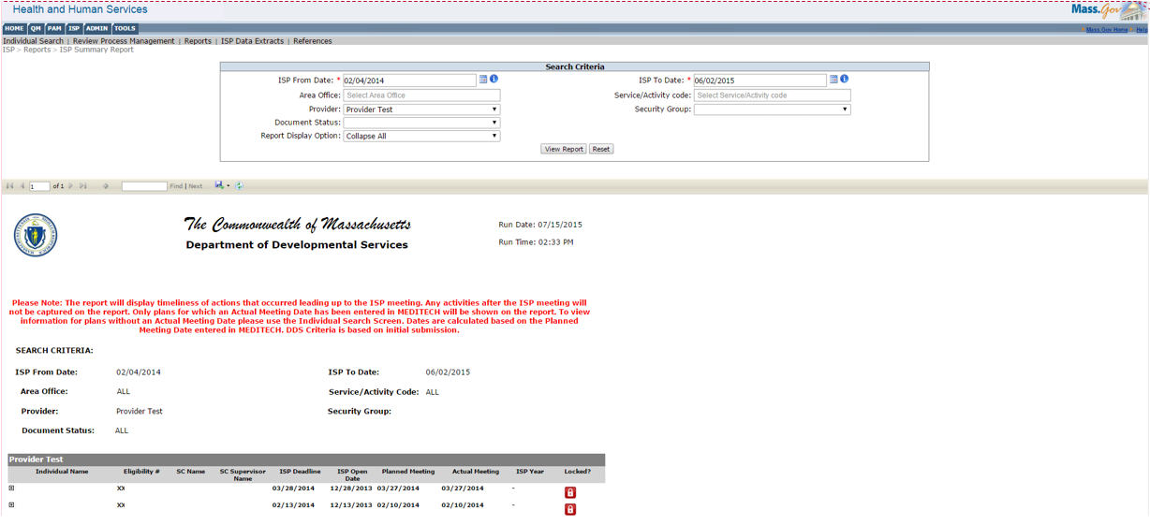
The Report is sorted by Individual Name and it displays the Eligibility number, Service Coordinator Name, Service Coordinator Supervisor Name, ISP Deadline, Planned Meeting and Actual Meeting Date, ISP Year and Lock Status.
ISP Year shows either “Update Year” or “Full Year” for plans where the Service Coordinator has made a year selection. A hyphen is displayed for plans with Planned Meeting Date less than 3/15/2015 as no plan selection was available for them. “Not Selected” appears plans with Planned Meeting Date greater than 3/15/2015 where DDS staff have not yet made a selection.
The Lock Status indicates whether the Individual’s ISP is within the 150 days post ISP Meeting. The blue lock symbol means the plan can still be updated and is unlocked. The red lock symbol means the plan has been locked and is over 150 days past the ISP Meeting Date.
- Click the “+” sign to expand and view Individual’s ISP details.
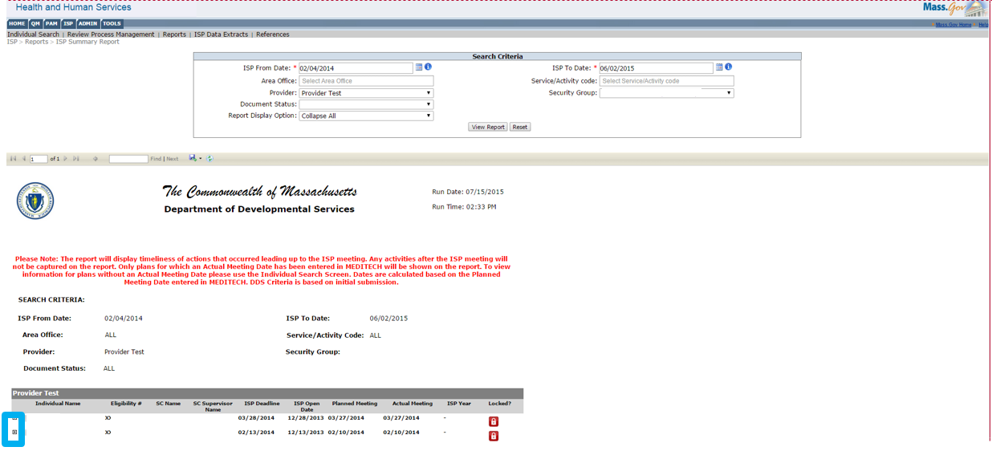
Assessment Details
Assessment Details provides details on the Assessment type and represents actions of both Service Coordinators and Providers. The highlighted section of the Summary Report below represents actions of Service coordinators. Utilizing the report allows Providers to record the timeliness of Service Coordinators requesting Assessments for an individual.
- “Requested Due” column is the date on which the assessment is due to the Provider. The request is due to the provider 30 days prior to the ISP Meeting.
- “Requested On” column is the actual date the Service Coordinator sent the assessment to the Provider.
- “Request Deadline Met” column reads either “yes” or “no”. “Yes” means the deadline was met, “No” means the deadline was not met and the assessment was requested after the due date.
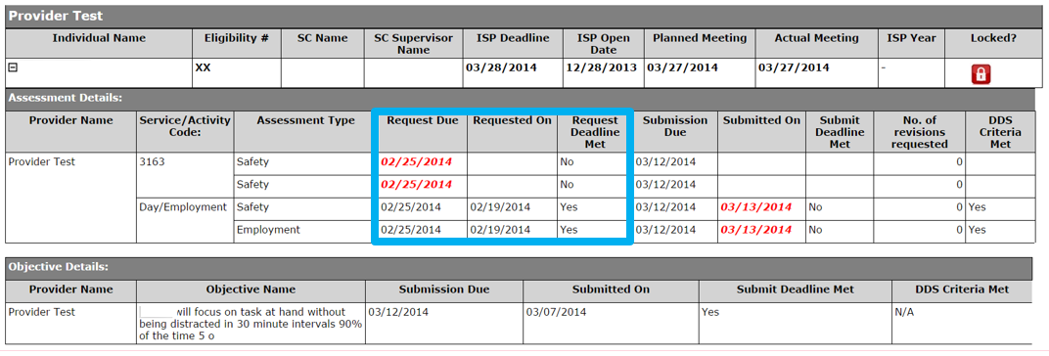
The highlighted section of the Summary Report below represents actions of Providers

- “Submission Due” column is the date the assessment is to be submitted by.
- “Submitted On” column is the actual date the assessment was submitted.
- “Submit Deadline Met” column measures whether the assessment was submitted prior to the due date. If the Assessment was submitted before the due date the column reads “Yes”. If the assessment was submitted past the due date the column reads “No”.
- “DDS Criteria Met” column measures whether or not the assessment met DDS criteria with initial submission or if revisions were requested to the assessment. If revisions were requested the column reads “No.”
- “No. of Times Revision Requested” column measures the number of times revision was requested on an Assessment submitted by the Provider.

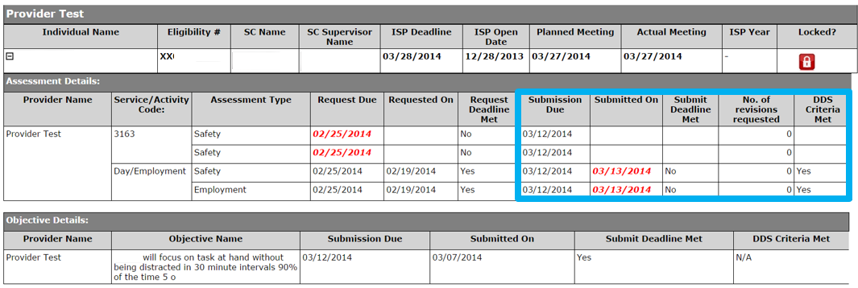

Note: Red, bolded and italicized text indicates that the actions were not performed on time.

Note: If there are no standardized assessments requested for the individual either because the Service Coordinator did not request them before the meeting or the individual does not require any assessments, the message “No standardized assessments have been requested and/or no assessments are required for the individual” is displayed in the event that there are no mandatory assessments required for that individual.

However, mandatory assessments will always appear on the report. Therefore, even if the Service Coordinator has not requested mandatory assessments, they will appear on the report, but there will be no date in the “requested on” column.
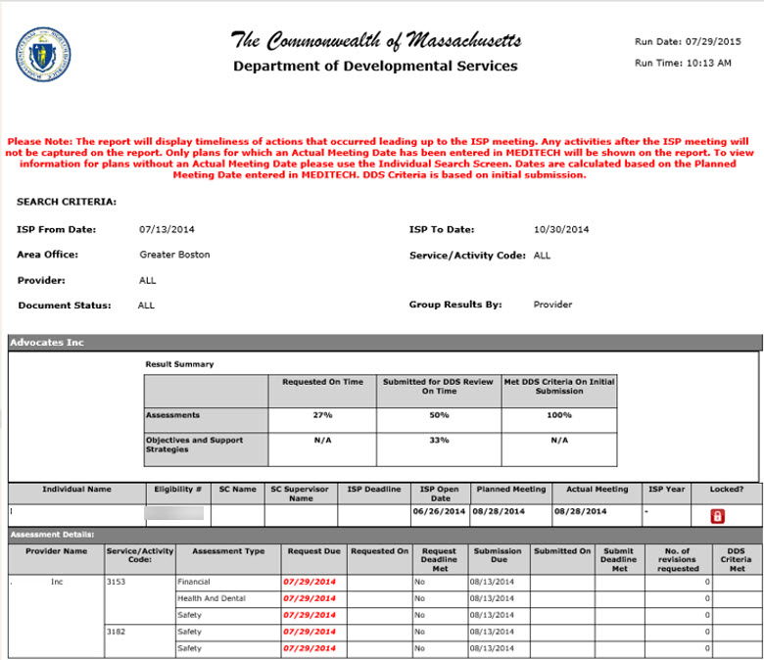

Objective Details
The highlighted section of the Summary Report provides details on the Individual’s Objectives and Support Strategies.
- “Submission Due” column is the date the Objective was to be submitted by
- “Submitted On” column is the actual date the Objective was submitted.
- “Submission Deadline Met” column measures whether or not the Objective was submitted before the due date. If the Objective was submitted before the due date the column reads “Yes.” If the Objective was submitted after the due date the column reads “No.”
- Red, bolded and italicized text indicates that the actions were not performed on time
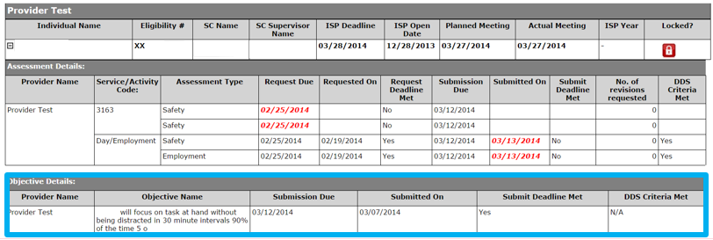
Exporting the Summary Report
- Once the report is run, providers can export the data into a PDF or Word document. Select the Export drop down menu and click either “Word” or “PDF”
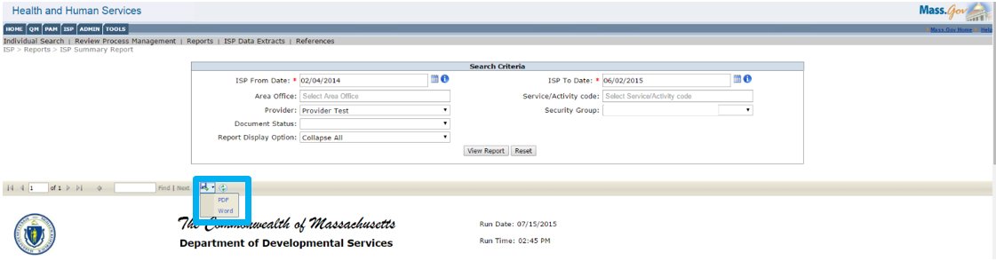
- A pop up-window will appear. Click “Open” to view the report in PDF or Word form.
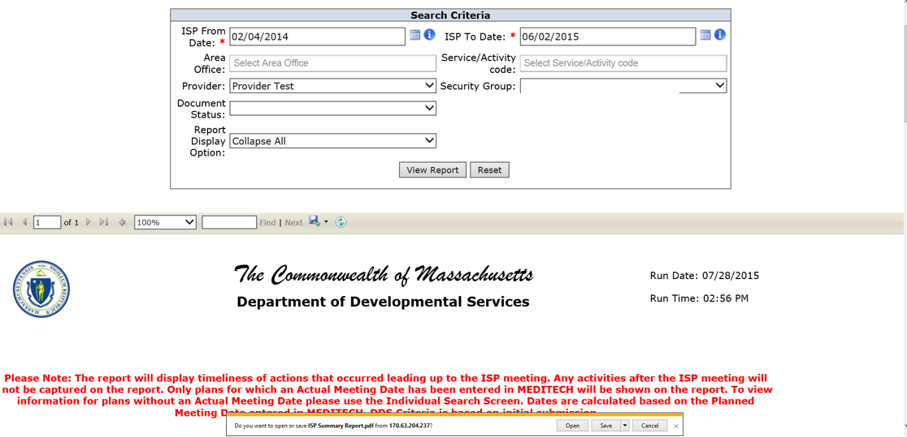

- View the Summary Report in PDF or Word and continue to print the report using the file print options.
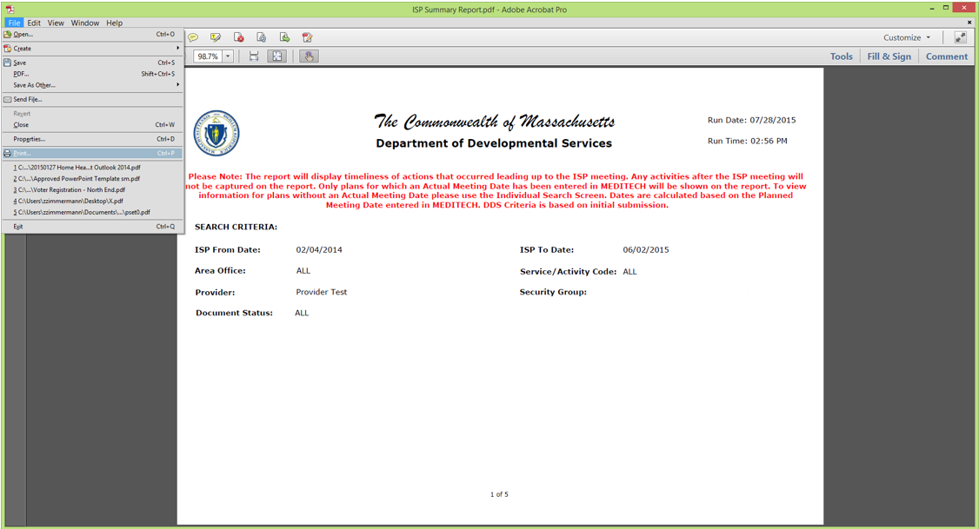

Next Steps:
- Print the exported report.
- Generate another report for a different time frame.

Progress Summary Report for DDS Staff
The Progress Summary Report is available to all users who have access to the ISP Module. The Progress Summary Report provides information about the Progress Summary submission, review and approval process. The report aggregates Progress Summaries based on their due date and enables you to identify upcoming or overdue Progress Summaries. It is a consolidated view of the status of the Progress Summaries assigned to you. An individual will be displayed in the report results once all the following conditions have been met:
- The Service Coordinator has entered the Actual Meeting Date into MEDITECH and the plan in HCSIS displays the Actual Meeting Date.
- The Service Coordinator has selected Objectives to be included in the ISP document and initiated a Progress Summary.

Accessing the Progress Summary Report

Scenario Description
The Progress Summary Report displays information about actions associated with the Progress Summary submission, review and approval process. It displays information related to Progress Summaries in HCSIS based on the due dates specified on the report. In this scenario, a user will access the Progress Summary Report and generate the report.

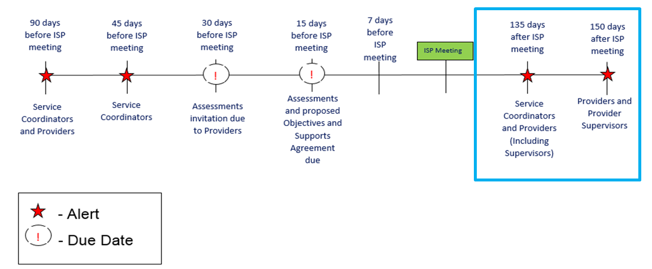

First Steps: Navigate to ISP module

Roles and Responsibilities:
- Service Coordinators: Generate and view the report
- Service Coordinator Supervisors: Generate and view the report

- Click on the Reports link in the 2nd level menu. The system navigates to the Reports page.

- On the Reports Landing Page, click “Progress Summary Report.” The system navigates to the Progress Summary Report.

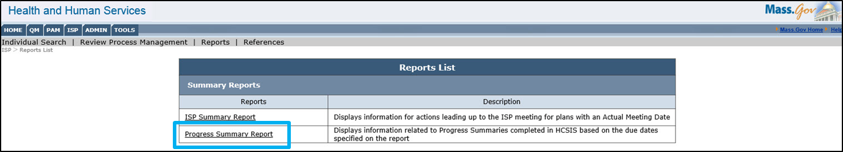

Note: This landing page has been added because there are now two reports available within the ISP module.

- Select a date range by selecting the calendar dropdown for the “From Date” and “To Date” fields.

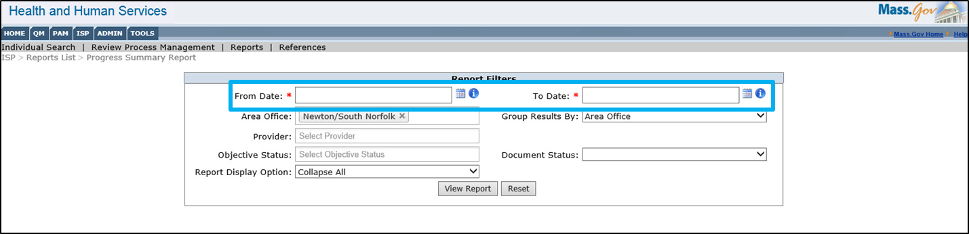

Note: These are mandatory fields. This filter allows users to view individuals within a specified date range. The dates are based on the Progress Summary due date. Please note that the report is intended to be used by multiple user bases – some of whom use it as a tool to identify Progress Summaries that are past due and others that use it to identify either upcoming or future progress summaries. With that in mind, it is possible to enter dates that have already past or dates that span up to one year in the future.

- If desired, users may narrow their search further by using the additional filters.
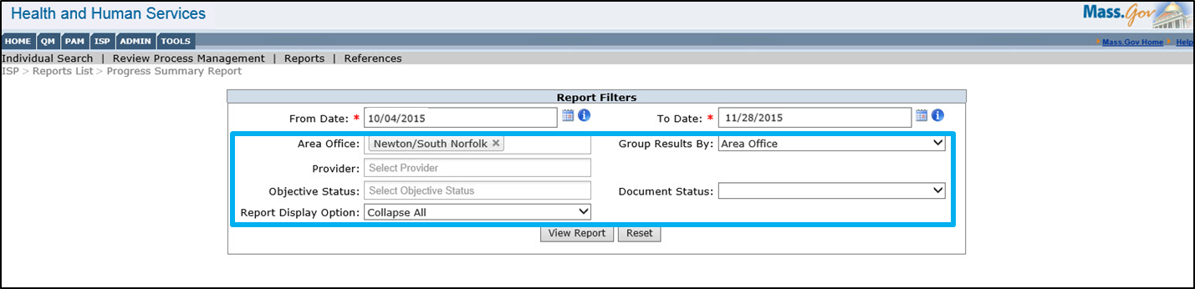
Area Office:
- For DDS users, the Area Office filter will pre-populate based on the Area Office to which the logged in user is assigned. For users with access to more than one Area Office this will be a multiselect dropdown. For central office users, all Area Offices will be displayed in the dropdown. After selecting the appropriate Area Office the report will only show individuals in the selected Area Office who have Progress Summary specified in the date range.
Provider Agency:
- DDS staff can filter the Provider dropdown using partial search or the drop-down menu to select Providers. Within the drop-down menu, multiple checkboxes can be selected. An auto-complete feature has also been enabled when using the partial search function.

Objective Status:
- DDS staff can filter by Objective Status by selecting the dropdown options of “Met”, “Partially met”, and “Discontinued.” Once selected, the report will display only individuals with Progress Summaries with Objectives in the selected status. If no selection is made on the Objective Status filter, the report will display Progress Summaries with Objectives in all statuses.

Group Results By:
- DDS staff can use the Group Results By drop-down menu to determine how the results of the search are ordered. The choices are “Provider” or “Area Office.” If “Area Office” is selected, the report will group results by Area Office, Service Coordinator, and then Individual. If “Provider” is selected, the report will group results by Provider then by Individual.
- If not selection is made, the Group Results By filter defaults to “Area Office.”

Report Display Option:
- DDS staff can use the drop-down menu to select the Report Display Option. The choices are “Expand All” or “Collapse All”. “Collapse All” will show all of the individuals with the Progress Summary Details collapsed. “Expand All” will show all of the individuals with the Progress Summary details expanded. Please note that choosing “Expand All” will increase the amount of time it takes to generate the report.
- The Report Display Option filter defaults to “Collapse All.”

Document Status:
- DDS Staff can use the drop-down menu to select the Document Status. The filter default is empty and the drop-down option is “Deadline Not Met Only”. If “Deadline Not Met Only” is selected, the report will only display individuals with Progress Summaries which are past the deadline date.
- Click “View Report”.

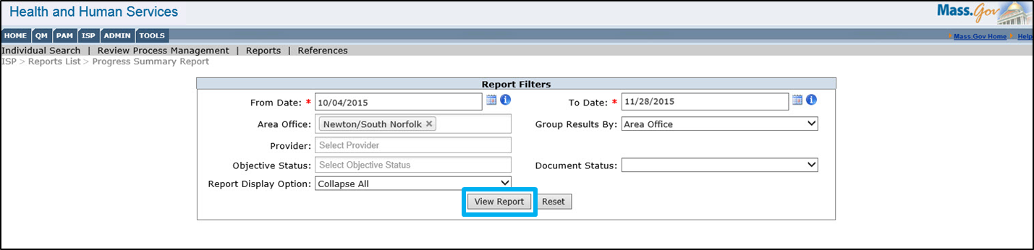

Note: The system displays the report. The report includes all the individuals satisfying the search criteria.

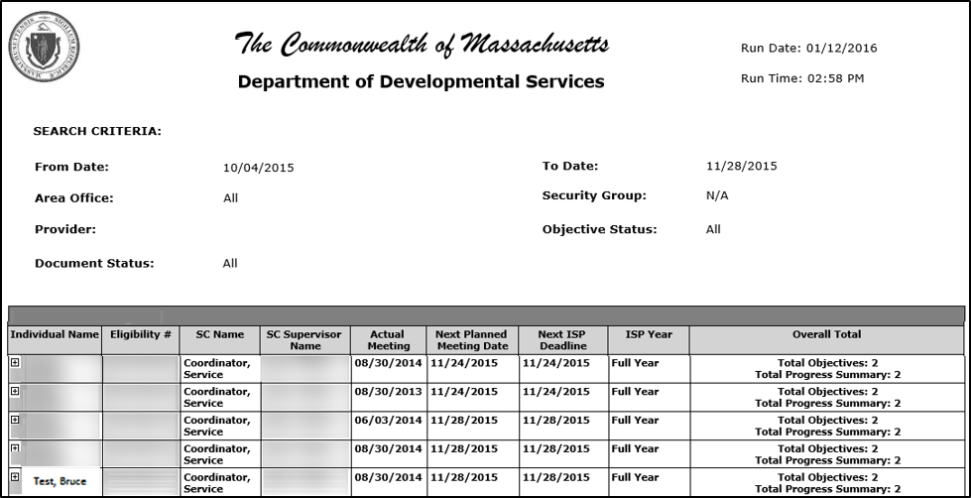

- To view additional details for an individual, select the (+) which is located to the left of the individual name column. Once clicked, the Progress Summary form will expand and display the details on the Reports page.

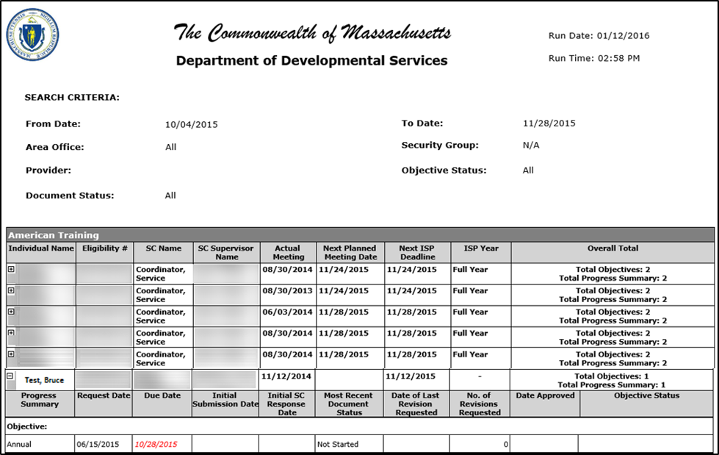

Note: The report displays the following fields:
- Individual Name
- Eligibility Number
- Service Coordinator Name
- Service Coordinator Supervisor Name
- Actual Meeting Date
- Next Planned Meeting Date
- Next ISP Deadline
- ISP Year
- Overall Total of Objectives and Progress Summaries
- Progress Summary
- Request Date
- Due Date
- Initial Submission Date
- Initial SC Response Date
- Most Recent Document Status
- Date of Last Revision Requested
- No. of Revisions Requested
- Date Approved
- Objective Status
Red, bolded and italicized text indicates that the actions were not performed on time.

- If desired, click the export icon and select “PDF” to export.

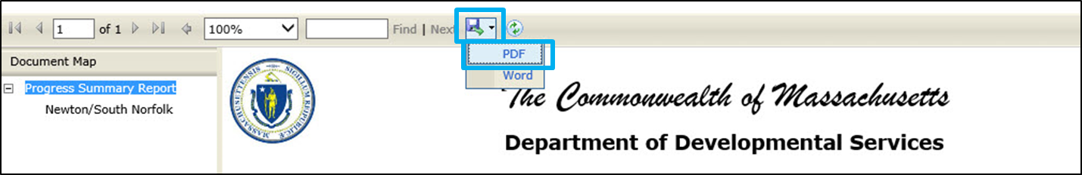

Note: The PDF will print the exact image that is displayed on the Reports page. If the Progress Summary Report is shown with the expanded information, the expanded information will be printed. If the Progress Summary report is collapsed, only the collapsed information is printed.

- Click “Open” to view the PDF of the Progress Summary Report.

- Click on the “File” tab and then click “Print” to print the PDF.

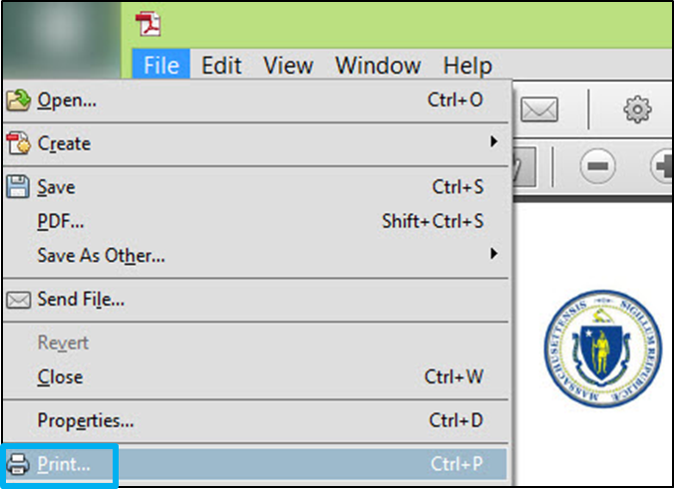

Progress Summary Report for Provider Staff
The Progress Summary Report is available to all users who have access to the ISP Module. The Progress Summary Report provides information about the Progress Summary submission, review and approval process. The report aggregates progress summaries based on their due date and enables you to identify upcoming or overdue progress summaries. It is a consolidated view of the status of the progress summaries assigned to you. An individual will be displayed in the report results once all the following conditions have been met:
- The Service Coordinator has entered the Actual Meeting Date into MEDITECH and the plan is HCSIS displays the Actual Meeting Date.
- The Service Coordinator has selected objectives to be included in the ISP document and initiated a Progress Summary.

Accessing and Using the Progress Summary Report as a Provider

Scenario Description
The Progress Summary Report displays information about actions associated with the Progress Summary submission, review and approval process. It displays information related to Progress Summaries in HCSIS based on the due dates specified on the report.

First Steps: Navigate to ISP Module

Roles and Responsibilities:
- Providers: Generate and view the report
- Provider Supervisors: Generate and view the report

- Click on the Reports link in the 2nd level menu. The system navigates to the Reports Landing page.

- On the Reports Landing page, select “Progress Summary Report”. The system navigates to the Progress Summary Report.

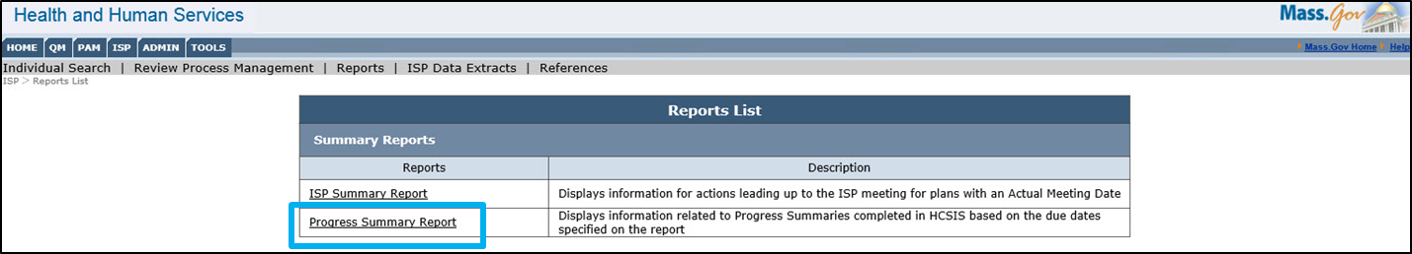

Note: This landing page has been added because there are now two reports available within the ISP module.

- Select the date from the calendar dropdown next to the “From Date” and “To Date” fields.

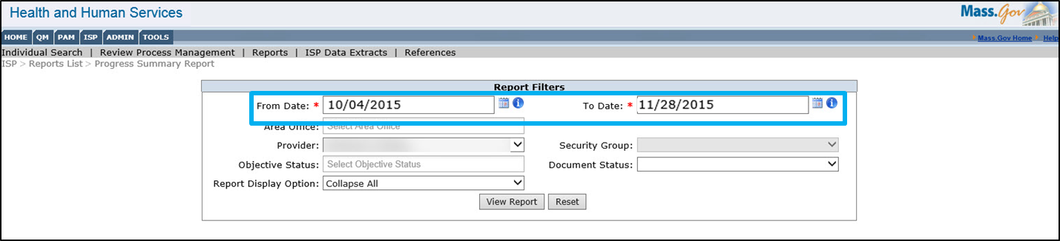

Note: The “From Date” and “To Date” are based on the Progress Summary due date. This filter allows users to view individuals within a specified date range. Conditions for the following dates are as follows: the “From Date” must be prior to the “To Date”, and both dates can be up to a year in the future. The range can span multiple years, all progress summaries for an individual between the selected dates will be included in separate lines of the report. Please note that the report is intended to be used by multiple user bases – some of whom use it as a tool to identify Progress Summaries that are past due and others that use it to identify either upcoming or future progress summaries. With that in mind, it is possible to enter dates that have already past or dates that span up to one year in the future.

- If desired, users may narrow their search further by using the additional filters.

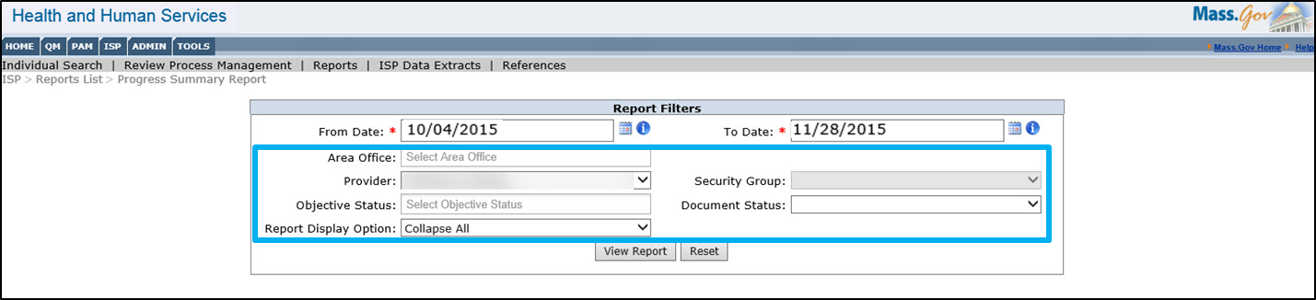

Area Office
- The filter will only display the Area Offices associated to the individuals the provider is providing services to.

Provider Agency:
- Provider staff can verify that the filter is populated with the correct Provider Agency name. Within the drop-down menu, multiple checkboxes can be selected. An auto-complete feature has also been enabled when using the partial search function.

Objective Status:
- Provider staff can filter by Objective Status by selecting the dropdown options of “Met”, “Partially met”, and “Discontinued.” Once selected, the report will display only individuals with progress summaries for objective in the selected status.

Report Display Option:
- Provider staff can use the drop-down menu to select the Report Display Option. The choices are “Expand All” or “Collapse All”. “Collapse All” will show all of the individuals with the assessment and objective details collapsed. “Expand All” will show all of the individuals with the Progress Summary details expanded. Please note that choosing “Expand All” will increase the amount of time it takes to render the report.
- The Report Display Option filter defaults to “Collapse All”.

Security Group:
- Provider Staff can select a security group from the filter. Please note that the dropdown will not be available if the Provider Agency does not have enhanced security set up.

Document Status:
- Provider Staff can use the drop-down menu to select the Document Status. The filter defaults is empty and the drop-down option is “Deadline Not Met Only”. If “Deadline Not Met Only” is selected, the report will only display individuals with Progress Summaries which are past the deadline date.
- Click “View Report.”

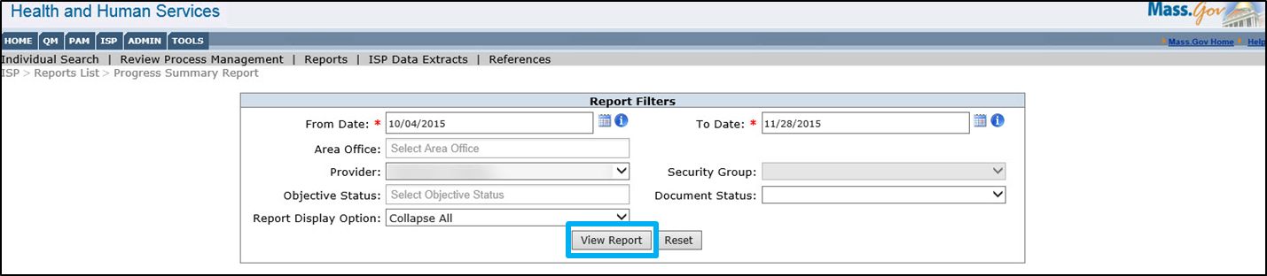

Note: The system returns the report and displays all the individuals satisfying the search criteria i.e. all the individuals within the applied filters.

- To view additional details for an individual, select the (+) sign which is located to the left of the individual name column. Once clicked, the Progress Summary form will expand and display the details on the Reports page.

Note: The report displays the following fields:
- Individual Name
- Eligibility Number
- Service Coordinator Name
- Service Coordinator Supervisor Name
- Actual Meeting Date
- Next Planned Meeting Date
- Next ISP Deadline
- ISP Year
- Overall Total of Objectives and Progress Summaries
- Progress Summary
- Request Date
- Due Date
- Initial Submission Date
- Initial SC Response Date
- Most Recent Document Status
- Date of Last Revision Requested
- No. of Revisions Requested
- Date Approved
- Objective Status
Note: Red, bolded and italicized text indicates that the actions were not performed on time.

- If desired, click the export icon and select “PDF” to export.

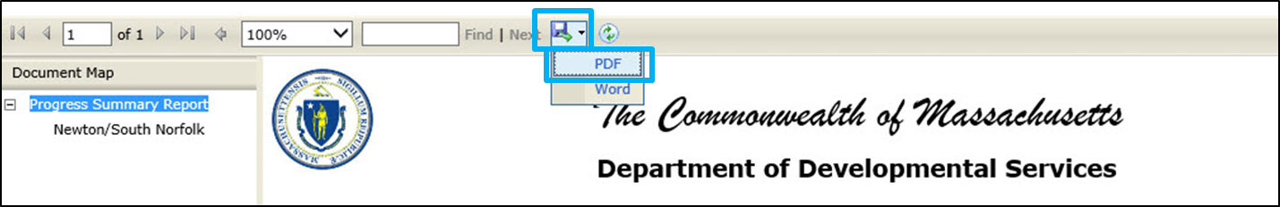

Note: The PDF will print the exact image that is displayed on the Reports page. If the Progress Summary Report is shown with the expanded information, that will be printed.

- Click “Open” to view the PDF of the Progress Summary Report.

- Click on the “File” tab and then click “Print” to print the PDF.

Viewing and Printing ISP Materials for DDS Staff
DDS staff can print the full ISP Document and all remaining documents in PDF and Word. The Full ISP Document will always print with a draft watermark in Word, while the PDF of the full ISP Document will never print with a draft watermark. For printing ISP materials separately as Vision, Provider Support Agreements, Assessments, Current Supports, Safety & Risk, Legal/Benefit/Financial Status, Successes/Challenges, Modifications and Progress Summary sections, the status of the document will determine whether or not the document prints with or without a “Draft” watermark. This process allows users to save electronic copies as well as print hard copies of ISP materials.
Note: Providers do not have access to the full ISP Document in HCSIS. Providers will continue to receive the hard copy of the complete ISP document from the Service Coordinator, 45 days post ISP meeting.
A “Historical ISP Materials” link will be present on the top right corner of the View/Print screen. Clicking on the link will result in the system displaying a pop-up that will allow users to access ISP Documents, Assessments, Provider Support Agreements and Progress Summaries from past plans. DDS staff are also able to print and view the full ISP historical documents. Refer to the next subsection on Historical Document Access for DDS Staff for more information.

Printing ISP Materials
The table below lists the conditions for which a “Draft” watermark is displayed for each component:
ISP Component | Draft Watermark?
Vision | Yes, unless shared with Providers.
Objectives and Support Strategies (OSS) | Yes, unless approved.  Printed in the format of a Provider Support Agreement.
Goals | Can only be printed in a PSA.  Printed together with OSS as Provider Support Agreement.
Assessments | Yes, unless approved.
Current Supports, Safety/Risk, Legal/Benefit/Financial Status, Successes and Challenges | Yes, unless the answer to “Can this information be considered complete?” is “Yes”.  (Applies only when printed separately from the ISP Document)
ISP Document | In PDF, the full ISP Document is printed without a “Draft” watermark at any time before or after the ISP meeting. However, in Word the “Draft” watermark appears at all times.
Modifications | Yes, unless approved
Progress Summary | Yes, unless approved

Update Year Considerations
- Vision
  - When expanded, the Vision section will display the Full Year ISP Vision responses and the updated information entered as part of the Update Year plan under each prompt.
  - The updated information will be displayed on a new line with the following title: “Updated Information.” If no updated information is entered for a specific question, the system will display “No Change” under the title.

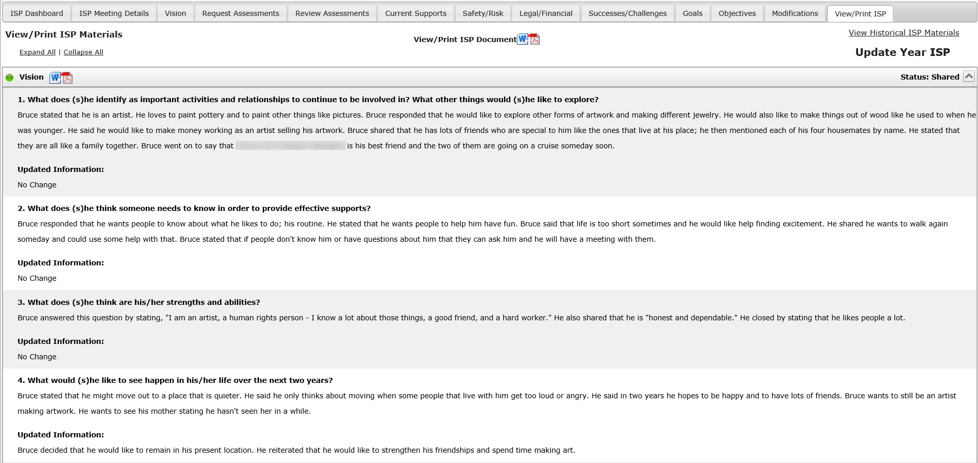

- Current Supports, Safety & Risk, Legal/Financial/Benefit Status, Successes/ Positive Events, Challenges, Emerging Issues, and Unmet Needs:
  - When expanded, this section will display the Full Year ISP Current Supports responses and the updated information entered as part of the Update Year plan under each section.
  - The updated information will be displayed on a new line with the following title: “Updated Information.” If no updated information is entered for a specific question, the system will display “No Change” under the title.

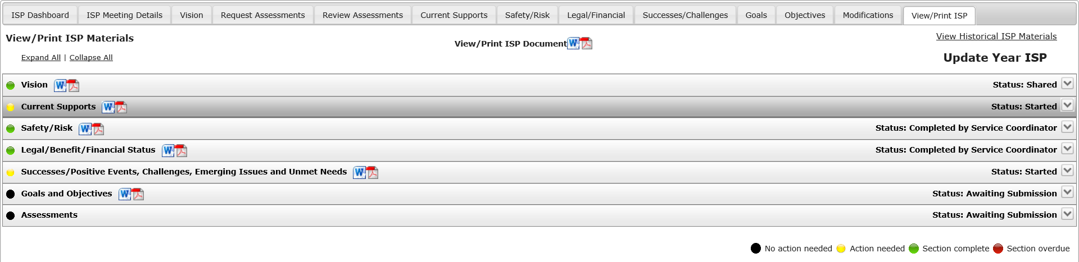
- Goals and Objectives
  - The updated information will be displayed on a new line with the following title: “Updated Information.” If no updated information is entered for a specific question, the system will display “No Change” under the title.
  - Goals cannot be printed independent of the Provider Support Agreement form.
  - The Update Year Status entered by the user will be displayed on the printable document in bold and separated from the document title with a dash, “-“. For example, “Objective title – Met” or “Goal Title – Discontinued”. On the View/Print screen, the status will be displayed in the right top corner of screen.

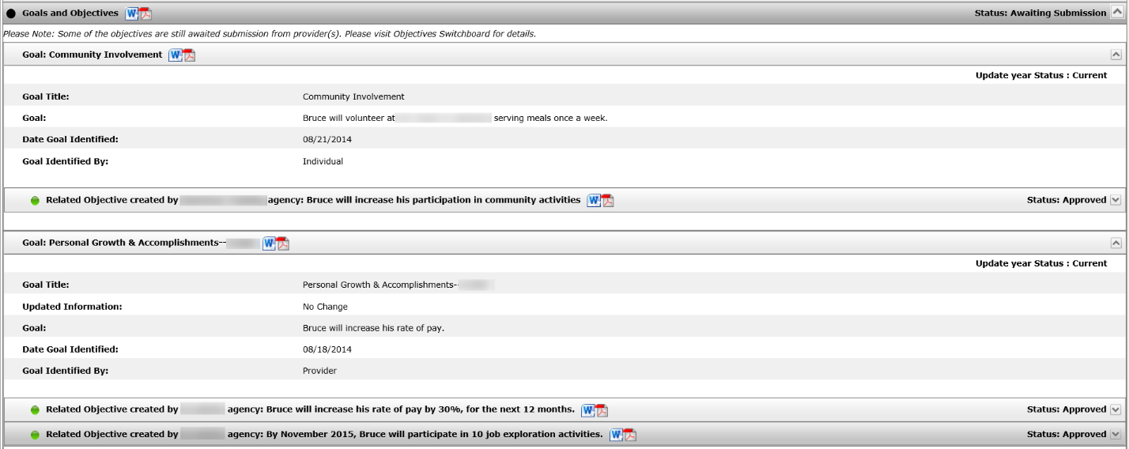

- Assessments
  - Only assessments requested as part of the ISP Update Year will be displayed. Assessment from the last Full Year plan will not be displayed in this section.
  - If no assessments have been requested, the following message will be displayed: “No {Assessment Type} Assessments are available. An assessment must be requested, created and approved to be able to view or print.”

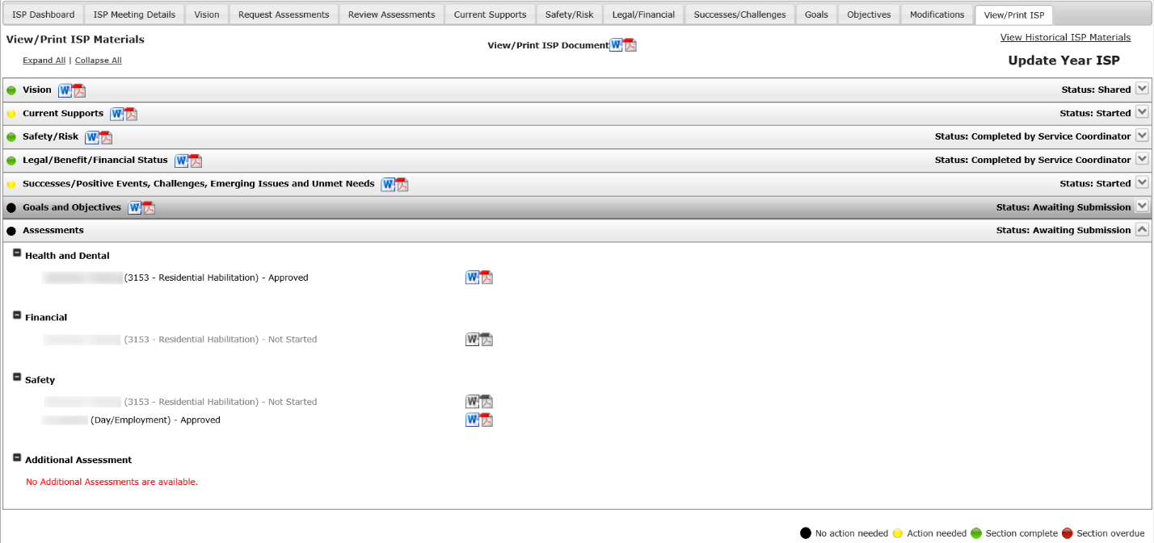

Printing an Individual Component of the ISP Document
Scenario Description: Service Coordinator or Service Coordinator Supervisor elects to print an individual component of the ISP document.
First Steps:
- The user searches for an individual
- The user views the Individual Dashboard

Roles and Responsibilities:
- Service Coordinators: Can view, save and print approved and unapproved ISP materials as well as the ISP Document.
- Service Coordinator Supervisors: Can view, save and print approved and unapproved ISP materials as well as the ISP Document.

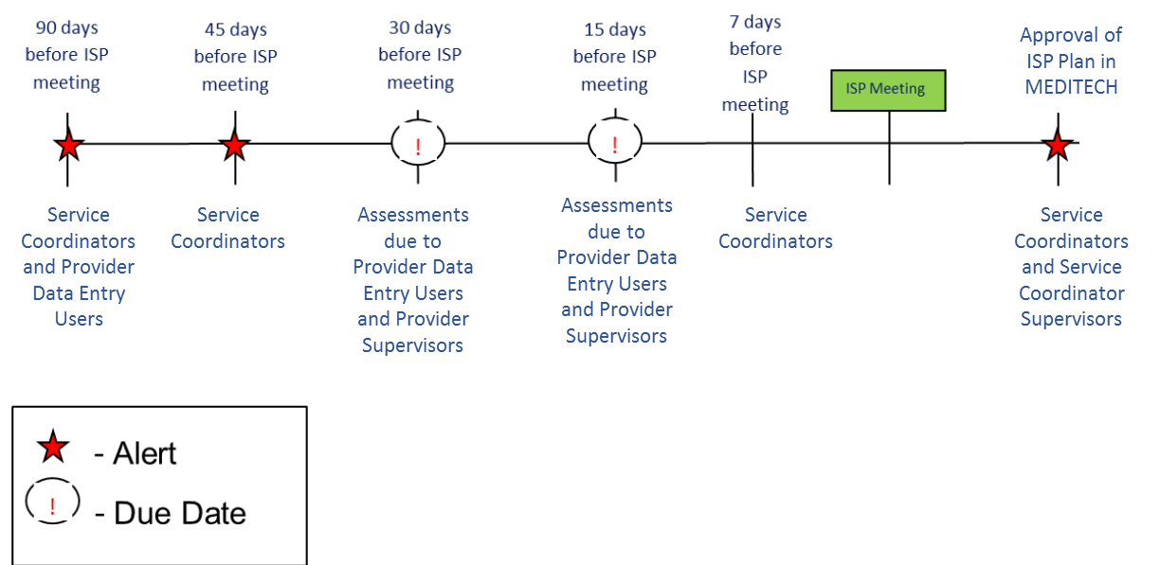
- Click the “View/ Print ISP” tab on the ISP Dashboard.
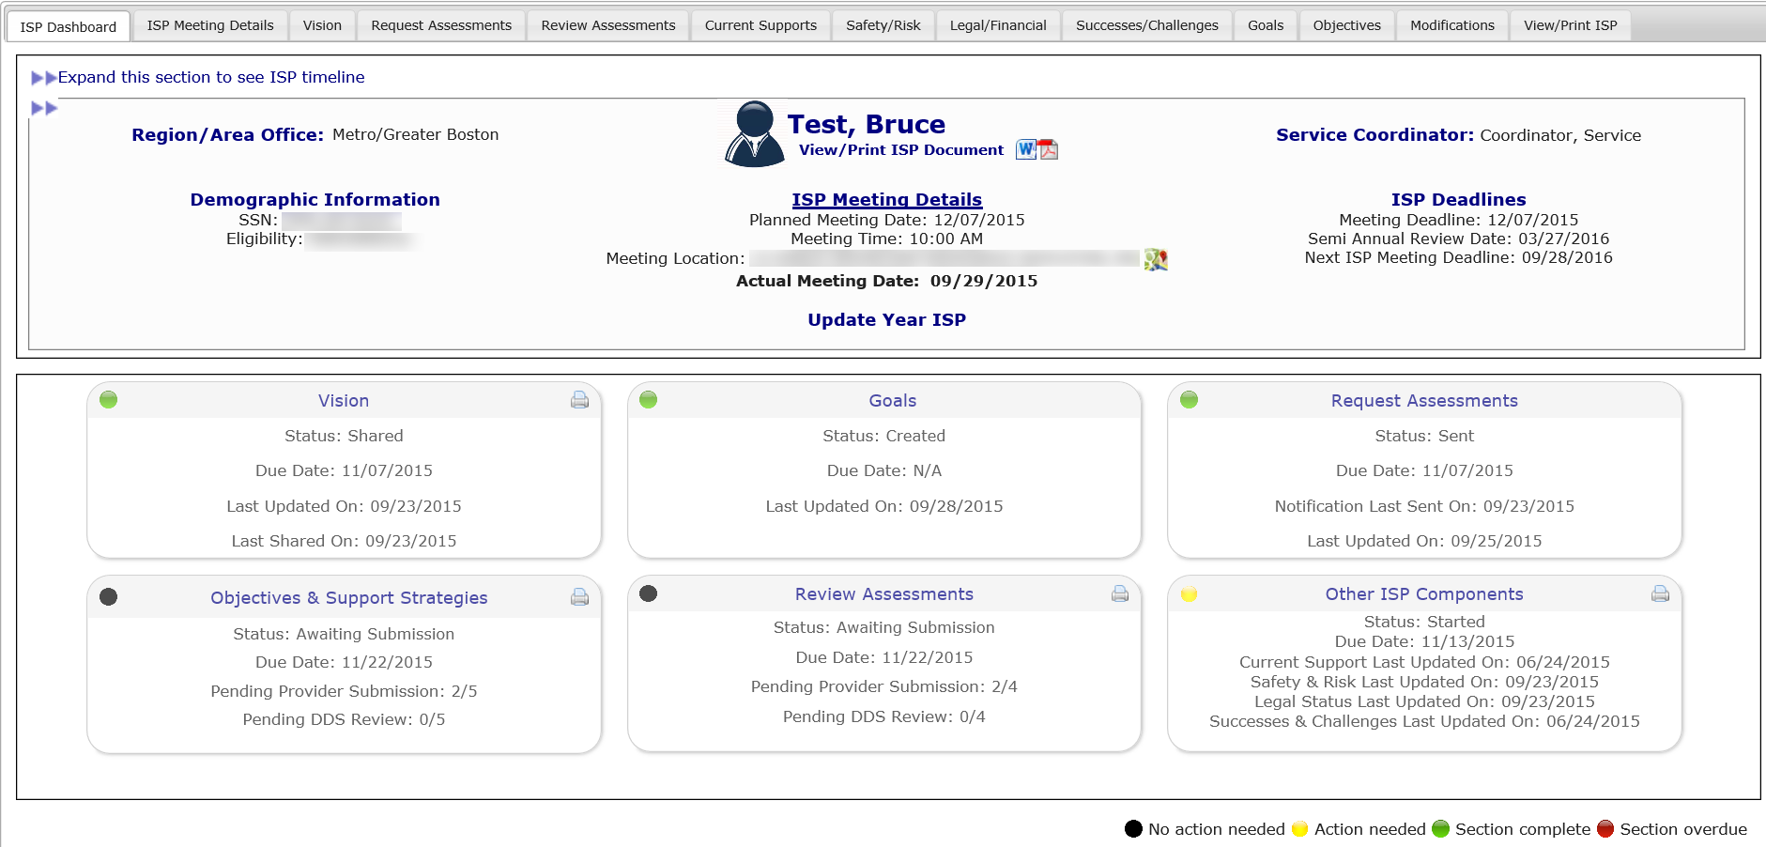
Note: The “View/Print ISP Materials” screen can also be accessed by clicking on any of the print icons available on the top right corner of each of the following boxes: Vision, Objectives & Support Strategies”, “Request Assessments”, and “Other ISP Components”.
170
Newhouse, Graham
- View the list of sections available on the screen. All available documents can be printed in both Word and PDF.

The View Print screen displays that status of the document with the same colored icon as the dashboard and text on the right side of the screen. The status is important for printing to understand when documents will print with a draft watermark. All documents will print with a “Draft” watermark unless they are in “Approved” status.
- Use the “Expand All” link to view the information available in each section or click directly on the section you would like to expand.
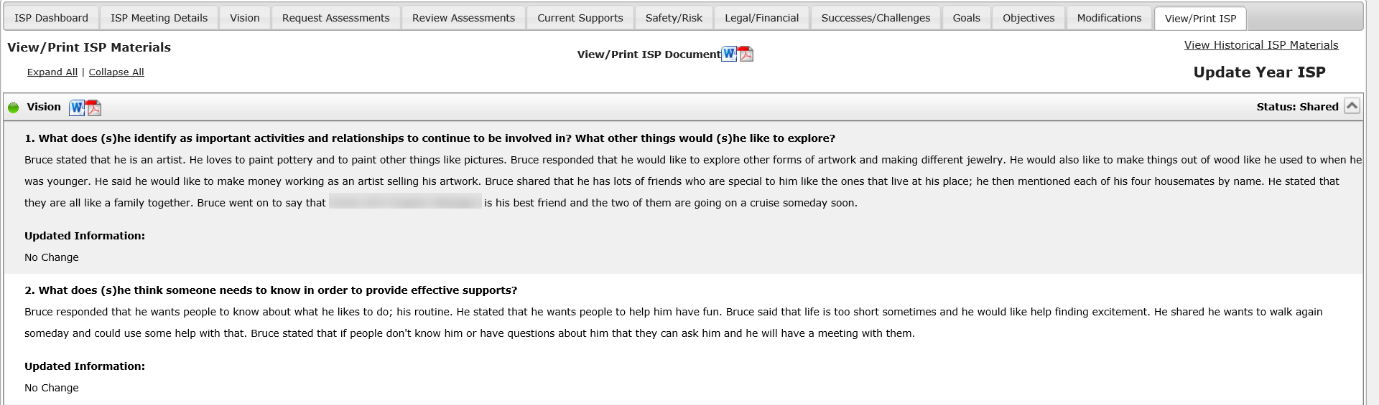
- Click the PDF or Word icon next to the Goals and Objectives title to print the Provider Support Agreement forms for all available Objectives.
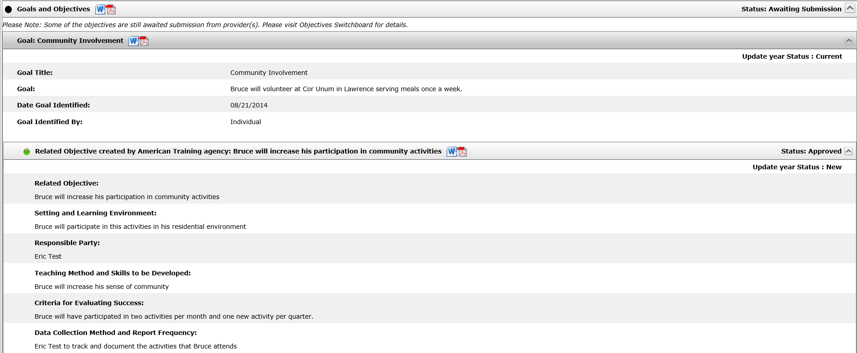
Note: Clicking the PDF or Word icon next to a specific Goal will print the Provider Support Agreements for only the Objectives associated with the selected Goal rather than all of the Goals and objectives for an individual. Clicking on the PDF or Word icon next to an Objective will open the Provider Support Agreement for that Objective only.
After clicking on a PDF or Word icon, a pop-up window will appear on the screen that will prompt you to open or save the selected document. The pop-up may look different depending on the browser.
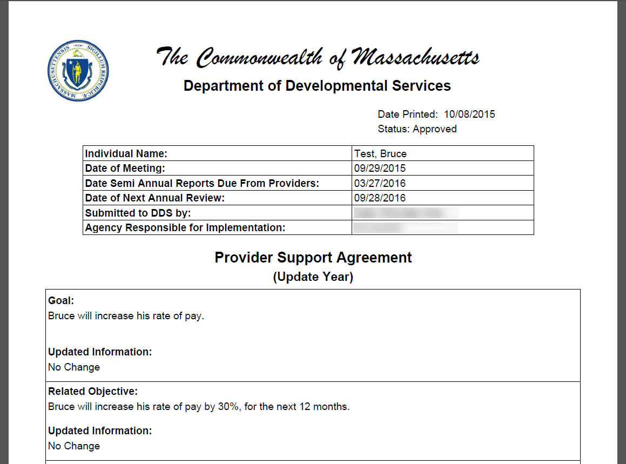
Note: The draft watermark is printed on the Provider Support Agreement form if the status of the document has not been approved.

- View the document and print by clicking “File” and then “Print” OR Ctrl + P.
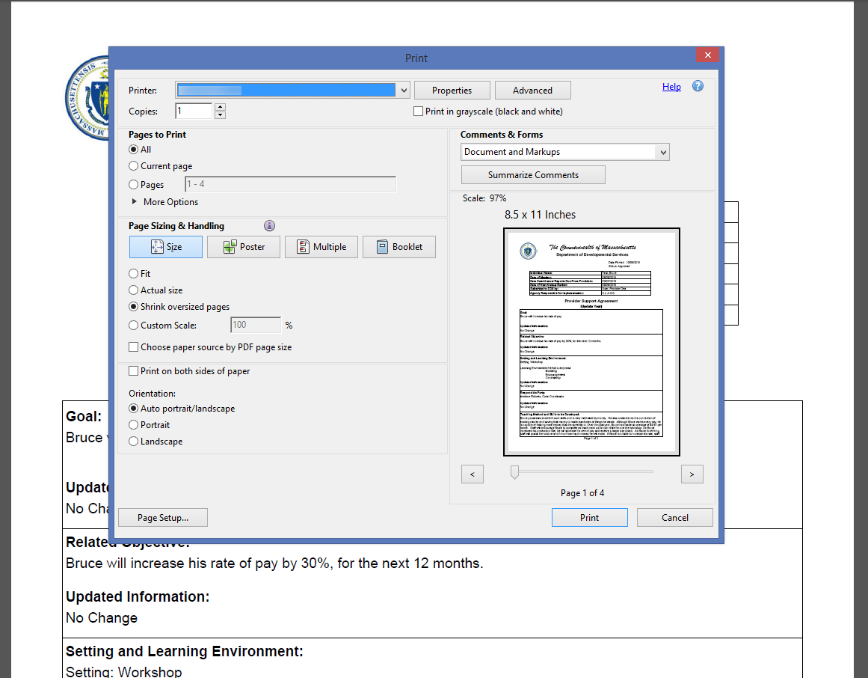
Note: This screen might also look different depending on the version of Adobe being used.
Viewing and Printing the Entire ISP Document

Scenario Description: Service Coordinators and Service Coordinator Supervisors can print the full ISP Document. The full ISP Document will never print with a “Draft” watermark even if a section has not been finished if it is viewed in PDF. The ISP Document will always print with a “Draft” watermark in Word.

First Steps:
- The user searches for an individual
- The user views the Individual Dashboard
- The user navigates to the “View / Print” tab

Roles and Responsibilities:
- Service Coordinators: Can view, save and print approved and unapproved ISP materials as well as the ISP Document.
- Service Coordinator Supervisors: Can view, save and print approved and unapproved ISP materials as well as the ISP Document.

- Click on the Word or PDF icon next to “View/Print ISP Document”.
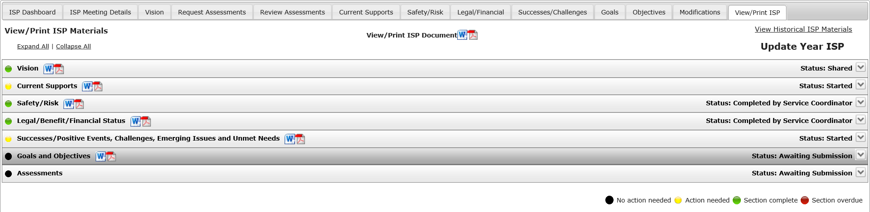
Note: The link is also available on the ISP Dashboard on an individual:
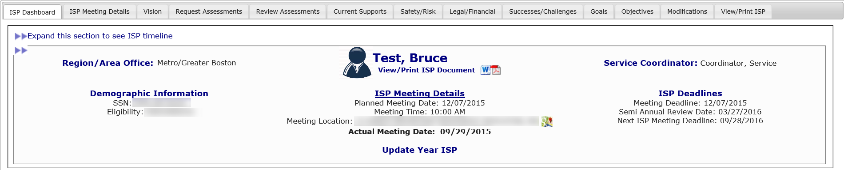
After clicking on a Word or PDF icon, a pop-up window will appear on the screen that will prompt you to open or save the selected document. The pop-up may look different depending on the browser.
- Click “Open” to view the full ISP Document.
- Print the full ISP document by clicking on “File” and “Print” OR Ctrl + P. The full ISP Document will never print with a “Draft” watermark even if a section has not been finished if it is viewed in PDF. The ISP Document will always print with a “Draft” watermark in Word.
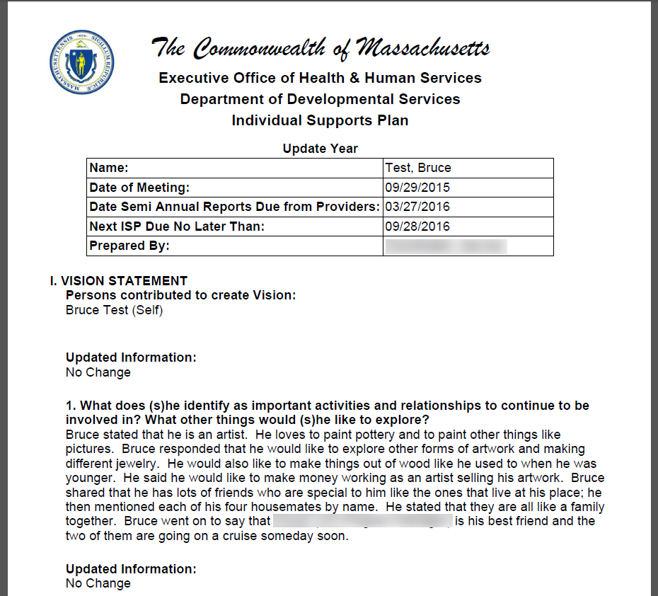
Note: The above scenario shows an Update Year ISP document. Below is what a Full Year ISP Document PDF document will look like.
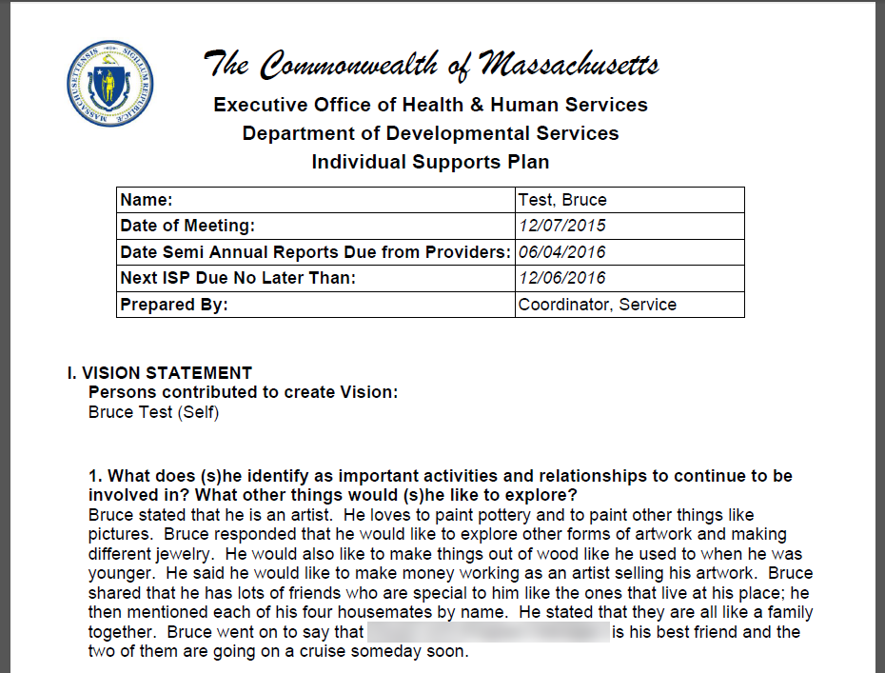
The Vision must be shared in order for it to print in the document. Goals and Objectives must be previously selected in order to be included in the ISP document. Please refer to Post ISP Meeting Activities for additional details on including objectives in the ISP document.
Next Steps:
- Service Coordinators and Service Coordinator Supervisors can print and bring a hard copy of draft materials to ISP meetings.
- Service Coordinators and Service Coordinator Supervisors can print additional documents from HCSIS.

Viewing and Printing Historical ISP Materials Access for DDS Staff

A Historical ISP Materials link will be present on the top right corner of the View/Print ISP Materials screen. Clicking on the link will result in the system displaying a pop-up with the following tabs: “ISP Documents”, “Assessments” and “Goals and Objectives”. The ISP Documents tab is visible only to DDS users. Providers will not have access to viewing and printing historical ISP Documents. All historical materials will be available in PDF.

- Documents on all tabs of the pop-up window will be grouped by the ISP Plan they come from. The Actual Meeting Date for the plan will be displayed.
- The Assessments tab will have four expandable/collapsible sections for each ISP: Safety Assessments, Financial Assessments, Health & Dental Assessments and Additional Assessments (applicable only for assessments requested prior to June 27th, 2014).
- The “ISP Documents” tab of the pop-up window will be displayed by default.
- If there are no historical documents, the system will display the following message: “No [Name] Documents available for the individual”.
- The Goals and Objectives tab will allow access to past Provider Support Agreements.
- All Assessments and Objectives from past plans will be pulled regardless of their status. If the user has no access to a document in a certain status, the PDF icon will be disabled and the user will not be able to view or save the document.
        - Service Coordinators, Service Coordinators Supervisors and Area Office Directors Data Entry roles will be able to access Assessments and Objectives in any of the following statuses: “Submitted for DDS Review”, “DDS Review Started”, “Revision Requested” and “Approved”.
        - Area Office Director Read-only role, Commonwealth and Regional users will only be able to access Assessments and Objectives in “Approved” status.
        - Only DDS Staff will be able to view historical ISP Documents.

Scenario Description
Accesing historical documents
First Steps:
- The user searches for an individual
- The user views the Individual Dashboard

Roles and Responsibilities:
- Service Coordinators: Can view, save and print Historical ISP Documents, Historical Goals and Objectives, Historical Assessments and Historical Progress Summaries.
- Service Coordinator Supervisors: Can view, save and print Historical ISP Documents, Historical Goals and Objectives and Historical Assessments.

- Click the “View/ Print” tab on the ISP Dashboard.
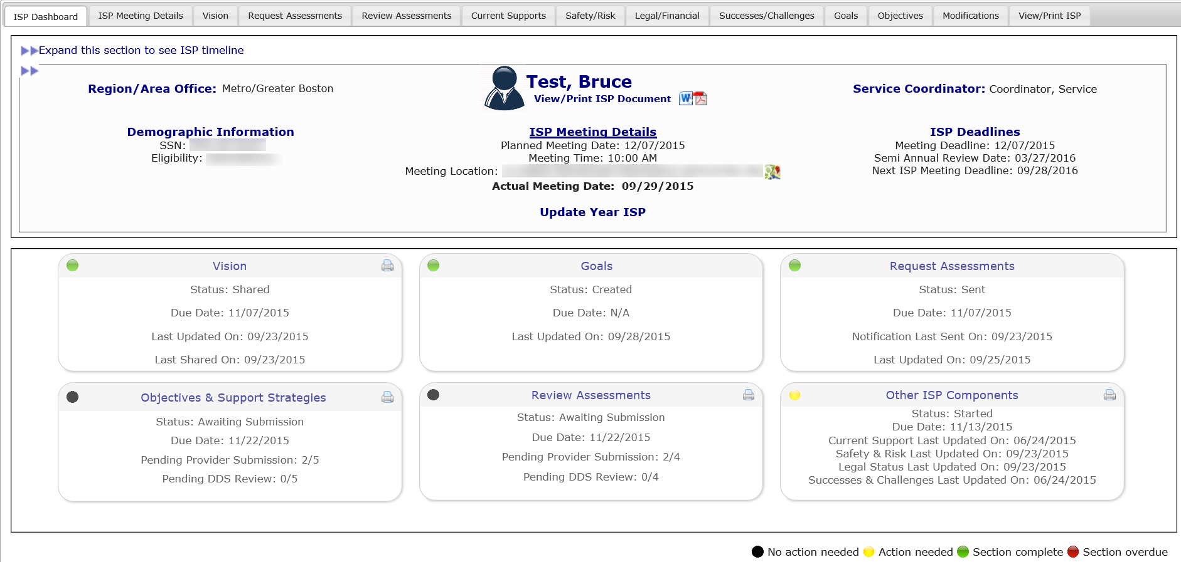
- Select the “View Historical ISP Materials” Link from the top right of the screen.

Note: The provider user will see Historical ISP Documents, Historical Assessments and Historical Goals and Objectives tabs. The popup will open to the Historical ISP Documents tab.

- Select the PDF icon next to the desired Historical ISP Plan to view and print the plan.

- Close the plan and click on the Assessments tab.

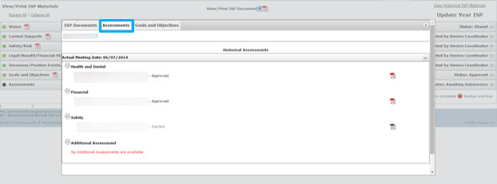

- Click on the section headers to expand and collapse the 4 types of assessments.

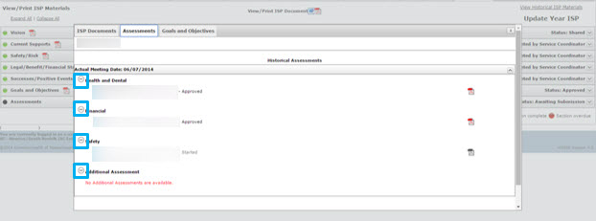

- Select the PDF icon next to an assessment to open the assessment in PDF.

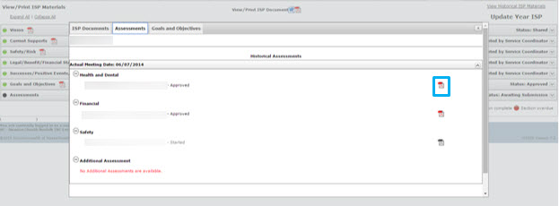

- Close the assessment and select the “Goals and Objectives” tab.

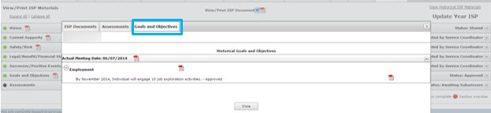

- Select the PDF icon next to an Objective to open the Provider Support Agreement for that Objective or click the PDF icon next to a Progress Summary form to open the Progress Summary form completed in that quarter.

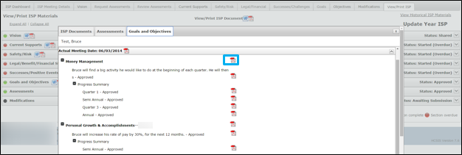
Viewing and Printing ISP Materials for Provider Staff
Providers can print the Vision once it has been shared with them, Assessments and Objectives & Support Strategies created by their Provider Agency in any status, and approved documents created by other Provider Agencies. The status of the document will determine whether or not the document prints with or without a draft watermark. This process allows users to save electronic copies as well as print hard copies of ISP materials.
Note: Providers do not have access to the full ISP document in HCSIS. Providers will continue to receive the hard copy of the complete ISP document from the Service Coordinator, 45 days post ISP meeting.
A “Historical ISP Documents” link will be present on the top right corner of the screen. Clicking on the link will result in the system displaying a pop-up that will allow users to access ISP Documents, Assessments, Provider Support Agreements and Progress Summaries from past plans. Refer to the next subsection on Historical Document Access for Provider Staff for more information.

Printing ISP Materials
The table below lists the conditions in which a “Draft” watermark is displayed for each component:
ISP Component | Draft Watermark?
Vision | Yes, unless shared with Providers.
Objectives and Support Strategies (OSS) | Yes, unless approved.  Printed in the format of a Provider Support Agreement.
Goals | Can only be printed in a PSA.  Printed together with OSS as Provider Support Agreement.
Assessments | Yes, unless approved.
Modifications | Yes, unless approved
Progress Summary | Yes, unless approved

Note: The conditions remain the same for printing in either PDF or Word.
Update Year Considerations
- Vision
  - Providers and Provider Supervisors will only be able to view or print the Vision Statement document if the Vision has been shared. All users see the same version of the Vision.
  - The Vision section will display the Full Year ISP Vision responses and the updated information entered as part of the Update Year plan under each prompt.
  - The updated information will be displayed on a new line with the following title: “Updated Information.” If no updated information is entered for a specific question, the system will display “No Change” under the title.

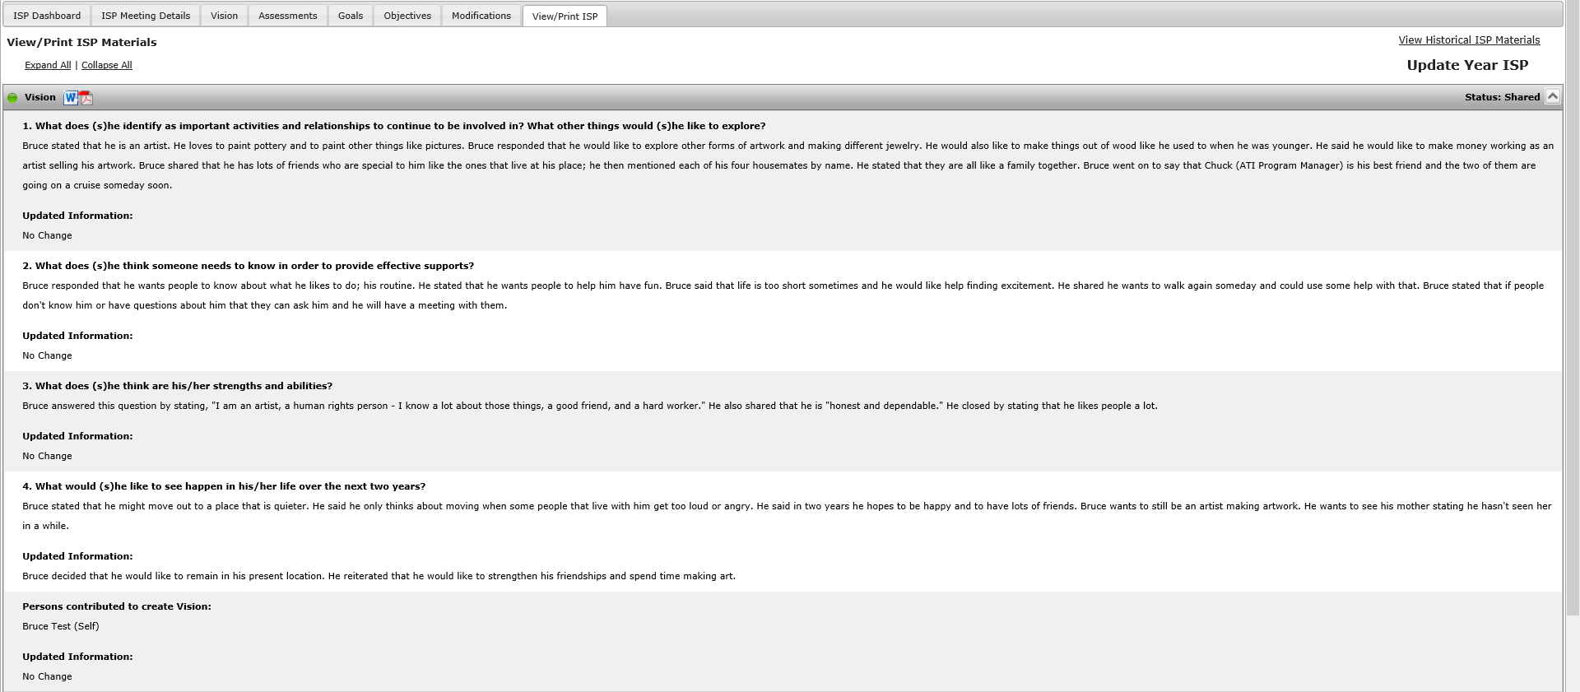

- Goals and Objectives
  - The updated information will be displayed on a new line with the following title: “Updated Information.” If no updated information is entered for a specific question, the system will display “No Change” under the title.
  - Providers and Provider Supervisors will not be able to view or print Provider Support Agreements for Objectives and Support Strategies created by a different Provider Agency until the Objectives have been approved.
  - The Update Year Status entered by the user will be displayed in bold and separated from the document title with a dash, “-“. For example, “Objective title – Met” or “Goal Title – Discontinued”.

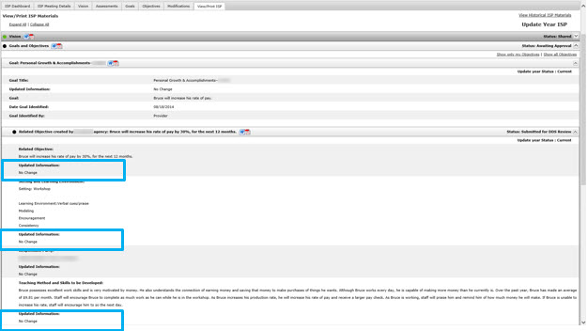

- Assessments
  - Only assessments requested as part of the ISP Update Year will be displayed. Assessment from the last Full Year plan will not be displayed in this section.
  - If no assessments have been requested, the following message will be displayed: “No {Assessment Type} Assessments are available. An assessment must be requested and created to be able to view or print.”

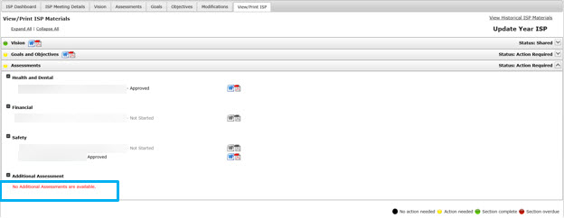
Printing an Individual Component of the ISP Document
First Steps:
- The user searches for an individual
- The user views the Individual Dashboard
Roles and Responsibilities:
- Providers: Can view, save and print the Vision, Provider Support Agreements, and Assessments.
- Provider Supervisors: Can view, save and print the Vision, Provider Support Agreements, and Assessments.
- Click the “View/ Print” tab on the ISP Dashboard.
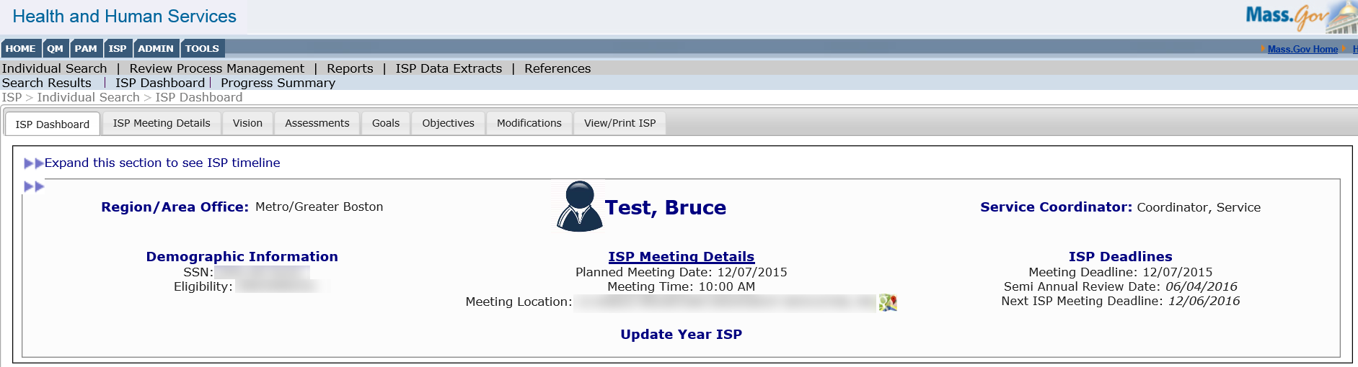
- View the list of sections available on the screen. The Vision, Provider Support Agreements, and Assessments can be printed in PDF or Word.

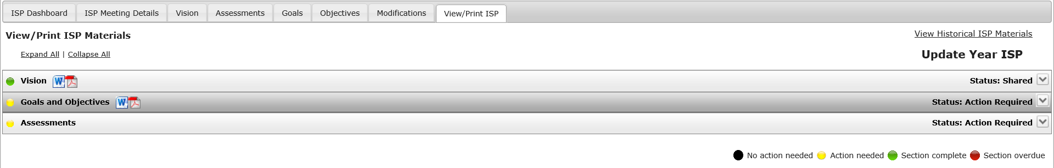

The View Print screen displays that status of the document with the same colored icon as the dashboard and text on the right side of the screen. The status is important for printing to understand when documents will print with a draft watermark. All documents will print with a “Draft” watermark unless they are in “Approved” status.
- Use the “Expand All” link to view the information available in each section.
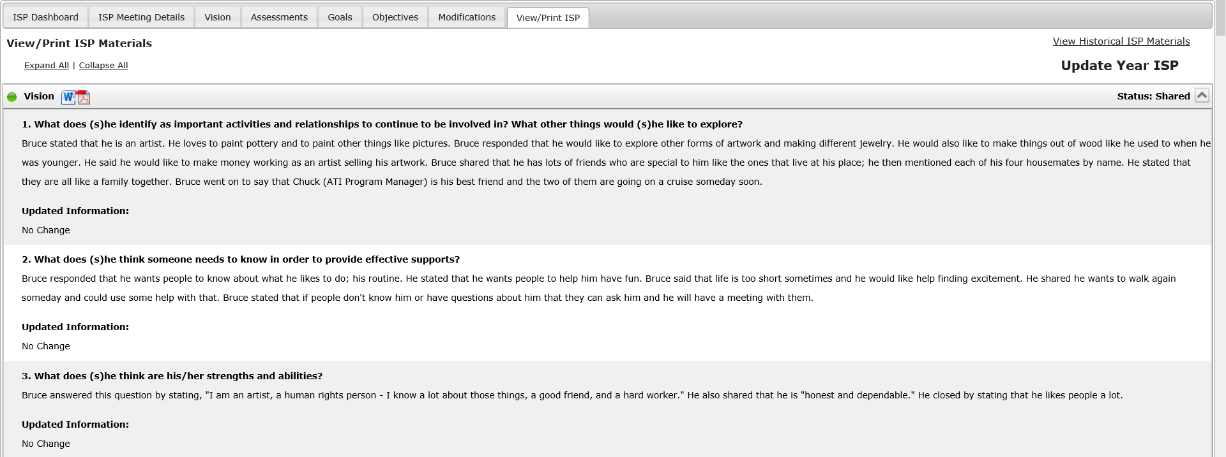
- Click on the PDF or Word icon next to the Vision section to open and print the shared Vision Statement.
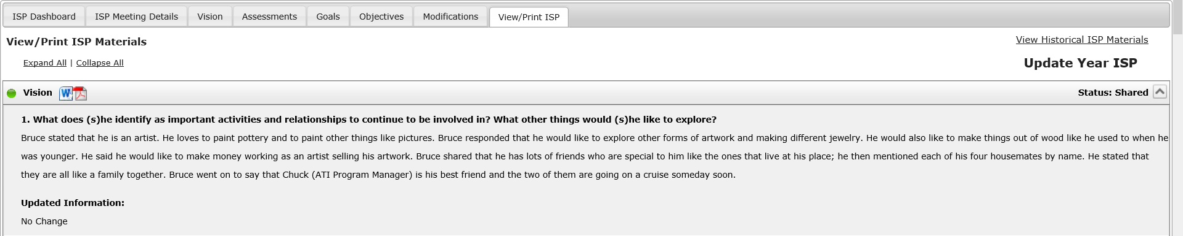
- A pop-up window will appear on the screen. Click “Open” or “Open to view the PDF”. The below pop-up may look different depending on your browser.
The Vision Statement will be displayed.
Note: Since the Vision has been shared it will print with no “Draft” watermark. If the Vision has not been shared, Providers will not be able to view or print.
- Click on the PDF or Word icon next to the Goal and Objectives section title. This will open the Provider Support Agreements form for all available Objectives. The related Goals will be printed with the associated Objective and Support Agreement.
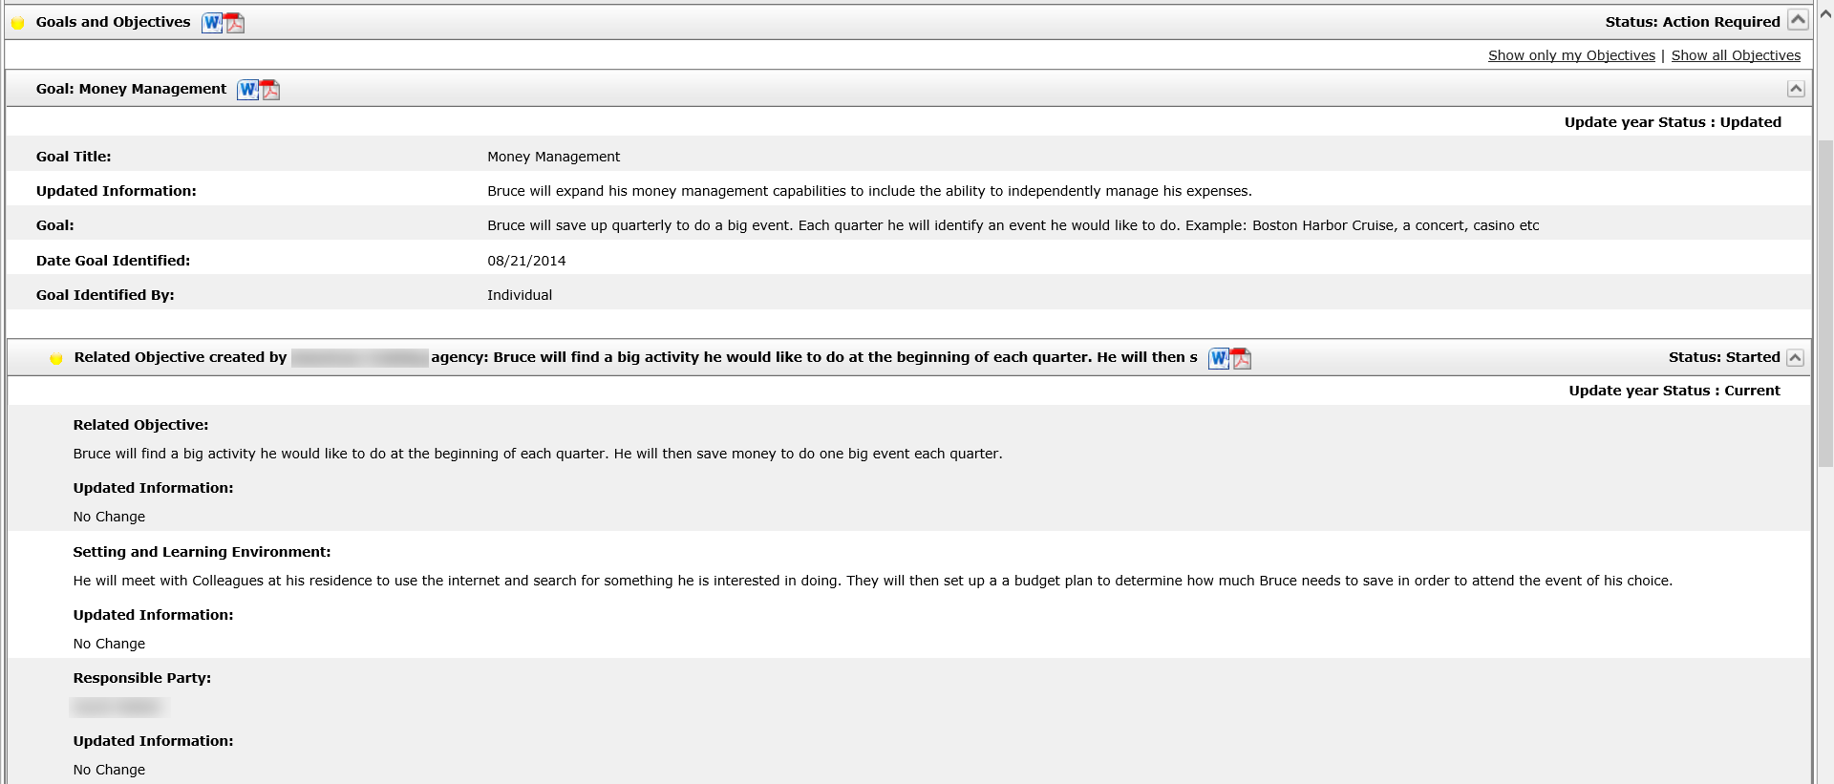
Note: Clicking the PDF or Word icon next to a specific Goal will print the Provider Support Agreements for only the Objectives associated with the selected Goal rather than all of the Goals and objectives for an individual. Clicking on the PDF or Word icon next to an Objective will open the Provider Support Agreement for that Objective only.
Note: To view Goals and Objectives created by your Provider agency only, click “Show only my Objectives,” which is located in the upper right hand corner of the screen.
After clicking on a PDF icon, a pop-up window will appear on the screen that will prompt you to open or save the selected document. The pop-up may look different depending on the browser.
- Click “Open” to view the document.
The Provider Support Agreement will be displayed.
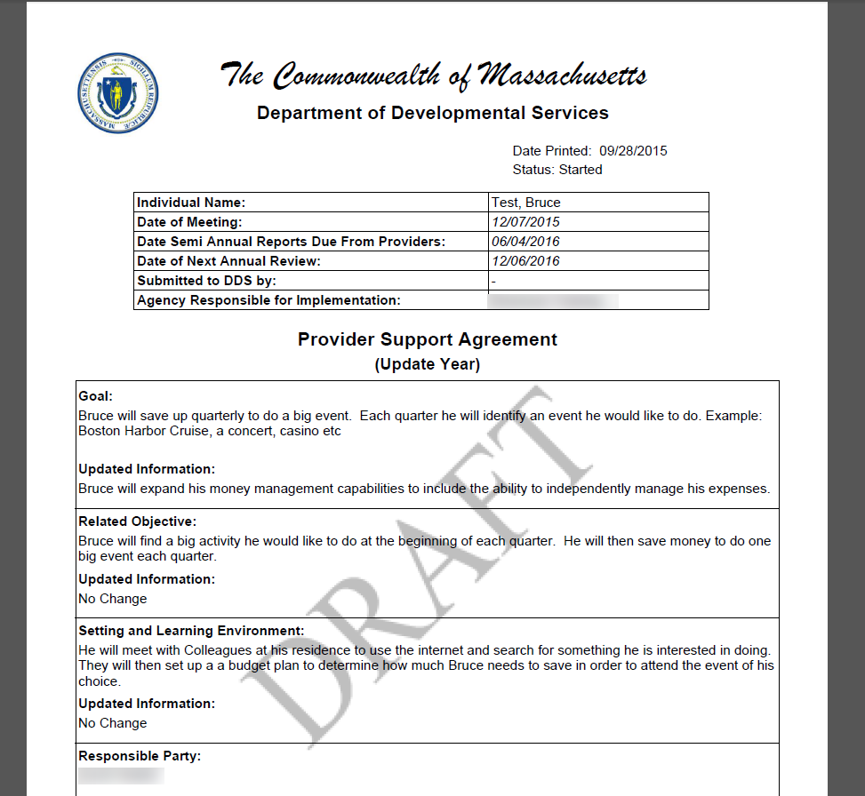
- View the document and print by clicking “File” and then “Print” OR Ctrl + P.
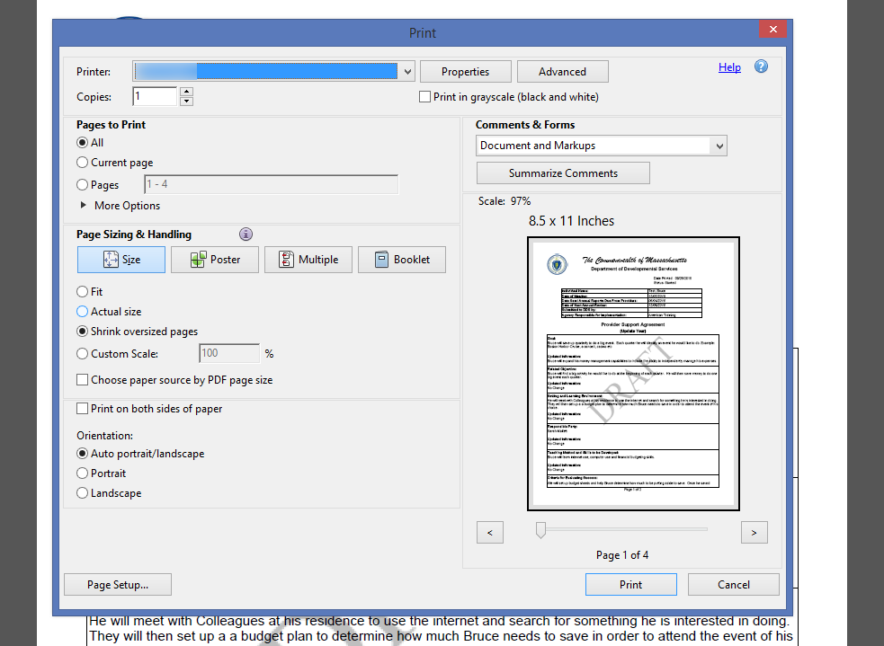
This screen might also look different depending on the version of Adobe or Word being used.
- Click the PDF or Word icon next to the specific Assessment you would like to print. Assessments will print with a “Draft” watermark unless in “Approved” Status. Repeat steps 7 and 8 to open and view the document.
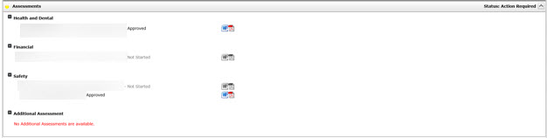
Next Steps:
- Providers can print and bring a hard copy of draft materials to ISP meetings.
- Providers can print additional documents from HCSIS.

Viewing and Printing Historical ISP Materials Access for Provider Staff

A “Historical ISP Materials” link will be present on the top right corner of the View/Print ISP Materials screen. Clicking on the link will result in the system displaying a pop-up where Assessments and Provider Support Agreements from past plans can be viewed and/or printed. All historical materials will be available in PDF.

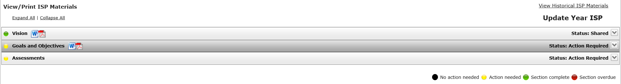
- The pop-up will automatically display the “Assessments” tab. In order to view historical Provider Support Agreements, click on the “Goals and Objectives” tab.
- Documents on all tabs of the pop-up window will be grouped by the ISP Plan they come from. The Actual Meeting Date for the plan will be displayed.
- The Assessments tab will have four expandable/collapsible sections for each ISP: Safety Assessments, Financial Assessments, Health & Dental Assessments and Additional Assessments.
- If there are no historical documents, the system will display the following message: “No [Name] Documents available for the individual”.
- All Assessments and Objectives from past plans will be pulled regardless of their status. If the user has no access to a document in a certain status, the PDF icon will be disabled and the user will not be able to view or save the document.
        - Providers and Provider Supervisors will be able to access Assessments and Objectives in all statuses as long as the documents were created by the same Provider Agency. If the documents were created by a different Provider Agency, the Providers and Provider Supervisors will only be able to view them if they are in “Approved” status.

First Steps:
- The user searches for an individual
- The user views the Individual Dashboard

Roles and Responsibilities:
- Provider Data Entry User: Can view, save and print Historical Goals and Objectives and Historical Assessments.
- Provider Supervisors: Can view, save and print Historical Goals and Objectives and Historical Assessments.

The following steps will be taken by either the Provider Data Entry User or the Provider Supervisor.

- Click the “View/ Print” tab on the ISP Dashboard.
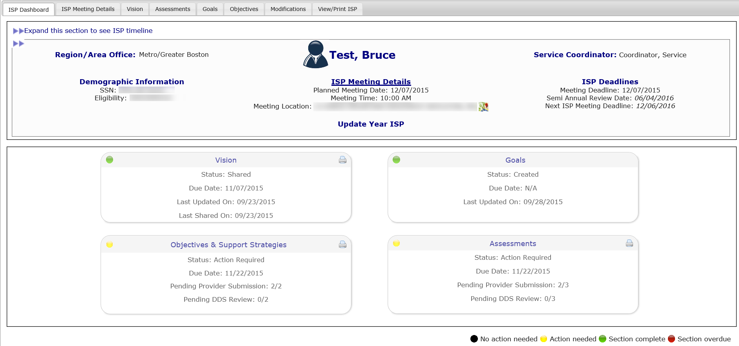
- Click “View Historical Documents” on the top right of the screen.

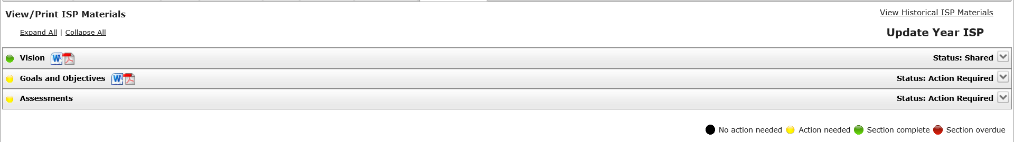
Note: The provider user will see Historical Assessments and Historical Goals and Objectives tabs. The popup will open to the Historical Assessments tab.

- Click on the section headers to expand and collapse the 4 types of assessments.

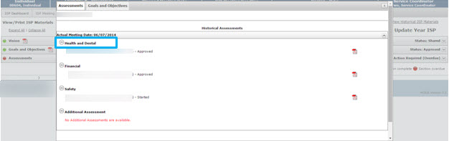

- Select the PDF icon next to an assessment to open the assessment in PDF.
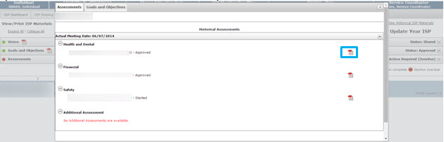

- Close the assessment and select the “Goals and Objectives” tab.

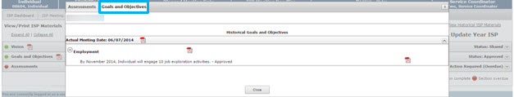

- Select the PDF icon next to an Objective to open the Provider Support Agreement for that Objective.

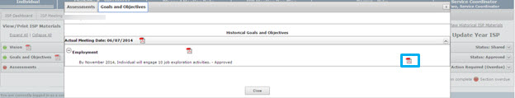

Enhanced Security for Providers
Enhanced Security will give Provider Organizations the ability to manage a user’s access to individuals in HCSIS based on the individual’s physical site location or other predetermined grouping.
Limiting access encourages additional users to utilize HCSIS and allows provider agencies to de-centralize data entry and prevents duplicate data entry. Limited access also provides streamlined alerts, where alerts will only be sent to the Providers and Provider Supervisors for which the alerts are relevant based on the caseload of each Provider staff member.
Note: Review Process Management search results and the ISP Summary Report allow Providers who have implemented Enhanced Security to filter results by Security Group. For more information, refer to the Review Process Management and ISP Summary Report for Provider Staff sections of the User Guide.
The Enhanced Security Manual is available on the DDS website: HCSIS>Administration>User Guide-Provider Administration Enhanced Security.
Contact The DDS Customer Services Help Desk for assistance with implementing this security feature. The Customer Services Desk can be reached via email at DDS.Customerservices@state.ma.us or by phone at 1-866-367-8163 or 617-994-5050.

