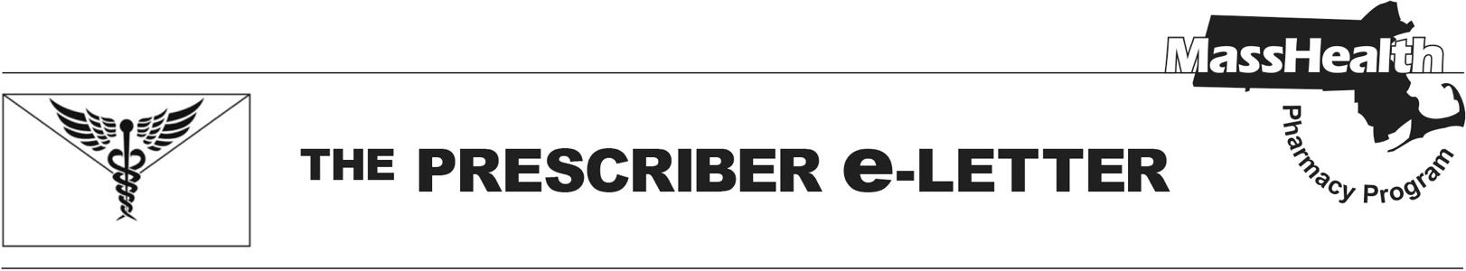
The Prescriber e-Letter,
Volume 16, Issue 1, January 2026

Respiratory Syncytial Virus Coverage Updates

MassHealth updated coverage for respiratory syncytial virus (RSV) products effective November 17, 2025. As of June 2025, the Centers for Disease Control and Prevention (CDC) recommend a single dose of RSV vaccine for all adults aged 75 and older and for adults aged 50 to 74 at increased risk of severe lower respiratory tract disease (LRTD) due to RSV. Infants are recommended to be protected from severe LRTD due to RSV by administration of an RSV vaccine to the mother between 32 and 36 weeks gestation or immunization of the infant with a long-acting monoclonal antibody after birth. The following provides an overview of MassHealth RSV coverage, including specific updates to certain products and prior authorization (PA) requirements.

MassHealth RSV Monoclonal Antibody and Vaccine Coverage Effective November 17, 2025

RSV Vaccine/Drug | No PA Required | PA Required
Abrysvo® (RSV vaccine)* | ≥18 years | <18 years^
Arexvy® (RSV vaccine, adjuvanted)* | ≥50 years | <50 years
mRESVIA® (RSV vaccine, mRNA)* | ≥60 years | <60 years
Beyfortus® (nirsevimab-alip) | <8 months | ≥8 months
Enflonsia® (clesrovimab-cfor) | <8 months | ≥8 months
Synagis® (palivizumab) | N/A | All ages
*Limit of one lifetime dose
^Abrysvo is available without PA through medical billing for use in pregnant people.

Pharmacy Coverage Effective November 17, 2025

Beyfortus® Coverage Update
Beyfortus® (nirsevimab) will continue to be covered without PA for MassHealth members younger than eight months. For members eight months or older, PA will be required to determine medical necessity based on comorbidities. Beyfortus® (nirsevimab) is available through the Massachusetts Department of Public Health Vaccines for Children program.

Enflonsia® FDA-Approval
Enflonsia® (clesrovimab-cfor) was approved by the Food and Drug Administration (FDA) on June 9, 2025, for the prevention of RSV LRTD in infants who are born during or entering their first RSV season. Enflonsia® (clesrovimab-cfor) will be added to the MassHealth drug list without PA for MassHealth members younger than eight months. For members eight months or older, PA will be required to determine medical necessity based on comorbidities. Enflonsia® (clesrovimab-cfor) is available through the Massachusetts Department of Public Health Vaccines for Children program.

Synagis® Coverage Update
Synagis® (palivizumab) will continue to require PA for all ages. MassHealth clinical criteria will be updated to include clinical rationale for use instead of Beyfortus® (nirsevimab) or Enflonsia® (clesrovimab-cfor). Additional documentation will also be required upon submission for the diagnoses of chronic lung disease (CLD) of prematurity, bronchopulmonary dysplasia (BPD), prematurity, or congenital heart disease (CHD). Notably, Synagis® (palivizumab) will be discontinued effective December 31, 2025.

RSV Vaccines

Abrysvo®
Abrysvo® is FDA-approved for active immunization of pregnant individuals at 32 to 36 weeks gestation for the prevention of LRTD and severe LRTD caused by RSV in infants from birth through six months and for active immunization in adults 18 years or older for the prevention of LRTD caused by RSV. Abrysvo® will continue to be covered without PA for MassHealth members aged 18 or older. For members younger than 18, including those who are pregnant, PA is required for pharmacy claims. However, no age restriction is in place for Abrysvo® through the medical benefit due to its indication for use in pregnancy. Providers can bill for Abrysvo® using procedure code 90678. Providers should refer to appropriate provider manuals for more information.

Arexvy®
Arexvy® is FDA-approved for active immunization for the prevention of LRTD caused by RSV in individuals aged 60 or older and individuals aged 50 to 59 who are at increased risk for LRTD caused by RSV. Arexvy® will continue to be covered without PA for pharmacy claims for members aged 50 or older. However, PA is still required for members younger than 60 years of age through the medical benefit. Criteria will be updated to align with the pharmacy benefit in the next Subchapter 6 update, with all claims reprocessed back to January 1, 2026. Providers can bill for Arexvy® using procedure code 90679. Providers should refer to appropriate provider manuals for more information.

mRESVIA®
mRESVIA® is FDA-approved for the active immunization for the prevention of LRTD caused by RSV in individuals aged 60 or older. On June 12, 2025, this indication was expanded to include active immunization in individuals 18 to 59 years old at increased risk for LRTD caused by RSV. Coverage will be updated to remove the PA requirement for pharmacy claims in individuals aged 18 to 59 on January 5, 2026. This change will also be reflected in the next Subchapter 6 update with all medical claims reprocessed back to January 1, 2026. Providers can bill for mRESVIA® using procedure code 90683. Providers should refer to appropriate provider manuals for more information.

References
Centers for Disease Control and Prevention. ACIP Recommendations [webpage on the Internet]. Atlanta (GA). Centers for Disease Control and Prevention; 2025 [cited 2025 Oct 24]. Available from: cdc.gov/acip/vaccine-recommendations/index.html

The Prescriber e-Letter is an update designed to enhance the transparency and efficiency of the MassHealth drug prior-authorization (PA) process and the MassHealth Drug List. Each issue highlights key clinical information and updates to the MassHealth Drug List. The Prescriber e-Letter was prepared by the MassHealth Drug Utilization Review Program and the MassHealth Pharmacy Program.
____________________________________________________________________________________
Please send any suggestions or comments to prescribereletter@massmail.state.ma.us

