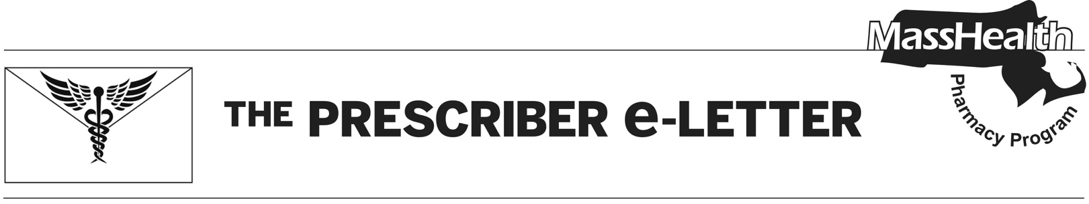
The Prescriber e-Letter,
August 2024, Volume 14, Issue 2

Prior Authorization Removal for Generic Buprenorphine/Naloxone Tablet for MassHealth Members
Suboxone® (buprenorphine/naloxone film) is currently available without prior authorization (PA) for doses up to 24 mg of buprenorphine per day. Effective October 1, 2024, PA will also be removed for generic buprenorphine/naloxone tablets for doses up to 24 mg of buprenorphine per day. This change in management applies to pharmacy claims for buprenorphine/naloxone and may not apply to opioid treatment programs.
Buprenorphine/naloxone is approved by the US Food and Drug Administration for maintenance treatment of opioid use disorder (OUD). The Substance Abuse and Mental Health Services Administration (SAMHSA) promotes the use of buprenorphine and buprenorphine/naloxone agents for the treatment of OUD.
Please refer to the SAMHSA Quick Start Guide for best practices when prescribing buprenorphine.¹

MassHealth Opioid Dependence and Reversal Agents Coverage Effective October 1, 2024

Drugs That Do Not Require PA
Maintenance Medications
- buprenorphine/naloxone tablet ≤ 24 mg/day
- Suboxone® (buprenorphine/naloxone film) ≤ 24 mg/day
- Sublocade® (buprenorphine extended-release injection)
- Vivitrol® (naltrexone injection)

Rescue Medications
- Kloxxado® (naloxone 8 mg nasal spray)
- naloxone vial, 0.4 mg/mL syringe, 2 mg/2 mL syringe
- naltrexone tablet
- Narcan® (naloxone 4 mg nasal spray)
- Rivive® (naloxone 3 mg nasal spray)
- Zimhi® (naloxone 5 mg/0.5 mL syringe)

Drugs That Require PA
Maintenance Medications
- Brixadi® (buprenorphine extended-release injection)
- buprenorphine sublingual tablet
- buprenorphine/naloxone tablet > 24 mg/day
- Suboxone® (buprenorphine/naloxone film) > 24 and ≤ 32 mg/day, > 90 days
- Suboxone® (buprenorphine/naloxone film) > 32 mg/day
- Zubsolv® (buprenorphine/naloxone sublingual tablet)
Rescue Medications
- LifEMS® Naloxone (naloxone syringe kit)
- Lucemyra® (lofexidine)
- Opvee® (nalmefene nasal spray)
Additional information can be found on the MassHealth Drug List.

Hepatitis C Direct Acting Antiviral PA Update
Effective October 1, 2024, the drug-drug interaction PA criteria will be removed for hepatitis C direct acting antivirals (DAAs). This change in management aligns with MassHealth’s efforts to reduce barriers to treatment for hepatitis C.
Guidance from the American Association for the Study of Liver Disease and Infectious Disease Society of America for testing, managing, and treating hepatitis C recommends evaluating patients for potential drug-drug interactions before starting treatment. It also recommends that interacting co-medications be paused or switched, when possible, to an alternative medication during the DAA course.² Reviews of drug-drug interactions are generally performed by the provider and validated or resolved by the dispensing pharmacist.
MassHealth currently has point-of-sale rules for generic sofosbuvir/velpatasvir, Epclusa® (sofosbuvir/velpatasvir) pellet pack and 200mg/50mg tablet, and Mavyret® (glecaprevir/pibrentasvir). With the removal of the drug-drug interaction criteria, claims for these drugs will usually pay at the pharmacy without PA if a claim meets the following criteria.
- Member is ≥ 3 years of age.
- Member is treatment naïve (has no previous pharmacy claims of hepatitis drugs).
- Member does not have pharmacy claims for drugs that suggest decompensated cirrhosis (i.e., lactulose, nadolol, rifaximin, and spironolactone ≥ 50 mg).
- The claim is within quantity limits for appropriate dosing.

References
- Substance Abuse and Mental Health Services Administration. Buprenorphine Quick Start Guide. SAMSHA. Available at samhsa.gov/sites/default/files/quick-start
-guide.pdf.
- American Association for the Study of Liver Diseases and Infectious Diseases Society of America. HCV Guidance: Recommendations for Testing, Managing, and Treating Hepatitis C [guideline on the internet]. Alexandria (VA): AASLD/IDSA 2022 October [cited 2024 Jul 30]. Available at hcvguidelines.org.

The Prescriber e-Letter is an update designed to enhance the transparency and efficiency of the MassHealth
drug prior-authorization (PA) process and the MassHealth Drug List. Each issue highlights key clinical
information and updates to the MassHealth Drug List. The Prescriber E-Letter was prepared by the
MassHealth Drug Utilization Review Program and the MassHealth Pharmacy Program.

