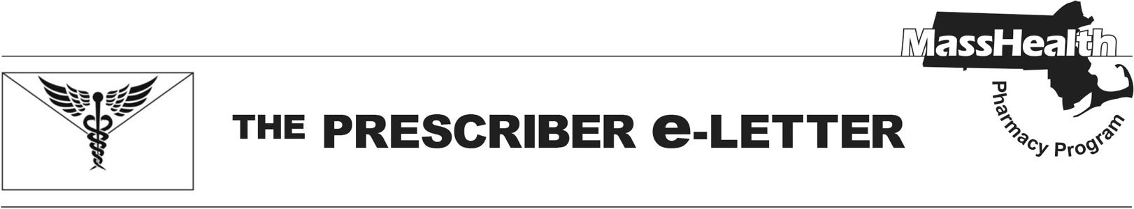
Volume 15, Issue 23, December 2025

Updated Changes to the Health Safety Net Formulary – Effective January 12, 2026

Pharmacy Facts 258 provided an initial overview of important changes to reimbursable Health Safety Net Program (HSN) pharmacy services.

In addition to the changes outlined in Pharmacy Facts 258, the following changes will also apply.
- The HSN Program will continue to reimburse for brand antiretrovirals with no generic equivalent and generic antiretroviral agents without prior authorization (PA) until further notice.
- Existing PAs for preferred non-drug products (e.g., continuous glucose monitors, continuous subcutaneous insulin infusion devices, preferred test strips over quantity limits) will not be terminated and will be honored for the duration of the existing prior authorization.

Please see updated summary table below.

HSN Formulary – Effective January 12, 2026
Generally reimbursable without PA: | Generally reimbursable with PA:
- Generic medications (including unbranded biosimilars)  - Select brand medications including:  - Most drugs on the MassHealth Brand Preferred Over Generic List (BOGL)  - Brand antiretrovirals with no generic equivalent  - Select non-drug products (i.e., alcohol swabs, ketone test strips, lancets, pen needles, syringes, urine glucose test strips)  - Preferred test strips within quantity limits  - Vaccines | - Preferred non-drug products (e.g., continuous glucose monitors, continuous subcutaneous insulin infusion devices, preferred test strips over quantity limits)  - Most brand medications not listed on the MassHealth BOGL  - Other medications when clinically necessary
Submitting Prior Authorization Requests

As a reminder, all currently approved PAs for medications will be terminated effective January 12, 2026. Requests for brand medications not on the BOGL will be evaluated for appropriate diagnosis, trial(s) with all clinically appropriate generic and BOGL alternatives, medical necessity, and documentation of application to manufacturer patient assistance program (if available).

Providers may begin submitting PA requests for HSN patients ahead of January 12, 2026, using the new HSN specific PA form available on the HSN Formulary Page of the MassHealth Drug List. All requests submitted on this form will be evaluated against the HSN clinical criteria going into effect on January 12, 2026, as outlined above.
- If the PA is approvable under HSN PA criteria effective January 12, 2026, the PA will be approved with a start date of January 12, 2026.
- If the PA is not approvable under HSN PA criteria effective January 12, 2026, the request will be returned with an explanation that the patient does not meet the future criteria.
- If providers are seeking prior authorization under the current HSN formulary, providers may submit the request using the appropriate MassHealth/HSN PA form for review under the current MassHealth/HSN PA criteria.

Prescribers who have questions regarding a HSN PA may contact the Drug Utilization Review Program at (800) 745-7318.

The Prescriber e-Letter is an update designed to enhance the transparency and efficiency of the MassHealth drug prior-authorization (PA) process and the MassHealth Drug List. Each issue highlights key clinical information and updates to the MassHealth Drug List. The Prescriber E-Letter was prepared by the MassHealth Drug Utilization Review Program, the MassHealth Pharmacy Program.

___________________________________________________________________________________________
Please send any suggestions or comments to prescribereletter@massmail.state.ma.us

