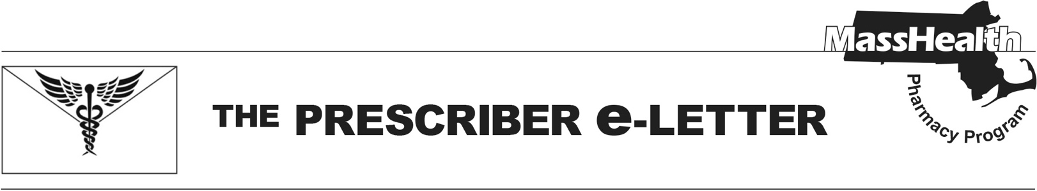
The Prescriber e-Letter,
Volume 15, Issue 3, February 2025

Upcoming Changes to MassHealth Coverage of Rapid-Acting Insulin
MassHealth Pharmacy currently covers the authorized generic formulations of insulin lispro (Humalog®) and insulin aspart (Novolog®) without prior authorization (PA) and covers the branded formulation without PA when there is no authorized generic equivalent (i.e., Humalog® [insulin lispro] 100 units/mL cartridge; Humalog® [insulin lispro] 200 units/mL).

Effective April 1, 2025, insulin aspart (Novolog®) will require PA
Effective April 1, 2025, PA will be required for all MassHealth members prescribed insulin aspart (Novolog®) to encourage the use of the cost-effective short-acting insulin agents. If clinically appropriate, please consider transitioning your members to insulin lispro (Humalog®), which will remain available without PA. If transition to insulin lispro (Humalog®) would not be clinically appropriate, you must submit a PA for insulin aspart (Novolog®) to MassHealth. The PA clinical criteria will require documentation of an appropriate diagnosis and inadequate response, adverse reaction, or contraindication to insulin lispro (Humalog®) (e.g., inadequate blood glucose control, documented intolerance or hypersensitivity, FDA-labeled contraindication, etc.).

Summary of PA Status of Rapid-Acting Insulin Products

Available without PA
- Humalog® (insulin lispro) 100 units/mL cartridge, 200 units/mL
- insulin lispro 100 units/mL prefilled syringe, vial
PA Required
- Admelog® (insulin lispro)
- Apidra® (insulin glulisine)
- Afrezza® (insulin human inhalation powder)
- Humalog® (insulin lispro) 100 units/mL prefilled syringe, vial
- Humalog Tempo® (insulin lispro)
- Fiasp® (insulin aspart)
- insulin aspart
- Lyumjev® (insulin lispro-aabc)
- Lyumjev Tempo® (insulin lispro-aabc)
- Novolog® (insulin aspart)

The MassHealth Drug List, including Therapeutic Class Table 26 (outlining the coverage status and PA criteria for antidiabetic agents) and the Antidiabetic Agents PA form, will be updated to reflect these changes. Additional information can be found on the MassHealth Drug List.

The Prescriber e-Letter is an update designed to enhance the transparency and efficiency of the MassHealth drug prior-authorization (PA) process and the MassHealth Drug List. Each issue highlights key clinical information and updates to the MassHealth Drug List. The Prescriber E-Letter was prepared by the MassHealth Drug Utilization Review Program and the MassHealth Pharmacy Program.

