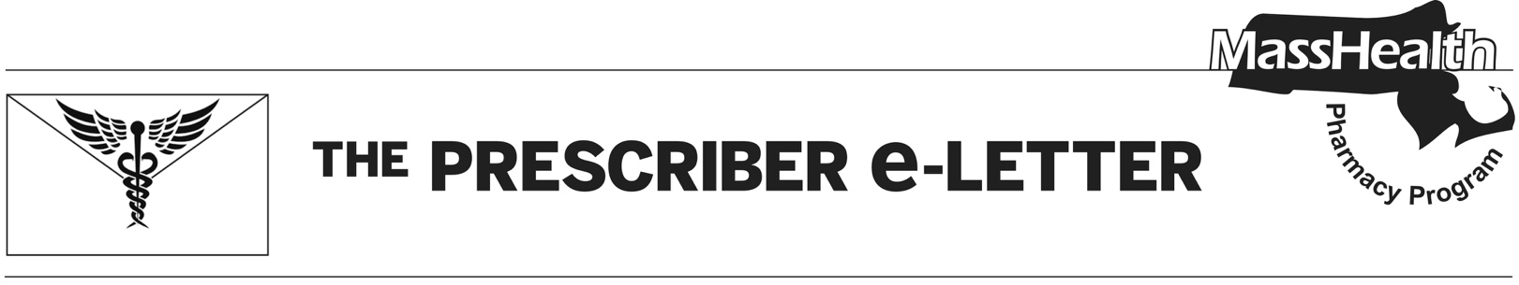
The Prescriber e-Letter,
July 2021 Volume 11, Issue 3

Continuous Glucose Monitoring

Different types of continuous glucose monitoring (CGM) that currently exist include real-time continuous glucose monitors (rtCGM), such as Dexcom G6® and Medtronic Guardian®, which measure and display glucose levels continuously; intermittently scanned continuous glucose monitors (isCGM), such as Freestyle Libre® 14-day and Freestyle Libre® 2, which measure glucose levels continuously while displaying values only when swiped by a reader or smartphone; and professional continuous glucose monitors, which are worn for a set period of time and are not fully owned by patients.

The Standards of Medical Care in Diabetes 2021 notes that when these devices are used as close to daily as possible (such as with rtCGM, which must be used at least every eight hours or data will be lost) and patients receive adequate education, training, and support, CGM can aid in identifying and correcting patterns of hyper- and hypoglycemia to improve HgbA1c levels.

In order to expand access to CGM products for MassHealth members, effective January 1, 2021, Dexcom G6, Freestyle Libre 2, and Freestyle Libre 14-day will be covered through the pharmacy benefit with a prior authorization (PA) requirement; previously, these devices were available only through the durable medical equipment (DME) benefit. Of note, all devices available through the MassHealth pharmacy benefit do not require fingerstick calibration and are approved for dosing decisions without testing.

Table 1. Continuous Glucose Monitoring Devices
Products That Require PA | No PA
Dexcom G6®
Freestyle Libre 14 day®
Freestyle Libre 2®

Dexcom G6 and Freestyle Libre devices may still be obtained through the DME benefit, while the Medtronic Guardian remains covered by DME only.

Continuous Subcutaneous Insulin Infusion

Continuous subcutaneous insulin infusion (CSII) or insulin pump delivery systems provide rapid-acting insulin throughout the day in order to manage blood glucose levels. The Endocrine Society recommends CSII for patients with type 1 diabetes who have not achieved target A1c goals, or those who have achieved A1c goals but have a history of severe hypoglycemia or high glucose variability. They also recommend consideration of CSII use in patients with type 2 diabetes who have poor glycemic control despite intensive insulin therapy, oral agents, other injectable therapy, and lifestyle modifications.

Omnipod® and Omnipod Dash® require a minimum of 85 units of insulin to be operational, can deliver up to 200 units of insulin, and provide continuous delivery for up to 72 hours. V-Go® delivers 20 to 40 units/day of preset basal insulin and 36 units of on-demand bolus dosing. All devices are waterproof. Omnipod® uses a personal diabetes manager for insulin infusion and has an app to assist with carbohydrate counting and device tutorials. V-Go® bolus insulin is controlled by buttons located on the device.

In order to expand access to CSII products for MassHealth members, effective July 1, 2021, Omnipod®, Omnipod Dash®, and V-Go®, will be covered through the pharmacy benefit with a PA requirement. Other CSII devices may be available through the DME benefit with a PA.

Table 2. Subcutaneous Insulin Infusion Products
Products That Require PA | No PA
Omnipod®
Omnipod Dash®
V-Go®

