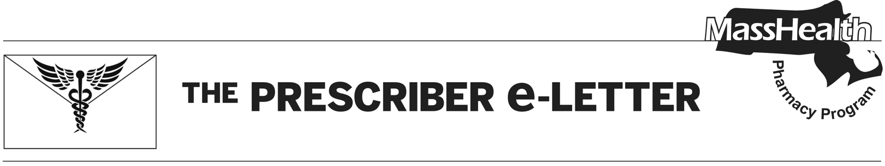
October 2022, Volume 12, Issue 3The Prescriber e-

Overview of Implementation of Adult Prescription Stimulant Restrictions

Prescription stimulants are commonly used for the treatment of attention-deficit/hyperactivity disorder (ADHD), narcolepsy, and excessive daytime sleepiness (EDS) in children and adults. In 2020, the National Institute on Drug Abuse (NIDA) reported 10.3 million people in the US abusing or misusing CNS stimulants.¹

Drug overdose deaths that involved a psychostimulant with abuse potential, including methamphetamine, rose from 547 in 1999 to 23,837 in 2020.¹ In Massachusetts specifically, an analysis of stimulant prescription rates indicated rapid growth from 2010 to 2019.²

For the treatment of ADHD, the use of stimulant medications in adults is typically appropriate. The diagnosis of ADHD in adults should consider diagnostic criteria as outlined in the Diagnostic and Statistical Manual of Mental Disorders, 5th edition.³

In addition, the use of long-acting (LA) agents is recommended by treatment guidelines, as clinical literature indicates that short-acting formulations are more commonly abused than LA formulations, with the highest proportion of misuse among young adults.⁴⁻⁶

Description of Restrictions for Adult Use of Prescription Stimulants

Given this information, MassHealth will implement restrictions on stimulant medications for adults beginning on December 12, 2022. Prior authorization (PA) will be required for adult members 21 years of age and older who are newly starting any stimulant
medication (defined as anyone who has not filled a stimulant within the last 90 days).

Please note that adult members 21 years of age and older initiating treatment with a CNS stimulant will require an appropriate diagnosis for the use of the stimulant medication. If applicable, such requests must also meet PA criteria unique to the requested drug, as well as any applicable quantity limits.

The MassHealth Drug List, including Therapeutic Class Table 31 outlining the coverage status and PA criteria for CNS stimulants and the Cerebral Stimulant and ADHD Drugs PA form, will be updated to reflect these changes. The MassHealth Drug List can be found at www.mass.gov/masshealth/pharmacy.

References

- Overdose Death Rates. National Institute on Drug Abuse (NIDA). Available from: https://nida.nih.gov/drug-topics/trends-statistics/overdose-death-rates.
- Bebinger M. Study: Massachusetts leads in stimulant prescriptions. WBUR. 2021 May 5. Available from: https://www.wbur.org/news/2021/05/05/study-massachusetts-leads-in-stimulant-prescriptions.
- American Psychiatric Association: Diagnostic and Statistical Manual of Mental Disorders, 5th edition. Arlington, VA., American Psychiatric Association, 2013.
- Post RE, Kurlansik SL. Diagnosis and Management of Attention-Deficit/Hyperactivity Disorder in Adults. Am Fam Physician. 2012 May 1;85(9):890-896.
- National Institute for Health and Clinical Excellence. Attention deficit hyperactivity disorder: Diagnosis and management. London (UK). September 2019. Available at: https://www.nice.org.uk/guidance/ng87/.
- Board AR, Guy G, Jones CM, Hoots B. Trends in stimulant dispensing by age, sex, state of residence, and prescriber specialty–United States, 2014-2019. Drug and Alcohol Dependence–Science Direct. 2020 Dec 1;217:108297. doi: 10.1016/j.drugalcdep.2020.108297.

The Prescriber e-Letter is an update designed to enhance the transparency and efficiency of the MassHealth drug prior-authorization (PA) process and the MassHealth Drug List. Each issue highlights key clinical information and updates to the MassHealth Drug List. The Prescriber E-Letter was prepared by the MassHealth Drug Utilization Review Program and the MassHealth Pharmacy Program.

