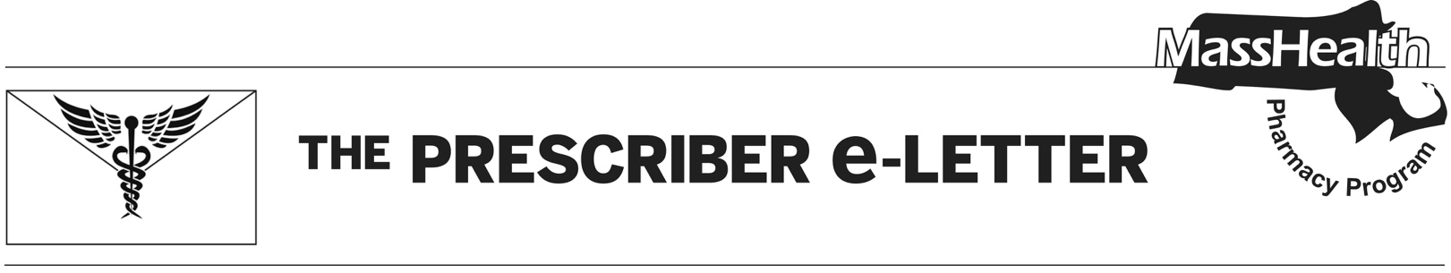
September 2023, Volume 13, Issue 3

Discontinuation of Brand Flovent® Products

GlaxoSmithKline (GSK) notified the United States Food and Drug Administration (FDA) on June 2, 2023, of an upcoming discontinuation of brand Flovent® HFA (fluticasone propionate inhalation aerosol) and Flovent® Diskus® (fluticasone propionate inhalation powder) products. These brand products will no longer be available for ordering as of December 31, 2023.¹ It is anticipated that supply of these products will be depleted in early 2024.

Generic Fluticasone Products Update

An authorized generic (AG) of Flovent® HFA is currently available. MassHealth expects that Teva will launch a generic version of Flovent HFA 110 mcg/inhalation in 2023 upon successful completion of a bioequivalence study. Additionally, an unidentified competitor has filed an abbreviated New Drug Application (aNDA) for a generic version of Flovent® HFA 220 mcg/inhalation, with the goal of launching in 2024 or 2025.² GSK plans on launching an AG of Flovent® Diskus® (fluticasone propionate inhalation powder) in October 2023.

Coverage for Generic Fluticasone Propionate for MassHealth Members

MassHealth currently applies the brand-preferred designation to both Flovent® HFA and Flovent® Diskus® (pending generic availability), as these products are less costly than the generic formulations. MassHealth will continue to pay for branded Flovent® products until the remaining supply in circulation is exhausted.

Effective December 4, 2023, prescriptions for authorized generics of Flovent® (fluticasone propionate) and Flovent® Diskus® (fluticasone propionate inhalation powder) will require prior authorization (PA) for new utilizers due to the higher cost of these generics compared to alternative inhaled corticosteroids. PA approval for this formulation will require prescribers to provide documentation of a diagnosis of asthma, and an inadequate response or adverse reaction to two, or contraindication to all,

inhaled corticosteroids available without PA. MassHealth will allow members already stable on Flovent® inhalers to use generic fluticasone inhalers without PA until March 4, 2024, to give prescribers time to transition members to an alternate inhaler. After this time, PA will be required for all utilizers of generic fluticasone inhalers.

The following inhaled corticosteroid products are currently available on the MassHealth Drug List (MHDL) without PA:
- Asmanex® HFA (mometasone inhalation aerosol)
- Asmanex® Twisthaler® (mometasone inhalation powder)
- Pulmicort® Flexhaler (budesonide inhalation powder)

PA restriction for Arnuity® Ellipta® (fluticasone furoate inhalation powder) will be removed on December 4th, 2023. Before then, MassHealth may allow Arnuity to process without PA to facilitate access for members transitioning from Flovent HFA. If MassHealth allows Arnuity to pay without PA before December 4, 2023, it will issue additional guidance through a Pharmacy Facts, available at MassHealth Pharmacy Facts (2016–Current) | Mass.gov.

Other changes to the inhaled respiratory class effective December 4, 2023, include the removal of PA for the following products:
- Anoro® Ellipta® (umeclidinium and vilanterol inhalation powder)
- Serevent® Diskus® (salmeterol xinafoate inhalation powder)

Please refer to Table 23: Respiratory Agents – Inhaled in the MHDL for more information.

References
- U.S. Food & Drug Administration. FDA Drug Shortages. 2023 Jun 2 [cited 2023 Sep 4]. Available from: FDA Drug Shortages.
- IPD Analytics. Projected generic launch schedule. [cited 2023 Sep 4]. Data on file.

The Prescriber e-Letter is an update designed to enhance the transparency and efficiency of the MassHealth
drug prior-authorization (PA) process and the MassHealth Drug List. Each issue highlights key clinical
information and updates to the MassHealth Drug List. The Prescriber E-Letter was prepared by the
MassHealth Drug Utilization Review Program and the MassHealth Pharmacy Program.

