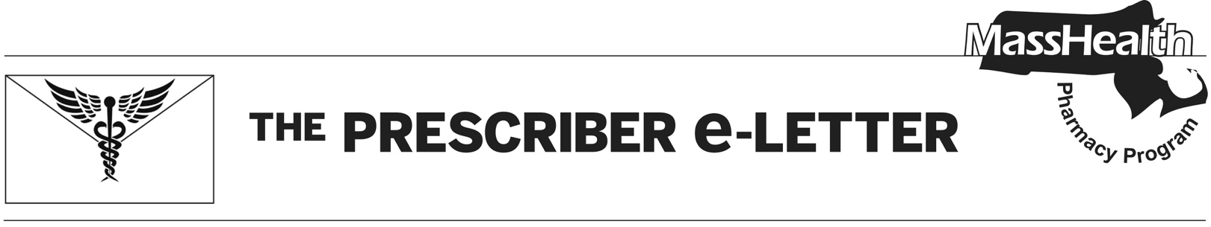
The Prescriber e-Letter,
December 2023, Volume 13, Issue 4 (updated)

Discontinuation of Levemir® (insulin detemir)
Novo Nordisk announced to the United States Food and Drug Administration (FDA) on November 8, 2023, the planned discontinuation of Levemir® (insulin detemir) FlexPen® and vials. Supply disruptions of the FlexPen® are anticipated to begin mid-January 2024, followed by discontinuation of the FlexPen® formulation on April 1, 2024, and discontinuation of the vial formulation on December 31, 2024.
There are currently no commercially available biosimilars or authorized generics for insulin detemir. Alternative long-acting insulin products covered under the MassHealth pharmacy benefit include the following.

Agents without Prior Authorization (PA)
- Lantus® (insulin glargine)
- Toujeo® (insulin glargine)
- Tresiba® (insulin degludec)

Agents Requiring PA
- Basaglar® (insulin glargine)
- Semglee® (insulin glargine-yfgn)

Discontinuation of GlucaGen® HypoKit® (glucagon)
Novo Nordisk announced to the FDA on November 18, 2023, the planned discontinuation of GlucaGen® HypoKit® (glucagon) in the United States. This discontinuation will be effective July 1, 2024.
Generic formulations of glucagon are commercially available. Additionally, there are multiple branded alternative formulations. The following glucagon products are available through the MassHealth pharmacy benefit.

Agents without PA
- Baqsimi® (glucagon nasal powder)
- glucagon vial
- Gvoke® (glucagon auto-injection, prefilled syringe, vial)
- Zegalogue® (dasiglucagon) – PA required until March 4, 2024

Discontinuation of Flovent® (fluticasone)
GlaxoSmithKline announced to the FDA on June 2, 2023, the planned discontinuation of brand Flovent® HFA (fluticasone propionate inhalation aerosol) and Flovent® Diskus® (fluticasone propionate inhalation powder) products. These brand products will no longer be available for ordering as of December 31, 2023.¹
Authorized generics of Flovent® HFA and Flovent® Diskus® are currently available. Members stable on Flovent products may receive brand Flovent products while available or generic fluticasone products until March 4, 2024.
Alternative inhaled corticosteroids covered under the MassHealth pharmacy benefit include the following.

Agents without PA
- Fluticasone propionate inhalation – <5 years old
  - PA required for new starts for members <5 years old until March 4, 2024.
- Arnuity® (fluticasone furoate inhalation powder)
- Asmanex HFA® (mometasone inhalation aerosol)
- Asmanex Twisthaler® (mometasone inhalation powder)
- Pulmicort® Flexhaler (budesonide inhalation powder)

Agents Requiring PA
- Fluticasone propionate inhalation – >5 years old
  - Members stable on Flovent® HFA and Flovent® Diskus® will not require PA until March 4, 2024.
- Alvesco® (ciclesonide inhaler)
- Armonair Digihaler® (fluticasone propionate inhalation powder)
- Pulmicort® (budesonide inhalation suspension) – >13 years old
- Qvar RediHaler® (beclomethasone inhaler)
Please refer to the MHDL web site for more information.

The Prescriber e-Letter is an update designed to enhance the transparency and efficiency of the MassHealth drug prior-authorization (PA) process and the MassHealth Drug List. Each issue highlights key clinical information and updates to the MassHealth Drug List. The Prescriber E-Letter was prepared by the MassHealth Drug Utilization Review Program and the MassHealth Pharmacy Program.

. U.S. Food & Drug Administration. FDA Drug Shortages. 2023 [accessed 2023 Nov 16]. Available from: FDA Drug Shortages.

