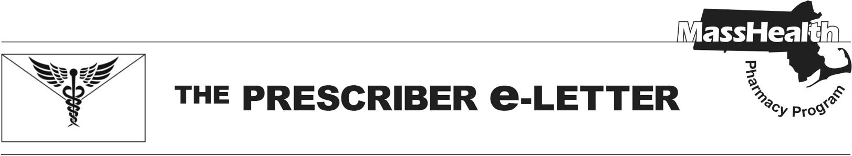
Volume 16, Issue 4, February 2026

Scope of Reimbursable Pharmacy Services under the Health Safety Net (HSN) and Covered under MassHealth Limited
Recent Changes to HSN Reimbursable Pharmacy Services
On January 12, 2026, the HSN formulary was updated to include primarily generic medications. Under the new HSN formulary, most brand medications require prior authorization (PA). Current exceptions include drugs on the MassHealth Brand Name Preferred Over Generic List (BOGL) and antiretroviral medications without generic alternatives. More information is on the MassHealth Drug List HSN Formulary page. Please see Pharmacy Facts 258, 265, and 267 for more information on HSN formulary changes.
MassHealth Limited Coverage and HSN Reimbursable Pharmacy Services
Some patients with MassHealth Limited may also qualify for pharmacy service reimbursement through HSN. This allows HSN pharmacies (those part of or contracted with a community health center or an acute hospital) to bill for eligible medications or supplies payable under the program.

MassHealth Limited coverage provides emergency health services to qualified patients ineligible for MassHealth Standard. Pharmacy coverage under MassHealth Limited is restricted to select antibiotics and select COVID-19 antiviral medications and does not include comprehensive outpatient prescription coverage.

HSN is not insurance and is not Medicaid. The HSN makes payments to Massachusetts community health centers and acute hospitals for certain health care services provided to qualified low-income, uninsured, or underinsured Massachusetts residents.

Considerations When Applying to Manufacturer Patient Assistance Programs (PAPs)
Completing manufacturer PAP applications can be complex and time consuming. The guidance below is intended to help pharmacies and providers complete these applications.

For patients with MassHealth Limited coverage and HSN eligibility (who do not have other coverage), please note that they do not have insurance coverages for drugs other than antibiotics and COVID-19 antivirals.

Uninsured patients with only HSN eligibility are uninsured.

Some PAPs may request attestation that participation in their program is not a requirement for drug coverage. Attestation will largely depend on the language used by the program. If the application asks whether an “insurer” or “employer” is directing the patient to apply, consider that HSN is not insurance and does not provide coverage.

The Prescriber e-Letter is an update designed to enhance the transparency and efficiency of the MassHealth drug prior-authorization (PA) process and the MassHealth Drug List. Each issue highlights key clinical information and updates to the MassHealth Drug List. The Prescriber e-Letter was prepared by the MassHealth Drug Utilization Review Program, the MassHealth Pharmacy Program.

