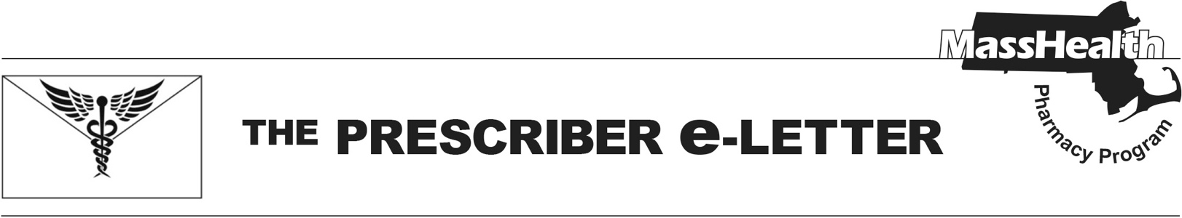
The Prescriber e-Letter,
Volume 14, Issue 4, October 2024

Pediatric Behavioral Health Medication Initiative Updates
The MassHealth Pharmacy Program, in collaboration with the Department of Children and Families (DCF) and the Department of Mental Health (DMH), developed the Pediatric Behavioral Health Medication Initiative (PBHMI). The PBHMI proactively requires prior authorization (PA) for potentially dangerous combinations of behavioral health medications prescribed to members younger than 18.

The MassHealth PBHMI is designed to ensure that MassHealth pediatric members receive medically necessary behavioral health medications that are safe and effective, and that optimize patient care.

As part of continuous quality-improvement and assurance efforts, and in accordance with clinical literature and consensus guidance, the changes outlined below were made to the PBHMI PA requirements on October 1, 2024. The tables below show the previous requirements and the recent changes.

Thank you for helping to ensure that medically complex pediatric MassHealth members receive safe, effective, and optimized behavioral health medication regimens.

Previous Requirements
PA is required for antipsychotics in members <6 years old.
Prazosin is not included in any PBHMI requirements.
Regimens including any four or more behavioral health medications require PA (agents considered to be used only for seizure diagnoses are not included).

Requirements Effective October 1, 2024
PA will be required for antipsychotics in members <10 years old.
Prazosin will require PA for members <6 years old and when included as part of a polypharmacy regimen as described below.
Regimens including any five or more behavioral health medications will require PA (agents considered to be used only for seizure diagnoses are not included).

Regimens including four or more behavioral health medications will continue to require PA if one of the following medications is included: an antipsychotic, a benzodiazepine, divalproex, lithium, and/or a tricyclic antidepressant (agents considered to be used only for seizure diagnoses are not included).

The MassHealth Drug List is on the MassHealth Pharmacy Program website at www.mass.gov/masshealth/pharmacy.

Please refer to Therapeutic Class Table 71 for the most up-to-date information about the PBHMI.

The Prescriber e-Letter is an update designed to enhance the transparency and efficiency of the MassHealth drug prior-authorization (PA) process and the MassHealth Drug List. Each issue highlights key clinical information and updates to the MassHealth Drug List. The Prescriber E-Letter was prepared by the MassHealth Drug Utilization Review Program and the MassHealth Pharmacy Program.

