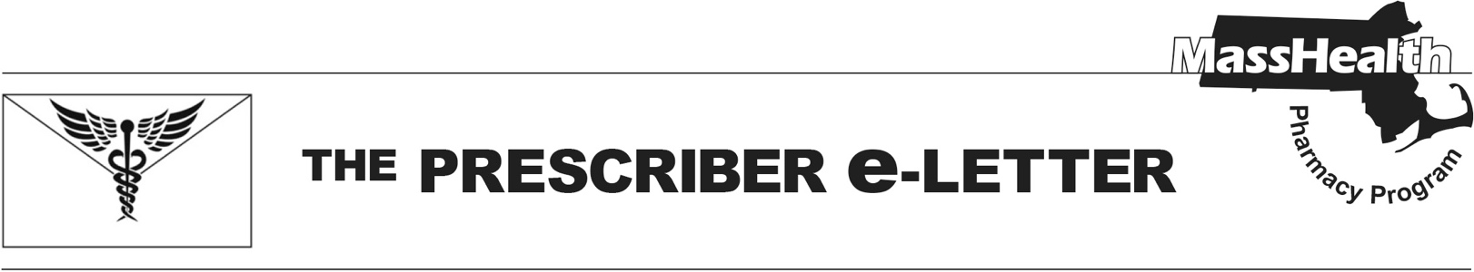
Volume 15, Issue 5, April 1, 2025

Change to the Management of Anti-Obesity Medications for Health Safety Net (HSN) Patients
In accordance with Health Safety Net regulations at 101 CMR 613.03(2)(e), the Health Safety Net does not pay for drugs used for the treatment of obesity. Effective April 15, 2025, the following drugs will no longer be payable for HSN patients for weight loss. Existing prior authorizations will be payable through May 15, 2025.

Anti-Obesity Agents
benzphetamine
diethylpropion, diethylpropoin extended-release
Saxenda® (liraglutide)
Xenical (orlistat)
phendimetrazine, phendimetrazine extended-release
Lomaira®, Adipex-P® (phentermine capsule, tablet)
Wegovy® (semaglutide)
Zepbound® (tirzepatide)

- Any drug being used off-label for weight loss is not permitted.
- HSN patients stable on an anti-obesity agent, including patients with existing prior authorizations for anti-obesity agents, will be able to continue getting the drug through May 15, 2025.
- Wegovy® (semaglutide) and Zepbound® (tirzepatide), may still be payable by HSN for other medically accepted indications. Submission of a new prior authorization will be required to review for medical necessity.

Providers should work with patients to transition to alternative therapies where appropriate.

- Patients with diabetes may be switched to a diabetic GLP-1, such as Victoza® (liraglutide), which is available without prior authorization. Prior authorization status and criteria for other diabetic GLP-1 medications can be found on the MassHealth Drug List.

The MassHealth Drug List is on the MassHealth Pharmacy Program website at www.mass.gov/masshealth/pharmacy.

The Prescriber e-Letter is an update designed to enhance the transparency and efficiency of the MassHealth drug prior-authorization (PA) process and the MassHealth Drug List. Each issue highlights key clinical information and updates to the MassHealth Drug List. The Prescriber E-Letter was prepared by the MassHealth Drug Utilization Review Program, the MassHealth Pharmacy Program, and the Health Safety Net Program.

