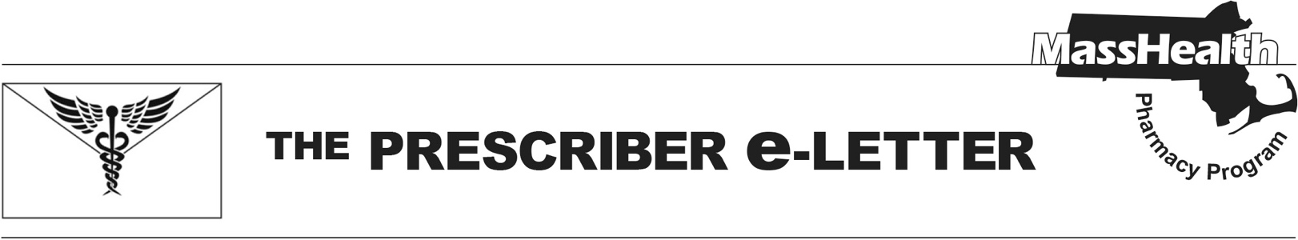
The Prescriber e-Letter,
Volume 14, Issue 5, October 2024

Respiratory Syncytial Virus Coverage Updates

MassHealth coverage for respiratory syncytial virus (RSV) products was updated effective October 1, 2024. The RSV season typically occurs from mid-October through March. MassHealth monitors RSV percent positivity rate and notes an official start to the season when percent positivity is three or greater for two consecutive weeks. As of June 2024, the Centers for Disease Control (CDC) recommends a single dose of RSV vaccine for all adults 75 and older and for adults 60 to 74 at increased risk of severe RSV. The CDC also recommends an RSV vaccine for pregnant people. Alternatively, a monoclonal antibody can be given to the baby after birth. The following provides an overview of MassHealth RSV coverage, including specific updates to certain products.

MassHealth RSV Monoclonal Antibody and Vaccine Coverage Effective October 1, 2024

RSV Vaccine/Drug | No PA Required | PA Required
Abrysvo® (RSV vaccine) | ≥ 60 years* | < 60 years*^
Arexvy® (RSV vaccine, adjuvanted) | ≥ 50 years* | < 50 years*
mRESVIA® (RSV suspension) | ≥ 60 years* | < 60 years*
Beyfortus® (nirsevimab-alip) | <8 months | ≥8 months
Synagis® (palivizumab) | N/A | All ages
*Limit of one lifetime dose
^Abrysvo is available without PA through medical billing for use in pregnant people.

Pharmacy Coverage Effective October 1, 2024

Beyfortus Coverage Update
Beyfortus® (nirsevimab) will not require prior authorization (PA) for MassHealth members eight months or younger. For members eight months or older, PA will be required to determine medical necessity based on comorbidities. Beyfortus® (nirsevimab) is available through the Massachusetts Department of Public Health Vaccines for Children program.

Synagis Coverage Update
Synagis® (palivizumab) will continue to require PA. MassHealth clinical criteria was updated to include clinical rationale for use instead of Beyfortus® (nirsevimab). Clinical criteria for review of Synagis® (palivizumab) includes age; rationale for use instead of Beyfortus® (nirsevimab); and additional documentation, depending on diagnosis of chronic lung disease (CLD) of prematurity, bronchopulmonary dysplasia (BPD), prematurity, or chronic heart disease (CHD).

Abrysvo® (RSV vaccine) Coverage Update
Abrysvo® was approved by the Federal Drug Administration (FDA) on May 31, 2023, for active immunization for the prevention of lower respiratory tract disease (LRTD) caused by RSV in adults 60 years or older. On August 21, 2023, Abrysvo® received an additional indication for pregnant people at the gestational age of 32 through 36 weeks for the prevention of LRTD and severe LRTD caused by RSV in infants from birth through six months. Abrysvo® will be covered without PA for MassHealth members 60 or older; however, it will require PA for pharmacy claims for members younger than 60, including those who are pregnant. Abrysvo® does not require PA through the medical benefit due to its indication for use by pregnant people. Providers can bill for Abrysvo® using procedure code 90678. Providers should refer to appropriate provider manuals for more information.

Arexvy® (RSV vaccine) Label Expansion
Arexvy® was FDA-approved on May 3, 2023, for active immunization for the prevention of LRTD caused by RSV in individuals 60 or older. On June 10, 2024, Arexvy® received an expanded indication to include individuals 50 through 59 who are at increased risk for LRTD caused by RSV. Effective October 1, 2024, MassHealth covers Arexvy® without PA for members 50 or older.

mRESVIA® (RSV vaccine suspension) FDA-Approval
mRESVIA® is a ribonucleic acid (RNA)-based RSV vaccine that was FDA-approved on May 31, 2024, for the active immunization for the prevention of LRTD caused by RSV in individuals 60 or older. mRESVIA® will be covered without PA for MassHealth members 60 or older, starting October 1, 2024.

References
CDC. ACIP Presentation Slides: June 26–28, 2024. Accessed September 10, 2024. https://www.cdc.gov/vaccines/acip/meetings/slides-2024-06-26-28.html

The Prescriber e-Letter is an update designed to enhance the transparency and efficiency of the MassHealth drug prior-authorization (PA) process and the MassHealth Drug List. Each issue highlights key clinical information and updates to the MassHealth Drug List. The Prescriber E-Letter was prepared by the MassHealth Drug Utilization Review Program and the MassHealth Pharmacy Program.

